Research In Context (ADAD5003)
Student Name: Hunter Hare
Student Number: 2103414
Word Count: 2426
Bibliography Word Count: 372

Question 4: Why is Information Design important? Explore how Information Design helps to shape the world around us as well as our understanding of it.

We live in a world where information design has become very important and is heavily relied on. Information design, also known as data visualization or infographics is now a major part of our global communication and allows us to communicate quickly with others and with ease. But, to understand why information design is so vital in our society today, we must first understand what this data visualisation is. So what is information design? It is defined as the “visual representation of data” according to Michael Friendly (2007), this implies that any type of design from maps, graphs, signs and charts, etc are a form of infographic. In this essay I will discuss how information design has evolved over the recent decades, as well as how we use it to benefit us in our social life, work and everyday lives. I will also discuss how some people may find information design to be misleading and untrustworthy, when the designers do not show the key message or intentions in their infographic.

Information design is incredibly important as it is a brilliant form of communication allowing the general public to understand certain facts and figures and other key information within a short period of time and with ease (Meirelles, I, 2013). Three examples of how this data visualization is useful to our everyday lives are communication, such as sign language, signs and symbols, and showing statistics for example, news broadcast or informative diagrams (Michael Friendly 2007).

Sign language and information graphics.
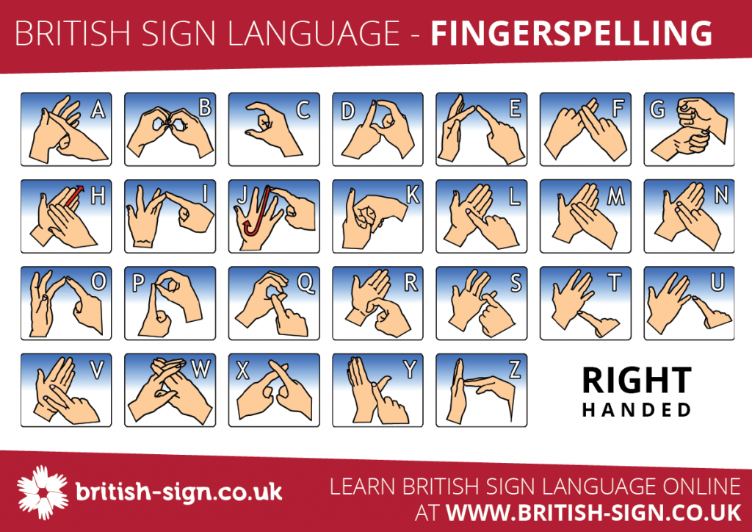

Figure 1: British Sign Language – Fingerspelling.

Over the last couple of decades information design has truly evolved and shaped the world and society around us making it much more inclusive and positive. We no longer only see this type of design printed out on posters and drawn on boards but we see it everywhere we go from the type of communication we use, to our phones and public transport; this data visualisation has evolved with society and alongside the introduction of new technology to help us in our everyday lives; whether it is showing us the weather forecast, giving us street directions or showing us business insights and statistics, information design is everywhere. For example, the image above (Figure 1) shows an example of how information design has evolved from these drawings and standard typography, (such as written language,) which we are familiar with to a form of communication using the body and facial expressions. “Sign language is a visual means of communicating using gestures, facial expression, and body language.” (British Sign, 2022). Sign Language is most commonly used by those who suffer from hearing impairments or complete loss of hearing as it allows them to communicate without the need for spoken language. This implies that information design is now more than just designing informative posters and showing written statistics but it also includes communication of data through our bodies, where the body is seen as the interface and these gestures and expressions are recognized as signs and symbols communicating information similar to spoken or written language (Lise Amy Hansen, 2011). So how and why is this important especially in today’s society? Firstly, it allows more people to communicate and discuss information effectively as well as opening up a new opportunity to communicate with ease with those who have full or partial hearing loss, “for many Deaf people, to learn English is to learn a second language.” (Sign Health, 2022). Before sign language was created and designed everyday life was difficult for the majority of those with suffering from hearing loss, for example, in the workplace people would often rely on lip reading or writing things down which is time consuming and often difficult. Trying to communicate to doctors or GPs would also be a struggle for many, and it would often be a very strenuous situation; understanding the symptoms and procedures doctors may be describing or prescribing without being able to hear the full in depth explanation often leads to misinterpreting vital information (Sign Health, 2022). However, with the increase of sign language communication for a huge number of deaf and partial hearing people has become more accessible and less frustrating. This particular type of information design has helped roughly 145,00 people suffering with hearing loss in the UK alone, according to a 2011 survey by British Sign. In addition, the teaching of sign language is fortunately very accessible and easy to understand with simple infographics such as Figure 1 shows above, as well as longer articles and websites such as British Sign. This particular infographic (shown in Figure 1) is a brilliant example of a clear and direct representation of data; due to its clean structure and evident hierarchy the information being shown is obvious and readable. The sans-serif typefaces are a responsible choice as they allow the eyes to read the data clearly without distraction and the colours are kept to a minimum to allow the information to be the main focus point. The illustrative diagrams are simple yet informative showing exactly what the intended message is, how to use fingerspelling. Unfortunately sign language is not a universal language although it would be an even bigger breakthrough and advantage if it were, but sign language differs from country to country (Sign Health, 2022) so these infographics will also show different information in different countries.

Signs, symbols and information design.
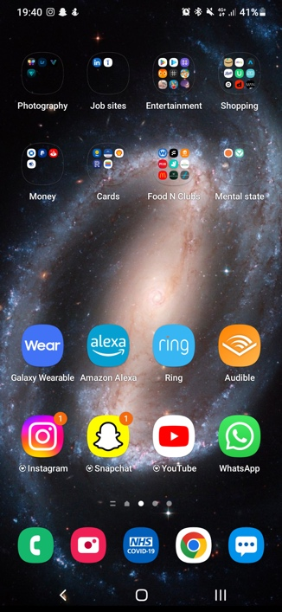
Figure 2: Phone Screenshot, 23rd November 2022.

For most people the first thing that we do when we wake up is check our phones for notifications, news and social media updates, but what we really see first is signs and symbols helping us navigate our phones effectively, quickly and effortlessly. We as a society can now recognise a popular symbol such as application icons or the home button that we find on our phone screens in a matter of seconds, sometimes even less. According to Wang, & Li, X. (2017) the design of the application icon is extremely important for user attraction and appeal, it also allows us to recognize information in much shorter time compared to reading a word or phrase. In addition, there is less space needed to display the required information whereas a word or illustration would take up more space. The use of symbols began in the mid 1970’s when consumers and manufacturers required symbols for new and upcoming technologies for example radios, household machines, and vehicles (Meirelles, I 2013). These symbols, also known as icons, need to be readable and clear but they also need to be scalable allowing them to fit into smaller places such as on the buttons of phones. For an icon to be successful it is essential for it to be simple yet distinguishable.
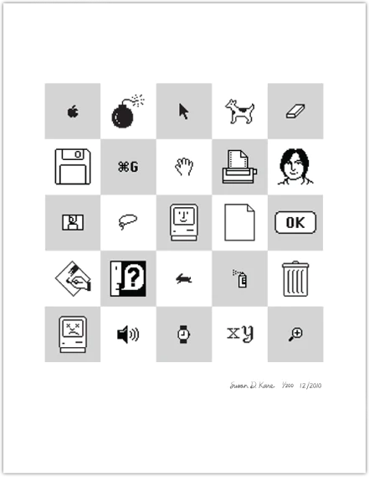
Figure 3: Susan Kare Icons – 1984 A-Z on Grey.

Some of the most famous icon designs were created in 1982 by Susan Kare, who produced icons and typefaces for Apple, (Kare Prints, 2022). Here Kare designed the Chicago typeface as well as the well-known icons used on the Macintosh computer, one of the original Apple Macs. These icons shown in Figure 3 have allowed designers and software users to have an easy and user-friendly experience. By being able to understand what the software tools were without needing to read words helps to reduces space required for them on the screens as well as being very recognizable in a short period of time, ultimately helping to reduce the time needed for the design process. When icons are designed correctly, they communicate the core idea and purpose behind the action (Babich, Smashing Magazine, 2016). In our society today the majority of software we use as designers such as Adobe Photoshop have icons due to it becoming a pattern that we have become very familiar with as designers and users, in fact we now expect websites, software and apps to have icons representing actions such as a home button or menu tab. However, when icons are designed poorly it can lead to many disadvantages for example, hiding functionality, being difficult to recognize and remember but also requiring more space than necessary (Babich, Smashing Magazine, 2016), this is important to remember when designing icons as the first job or role of that icon is to tell the user where they need to go. So how has the introduction of these icons made an impact on our society and helped shape our world? Well, for many designers who use software like adobe illustrator or photoshop it has enabled us to have quick navigation and a larger screen area for designing. When it comes to the general public, icons have been placed almost everywhere from our phones, cars and home appliances where they have made a huge impact on the way we interact with technology and how we will interact with it going into the future. These little icons have started a new era of design, aiding in the transition from paper and pencil designs to the newest software designs using technology such as the Apple Mac.

The news and data visualisation – How it affected the Covid-19 Pandemic.

Figure 4: BBC (2021) Covid-19: PM urges 'optimistic but patient approach' to pandemic.
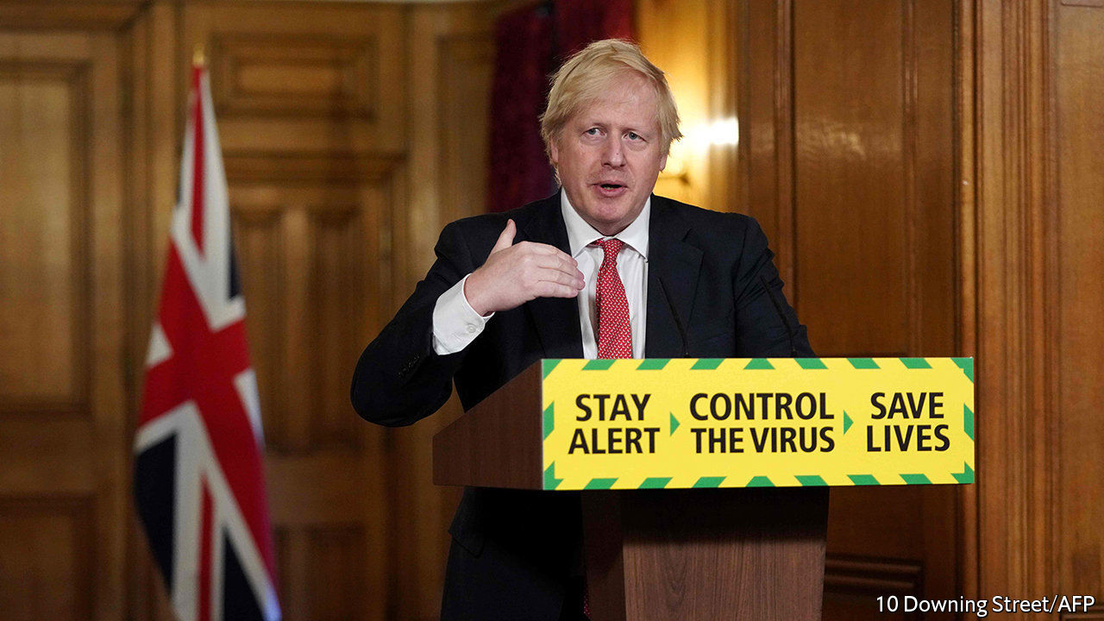
Figure 5: The Economist (2020) Boris Johnson’s new covid-19 campaign falls flat.

The Covid-19 pandemic was and still is an incredibly tough and stressful time for the world. In December 2019 we watched as the news and Boris Johnson announced the unforgettable beginning of the Covid-19 pandemic, leading to many lockdowns all across Britain, and the unfortunate loss of approximately 200,000 people in the UK alone (GOV.UK, 2022). It was a time where information design was vital, but mistakes were made. There were many occasions where infographics allowed the government to communicate messages such as in Figure 4 where Boris Johnson stands behind the first slogan “Stay Home, Protect The NHS, Save Lives” (BBC, 2021), this slogan is a good example of clear and straightforward information design that helps and guides the general public in these uncertain times. The slogan is outlined with a red boarder, the colour red here was a brilliant design choice as is it recognized as a strong warning colour (Kauppinen-Räisänen, 2018) allowing the public to understand the importance of the information being given to them. The clear sans-serif typeface is readable and calmly communicates exactly what the government intends. According to the Association of Anaesthetists (2020) it is always a challenge to communicate knowledge and statistics of the pandemic and other important issues to the general public, the people who need it the most. However the slogan got redesigned (Figure 5) to a confusing and misleading design. This design led to the panic and confusion from the Corona virus outbreak to worsen as instructions were unclear and indirect. Although the words remain in the clean sans-serif typeface, the meaning and choice of words like “Control the Virus” (Figure 5) seem unrealistic and confusing. This version of the slogan has been labelled as “vague and Imprecise” (The Economist, 2020). The green boarder surrounding the text is also deceptive as we recognize the colour green to resemble healthy, alive and good, which when matched with the confusing type creates a poor infographic design. The main intention of this slogan is to warn people of the dangers of the virus and instead of directing the general population to stay isolated and abide by the social distancing rules it creates a sense of hesitation and perplexity. Comparing the two slogans, Figure 4 and Figure 5 we learn how important correct and responsible data visualisation is especially when designed for such a huge audience, the general public of the UK. So, what have designers learnt from this mistake? We have learnt that the simplest errors such as the wrong word choice or colour can make such a massive impact on how information is being perceived by the viewers and implies that all designers need to be aware of these major components when designing anything but especially information design as it will make or break the whole infographic.

How information design can be misleading.

We see a clear example of how data visualisation can be misleading in Figure 5; it is incredibly important for infographic designers to understand how their work impacts the viewers and how they perceive it. For example when the broadcast (Figure 5) was shown it only panicked the public more and caused confusion and stress. We witnessed one of the biggest panics during the Covid-19 pandemic and infographics such as Figure 5 did not help one bit. Designers, when choosing to create an infographic, must accept the responsibilities and consequences of their designs. We must be aware that the wrong colour choice or typeface can send a completely different message than intended or create a sense of perplexity. Although data visualisation is vital to our society nowadays, it is also essential that we do not create panic or mislead our viewers.

Conclusion.
Throughout this essay I have discussed the importance of information design and how it has shaped our world and society into a modern, positive and communicative place, from the use of sign language to symbols we see, and to the famous broadcasts from the then Prime Minister, Boris Johnson during the Covid-19 pandemic. It is clear that information design is essential to our everyday lives as it guides us and simplifies the way we live and communicate. However, I have also covered the importance of studying data visualisation to reduce the chances of misleading and confusing the audience, and how some examples of this deceptive information design can cause panic and frustrations from the viewers, deterring away from the message and intention of the infographic. So, what have we learnt? I, for example have learnt that information design isn’t easy, as it’s not about throwing statistics together on a page and making it look attractive for the viewers, but it is much more powerful than we think. I have learnt that not everyone can be an infographic designer as it takes skill and practice for it to not be confusing, the key thing that I have discovered from writing this essay is that data visualisation is a form of communication and its main role is to display the message intended in a clear and responsible way, we as designers must take on that responsibility when we accept the work, and understand that there can be consequences to our designs if they are not accurate or understandable. Personally, I believe that information design has shaped our world and our future. It has opened up opportunities that we as graphic designers can take advantage of.

Bibliography:

Figures:

Figure 1: British Sign Language (2022.) – Fingerspelling. Available at: https://www.british-sign.co.uk/fingerspelling-alphabet-charts/
(Accessed on 19th November 2022.)

Figure 2: Hunter Hare (23rd November 2022.) Phone Screenshot.

Figure 3: Susan Kare Icons – 1984 A-Z on Grey. Available at: https://kareprints.com/
(Accessed on 25th November 2022.)

Figure 4: BBC (15 February 2021) Covid-19: PM urges 'optimistic but patient approach' to pandemic. Available at: https://www.bbc.co.uk/news/uk-56075832
(Accessed on 26th November 2022.)

Figure 5: The Economist (May 11th, 2020) Boris Johnson’s new covid-19 campaign falls flat.
Available at: https://www.economist.com/britain/2020/05/10/boris-johnsons-new-covid-19-campaign-falls-flat
(Accessed on 26th November 2022.)

Articles:

British Sign (2022.) Home Page.
Available at: https://www.british-sign.co.uk/
(Accessed on 19th November 2022.)

British Sign (2022.) - What is British Sign Language?
Available at: https://www.british-sign.co.uk/what-is-british-sign-language/
(Accessed on 19th November 2022.)

GOV.UK (24 November 2022) Deaths in: United Kingdom.
Available at: https://coronavirus.data.gov.uk/details/deaths
(Accessed on 26th November 2022.)

Kare Prints (2022.) About Page.
Available at: https://kareprints.com/pages/about
(Accessed on 25th November 2022)

Lise Amy Hansen (2011) Full-body movement as material for interaction design. Available at: https://www-tandfonline-com.ezproxy.uwtsd.ac.uk/doi/full/10.1080/14626268.2011.622284
(Accessed on 21st November 2022.)

Nick Babich, Smashing Magazine (2016.) - Icons as Part of a Great User Experience.
Available at: https://www.smashingmagazine.com/2016/10/icons-as-part-of-a-great-user-experience/
(Accessed on 26th November 2022.)

Sign Health (2022.) Home Page.
Available at: https://signhealth.org.uk/
(Accessed on 23rd November 2022)

Sign Health (2022.) - Who uses British Sign Language (BSL)?
Available at: https://signhealth.org.uk/resources/learn-about-deafness/british-sign-language-and-english/
(Accessed on 23rd November 2022)

Wang, & Li, X. (2017). Effects of the aesthetic design of icons on app downloads: evidence from an android market. Electronic Commerce Research, 17(1), 83–102. Available at: https://web-s-ebscohost-com.ezproxy.uwtsd.ac.uk/ehost/pdfviewer/pdfviewer?vid=0&sid=27eff49a-acd2-43a9-8aa5-336deea2f1ac%40redis (Accessed on 21st November 2022.)

Books:

Kauppinen-Räisänen, Hannele; Jauffret, Marie-Nathalie. (2018) Using colour semiotics to explore colour meanings. Qualitative Market Research, pp. 101-117. Available at: https://www.proquest.com/docview/1986154294?accountid=130472&parentSessionId=SufiKR1%2F%2FG0u0%2FBoEcCUCUKuPd6CJ35LEbfaKFigTPs%3D&pq-origsite=primo
(Accessed on 26th November 2022.)

Marchese, C. (2021). The roots of data-driven design. In Information Design for the Common Good: Human-Centric Approaches to Contemporary Design Challenges (pp. 12–39). London: Bloomsbury Visual Arts. (Accessed on 6th November 2022)
Association of Anaesthetists (30 March 2020). Social media for rapid knowledge dissemination: early experience from the COVID-19 pandemic. Available at: https://associationofanaesthetists-publications-onlinelibrary-wiley-com.ezproxy.uwtsd.ac.uk/doi/full/10.1111/anae.15057 (Accessed on 26th November 2022)

Meirelles, I (2013), Design for Information: An Introduction to the Histories, Theories, and Best Practices Behind Effective Information Visualizations, Quarto Publishing Group USA, Osceola. Available at: ProQuest E-book Central. (Accessed on 6th November 2022.)

