2nd assignment
Marketing in Practice

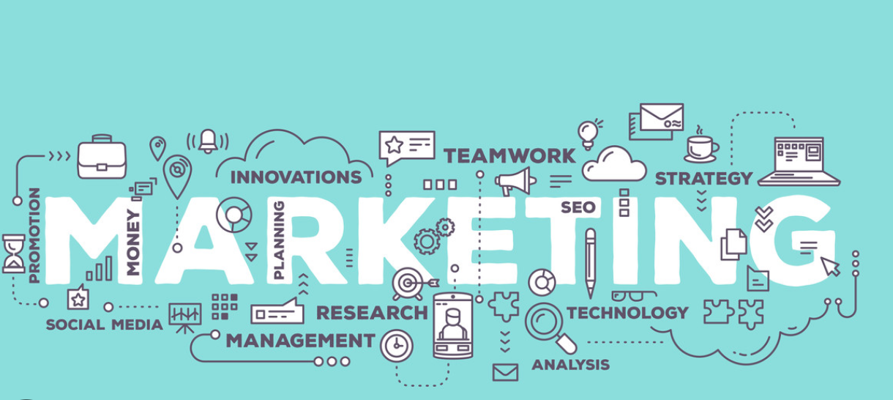

Aneta Wargacka
2003715

Table of content …………………………………………………………2

Executive Summary………………………………………………………3

Introduction ………………………………………………………………3

Communication channels ………………………………………………. 3;4

Campaign ideas ………………………………………………………… 4

Budget splits …………………………………………………………… 5

Measuring campaign performance …………………………………. 6;7

Conclusion………………………………………………………………. 7

References ………………………………………………………………. 8

Executive summary

This report centres on the marketing campaign for the new product "Lush Box" from a Mediterranean diet company, with a particular focus on using proper communication channels to introduce a vegan cooking box in Swansea. The report outlines campaign goals, strategies, budget, and media usage. It discusses potential communication channels, such as advertising and sales promotions, along with the utilization of social media posts and influencer marketing. The main objective is to promote the benefits of a plant-based diet and offer incentives to attract new customers. Furthermore, the report includes a budget allocation based on research findings. To gauge the effectiveness of the strategies, Key Performance Indicators (KPIs) will be employed. The report concludes that billboards, advertising prints, social media, websites, and blogs are viable solutions for the campaign.

Introduction

The aim of this report is to present a campaign proposal for "Lush Box," a new vegan culinary box service launching in the Swansea area.

The campaign proposal is a valuable resource for planning business campaigns and includes essential elements such as fundraising, budget planning, presentation, and marketing strategy. Our company has allocated a budget of £500,000 to acquire 5,000 new customers through the launch of the vegan cooking box. The report provides comprehensive details on the campaign creation process, outlining the strategies and tactics to be employed.

Communication Channels

Billboards or banners are traditional communication channels, serving as a form of outdoor advertising and a powerful tool to promote our new product. They attract the attention of passers-by and drivers (Mishra, 2023). A concise message showcasing our company's purpose will be displayed on the billboards to attract potential customers. We will place the billboards in strategic locations like Morriston, where there's a footpath with heavy pedestrian traffic and a traffic light that allows drivers to notice and read about our new vegan box product. The cost of a roadside billboard is £200 per week (Team B. A., 2023). We will place billboards in various busy areas in and around Swansea, as this marketing approach is more cost-effective compared to digital displays, which require special screens, software, and maintenance. According to Impact's study (2022), potential customers may feel overwhelmed by the brightness and information displayed on digital screens. Billboards are also more affordable than TV and print ads. However, to cater to potential elderly customers and maximize sales of the vegan boxes, Lush Box will utilize print advertisements.

Partnership marketing: We will collaborate with influencers who promote veganism and a healthy lifestyle to expand our reach.

Private social media posts: Regular and daily posts on our social media platforms will help build brand loyalty.

Advertising printing will be tailored to older customers who may not have access to digital marketing. It is an effective solution for individuals who read at a slower pace, as they are more likely to read the text than process digital content (Team I. E., 2023). We plan to print 25,000 ads and use posters to attract customers.

Our company will leverage social media platforms such as Facebook and Instagram to showcase our new product, posting photos of our vegan boxes and using short, simple messages with relevant hashtags to increase visibility.

Website:
Our corporate website will serve as a platform to advertise our vegan boxes. The "Vegan Box Launch" tab will be designed for user-friendly navigation. Our company covers the domain and SEO (search engine optimization) costs, so we do not anticipate significant expenses. The homepage will prominently feature a large photo of the new service and concise product information, ensuring clarity and understanding of our message.

Blogs:
We will use blogs to further promote our new product, allowing the company to provide more in-depth information about it.

Television and Radio:
We will feature attractive advertisements on TV and radio during peak viewing times to reach a wider local audience. Additionally, we will utilize local newspapers and magazines to target our intended audience. Press releases will also be distributed to local media outlets to promote the vegan culinary box.

Personal Selling:
Interacting directly with customers will be part of our marketing approach.

Sales Promotions:
To encourage customer subscriptions, we will offer special promotions, incentives, and time-limited offers.

Campaign ideas (messages/ offers)

Sales techniques can effectively encourage potential customers to purchase our new product - vegan boxes. Aligned with our budget of £500,000, we can entice customers with short-term deals, offering a 20% discount and free delivery on their first order, aiming to maximize our profits.

According to Esselstrom (2020), offering a lifestyle discount is the most effective way to promote Vegan Boxes to students in Swansea, where there are approximately 30,000 students. The discount provided to them will be 25% on each purchase.

Flash Sales, as mentioned by Grace (2021), is another impactful sales promotion strategy. Since our company sells Vegan Boxes online, we can utilize flash sales to offer a limited-time 10% discount for today only, using the promo code: Lash2023. This opportunity should be advertised on our website, blogs, and social media platforms to attract customers.

The core message for our campaign to clients is crucial and should remain simple: "Make you smile." This message will be prominently displayed on our billboards, advertising press, social media, website, and blog. We will focus on highlighting the benefits of a vegan diet, showcasing how it positively impacts lifestyle by increasing physical activity and slowing down the body's aging process. Additionally, we will emphasize its significant contribution to the fight against climate change. The campaign will also provide customers with information about the inclusion of healthy recipes in the boxes, all supported by evidence and academic theories.

Additionally, the campaign will inform customers about the inclusion of healthy recipes in the boxes, backed by evidence and academic research.

Budget splits

It is recommended to allocate the budget as follows, based on the cost-effectiveness and potential impact of each channel:

Digital media (online advertising, social media, influencer marketing): 25%
Direct Marketing (Direct Mail, Email): 25%
Advertising (television, radio, print, digital): 30%
Personal Selling: 10%
Sales promotions (special offers, incentives): 5%
Public relations: 15%

It is important to carefully consider how to distribute the budget to accurately evaluate the cost-effectiveness and potential impact of each utilized channel.

Measuring campaign performance

The development of performance metrics is crucial to thoroughly understand the results of our actions and the effectiveness of our marketing activities. Utilizing these metrics properly will help determine if the campaign achieves its objectives and assess the efficiency of capital utilization.

- KPI for Each Media:

Advertising (Digital Media, Magazines, TV, Radio): Analysing ad broadcasting frequency and associated costs.

Direct Marketing: Measuring clicks to track the subscription rate.

Public Relations: Evaluating the effectiveness of media cooperation.

Digital Media (Advertising): Assessing the performance of digital advertising efforts.

Personal Selling: Monitoring customer interactions during direct sales activities.

- Relevant Campaign Metrics:
Monitoring the number of new subscribers acquired during the campaign to reach the goal of gaining 5,000 customers.

- Online Analytics:
Tracking website visit frequency to identify customer preferences.
Calculating return on investment based on income from new subscriptions.
Conducting analyses and research on campaign-related data to understand and identify the target audience and customer needs.
Gathering and analysing customer feedback to understand effective aspects of the campaign.
Providing regular performance reports detailing the results of the campaign and holding meetings to discuss potential changes and improvements.

Billboards will be large and easy to read, featuring a short catchy message targeting drivers, cyclists, and pedestrians. The success of the billboard campaign will be measured based on its location. For example, the number of people or vehicles passing a billboard per day, the number of potential daily views, and the number of people or vehicles that saw or interacted with the billboard (Giordano, 2022). Moreover, the campaign's effectiveness can be evaluated by considering traffic patterns. Placing billboards in high-traffic areas ensures more people can read the displayed content. Spring and Summertime are especially suitable for billboard promotions as people frequently stop at traffic lights and open car windows, providing ample exposure to the billboard content. Silk (2017) mentioned that Swansea Mumbles Road, Carmarthen Road, Llanelli Tan y Coed, Pwll Road, and Sandy Road in Cardiff are the busiest roads.

Print ads will be evaluated by incorporating coupons and free gifts to showcase the company's value to potential clients, with a focus on the elderly, though not exclusively. The sales of Vegan Boxes will be tracked, and customers will be asked how they learned about the company. This data will aid in assessing the effectiveness of print ads in maximizing return on investment (Roggio, 2009).

The Social Media Campaign will be monitored using metrics like likes, shares, comments, and saves. Stephenson (2022) recommends using average reach to measure the number of people exposed to the content. By analysing engagement metrics, the company can also ascertain the count of new followers, likes, comments, and shares linked to promoting new vegan boxes. A growth rate of 10 to 100 clients per month is considered significant.

For the Website campaign, we will use the Click-through rate to measure the number of people clicking on or viewing the website. Additionally, the Blogs campaign will be assessed by tracking overall blog visits over a six-month period. The company will also utilize the HubSpot tool to gain better insights into the demographics and behaviours of website visitors (Tanton, 2022).

Conclusion

In conclusion, to achieve a successful campaign for the new product, we must carefully select communication channels. Billboards, print ads, social media, websites, and blogs have been chosen as they are highly effective in promoting the vegan cooking boxes. Providing offers to customers is essential to demonstrate their value and appreciation. Proper budget allocation is necessary to manage expenses and ensure it matches the company's capacity. Measuring performance is crucial to ensure the campaign utilizes the right communication channels and controls costs effectively.

References

Esselstrom, M. (2020, May 29). Lifestyle Marketing. Retrieved from Savy:
https://savyagency.com/lifestyle-marketing/

exapmles, T. (n.d.). 12+ Campaign Proposal Examples in PDF | MS Word | Apple Pages | Google Docs. Retrieved from Examples: https://www.examples.com/business/campaign-proposal.html

Giordano, J. (2022, November 2). Measure Billboard Performance. Retrieved from Onescreen.ai: https://www.onescreen.ai/blog/using-google-analytics-to-measure-billboard-performance

Grace, F. (2021, February 1). What is a Flash Sale? A Step-By-Step Guide to Make Your Sales Event a Success. Retrieved from Active Campaign https://www.activecampaign.com/blog/flash-sale

impact, t. (20222, June 10). True Impact. Retrieved from Digital Billboard vs Traditional Billboards: https://trueimpactmedia.com/blog/digital-billboard-vs-traditional-billboards/

Mishra, P. (2023, March 24). What is Billboard Advertising? [Complete Guide]. Retrieved from feedough.com: https://www.feedough.com/what-is-billboard-advertising/

Roggio, A. (2009, April 28). Ecommerce Know-How: Four Ways to Measure Print Advertising
Effectiveness. Retrieved from Practical Ecommerce:
https://www.practicalecommerce.com/Ecommerce-Know-How-Four-Ways-to-Measure-Print-Advertising-Effectiveness

Silk, H. (2017, February 21). These are the busiest roads in Cardiff and Swansea. Retrieved from Wales Online: https://www.walesonline.co.uk/news/wales-news/busiest-roads-cardiff-swansea-12631019

Stephenson, S. (2022, July 29). How to Measure the Success of a Social Media Campaign. Retrieved from LocaliQ: https://localiq.co.uk/blog/how-to-measure-the-success-of-a-social-media-campaign

Tanton, A. (2022, June 24). Ways to Measure the Success of a Campaign. Retrieved from DemandScience: https://demandscience.com/resources/blog/ways-to-measure-campaign-success/

