STUDENT ID:2211492
Lecturer: CHRISTIAN FELICAS/ UWTSD – University Of Wales Trinity Saint David
Evidence of Learning (E-Portfolio)

Evidence of Learning (E-Portfolio)

Table of Contents
Introduction 3
Task 1 Produce an about me section suitable for a LinkedIn profile. 4
Task 2 Importance of storytelling. 6
Task 3 Questionnaire analysis 8
Task 4 Design of the website and marketing materials 15
Login details of the website 17
Screenshots of the webpages 18
Marketing materials 20
Conclusion 22
References 23

Introduction
Digital learning skills and ability help the individual to apply different knowledge to the academic performance and career development. This part of report will focus on discussing the importance of storytelling for brand development, own network development, questionnaire development and the website development for the new business.

Task 1 Produce an about me section suitable for a LinkedIn profile.
Professional network is necessary for the individual when it comes to the development of the business organisation. People are embracing LinkedIn profile in order to create and manage professional networking and connectivity. As I have been thinking of starting a new business plan and managing personal and professional network, I need to work on introducing myself or branding my ability. This is as follows:
I am an experienced writer and joiner with skills, well-developed knowledge, and experience in ground work. I have always been passionate about innovation and creativity which have helped me to learn culture, language and factors in the business markets. From the academic area, I have ensured to be part of the teamwork while leading them. I find the leadership position with full of opportunities and learning options. I have learned different leadership skills, leadership styles and approach from the experience and activities. I can lead and direct diversified individual under the competitive and challenging environment. I have worked as the customer service officer in a local retail store. The position has provided me options to gain experiences and learning from the challenges and customer service situation. I have worked on my technical and soft skills to maintain communication and customer service within the challenging environment. I have also learned from others while improving my experience and learning. I have participated into teamwork for voluntary service and charity work for the society that helped me to gain knowledge about human behaviour and interaction. Moreover, I have working in a business plan of my business in online to be an entrepreneur.
I am a flexible and experienced individual with great technical and soft skills. I have worked on my skills and qualification in the academic area and workplace which have improved my competencies. I am a good communicator with negotiation and inter personal skills. I have worked on managing my communication skills and interaction skills and abilities. My experiences in the workplace as the customer service officer have motivated me to work on my skills. From the experiences, I have been able to improve my communication and interpersonal skills. I can handle interaction, negotiation, and sharing of data with motivation and encouragement for the customers. I am used to working in a team whilst also being capable of working on my skills, helping others and observing them. I am capable of using own initiative to make teamwork effective in nature. My initiative has always helped me to be confident while supporting others in the teamwork. I am skilled in supporting and motivating others while dealing with problems in an effective and resourceful manner and negotiating for better outcome and beneficial agreement. My teamwork and team management skills have helped me to handle temper and work with others. I am always enthusiastic to learn, improve skills, observe others and undertake new challenges. This has helped me to gain knowledge of the challenge and handle issues while working with others.
I have developed good planning, resource management, & organisational skills. I am pretty much confident working independently and I can be a hard-working and honest individual to make any decision. I am motivated individual to be an individual working in the challenging environment. My skills and knowledge, professional abilities and capabilities have made me an independent and confident person. I am responsible and mature team worker. I have been able to accept change and adapt to the change. Hence, I am an adaptable to all challenging situations while working well under pressure. My time management skills have helped me to adhere to strict deadlines. I’m a nice and friendly person. I choose to learn from others while respecting their preference, opinion and judgement. I choose to be motivated while being enthusiastic towards new thing.
In future, I will be working on project management skills, time management skills and other skills which can help me to build set of hard and soft skills. I will be working on my career planning and development to have better skills in the future. I am already working on some of the areas for the strengths and abilities which are hard to be improved. I prefer to be connected and improving my networking skills and abilities to enhance my knowledge for being a better and confident entrepreneur.

Task 2 Importance of storytelling.
Brand building helps any organisation to create image and brand of the business while communicating and interacting with customers (Crespo et al., 2023). Without proper branding, the organisation cannot educate the customers about the business and it can affect the sale and revenue of the organisation. The entrepreneur has to pay attention to the brand building with right strategy and approach in the business markets (Donzé and Wubs, 2019). Hence, the application of storytelling has been common among the companies.
A personal brand story represents the cohesive narrative combining and encompassing the information, facts and feelings created the brand (Hofman-Kohlmeyer, 2017). On the other hand, the brand story in the organisation represents the information, content and facts of the business to communicate with the audience and customers. Brand storytelling is important for the organisation as it analyses and offers companies the options and opportunity to communicate and personalize their brand (Crespo et al., 2023). The organisation will be able to manage deeper connection with their customers through storytelling. Developing a successful brand storytelling strategy can help the organisation to boost the marketing and promotional approach. Brand storytelling represents the strategy used in the organisation to increase the audience, connect and communicate with them and create an emotional connection with them in the workplace (Donzé and Wubs, 2019). The organisations tend to create brand story to increase brand awareness. This represents the act of sharing and telling a story through various platforms, mostly through the digital means. The organisations are using social media posts, images and videos to capture the attention of the existing, potential and target audience (Júnior et al., 2023). Even the organisation can strengthen the brand value and connection with them while improving the image and promoting greater engagement with the brand.
Connecting the audience has been critical for the organisations in the competitive markets (Crespo et al., 2023). Diversified groups of the customers prefer different communication processes and methods and the organisations can see the challenges regarding the interaction. In such situation, the organisations have to build a successful brand storytelling strategy to establish a better relationship with its audience (Hofman-Kohlmeyer, 2017). The customers and audience learns more about the brand and connect with the brand of the company. Studies showed that customers and consumers are driven by personal connections online and digital platform. Consumers want to build relationships, communicate and give the feedback and built network and connectivity with the brands (Crespo et al., 2023). Also, the customers demanding more options for being engaged and connected to the brand. The organisation can evoke emotions within the target customers and audience and establish a relationship while managing brand storytelling. From the large to the small organisation, marketing and promotional approaches are needed for the businesses (Donzé and Wubs, 2019). To promote and market brand and product of the business, the organisations are investing their content and resources to storytelling. Brand storytelling is helping the companies to stay apart from competitors. A good brand storytelling strategy is required for the companies to foster a community of engagement, customer relationship management and communication (Crespo et al., 2023). The organisation is more able to humanises the brand while enhancing and building more authentic connections with brand storytelling in the platform. The organisations need to have proper idea and knowledge of building and establishing the brand storytelling strategy to be effective (Hofman-Kohlmeyer, 2017). The organisations must first be clear about the brand, objectives and strategy to communicate them in the workplace. With the understanding and knowledge of the target audience, the organisation can build and manage storytelling while managing personal connection with them (Donzé and Wubs, 2019). Storytelling can be a great tool for the marketing that helps the organisation to connect with the target customers and audience emotionally. Also, the story can convey the fact and brand’s message of the company and create a bond with the chosen customers (Júnior et al., 2023). The organisations can easily apply storytelling practice for the marketing of the business. The good story engages the emotion and thinking of the customers while making the feel connected to the characters (Lundqvist et al., 2013). Moreover, storytelling allows the organisation to set the tone for the brand. In such situation, the organisation has to ensure the establishment of the engaging content and fact for the customers. Even the organisation needs to approach proper brand storytelling while targeting the customers based on their preferences (Smith and Wintrob, 2013). Hence, the importance of storytelling has been increasing in this competitive and modern markets.

Task 3 Questionnaire analysis
For the questionnaire analysis, the questions are provided below:
Survey questionnaire
Reasons for survey: Purpose of market research for the business plan
The questions:
1. Market research is essential for collecting data before making a decision for the business.
- Strongly agree
- Agree
- Neutral
- Disagree
- Strongly disagree
2. With the help of market research, the owner/entrepreneur can collect information regarding potential and existing customers of organisation.
- Strongly agree
- Agree
- Neutral
- Disagree
- Strongly disagree
3. The competitor data and information can be collected from market research.
- Strongly agree
- Agree
- Neutral
- Disagree
- Strongly disagree
4. In case of developing business strategy and goal, the market research is essential for the organisation.
- Strongly agree
- Agree
- Neutral
- Disagree
- Strongly disagree
5. For starting and expanding the business, the importance of market research is higher.
- Strongly agree
- Agree
- Neutral
- Disagree
- Strongly disagree
6. The market research can be costly and time-consuming for the organisation.
- Strongly agree
- Agree
- Neutral
- Disagree
- Strongly disagree
7. Primary research is effective compared to secondary market research.
- Strongly agree
- Agree
- Neutral
- Disagree
- Strongly disagree
8. The organisations may use secondary market research for collecting vast amount of data.
- Strongly agree
- Agree
- Neutral
- Disagree
- Strongly disagree
9. The organisation cannot rely on the market research for making decision.
- Strongly agree
- Agree
- Neutral
- Disagree
- Strongly disagree
10. The right application of tools and technologies can improve the effectiveness of market research.
- Strongly agree
- Agree
- Neutral
- Disagree
- Strongly disagree

Analysis of the Data:
Market research is essential for collecting data before making a decision for the business.
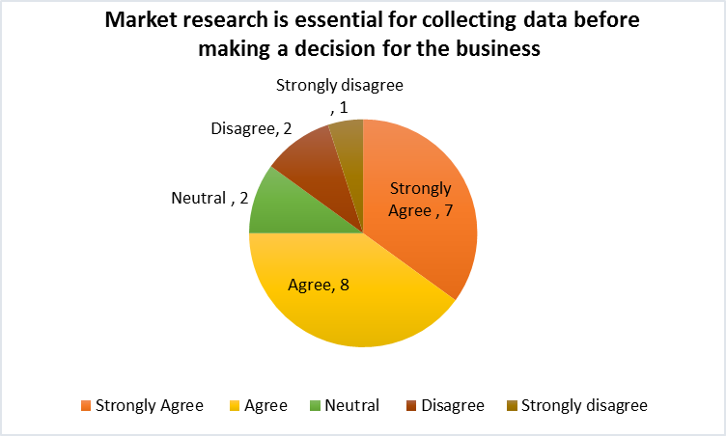
The figure represents that 15 of the respondents from 20 have agreed that market research is essential for collecting data before making a decision for the business. 2 of them have been neutral and 3 of them have disagreed to the fact. Research helps the researcher to collect different types of data from sources to have knowledge about any issue (Saunders et al., 2016). Also, the market research can be effective in applying different research tools for the paper (Burns and Bush, 2014).

In case of developing business strategy and goal, the market research is essential for the organisation.
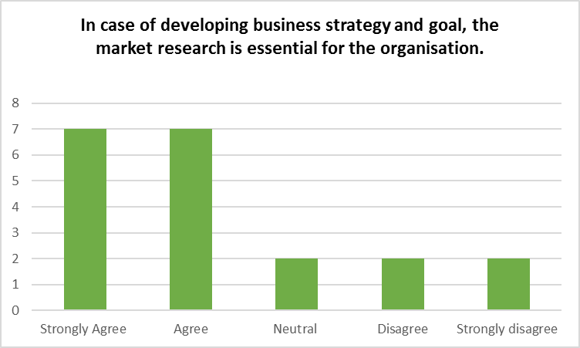
The figure represents that 14 of the respondents have agreed that in case of developing business strategy and goal, the market research is essential for the organisation. 2 of them have been neutral and 4 of them have disagreed to the fact. The organisation needs to pay attention to market research for having knowledge about the market and making business goals and strategy (Alshurideh et al., 2020).

The market research can be costly and time-consuming for the organisation.
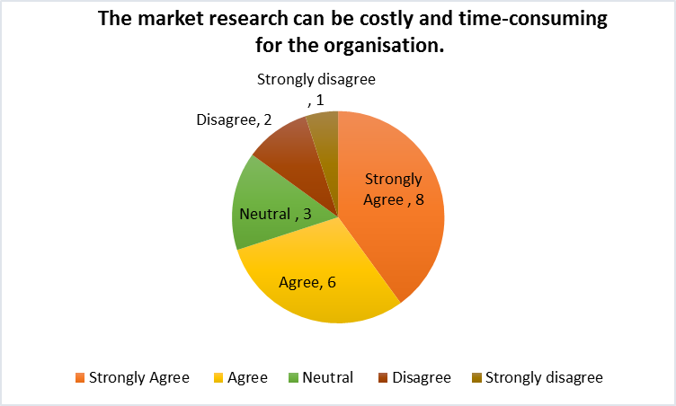
The figure represents that 14 of the respondents have agreed that the market research can be costly and time-consuming for the organisation. 3 of them have been neutral and 3 of them have disagreed to the fact. The organisation/researcher can see the challenges of conducting the research as it can be time consuming in some cases (Bougie and Sekaran, 2019).

The right application of tools and technologies can improve the effectiveness of market research.
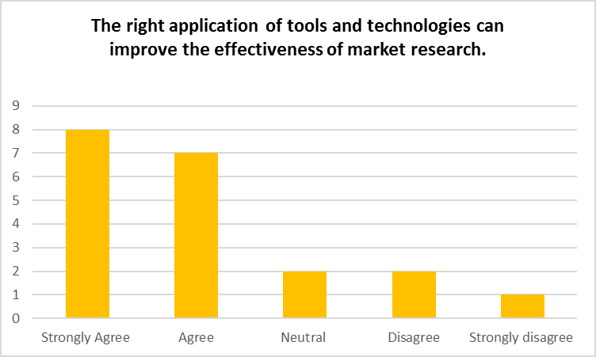
The figure represents that 15 of the respondents have agreed that the right application of tools and technologies can improve the effectiveness of market research. 2 of them have been neutral and 3 of them have disagreed to the fact. The organisation needs to apply methods and research tools for improving the data collection and analysis for business and decision in the market (Deepak and Jeyakumar, 2019).

Task 4 Design of the website and marketing materials
When it comes to the development of the business, the organisation has to pay attention to the promotional platform, marketing activities, approach and strategy (Taylor et al., 2002). The right marketing approach helps the businesses to grow and educate the customers about the products. Hence, the organisations are paying attention to different options in digital platform and social media platforms (Disastra et al., 2019). In this part, I have conducted the questionnaire for the development of the website and marketing materials, content based upon the questionnaire analysis and website development as well. Website helps any organisation/owner to create the image, name and fame in the business markets (Taylor et al., 2002). Having a website allows the customers to know about the organisation, find the business at any time and products of the organisation. The consumers can access the information they need in the website. Hence, for the business development, a website has been developed. A café will be developed as the new business and this has been proposed to the managing enterprise 21st century assignment. The development of the business also requires proper understanding of the markets, marketing materials and website development.
A questionnaire has been conducted in the previous part. The main content of the questionnaire was the marketing research and effectiveness of the marketing research for any organisation. The marketing research helps in collecting and gathering information about the business to make decisions for the strategy and operation (Bougie and Sekaran, 2019). The questionnaire analysis has represented the necessity of the market research for collecting data before making a decision for the business. The findings have also stated that developing business strategy and goal require proper market research and it some cases, the market research can be costly and time-consuming for the organisation. Hence, creating a website can help the organisation to gather more data from customers and improving marketing materials for the business (Disastra et al., 2019). I have created a website for the organisation to promote the business and market the product and service. While working in the website development, I have focused on different options and elements. I have ensured to pay attention to the SEO, AI and content. SEO or Search engine optimization represents the process of making the website more attractive and better for search engines (Sivarajah et al., 2020). This can help the organisation to maintain frequency of the customers. Moreover, the organisation needs to ensure that the segmentation of the customers is given priority with the options available in the website. For the developed website, I have put information about the organisation, the products, its effectiveness and address. I have also ensured to focus on AI for the website and activities. AI helps the website to use the data of the customers and platform for making the website better (Sivarajah et al., 2020). AI website design collects information about website visitors, their preference, view, behaviour and actions. In the website, I will ensure to collect data in website which can help in managing market research and marketing activities.
The website also is used as the marketing materials for the business. Marketing materials are any designs and strategies for the products or content to market and promote the business, brand value and image (Kemper et al., 2019). The application of marketing materials helps the organisations to promote the products and services while managing visibility of the business. Different types of marketing materials and tools are adopted in the companies for the promotion of the business (Karim, 2020). Website is one of them which helps in promoting the brand while educating the customers and creating the content. In case of the new business and website development, the marketing materials are also related to the information available in the website. The application of website has helped the business to promote the brand, product, and service with the information and options for the communication. Social media marketing helps the organisation to promote the brand with less cost and time. The social media marketing is one of the effective marketing tools and platforms for the business marketing, customer engagement, communication and promotion (Soegoto and Utomo, 2019). I have also paid attention to the social media marketing to promote the brand. I have added a picture available in social media marketing for the selected café. I have used tools and materials for the selection and development of website and marketing materials. I have also focused on developing my ICT skills for creating e-portfolio and documents for the business.

Login details of the website
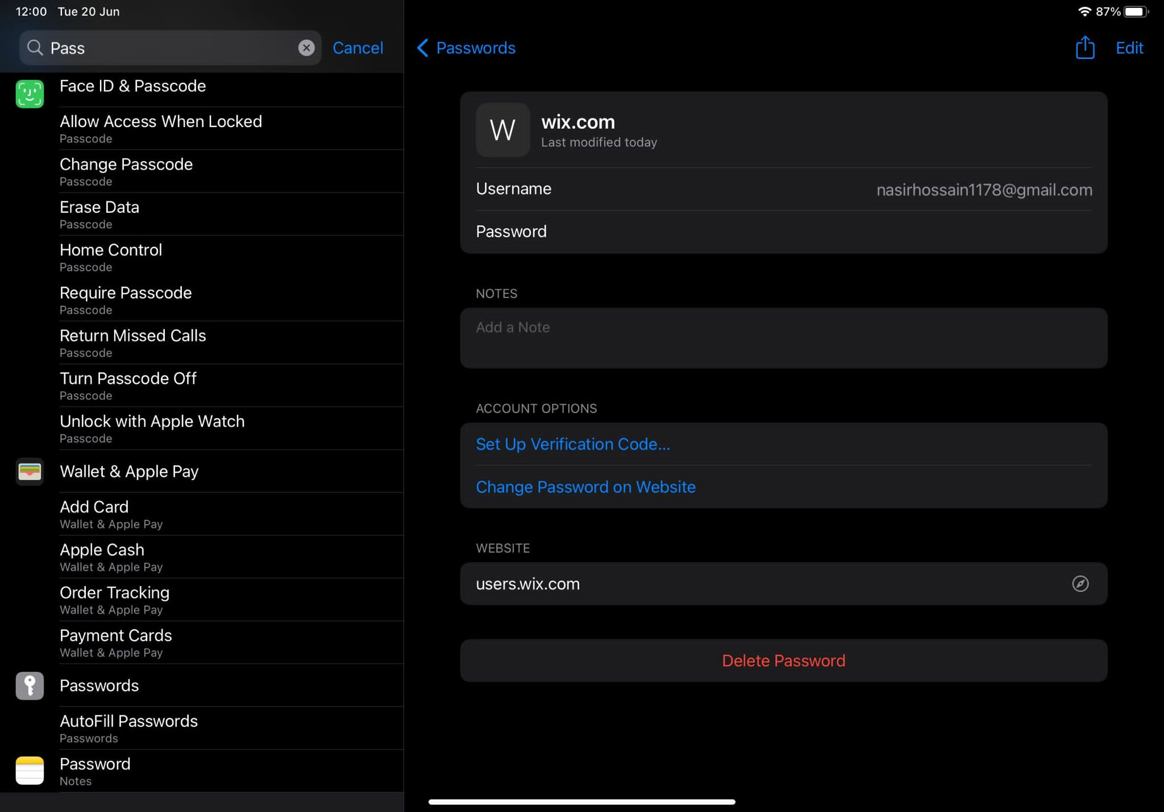

Screenshots of the webpages
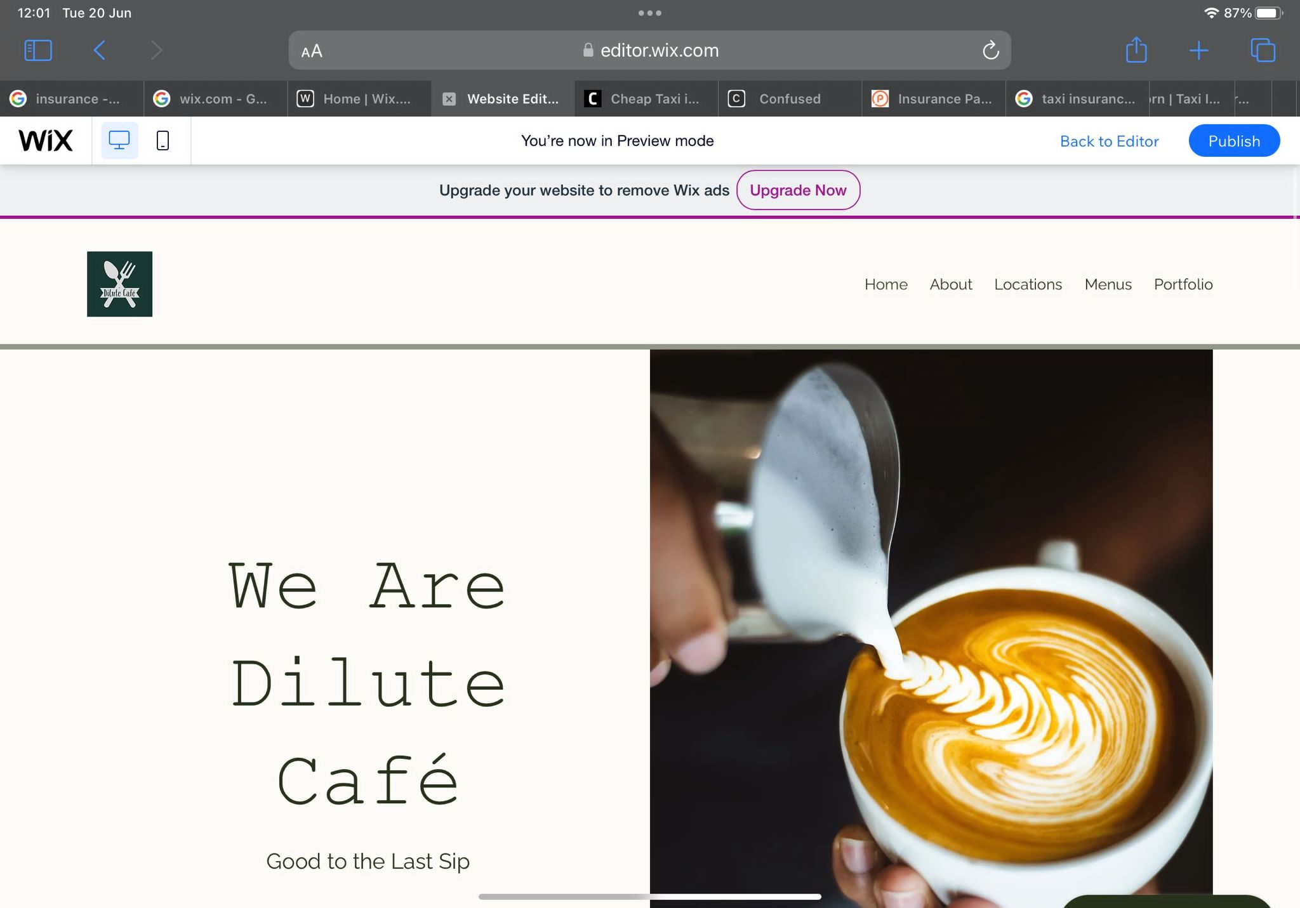
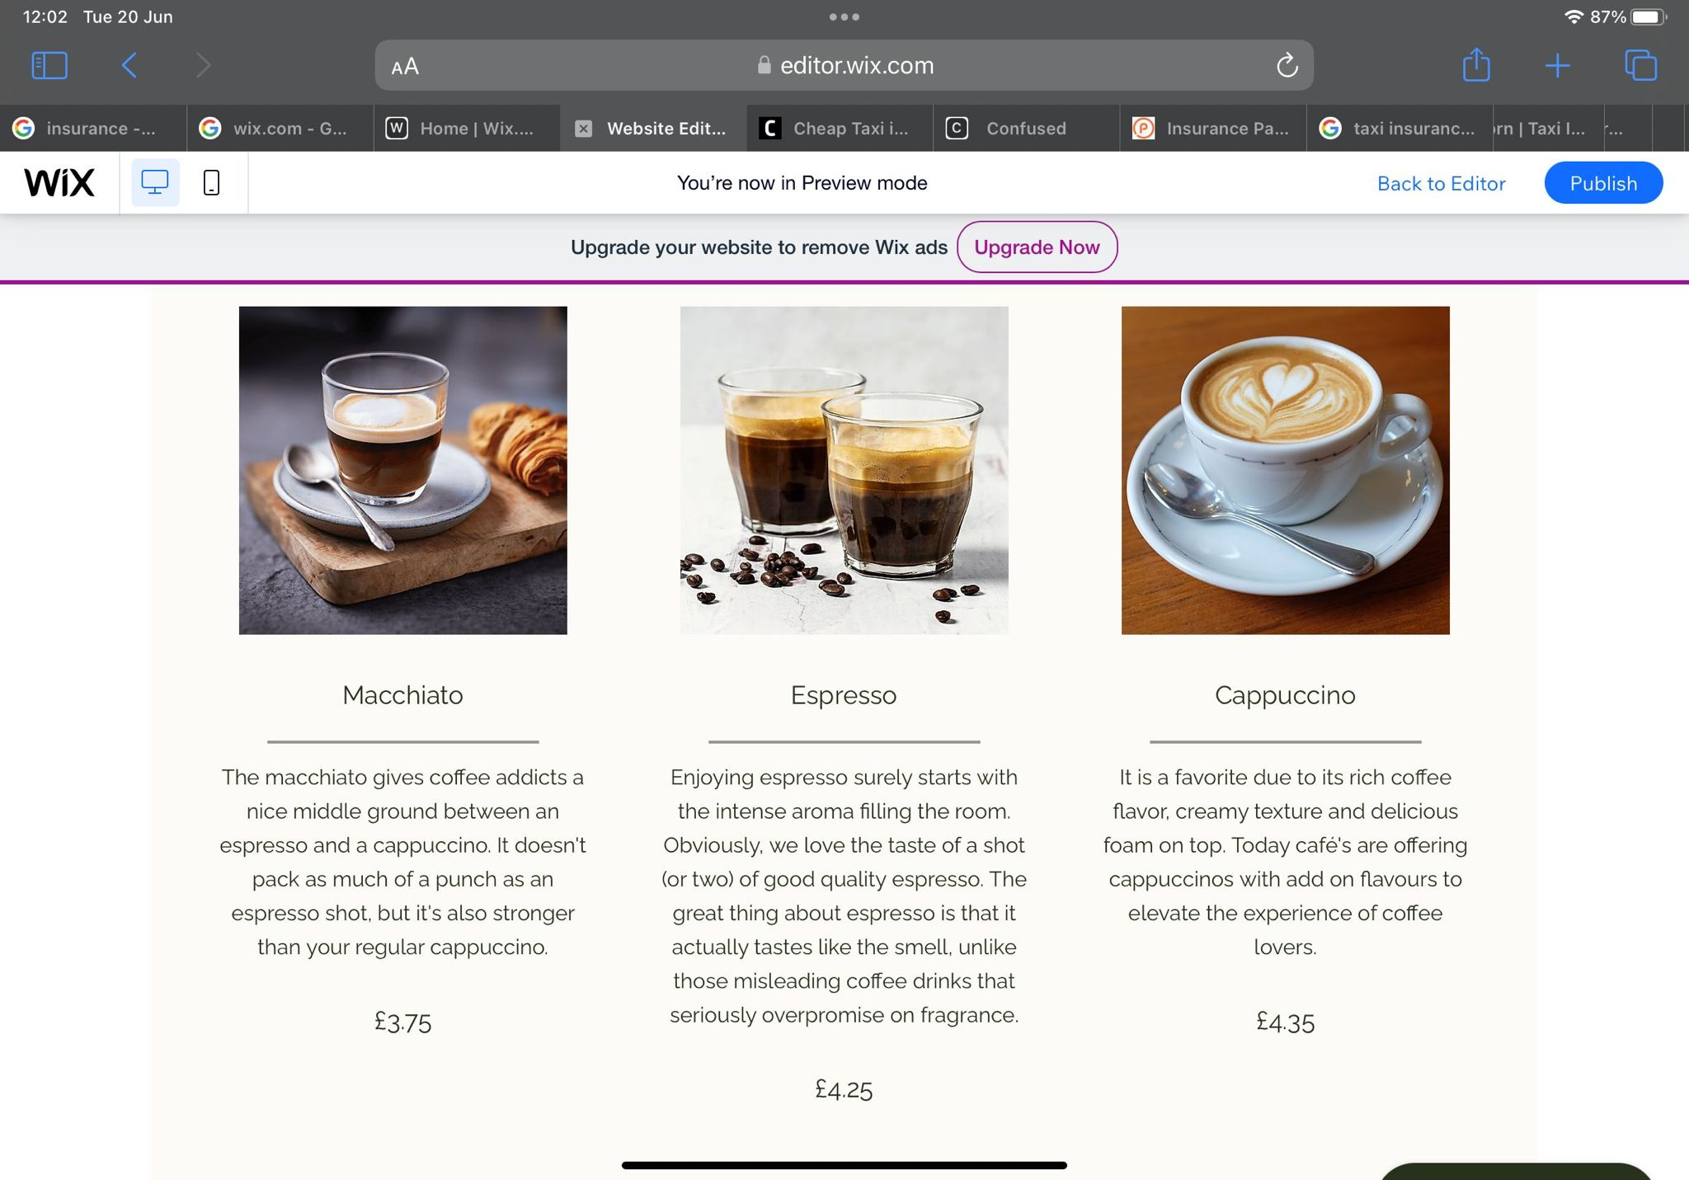

Marketing materials
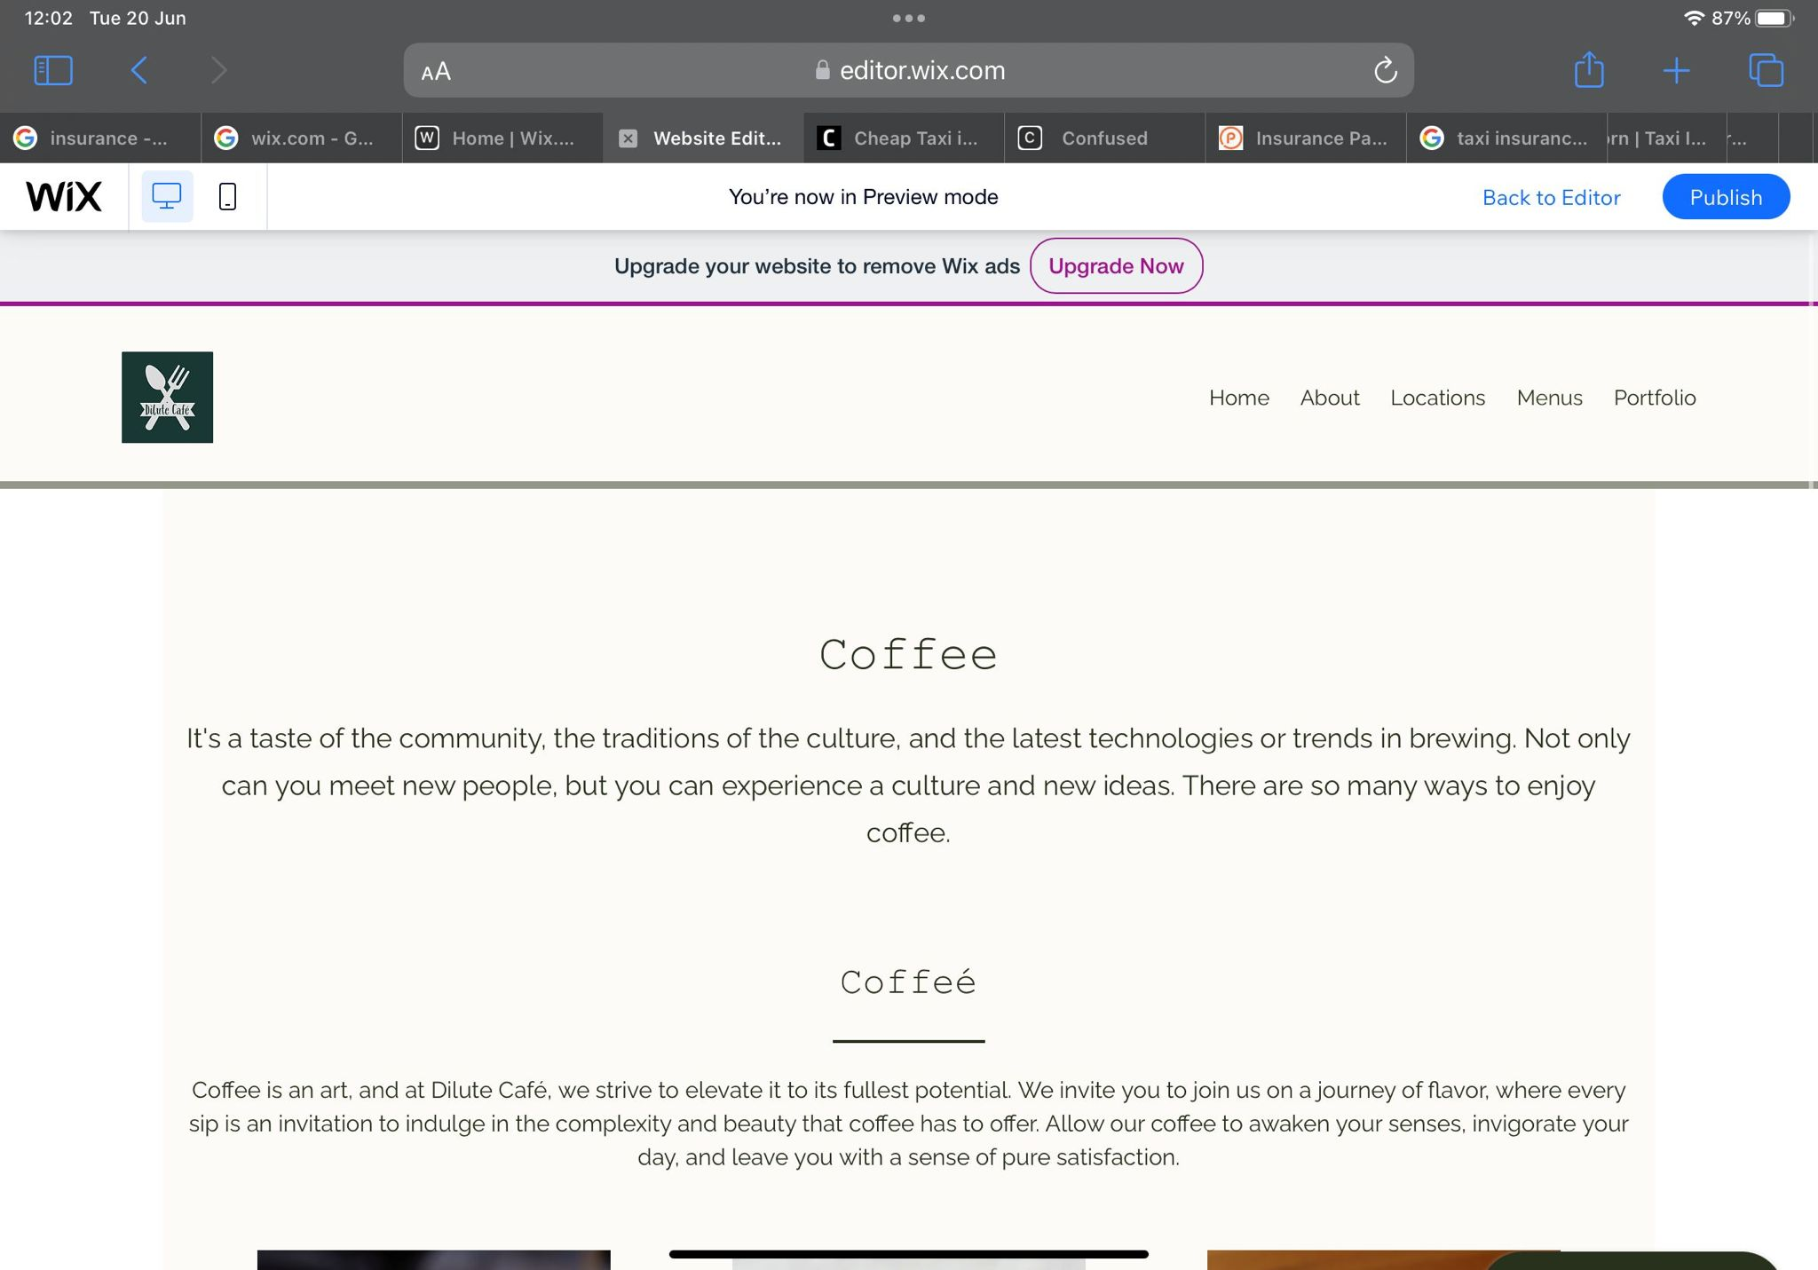
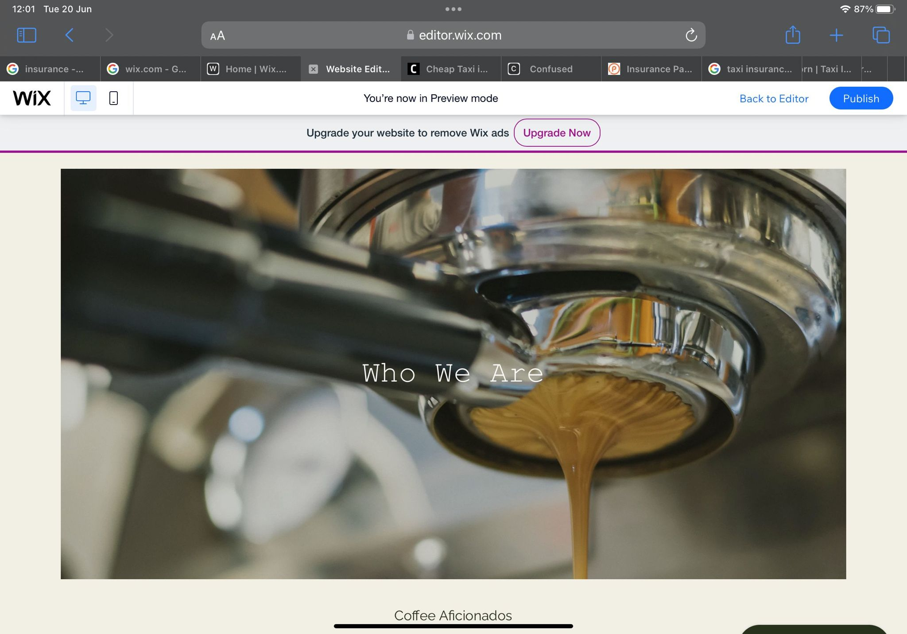
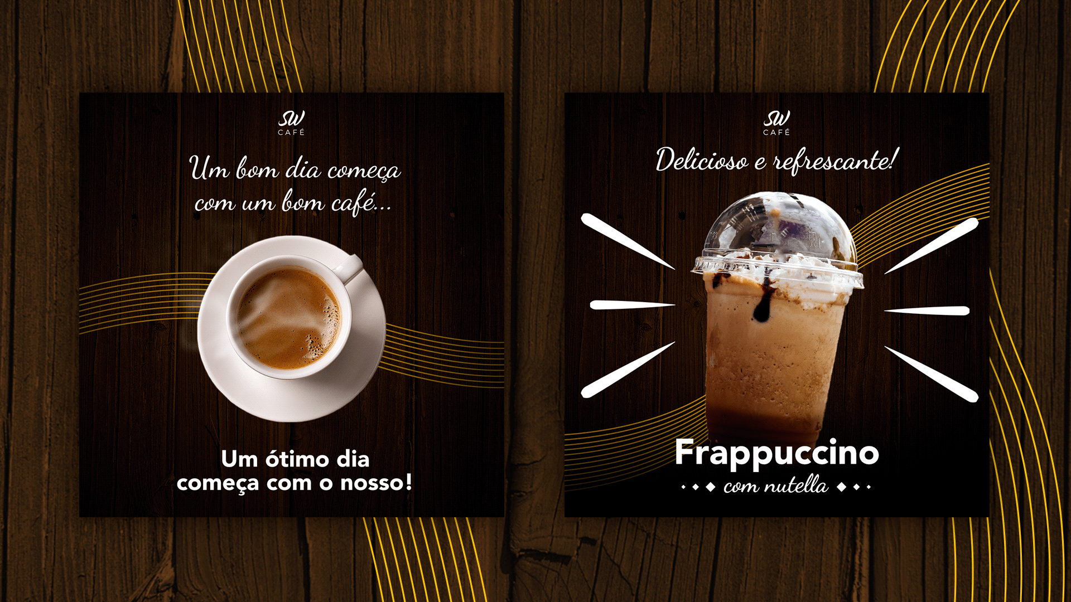

Conclusion
The knowledge of the technologies and internet help the organisation to improve its performance, operation and marketing of the businesses. The promotional and marketing activities of the organisation contribute to the improvement of the business image and brand value. The website development, brand marketing, storytelling of the brand, and marketing materials are helping the organisations to promote the business, image and product. Also, this section has assessed the questionnaire analysis for making website development.

References
Alshurideh, M., Gasaymeh, A., Ahmed, G., Alzoubi, H. and Kurd, B., 2020. Loyalty program effectiveness: Theoretical reviews and practical proofs. Uncertain Supply Chain Management, 8(3), pp.599-612.
Bougie, R. and Sekaran, U., 2019. Research methods for business: A skill building approach. John Wiley & Sons.
Burns, A. and Bush, R., 2014. Marketing research. Boston: Pearson.
Crespo, C.F., Ferreira, A.G. and Cardoso, R.M., 2023. The influence of storytelling on the consumer–brand relationship experience. Journal of Marketing Analytics, 11(1), pp.41-56.
Deepak, R.K.A. and Jeyakumar, S., 2019. Marketing management. Educreation Publishing.
Disastra, G.M., Suryawardani, B. and Sastika, W., 2019, May. Website atmosphere, perceived flow and its impact on purchase intention. In 1st International Conference on Economics, Business, Entrepreneurship, and Finance (ICEBEF 2018) (pp. 545-548). Atlantis Press.
Donzé, P.Y. and Wubs, B., 2019. Storytelling and the making of a global luxury fashion brand: Christian Dior. International Journal of Fashion Studies, 6(1), pp.83-102.
Hofman-Kohlmeyer, M., 2017. The role of storytelling in building a brand. Humanitas University's Research Papers Management, 18(3), pp.131-145.
Júnior, J.R.D.O., Limongi, R., Lim, W.M., Eastman, J.K. and Kumar, S., 2023. A story to sell: The influence of storytelling on consumers' purchasing behavior. Psychology & Marketing, 40(2), pp.239-261.
Lundqvist, A., Liljander, V., Gummerus, J. and Van Riel, A., 2013. The impact of storytelling on the consumer brand experience: The case of a firm-originated story. Journal of brand management, 20, pp.283-297.
Karim, K., 2020. Re-conceptualization of business model for marketing nowadays: Theory and implications. Journal of Asian Finance, Economics and Business, 7(7), pp.279-291.
Kemper, J.A., Hall, C.M. and Ballantine, P.W., 2019. Marketing and sustainability: Business as usual or changing worldviews?. Sustainability, 11(3), p.780.
Saunders, M., Lewis. P., and Thornhill, A., 2016. Research Methods for Business Students. (7th Ed). UK: Pearson
Sivarajah, U., Irani, Z., Gupta, S. and Mahroof, K., 2020. Role of big data and social media analytics for business to business sustainability: A participatory web context. Industrial Marketing Management, 86, pp.163-179.
Smith, K. and Wintrob, M., 2013. Brand storytelling: a framework for activation. Design management review, 24(1), pp.36-41.
Soegoto, E.S. and Utomo, A.T., 2019, November. Marketing strategy through social media. In IOP conference series: Materials Science and Engineering (Vol. 662, No. 3, p. 032040). IOP Publishing.
Taylor, M.J., McWilliam, J., Forsyth, H. and Wade, S., 2002. Methodologies and website development: a survey of practice. Information and software technology, 44(6), pp.381-391.

