[Date]
Mark Vaughan (1909160)
University of Wales TRinity St David
Assignment Report
Internet Technology and Architecture Semester 1

Contents
1. Introduction 2
2. Requirements 2
3. Implementation 2
3.1 Page Design 3
4. Evaluation 6
4.1 Usefulness & usability 6
4.2 Search Engine Optimisation 6
4.3 Site |Accessibility 8
Section 5 References 10
5.1 Online Resources. 10
5.2 Bibliographical references 10
5.3 Web Site Example Pages 11
Colt M1911a1 Pistol 11
5.4 Validation Check Evidence 18

Introduction
This report will describe and evaluate the construction and structure of a website based on the one of the authors main interests. It will also describe the problems encountered and their solution. The reader should be made aware that the site is the first to be built by the author with any meaningful purpose and that the design is a prototype and not meant for live operation. Due to the complexity of the subject. The site will not be completed within the allotted timeframe but should be viewed as a demonstrator of ideas and technique.

Requirements
This website has been created to provide general details about the weapons of war. It will be formatted in a chronological order covering pre-history to the modern day. To describe how the weapons evolved, a tree format will be used with the base of the tree being the pre-genitor of the succeeding weapons and will then extend upwards branching into different weapon types and formats through the ages as weapons developed. The content will be kept basic and non- technical and a resource section on the site will provide links and sources leading to more ‘authoritative’ content. Aimed at a general audience, the sites purpose is to provide an interesting overview of how weapons appeared and how they evolved through the ages into the varied and unique forms of today.
Part of the brief includes the requirement for the site to be WCA3/W3C standards compliant which means that the site should be readable by machine readers, visitors with impairments as well as the average user. The site should also be viewable on a wide range of devices and should be built with responsive formats using HTML5 and CSS technologies as standard.
- Implementation
Websites, like a house, starts with a good foundation, for this site the author used a combination of bootstrap four, CSS 3.0 and of course HTML5. The use of HTML5 and CSS S was used to ensure that the requirements for accessibility were maintained to the latest standards. The use of bootstrap four was used to enable better formatting on the page and to ensure that elements placed stay in position despite the view port size changing from device to device. As the website was designed to be responsive it was decided that the default for web pages was to be based around a minimal view port size. It was also decided to keep the links, descriptions, and general page layout simple in order to maintain compatibility with the four principles of Accessibility as stated by the WCA. During the assembly process, web pages were subject to on-going validity checks using the built-in Visual Studio accessibility checker and the Web site-based checker(http://validator.w3.org/).
The website was designed as a prototype for a future live site. Because of this, search engine optimization was not undertaken, but extra links between pages and to external sites were added to enhance the search engines ranking of this website. Future developments of this website will include optimizations that will increase rankings by, use of key phrases in headings, added metadata tags and a re-ordered directory structure of the web pages. Optimization will also include the inclusion of a site map page with internal links on selected pages.

3.1 Page Design
The website's pages will operate on the general layout which will include a fixed header which will incorporate links to other parts of the site, a logo with title and a general page 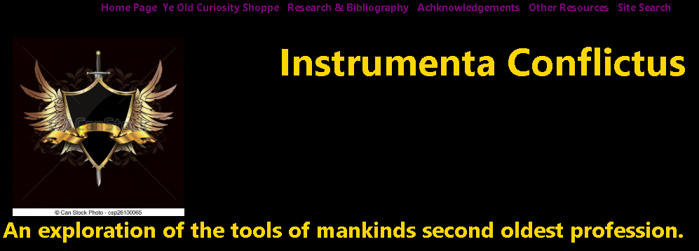title which will describe the function of the page.

On the bottom of the page a generic footer will also be included which will cover contact and media pages.

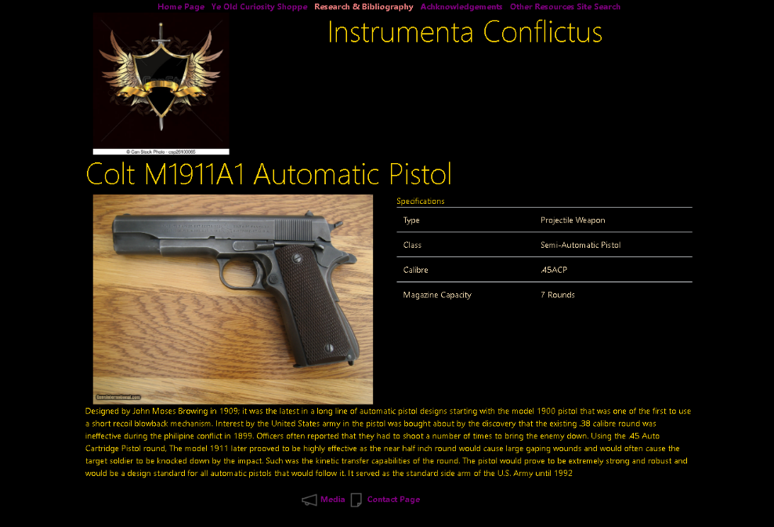
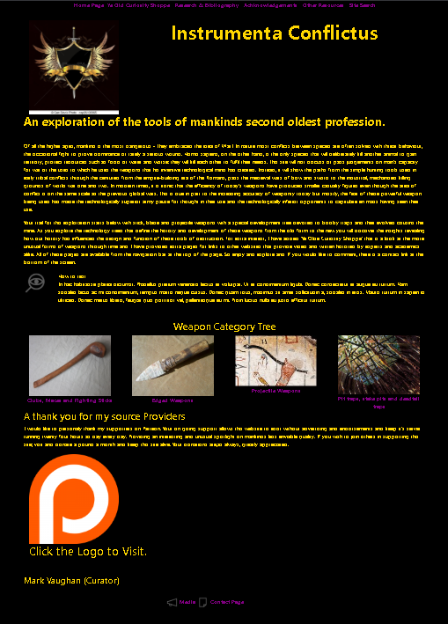
To maintain a good general linear layout the use of side bars will be minimised. The colour scheme of the website will be based around a black background with gold text. The idea for this is to provide a high contrast image on screen without excessive glare, avoid use of blue and green in the colour mix to help with viewers with colour blindness and the use of blue and red for the links to provide contrast with the main page and also provide a distinct indication of the links status. Unused links will appear as blue, used links will appear as purple, disabled or unavailable links will appear as a coral colour. The choice of this colour scheme was also to help with people with red/ blue or red/green colour distinction problems. For ease of maintenance the number of pages in the website are based around several standard formats. These are home page, interest page, reference page, resource page and several specialist pages that describe the history and development of weapons in a tree format. The homepage is the standard introductory page for the website in addition to the standard elements it will have text that will describe the function of the website and a brief text block to explain on how the actual site is used. Underneath this will be 4 linked images that will act as the route to the base of the four main history trees which will be for stick, blade, projectile and booby trap weapons.
Individual weapon details will be described on this weapon page template it will consist of an image a main heading a specification block add a written history text at the bottom of the page as usual standard header and footers are included.
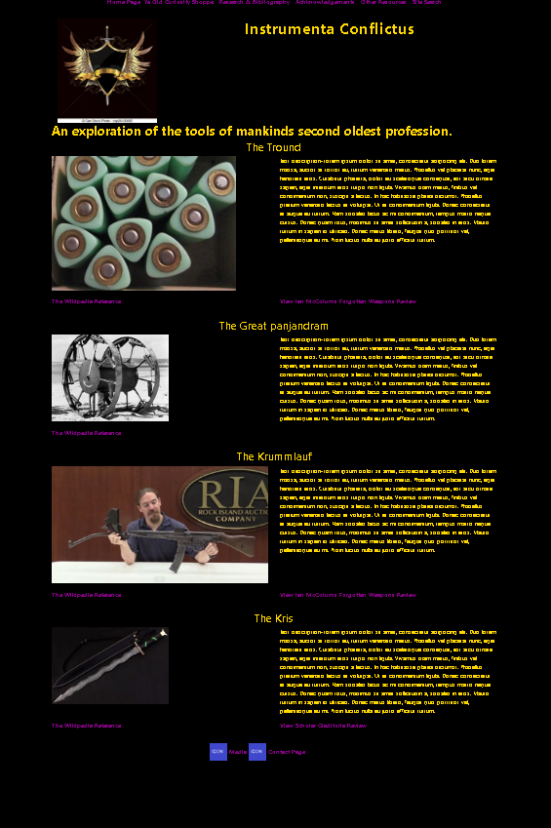
Interest pages are Nonspecific information pages that designed to encourage further interest in the history of weapons. The prototype example of this type of page can be found on the linked marked Ye old curiosity shop. This page shows a number of different weapons from different eras which have unusual characteristics that make them curiosity's the prime example is the Tround which is a triangular bullet and also the Kris which is a Far East and sword or knife the pronounced wavy blade .
On this website the reference page will act as a link to previously researched articles and websites as annotated using the IEEE format. This page will also act as a bibliography stating books that have been used for research but, with information that has not been incorporated into this site. The reference page is separate from the resource page, which has a similar function but serves as a library function to act as a pointer to other resources is for those with a more academic interest in weapons.
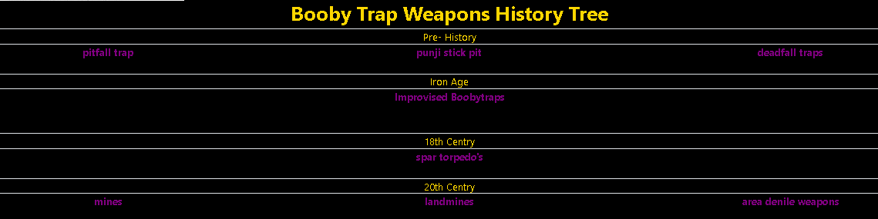
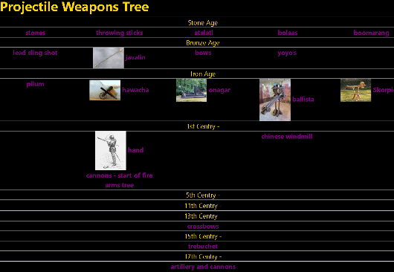
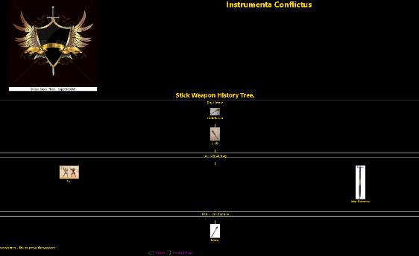
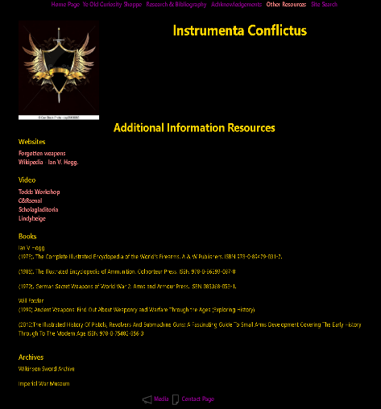
During the planning stage, several problems occurred when trying to decide on what format the history of weapons should follow. Because some weapons like the boomerang can be classified as a stick weapon or a projectile weapon, there is a degree of crossover between the categories. A standard tree structure has been used with the intention of adding cross links two other weapon tree categories on other pages. With experimentation, this operates successfully, but can be awkward in showing the structure of the weapons development on the web page where placement of the connecting links is not static. An alternative method was to use a linear approach where links to the various pages are stacked vertically from the top, with the starting weapon and down through the development tree branch. This would require multiple root pages to be devised that would act as starting points for the various developmental branches of the weapon type. An example of this would be development of the staff/quarter staff to spears, Pikes and later Halberds and Glaives. The latter of which would develop later into a wide range of specialist weapons such a billhooks and would by necessity, act as a root for those development trees. A non-linear method was also considered where the description of the weapon on the page would be as normal but underneath would be separate links two other weapons which were further along in the development history this makes navigation less obvious and requires the user to jump from page to page in order to locate a particular weapon or device. The header incorporates a site search link to lead to a page designed specifically to search the pages on the website for a key namely the name of the weapon.
Examples of these methods can be found on the pages marked: Edged_blade_tree.html, Projectile_Weapons.html and area_denial_weapons.html.

4. Evaluation
The author admits that only minimal research was undertaken. This is not due to the time pressure to complete the assignment being a factor but, more to the fact that the author has spent many years in personal study gaining knowledge of computers and information systems. The course of the study was unmanaged, and a bibliographical record was not kept. The more useful reference texts, I have purchased and are in my personal library, which, since 1987, has been growing. As with the computer studies, my knowledge of weapons has been gleaned over the years from studious reading courtesy of my local lending library and in later years, the internet. Janes Defence has been my prime resource over the years although manufacturer and archaeological websites have also been useful. The omission of a well-maintained bibliography is on reflection a big mistake, bearing in mind that the study was for personal satisfaction and not as an exercise in academic achievement. The author has included a bibliography to show the correct form of annotation has been learnt. The refences are based on texts within my own library and in the case of the more technical aspects of the site design, research into the latest versions of HTML and CSS was undertaken utilising the university’s Library. The use of Bootstrap is also a first and the requirement to learn the technology whilst embedding the code added to the problems related to the reduced time available. This being the first solo website the author has hand crafted.

4.1 Usefulness & usability
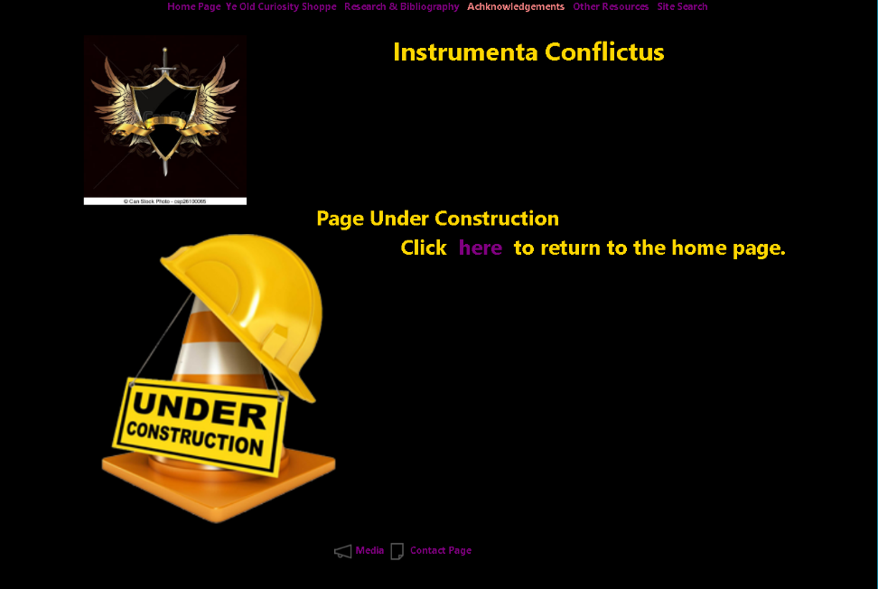
As a person with existing visual and other disabilities, the websites design was crafted with accessibility as the main feature. Being developed by a person with personal insight into the problems involving matters such as readability is an advantage. It is for these reasons that the site was devised with the most basic framework as the starting point. Testing the site with either or both CSS and Bootstrap disabled, proved that the content was still accessible if a little less functional. Once the site had advanced enough, a member of the author’s family was asked to use the site, navigate the test pages, and report any issues. No major problems were mentioned by the tester; however, the lack of a construction page was commented on as blind links gave no clear indication that the link had been activated. This has now been rectified.

4.2 Search Engine Optimisation
As previously mentioned, this website is a prototype, and the search engine optimisation is omitted. Future improvements in this area will now be discussed.
In preparation for this report research into search engine operations found that early methods of page ranking depended on the number of keywords or the page. Webpage developers often abused this method of page ranking by spamming header sections with multiple keyword entries. Later methods relied on the detection of the number of links to internal and external pages on the website and proved to be less vulnerable to artificial manipulation. This site will use some keyboards to highlight page descriptions but will use more external links to improve the sites page ranking.
Of all search engines, Google is the most prominent and the most widely used search engine to date its search crawlers, or Google bots have the highest search record on the web. Web pages are ranked by the number of links to external sites; page rankings will be downgraded where multiple or excessive backlinks to internal pages are found. The website will keep the number of backlinks to a minimum and will design the flow of the website to operate from a limited number of critical pages. Each key page will act as a miniature index for the site.
Research into Google's page indexing methods indicated that users are irritated by search results that led to further search pages. On this site, ' notext' metadata tag has is added to prevent search crawlers from indexing the search page and eliminated the page from Indexed search listings.
During the design process of this website the attention to page titles has been minimal. The current titles are short and not very descriptive. To improve this feature, the title section in the header will be rewritten with a more descriptive and accurate title. The change will affect how web crawlers rank the page and there by improve the ranking.
Part of a crawlers indexing process is to examine the head section of an HTML file with the aim of extracting information that will improve the page description and provide Hey standard from which the page can be ranked. The use of metadata for this purpose will be added to web pages on this site using detailed descriptive language that can be used search keys for the Internet search engines. The length and detail of the metadata is yet to be decided but will be kept short and accurate to aid easy site maintenance without compromising the pages search ranking.
On inspection, the page storage on this site is monolithic. To improve search engine capability. The root directory needs to be split into separate subdirectories and categorised by weapon type and/or Era. This change will aid the search crawler to index the website more effectively and will allow the creation of all sensible breadcrumb links in future pages.

Breadcrumb links are useful feature. They use allows the reader to quickly backtrack along a directory structure to reload a previous page. On this website, the feature has not been introduced at this time. It is planned, to introduce this feature into the main page format to further aid Accessibility.

4.3 Site |Accessibility
WCAG 2.1 states that there are four main principles for good accessibility. This website design will now be evaluated with reference to each principle.
The Website must be perceivable.
This principle requires that the imagery, structure, and link flow must be understandable and visible for all users. The simple structured layout of the pages complies with this requirement. Commonly required links are consistently placed in the page header and are clearly labelled to show the function. Likewise, the communication features such as messaging and social media links are place in each page’s footer section. To further aid users with limited ability, Descriptive text is embedded in all suitable elements to provide and alternative non-visual option. This can be used by screen reading software, artificial software constructs such as web crawlers and translation software. The links are coloured to distinguish themselves from the general background and are of an even tone to avoid problems with high contrast perception. The introductory page states in simple terms how to use the site and the intervening links on the descriptive pages are placed to present the path forward or backward in the discovery tree.
The Website Must be operable.
This requirement concerns the viewers ability to navigate the site using specialises hardware or being able to use the site with limited abilities i.e. sight disabilities. To facilitate this requirement, no event triggering elements were incorporated. The lack of buttons, timers and the like, removes restrictions such as time limits that may cause problems for users that cannot perceive the sites content adequately or are slow in understanding the sites function. This allows any impaired user to navigate the site in their own time, be able to back track to a previous page if lost and find and utilise the navigation bar to proceed to one of the default navigation pages. Similarly, the use of flashing or attention getting imagery has been removed to minimise distractions. As hyperlinks are used as the main method of navigating the site, assistive technologies will have no trouble in allowing the user to jump to required links using the keyboard only. A basic functionality of the is kind is built into most modern browsers by default, an example of this would be the use of the TAB key to move to the next page link. The design of the site allows hyperlinks of be easily recognised by using the highlighting feature provided by CSS. Any valid link will change colour when a mouse pointer hovers over the link. The colour scheme used on this site is geared to make such highlights easily seen and with suitable contrast to make the link apparent to most users.
Future amendments to the site will include optional audio ques, a text vocalisation function and a colour pallet editor linked to the user’s ID that will allow the user to customise the site for optimum function. Further improvements will include extended formatting for device types and will feature alternative pages that are formatted for the viewport size used.
3. The Website must be understandable.
The function of a website is to be able to portray information and this is the basis for the third principle. The website function is to provide basic information about weapons and their development history. The home page does that from the start. The inclusion of a how to paragraph further explains how the site is laid out and how it can be navigated. The subject matter is technical and does come with some jargon. Where time allows, a glossary page would be created and the inclusion of tooltip text into the base code would be included. Time to complete this assignment was limited and has not been implemented. Therefore, the site has been designated as a prototype platform. As the site is developed, other options will be added such as soundbites pronouncing the word (to be made optional) and multi-lingual translation using a third-party engine like Google translate. For the most part the language used is kept simple and the use of Grammarly has been found to be helpful as the author is prone to using a writing style that is less basic.
4. The website must be robust.
Robustness in this context refers to the future ability to adapt to new technologies. This is a maintenance aspect of the site to allow for easy updating for new forms of user interaction and allow for reduced effort in making changes. This site was engineered to be simple in nature and non-complex visually. As the basis of the site is a basic boilerplate HTML5 coding structure, changes to the site at this level are easy, quick, and as consistent code validation is used, reliable. Cosmetic changes are equally easy as changes to the CSS style sheet will adapt the entire site to the new format at a single stroke. As new web abilities appear, the changes can be added to the main structure as a ‘bolt-on’ improvement without disturbing the basic functionality of the site and can be removed just as easily.

Section 5 References

5.1 Online Resources.
4 principles of accessibility -
https://dynomapper.com/blog/27-accessibility-testing/274-4-principles-of-accessibility
W3C Web Accessibility Initiative Website.
https://www.w3.org/WAI/standards-guidelines/wcag/
Beginner guide to search engine optimisation
https://moz.com/beginners-guide-to-seo
W3Schools.
https:\\wweschools.com

5.2 Bibliographical references
[1] D. Oliver. D. Oliver. Sams Teach Yourself HTML and CSS in 24 Hours Sams Teach Yourself HTML and CSS in 24 Hours (7th ed. ed.) 2006.
[2] V. Verardi and M. Gassner. V. Verardi and M. Gassner. Robustness for dummies. Robustness for dummies. IDEAS Working Paper Series from RePEc IDEAS Working Paper Series from RePEc 2012.
[3] T. Ruddy. T. Ruddy. HTML explained for dummies. HTML explained for dummies. Link - Up Link - Up 1212(4), pp. 33. pp. 33. 1995.
[4] J. Valade. J. Valade. PHP & MySQL for Dummies PHP & MySQL for Dummies 2002Available: http://www.loc.gov/catdir/toc/wiley023/2002100239.html.
[5] Eric A. Meyer. CSS: The Definitive Guide, 3rd Edition. O'Reilly Media, Inc, 2006. Available: https://learning.oreilly.com/library/view/~/0596527330/?ar

5.3 Web Site Example Pages
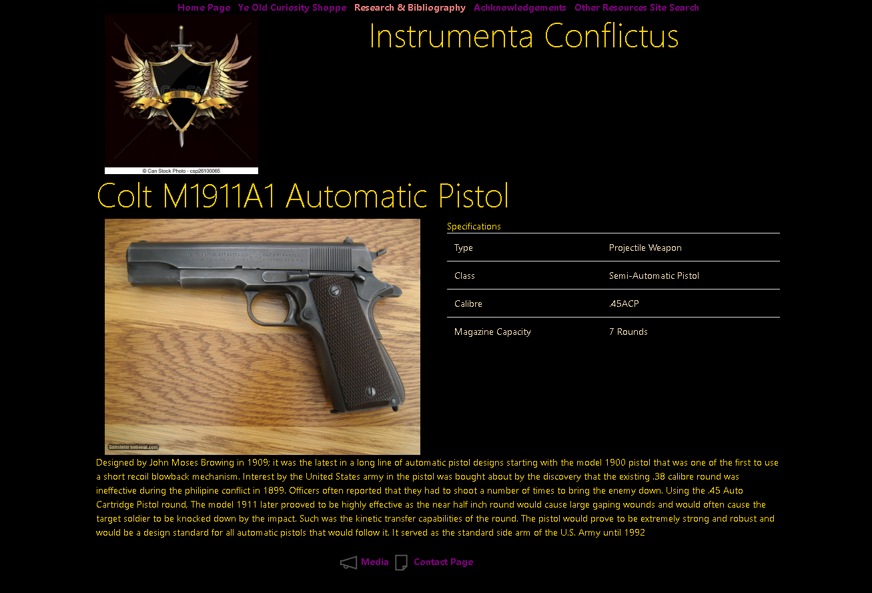

Colt M1911a1 Pistol

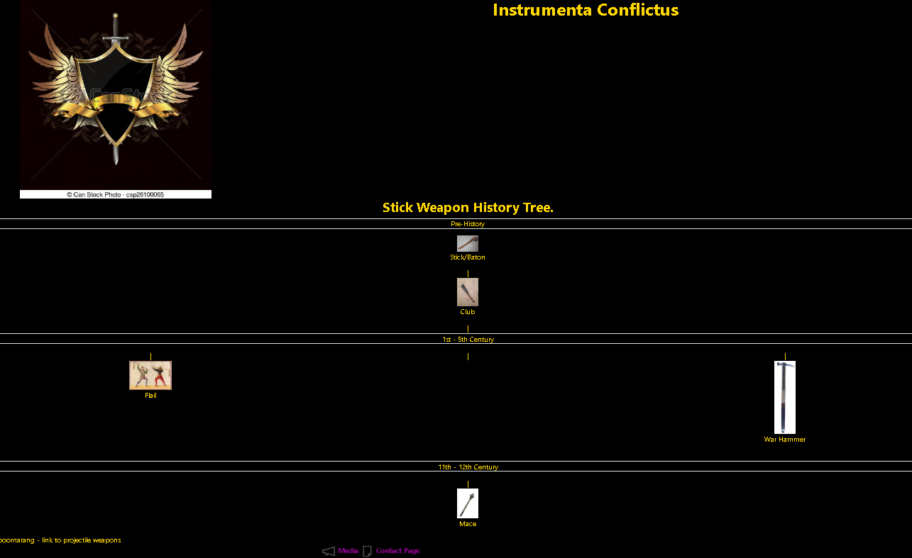Initial Stick Weapon Tree Link Page type 1
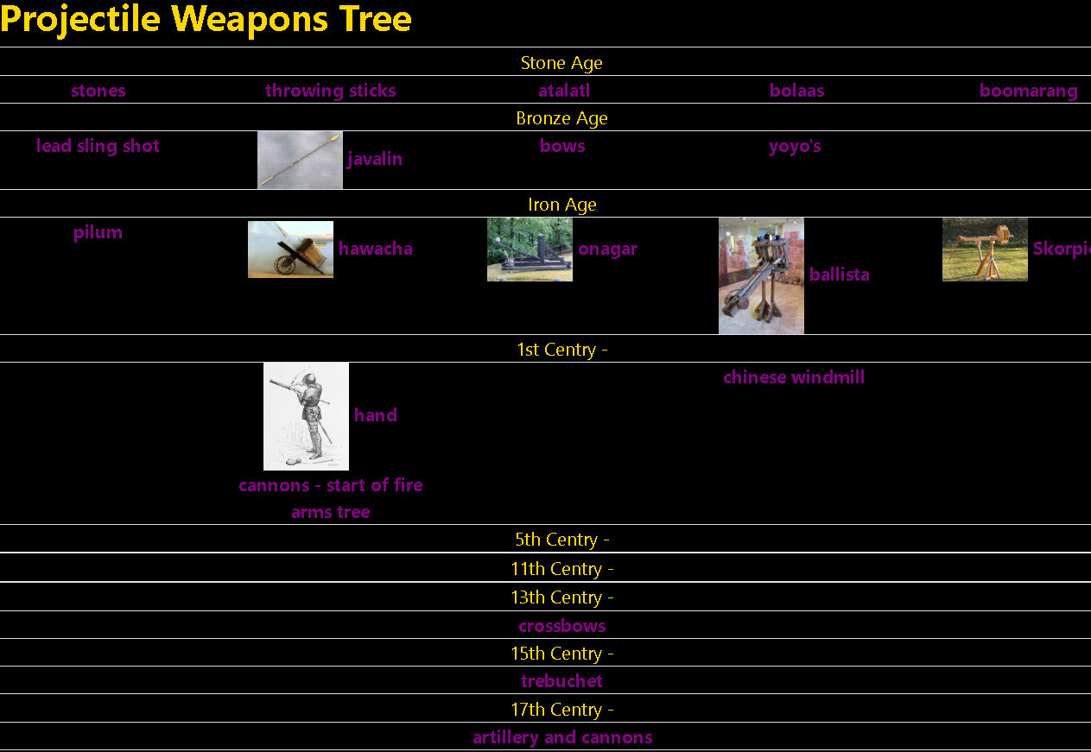

Initial Projectile Weapons Tree Link Page Type 2

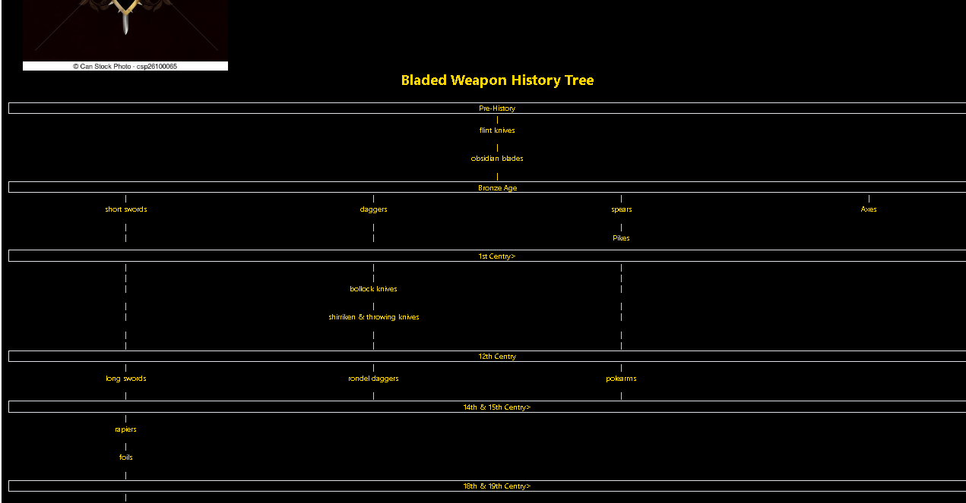
Initial Bladed Weapon Link Tree Type 3
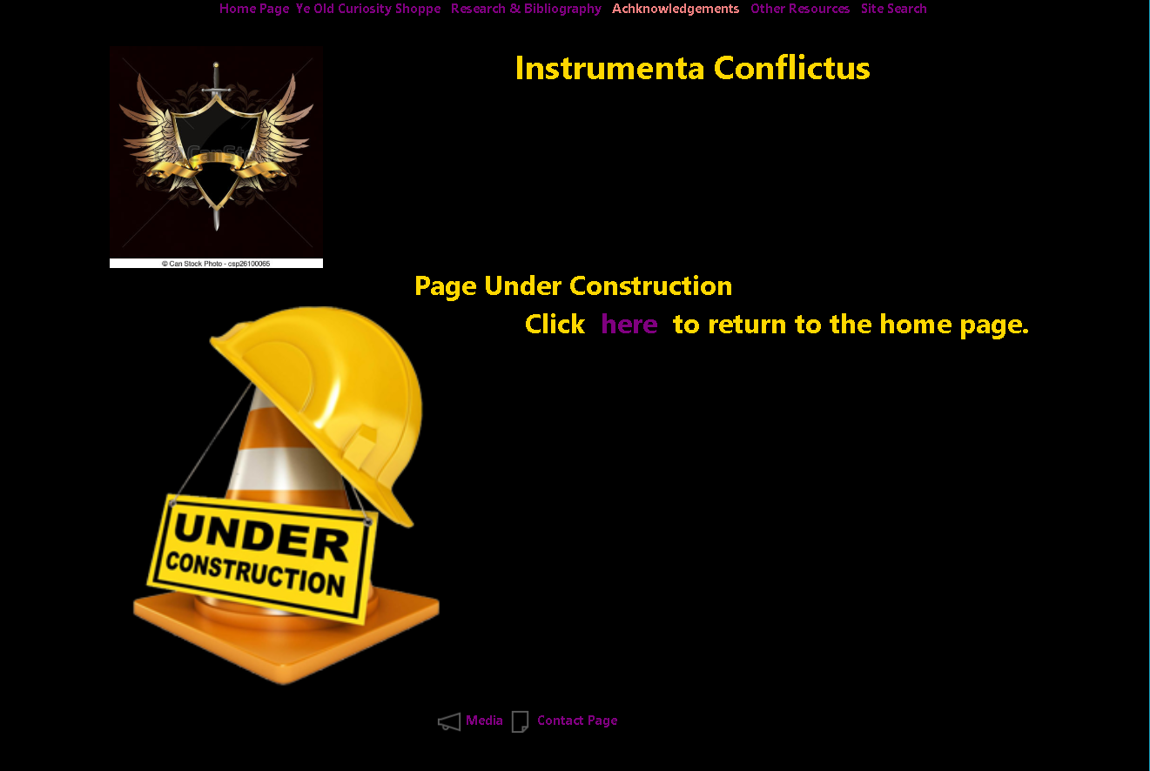

Introduced Under Construction Page.

Ye Olde Curiosity Shoppe Interest Page

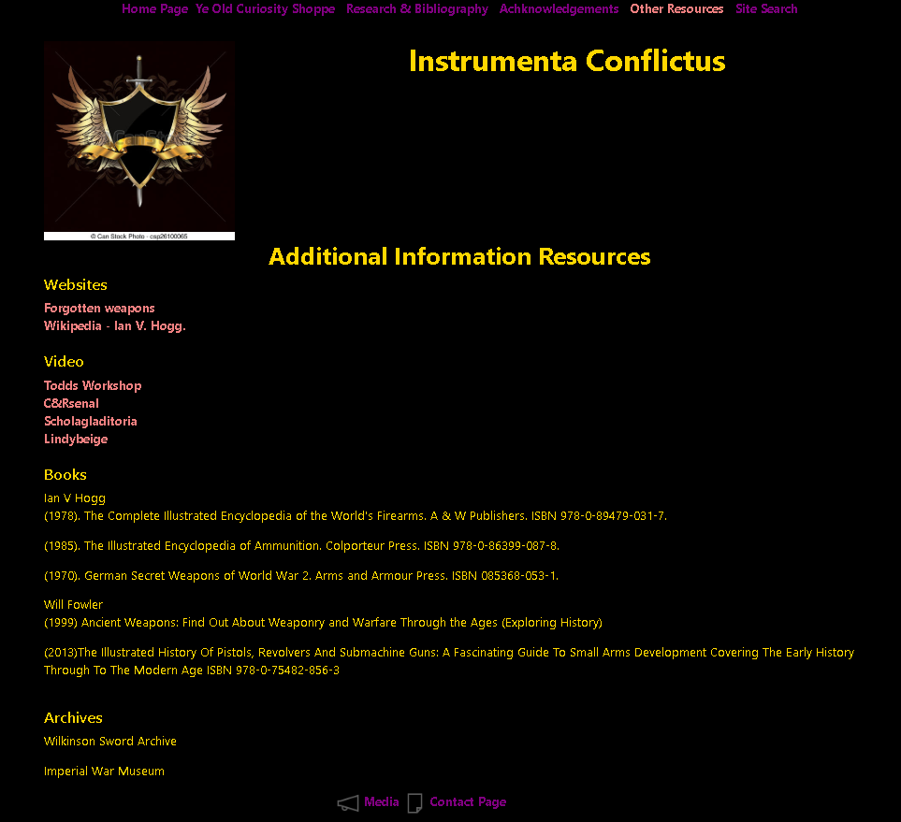

Additional Resources Reference Page

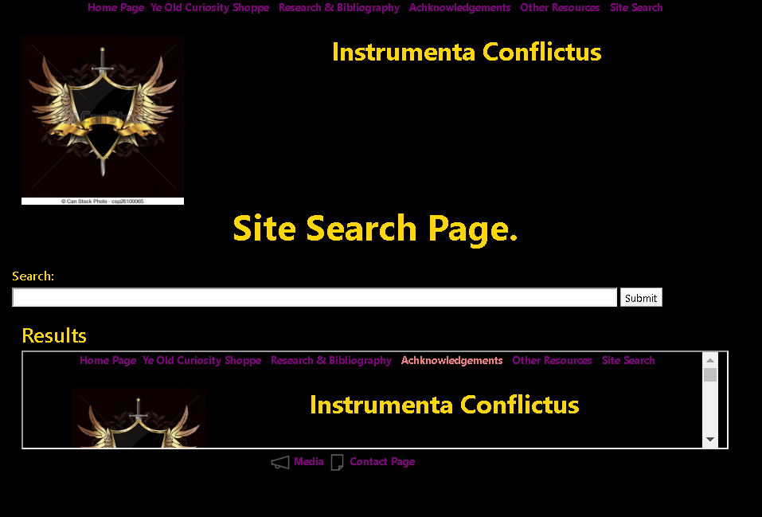

Prototype Search Page – Site Only

Sites Index Page

b5.4 Validation Check Evidence



