Formative Assignment two. Past Peoples, Present Societies: Research Methods and Skills
Location
Rowena Cottage, Pembridge, Herefordshire UK
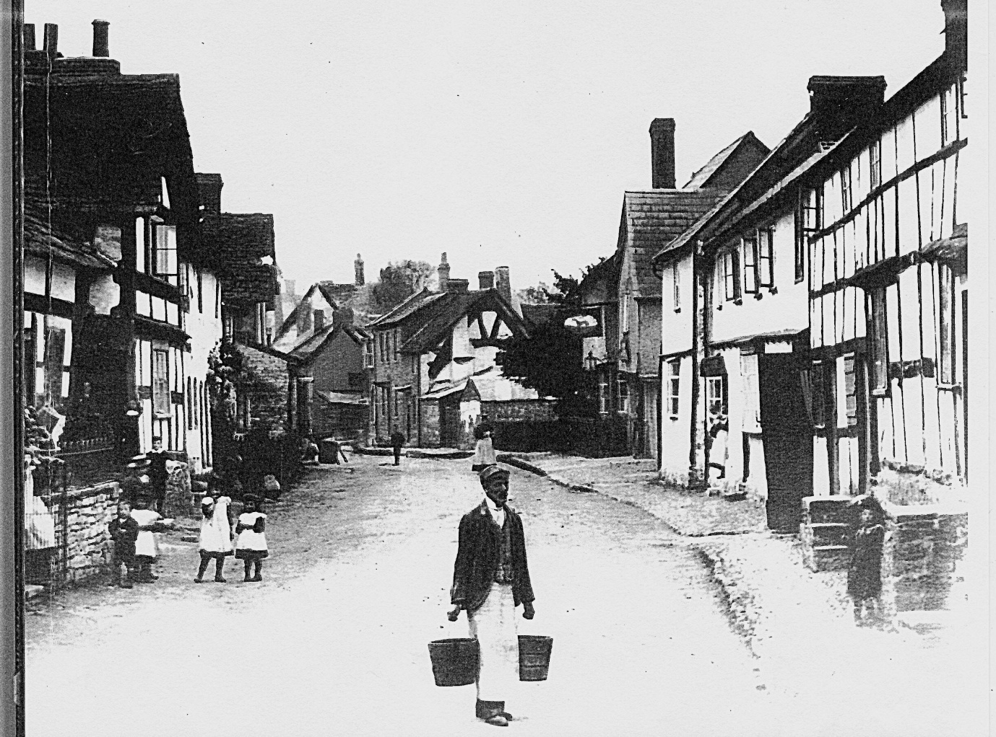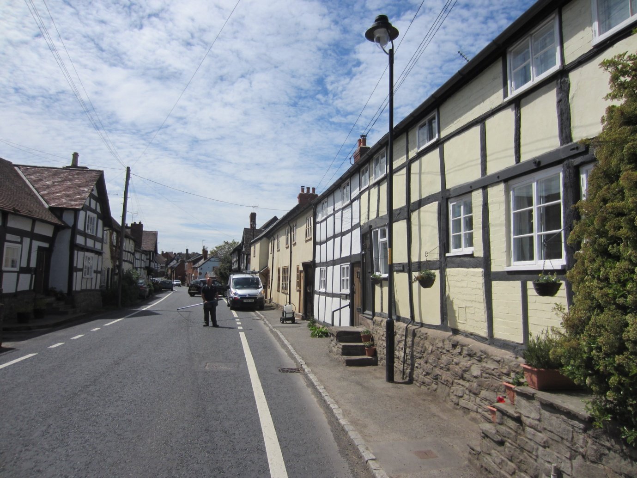
Intention
- To investigate and record the history of Rowena Cottage, Pembridge, Herefordshire UK.
- To ascertain its age, status, context within the built environment of Pembridge. Its relationship to the surrounding buildings and to the social fabric of the village.
- To explore the changing nature of the building through an exploration of its construction style and how this has affected the relationship between it, its occupiers and the evolving social dynamics of the area.
Methodology
Although stylistic dating of the building will give us an approximate build date of the mid to late 16th century this is a very contentious assumption. Archival records will be examined along with national collections in respect of the building type, location and its context. Online searches of documents held locally will require physical examination due to a lack of digitization of records.
The property is such that when it was built it was for an occupier drawn from the lower classes, this is ascertained due to its size and position. As such it may well be under-represented in the documentary records; however it is located alongside higher status buildings which will furnish the investigator with ‘book ends’ for enquiries.
Archival Sources
Francis Frith collection
https://www.francisfrith.com/uk/search
An online Archive of photographs from the UK and ROW. This provides a valuable insight in to the changing nature of the building back to the late 19th century. The photographs held, and for sale, come from private collections since 1860.
The National Archives
London,Kew, The National Archives, Census records 1841-1911, accessible through Ancestry.com
Census records provide granular detail of the occupiers and their occupations. Individuals movements can be traced across the intervals of a decade, for instance from living in this house to moving to the Almshouses at the end of the street. Social elevation or degredation through physical movement.
The Woolhope Club
Hereford, The Woolhope Naturalist’s Field Club, Transactions and collections.
An invaluable source of local amateur and professional historians observations of the area since 1852. Collections include maps and local history recollections and records.
Hereford Archive and Records Centre
Hereford, Hereford Archive and Records Centre,
Voters records, rate books, tithe maps, Parish Records, Probate records, Hearth tax etc

