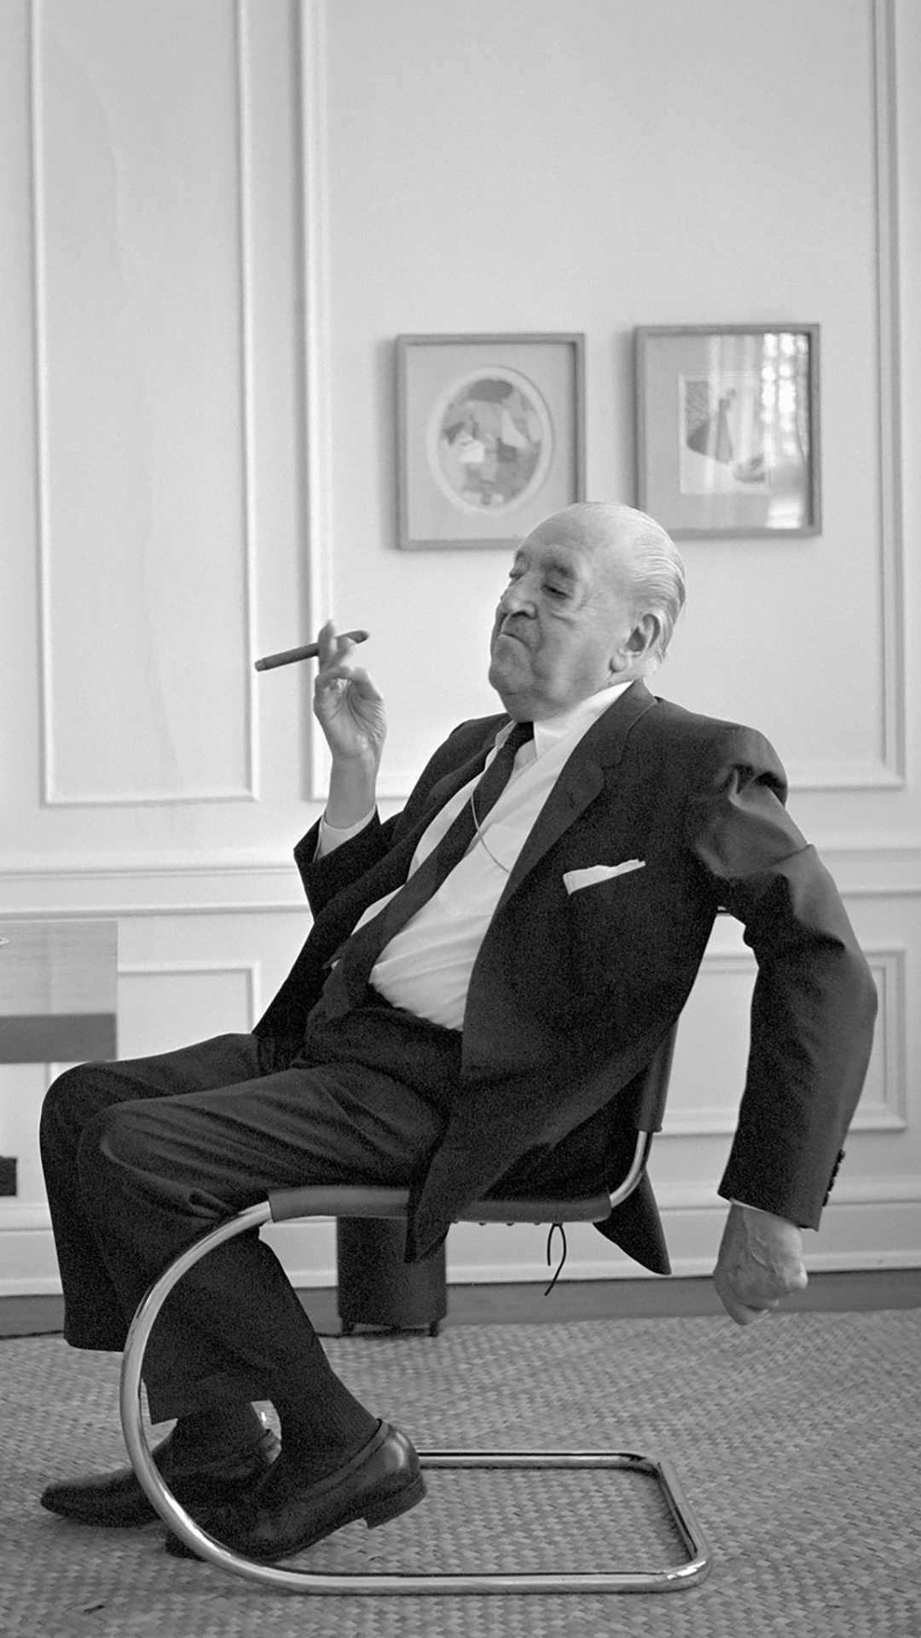  Figure 1 – Ludwig ‘Mies’ van der Rohe (internionline, 2021)  history & theory 1  M4X01975 | Nicholas Smith (2006099)  BSc Architecture

Historical Background
Originally commissioned for the 1929 International Exposition in Barcelona, the ‘German Pavilion’ was an iconic piece of early architectural modernism by Ludwig ‘Mies’ van der Rohe and Lilly Reich.

George von Schnitzler who commissioned the German National Pavilion wanted it to represent the new post 1st world war Weimar Republic as a pacifist nation that was rebuilding both its economy and reputation. Schnitzler asked Mies to create a self-portrait through architecture which would symbolise a ‘voice to the spirit of a new era’ (Stach, 2018).

Set on Montjuic, the pavilion was originally given a more central location for the exposition. Mies declined this and instead opted for a more secluded spot set at the bottom of a wooded hillside area.

The pavilion was only a temporary structure for the exposition and as such was demolished after 9 months in 1930. This could have been the end for the pavilion had it not been for the prints by Niemann & Stone for the Berliner Bild-Bericht series. Mies choreographed, cropped and re-touched these 16 prints to ensure the pavilion was as he wanted it to be seen (Stach, 2018).

The fact that the pavilion only existed in the form of this series of photographs only added to its reputation as one of the 20th centuries most iconic buildings and ultimately led to its reconstruction some 50 years later. In 1980, architects Solá-Morales, Cirici & Ramos were tasked by Barcelona City Council to research and rebuild the pavilion. Work on rebuilding the pavilion in its original site began in 1983 and was completed in 1986 (miesbcn, 2021).

Plan & Section

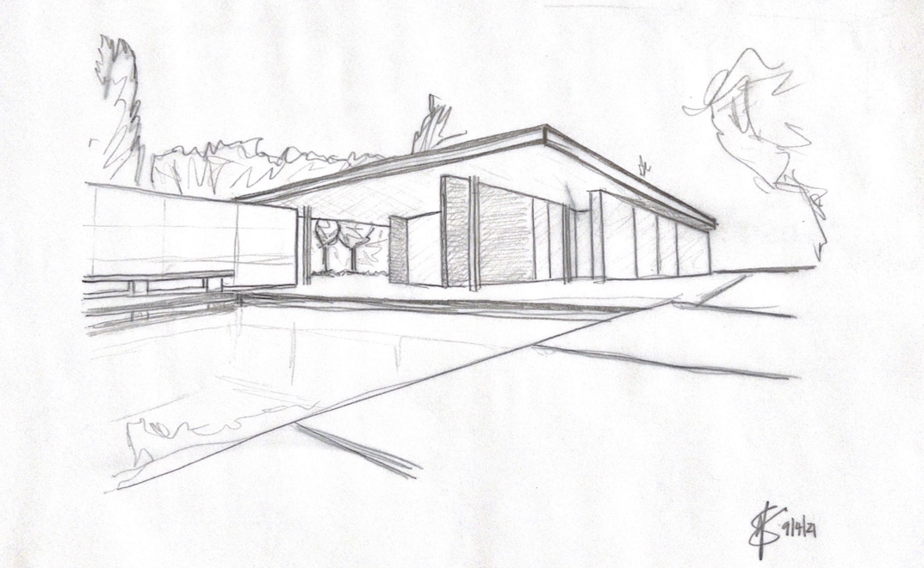
Figure 2 – Freehand sketch of the pavilion, 2021
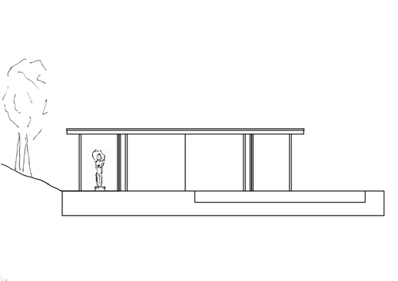
Figure 3- Plan and section of Barcelona Pavilion created with AutoCAD & Photoshop, 2021

The pavilion is set atop a 1.3m travertine clad platform of masonry construction. The composition is essentially split in to two pieces, to the left side sits a large pool and a small utility building, then to the right sits the main building with an adjoining smaller pool.

Access to the platform is from a set of steps in the south-east corner. Once ascended, access to the main structure is through glass double doors. Mies didn’t plan to have doors on the pavilion, they were only added at the insistence of the Spanish authorities (inexhibit, 2021).

It is thought that because the site of the pavilion was in front of a set of steps on the hillside to the rear which led to the Spanish village, Mies wanted to encourage people to transition through the space of the pavilion as they made their way from the exposition to the village. The positioning of the interior walls seems to add weight to this theory as for the most part they shield the view of the steps (Copans and Neumann, 2017).

The roof structure is supported by eight cruciform chrome plated steel columns. These, in accordance with Le Corbusier’s ideas, allow the internal walls to be placed freely, without the necessity to be load bearing. This also allowed the roof to appear like it was floating above the walls (archdaily, 2021)

The main travertine wall at the rear of the composition not only defines the space from the hillside at the rear, but it also creates a private walkway from which people can transition from the main structure to the utility building. During its time at the exposition, this would allow servers to pass freely between the two spaces without being visible to the guests of the German representatives.
In front of the wall is a travertine clad bench which runs virtually the full length of the wall and allows visitors to sit and gaze at the reflecting pebble lined pool.

Materials & Light
Fundamentally, the pavilion is constructed of three main materials: Steel, Glass & Stone. The structural steel, with the exception of the chrome plated cruciform columns is hidden within the structure.

The extensive use of glass housed in steel frames allows light to freely penetrate the interior space and also helps create reflections which create optical illusions of spaces which do not exist. Mies also incorporated two opaque glass walls within the structure. These were placed back-to-back and housed the only lighting for the pavilion. The opaque glass, which is illuminated during the day with light from the clerestory, gives a sense of privacy within the internal space as it creates a barrier from the large pool and terrace area (Stach, 2018).

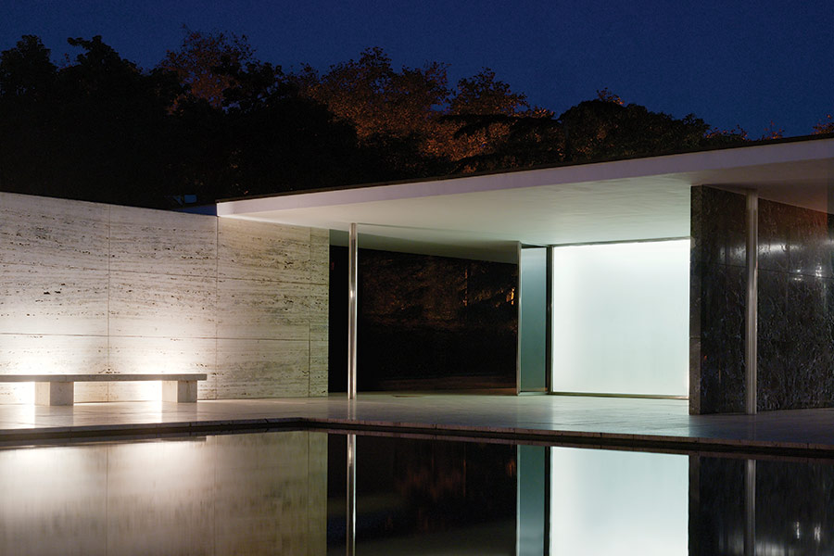
Figure 4 - ©Kristo, G
There are four types of stone used. Travertine, Golden Onyx, Tinos Marble & Verte-Antique Marble. The stone was cut and arranged in such a way as to create symmetry and repetition of the natural patterns within the seams. By doing this the walls become the artwork. Mies was insistent that there would be no artwork displayed in the pavilion, he wanted the pavilion to be the artwork (Ignant, 2021).

The reproduction of the bronze sculpture ‘Der Morgen’ (Dawn) by Georg Kolbe (1925) is set on the same plane as the main travertine wall at the rear of the composition, the sculpture is visible from multiple angles through the building and essentially draws your eye through the space. It sits in a black glass lined pool which makes it inaccessible to walk around (Copans and Neumann, 2017).

The use of fabric is sparse in the pavilion. There is a floor-to-ceiling velvet curtain which is aligned to the carpeted area. The curtain can be drawn to create a more private space should it be needed.

Idea & Theories
Researching the chronology of Mies’ work it is easy to see the evolution of his ideas and of modernism in general. Like a great artist he evolved and polished his masterpiece over the years, refining and enhancing it through experimentation in a bid to create the definitive work. Above all though, these ideas were being further enhanced during the melting pot which was the modernist movement and with the influence in particular of Le Corbusier, The Bauhaus and De Stijl.
The Brick Country House (1924) study saw Mies experimenting with the idea of an open floor plan and freely place walls, which was arguably inspired by De Stijl leader Theo van Doesburg’ Rhythm of a Russian Dance (1918) painting (Stach, 2018). Although the Barcelona pavilion is a much more simplified plan than the Brick Country House it is easy to see the similarity in the composition.

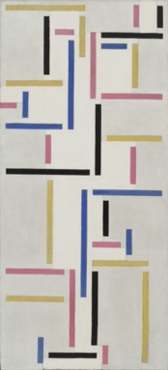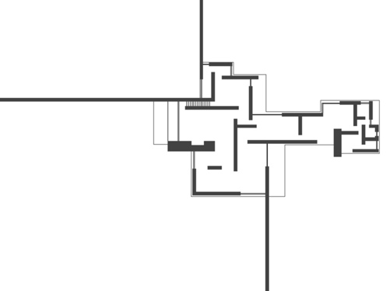
Figure 5 – The Rhythm of a Russian Dance (van Doesburg, 1918) & floor plan Brick Country House (Archilogic, 2017)
In 1927, Le Corbusier published his pioneering ‘Five points of a new architecture’. In it, he champions the use of ‘pilotis’ or load bearing columns, which enable the building to be freed from load bearing walls which subsequently allows the development of a ‘free plan’. Mies in using the eight cruciform steel columns in the pavilion followed this method. This allowed him to essentially de-construct the traditional box-like structures and not be constrained by the positioning of the internal walls, instead he was able to freely place the large marble and onyx partitions (lescouleurs, 2020).

For the Velvet and Silk Café (1927) Mies again collaborated with Reich to create an installation at a Berlin exhibition for women’s fashion. In it they use curved furniture designed by Mies and floor-to-ceiling velvet curtains to create clearly defined spaces within an open plan setting (MoMA, 2021). Both concepts were incorporated in the Barcelona pavilion in the form of the Barcelona Chair and the red velvet curtain (figure 6).

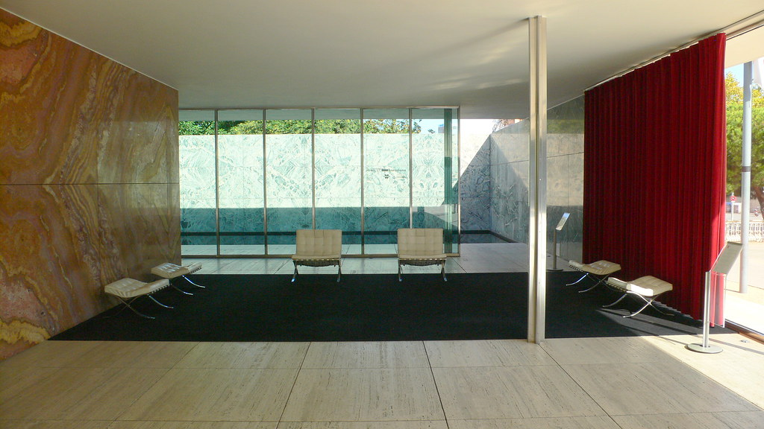
Figure 6 - ©MDS75, 2006
Haus Lange & Esters (1927/28) although a much less opulent, still shows the development of ideas Mies was to incorporate in the pavilion. The rear elevation of Haus Lange (figure 7) is constructed on a platform with steps leading up to the building, much like the pavilion albeit in a standard masonry construction not travertine clad. There are also similarities to be drawn from the elongated plan incorporating overhanging roof structures and large glazed areas.

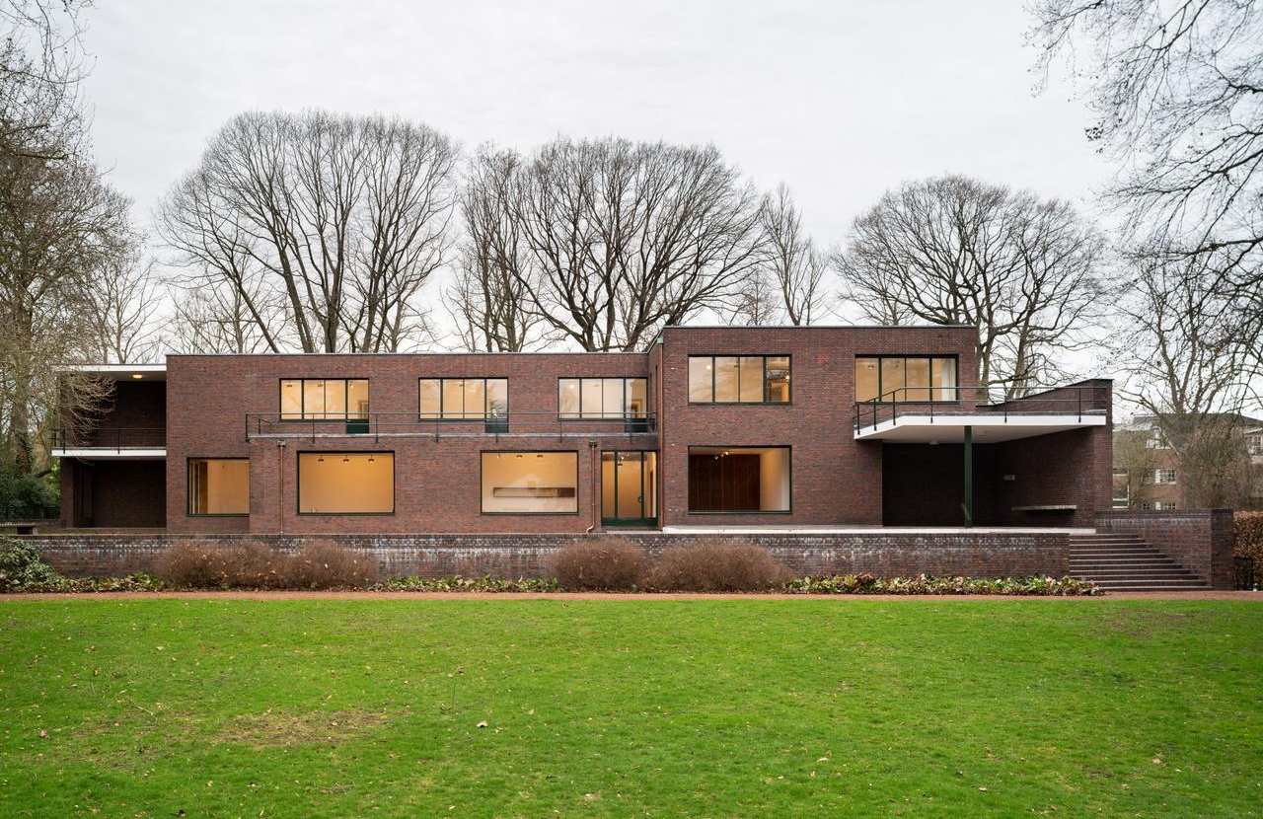
Figure 7 – Haus Lange ©Rose, D
Conclusion
There is little doubt that the Barcelona pavilion is one of the most iconic examples of 20th century architectural modernism. The fact that it existed only in photographic form for half a century only added to its allure and mystique. The fundamental ideas and form have been replicated repeatedly ever since it was first built and continue to influence buildings today.

Mies’ famously said, ‘less is more’ and ‘God is in the details’. Both of these statements are exemplified by the precision and detail of the pavilion. The palette of materials he used throughout undoubtedly exceeded Schnitzler’s original brief. This was an exciting, opulent building which was ahead of its time, something the Weimar Republic was keen to emphasise of its own development through the pavilion.

The positioning of one of the columns in the centre of the main space however is interesting (figure 8). It’s clearly a highly functional piece of the structure but it seems to be at odds with the free plan nature. It also appears to dictate the location of the carpet and furniture, which is offset in the space and almost looks confined. Maybe Mies wanted this to be on show in this way? Perhaps he felt that the column was as important a statement as the Barcelona chair with which it occupies the space? One can’t help but wonder what he really thought of its positioning though. Afterall, the concept was based around the idea of a free plan. Has the free plan idea been achieved with a structural column sited within it?

Ultimately, this is one of the most iconic buildings by one of the most important architects of the modern movement. Yes, it is a replica of the original and yes, its aura was enhanced by the fact it didn’t exist for half a century but the influence it has had on so many architects and buildings is tangible.
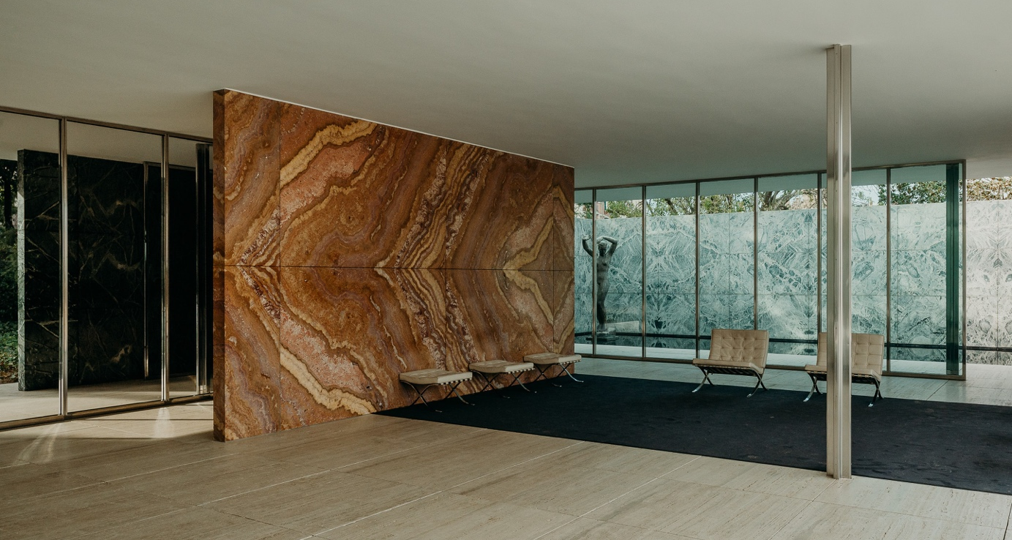
Figure 8 – ©Merin, G
Reference list:

archdaily (2021) ‘AD Classics: Barcelona Pavilion’
Available at: https://www.archdaily.com/109135/ad-classics-barcelona-pavilion-mies-van-der-rohe
(Accessed 19 March 2021)

archilogic (2017) ‘Repurposing Brick Country House’
Available at: https://medium.com/archilogic/repurposing-brick-country-house-96b20f5b53f6
(Accessed 19 April 2021)

Copans, R and Neumann, S (2017) ‘The German Pavilion in Barcelona [video]’
Available at: https://www.youtube.com/watch?v=taFXWpQLXsg
(Accessed 6 April 2021)

Ignant (2021) ‘The Barcelona Pavilion by Mies van der Rohe is a textural delight’
Available at: https://www.ignant.com/2020/02/28/the-barcelona-pavilion-by-ludwig-mies-van-der-rohe-is-a-textural-delight/
(Accessed 8 April 2021)

Inexhibit (2021) ‘The German Pavilion in Barcelona’
Available at: https://www.inexhibit.com/mymuseum/the-german-pavilion-in-barcelona-by-mies-van-der-rohe/
(Accessed 2 April 2021)

Kristo, G (2021) ‘Barcelona Pavilion’
Available at: https://www.archdaily.com/109135/ad-classics-barcelona-pavilion-mies-van-der-rohe
(Accessed 17 April 2021)

Interni (2021) ‘Van Der Rohe Mies’
Available at: https://www.internionline.it/designer/mies-van-der-rohe/
(Accessed 7 April 2021)

Les Couleurs (2020) ‘Le Corbusier’s five points of a new architecture’
Available at: https://www.lescouleurs.ch/en/journal/posts/the-five-points-of-a-new-architecture/
(Accessed 20 March 2021)

MDS75 (20006) ‘Barcelona Pavilion’
Available at: https://www.flickr.com/photos/mdsmith75/503155565/
(Accessed 17 April 2021)

Merin, G (2021) ‘Barcelona Pavilion’
Available at: https://www.archdaily.com/109135/ad-classics-barcelona-pavilion-mies-van-der-rohe
(Accessed 17 April 2021)

miesbcn (2021) ‘Fundacio Mies van der Rohe Barcelona’
Available at: https://miesbcn.com/the-pavilion/
(Accessed 17 March 2021)

MoMA (2021) ‘The velvet and silk café 1927’
Available at: https://www.moma.org/audio/playlist/34/565
(Accessed 17 March 2021)

Rose, D (2021) ‘Haus Lange Garden Side’
Available at: https://anders-wohnen.online/en/Anders-Wohnen/Die-Hauser
(Accessed 17 April 2021)

Stach, E (2018). Mies van der Rohe: Space – Material – Detail

Van Doesburg, T (1918) ‘The Russian Dance’ [oil on canvas]
Available at: https://www.moma.org/audio/playlist/34/565
(Accessed 17 April 2021)

