Assignment coversheet & feedback form

THIS SHEET MUST BE THE FIRST PAGE OF THE ASSIGNMENT YOU ARE SUBMITTING (DO NOT SEND AS A SEPARATE FILE)

For completion by the student:
Student Name:
Jefferson Collins
Student University Email: 2328334@student.uwtsd.ac.uk
Module code:HPCA7028  Module title:  SACRED SKIES  Postgraduate/Distance Learning | Student ID number:2328334 |  |  | Educational support needs:  Yes/No
Assignment title:
ESSAY 2

Assignment due date:2nd May 2024
This assignment is for the 1^{st x} 2nd 3rd 4th 5th 6th module of the degree
I confirm that this is my original work and that I have adhered to the University policy on plagiarism.
Signed ………………………………Jefferson Collins……………………………
Email submission:if you are submitting this form via email, please tick this box □x
(as a substitute for your signature) to confirm that you agree to the above declaration.
Assignment Mark
1st Marker’s Provisional mark
2nd Marker’s/Moderator’s provisional mark
External Examiner’s mark (if relevant)
Final Mark

NB. All marks are provisional until confirmed by the Final Examination Board.

For completion by Marker 1 :
Comments:

Marker’s signature: |  |  | Date:
For completion by Marker 2/Moderator:

Comments:

Marker’s Signature: |  | Date:
External Examiner’s comments (if relevant)

External Examiner’s Signature: |  | Date:

This paper will examine two celestial ceilings in New York City painted 101 years apart. It will suggest that they present fundamentally different conceptions of the sky and the notion of cosmic order in relation to changing perceptions of the nature of the city. A brief examination of the complex history of the Grand Central Terminal ceiling will be followed by the contrasting example of the Albertine Bookshop.

Grand Central Terminal

‘In New York we travel heavenward as well as on the surface’
William Aiken Starrett

Grand Central Terminal has been called ‘one of the grandest spaces the early 20th century ever enclosed.’ A project funded by the Vanderbilt family, it was built between 1903-13 by the collaboration of two firms, Warren & Wetmore and Reed & Stem along with engineer William J. Wilgus (1865-1949) and was one of a number of major public structures built during a period of significant urban reform in New York City. It replaced an earlier station of the 1870s that had become infamous for overcrowding at a time when the menace and threat of the crowd was a major public discourse. ‘Just as the railroads organized new scales of urban and national geography they also generated zones of intensified crowd activity […] the urban crowd was beginning to be construed mythically as a force of nature’ wrote Anthony Raynsford. At Grand Central the engineers and architects, influenced by the ‘The City Beautiful’ philosophy, effectively created a machine for the movement of large numbers of people, hiding the platforms and trains underground while the buildings above, built in the Beaux Arts style that had become the aesthetic badge of American economic power, acted, in the words of it’s architect, as a ‘gate to a city’ and an ‘arch of triumph.’ According to Raynsford ‘as an urban monument, Grand Central Terminal stages an elaborate spectacle whose mythical object is the metropolitan crowd.’

The celestial ceiling above the main concourse lies at the heart of the station complex and has become one of its most recognizable motifs. As with the rest of the building, it was also a collaboration, being conceived by architect Whitney Warren (1864-1943) and astronomer Dr. Harold Jacoby (1865-1932) and executed by Charles Basing (1864-1933) with James Monroe Hewlett (1868-1941) of the Hewlett-Basing Studio, and around fifty assistants. It was Jacoby who sourced the figures, primarily using Johann Bayer’s 1603 star atlas Uranometria, though French artist Paul Cesar Helleu (1859-1927) was responsible for drawing the design. The ceiling, 275x120 feet in length and width and 125 feet above the floor, was painted during 1912 in cerulean blue tempera with gold leaf used for the figures and the 2,500 stars. Around 60 of the larger stars were open and lighted by electric bulbs. Pictured were the zodiacal signs from Aquarius to Cancer plus the well-known constellations of Orion and Pegasus, and two lesser-known, Musca Borealis and Triangulum Major. The lines of the ecliptic and equator glide across the vault and hold the composition together while stars dot the remaining expanses of space. A pamphlet published by the New York Central Railway Company for the opening of the station on 2nd February 1913 offers some telling insights into the mentality of the company’s vision:

‘It is safe to say that many school children will go to the Grand Central Terminal to study this representation of the heavens, which places the celestial bodies within close range of vision. To insure astronomical accuracy and beauty of form, the highest authorities were consulted, among them Dr. Jacoby of Columbia University, and the research was carried back to manuscripts and treatises of the Middle Ages.’ The New York Times wrote confidently before the opening that ‘the figures and signs in their relation to one another and to the ecliptic and equator are as nearly as possible astronomically correct.’

Just over a month later, The New York Times reported that a commuter had ‘pointed out wrathfully’ that the constellations had in fact been rendered ‘backwards’ as seen from outside the celestial sphere as opposed to from Earth. Though this perspective of the constellations was common on globes of the Renaissance following the Hipparchus rule Jacoby claimed that the leaflet printed before the opening showed the ceiling as it should’ve been rendered and that Basing had incorrectly projected the sketch backwards. “Apparently the design had been placed on the floor and then on the ceiling” he said. “It might have been better if the artist had held the diagram over his head and transferred it.” According to The Times Basing ‘showed little interest in the technical defects and added that he thought the work had been done very well.’ The stars of Orion are alone in being correctly rendered on the ceiling. Michael Mendillo’s idea, that Orion’s status as an easily recognizable and popularly well-known constellation merited it’s rendering as-seen-from-Earth is perhaps worth serious consideration. The quote, sometimes attributed to William Vanderbilt, that the ceiling represented ‘God’s eye view’ is a dubious yet frequently-cited part of Grand Central lore.

A decade later the ceiling was in such terrible condition that plans were underway to paint a whole new design by Robert Winthrop Chanler, though it too would be an idiosyncratic rendering. “I wouldn’t advise any navigator to set his compass to my sky” Chanler was reported to have said. The planned repairs did not occur until 1944 by which time the ceiling had been so badly damaged by fumes, soot and damp that it was in need of a complete renovation. One of the original Hewlett-Basing Studio assistants, Charles Gustave Gulbrandsen (1890-1974) was recalled to oversee the work. The original plaster ceiling had to be covered by boards and a whole new ceiling painted in oil to Gulbrandsen’s design. Though largely faithful to the original it included the addition of the Triangulus Minor constellation as well as innumerable signatures from friends, colleagues and family invited to leave their marks on the heavens. The orientation remained as it had been. “The ceiling is decoration, not a map” Gulbrandsen said. “The constellations are north. They should be south. So what?” The ceiling was cleaned and conserved in a significant restoration by John Canning & Co towards the end of the 1990s who not only installed new lights but also retained as historical artifacts the many added signatures. In their balanced opinion ‘while we may think it more logical for the composition to have an earth-to-heavens point of view, there is simply no evidence of the mural’s orientation being a mistake – or intentional for that matter – either on the part of Mr. Helleu or of those who painted it.’

The idea for a painted ceiling had been a late afterthought when the plan for a glass caisson had to be abandoned. Interviewed for The New York Times Warren said

‘This astronomical ceiling of blue and gold was decided upon to fill the need for a flat surface of some sort. We wanted to get away from the caison [sic] ceiling patterned after the Pantheon at Rome […] “And the starry ceiling” his interviewer suggested “reflects the guidance of travelers of old?” Mr Warren assented, and paused to ask if the composition of the decoration had not been successful, approving the break in the monotony of mere stars by the golden figures of the zodiac and the great sweeping arcs of the circles.’

One of the most noticeable aspects of the ceiling is the absence of figures, the enormous expanses of space. In part this reflects the abandoned plan for the glass roof and the view of the sky Warren hoped it would provide along with the reality that for New Yorkers, looking up in a city of smog and light pollution yielded a view of very few stars. In a period marked by the rise of the skyscraper there was a corresponding concern for the lack of visible sky and light. This culminated in the New York City Zoning Ordinance of 1916 dictating that skyscrapers should be built with setbacks to allow light to filter to streets below. The City Beautiful Movement, which sought to create wide and open urban spaces, was conscious of the sky and the light with many Beaux Arts architects even refusing commissions to build skyscrapers altogether. Talbot Hamlin’s comment, that the Grand Central ceiling ‘seems almost an attempt to make it all part of outdoors’ was an apt observation. But there is also a sense of, as one early reviewer said, not just of looking up at the sky but of ‘the effect of limitless space.’ The notion of expansion into seemingly limitless space lay in American consciousness, a part of the national myth of ‘manifest destiny’ that had sent settlers west during the previous century, their numbers increasing with the construction of the railroads. The US Census Bureau had officially recorded the breakup of the American frontier in 1890 however, since which time there had been a greater push to maintain and protect areas of America’s wilderness culminating in the creation of the National Park Service in 1916. Theodore Roosevelt, speaking in 1905, said that he saw in the civilization of cities the ‘unhealthy softening and relaxing of fibre,’ the remedy for which was the fostering of ‘fundamental frontier virtues.’ ‘There are no words’ he said ‘that can tell of the hidden spirit of wilderness.’ The constellations of Orion and Pegasus seem to speak of the virtues Roosevelt outlined. Though representations of Orion tend to show him, in Robin Hard’s words as ‘a rather crude and primitive figure’ Bayer’s bearded Orion, lifting his club to the charging bull of Taurus, is notable for looking less like a hero from classical antiquity, as he does in the other notable star charts of Helvetius, Flamsteed, Bode or Jamieson, and more like a mythical wild man, a figure in European culture with roots in the Roman Silvanus. The figure of the wild man was popular during the Renaissance and connected to the notion of the wisdom and threat of untamed, uncultivated nature, a theme elaborated in the 1880s by Walt Whitman in Song of Myself when he wrote of the ‘friendly and flowing savage.’ Pegasus meanwhile, emerging from clouds, brings to mind the colloquial nineteenth century moniker for the train, 'the iron horse’ memorably described by Henry David Thoreau in Walden conflating railroad travel to the inevitability of cosmic motion and revealing a paradoxical attitude that the train, like the crowd, was both monstrous and part of the elemental natural order

‘When I meet the engine with its train of cars moving off with planetary motion - or, rather, like a comet, for the beholder knows not if with that velocity and with that direction it will ever revisit this system, since its orbit does not look like a returning curve - with its steam cloud like a banner streaming behind in golden and silver wreaths, like many a downy cloud which I have seen […] what kind of winged horse or fiery dragon they will put into the new Mythology I don't know […] If the cloud that hangs over the engine were the perspiration of heroic deeds, or as beneficent as that which floats over the farmer's fields, then the elements and Nature herself would cheerfully accompany men on their errands and be their escort.’

The zodiacal constellations range from Aquarius to Cancer and the lines of the ecliptic and equator cross at the point of the Spring equinox, intimating the notion of beginnings in the liminal space of the terminal. Reed & Stem and Warren & Wetmore had reached an agreement in February 1904 and the station was opened in February 1913, perhaps a factor in the creation of a sky that begins with Aquarius. The most curious of the figures are the three minor constellations above the sign of Aries. Musca Borealis was not sourced from Bayer but from Alexander Jamieson’s Urania’s Mirror (1825), unique among the representations of the constellation for having, as in the Grand Central example, two sets of wings in the manner of a bee. Plancius, who created the constellation in 1612 named it not Musca ‘the fly’ but Apis ‘the bee.’ Bartch changed the name to Vespa ‘the wasp’ on his map of 1624 before Hevelius gave it the name of fly in 1687. Gradually it fell from use from the mid-nineteenth century on until the IAU created it officially defunct in 1922. Yet despite its minor status the constellation was placed almost centre of the composition along with Triangulum Majus. As a symbol the bee has a long and rich history for many cultures. Aristotle, in his On the History of the Animals, stated that bees had a threefold structure consisting of kings, workers and drones and, in On the Heavens wrote that

‘Just as the Pythagoreans say, the whole and all things [in it] are bound by three; for a beginning a middle and an end compromise the number of the whole, which is to say they compromise the number of the triad. And so, taking this fact from nature as one of nature’s laws, we also use this number for the worship of the gods.’

The inclusion of Musca Borealis and Triangulum Majus and Minus may reflect masonic influence from one or more of those involved in the project. In Masonic symbolism, following Aristotle as well as other traditions, the bee is related to industry and regeneration and the triangle, especially in its double form and thus having six points, is symbolic of ‘the deity, the universe and perfection.’ This may explain Gulbrandsen’s otherwise enigmatic inclusion of Triangulum Minor, one of ‘the least imaginative’ and least known of minor constellations, in his 1944 re-rendering. If so, it adds an intriguing possibility that the ‘God’s eye view’ of the constellations as seen from outside the celestial sphere rather than on Earth was perhaps an intentional conceit in keeping with the masonic belief of God in man. Alternately, the minor constellations may simply reference the aim of Grand Central’s architects in answering the need that had been summed up in 1909 by architect Daniel Burnham when he wrote that ‘the time has come to bring order out of chaos incident to rapid growth.’ The hint that railway technology could be a part of a natural process of order had been imagined earlier in the 1840s when Ralph Waldo Emerson had written of the railway that it falls ‘within the great Order not less than a beehive or the spiders geometrical web. Nature adopts them very fast into her circles’ and seeing railroads as being the products of the ‘World-Soul.’ The minor constellations on the ceiling reflect the sense that the conceits of the architects are part of greater cosmic and mythologic order.

The use of Bayer’s figures give the ceiling a sense of historic continuity, that it is part of a tradition, linking the monumental space back to those of the Renaissance and also the Classical past that had inspired the urban philosophy of the structure. Unlike many of the celestial ceilings of the Renaissance the majority of the vault appears empty, devoid of overt mythologizing. Yet space, in both terrestrial and extraterrestrial forms, is at the heart of myth in America. And as Roderick Nash wrote ‘wilderness was the basic ingredient of American civilization.’

The Albertine Bookshop

‘As New York enters the third decade of the twenty-first century, it is in imminent danger of becoming something it has never been before: unremarkable. It is approaching a state where it is no longer a significant cultural entity but the world’s largest gated community, with a few cupcake shops here and there. For the first time in its history, New York is, well, boring.’

The Albertine bookshop is housed in the Payne Whitney mansion in Manhattan built by Stanford White between 1902-06 in the High Italian Renaissance style. Since 1952, the building has housed the Cultural Services of the French Embassy. Though there had been two small private French libraries in the house since the fifties, the bookshop within the mansion was opened in September 2014. Its interiors were created by French designer Jacques Garcia for Antonin Baudry, Cultural Councilor for the French embassy. Though one of the Albertine’s websites states that the celestial ceiling is ‘in the style of a Renaissance fresco’ the other more correctly states that the ceiling is ‘a hand-painted mural of constellations, stars, and planets […] modeled after the extraordinary ceiling of the music room at the Villa Stuck in Munich, Germany, crafted by Franz von Stuck.’ It was crafted by Atelier Mériguet-Carrère, the company also responsible for refurbishing the Oval Office in the White House.

Franz von Stuck (1863-1928) was a notable German symbolist. The celestial ceiling, still in existence in the Villa Stuck music room, was painted in 1898 and depicts the diagrammatic orbiting of planets based on Renaissance examples of the Copernican system with the addition of the post-renaissance discoveries of Uranus and Neptune. The zodiac signs are each drawn twice, once as a glyph and again as a pictorial representation. A shooting star enters the zodiacal circle in Leo and falls between the orbits of Earth and Mars and the rest of the expanse is covered by gold stars on a deep ultramarine background. The planet placements seem not to correspond with a known astrological chart of any kind and are likely arranged for artistic balance. Unlike Stuck’s original, the Albertine has three lamps hanging from it in spite of the design and also several cut-outs leading to electrical outlets and sprinklers.

In a city that has lost many of its bookshops and in ‘an age whose architectural emblem is the airport waiting lounge’ the Albertine ceiling has garnered much attention and praise. The bookshop takes its name from the enigmatic woman at the heart of Proust’s À la recherche du temps perdu and like its namesake has served to fascinate those who have written about it. ‘Truly an escapist's dream’ wrote the reviewer for Time Out while The Paris Review felt that the bookshop ‘resembles a magnificent private library of the sort you’d expect to find in a turn-of-the-century estate.’ The effect was intentional. ‘This is not intended as a retail place,’ Baudry said. ‘It’s more like a grand private library, with nothing that you wouldn’t want to have at home.’ Despite this, Baudry bought in the design agency Pentagram who had previously been responsible for the re-branding of Grand Central Terminal in 2013 which, after that date, became simply ‘Grand Central’ to help create an identity for the shop. Pentagram’s website states that the company ‘has designed a distinctive new identity for Albertine inspired by French vernacular typography. The designers worked closely on the project with the store’s founder, Antonin Baudry […] The shop has been envisioned as less a retail space than a reading room that invites visitors to linger, and the identity invokes the connection between books, knowledge, and Enlightenment, with references to Parisian Art Deco.’ The ceiling was used as the basis for the brand with the sunburst becoming the defining logo repeated on stationary, bags and luxury merchandise. Albertine has a two-tiered membership system, ‘sunburst’ for $55 a year and ‘constellation’ for $75 though ironically there are no constellations on the ceiling, only stars. ‘Few objects are offered alone’ wrote Jean Baudrillard of the current age that he defined as being one of simulacra ‘without the context of objects to speak for them.’

The choice to recreate a ceiling of 1898 rather than commission a unique work may be seen as both a reticence to gamble on an artists ‘new’ vision of the cosmos but also a desire to reference an older, more established vision and the world it came from. In Albertine’s case, it is the world of fin de siècle Europe, corresponding to the Gilded Age of the United States, a period of enormous economic growth and, for some, expansionist optimism that had spawned buildings such as Grand Central. The name Albertine conjures images of Parisian high society of the same period. Von Stuck’s diagram is based on the model of Copernicus (1473-1543), and so the aim of Baudry and the designers, to create a space referencing knowledge and enlightenment, is rooted in a very specific juncture in European thought and perception, ‘the Copernican revolution,’ arguably the birth of the modern self. According to Nicholas Campion ‘Copernicus’s masterstoke in simplifying the geometrical platonic cosmos, saving it from Aristotelian complexities, matched perfectly with the prevailing notion of celestial harmony as a metaphor for political and social harmony.’ Though he radically altered former perceptions with the notion that the Earth was not stationary, Copernicus’ vision was however conservative, and in placing the sun at at the centre of the system he was returning to the cosmology of the Pythagoreans. He wrote of the sun ‘not unhappily do some call it the lantern; others, the mind and still others, the pilot of the world.’ ‘Copernicus was not seen by his contemporaries and immediate followers as a revolutionary’ wrote Heineger ‘[but] more in the role of revivalist, as one who had resurrected and reasserted an ancient world-view.’ In De revolutionibus orbium caelestium Copernicus named Philolaus as one of his predecessors due to the latter having written of the ‘central fire’ though there was debate, that continues to the present, about whether this central fire was, or was not, The Sun.

Though Copernicus is a key figure in the paradigm shift of the ‘scientific revolution’ De revolutionibus begins with the idea of the divine sun and there are, as Campion wrote, implications for the notions of words such as ‘illumination’ and and ‘enlightenment’ as having spiritual qualities.’ Baudry said of the renaissance that it was ‘a time when science and poetry were not separated’ and in a different interview said ‘I want this to be a place that has a soul.’ The perception of a loss of soul in New York has become an increasingly common notion in the 21st century, with books such as Naked City: The Death and Life of Authentic Urban Spaces (Sharon Zukin 2010) and Vanishing New York: How a Great City Lost its Soul (Jeremiah Moss 2017) examining the issue. Though far from unique to the city and reflecting a wider climate of globalization, loss of soul is linked to gentrification, large-scale urban renewal, a shift from manufacturing to the service and tourist industries resulting in rising property values, ‘museumification’ and a corresponding decline of the city’s former dynamism. Zukin, a sociologist and native New Yorker echoed Baudrillard when she wrote how she had been ‘dismayed by the way the city has morphed from a lumbering modern giant to a smooth, sleek, replica of its former self.’ The call for soul, the desire to create, in Baudry’s words a place ‘where you can have intimacy and meet people’ not only situates the ethos of the bookshop against what Zukin calls ‘predictable space’ but also against the grain of current Posthumanist critiques that question the boundaries of what it means to be human ‘following the onto-epistemological as well as scientific and bio-technological developments of the twentieth and twenty-first centuries.’ Baudry’s desire to foster a human meeting place under a representation of the system of the universe, places the idea of human interaction firmly within a solar framework. ‘The rational mind of ‘modern man’ wrote Richard Tarnas ‘identified itself with the Sun, with the Solar Logos of the divine reason.’ Whether by accident or design, in invoking Copernicus’ heliocentric system and in using Von Stuck’s central sunburst as a defining logo, The Albertine has aligned its ethos as a place for knowledge and enlightenment with a common New Age trope of soul that arguably has its origins, via Jung, Hegel and the Romantic Idealists, in Plato and the Pythagoreans.

Conclusion

Both ceilings were sourced from European iconographic traditions, the Renaissance star atlas in the case of Grand Central and the diagrammatic form of the Copernican heliocentric system in The Albertine. Both ceilings have been subject to misunderstanding from both official and unofficial sources. In several places, including a published book and a plaque once on display in the concourse, the Grand Central ceiling was described as depicting a ‘Mediterranean’ sky. Claims that it was based on a ‘medieval manuscript’ as first reported in the New York Times have continued to the present. The Albertine is routinely described as having a ceiling in ‘Renaissance style’ or even ‘Florentine-inspired astronomical mural.’As signifiers, in Ferdinand de Saussure’s term, words such as ‘Florentine,’ ‘Mediterranean,’ ‘Renaissance,’ and ‘Middle Ages’ seemingly are used to position the authenticity, ‘accuracy’ and authority of the ceilings in a European past. In Grand Central’s case the authority of ‘an old Medieval manuscript’ was then blamed when the ceiling was found to be technically inaccurate.

The only partial rendering of the ecliptic gives a sense that, for all its monumentality, Grand Central is merely a part of the universe. That despite its name, it is not central. It could be argued that the lack of constellation figures, the disregard for technical accuracies, the paucity of stars, the sense of uncentredness, reveals a distinct disenchantment in the possibilities of the post-scientific enlightenment, early twentieth century sky to contain human myth. But the expanse across the vault, the rendering of Orion in his more savage silvan guise, the feeling of movement in the figures, the freedom of the composition unbound by historical or technical exactness, the sense of unlimited space point to the way American myth, that of the dream of endless terrestrial space and the optimism of ‘manifest destiny’ connected to technology was reflected in the sense of a similarly endless sky. Not without coincidence was the concourse chosen to display the Redstone Missile in 1957 in response to the USSR’s Sputnik at the height of the space race.

The high-minded Modernist philosophy of the Grand Central planners was to tame the mythological crowd-as-force-of-nature with a structure that is both a triumphal gateway and theatre for human movement, a sense of order that finds reflection in the timelessness order of the stars. In contrast The Albertine, in a city now less concerned by the mythological crowd as much as the positive and negative effects of global capital, in seeking to create the sense of a private, high status interior, harked back to two points in history, one aesthetic, one philosophic. The diagram of the Copernican heliocentric system aligns the ethos of the bookstore with one of the major scientific events of the European Renaissance while simultaneously engendering a space experienced not only as magical, dreamy and unusual in a city of arguably increasing ubiquity but one that invites, as Baudry intended, the discussion of ‘art, finance and politics.’ The ceiling is a near-faithful copy of its original, a work of European Modernist interior decor that posits a fixed and rational reflection of the scheme of the universe with the Sun, harking back to far older philosophies, at its centre, giving the notions of soul and also mind universal centrality. Unlike Grand Central it does not promote a sense of limitless movement but rather a fixed system. In this way there is perhaps a reflection in the concentric diagram of the heavens to the comparative fixity of written Roman Law that was to form the basis of French Civil Law as opposed to the unwritten English Common Law that underpinned the American constitution and with it, a certain very different idea of the individual and freedom. Though both interiors engage with the idea of human interaction being linked to a cosmic order in Albertine’s case the the Sun, that can also be carried away from the shop on tote bags and stationary, becomes a symbol not only of human mind but also badge of individuality. ‘All decoration means something if it is appropriate’ said Warren, a comment that can perhaps speak for both ceilings.

Bibliography

Barentine, John C. (2016) The Lost Constellations Chichester, Springer-Praxis

Baudrillard, Jean (1988) For a Critique of the Political Economy of the Sign in Jean Baudrillard: Selected Writings (ed Poster, Mark) Stanford, Stanford University Press

Campion, Nicholas (2009) The History of Western Astrology, Vol II, The Medieval and Modern Worlds, London, Continuum

Campion, Nicholas (2017) The New Age in the Modern West, Counterculture, Utopia and Prophecy from the Late Eighteenth Century to the Present Day London, Bloomsbury

Cronkite, Ferris G. (1951) The Transcendental Railroad in The New England Quarterly, Sep 1951, Vol. 24, No. 3. Cambridge MA, New England Quarterly Press

Curl, James Steven (2011) Freemasonry and the Enlightenment, Architecture, Symbols and Influences, London, Historical Publications.

Erastothenes and Hyginus (trans Robin Hard) (2015) Constellation Myths with Aratus’s Phaenomena Oxford, Oxford University Press

Fenske, Gail (2005). The Beaux-Arts Architect and the Skyscraper: Cass Gilbert, the Professional Engineer, and the Rationalization of Construction in Chicago and New York In Moudry, Roberta (ed.). The American Skyscraper: Cultural Histories, Cambridge, Cambridge University Press

Ferrando, Francesca (2013) Posthumanism, Transhumanism, Antihumanism, Metahumanism, and New Materialisms: Differences and Relations in Existenz 8/2 Fall 2013

Hamlin, Talbot (1926) American Spirit in Architecture New Haven, Yale University Press.

Herlihy, Anna Friedman (2007) Renaissance Star Charts in Woodman, David (ed), The History of Cartography, Volume 3 Part 1, Cartography in the European Renaissance, Chicago, University of Chicago Press

Hitchcock, Henry Russell (1971) Architecture: Nineteenth and Twentieth Centuries Harmondsworth, Penguin

Kingsley, Peter (1995) Ancient Philosophy, Mystery and Magic Oxford, Clarendon Press

Koolhaas, Rem (2014) Delirious New York: A Retroactive Manifesto for Manhattan, New York, The Monicelli Press.

Lehoux, Dayrn (2019) Why Does Aristotle Think Bees are Divine? Proportion, Triplicity and Order in the Natural World in The British Journal for the History of Science, Volume 52, Issue 3, September 2019, Cambridge, Cambridge University Press

Mackenzie, John M. & Richards, Jeffrey (1988) The Railway Station, A Social History Oxford, Oxford University Press

Mendillo, Michael (2022) Saints and Sinners in the Sky: Astronomy, Religion and Art in Western Culture Chichester, Springer-Praxis

Middleton, William D. (1977) Grand Central, The World’s Greatest Railway Terminal San Marino CA, Gold West Books

Nash, Gerald D. (1980) The Census of 1890 and the Closing of the Frontier in The Pacific Northwest Quarterly. 71 (3)

Nash, Roderick (1975) Wilderness and the American Mind New Haven, Yale University Press

Robins, A. W. (2013) Grand Central Terminal, 100 Years of a New York Landmark New York, New York Transport Museum, Abrams Press

Schlichting, Kurt C. (2001) Grand Central Terminal: Railroads, Architecture and Engineering in New York Baltimore, Johns Hopkins University Press

Sennett, Richard (1996) Flesh and Stone: The Body and the City in Western Civilization, New York, Norton

Tarnas, Richard (2006) Understanding Modern Disenchantment in Sky and Psyche (ed Campion, Nicholas & Curry, Patrick) Edinburgh, Floris Books

Thoreau, Henry David (1854) Walden, or Life in the Woods, Boston, Ticknor & Fields

Whitman, Walt (1917) Leaves of Grass, New York, Garden City.

Zukin, Sharon (2010) Naked City: The Death and Life of Authentic Urban Spaces, Oxford, Oxford University Press. px

Newspapers and Websites

Central Terminal Opening on Sunday, The New York Times, January 29th 1913

The Great Railway Terminal go the Future, The New York Times February 9th 1913

Constellations Reversed, The New York Times, March 23rd 1913

Plan New Heavens for Grand Central, The New York Times, April 11th 1924

So What’s the Big Idée? The New York Times, October 9th 2014

A First Look at Dreamy French Bookshop Albertine, Time Out, September 26th 2014

Inside Albertine, The Paris Review, September 26th 2014. www.parisreview.org

The French Bookshop Seducing New York, France 24, 20th October 2014

The Death of a Once Great City, Harpers, July 2018 https://harpers.org/archive/2018/07/the-death-of-new-york-city-gentrification/

Albertine Reparue: A French Bookshop in New York https://www.newyorker.com/books/page-turner/albertine-reparue-french-bookshop-new-york

https://www.pentagram.com/work/albertine-1/story

https://neildegrassetyson.com/photos/2002-10-city-of-stars/grand-central-terminal/

www.villa-albertine.org

www.albertine.com
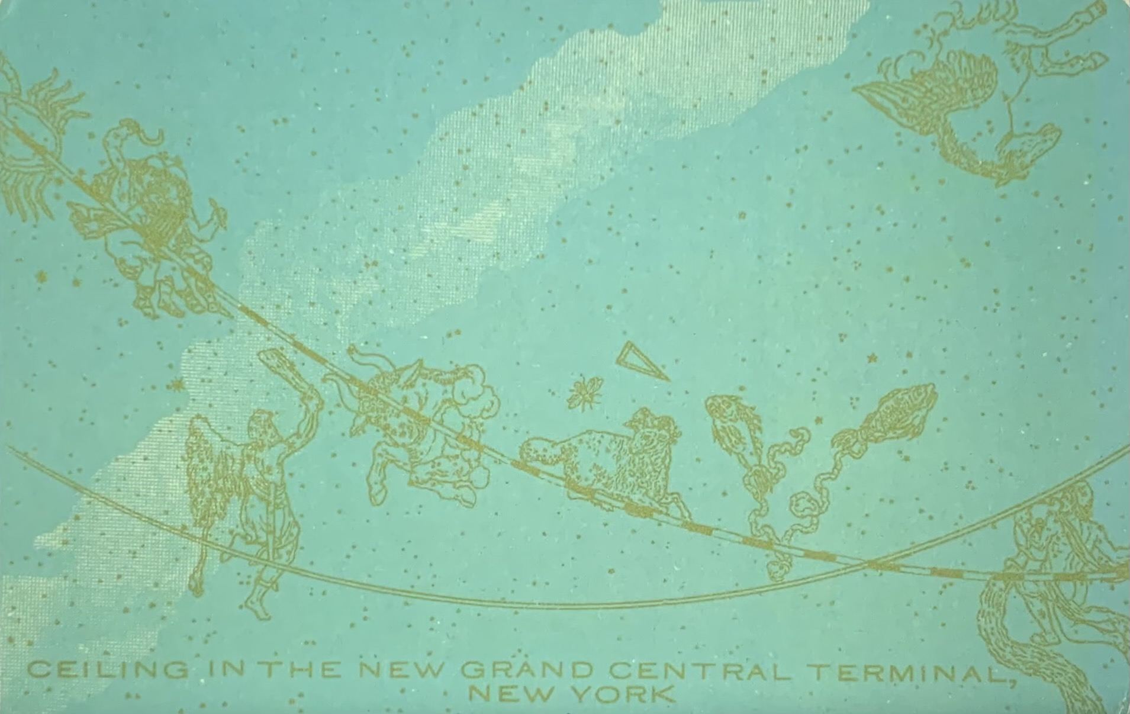
Picture Section
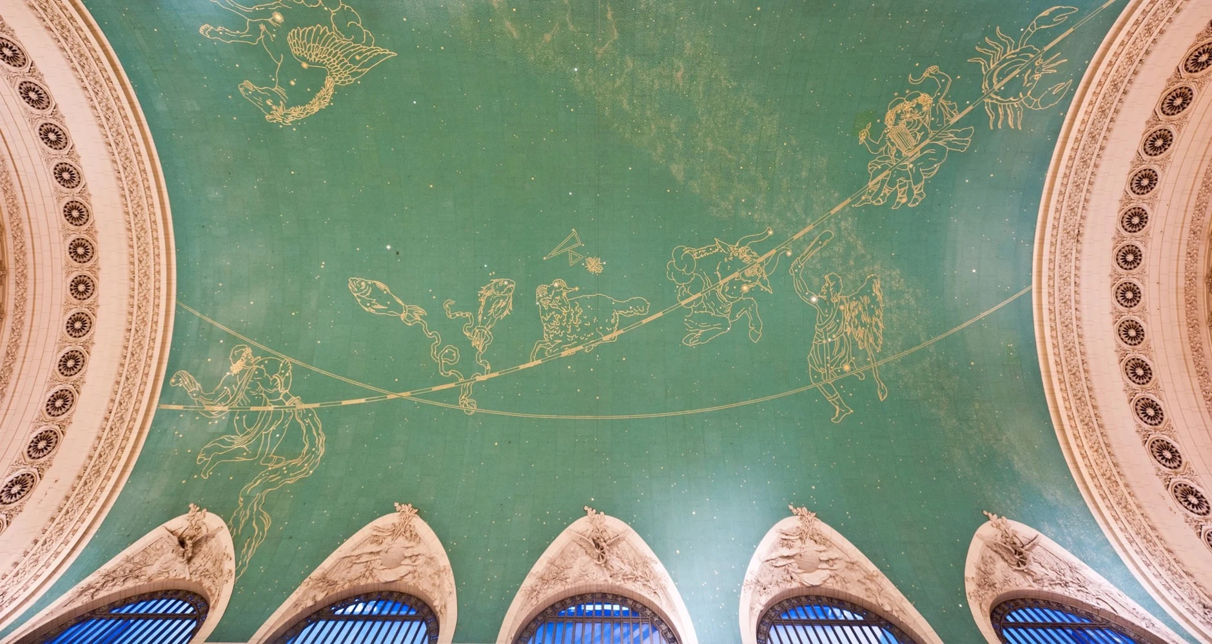
FIGURE 1: Postcard printed c1913 before the opening of Grand Central Terminal
FIGURE 2: Grand Central Ceiling today (courtesy of www.farmersalmanac.com)
FIGURE 3: Musca Borealis, Triangulum Major, Triangulum Minus above Aries
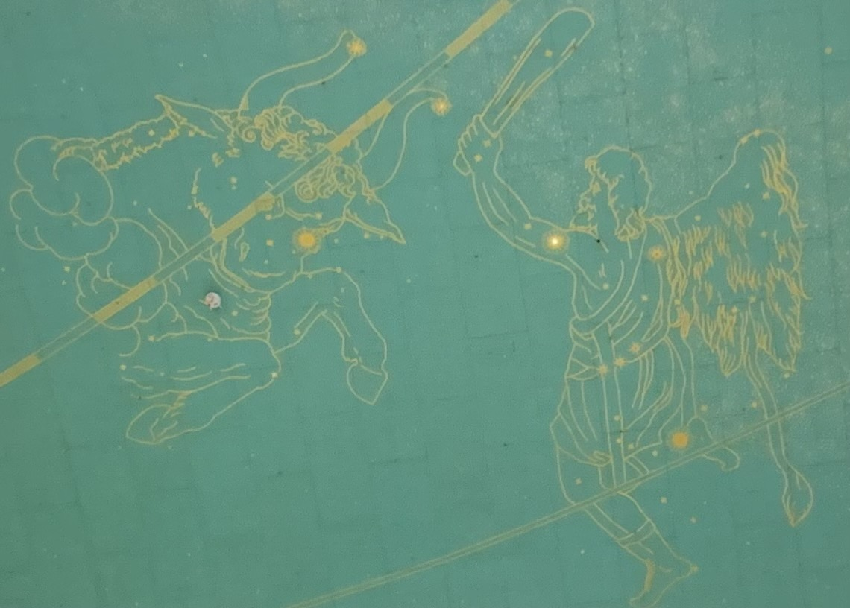
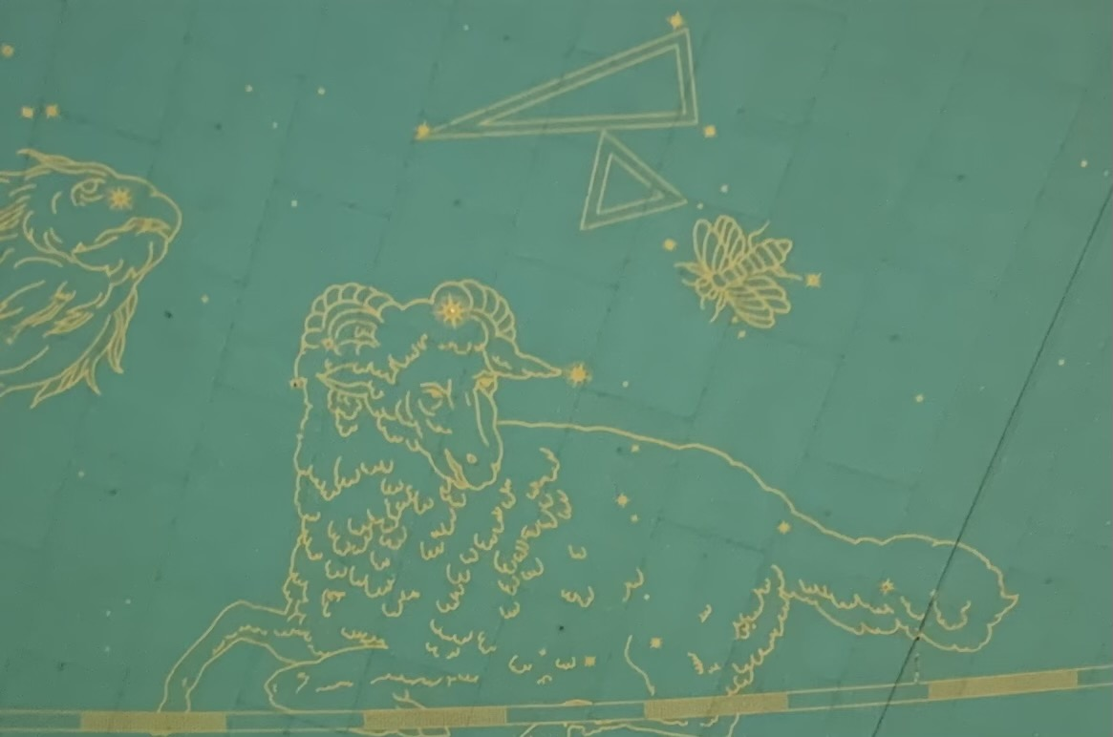
FIGURE 4: Orion the Hunter and Taurus (courtesy of bookwormhistory.com)
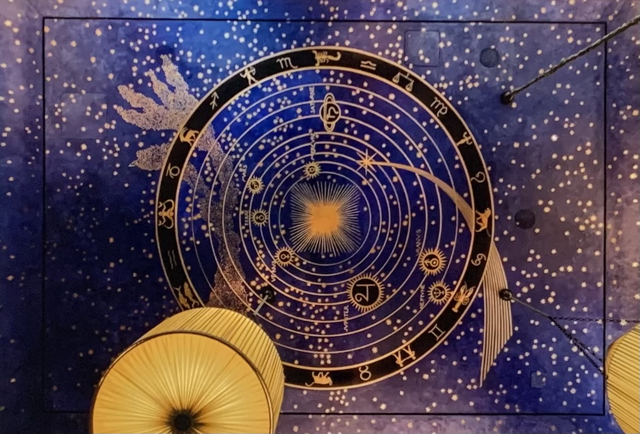
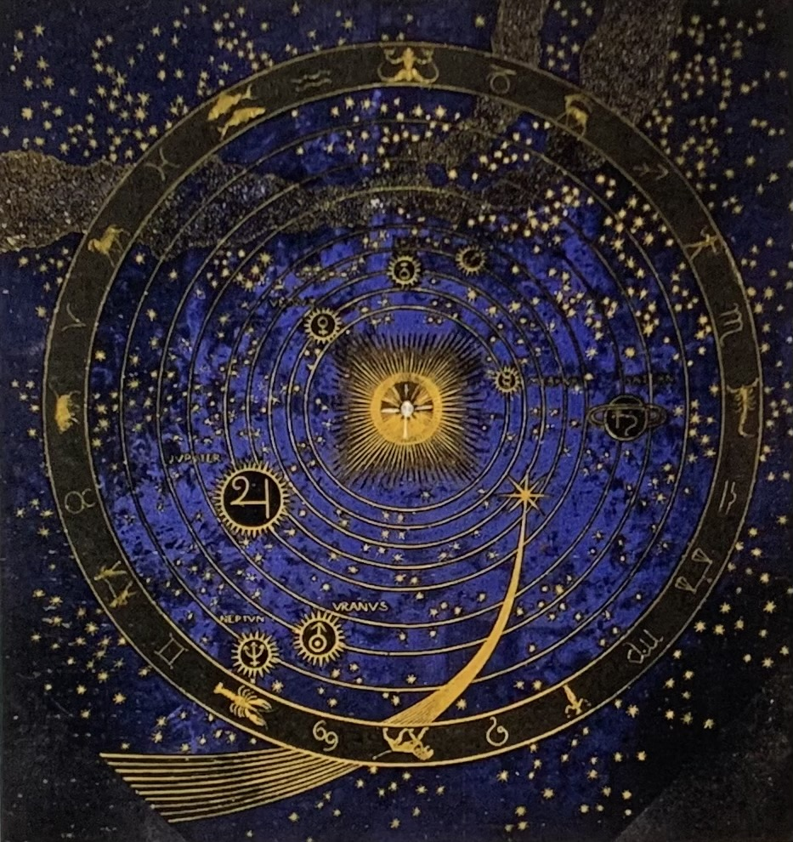
FIGURES 5 & 6: The Albertine Bookshop ceiling (above) (courtesy of www.albertine.com). Music Room of Villa Stuck (below) (courtesy of design-is-fine.org)

Starrett quoted in Koolhaas, Rem (2014) Delirious New York: A Retroactive Manifesto for Manhattan, New York, The Monicelli Press. p89
Hitchcock, Henry Russell (1971) Architecture: Nineteenth and Twentieth Centuries Harmondsworth, Penguin, p544
Raynsford, Anthony (1996) Swarm of the Metropolis: Passenger Circulation at Grand Central Terminal and the Ideology of the Crowd Aesthetic in Journal of Architectural Education, Vol. 50, No. 1 (Sep., 1996), London, Taylor & Francis. p2
Whitney Warren quoted in The Great Railway Terminal go the Future, The New York Times February 9th 1913. p81
Raynsford (1996). p2
Robins, A. W. (2013) Grand Central Terminal, 100 Years of a New York Landmark New York, New York Transport Museum, Abrams Press. p38
Robins (2013). p90
Middleton, William D. (1977) Grand Central, The World’s Greatest Railway Terminal San Marino CA, Gold West Books. p75
Quoted in Constellations Reversed, New York Times, March 23rd 1913, p10
Central Terminal Opening on Sunday, New York Times, January 29th 1913, p13
Constellations Reversed (1913), p10
Herlihy, Anna Friedman (2007) Renaissance Star Charts in Woodman, David (ed), The History of Cartography, Volume 3 Part 1, Cartography in the European Renaissance, Chicago, University of Chicago Press. p115
Constellations Reversed (1913). p10
Constellations Reversed (1913). p10
Mendillo, Michael (2022) Saints and Sinners in the Sky: Astronomy, Religion and Art in Western Culture Chichester, Springer-Praxis. p191
Touring Grand Central Terminal: Much More Than Trains, Forbes, January 6th 2023. Or, in this case, attributed to Cornelius Vanderbilt who had died in 1877. https://www.thetravel.com/what-to-experience-at-the-grand-central-terminal-in-nyc/
Plan New Heavens for Grand Central, New York Times, April 11th 1924, p16
Quoted in Robins (2013). p90
Inside the Sky Mural Restoration at Grand Central Terminal https://johncanningco.com/blog/sky-mural-restoration-at-grand-central-terminal/
The Great Railway Terminal go the Future, The New York Times February 9th 1913. p81
Fenske, Gail (2005). The Beaux-Arts Architect and the Skyscraper: Cass Gilbert, the Professional Engineer, and the Rationalization of Construction in Chicago and New York In Moudry, Roberta (ed.). The American Skyscraper: Cultural Histories, Cambridge, Cambridge University Press. p22
Hamlin, Talbot (1926) American Spirit in Architecture New Haven, Yale University Press. p212
Central Terminal Opening on Sunday, (1913) p13
Nash, Gerald D. (1980) The Census of 1890 and the Closing of the Frontier in The Pacific Northwest Quarterly. 71 (3). p98
Roosevelt quoted in Nash, Roderick (1975) Wilderness and the American Mind New Haven, Yale University Press. pp150-151
Erastothenes and Hyginus (trans Robin Hard) (2015) Constellation Myths with Aratus’s Phaenomena Oxford, Oxford University Press. p104
Whitman, Walt (1917) Leaves of Grass, New York, Garden City. p88
Thoreau, Henry David (1854) Walden, or Life in the Woods, Boston, Ticknor & Fields. p126-127
Schlichting, Kurt C. (2001) Grand Central Terminal: Railroads, Architecture and Engineering in New York Baltimore, Johns Hopkins University Press. p88
Barentine, John C. (2016) The Lost Constellations Chichester, Springer-Praxis. p251
Barentine (2016). p239
Barentine (2016). p252
A beehive also appears in The Glory of Commerce sculptural group above the main entrance along with Mercury, Vulcan and Minerva.
Aristotle quoted in Lehoux, Dayrn (2019) Why Does Aristotle Think Bees are Divine? Proportion, Triplicity and Order in the Natural World in The British Journal for the History of Science, Volume 52, Issue 3, September 2019, Cambridge, Cambridge University Press. p51
Curl, James Steven (2011) Freemasonry and the Enlightenment, Architecture, Symbols and Influences, London, Historical Publications. p309
Curl (2011). p321
Ian Ridpath quoted in Barentine (2016). p439
Burnham quoted in Raynsford (1996). p7
Emerson quoted in Cronkite, Ferris G. (1951) The Transcendental Railroad in The New England Quarterly, Sep 1951, Vol. 24, No. 3. Cambridge MA, New England Quarterly Press. p314
Nash, Roderick (1975) Wilderness and the American Mind New Haven, Yale University Press, p1
The Death of a Once Great City, Harpers, July 2018 https://harpers.org/archive/2018/07/the-death-of-new-york-city-gentrification/
www.villa-albertine.org
www.albertine.com
Sennett, Richard (1996) Flesh and Stone: The Body and the City in Western Civilization, New York, Norton, p349
A First Look at Dreamy French Bookshop Albertine, Time Out, September 26th 2014
Inside Albertine (2014)
So What’s the Big Idée? New York Times, October 9th 2014. Section 3, p23
https://www.pentagram.com/work/albertine-1/story
Baudrillard, Jean (1988) For a Critique of the Political Economy of the Sign in Jean Baudrillard: Selected Writings (ed Poster, Mark) Stanford, Stanford University Press. p31
Campion, Nicholas (2009) The History of Western Astrology, Vol II, The Medieval and Modern Worlds, London, Continuum. p108
Copernicus quoted in Heninger Jr, S. K. (1977) The Cosmographical Glass, Renaissance Diagrams of the Universe, San Marino CA, The Huntington Library Press. p47
Heninger Jr (1977) p48
Kingsley, Peter (1995) Ancient Philosophy, Mystery and Magic Oxford, Clarendon Press. p173
Notably Keplar, in Epitome Astronomiae Copernicanae believed that Philolaus and other Pythagoreans hid their knowledge of the Sun as being at the centre of the universe behind the notion of the central fire.
Campion, Nicholas (2017) The New Age in the Modern West, Counterculture, Utopia and Prophecy from the Late Eighteenth Century to the Present Day London, Bloomsbury. p42
Albertine Reparue: A French Bookshop in New York https://www.newyorker.com/books/page-turner/albertine-reparue-french-bookshop-new-york
So What’s the Big Idée? p23
Zukin, Sharon (2010) Naked City: The Death and Life of Authentic Urban Spaces, Oxford, Oxford University Press. px
Albertine Reparue: A French Bookshop in New York, The New Yorker, December 3rd 2014 https://www.newyorker.com/books/page-turner/albertine-reparue-french-bookshop-new-york
Zukin (2010). p4
Ferrando, Francesca (2013) Posthumanism, Transhumanism, Antihumanism, Metahumanism, and New Materialisms: Differences and Relations in Existenz 8/2 Fall 2013. p26
Tarnas, Richard (2006) Understanding Modern Disenchantment in Sky and Psyche (ed Campion, Nicholas & Curry, Patrick) Edinburgh, Floris Books. p193
Middleton (1977). p75
https://neildegrassetyson.com/photos/2002-10-city-of-stars/grand-central-terminal/
The French Bookshop Seducing New York, France 24, 20th October 2014
Inside Albertine, The Paris Review, September 26th 2014. www.parisreview.org
The Great Terminal of the Future (1913), p81

