Module: Leadership and management, theory and practice
Module code: LCBB6003

Student name:
Student ID:
Table of Contents
Introduction 3
Jeff Bezos - the World's Richest Man 3
Jeff Bezos - The Charismatic Leader 4
Bezos Leadership Style 5
Leadership Principles 7
Customer obsession and company ownership 7
The invention as well as simplification 8
Curiosity 9
Hiring and developing the best 9
Always insist on the high standard 10
Think big 11
Conclusion 11
References 13

Introduction
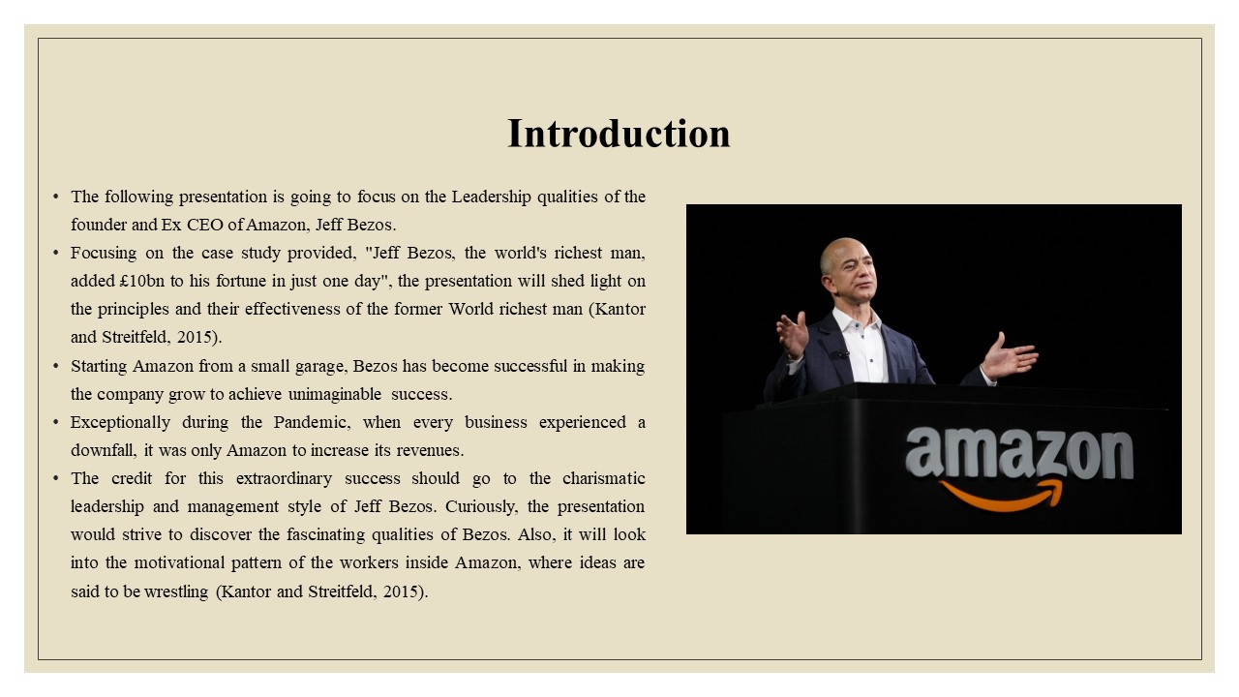
The presentation will look into the leadership qualities of the founder and Ex CEO of Amazon, Jeff Bezos. It will strive to discover how he managed to grow the company so strong that even the Pandemic could not affect it.

Jeff Bezos - the World's Richest Man
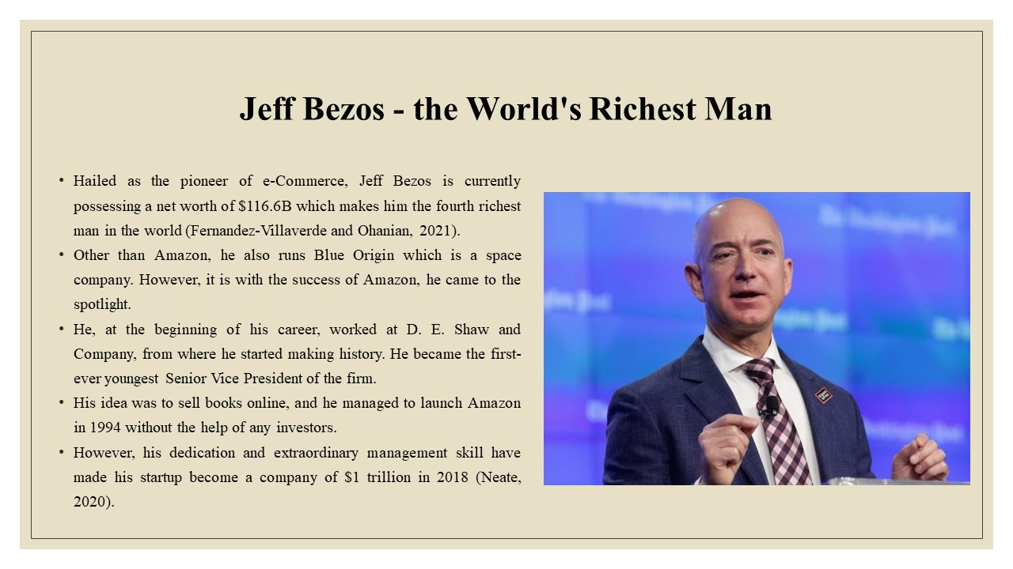
With the success of Amazon, the founder, Jeff Bezos came to be hailed as the pioneer of e-Commerce. He began his start-up when there was hardly any popularity of the internet and almost nobody possessed the idea of online selling (Fernandez-Villaverde and Ohanian, 2021). From that place, he could make the company stand firm and progress to become world-famous.

Jeff Bezos - The Charismatic Leader
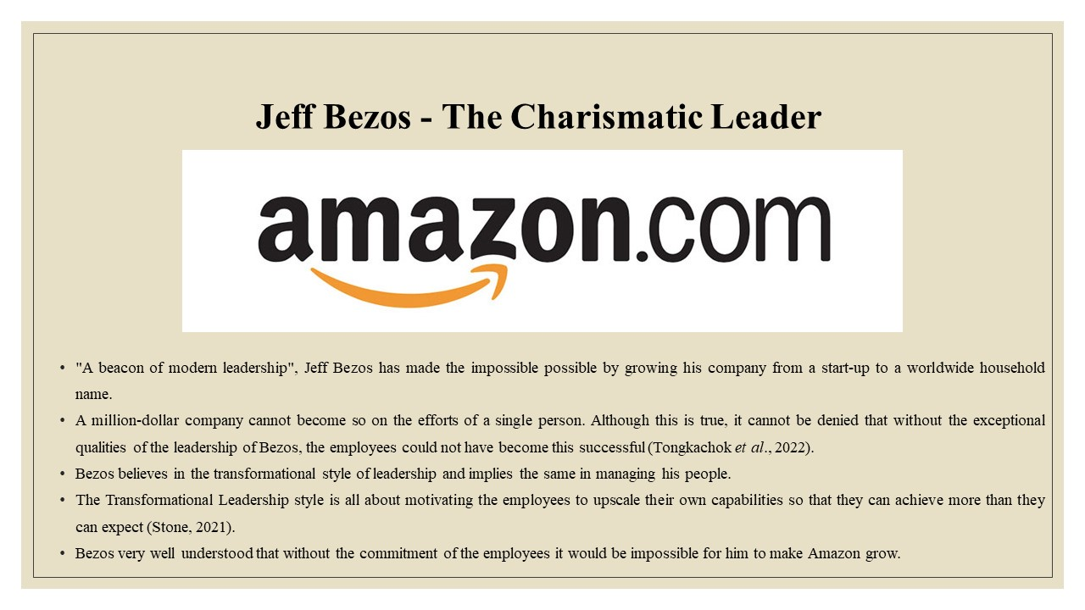
Amazon stands strong and continues to grow depending on the fundamental leadership principles of Jeff Bezos. He is often said to be a beacon of modern leadership for his insightful thinking capabilities that he put forth while incorporating the Transformational Leadership Style (Fernandez-Villaverde and Ohanian, 2021).
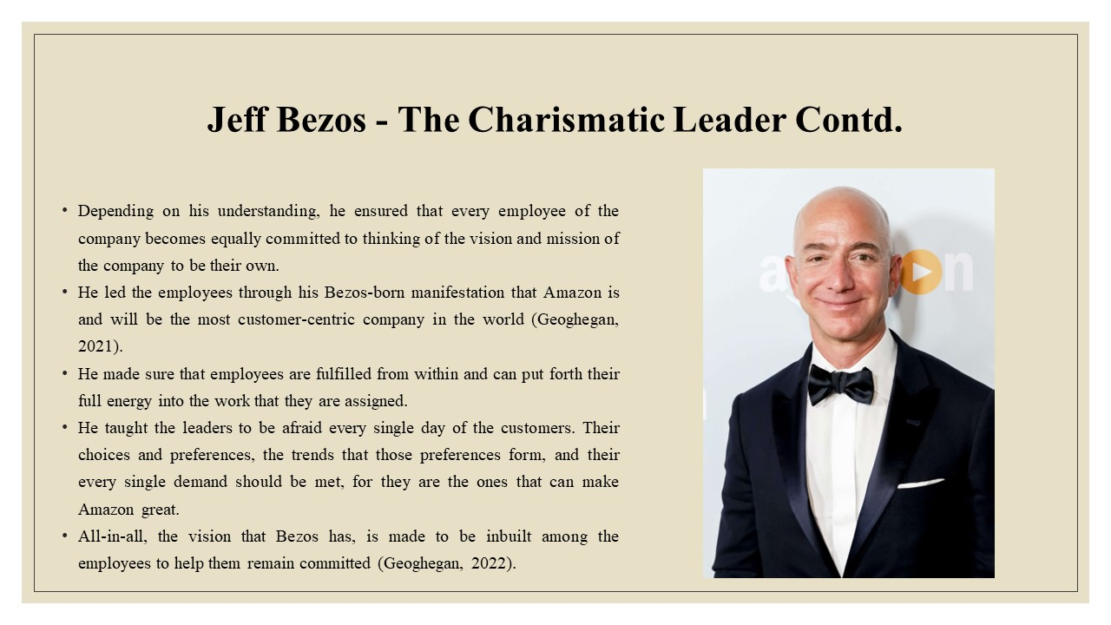
The employees are directed to be terrified of the customers and to ensure that their needs and demands are met on every single purchase they make. Bezos-born motivation is something that the employees are motivated by (Geoghegan, 2022). In addition, he ensures that employees are provided with more than their basic needs.

Bezos Leadership Style
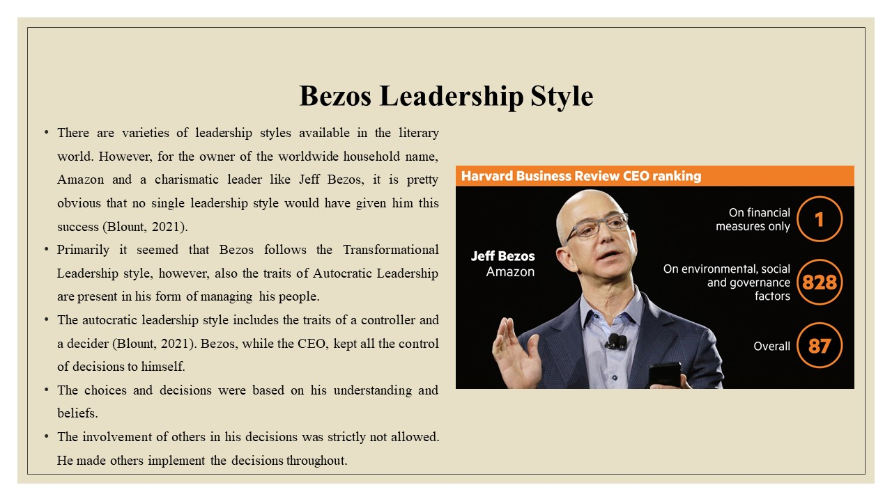
For a leader of a worldwide company, Jeff Bezos, following a particular leadership style was not possible. He had his intuitions working in every situation to fulfil the need of the moment. Within his leadership traits, both the style of Autocratic and Transformational leadership are found (Blount, 2021).
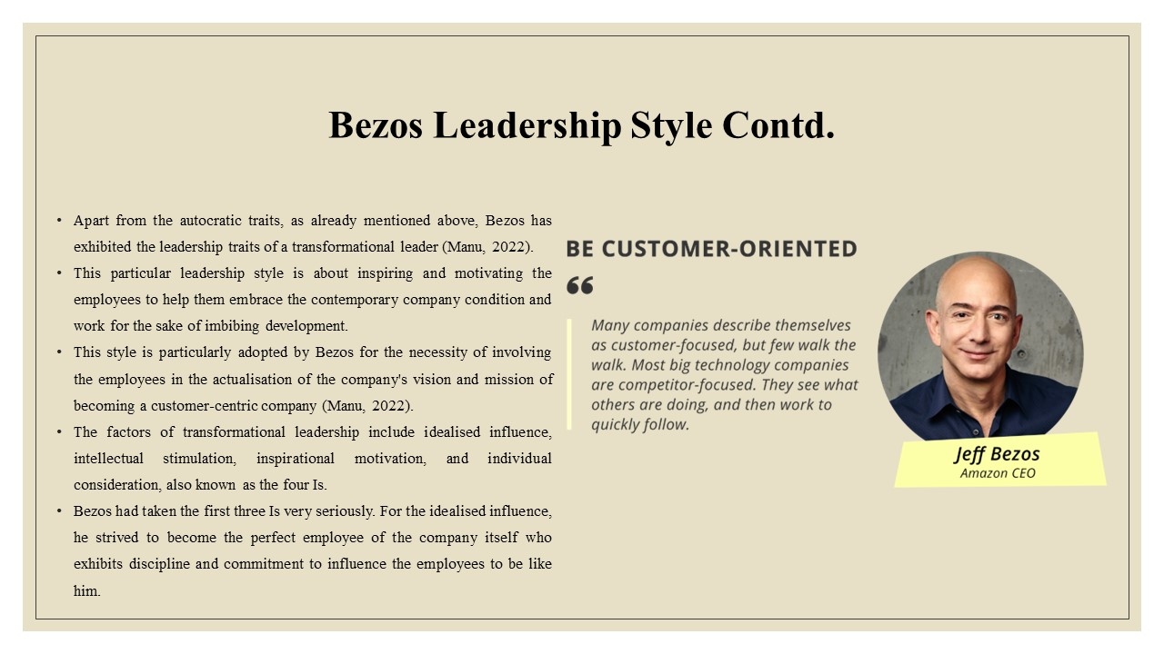
Transformational leadership traits are utilised by this charismatic leader in establishing a healthy relationship with the employees (Manu, 2022). Among the four traits of the style, three are followed religiously for helping the employees become their better versions.
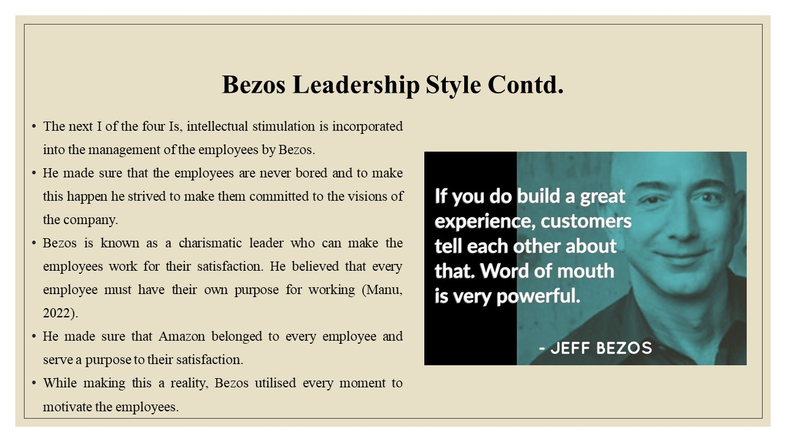
Bezos strived to represent the image of a disciplined and committed employee to help others maintain a similar image (Manu, 2022). Moreover, he strived to make the employees align their vision with that of the company.

Leadership Principles
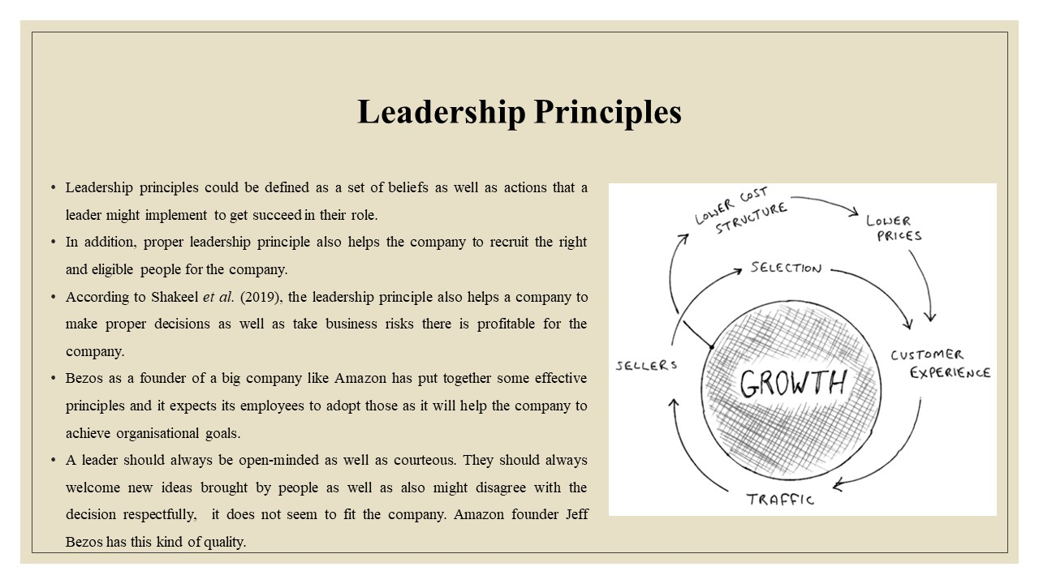
Jeff Bezos has do not welcome overwhelming ideas that do not fit the company so that it could maintain a good relationship with others. He always welcomes ideas that could help Amazon to grow.

Customer obsession and company ownership
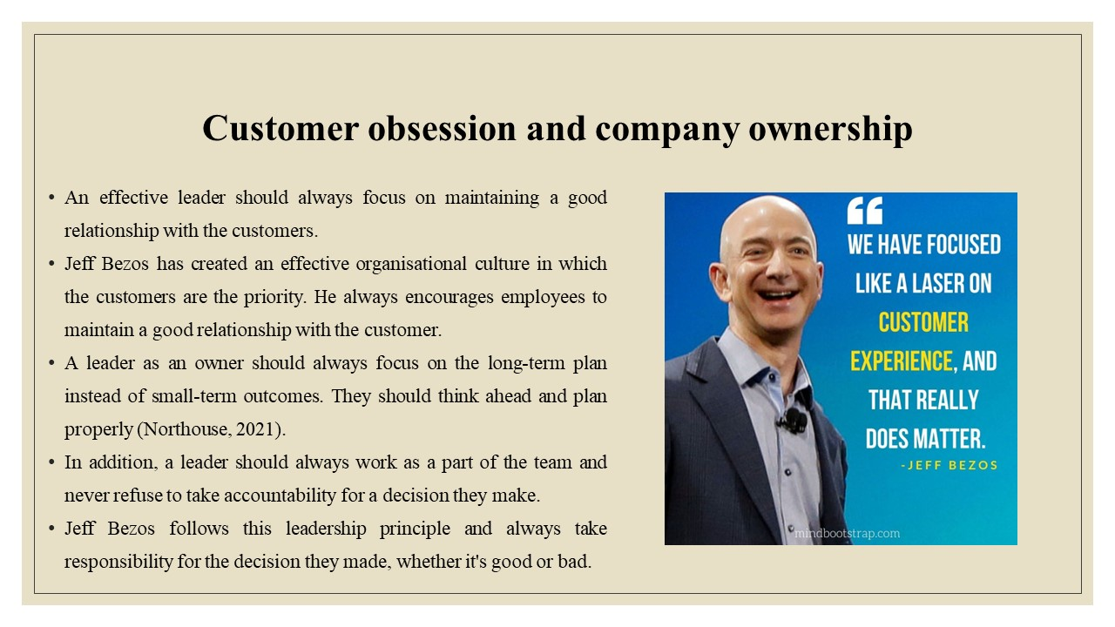
In addition, a leader should always work on different levels of jobs whether entry-level or executive-level. According to Amazon’s leadership, no work is small to carry out. It believes that progress is meant to be made in every sector thus it encourages people to have experience in every sector (Gradinaru et al., 2020).

The invention as well as simplification
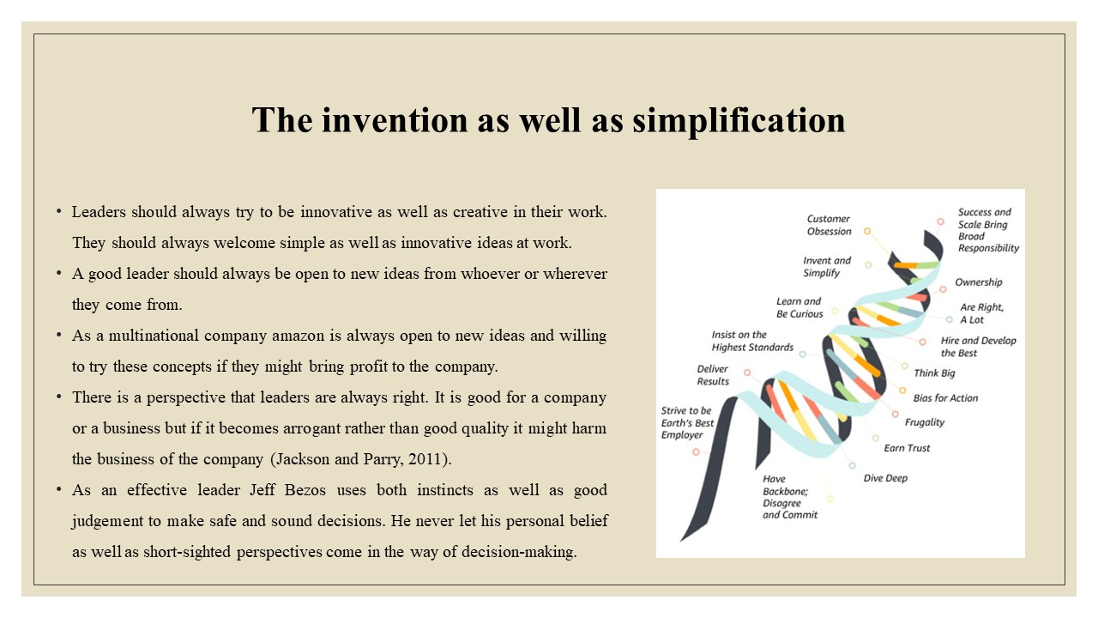
Jeff Bezos always tries to make a business decision after reviewing and researching the environment properly. In addition, he is always willing to take risks at work, if the risk is worth profit (Burfeind, 2019).

Curiosity
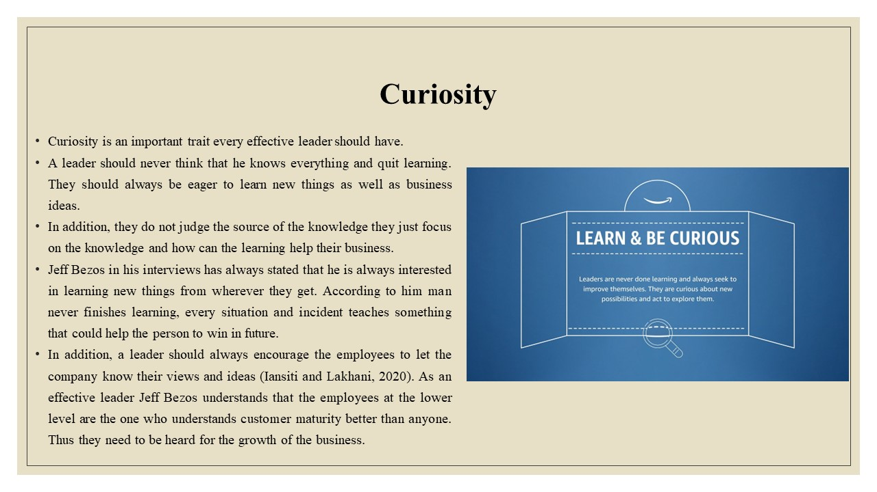
Amazon leadership believes that a leader should always hear what people have to say peacefully while talking to them respectfully. As the employees are an important pillar of a company, a company like Amazon needs to create bonds of trust with the employees as it will help the company to achieve the organisation's goals.

Hiring and developing the best
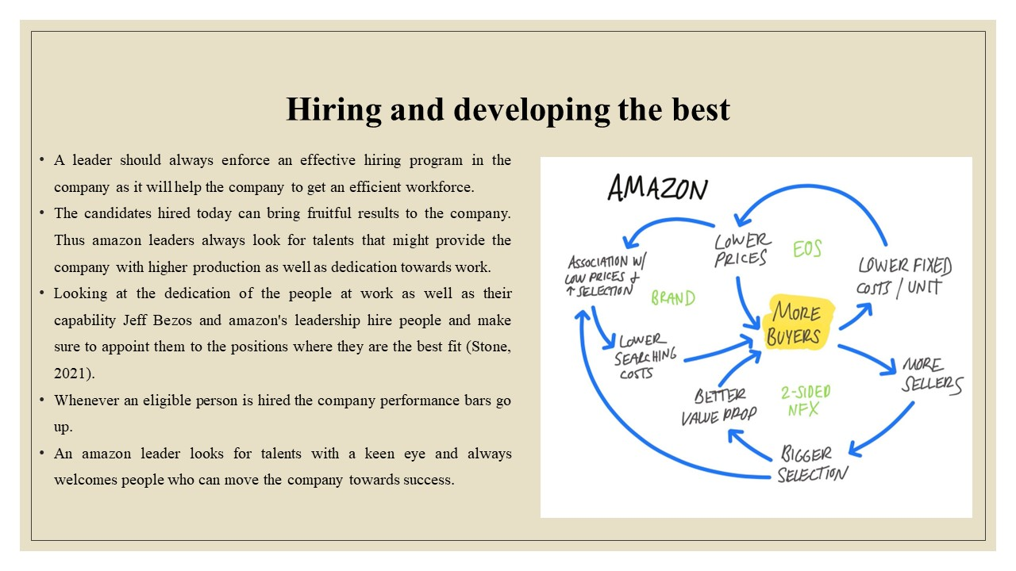
Amazon leaders like Jeff Bezos are also willing to train their employees as well as fresher’s well so that they can add value to the company. They coach them properly so that they not only develop themselves but can develop the company too.

Always insist on the high standard
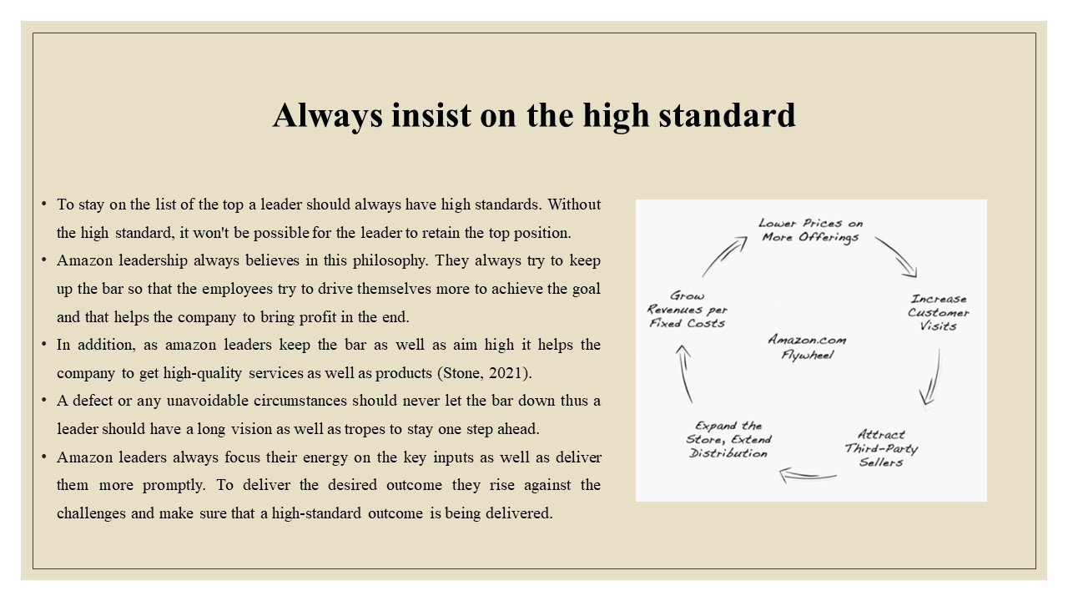
In addition, Amazon’s leadership has been able to earn their employee trust as well as establish the company as a strong brand successfully.

Think big
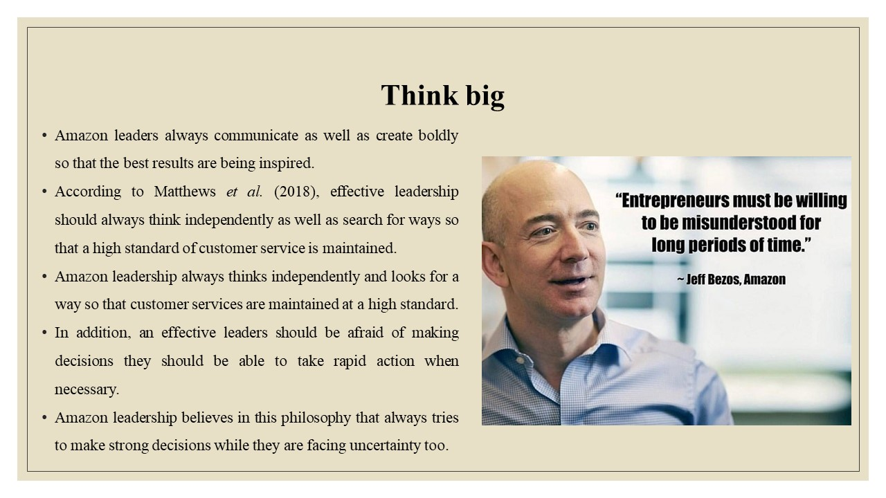
In addition, Amazon’s leadership always functions at all levels of the company. stay stays associated with the details as well as asks for audits frequently so that they can have an idea about what is going on in the company.

Conclusion
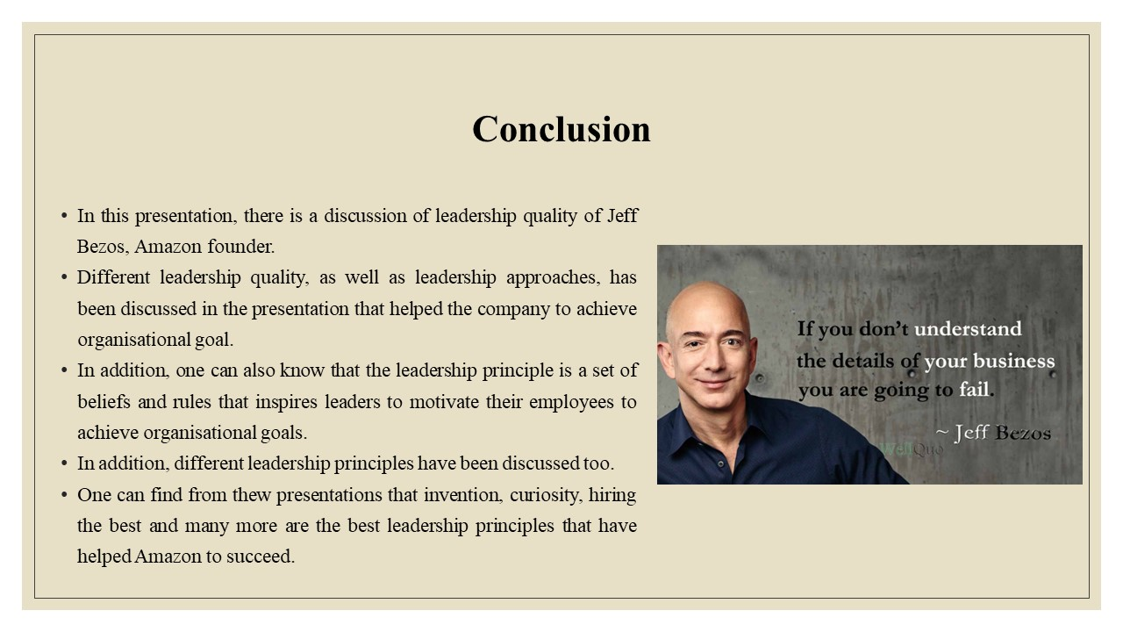
In addition, from the presentation, one can also learn that leadership qualities can help the companies like Amazon to grow. In addition, it has also been found that Jeff Bezos's effective leadership has helped Amazon to survive Covid-19 and earn profit even during that time.

References
Blount, M.A., 2021. Crisis Leadership: An Examination of Effective Leadership Styles and Mindset (Doctoral dissertation, Johnson & Wales University).
Burfeind, J., 2019. Leading Cultural Change in the Newspaper Industry: How Jeff Bezos saved The Washington Post. Manager, (29), pp.125-138.
Fernandez-Villaverde, J. and Ohanian, L.O., 2021. Billion-Dollar Strawman: Protesters have been accusing Amazon mogul Jeff Bezos of being, well, rich. But he's made the rest of us richer too. Hoover Digest, (1), pp.29-33.
Geoghegan, P., 2021. Lust for life immortal: The worlds of Peter Thiel and Jeff Bezos. TLS. Times Literary Supplement, (6190), pp.5-6.McGraw, S.C., 2022. The Relationship between Leadership Style as a Moderator of Organizational Culture and Innovation Performance (Doctoral dissertation, Capella University).
Gradinaru, C., Toma, S.G., Catana, S. and Andrisán, G., 2020. A view on transformational leadership: The case of Jeff Bezos. Manager, (31), pp.93-100.
Iansiti, M. and Lakhani, K.R., 2020. Competing in the age of AI: strategy and leadership when algorithms and networks run the world. Harvard Business Press.
Jackson, B. and Parry, K., 2011. A very short fairly interesting and reasonably cheap book about studying leadership. Sage.
Kantor, J., and Streitfeld, D., 2015. Inside Amazon: Wrestling Big Ideas in a Bruising Workplace. nytimes.com. [online] Available at: <https://www.nytimes.com/2015/08/16/technology/inside-amazon-wrestling-big-ideas-in-a-bruising-workplace.html?action=click&amp%3Bpgtype=Homepage&amp%3Bregion=CColumn&amp%3Bmodule=MostViewed&amp%3Bversion=Full&amp%3Bsrc=mv&amp%3BWT.nav=MostViewed> [Accessed 23 November 2022]
Manu, A., 2022. Transformational leadership. In The Philosophy of Disruption (pp. 67-77). Emerald Publishing Limited.
Matthews, B.L., Harbin, J. and Daigle, J., 2018. The New York Times Versus Amazon: Is Jeff Bezos' head still in the clouds?.Journal of Organizational Psychology, 18(3).
Neate, R., 2020. Jeff Bezos, the world's richest man, added £10bn to his fortune in just one day. The Guardian. [online] Available at: <https://www.theguardian.com/technology/2020/jul/21/jeff-bezos-the-worlds-richest-man-added-10bn-to-his-fortune-in-just-one-day> [Accessed 23 November 2022]
Northouse, P.G., 2021. Leadership: Theory and practice. Sage publications.
Shakeel, F., Kruyen, P.M. and Van Thiel, S., 2019. Ethical leadership as process: A conceptual proposition. Public Integrity, 21(6), pp.613-624.
Stone, B., 2021. Amazon unbound: Jeff Bezos and the invention of a global empire. Simon and Schuster.
Tongkachok, K., Garg, S., Balakrishnan, S. and Vijayalakshmi, N.S., 2022. Impact of Transformational Leadership on Organizational Performance Through Employee Motivation. ECS Transactions, 107(1), p.12873.

