

Iqra Haseen
2407622
BMHP5015
Changemakers: Building your personal brand for sustainable employment
Component 2

Contents page:

Introduction: page 3
Job advertisement: pages 3/5
Job role employability skills: pages 5/6
Evaluation of my own skills: pages 6/7
Action plan: pages 7/8
Building my own personal brand: pages 8/9
Promoting my professional identity: page 9
Building a professional network for successful employment: pages 9/10
Conclusion: page 10
References: pages 11/12

Introduction:
A healthcare assistant (HCA) supports nurses and other healthcare workers, “You'll work under the guidance of a healthcare professional,” (Healthcare assistant, no date), in providing effective, secure and person-Centered care. Healthcare assistants work in hospitals, the community, residential care homes and GP surgeries. “HCAs work in a wide variety of settings, including hospitals, GP practices, mental health units or in the community.” (Healthcare support worker or healthcare assistant, no date). Assisting patients with personal care, health monitoring and wellbeing. I have chosen this career because I enjoy helping others and I want to make a positive impact on people’s lives. At this current moment, I do not have any healthcare experiences, but my studies in Health and Social Care, GCSE’s and BTEC qualifications have given me a good base to work from within this profession. In this report I will discuss the employability skills needed to fulfil the Healthcare assistant job role, evaluate my own skills and produce a personal development plan to help me achieve my career goal.

Job advertisement:
I have chosen to report on the NHS Healthcare assistant vacancy, advertised on the NHS Jobs website (Healthcare Assistant jobs - NHS Jobs, no date)
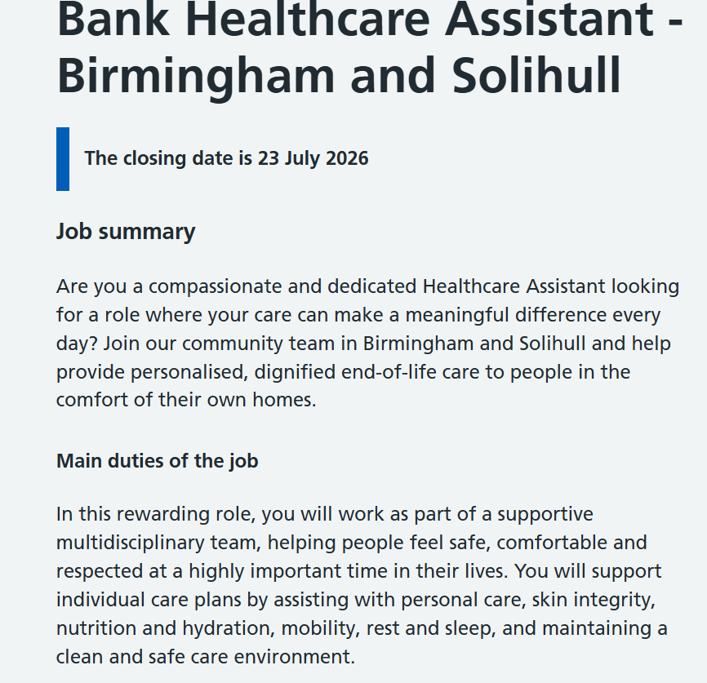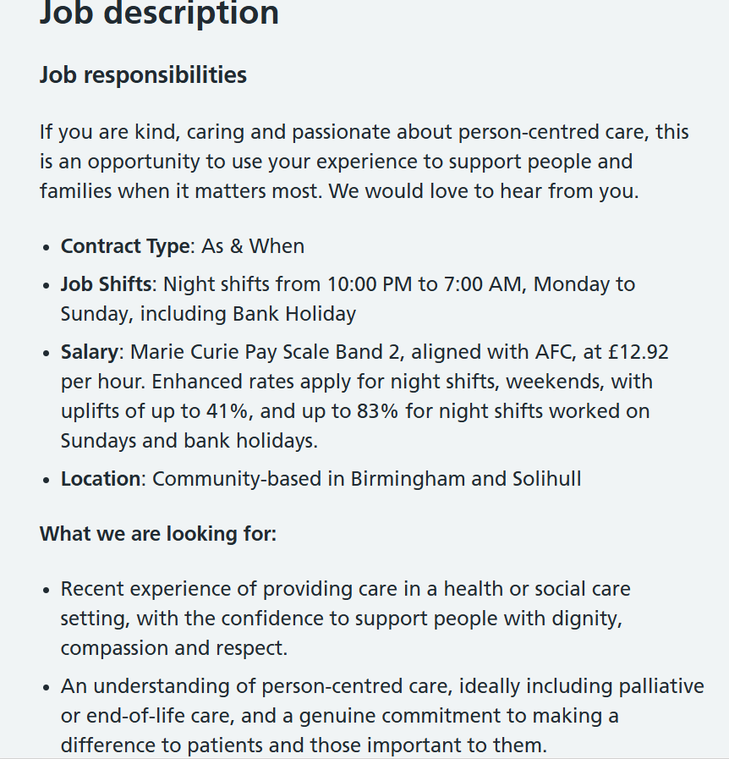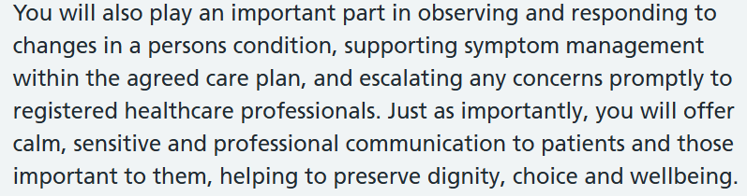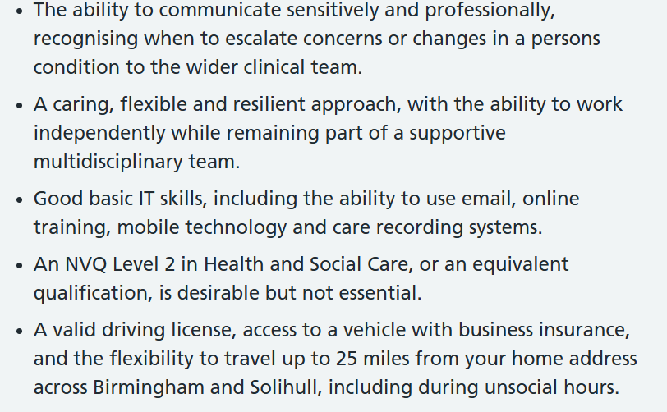
The vacancy describes the Healthcare Assistant as a crucial member of the multidisciplinary healthcare team, working under the supervision of registered nurses and other healthcare professionals. The right applicant will be responsible for providing high quality, person-Centered care and will respect patient dignity, privacy and independence. “You will work as part of a supportive multidisciplinary team, helping people feel safe, comfortable and respected at a highly important time in their lives.” (Job advert, no date). Your day-to-day duties will include helping patients with washing, dressing, eating and moving around, doing routine checks, helping to maintain infection prevention and control procedures, maintain accurate patients records and communication effectively with patients, relative and staff. “Support individual care plans by assisting with personal care, skin integrity, nutrition and hydration, mobility, rest and sleep, and maintaining a clean and safe care environment.” (Job advert, no date).
The job additionally emphasises the need for compassionate care and commitment to NHS values. Healthcare Assistants are expected to provide physical support to patients, “you will offer calm, sensitive and professional communication to patients and those important to them, helping to preserve dignity, choice and wellbeing,” (Job advert, no date), but also emotional support, ensuring patients feel respected, listened to and involved in decisions about their care. “Monday to Sunday, including Bank Holiday” (Job advert, no date). The role is flexible as staff may work shifts including evenings, weekends and bank holidays.
The person specification sets out several key qualities. Applicants should have excellent communication skills, compassion, empathy, teamwork and organisational skills. “Confidence to support people with dignity, compassion and respect.” (Job advert, no date). They should be able to work under pressure, manage their time effectively and be able to maintain confidentiality in line with NHS policies and professional standards. Basic literacy, numeracy and digital skills “Good basic IT skills, including the ability to use email, online training, mobile technology,” are all essential as healthcare assistants use electronic patients record systems and complete clinical documentation correctly.
The advertisement indicates applicants with the correct views, attitudes and willingness to learn are encouraged to apply, even though past healthcare experience is preferred. This important to me because, even though I do not have direct healthcare experience, my health and social care education has given me applicable abilities. My knowledge of person-Centered care, protection, diversity and equality, communication, and professional ethics has grown because of my education. I’m dedicated to lifelong learning, and I think that training, volunteering and clinical practice under supervision will help me gain the necessary practical skills.
All things considered, the position shows the NHS’s dedication to offering effective, secure and compassionate care. For those who are compassionate, motivated and keen to pursue a long-term career in the health sector, this position is an ideal opportunity.

Job role employability skills:
To deliver safe, efficient and compassionate care, healthcare assistants need a variety of employable skills. These abilities are necessary for attending patients’ needs and assisting the larger medical professionals.
Communication is one of the most essential skills. Everyday, healthcare assistants interact with nurses, patients, families and other medical professionals. “Carer should try to use both verbal and non-verbal communication skills.” (UK Quality Care Solutions Ltd., no date). Effective verbal and nonverbal communication ensures that patients are aware of their care, builds trust and lowers anxiety; because it helps healthcare assistants recognise patients’ worries and appropriately report any changes in their condition, “When care assistants practice active listening, they build trust” (Davidson, 2025), active listening is equally essential.
Another important employability skill is teamwork. Healthcare assistants can work together with physicians, occupational therapists, nurses, and physiotherapists in a multidisciplinary team. “By working in teams, we can deliver much more” (England, no date). Good collaboration guarantees efficient treatment performance and enhances patient safety. A positive work environment is facilitated by respecting co-workers, sharing information and helping other.
Additionally, healthcare assistants need to show empathy and compassion. “Empathetic professional comprehends the needs of the health care users, as the latter feel safe to express the thoughts and problems that concern them.” (Moudatsou et al., 2020). Giving patients emotional support helps safeguard their dignity and well-being because many of them suffer from pain, fear or anxiety. Healthcare assistance frequently cares for multiple patients during a shift, which calls for strong time management and organisational skills. Setting priorities properly guarantees that care is provided promptly and safely.
Lastly, professionalism is important. “Breaking confidentiality can affect the care” (Introduction to confidentiality, 2024). Healthcare assistants are required to uphold confidentiality, follow to infection control protocols, respect diversity and equality and fulfil their professional obligations. To appropriately update electronic patient records, they also require basic digital abilities; because healthcare procedures and technology are always changing, it is crucial to pursue ongoing education and professional development. All things considered, these employability skills allow healthcare assistants to effectively work within the NHS while providing high-quality, person-centred care.
Evaluation of my own skills:
Before looking for a profession as a healthcare assistant, I can establish my areas of improvement and strength by evaluating my present skills. Even though I do not have direct healthcare experience, my education and life experiences have given me a range of transferable abilities that will help me in my future profession.
Working well in a team is one of my best qualities. During my BTEC and university courses, working in groups has improved my cooperation, consistency, and problem-solving abilities. I am aware that healthcare assistants collaborate closely with nurses and other professionals, and I am sure I can make a valuable contribution to a multidisciplinary team. I also think of myself as patient, empathetic, and caring. I want to help people, and I am aware that patients could need both physical and mental support. These qualities, in my opinion, are consistent with the NHS’s goal to provide high quality treatment, empathy and respect.
I am aware of my weaknesses; my lack of practical healthcare experience is my disadvantage. I need to gain confidence in providing individualised care and assisting patients in actual clinical setting because I haven’t yet worked in a hospital, assisted living residence or community healthcare setting. I intend to volunteer in a care setting and fulfil relevant training. Additionally, I wish to increase my understanding of medical terms and clinical methods. Even though my course has covered a lot of healthcare topics, I will be able to apply this information more successfully if I attend further training and gain practical experience.
Ive been able to understand my current skills and pinpoint areas that require improvement due to this self-evaluation. My goal is to become a skilled and caring healthcare assistant who can deliver safe, person-Centered car through professional training, volunteer work, and ongoing education.
Action plan:
It takes thoughtful planning to develop the knowledge, abilities and experiences needed to work as a healthcare assistant. I have made a 5-year action plan to help me reach my professional goal because I have no previous experience in the healthcare industry. Gaining real-world experience, strengthening my employability skills and growing professionally are my main goals of this plan.
Time | Goal | Actions | Expected outcome
Year 1 | Boost knowledge about healthcare and communication | Finish my Level 5/6 Health and Social Care modules, participate in training sessions, and finish free online courses offered by the NHS. (NHS E-Learning Courses | Online learning for NHS staff, no date). | Increase confidence, communication, and understanding of medical practices.
Year 2 | Develop practical experience | Apply for volunteer positions in community healthcare organisations, assisted living services, or hospitals. Try to, shadow experienced medical professionals. | Gain useful experience working with patients and learn practical care skills.
Year 3 | Develop professional abilities | Successfully complete the Care Certificate, “The Care Certificate is an identified set of standards that health and care professionals adhere to in their daily working life.” (Care Certificate | NHS England | Workforce, training and education, 2025), go to first aid, infection control, and safeguarding training, and develop digital abilities for digital patient records. | Fulfil basic NHS standards and improve professional skills.
Year 4 | Develop professional knowledge | Apply for jobs as a healthcare assistant with the NHS or private healthcare providers. Keep taking courses for Continuing Professional Development (CPD) “the structured process of tracking and documenting the skills, knowledge, and experience gained throughout a professional career” (Rosewarne, 2026), and ask supervisors for standard feedback. | Get a job, expand medical knowledge, and gain self-assurance in providing person-centred care.
Year 5 | Job advancement | Gain leadership experience, mentor new employees when necessary, and look at opportunities to move into positions as senior healthcare assistants or continue nursing education. | Maintain progress and professional growth in the healthcare sector.

This action plan reflects my dedication to continuous learning and personal development. It also shows the NHS’s commitment to using ongoing education to raise the standard of treatment. By keeping to this strategy, I will gain professional skills, self-assurance and practical experience required to deliver safe, considerate, and efficient patient care. I will be able to track my development and pinpoint areas for improvement with regular self-reflection and feedback from teamwork and managers.
Personal Brand:
The professional image and reputation that a person displays to employers, co-workers and the public is known as their personal brand. Building a strong personal brand is essential since it shows dedication to a chosen job, professionalism and dependability. I will be professional in all educational and work settings, to develop my own brand. I will show the professionalism, dignity, empathy and accountability that are expected of healthcare assistants. Additionally, I will draft a professional CV that highlights my professional background, accomplishments, volunteer work and transferable skills.
I also intend to make and keep up a professional LinkedIn page that highlights my academic accomplishments and professional aspirations. Ill frequently add updated qualifications, certificates and useful experience to my profile. My personal brand will be strengthened by completing further training courses in areas like first aid, infection prevention and safeguarding. I think ill be more convincing to potential NHS employers if I present myself professionally, show that im ready to learn and have a passion for patient care.
Promoting my professional identity:
The term ‘professional identity’ describes how people see themselves in the chosen profession and how others see them. I acknowledge the significance of creating a professional identity based on the NHS values of compassion, respect, dignity and teamwork as a possible healthcare assistant. By upholding high standards of behaviour throughout my courses, assignments, and future work, I will strengthen my professional identity. I guarantee to uphold patients’ privacy, follow professional standards and take responsibility for my actions. Throughout my career, continuous professional development (CPD) will also assist me in expanding my knowledge and skills. “It supports career progression by providing evidence of continuous learning” (Rosewarne, 2026).
To improve my performance and find learning opportunities, I will ask lecturers, supervisors and co-workers for feedback. I will be able to assess my experiences and keep improving my work through reflective practice, such as applying Gibbs’ reflective cycle. “Gibbs’ Reflective Cycle is a framework for reflection, commonly used in learning and professional development.” (Simply Psychology, 2025). I will establish a solid professional identity that matches the standards of healthcare assistants employed by the NHS by showing professionalism, honesty and a dedication to continuous learning.
Building a professional network for successful employment:
Professional networking is an essential aspect of career development, because it offers chances to learn from experienced professionals, job opportunities and get assistance throughout a career. I will attend healthcare workshops, and NHS recruitment events to expand my professional network. These gatherings offer chances to network with medical experts and discover the latest advancement in the NHS.
I additionally want to use LinkedIn to develop connections with nurses, healthcare groups and healthcare assistants. I can stay up to date on employment openings, training opportunities and developments in healthcare by keeping up with the NHS organisation and professional organisations. Furthermore, volunteering can help me to establish connections with medical professionals who may offer valuable advice, job references and training. Building strong professional relationships based on mutual respect, trust and clear communication will improve my employability and help me progress my career over time. Along with contributing to increasing my job opportunities, networking will promote continuous learning and professional development throughout my career in healthcare.
Conclusion:
In conclusion, this report has looked at the abilities and characteristics needed to work as a healthcare assistant in the NHS. It has demonstrated that delivering excellent person-centred care requires professionalism, teamwork, compassion and communication. Even though I do not currently have any healthcare experience, my GCSEs and BTEC qualifications and courses in health and social care have allowed me to develop transferable skills that are relevant to this position. My action plan describes how I plan to get my practical experience, finish more training, and progress my career. I will be well prepared for a successful career as a healthcare assistant within the NHS by developing my personal brand, growing my professional network and making a commitment to continuous education.
References:

Care Certificate | NHS England | Workforce, training and education (2025). Available at: https://www.hee.nhs.uk/our-work/care-certificate.

Davidson, O. (2025) The power of active listening in care. Available at: https://www.caremark.co.uk/news/the-power-of-active-listening-in-care/.

England, N. (no date a) NHS England » We are a team. Available at: https://www.england.nhs.uk/looking-after-our-people/the-programme-and-resources/we-are-a-team/.

Healthcare assistant (no date). Available at: https://www.healthcareers.nhs.uk/explore-roles/healthcare-support-worker/roles-healthcare-support-worker/healthcare-assistant.

Healthcare support worker or healthcare assistant (no date). Available at: https://www.nhsprofessionals.nhs.uk/nhs-staffing-pool-hub/careers-in-healthcare/healthcare-support-worker-or-healthcare-assistant.

Healthcare Assistant jobs - NHS Jobs (no date). Available at: https://www.jobs.nhs.uk/candidate/search/results?searchFormType=main&keyword=Healthcare%20Assistant&language=en.

Introduction to confidentiality (2024). Available at: https://www.hcpc-uk.org/standards/meeting-our-standards/confidentiality/guidance-on-confidentiality/introduction-to-confidentiality/.

Job advert (no date). Available at: https://www.jobs.nhs.uk/candidate/jobadvert/B0516-26-0154?country=GB-ENG&searchFormType=main&keyword=Healthcare%20Assistant&location=Birmingham&language=en.

NHS E-Learning Courses | Online learning for NHS staff (no date). Available at: https://www.nhselect.nhs.uk/Online-learning/Online-courses.

Moudatsou, M. et al. (2020) 'The role of empathy in health and social care professionals,' Healthcare, 8(1), p. 26. Available at: https://doi.org/10.3390/healthcare8010026.

Rosewarne, A. (2026) What Is CPD? CPD Meaning, Full Form & 2026 Guide. Available at: https://www.cpdstandards.com/what-is-cpd/.

Simply Psychology (2025) Gibbs Reflective Cycle. Available at: https://www.simplypsychology.org/gibbs-reflective-cycle.html.

UK Quality Care Solutions Ltd. (no date) Communication work manual, UKQCS Training, pp. 1–15. Available at: https://www.skillsforcare.org.uk/resources/documents/Recruitment-support/Support-for-Individual-employers/IE/Recruitment-models/My-Life/Session-four/Induction-Workbook-Communication.pdf.

