Working with Artificial Intelligence
For most people, artificial intelligence brings to mind replacing jobs with robots. However, 1,500 companies studied by the management consulting firm Accenture found that the largest performance gains were when humans and machines worked together.
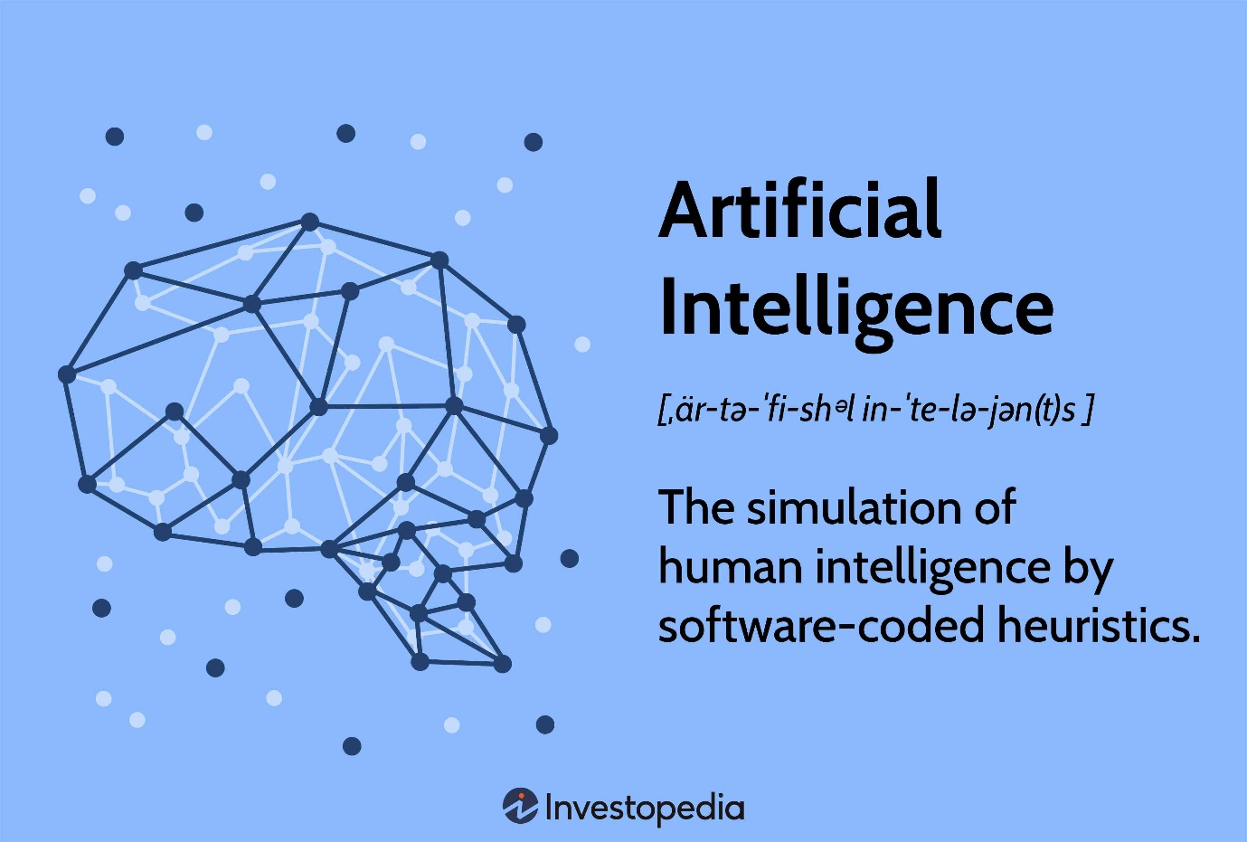
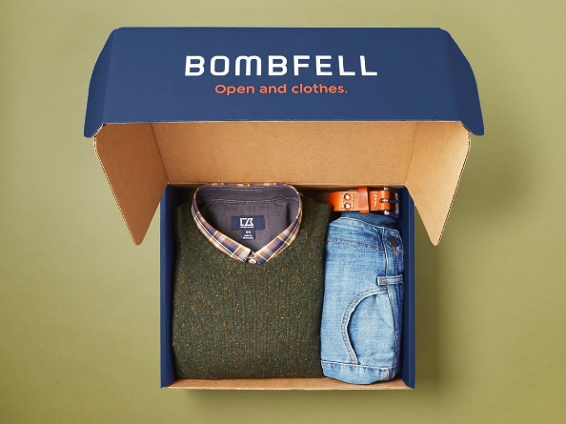
What does humans and machines working together look like? At clothing retailer H&M, human buyers and planners use artificial intelligence (AI) to guide their work. They rely on data to figure out what styles will be purchased, by which types of customers, and what their customers might need in future seasons. Buyers and planners then build on that data to make final decisions.
A similar process is used by Nathan Cates, a buyer at Bombfell, an online styling service for men that sends customers boxes of clothing that they can keep or return. Before buying an item, Cates insists on touching the fabric and testing it for features such as fabric sheerness and fit. But, in contrast to H&M, these tasks are not currently accomplished well by machines.

If you call your pharmacy to refill a prescription and don't talk to a human, pharmacy employees are freed up to spend their time on customer questions that are more complex. Some companies, like the Swedish bank SEB, use AI to monitor customer calls handled by humans to see how similar problems might be resolved or even prevented in the future.
It's also possible to see humans and computers working together to increase employees' physical capabilities. At Hyundai, robotic devices are worn by some manufacturing employees that give them more strength and endurance than any normal human.
While it's difficult to predict exactly how artificial intelligence will affect jobs in the future, there are some aspects of jobs that may be impossible to automate effectively. As CEO Chida Khatua of the asset-management firm EquBot put it, "If I'm the customer explaining what I want, humans need to be involved. Sometimes I don't know what I really want."

Discussion questions:
- In what ways do machines add to the work of managers and other employees (instead of replacing them)?
- How might AI change a manager's job in 2030?
- What kind of skills or tasks do you think are least likely to be done by machines or computers in the future?
- What can you do to make yourself more valuable to companies so that they need you (and not a machine) to get work done?

Source: Robbins, S., and Coulter, M. (2021) Management, Global Edition. 15th edn. Pearson. P. 51

