Professional placement

abacare
module code: BMBM5025
Libby James (2317249)
Contents list
Component 1: professional experience report………………. page 3-5
introduction
main responsibilities and work undertaken
applying business and management theories
innovation and creativity

Component 2: reflective analysis…………………………………page 5-8
Initial expectations vs reality
Personal performance and skill development
Challenges and how I overcome them
Impact on my future career

Component 3……………………………………………………………. page 9
Poster

Reference list………………………………………………………………page 10

Introduction: placement overview
My placement took place within Abacare UK, a well-established domiciliary care provider that supports individuals in their own homes across various regions in the UK. Abacare’s mission is to promote independence, dignity, and personalised care for individuals who may be elderly, disabled, or living with long term health conditions. Uniquely, I completed this placement while continuing in my ongoing role as a carer with the organisation, allowing me to align academic learning with real life experience in a hand on, high responsibility environment.
This placement provided an opportunity to develop deeper insights into the care industry, understand the structure and delivery of care at a professional level, and explore how theory translates into practical day to day work. Through my direct engagement with clients and close collaboration with team members and supervisors, I gained a clearer understanding of the complex needs of service users and the level of responsibility involved in front line care.

Main responsibilities and work undertaken
As a carer with Abacare, my responsibilities were centred on delivering person centred care tailored to the needs of everyone. My daily tasks include assisting clients with washing, dressing, cooking, domestic activities, administering medication, and offering companionship.
A typical shift required adaptability, empathy, and an elevated level of attentiveness. For example, on one occasion I supported a client who had recently experienced a fall and was hesitant to accept help with personal hygiene. I approached this with patience, building trust through conversation, and eventually helped them feel more comfortable with the care process. Situations like this underscore the importance of emotional intelligence and understanding personal dignity in care.
I also had to follow strict protocols when administering medication, double checking MAR (Medicine Administered Records), dosage instructions, and ensuring all medications were administered within the correct time windows. The margin for error is non-existent in this aspect of care, which heightened my attention to detail and responsibility.

Applying business and management theories
Several key business and management models helped me reflect on and better understand my professional role and the work environment.

- Maslow’s Hierarchy of needs
In care work, meeting a client’s basic needs such as, food, hygiene, and safety is essential. But we also strive to meet higher level needs such as belonging, self-esteem, and self-actualisation. Many clients express a desire to maintain Independence or continue hobbies, and part of my job was to support them in achieving this, even in small ways. For example, assisting a client in preparing their breakfast rather than doing it all for them helped restore a sense of autonomy.

- Kolb’s learning cycle
My learning during this placement followed Kolb’s experiential learning model, which includes concrete experience, reflection, conceptualisation, and experimentation. For instance, when a client refused medication, I reflected on how I communicated, reviewed best practices, and later tried a different approach, explaining the purpose of the medication in simpler terms and involving the client in the process.

- SWOT analysis (applied to role)
Strengths: Empathy, Strong work ethic, Adaptability.
weaknesses: Limited initial confidence in challenging situations.
opportunities: Learn advanced care techniques, build leadership skills.
Threats: emotional burnout, time pressure, client resistance to care.

This analysis helped me identify personal areas for development while appreciating the unique strengths I brought to the role.

Innovation and creativity
Although care routines can be structured, there is still room for creativity and initiative. I made several small but impactful changes during my placement to improve the quality of care and streamline my own workflow.
One example was developing a “comfort checklist” for clients with dementia, which then helped reduce agitation during morning routines. It included simple things like playing their favourite music while assisting with care, offering a warm drink, and starting with light conversation. This small innovation contributed to a smoother start to the day and improved the client’s cooperation and mood.
I also began meal prepping in advance with a few clients who had memory issues, labelling food in clear containers with “lunch” or “dinner” and visual cues to help them remain independent between visits.
My whole placement with Abacare allowed me to apply my existing professional knowledge in a more reflective, structured wat, supported by academic frameworks. It deepened my appreciation for the responsibilities of care work and the many skills, both technical and interpersonal that it demands. Through everyday routines and challenging moments alike, I contributed positively to clients’ lives while strengthening my own capabilities as a carer and a future professional in the health and social care sector.

Initial expectations vs reality
When I started my placement with Abacare, I felt confident because I was already working there as a carer. I expected that the placement would mostly just reflect what I was already dig daily such as, supporting clients with personal care, meal prep, and giving medication. But doing the placement alongside my job made me pay attention to things I did not think much about before.
I started noticing not just what I was doing, but why certain procedures existed. I found myself reflecting more on communication, risk assessments, and how trivial things like tone of voice or timing can have a significant impact on someone’s day. I also began looking more critically at my own practice and thinking about how I could improve, which I failed to do before the placement.
What surprised me the most was how different every single shift could be. Even if I had the same client two days in a row, the experience might be different depending on their mood, physical condition, or even the weather. The unpredictable nature of the care work is something I have learned to manage better, and it has helped me grow not just professionally but personally as well.
Personal performance and skill development
Over the course of the placement, I noticed several areas where I have grown. Primarily, communication. Whether I was explaining medication, comforting a client during a difficult moment, or checking in with a colleague, I realised how vital clear, clam, and respectful communication is.
Another major area of development was problem solving. I have had situations where a client refused care, or when medication instructions were not clear on the chart, and I had to think quickly while staying within the rules. I have become better at staying calm under pressure and using my own initiative without overstepping professional boundaries.
Time management is another skill I have really strengthened. With tight schedules and unexpected tasks popping up, I have had to prioritise on the go, sometimes skipping less urgent tasks to give to someone extra emotional support, then catching up later, it is not easy, but I have learned how to balance efficiency with compassion.
One example that stands out was supporting a new client who did not want help at all first time. I did not push, I just spoke to them gently, asked a few light questions, and offered support in small steps. After a few visits, they were more open and comfortable. That situation taught me that patience and consistency can build real trust, especially when working with vulnerable people. Even though I have not received any formal feedback yet, I have stated to notice clients seem more at ease around me which feels like a subtle form of recognition.

Challenges and how I overcame them
Working in domiciliary care brings daily challenges, some expected, and some completely unpredictable. The placement gave me space to look at these moments not just as problems, but as learning opportunities.
- Emotional burnout and boundaries.
One major challenge was emotional burnout. It is hard not to take certain situations home with you especially when you form bonds with clients who are lonely or unwell. There were times I felt overwhelmed after a tough visit or when a client’s condition worsened suddenly.
What helped me was learning to set emotional boundaries without losing empathy. I started journaling after work to process my thoughts privately and talking to colleagues who understood what I was going through. I also began taking small steps for self-care such as, walking between visits, listening to music in the car, or even just deep breathing. Over time, this helped me build emotional resilience and reduce stress while still being present for my clients.

- Client refusal of care.
Another regular challenge is when clients refuse care, especially those with dementia or mental health issues. At first, I did not always know the right way to respond, should I push? should I leave? it was hard to know what the safest and most respectful way was of approaching this.
One time, a client refused personal care and medication completely. Instead of escalating the situation, I used a calm, soft approach, sat down and spoke with them about their day, and gradually introduced the care tasks into the conversation. I also double checked their care plan to understand their background better. Eventually, they accepted help, but it reminded me that building trust and using patience can be more effective than rushing.
I also now feel more confident contacting the office or senior staff when I am unsure, I have learned that it is better to double check than to assume.
- Time pressures and multitasking
A constant challenge in care work is managing time across multiple clients, especially if one visit takes longer than expected. Early on, I felt guilty if I ran behind schedule even if the delay was due to something out of my control, like an emergency or a distressed client.
Now, I have learned to priorities tasks, work efficiently without rushing, and communicate clearly with the office when delays happen. I also try to stay one step ahead by reviewing my client list each morning and mentally preparing for potential challenges. This helped me become more organised and confident in how I structure my day.
Applying Gibbs reflective cycle helped me with these situations. I started thinking more intentionally about what happened, how I felt, what went well, and what could I change. This reflective process made me feel more in control and more prepared for the next challenge.

Impact on my future career
This placement confirmed that I am in the right line of work. I love building relationships with people, helping then stay comfortable and independent, and being someone they can rely on. At the same time, it made me realise that I want to progress within the care sector.
Before this experience, I sometimes saw care as “just a job.” But now, I see it as a genuine career path, one that is challenging, skilled, and deeply meaningful. Helping someone feel safe, clean, and cared for in their own home is a huge responsibility, and I personally have gained real pride in what I do.
The skills I have developed in this placement like, communication, resilience, and adaptability, will help me in any future role, not just care. I also now understand how important ongoing training and reflection are. Just because you are doing the job does not mean you have stopped learning. That is something I will take with me wherever I go.
Long term, I would love to explore roles that combine practical care work with leadership or even policy, making around social care. Theres so much room for improvement in how carers are supported, and this placement has made me more aware of those gabs and more motivated to be part of the solution.

Overall, this placement with Abacare has been more than just a requirement, it has been a turning point in how I view myself, my role, and my future in care. While I entered the experience thinking I already knew the job well, the act of stepping back, reflecting, and analysing my work has opened my eyes to the deeper skills and responsibilities that come with caring for others. I have faced emotional and practical challenges, and I have learned to respond with patience, empathy, and professionalism. I have also strengthened vital skills such as, communication, time management, and resilience, and have also discovered new interests in leadership, mentoring, and lifelong learning. Most importantly, I have found pride and purpose in my work knowing that I am not just supporting people physically, but also helping them maintain dignity, independence, and quality of life. This placement has shaped not just how I work, but how I hope to grow in the future, into a confident, skilled, and compassionate care professional who makes a real difference in people's lives.

Poster
Link: https://uowtsd-my.sharepoint.com/:w:/g/personal/2317249_student_uwtsd_ac_uk/ETqIM8sFRxpCmo4HPsr7R8sB0niFxVU_299nRz4mMNuuGQ?e=uaAEjb

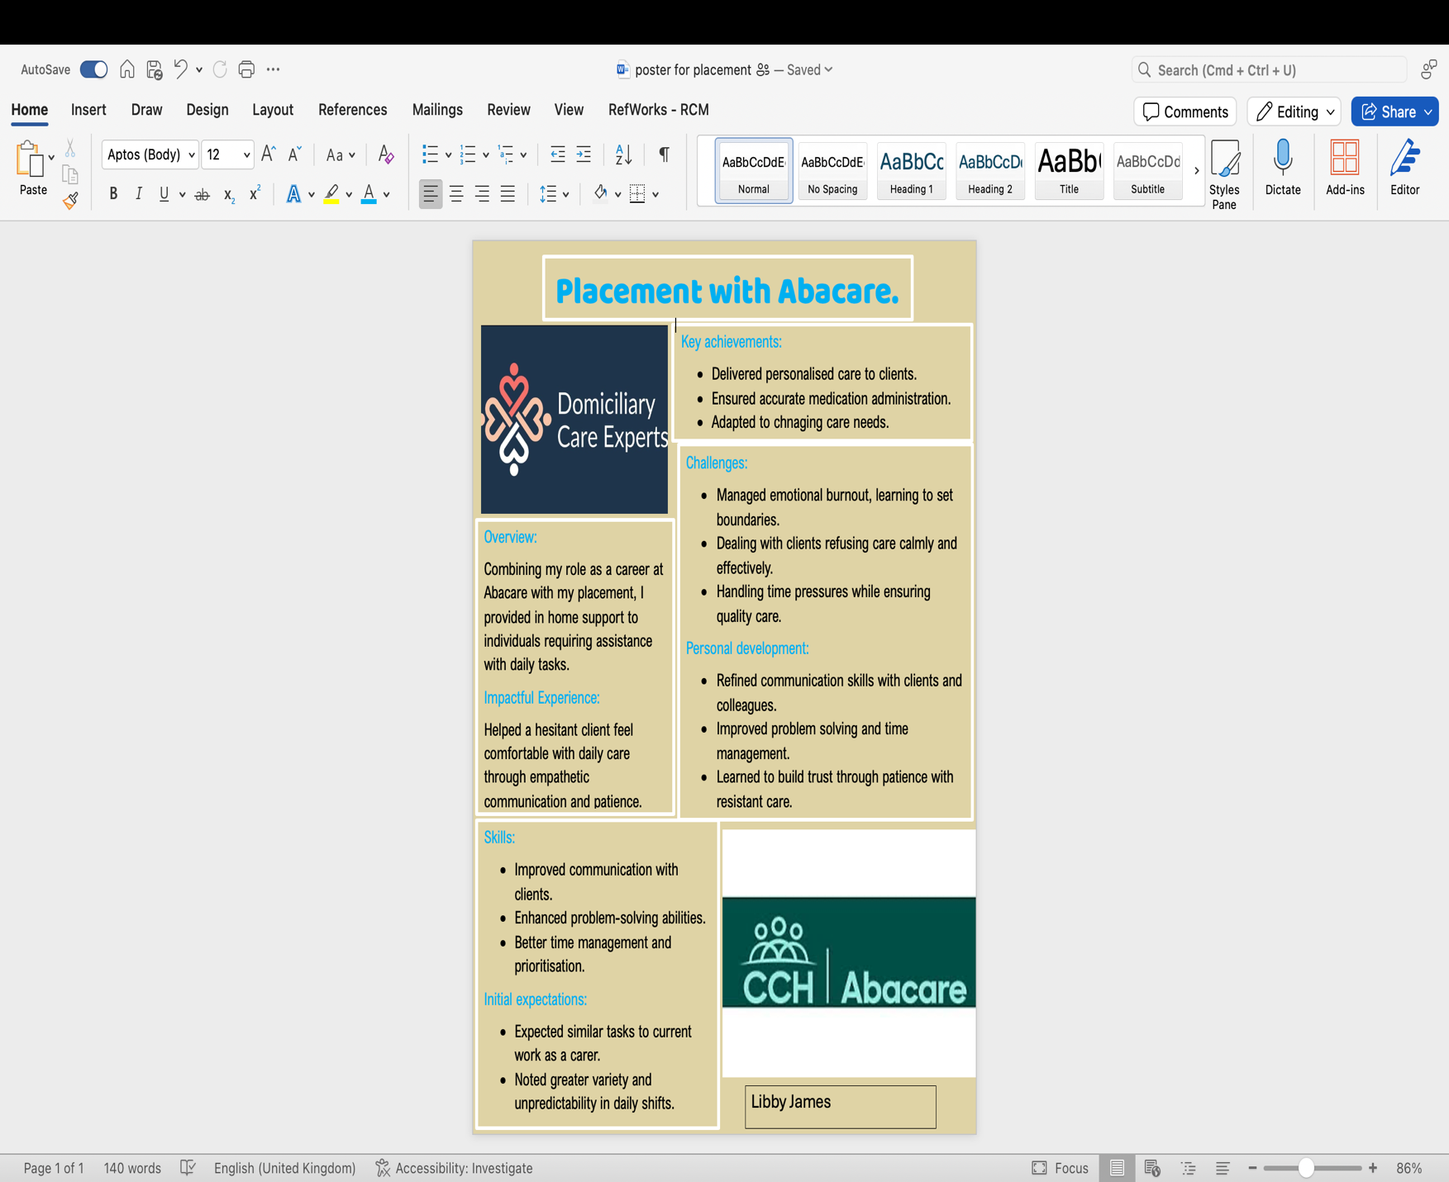

Reference list
Department of Health and Social Care, 2022. Care and support guidance. (Available on: https://www.gov.uk/guidance/care-and-support-statutory-guidance), accessed on 16/04/2025).
Gibbs, G, 1988. Learning by doing: a guide to teaching and learning methods. Oxford: Oxford Polytechnic.
Kolb, D.A, 1984. Experiential learning: Experience as the source of learning and development. Englewood Cliffs, NJ: Prentice-hall.
Maslow, A.H., 1943. A Theory of human motivation. Phycological review, 50(4), pp. 370-396.
McLeod, S, 2020. Maslow’s hierarchy of needs. (Available on: https://www.simplypsychology.org/maslow.html), accessed on 16/04/2025.
NHS, 2021. Person-centred care made simple, London. The health foundation.
Skills for care, 2023. The state of the adult social care sector and workforce in England 2023. (available on: https://www.skillsforcare.org.uk/adult-social-care-workforce-data/Workforce-intelligence/publications/national-information/The-state-of-the-adult-social-care-sector-and-workforce-in-England.aspx), accessed on 16/04/2025.
Tuckman, B.W, 1965. Developmental sequence in small groups. Psychological bulletin, 63(6), pp. 384-399.

