
University Of Wales Trinity Saint David
Student ID: 2315379

24 April 2024
Meera Shah
Corporate Finance

Contents
Part A 3
1 Brief History of Amazon 3
2 Business Model of Amazon 3
3 Amazon Marketplace 3
4 Major competitor 4
5 Major events over the past five years 4
Part B 5
6. Financial Ratios 5
7. Liquidity Ratio 5
7.1Types of Liquidity Ratios: 6
8 Leverage Ratio 6
9 Financial figures of Amazon 7
9.1 Comment: 9
Liquidity Ratio 9
Leverage Ratio 10
10 Financial figures of Walmart 10
10.1 Comment 12
Liquidity Ratio: 12
Leverage ratio: 13
11 Critical Analysis of Both Corporation’s Financial Performance 13
12 Capital Structure Theory 14
13 Pecking Order Theory 15
14 Average Annual Share Return 16
14.1 Comment 17
15 Weighted Average Cost of Capital 17
15.1 WACC Formula’s Brief Intro. 17
15.2 Amazon’s WACC Calculation 18
Part C 19
16 Largest investment during past five years 19
17 The purpose(s), aims and expected outcomes of this investment. 19
18 The size of the investment, and how it was financed. 19
19 The feasibility of the investment, in terms of its current business 19
20 The current outcome of the investment 20
Conclusion 20
Bibliography 21

Index of Tables
Table 1 7
Table 2 8
Table 3 10
Table 4 11
Table 5 14
Table 6 16

Index of Figures
Figure 1 8
Figure 2 9
Figure 3 11
Figure 4 12
Figure 5 14
Figure 6 16

Part A

Brief History of Amazon

According to (Ria, 2023) Jeff Bezos established Amazon in Seattle, Washington, in July 1994, first as an online book retailer. The business swiftly broadened its scope, stepping into new product categories and developing into an all-encompassing online marketplace. Amazon's success may be largely attributed to its focus on customer-centric practices, effective logistics, and cutting-edge technology like its algorithms for recommendation and cloud computing capabilities provided by Amazon Web capabilities (AWS). After going public in 1997, the business strengthened its position in the industry with smart acquisitions like Whole Foods and Zappos. Continuous diversification, technical innovation, and an unwavering focus on the customer experience have been hallmarks of Amazon's success.

Business Model of Amazon

Amazon is an online marketplace that facilitates the connection between customers and sellers. The business sells products to make money, and it also charges for services like advertising and fulfilment. Benefits of the subscription programme Amazon Prime include free delivery and access to special discounts. In addition, the business makes significant investments in digital media and content and permits outside vendors to use its marketplace. With Fulfilment by Amazon (FBA), Amazon's logistics network manages shipping, packing, and storage while also bringing in extra money. Amazon's advertising division enables vendors to advertise their goods on the website. Because of its varied business strategy, Amazon can investigate new prospects and adjust to shifting market conditions (Pereira, 2022).

Amazon Marketplace

Jeff Bezos started Amazon in 1994 as an online bookshop, but it swiftly grew into a multifaceted marketplace with a wide range of goods. With an unwavering focus on efficiency, innovation, and the customer experience, Amazon transformed e-commerce and rose to prominence in the global retail industry. Through its marketplace platform, independent vendors may connect with millions of consumers globally, fostering more expansion and diversity. Amazon has cemented its leadership in online shopping and technological innovation with programmes like Amazon Prime, which provides quick shipping and access to exclusive content, and investments in AI and cloud computing. Customers can shop for practically everything on Amazon's marketplace, from gadgets and books to food and entertainment, and it's influencing how people purchase and sell items all around the world. The third-most popular Amazon marketplace for sellers is Amazon UK. The UK is home to about 43% of Amazon sellers in the UK marketplace. In addition, 13% are headquartered in the US and 9% are in China (Shivesh, 2024).

Major competitor

One of Amazon’s main competitors is Walmart Inc., a worldwide retail conglomerate. Despite its conventional brick-and-mortar stores, Walmart has greatly developed its online presence and e-commerce skills to directly compete with Amazon in recent years. Walmart sells many things online, including food, electronics, clothing, and household items, with many options for in-store pickup and quick delivery. Walmart has also invested in technologies and initiatives to improve its online shopping experience and logistics network, hoping to challenge Amazon’s supremacy in the e-commerce industry.

Major events over the past five years

- In September 2019, Amazon CEO Jeff Bezos launched “The Climate Pledge,” promising the corporation to become net-zero carbon by 2040, a decade earlier than the Paris Agreement’s ambitions. As part of this vow, Amazon announced intentions to buy 100,000 electric delivery vehicles from Rivian, a significant investment in sustainable mobility. This campaign showcased Amazon’s commitment to environmental sustainability and efforts to combat climate change (Amazon, 2019).
- The COVID-19 pandemic in 2020 caused a spike in demand for Amazon’s cloud computing and e-commerce services. Due to the rising demand, it became more difficult to maintain inventory levels, meet delivery dates, and enhance workplace safety inspections. Further boosting sales and drawing in new members was the postponement of Amazon’s yearly Prime Day event in October 2020 due to the pandemic (Palmer, 2020).
- One big event for Amazon in 2021 was the revelation that Jeff Bezos would step down as CEO. Bezos stated in February 2021 that he would become Executive Chairman of the Amazon Board, with Andy Jassy, the former CEO of Amazon Web Services (AWS), succeeding him as CEO. This leadership change was a watershed point in Amazon’s history, as Bezos had been the company's CEO from its inception in 1994, playing a critical part in its growth and success throughout time (Haselton, 2021).
- One of the major events surrounding Prime Day in 2022 was Amazon's decision to extend the event to two days, offering an unparalleled range of sales and discounts throughout its website. In addition to providing Prime members with substantial discounts, the event showcased new product releases and promotions from several merchants and brands. Amazon also highlighted eco-friendly items and activities on Prime Day as part of its sustainability efforts. Amazon's Prime Day demonstrated its ongoing dominance and creativity in the retail sector in the face of intensifying competition in the e-commerce arena (Press Center, 2022).
- In September 2023, Amazon’s fall product launch event at its HQ2 facility in Arlington, Virginia, provided information on the most recent AI-powered improvements for Alexa and Amazon’s smart home platform. Generative AI art for Fire TV and Echo Show devices, as well as faster, smoother replies, are essential now that technologies like Bing, Bard, and ChatGPT have upped the bar for conversational and generative AI (Davis, 2023).

Part B

Financial Ratios

A method of analysis for assessing a company's financial health and performance is a financial ratio. It offers perception into several operational facets of a business, including profitability, liquidity, efficiency, and solvency. Financial ratios are computed by dividing one financial statistic by another. They are frequently used to compare the cash flow, income, and balance sheets of a firm with one another. These ratios assist analysts, managers, and investors in evaluating a company's advantages and disadvantages, making defensible choices, and comparing results against rivals and industry standards (Corporate Finance Institute, 2023).

Liquidity Ratio

A company's liquidity ratio indicates how well it can use its liquid assets to settle its short-term debts and commitments. It shows the state of the company's finances and capacity to deal with unforeseen costs or slowdowns in the economy. The fast ratio and the current ratio are examples of common liquidity ratios. While the quick ratio concentrates on the most liquid assets (such as cash and marketable securities) compared to current obligations, excluding inventories, the current ratio relates current assets to current liabilities. While lower ratios may point to possible financial trouble, higher ratios imply greater financial flexibility and a lesser danger of default (CFI Team, 2020).

Types of Liquidity Ratios:

1. Current Ratio
Current Ratio = Current Assets / Current Liabilities
The current ratio is the most straightforward liquidity ratio to calculate and comprehend. On a company's balance sheet, the current assets and current liabilities line items are visible to all parties. One way to compute the current ratio is to divide current assets by current liabilities (CFI Team, 2020).

Quick Ratio

Quick Ratio = (Cash + Accounts Receivables + Marketable Securities) / Current Liabilities

The quick ratio is a more major measurement of liquidity than the current ratio. Both are equivalent in the sense that current assets are the numerator and current liabilities are the denominator.
However, the quick ratio only considers a small number of current assets. More liquid assets are taken into account, including cash, marketable securities, and accounts receivable. Current assets such as inventory and prepayments are not included since they are less liquid. As a result, the quick ratio provides a more accurate indicator of a company's ability to fulfil its short-term obligations (CFI Team, 2020).

Cash Ratio

Cash Ratio = (Cash + Marketable Securities) / Current Liabilities
The liquidity test is further refined by the cash ratio. Only a company's cash and marketable securities its most liquid assets are taken into account by this ratio. They are the resources that a business can use the quickest to cover short-term debt (CFI Team, 2020).

Leverage Ratio

A financial indicator called the leverage ratio is used to evaluate how much debt a firm has concerning its equity and assets. It is computed by dividing the entire debt of the business by either the equity or the total assets. This ratio sheds light on a company's debt-to-capital ratio and the extent to which it depends on outside funding for operations. Because the firm has more debt than equity or assets, a greater leverage ratio denotes increased financial risk. This can exacerbate losses during downturns in the economy or other unfavourable circumstances. Conversely, a lower leverage ratio is indicative of increased financial stability and decreased risk (CFI Team, 2022).

9 Financial figures of Amazon
Table 1

(In millions) | 2023 | 2022 | 2021 | 2020 | 2019
Current Assets | $172351 | $146791 | $161580 | $132733 | $96334
Current Liabilities | $164917 | $155393 | $142266 | $126385 | $87812
Operating Cash flow | $84946 | $46752 | $46327 | $66064 | $38514
Inventory | $33318 | $34405 | $32640 | $23795 | $20497
Total Assets | $527854 | $462675 | $420549 | $321195 | $225248
Total debt / Total Liabilities | $17.88 | $21.21 | $17.27 | $13.96 | $14.34
Shareholders’ equity | $201875 | $146043 | $139245 | $93404 | $62060
Revenue | $574785 | $513983 | $469822 | $386064 | $280522
Cash | $86780 | $70026 | $96049 | $84396 | $55021
Net profit after tax | $30437 | $-2719 | $33360 | $21315 | $11602

Source: (Macrotrends, 2019)

Table 2
Ratios | Formula | Years
 |  | 2023 | 2022 | 2021 | 2020 | 2019
Current Ratio | Current Assets / Current Liabilities | 1.0451 | 0.9446 | 1.1358 | 1.0502 | 1.097
Quick Ratio | [Current Assets – Inventory – Prepaid expenses] / Current Liabilities | 0.84 | 0.72 | 0.91 | 0.86 | 0.86
Operating Cash Flow Ratio | Cash flow from Operations/ Current Liabilities | 0.51 | 0.30 | 0.33 | 0.52 | 0.44
Debt to equity ratio | Total Debt / Shareholders’ Equity | 1.62 | 2.17 | 2.04 | 2.44 | 2.63
Debt ratio | Total Debt / Total Assets | 0.62 | 0.68 | 0.67 | 0.71 | 0.72
Equity Ratio | Total Equity / Total Assets | 0.38 | 0.32 | 0.32 | 0.29 | 0.28

Source: Created by learner

Figure 1

Source: Calculated by learner
Figure 2

Source: Created by learner

9.1 Comment:

Liquidity Ratio: A current ratio of more than one is a good indicator of the stability of the company's finances. Between 2019 and 2023, Amazon's current ratio did not change from 1.09 to 1.04, indicating that the company can easily pay off its obligations. A quick ratio that's less than one suggests that the corporation would find it challenging to use its most liquid assets to pay its short-term debts. It may lead to more investigation of the company's working capital management and financial stability. Here, we can see that Amazon’s quick ratio has remained similar around 0.86 in the last five years which indicates the need for caution or further investigation into the company's financial condition. Over time, the cash flow operations have been appealing. It was 0.44 in 2019 and increased by 0.6 points in the year 2023. It illustrates the business's capacity to turn a profit from its main operations, which is essential for long-term expansion and monetary stability.

Leverage Ratio: Amazon’s financial ratio illustrates the steady pattern of declining leverage. The debt-to-equity ratio indicates a company's financing mix, with high ratios indicating aggressive debt financing, increasing financial risk, and low ratios indicating a conservative approach with greater equity financing, potentially reducing risk but slowing growth. Here, we can say that the debt-to-equity ratio of the firm is declining from 2.63 to 1.62 in the year 2023. Which indicates a reduction in the company's reliance on debt financing relative to its equity. This suggests that the company has either paid down its debt, raised additional equity capital, or a combination of both. In Amazon’s debt ratio from Figure 2, we can see that the debt ratio has remained the same in the last 5 years just minimal movements we captured. Same for the equity ratio, Over the last five years, a steady equity ratio indicates that the company's share of equity financing concerning its total assets has not changed. This stability shows that the company's capital structure has remained mostly stable in terms of the ratio of debt to equity.

10 Financial figures of Walmart
(In millions) | 2023 | 2022 | 2021 | 2020 | 2019
Current Assets | $75655 | $81070 | $90067 | $61806 | $61897
Current Liabilities | $92198 | $87379 | $92645 | $77790 | $77477
Operating Cash flow | $28841 | $24181 | $36074 | $25255 | $27753
Inventory | $56576 | $56511 | $44949 | $44435 | $44269
Total Assets | $243197 | $244860 | $252496 | $236495 | $219295
Total debt / Total Liabilities | $24.77 | $25.57 | $27.30 | $30.99 | $35.95
Shareholders’ equity | $83754 | $91891 | $87531 | $81552 | $79634
Revenue | $611289 | $572754 | $559151 | $523964 | $514405
Cash | $8625 | $14760 | $17741 | $9465 | $7722
Net profit after tax | $16270 | $11292 | $13940 | $13706 | $15201
Table 3

Source: (Macrotrends, 2019)
Table 4
Ratios | Formula | Years
 |  | 2023 | 2022 | 2021 | 2020 | 2019
Current Ratio | Current Assets / Current Liabilities | 0.82 | 0.93 | 0.97 | 0.79 | 0.80
Quick Ratio | [Current Assets – Inventory – Prepaid expenses] / Current Liabilities | 0.18 | 0.26 | 0.26 | 0.20 | 0.18
Operating Cash Flow Ratio | Cash flow from Operations/ Current Liabilities | 0.38 | 0.27 | 0.39 | 0.32 | 0.36
Debt to equity ratio | Total Debt / Shareholders’ Equity | 1.90 | 1.66 | 1.88 | 1.90 | 1.75
Debt ratio | Total Debt / Total Assets | 0.66 | 0.62 | 0.65 | 0.66 | 0.64
Equity Ratio | Total Equity / Total Assets | 0.34 | 0.38 | 0.35 | 0.34 | 0.36

Source: Created by learner

Figure 3

Source: Calculated by learner
Figure 4

Source: Created by learner

10.1 Comment

Liquidity Ratio: In terms of Walmart’s current ratio has remained constant between 0.79 to 0.97 in the years 2019 to 2023 which indicates that the company has maintained a relatively stable ability to meet its short-term financial obligations using its current assets. While the specific ratio values may fluctuate slightly, the overall trend indicates a consistent liquidity position over the years. This stability could signify effective management of working capital and a balance between cash, inventory, and accounts receivable. However, a current ratio below 1 may raise concerns about the company's short-term liquidity and ability to cover its current liabilities with available assets. Over the course of the previous five years, Walmart's quick ratio has been continuously low, ranging from 0.18 to 0.26. This indicates a continuing issue in satisfying short-term commitments using its most liquid assets, which do not include inventories. This pattern suggests that the firm could have liquidity issues since it might find it difficult to pay short-term obligations without using a lot of inventory. Walmart's operational cash flow ratio, which ranged from 0.27 to 0.39 during the last five years, indicates variations in the amount of cash it can produce from its core business activities in comparison to its total liabilities. Walmart's operational cash flow covers a fraction of its overall obligations, even though the ratio numbers change. Nonetheless, the ratio stays below 1, suggesting that operational cash flow may not be sufficient to meet the company's liabilities.

Leverage ratio: Walmart's debt-to-equity ratio, fluctuating between 1.66 and 1.90 over the past five years, indicates moderate leverage in its capital structure, with more debt financing than equity for operations and growth. Investors may monitor fluctuations to assess financial risk. Walmart's constant balance between debt and equity in its capital structure is demonstrated by its stable debt ratio, which ranges from 0.62 to 0.66. Even while individual ratio figures fluctuate somewhat, this consistency may indicate good financial management and restricted borrowing, thereby decreasing financial risk and providing stability in operations and growth initiatives. Walmart has consistently relied on equity financing concerning its total assets, as seen by its equity ratio, which has fluctuated between 0.34 and 0.38 over the previous five years. The ratio shows that, regardless of small fluctuations, the percentage of equity in the company's capital structure is comparatively constant. The company's financial stability and resilience may be attributed to this consistency, which might be the result of a smart balance between debt and equity funding.

11 Critical Analysis of Both Corporation’s Financial Performance

Walmart is well known for its ability to create profits by leveraging scale and operational excellence. Although both Walmart and Amazon are large retailers, there are notable differences in their strategies and financial outcomes. Walmart is a classic brick-and-mortar retailer with a large physical footprint around the world and an emphasis on cost management and operational effectiveness. Though at a slower rate than Amazon's explosive rise, its financial performance is marked by consistency and stability. Nonetheless, Walmart encounters difficulties in adjusting to the digital retail environment since its online presence is not as strong as Amazon's.
Retail has been completely transformed by tech-driven e-commerce behemoth Amazon thanks to its huge online marketplace, cloud computing services, and cutting-edge technology. Its worldwide presence, growing product options, and strong logistics network are the main drivers of its exponential revenue development, as seen in its financial performance. Because it places a higher priority on long-term investments than on short-term returns, Amazon's profitability has fluctuated more. But because of its ambitious development plan, Amazon has risen to prominence in several industries besides retail, such as cloud computing and digital streaming (Morgan, 2021).
The debt-to-income ratio of Walmart has consistently been around 0.5–0.6. Because Walmart's debt ratio was lower than Amazon's, it was able to remain higher (Al Ghanem et al., 2021). With very few annual gains and drops and no discernible shift, the present ratios for the two firms are quite similar and nearly constant. Nonetheless, it is evident from the statistics and graph that Amazon now has a larger ratio than Walmart does practically in every phase. This implies that throughout the year, Amazon is more liquid than Walmart.
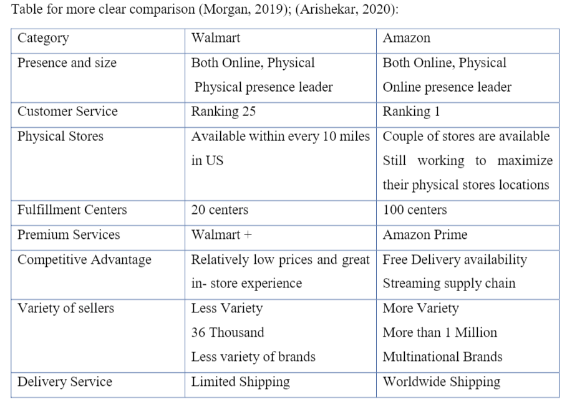
Table 5
Source: (Arishekar, 2020),

12 Capital Structure Theory
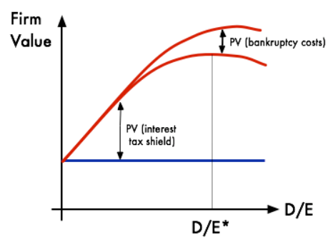
Figure 5

Source: Google images

The frameworks or ideas known as capital structure theories describe how businesses should decide how much debt and equity to finance to minimize the total cost of capital and increase shareholder value. These theories offer recommendations for the capital structure composition of a business depends on several variables, including risk, taxes, and economic difficulties (CFA Institute, 2022)

Investors and traders may utilise the trade-off theory of capital structure to assess a stock's valuation as a component of fundamental research. They can compute a firm's theoretical worth and identify the best capital structure for it by comprehending the theory. This might assist in determining the overvaluation or undervaluation of a stock (McCall, 2023).

13 Pecking Order Theory

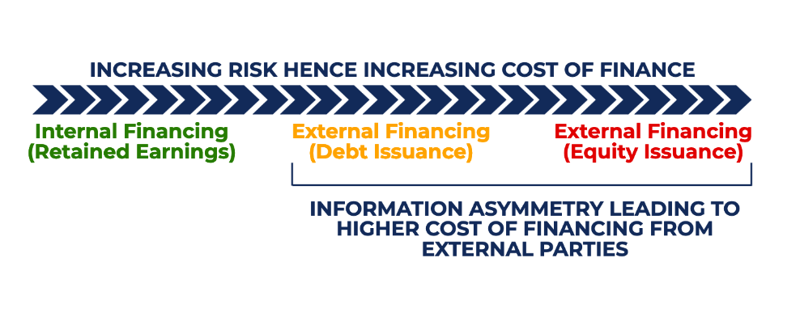
Source: (CFI Team, 2022b)

According to the pecking order hypothesis, businesses are more inclined to seek larger returns from external users like creditors and investors if they have greater knowledge about their performance, prospects, risks, and outlook. The asymmetry of knowledge causes an increase in the desire for returns from outside funding sources. The corporation provides retained profits financing, which reduces this knowledge asymmetry. Because debt financing is less expensive than equity, managers favour it. The seniority of claims to assets is also taken into account by the idea, with debtholders needing a smaller return because of their greater claim to assets (CFI Team, 2022b).

14 Average Annual Share Return

Table 6
Date | Close | Adj close | Current Price- Previous Price | Percentage of Return | Yearly Average Rate of Return
12/1/2019 | 92.392 | 92.392 | (8.044) | 8.71% | 1.46%
12/1/2020 | 162.8465 | 162.8465 | 2.54 | -1.56% | 4.41%
12/1/2021 | 166.717 | 166.717 | 17.143 | -10.28% | -0.38%
12/1/2022 | 84 | 84 | (19.13) | 22.77% | -2.09%
12/1/2023 | 133.32 | 133.32 | 2.69 | -2.02% | -4.84%

Source- (uk.finance.yahoo.com, n.d.)
Figure 6

Source: Created by learner

14.1 Comment

Average rate of return These averages contribute to investors assessing the possible returns and challenges associated with various investment alternatives by offering insights into the performance of different asset classes, including stocks, bonds, and real estate.
Here, we can see that Amazon’s yearly average rate of return in the years 2019 and 2020 performs well on average which is 1.46% and 4.41%. However, from the year 2021 chart has started declining substantially and we can see a huge drop off to -4.84 % in the year 2023. A declining trend in share returns typically indicates negative performance. It suggests that the company's stock price may be underperforming relative to previous years.

15 Weighted Average Cost of Capital

The weighted average cost of capital, or WACC, is the sum of money needed by a company to finance its operations. The WACC of a business is the amount that investors and lenders want to return on their capital (Girardin, 2023). A crucial statistic for figuring out profitability and operating expenses for businesses is the weighted average. Furthermore, the WACC calculates the rate of difference between market values and debt and equity costs (Business Class: Trends and Insights | American Express, 2023).

15.1 WACC Formula’s Brief Intro.

WACC = E/(E+D)*Cost of Equity + D/(E+D)*Cost of Debt*(1-Tax Rate)

  - E = Market Cap
The market value of all the shares of a company combined (also known as market capitalisation).

  - D = Debt market value
The amount investors would be willing to pay to buy that debt.

15.2 Amazon’s WACC Calculation

(All Values in USD)
Weight of Equity = E/(E+D) = 1912960.607/(1912960.607+138596.6) = 0.9324
Weight of Debt = D/(E+D) = 138596.6/ (1912960.607+138596.6) = 0.0676

Cost of Equity = Risk-Free Rate of Return +Beta *(Expected Return of The Market – Risk-Free Rate of Return)
= 4.665% + 1.16 * 6%
= 13.065%

Cost of Debt = 2.30%
Tax Rate = 18.96%
WACC = 0.9324 * 13.065% +0.0676 * 2.30% * (1- 18.96%)
= 12.31%

Part C

16 Largest investment during past five years

For more than $1 billion, Amazon purchased the self-driving car firm Zoox in June 2020. The development of completely autonomous vehicles for ride-hailing services was one of Zoox's bold and well-known goals. Through the acquisition, Amazon was able to increase its market share in the transportation and logistics sector and have access to Zoox's autonomous vehicle technological expertise. Amazon is now able to investigate new opportunities in the quickly developing mobility industry and maybe use autonomous cars for its delivery operations thanks to this calculated decision (Taulli, 2020). Amazon's share price rose to 134.64 after acquiring Zoox in June 2020, indicating a little improvement in the price chart.

17 The purpose(s), aims and expected outcomes of this investment.

Amazon bought Zoox to have access to cutting-edge autonomous vehicle knowledge and technology, which it planned to use to improve and perhaps transform its logistics and delivery services. Amazon sought to speed the development of autonomous delivery trucks with the acquisition of Zoox, to enhance customer satisfaction, cut delivery costs, and increase efficiency. The incorporation of autonomous cars into Amazon's delivery fleet was one of the anticipated results, which would allow the business to position itself as a leader in the developing autonomous mobility sector and provide faster and more dependable delivery services (Etherington, 2020).

18 The size of the investment, and how it was financed.

The precise amount of Amazon's acquisition is estimated to be above $1 billion (Taulli, 2020). We made an effort to find out how Zoox was funded, however, we assume Amazon most likely used a mixture of cash and maybe shares to pay for the acquisition of Zoox. Using cash is a popular acquisition strategy, particularly for businesses with large financial reserves like Amazon.

19 The feasibility of the investment, in terms of its current business

Amazon's long-term goal of innovating and streamlining its shipping and logistics processes is in line with the investment in Zoox. It appears possible for Amazon to incorporate Zoox's autonomous car technology into its operations given its extensive resources, technological know-how, and pre-existing infrastructure. Amazon may be able to increase the effectiveness and dependability of its delivery network by utilising Zoox's advances in self-driving technology, which would eventually lower costs and raise customer happiness. Additionally, Amazon's investment in Zoox is a calculated move to preserve its competitive edge in the quickly changing retail and transportation sectors. As a leader in e-commerce, Amazon has the size and market dominance to support the development and deployment of autonomous delivery vehicles (Group, 2020).

20 The current outcome of the investment

As of right now, continued research and development in autonomous vehicle technology is the result of Amazon's investment in Zoox. Amazon's Zoox robotaxis are getting ready to take a major leap ahead, with promises of increased speeds, longer range, and even nighttime operations in Las Vegas. With Zoox pushing the limits of what self-driving cars can accomplish, this news represents a substantial development in autonomous vehicle technology. Zoox hopes to improve consumer comfort and accessibility by extending its operating conditions to include night driving, which might completely transform urban transportation. This initiative demonstrates Amazon's dedication to innovation and its outlook for the mobility industry. As Zoox keeps improving its technology and broadening its service area, it opens the door to a new age of transportation that is more sustainable, safe, and effective (Bensinger, 2024).

Conclusion

Analysing the financial statistics of Walmart versus Amazon provides important information about the operational effectiveness and financial health of each company. Even though both businesses are massive retailers, Amazon's performance is especially noteworthy. Amazon's beneficial financial ratios show that it is strong in several important areas. First off, Amazon appears to be more adept at turning a profit from its operations and making good use of shareholder resources, as seen by its better profitability ratios, which include net profit margin and return on equity. This may be explained by Amazon's creative business strategy, fervent brand devotion, and variety of revenue sources outside of traditional retail. Furthermore, Amazon's liquidity measures, such as the quick and current ratios, show that it can easily satisfy short-term financial obligations. Amazon can make investments, grow, and manage economic uncertainty because of its cash position. Additionally, Amazon's efficiency ratios—such as asset and inventory turnover—showcase its skill at controlling assets and inventories to boost revenue and increase sales. This effectiveness helps Amazon maintain a competitive edge in the ever-changing retail market. In general, the financial ratios indicate that Amazon is in a stronger position to continue growing, innovate, and create value for its investors.

Bibliography
Al Ghanem, K., Al Qubaisi, N., Al Zaabi, H., Al Dhahmani, L., Al Naqbi, A., Al Dhanhani, H., Al Shamisi, F. and Nobanee, H. (2021). Financial Analysis of AstraZeneca. [online] papers.ssrn.com. Available at: https://papers.ssrn.com/sol3/papers.cfm?abstract_id=3895292 [Accessed 12 Apr. 2024].
Amazon (2019). Driving Climate Solutions. [online] Sustainability (US). Available at: https://sustainability.aboutamazon.com/climate-solutions [Accessed 11 Apr. 2024].
Arishekar (2020). Amazon Vs. Walmart - Competitive Analysis [2020]. [online] Amazon-ASIN. Available at: https://amazon-asin.com/blog/amazon-vs-walmart/ [Accessed 12 Apr. 2024].
Bensinger, G. (2024). Amazon’s Zoox robotaxis to drive faster, farther, at night in Las Vegas. Technology. Available at: https://www.reuters.com/technology/amazons-zoox-robotaxis-drive-faster-farther-night-las-vegas-2024-03-14/ [Accessed 19 Apr. 2024].
Business Class: Trends and Insights | American Express. (2023). WACC Formula: How to Calculate Weighted Average Cost of Capital. [online] Available at: https://www.americanexpress.com/en-gb/business/trends-and-insights/articles/wacc-formula/.
CFA Institute (2022). Capital Structure. [online] CFA Institute. Available at: https://www.cfainstitute.org/en/membership/professional-development/refresher-readings/capital-structure [Accessed 12 Apr. 2024].
CFI Team (2020). Liquidity Ratio. [online] Corporate Finance Institute. Available at: https://corporatefinanceinstitute.com/resources/accounting/liquidity-ratio/ [Accessed 12 Apr. 2024].
CFI Team (2022a). Debt to Equity Ratio. [online] Corporate Finance Institute. Available at: https://corporatefinanceinstitute.com/resources/commercial-lending/debt-to-equity-ratio-formula/ [Accessed 12 Apr. 2024].
CFI Team (2022b). Pecking Order Theory. [online] Corporate Finance Institute. Available at: https://corporatefinanceinstitute.com/resources/valuation/pecking-order-theory/ [Accessed 12 Apr. 2024].
Corporate Finance Institute (2023). Financial ratios. [online] Corporate Finance Institute. Available at: https://corporatefinanceinstitute.com/resources/accounting/financial-ratios/ [Accessed 12 Apr. 2024].
Davis, W. (2023). All the biggest announcements from Amazon’s September 2023 product launch event. [online] The Verge. Available at: https://www.theverge.com/2023/9/20/23881164/amazon-event-hardware-devices-alexa-echo-ring?ref=nearmedia.co%2Farchives%2F2 [Accessed 17 Apr. 2024].
Etherington, D. (2020). Amazon to acquire autonomous driving startup Zoox. [online] Tech crunch. Available at: https://techcrunch.com/2020/06/26/amazon-to-acquire-autonomous-driving-startup-zoox/?guccounter=1&guce_referrer=aHR0cHM6Ly93d3cuZ29vZ2xlLmNvbS8&guce_referrer_sig=AQAAALMo1DKqNIfVPdNHEyZw85ISytooZLm35xfmhWSZThCF-S-_HwBX8GSVEfh6ViWugg7qBloOdUcI5e4WD9dO093ifq75xHjIlLhp4K08HKBXyfh4VfQaDbO6s2QbMXNYMnYaXn_Ev7Ztw--Ns0xsq6MHaDKRl1cGHtRORd1dnVHS [Accessed 8 Apr. 2024].
Girardin, M. (2023). What Is Weighted Average Cost of Capital (WACC)? [online] Forage. Available at: https://www.theforage.com/blog/skills/wacc [Accessed 16 Apr. 2024].
Group, T.M. (2020). Amazon’s $1.2 bn Acquisition of Zoox. [online] MergerSight Group. Available at: https://www.mergersight.com/post/amazon-s-1-2-bn-acquisition-of-zoox [Accessed 8 Apr. 2024].
Haselton, T. (2021). Jeff Bezos to step down as Amazon CEO, Andy Jassy to take over in Q3. [online] CNBC. Available at: https://www.cnbc.com/2021/02/02/jeff-bezos-to-step-down-as-amazon-ceo-andy-jassy-to-take-over-in-q3.html [Accessed 11 Apr. 2024].
MacroTrends (2019). Amazon Income Statement 2005-2019 | AMZN. [online] Macrotrends.net. Available at: https://www.macrotrends.net/stocks/charts/AMZN/amazon/income-statement [Accessed 2 Apr. 2024].
McCall, J. (2023). Trade-off Model of Capital Structure | Trade-off Theory. [online] capital.com. Available at: https://capital.com/trade-off-model-of-capital-structure-definition#:~:text=The%20trade%2Doff%20theory%20states [Accessed 12 Apr. 2024].
Morgan, B. (2021). Who Wins The Battle Of Walmart Vs. Amazon? [online] Forbes. Available at: https://www.forbes.com/sites/blakemorgan/2021/06/14/who-wins-the-battle-of-walmart-vs-amazon/?sh=4f9e0c615ba7 [Accessed 12 Apr. 2024].
Palmer, A. (2020). How Amazon managed the coronavirus crisis and came out stronger. [online] CNBC. Available at: https://www.cnbc.com/2020/09/29/how-amazon-managed-the-coronavirus-crisis-and-came-out-stronger.html [Accessed 11 Apr. 2024].
Pereira, D. (2022). Amazon Business Model. [online] Business Model Analyst. Available at: https://businessmodelanalyst.com/amazon-business-model/ [Accessed 7 Mar. 2024].
Press Center. (2022). Prime Day 2022 was the Biggest Prime Day Event Ever. [online] Available at: https://press.aboutamazon.com/2022/7/prime-day-2022-was-the-biggest-prime-day-event-ever [Accessed 12 Apr. 2024].
Ria, A. (2023). A Brief History of Amazon - Future Startup. [online] Future Startup. Available at: https://futurestartup.com/2023/10/31/a-brief-history-of-amazon/ [Accessed 7 Mar. 2024].
Shivesh (2024). Amazon Marketplaces | Where should you start selling? [online] Aihello. Available at: https://www.aihello.com/resources/blog/amazon-marketplaces-where-should-you-start-selling/ [Accessed 11 Apr. 2024].
Taulli, T. (2020). Amazon Buys Zoox: Why Self-Driving Technology Is Existential. [online] Forbes. Available at: https://www.forbes.com/sites/tomtaulli/2020/06/27/amazon-buys-zoox-why-self-driving-technology-is-existential/ [Accessed 8 Apr. 2024].
uk.finance.yahoo.com. (n.d.). Amazon.com, Inc. (AMZN) stock historical prices & data – Yahoo Finance. [online] Available at: https://uk.finance.yahoo.com/quote/AMZN/history?period1=1555027200&period2=1681257600&interval=1mo&filter=history&frequency=1mo&includeAdjustedClose=true [Accessed 16 Apr. 2024].

