Module: Digital Skills and Research Methods
Assignment Title: DSR Assessment 2 Individual Report
Lecturer name: Amitave Banik
Student name: Narcis Andrei Mindru
Student ID: 2021407

Table of Contents
Introduction 3
Literature Review 4
Research Methodology 4
Critical Analysis Results 5
Primary Data Analysis based on Survey by Using Related Questions 6
Secondary Data Analysis Based on Theory and Learning Preview 11
Model of Technology Acceptance (TAM) 12
Model of Technology Readiness (TRI) 13
Discussion on Suggested Models 13
Reasoned Action Theory (TRA) 14
Planned Behavior Theory -TPB 15
Conclusion 17
References 18
Appendix 19

Introduction
Through the impact of global technology, the whole structure of the world has changed. In this time duration, IT and innovations are the primary basis of survival, and the ability to operate these innovations is excellent for creating a digital world. Virtual Learning Environment (VLE) VLE stands for Virtual Learning Environment, and it is an online portal that provides students and professors with immersive learning solutions. Unlike a virtual classroom, which is designed to emulate and substitute the actual classroom setting for distance learners, a virtual learning environment (or VLE) uses technologies to enhance the in-class experience, such as through visual connectivity, engagement, and quizzes or polls. The report show several research and theories on VLE (Chou and Liu, 2013).

Literature Review
From the research, the result and the impact of Virtual Learning Environment are entirely satisfactory because the students can easily access technological instruments during their study, class, and any place they want to join can be possible through the connection of the internet. While researching in the University of Wales, some significant issues arise that the students give the same opinion that they think VLE is an excellent way for proper use of time creates a great relationship among all circumstances by which the confidence for learning also increased. It is essential to develop a Virtual Learning Environment (Goldman, 2016). That is only possible when student teacher communication arises like a friendly way. Professional feedback can be developed due to VLE when the thinking ability increases without any cultural diversity. VLE usually helps build a fundamental of communication, engage students in professional debating, enhance understanding ability, increase knowledge and functional discussing ability, as it is synchronous and asynchronous transformation system that has a significant impact on co-operative social networking system. From the student viewpoint, VLE increases and builds learning styles and a strong personality. VLE is a universal term that is a great tool for all communities and for the learners. In this report a lot of question and research results arises that shows the value of Virtual Learning Environment. Some related theories, charts also showed here as an evidence for the above statement (Keppell, Souter, Riddle and Tynan, 2014).

Research Methodology
For operating this research and survey of Virtual Learning Environment (VLE), the online platform of the university and many students' identity are used.
These include several students while doing this research for differentiating the availability and proper impact of VLE using. The student identities, IP address, and time duration of their online activities are taken as tools for measuring VLE use, and then these specific students are grouped in various circumstances. Particular topics are given to the different groups on VLE and advised to complete all detailed information within 30 minutes. The specific issues include resource view, user view, course view, etc. (Kirsch and Sullivan, 2017)
There is a lot of analysis and several data where the results are different from one another's viewpoint based on subjective and qualitative perceptions.

Critical Analysis Results
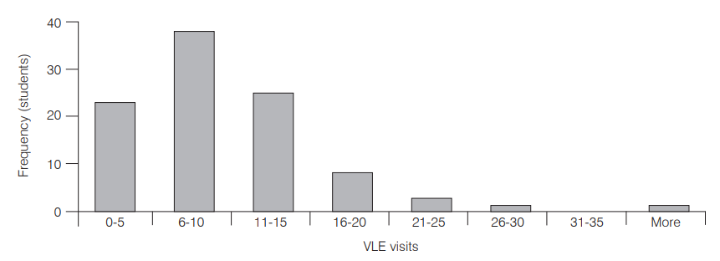
Figure: Frequency of visit to the Virtual Learning Environment showed (Livingstone, Kemp and Edgar, 2016)
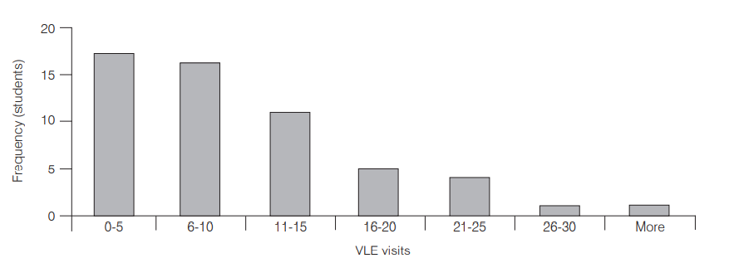
Figure: The frequency of visitors to the VLE by different project-based groups (Nickoson and Sheridan, 2012)
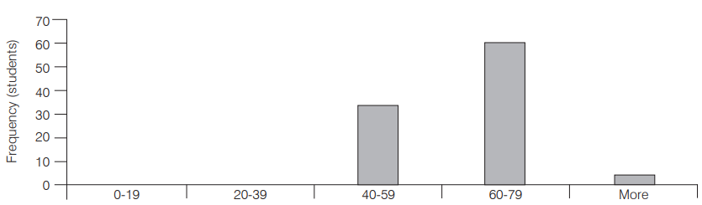
Figure: Showing the Survey results based on different viewpoint given to the students (Peterson, 2015)
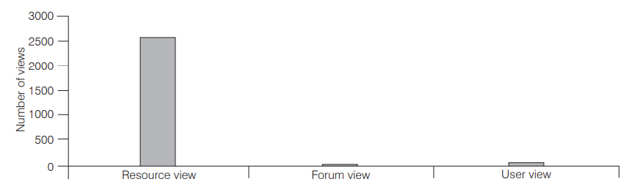
Figure: Showing several views of the student perspectives (Puolakanaho and Latvala, 2017)
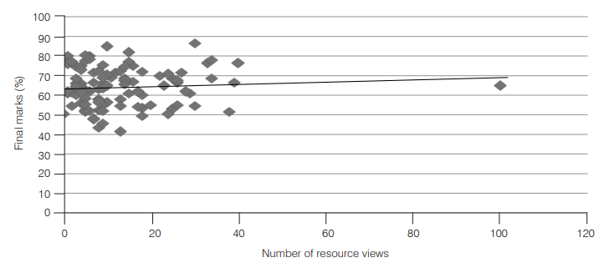
Figure: Variation of the number of Resource view and final marks (Sousa and Wilks, 2018)

Primary Data Analysis based on Survey by Using Related Questions
- How useful did everyone find to continue VLE?
From the survey and the research activity from University of Wales campus:
- Here many learners use VLE as an essential tool for downloading lectures and slides with the help of a safe password for various conferencing, group discussion, and so on.
- The second important issue arises that many students use this VLE as a source of outsourcing and do many part-time jobs. It impacts positively to the students besides making an impact on their academic studies.
- The students cannot access the VLE properly without the fundamentals thoughts, skills, and maturity.
- After doing this survey, there arises a suggestion that proper conducting, use and distribution of VLE is an advanced learning tool (Telford, Becker and King, 2018).

- What is the rate of help offering the resources learn from home?

Figure: Showing the rate of help offering the resources learn from home
- What is the rate of effects of VLE on Students?

Figure: Effects of VLE on Students
- How useful the Impact of VLE for solving General Questions about the course-related tasks?
While making questions, here uses many dimensions and expressions of the learners as a tool of Virtual Learning Environment. Further, this research accepted these questions and categorized them into two specific factors including:
- Virtual Learning Environment
- Traditional Learning
Primary Tasks | Virtual Learning Environment | Traditional Learning Process
Scheduling Process | The classes are scheduled as giving importance to the overall preference of the surroundings, and that's why it is pretty simple and different as the students are the learners. Hence, they are the core planner of making the schedule. | It is regularly where students should be present physically in the class every week.
Resource Factors | Instruments and tools are less costly, and extra facilities with proper resources are also provided without wasting time. | Core information units and physical libraries are used, and it takes more time.
Variation of courses | Popular and informative journals, information centers, and various digital platforms are used in VLE as an information tool that improves students' creativity. | With the proper study plan, teachers provide lectures and academic curriculums.
Location for providing materials | Various resources are used like discussion forums, video and audio conferencing. Here location is not fixed, but the learners can get service from anywhere. | Students should be present on the campus physically and in the class.
Figure : Variation of VLE and Traditional Learning (Chou and Liu, 2013)

- Did the students learn fast how to use a module?

Figure : Showing the survey on the module
- Does online learning help the students to learn how to solve the problem?

Figure: Showing the results for solving the problem through VLE
- How effective the VLE for enhancing the engagement in research and developing independent learning?
The following result has grown up by analyzing the survey using specific questions among the students.
70% of them agree (45%) or strongly agree (25%) about the topics that VLE is very effective for enhancing the engagement in research and developing independent learning by time and location. 60% agree or strongly agree that the proper guidance and module of VLE increase their thinking capability and creativity. 75% agree that VLE is so affordable and an easy learning tool for learning various information (Kirsch and Sullivan, 2017).
Analysis Tasks | Fully Agree | Slightly agree | Middle | Slightly disagree | Fully disagree | Average result
VLE that is responsible for independent learning based on time and location | 45.09% | 25.01% | 20% | 8.09% | 2.03% | 4.98
Guidance and module of VLE increase thinking capability | 10.5% | 50.09% | 15.09% | 15.8% | 10% | 3.89
VLE is an easy and affordable source for gathering information | 25% | 50.13% | 10.89% | 10.9% | 5.17% | 4.01
VLE is a medium of solid communication | 60.08% | 20.90% | 5.00% | 12.07% | 8.8% | 5.01
Figure 10: the relative analysis of Independent learning through VLE

Figure 11: VLE that is responsible for independent learning based on time and location

Figure: Guidance and module of VLE increase thinking capability

Figure: VLE is an easy and affordable source for gathering information
- What device do the students use for online learning?

Figure: Devices used by the students for VLE

- How helpful are the teachers while studying online?

Figure: helping rate of the teachers in online

Secondary Data Analysis Based on Theory and Learning Preview
While surveying in the University of Wales campus, the overall VLE also conducted through a theoretical framework. As measured from the students and institutional perspective, the students can easily use advanced technology to acquire information, study various surveys, make assignments and build co-operative communication. A brief experiment on VLE and it’s the effect in study is described based on several theories (Puolakanaho and Latvala, 2017).
The theories include:
- Model of Technology Acceptance (TAM)
- Model of Technology Readiness Index (TRI)
- Reasoned Action Theory (TRA)
- Planned Behavior Theory (TPB)

Model of Technology Acceptance (TAM)
The Technology Acceptance Model (TAM) is a customer-centered approach to measuring emerging technology adoption. After an initial trial, this model will be used to propose carrying out a new piece of technology to the whole company. While new models for successful online business education are evolving, multi-discipline studies have built on existing frameworks in business science. The technology adoption model is one such widely applied system (TAM). The TAM has been used as a grounding structure in several multidisciplinary experiments, either in its original form or as an expanded model. Although the model has little predictive capacity for beginner online learners or early course management systems, the research indicates that the TAM has emerged as a valuable tool for understanding course management system use and satisfaction with the internet as an instructional delivery platform (Sousa and Wilks, 2018).
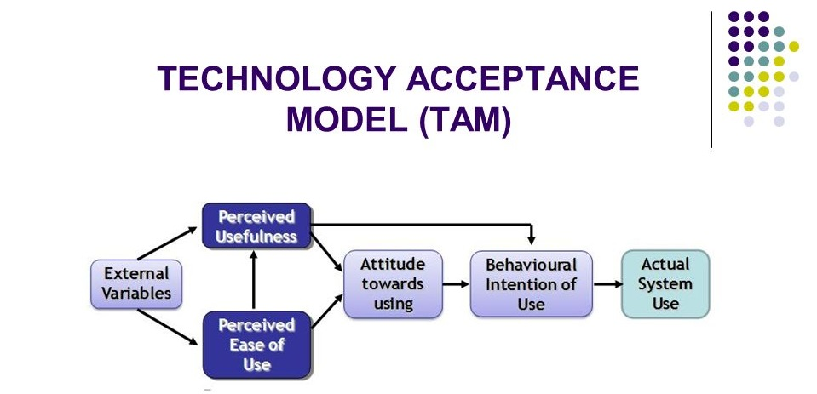
Figure: Model of Technology Acceptance (Telford, Becker and King, 2018)

Model of Technology Readiness (TRI)
Optimism, an optimistic understanding of technology, and the assumption that it gives people more power, versatility, and performance are the four fundamental aspects of technology readiness—the propensity to be a technological trailblazer and thought leader (Weller, 2016).
The four fundamentals parts categorized into two types including:
- Drivers
- Optimism
- Innovativeness
- Inhibitors
- Discomfort
- Insecurity
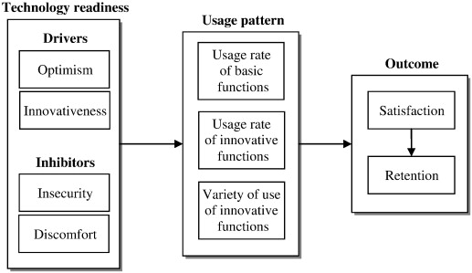
Figure: Technology Readiness Index Model (TRI) (Weiss, 2017)

Discussion on Suggested Models
- Drivers
- Optimism: a widespread trust in the beneficial effects of technology and creativity that has an optimistic attitude toward technology that believes it gives people more power, versatility, and productivity—the propensity to be a technological trailblazer and thought leader.
- Innovativeness: The need to be a thought pioneer and a scientific trailblazer. “The first operator of a modern invention will be the master of the following phenomena,” the business Innovativeness finds as a valuable tendency (Chou and Liu, 2013).

- Inhibitors
- Discomfort: Discomfort, a sense of being distracted by technology, and a perceived loss of power over it.
- Insecurity: it ids the violation of technology and reservations to operate correctly. Several students, according to analysis, lack protection over personal records and are unable to protect privacy. As a result, they are hesitant to use VLE or advanced technologies. Learners often believe that their knowledge could be sent to hackers or other people who could hurt them (Goldman, 2016).

Reasoned Action Theory (TRA)
The third difference from Information Integration theory is that Reasoned Action predicts behavioral motive using two elements: behaviors and norms (or other people's expectations). That is, when our behaviors lead us to do one thing but the relevant norms lead us to do another, both aspects have an impact on our behavioral purpose. This hypothesis also recognizes that there are certain variables that may reduce the impact of attitude on behavior. (Keppell, Souter, Riddle and Tynan, 2014).
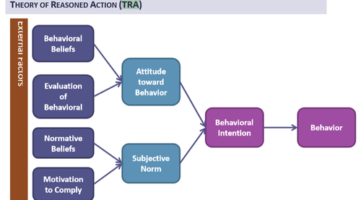
Figure: Theory of Reasoned Action (TRA) (Kirsch and Sullivan, 2017)
- Do the Students like Learning Online?

Figure: Students opinion (Livingstone, Kemp and Edgar, 20Planned Behavior Theory -TPB
The Theory of Planned Actions employs a person's personal attitude and perspective, as well as their assumed power over their behavior and society's subjective standards, to influence their behavioral purpose, which leads to the conduct or intervention. When someone has a pessimistic outlook and believes they don't have influence of an action, they are less likely to carry it out. Furthermore, if members of society do not approve of this behavior, it will have a negative effect on a person's motivation to carry it out (Peterson, 2015).
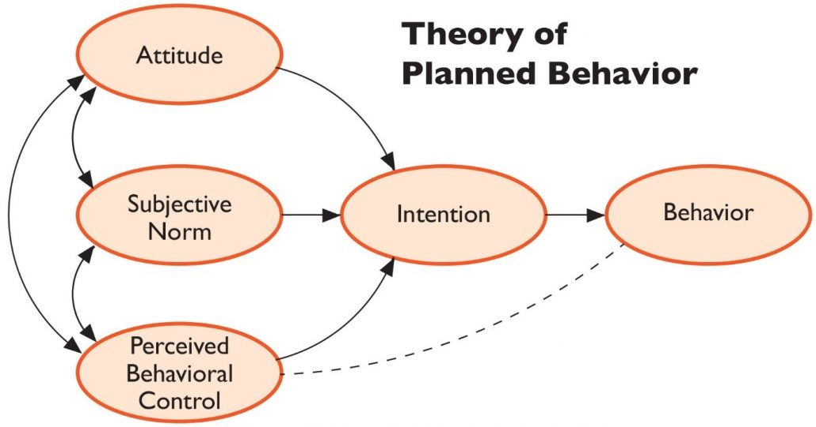
Figure: Theory of Planned Behavior (Puolakanaho and Latvala, 2017)

- Time duration of students spending on average through VLE?

Figure: the students spent on an average on the distance education (Sousa and Wilks, 2018)

Conclusion
The Virtual Learning Environment is a new phenomenon that higher and secondary education programs commonly refer to in the academic sector. This VLE has been used to control a large number of experiments. Besides, multiple models are developed, which were technically defined in this survey. Overall, the data indicate that the VLE can be used to improve the Independent Learning opportunity. A brief review of the collected literature follows a short description of the methods used to compile the data for this article. The parallels, disparities, benefits, and drawbacks of their technical features have been examined when studying the various VLE platforms (Telford, Becker and King, 2018).

References
Chou, S. and Liu, C., 2013. Learning effectiveness in a Web-based virtual learning environment: a learner control perspective. Journal of Computer Assisted Learning, 21(1), pp.65-76.
Goldman, R., 2016. Learning Proxmox VE. Birmingham, UK: Packt Publishing.
Keppell, M., Souter, K., Riddle, M. and Tynan, B., 2014. Physical and Virtual Learning Spaces in Higher Education. Hershey: IGI Global.
Kirsch, G. and Sullivan, P., 2017. Methods and methodology in composition research. Carbondale, Ill.: Southern Illinois University Press.
Livingstone, D., Kemp, J. and Edgar, E., 2016. From Multi-User Virtual Environment to 3D Virtual Learning Environment. Research in Learning Technology, 16(3).
Nickoson, L. and Sheridan, M., 2012. Writing studies research in practice. Carbondale: Southern Illinois University Press.
Peterson, M., 2015. The virtual learning environment. Lisse: Swets & Zeitlinger.
Puolakanaho, A. and Latvala, J., 2017. Embedding preschool assessment methods into digital learning games to predict early reading skills. Human Technology, 13(2), pp.216-236.
Sousa, M. and Wilks, D., 2018. Sustainable Skills for the World of Work in the Digital Age. Systems Research and Behavioral Science, 35(4), pp.399-405.
Telford, W., Becker, A. and King, W., 2018. VLE mapping of geological structure.
Weiss, J., 2017. International handbook of virtual learning environment. Dordrecht: Springer.
Weller, M., 2016. Virtual learning environments. London: Routledge.

Appendix
The Primary Research Questions that used in Virtual Learning Environment study are:
- How useful did everyone find to continue VLE?
- What is the rate of help offering the resources learn from home?
Very helpful / moderate helpful / slightly helpful / not at all helpful
- What is the rate of effects of VLE on Students?
Yes / No
- How useful the Impact of VLE for solving General Questions about the course-related tasks?
- Did the students learn fast how to use a module?
Yes / No
- Does online learning help the students to learn how to solve the problem?
Yes / No / Not enough / not particularly / not yet / not too much
- How effective the VLE for enhancing the engagement in research and developing independent learning?
Analysis Tasks | Fully Agree | Slightly agree | Middle | Slightly disagree | Fully disagree | Average result
VLE that is responsible for independent learning based on time and location | 45.09% | 25.01% | 20% | 8.09% | 2.03% | 4.98
Guidance and module of VLE increase thinking capability | 10.5% | 50.09% | 15.09% | 15.8% | 10% | 3.89
VLE is an easy and affordable source for gathering information | 25% | 50.13% | 10.89% | 10.9% | 5.17% | 4.01
VLE is a medium of solid communication | 60.08% | 20.90% | 5.00% | 12.07% | 8.8% | 5.01

- What device do the students use for online learning?
Laptop / Desktop / tablet / Mobile phone
- How helpful are the teachers while studying online?
Very helpful / moderate helpful / slightly helpful / not at all helpful

