

LOCATION: Swansea | LLEOLIAD: abertawe
LEVEL 5 | LEFEL 5
EXAMINATION PERIOD | CYFNOD ARHOLIADAU
MAY 2024 | 2024

MODULE CODE: ACDA5001
Electrical Engineering

TIME: 2 HOURS
Maximum Marks: 100
answer ALL the questions

Equipment or materials required – Calculator, formula sheet
Adnoddau neu ddefnyddiau sydd eu hangen - Cyfrifiannell

ANSWER ALL THE QUESTIONS
Question 1 [25 marks]
- A supply voltage of $V_{1}=15V$ is given to the circuit shown in fig:1. Determine the following
- The load current, [8 Marks]
- Value of load resistor, when maximum power is transferred across the load,
[3 Marks]
- Simplified circuit diagram for the circuit shown in fig.1 [3 Marks]
- The maximum power transferred across the load ($P_{L})$. [3 Marks]
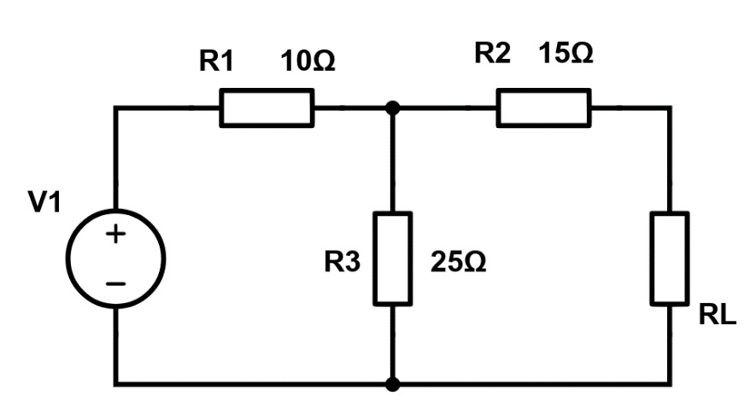
Fig:1
- Define Norton’s Theorem, with the aid of its equivalent Circuit. [5 Marks]
- Calculate the voltage $V_{DC}$ across the open circuited terminal of the circuit shown in fig:2. [3 Marks]
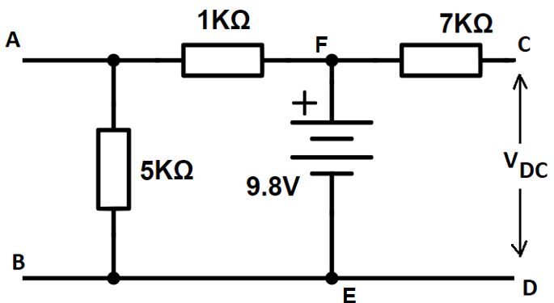
Fig:2

Question 2 [25 Marks]
- A 415V, three phase AC motor has a power output of 12.75kW and operates at a power factor of 0.77 lagging and with an efficiency of 85%. If the motor is delta-connected, determine the following,
- The Power input [5 Marks]
- The Line current [4 Marks]
- The Phase current [4 Marks]
- An Alternating voltage is given by the equation $V=100Sin (200πt-90)$. Calculate the following.
- The amplitude [2 Marks]
- The peak to peak voltage [2 Marks]
- The RMS voltage [3 Marks]
- The periodic time [3 Marks]
- The Frequency [2 Marks]
Question 3 [25 marks]
- A Coil of inductance $318.3mH$ is connected in series with a $200 Ω$ resistor to a $240V, 50Hz$ supply. Calculate the following.
- Inductive reactance of the coil [3 Marks]
- Impedance of the circuit [3 Marks]
- Current in the circuit [2 Marks]
- Potential difference across each components [4 Marks]
- Circuit phase angle [3 Marks]
- Find the RMS value and Phase of the current, $I=25+j40 A$ [4 Marks]
- Differentiate Active power, Reactive power and Apparent power [ minimum of two differences] [6 Marks]
Question 4 [25 Marks]
- List any five types of DC Generators. [5 Marks]
- A Transformer has a rated output of 200KVA at a power factor of 0.8. Determine the real power and the reactive power. [5 Marks]
- Describe the functions of the following components used in DC machines
- Field System [3 Marks]
- Yoke [3 Marks]
- Commutator [3 Marks]
- Carbon brush [3 Marks]
- Armature [3 Marks]

Diwedd/End

