


LEVEL 5 ASSESSMENT SPECIFICATION

Student name: | Sharifah Intan Nur Sufi Binti Syed Azhar | Student ID number: | 20200207
Programme: | IUMW
Module: | Changemakers: Creativity and Value Creation
Module code: | BMSW5008_SWAN | Contribution to Overall Module Assessment (%): | 50%
Lecturer: | Myfanwy Davies | Internal Verifier:
Assignment Title: | E-Portfolio Evidence of Learning | Word count (or equivalent): | 2000 or equivalent
Submission deadline: | 25th August, 2023 | Return date of provisional marks & written feedback:
Submission method: | All written assessments, where practical and possible, must be submitted via Turnitin unless otherwise instructed by the Lecturer. (Please DO NOT put this assessment specification into Turnitin or it will match many similarities with other students’ submissions.)  Alternative submission method (if applicable):  Late submission of the assessment will result in a late penalty mark. Penalties for late submission: Up to one week late, maximum mark of 40%. Over one week late, 0%. Only the Extenuating Circumstances Panel may approve a change to submission dates.
Academic honesty / referencing: | Academic honesty is required. In the main body of your submission you must give credit to authors on whose research and ideas your work is based. Append to your submission a reference list that indicates the books, articles, etc. that you have used, cited or quoted in order to complete this assessment.

TABLE OF CONTENT

TASK 1: RESEARCH QUESTION 3
1.1 RESEARCH QUESTION 3
1.2 RESEARCH APPROACH 5
1.2.1 DEDUCTIVE / INDUCTIVE / ABDUCTIVE 5
1.2.2 QUALITATIVE / QUANTITATIVE / MIXED METHODS 6
1.3 DATA COLLECTION METHOD(S) 7
1.3.1 PRIMARY / SECONDARY METHODS 7
1.4 DATA SAMPLING METHOD AND SAMPLE SIZE 8
1.4.1 DATA SAMPLING METHOD 8
1.4.2 SAMPLE SIZE 8
TASK 2: RESEARCH TECHNIQUE 9
TASK 3 12
TASK 4 13
REFERENCES 14
APPENDIX 17

TASK 1: RESEARCH QUESTION

1.1 RESEARCH QUESTION
- What are the factors that encourage consumers to still use Online Food Delivery Application to order food after COVID-19 Pandemic?

- What are factors that influence consumers' consistency in using Online Food Delivery Services and Application after COVID-19 Pandemic?

- What is the relationship between Online Food Delivery Application and its convenience to consumers after COVID-19 Pandemic?

Food and Beverage (F&B) industry was forced to adapt and provide new offerings to serve the high demand from consumers due to rapid improvement of telecommunication infrastructure, lack of time and convenience, cheaper smart devices, as well as the increase of purchasing power. Shopping online attracts consumers since it can be done comfortably, conveniently and at their leisure time (Poon & Tung, 2022).

According to Poon & Tung (2022) researchers have observed that consumer behaviour changes, taking into consideration that the working population has less time due to big cities' work-life culture. It has contributed to the rise of online shopping as consumers lead a busy lifestyle where they are too busy to physically go to shopping malls or restaurants.

Due to strict lockdown in 2020 and 2021, Online Food Delivery (OFD) significantly becomes a trend worldwide which answers the reason behind a shift from regular restaurants to order food online. The new imposed behaviours during pandemic will most likely remain as long-term situations, altering behaviour of consumers to be permanent. According to researchers, COVID-19 has reshaped the behaviour and thinking of consumers caused by their expectations during pandemic differently than before the crisis. This means the consumer behaviour will be influenced by new factors (Poon & Tung, 2022).

Researchers add value by continuing post-pandemic research regarding consumer behaviour towards online food delivery services for necessary reasons including how consumers will adapt to the new norm environment and will the changes in some behaviours that were caused by the pandemic continue for long-term.

In the post-pandemic era, many aspects of COVID-19 increase uncertainties. Therefore, this research concerns in understanding whether there is a relationship between consumers and the influential factors of Online Food Delivery (OFD) being used widely even after the pandemic ended (Li et al., 2022).

1.2 RESEARCH APPROACH

1.2.1 DEDUCTIVE / INDUCTIVE / ABDUCTIVE
Deductive approach begins with a social theory that researchers find compelling and they test its connection through data. This approach flows from a general level to a more specific one. Researchers study existing theories that others have done, and they test hypotheses that arise from those theories (Davis et al., 2020).

Inductive approach begins by researchers collecting relevant data to the topic of interest. Researchers will look for patterns in the data, work to develop a theory that explains the patterns. This approach flows from specific to general, data to theory, through sets of observations of experiences (Davis et al., 2020).

Unlike the above approach, the abductive approach can develop, explain and change theoretical frameworks within the research process. This approach allows researchers to address weaknesses found in above approaches and conclude it with a True or False outcome (Aberdeen, 2013).

Researchers chose deductive approach due to the flow of this research that makes it appropriate to use, where existing theories and other researcher’s studies will be used for this research findings. It aims to approach this research from a general view to a specific view that provides further assistance in furthering the research.

1.2.2 QUALITATIVE / QUANTITATIVE / MIXED METHODS
Qualitative research helps researchers generate hypotheses to further understand and investigate quantitative data. It gathers respondents' behaviour, experiences, and perceptions. This method could be a stand-alone study or be part of mixed methods that compile data from quantitative and qualitative. It has the ability to explain patterns and processes that could be difficult to interpret to quantify (Tenny et al., 2022).

Quantitative research concerned with analysis, presentation of numerical data, organisation, and interpretation. This method investigates facts, confirms the previous experiments, gives solutions for new and existing issues, supports chosen theories, or propounds new theories. It involves building knowledge, conducting experiments to find out the cause and effects, as well as providing a basis for future research (Apuke, 2017).

Mixed methods is an approach where researchers combine elements of quantitative and qualitative methods such as data collection, viewpoints, inference techniques and analysis for the purpose of in-depth understanding of a research conducted. It is to expand and to strengthen a research’s conclusion, hence, combining both methods to contribute (Schoonenboom & Johnson, 2017).

Since it is a quantitative method, it has pique researchers' interest to seek statistical results from this particular research conducted. The aim is to focus on figures and data that are obtained through primary research.

1.3 DATA COLLECTION METHOD(S)

1.3.1 PRIMARY / SECONDARY METHODS
Primary research is addressing a specific research question through either indirect methods such as observations or direct methods such as interviews or focus groups. The purpose of this method is to collect data at hand which has not been interpreted previously by other researchers (Hewson, 2006).

Secondary research is an analysis of data gathered from other researchers for primary purpose. This existing data gives applicable options to be used by researchers that may have limited resources and time. It can be qualitative or quantitative since it uses data gathered from databases and datasets by government or private sectors, published peer-reviewed papers, and meta-analyses (Unachukwu et al., 2018).

Due to this research being a quantitative research, the primary research will be through Google Form as a platform to do questionnaires. Researchers will conduct survey questions that are relevant to the research topics/findings and distribute it to relevant respondents.

Questionnaire is a list of printed questions for respondents to give his opinions or to be completed by them. The main purpose of the questionnaire is to collect quantitative primary data. It enables quantitative data to be gathered in a way that is standardised so internally the data will be coherent and consistent for analysis (Roopa & Rani, 2012).

1.4 DATA SAMPLING METHOD AND SAMPLE SIZE

1.4.1 DATA SAMPLING METHOD
Sample method refers to selected small groups as a representative of the population. Sampling method is the way observations are taken from the selected group of people in a population to be included as the sample for survey (Turner, 2020).

Due to the impossibility to obtain participants that belong to the research population of interest, typically researchers go for a smaller group to rely on upon gathering data. Data can be collected faster and at a low cost instead of reaching out to every member of the population of interest (Turner, 2020).

Researchers have chosen a convenience sampling method. A convenience sampling method refers to the process of data collection from a research population that is conveniently reachable to researchers (Golzar et al., 2022).

Since this method is where researchers make use of samples that are readily available and accessible, it can be appropriate to nearly any research. This sampling is appropriate if the research is planned to acquire people’s perceptions and if researchers plan to build hypotheses to be tested thoroughly (Golzar et al., 2022).

1.4.2 SAMPLE SIZE
For this research, the sample size is set to be 30 people to participate in the questionnaire. According to research, it is suggested that the suitable number of respondents for behavioural research is minimum 30 people and less than 500 people (Memon et al., 2020).

Depending on the nature of the research problem, research design, research questions, and population characteristics, sample size will vary. Having 30 people set for sample size, with the aim and how this research will be conducted, due to it not being a complex research a smaller group of people will be sufficient to measure the result of data collected (Memon et al., 2020).

TASK 2: RESEARCH TECHNIQUE
(The full charts for the questionnaire results will be under Appendix)
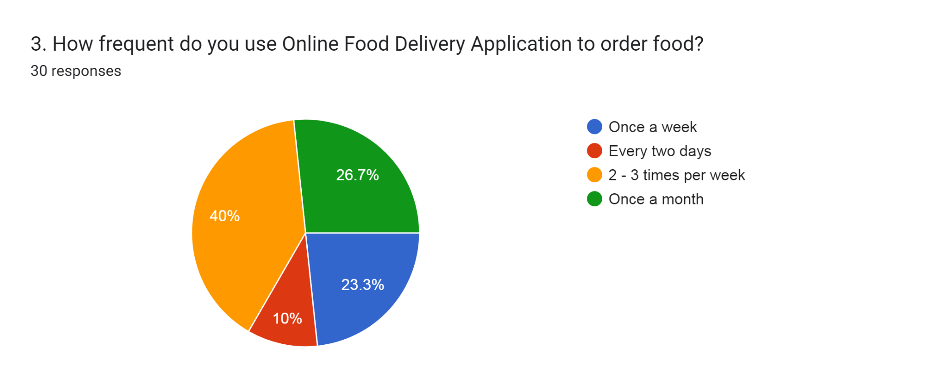
A study done by a group of researchers has used the “convenience factor” under Theory of Attitude. Convenience refers to cutting back expenses of non-monetary transactions such as time and energy through online services to purchase products. It reveals that users get the advantage of convenient ordering from home and have the food delivered which reduces time to go to the restaurant physically (Tarmazi et al., 2021).
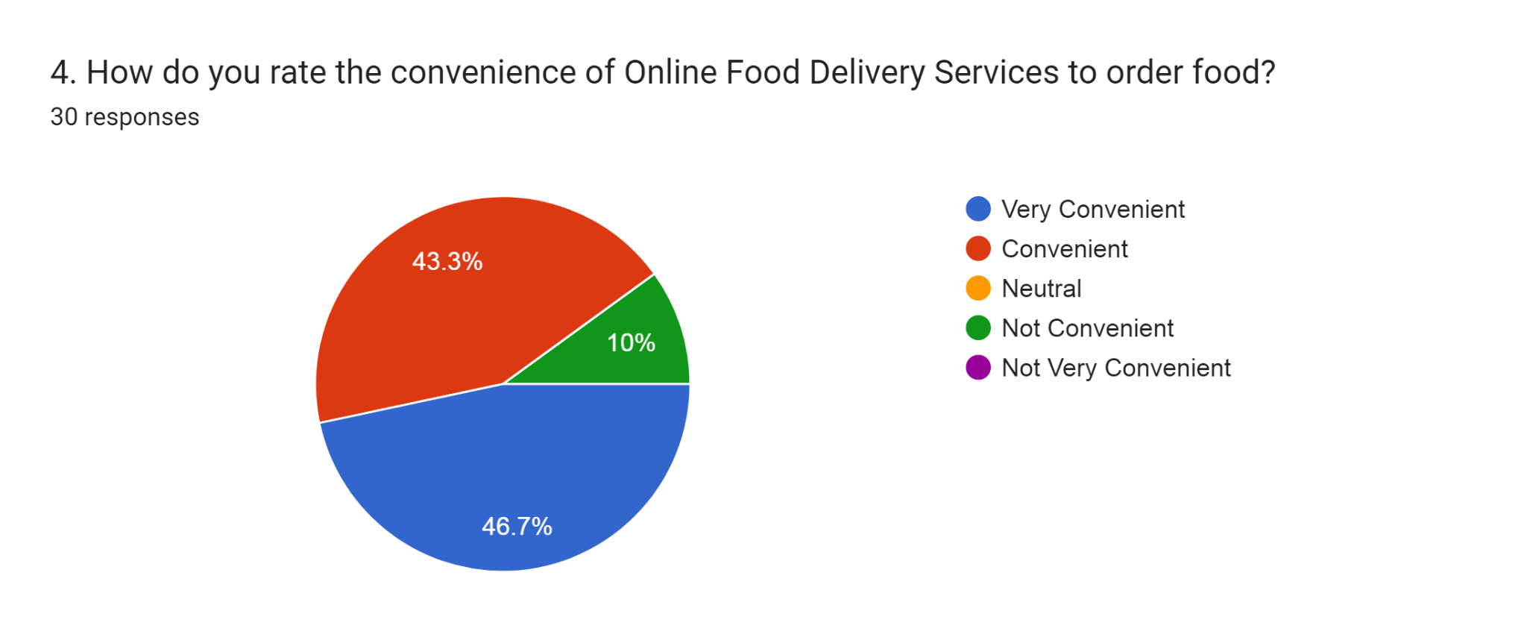
According to the result, the frequency of using online food delivery services is 40% of respondents use it 2-3 times per week, 26.7% use it once a month, 23.3% use it once a week, and 10% use it every two days. The result also shows that 46.7% of respondents agree it is very convenient to use online food delivery services and 43.3% agree it is convenient. Another 10% of respondents said otherwise, which they disagree with. It is not convenient to order food by using online food delivery services.

Based on a result of a research by Idris et al. (2021) stated there is a significant and positive relationship of factor of usefulness with the consumers intention to use online food delivery services. Previous research supports reporting that people believe in using online services, which gives a direct effect on individual’s intention to use online delivery services. Another researcher also claimed that when an online application is useful it allows for efficiency and effectiveness to increase regarding their purchasing activities which play a part for a positive relationship between consumers intention to use online food delivery services and the use of the Internet (Idris et al., 2021).
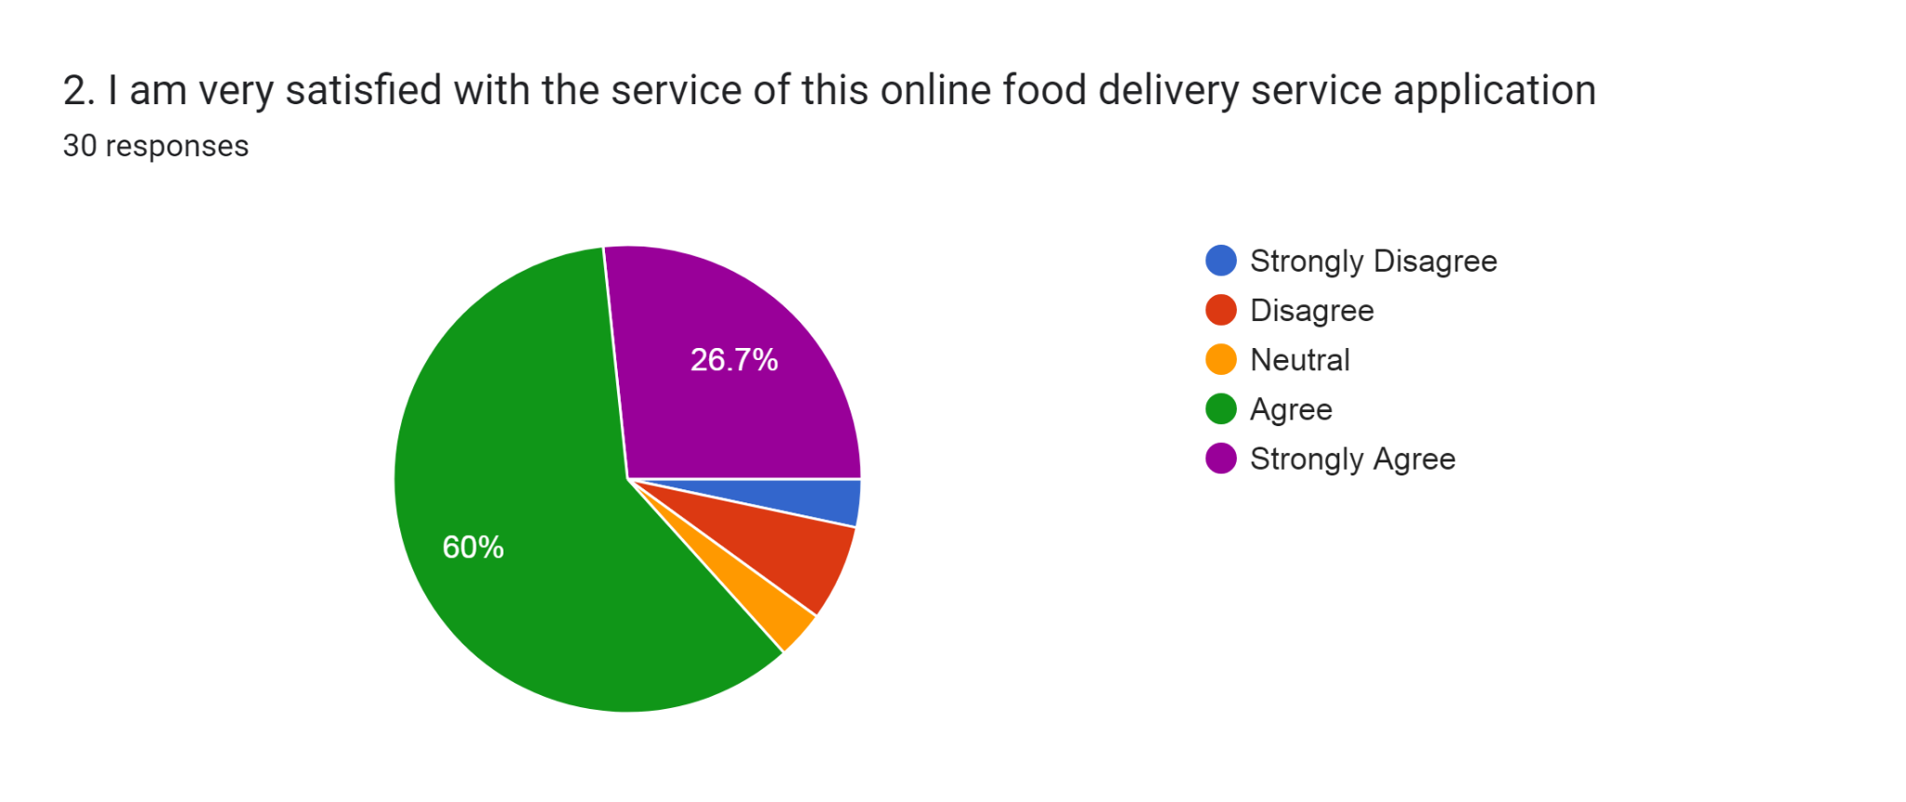
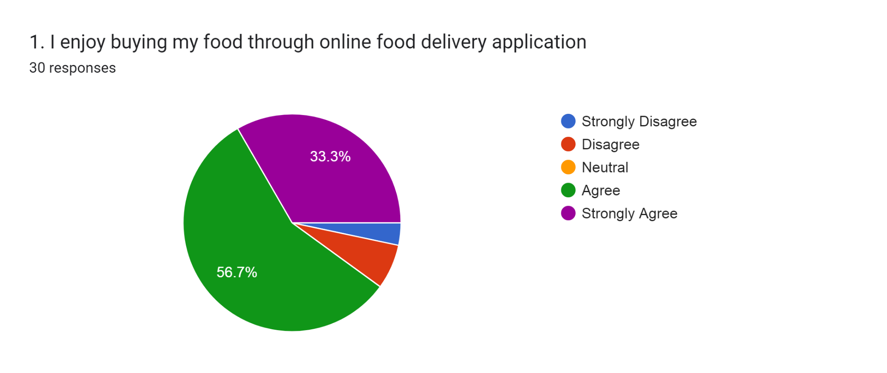
It can be supported by the result, whereby a majority of 56.7% and 33.3% of respondents agree and strongly agree they enjoy buying food through food delivery applications and using its services. Also, 60% of respondents agree and 26.7% strongly agree that they are satisfied with the service of their chosen food delivery services’ application. It can be proven that through being satisfied with the services and application, they enjoy buying food, therefore, an increase of purchasing activities that also increases consumers efficiency and effectiveness of using online food delivery services.
To conclude, when consumers believe these factors such as convenience, order accuracy, services performance, trust, and variety of choices are what shapes the attitude of consumers' intention to use online food delivery services that leads to their valued outcome. If a consumer perceives that online food delivery services bring convenience, more likely they will perceive the application to have greater value. For instance, the main reason people use mobile applications is because of convenience. The same applies to the context of how consumers see online food delivery applications (Pillai et al., 2022).

TASK 3
The link to the video presentation:
https://www.canva.com/design/DAFsjtoVkl0/bweLd2e2zdQ0VcbFXTezJg/view?utm_content=DAFsjtoVkl0&utm_campaign=designshare&utm_medium=link&utm_source=recording_view

The feedback that I got is that the presentation has a good identification of the problems, how I add value and how I am different. The slides prepared for the elevator pitch were nice, clear, and can be read well.

Things I can reflect upon in this pitch presentation is that I should have been more confident to show the original speed of the presentation video where the lecturer can hear my tone and pitch, and can assess accordingly although it goes over the time limit.

Sadly, due to prioritising the time of the presentation that goes over the limit, I made the decision to speed up the video to shorten it. The moment I received the feedback, I regretted not sending the presentation without having to speed it up as it made the lecturer face difficulty to assess and give further marks due to my mistake.

Therefore, the next time I do a presentation in the future, I will make sure to prevent setbacks that can lead me to send in the presentation video late. Also, I should be more punctual with the time limit and practise harder to convey the message more effectively next time.

TASK 4
The link to the poster:
https://www.canva.com/design/DAFtIrs6JKo/1B1hPwhtNXuaMJbIALmXIw/edit?utm_content=DAFtIrs6JKo&utm_campaign=designshare&utm_medium=link2&utm_source=sharebutton

REFERENCES
TASK 1 :
1.1 RESEARCH QUESTION
- Li, Y., et al. (2022). A thematic review on using food delivery services during the pandemic: Insights for the post-covid-19 era. International Journal of Environmental Research and Public Health, 19(22), 15267. Retrieved from https://doi.org/10.3390/ijerph192215267
- Poon, W. C., & Tung, S. E. (2022). The rise of online food delivery culture during the COVID-19 pandemic: An analysis of intention and its associated risk. European Journal of Management and Business Economics. Retrieved from https://doi.org/10.1108/ejmbe-04-2021-0128
1.2.1 DEDUCTIVE / INDUCTIVE / ABDUCTIVE
- Aberdeen, T. (2013). case study research: Design and methods (4th ed.). Thousand Oaks, ca: Sage. The Canadian Journal of Action Research, 14(1), 69–71. Retrieved from https://doi.org/10.33524/cjar.v14i1.73
- Davis, M., et al. (2020). 2.3 inductive and deductive reasoning. Foundations of Social Work Research. Retrieved from https://uta.pressbooks.pub/foundationsofsocialworkresearch/chapter/2-3-inductive-and-deductive-reasoning/
1.2.2 QUALITATIVE / QUANTITATIVE / MIXED METHODS
- Apuke, O. D. (2017). Quantitative research methods : A synopsis approach. Kuwait Chapter of Arabian Journal of Business and Management Review, 6(11), 40–47. Retrieved from https://doi.org/10.12816/0040336
- Schoonenboom, J., & Johnson, R. B. (2017). How to construct a mixed methods research design. Retrieved from https://www.ncbi.nlm.nih.gov/pmc/articles/PMC5602001/
- Tenny, S., Brannan, J. M., & Brannan, G. D. (2022). Qualitative study - statpearls - NCBI bookshelf. National Library of Medicine. Retrieved from https://www.ncbi.nlm.nih.gov/books/NBK470395/
1.3.1 PRIMARY / SECONDARY METHODS
- Hewson, C. M. (2006). (PDF) Primary Research. Research Gate. Retrieved from https://www.researchgate.net/publication/43127437_Primary_Research
- Roopa, S., & Rani, M. (2012). Questionnaire designing for a survey. The Journal of Indian Orthodontic Society, 46, 273–277. Retrieved from https://doi.org/10.5005/jp-journals-10021-1104
- Unachukwu, L. C., et al. (2018). Accessing secondary data : A literature review. Singaporean Journal of Business Economics and Management Studies, 6(6), 53–63. Retrieved from https://doi.org/10.12816/0048423

1.4.1 DATA SAMPLING METHOD
- Campbell, S., et al. (2020). Purposive sampling: Complex or simple? research case examples. Journal of Research in Nursing, 25(8), 652–661. Retrieved from https://doi.org/10.1177/1744987120927206
- Golzar, J., et al. (2022). Convenience sampling. researchgate. https://www.researchgate.net/profile/Jawad-Golzar-2/publication/366390016_72_P_a_g_e_Convenience_Sampling/links/639e7cdee42faa7e75d0bd89/72-P-a-g-e-Convenience-Sampling.pdf
- Turner, D. P. (2020). Sampling methods in research design. Headache: The Journal of Head and Face Pain, 60(1), 8–12. Retrieved from https://doi.org/10.1111/head.13707
1.4.2 SAMPLE SIZE
- Memon, M. A., et al. (2020). Sample Size For Survey Research: Review and recommendations. Journal of Applied Structural Equation Modeling, 4(2), i–xx. Retrieved from https://doi.org/10.47263/jasem.4(2)01

TASK 2 :
- Idris, N. A., et al. (2021). Consumers’ intention towards online food ordering and Delivery Service. Jurnal Intelek, 16(2), 37–47. Retrieved from https://doi.org/10.24191/ji.v16i2.396
- Pillai, S. G., et al. (2022). Online food delivery services and consumers’ purchase intention: Integration of theory of planned behavior, theory of perceived risk, and the elaboration likelihood model. International Journal of Hospitality Management, 105, 103275. Retrieved from https://doi.org/10.1016/j.ijhm.2022.103275
- Tarmazi, S. A., et al. (2021). Consumer purchase intention toward online food delivery service: The implication for future research. Malaysian Journal of Social Sciences and Humanities (MJSSH), 6(9), 347–354. Retrieved from https://doi.org/10.47405/mjssh.v6i9.972

APPENDIX
SECTION A (PART 1): DEMOGRAPHIC
1.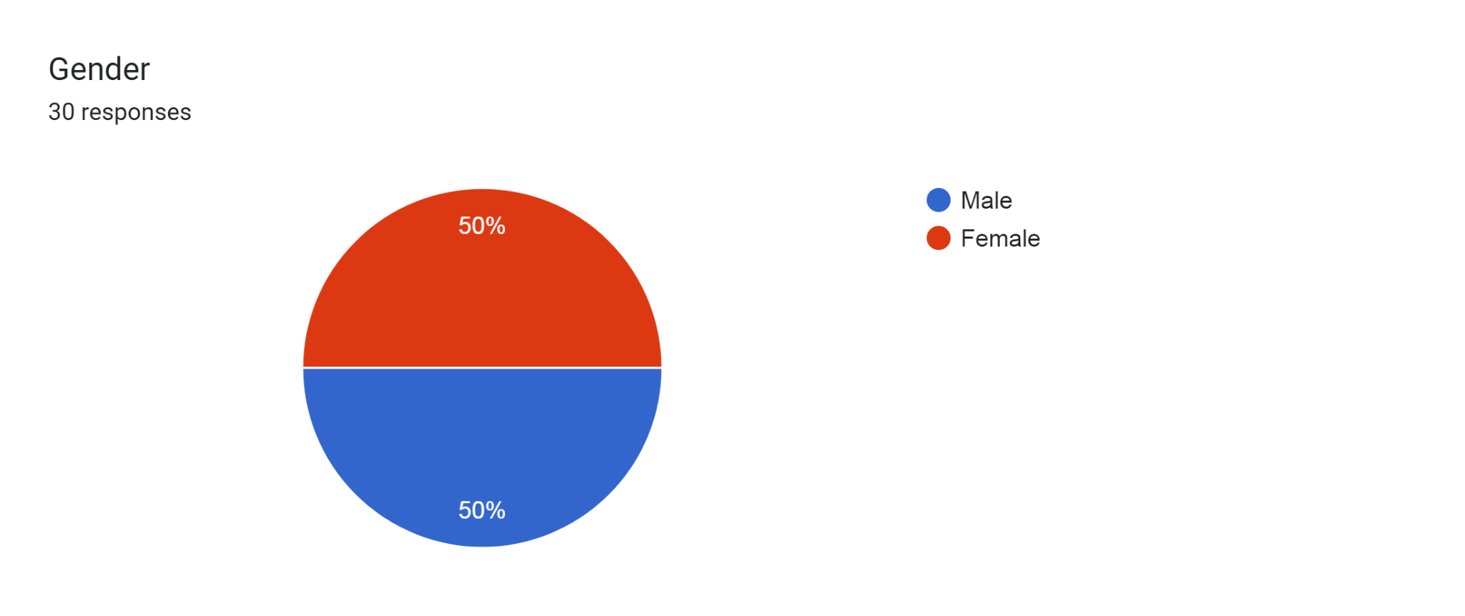
2.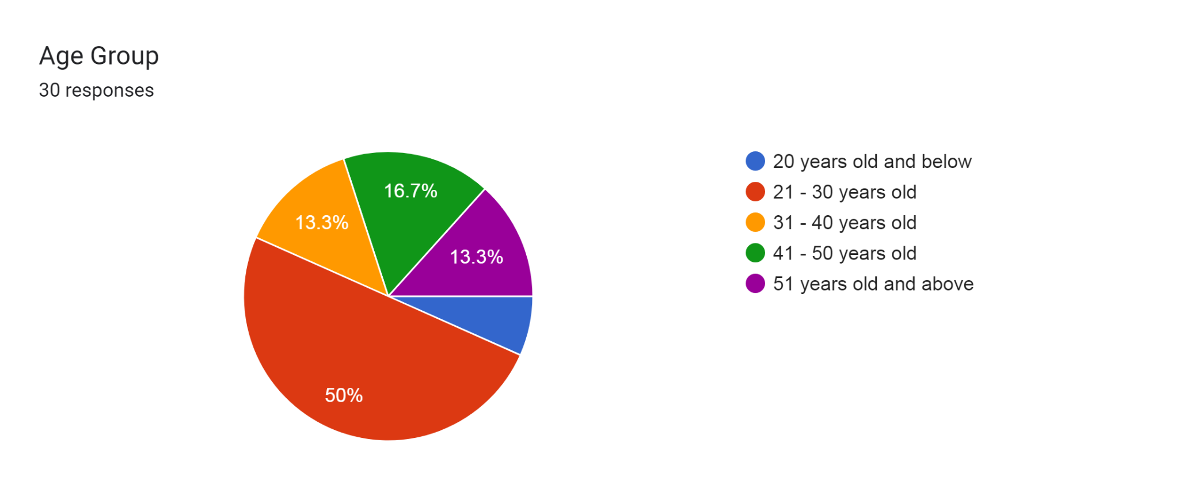

3.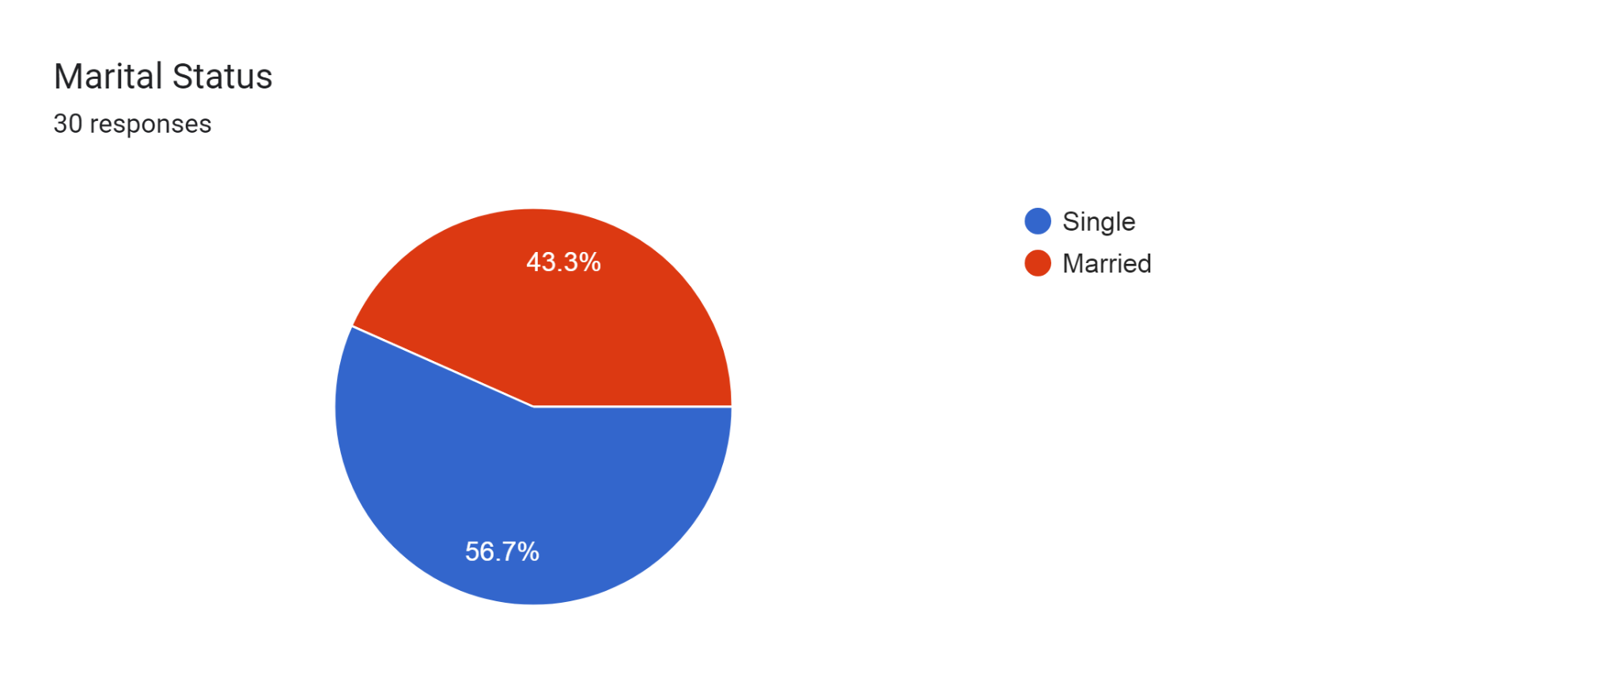
4.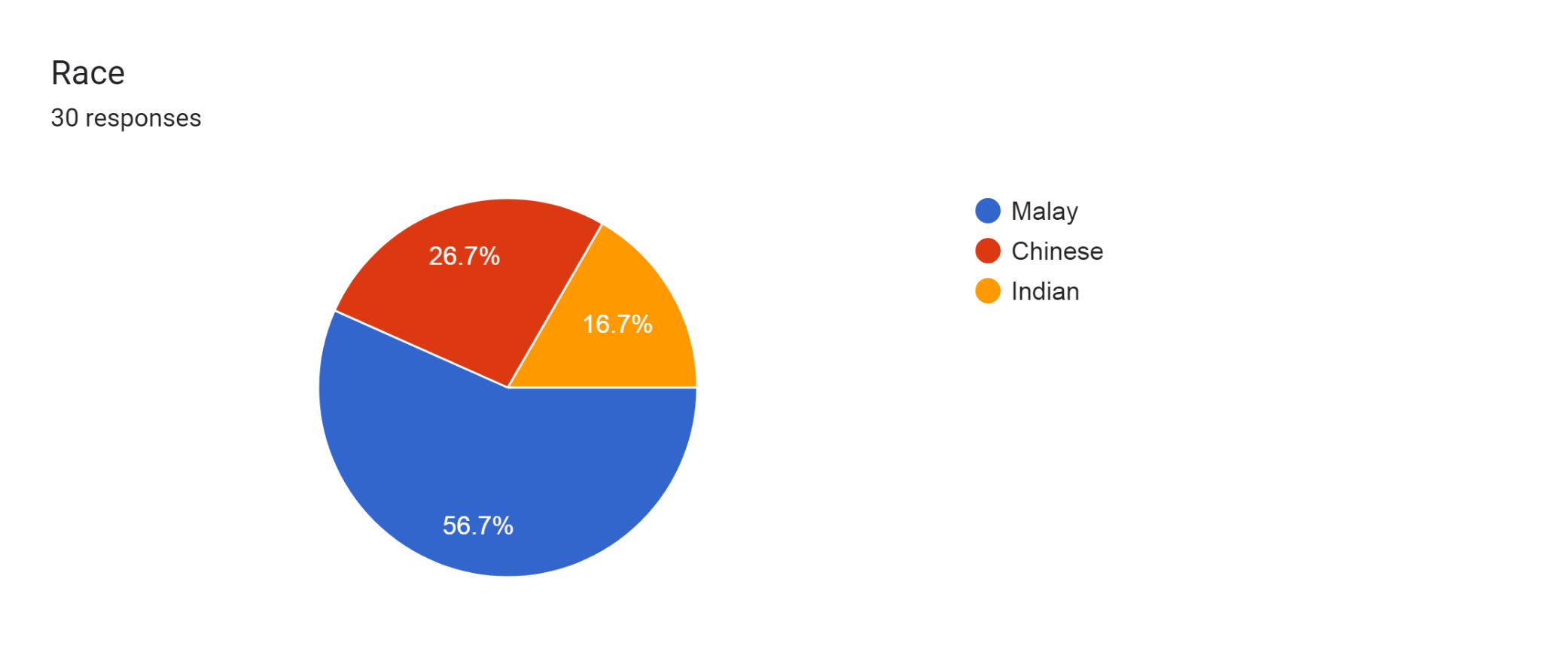

5. *Please ignore the section of “Full-time students” category as there was an error, instead please take the percentage of “Students,” which is the correct category.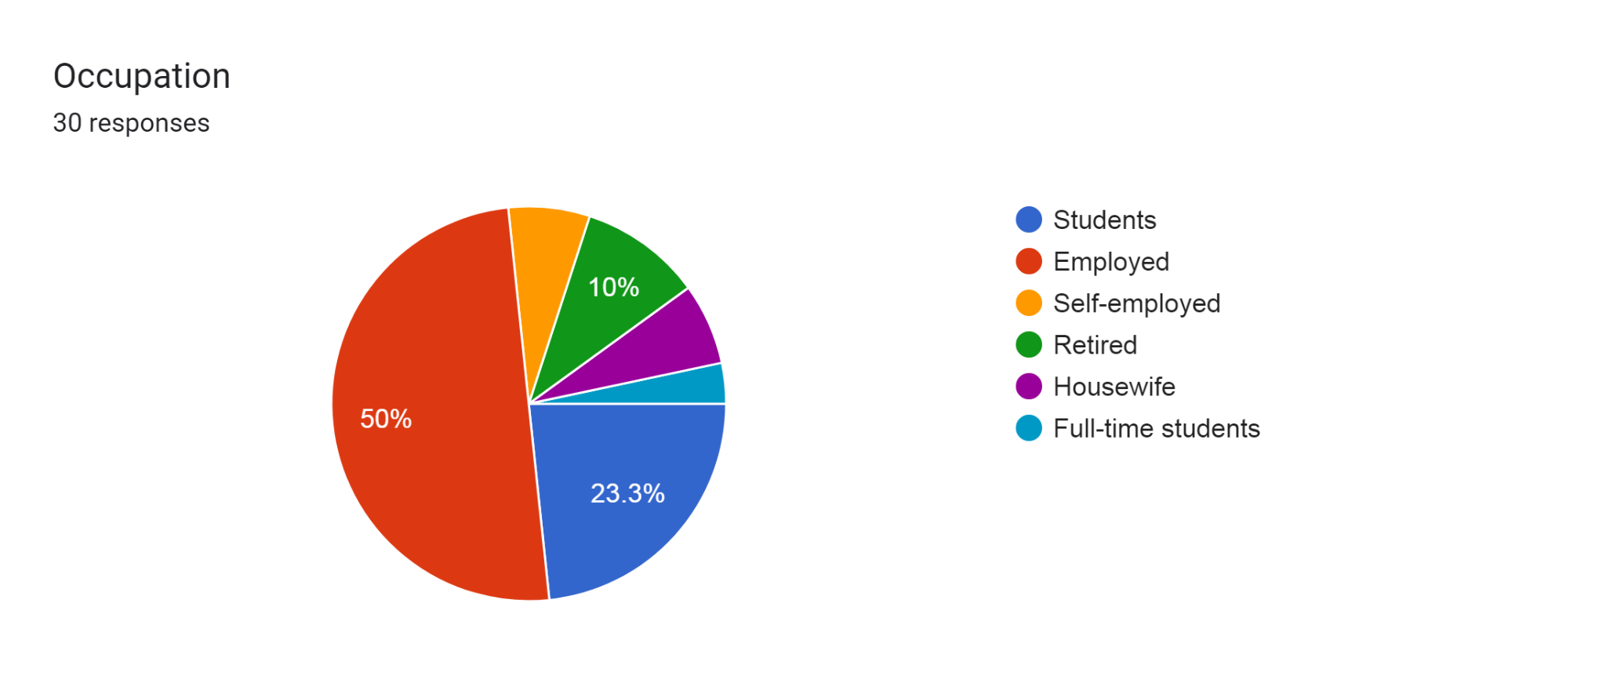
6.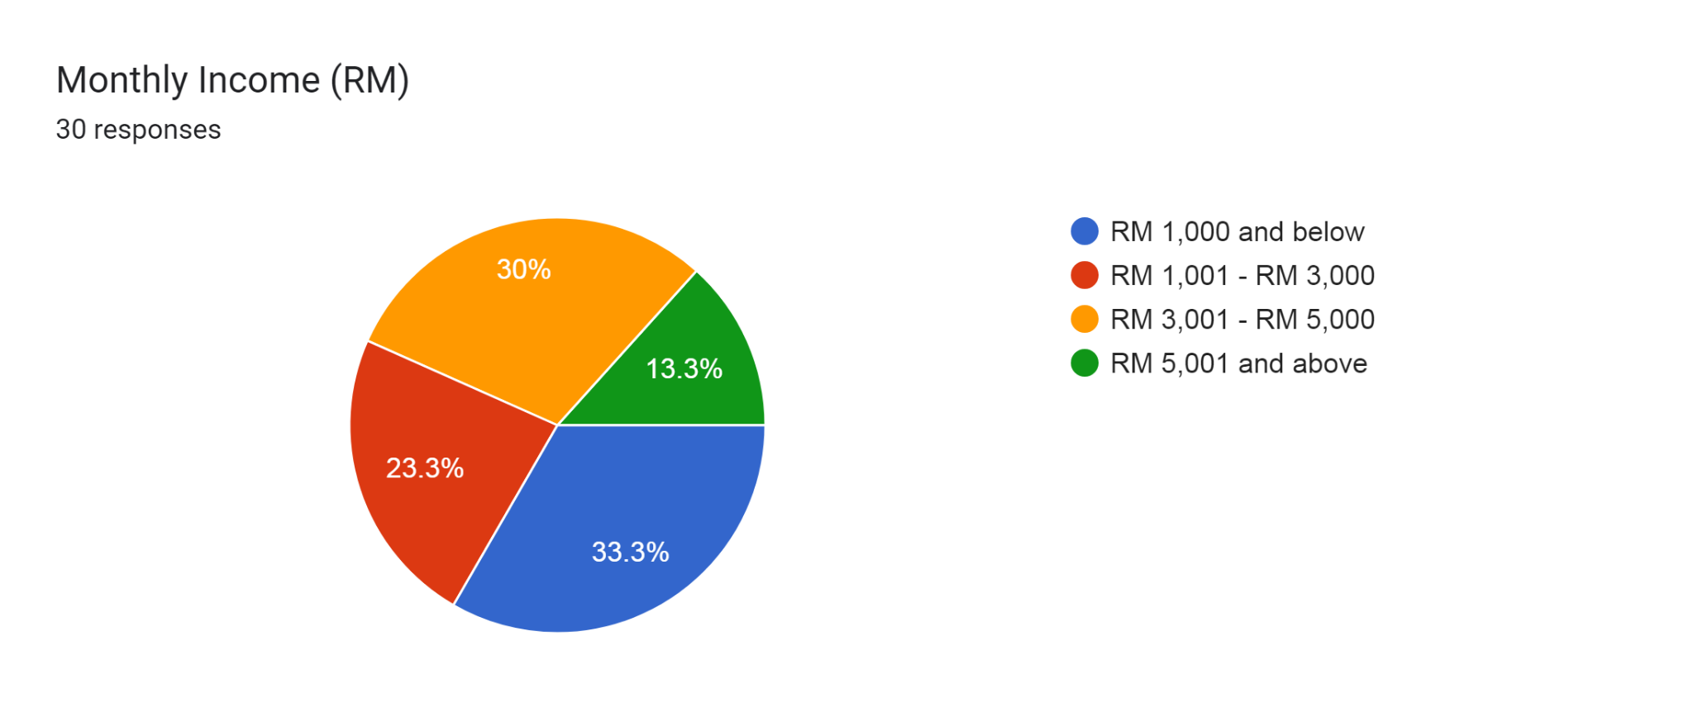

SECTION A (PART 2): FAMILIARITY WITH ONLINE FOOD DELIVERY SERVICES
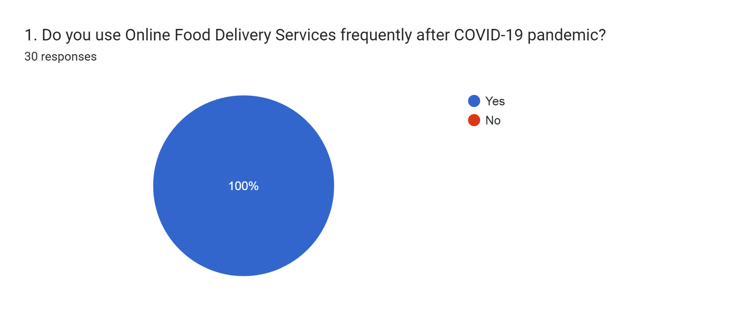
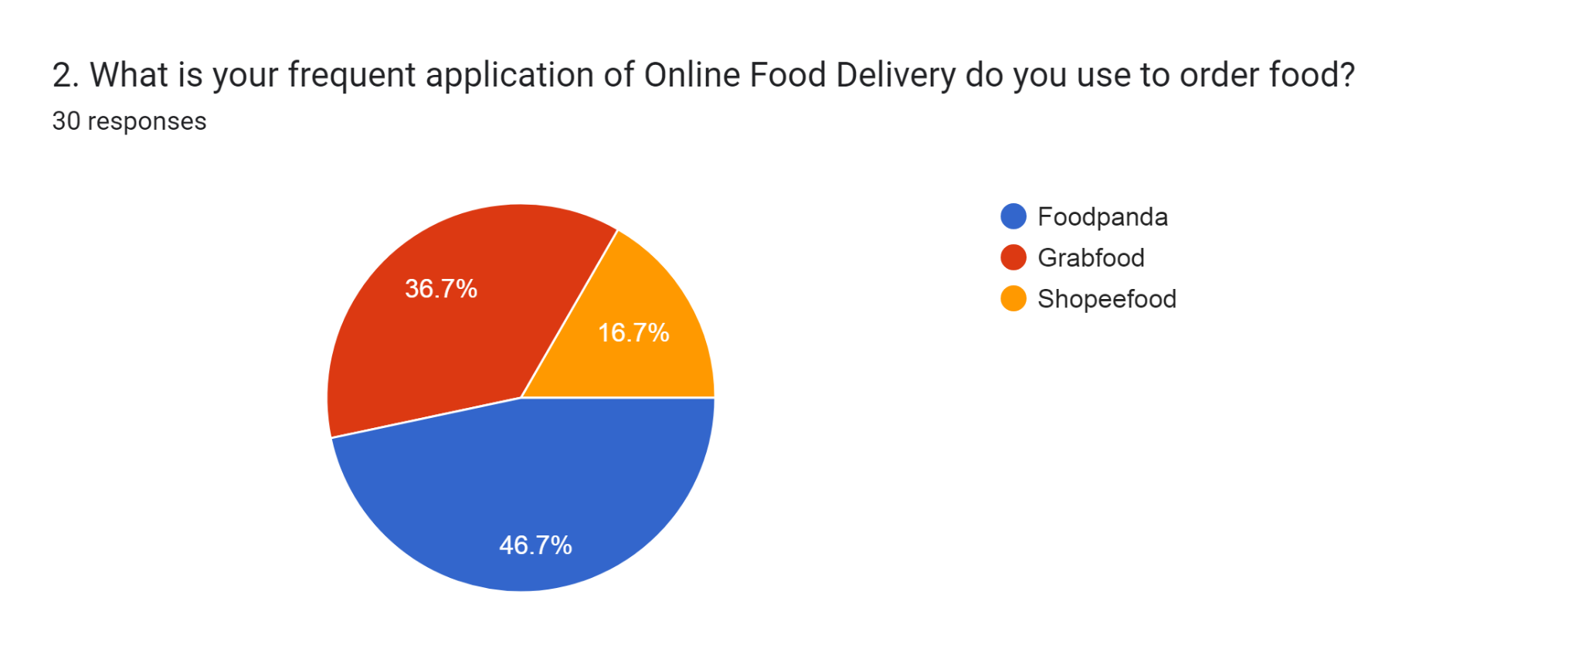

SECTION B: EFFICIENCY
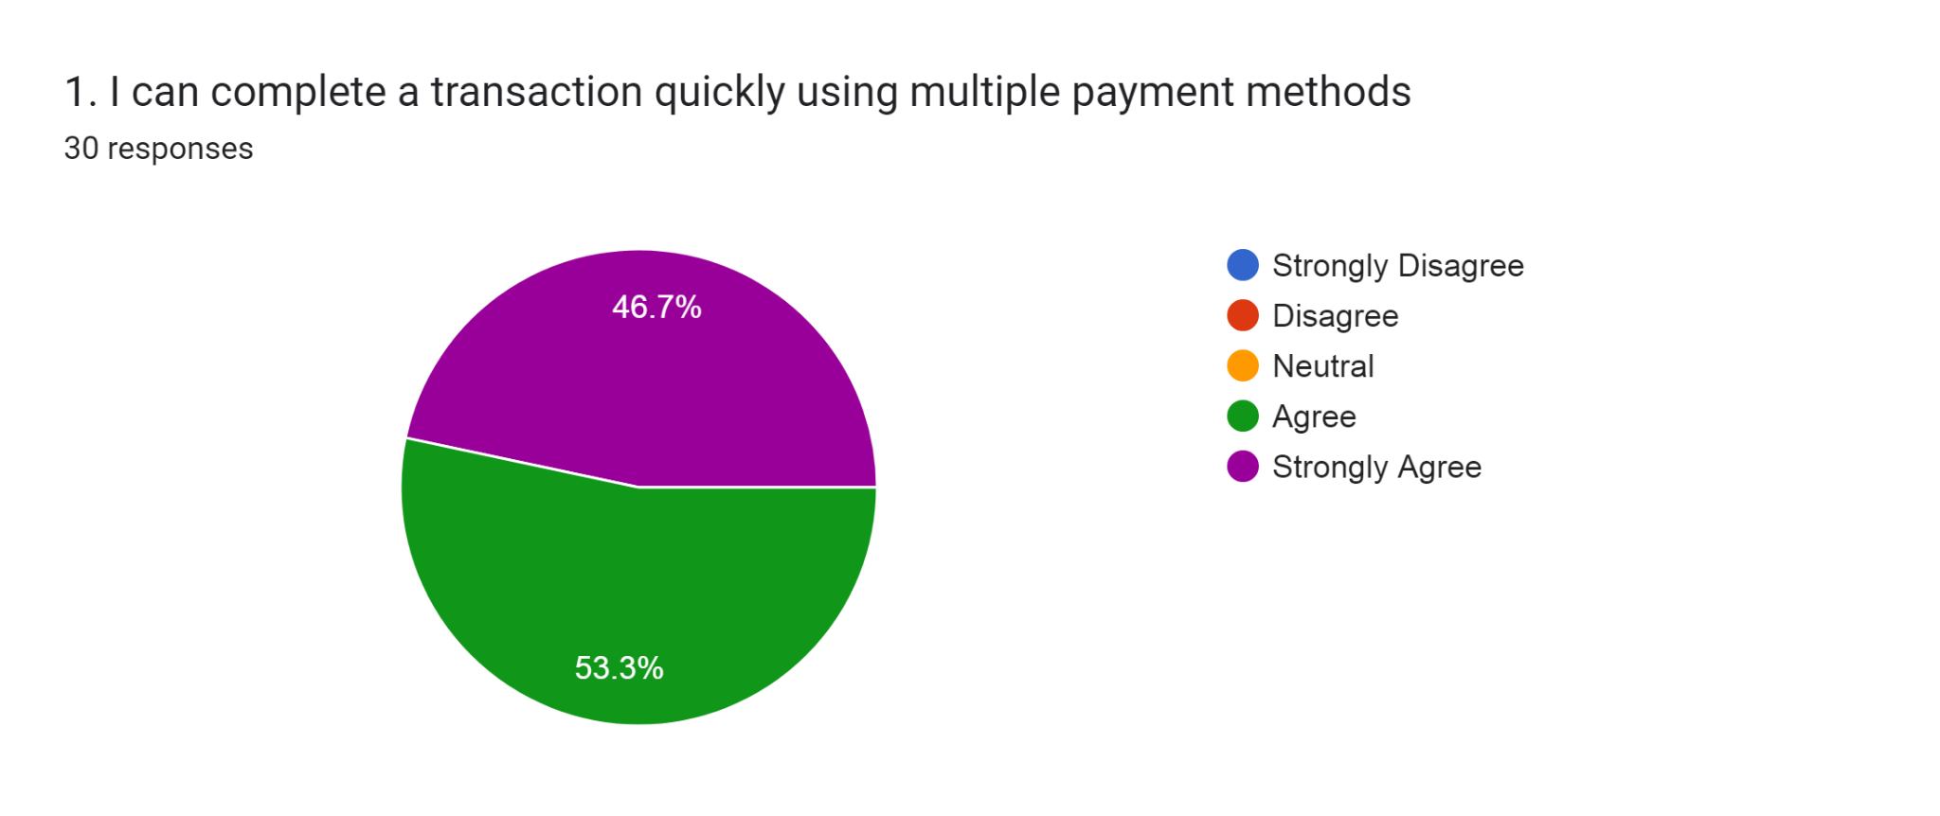
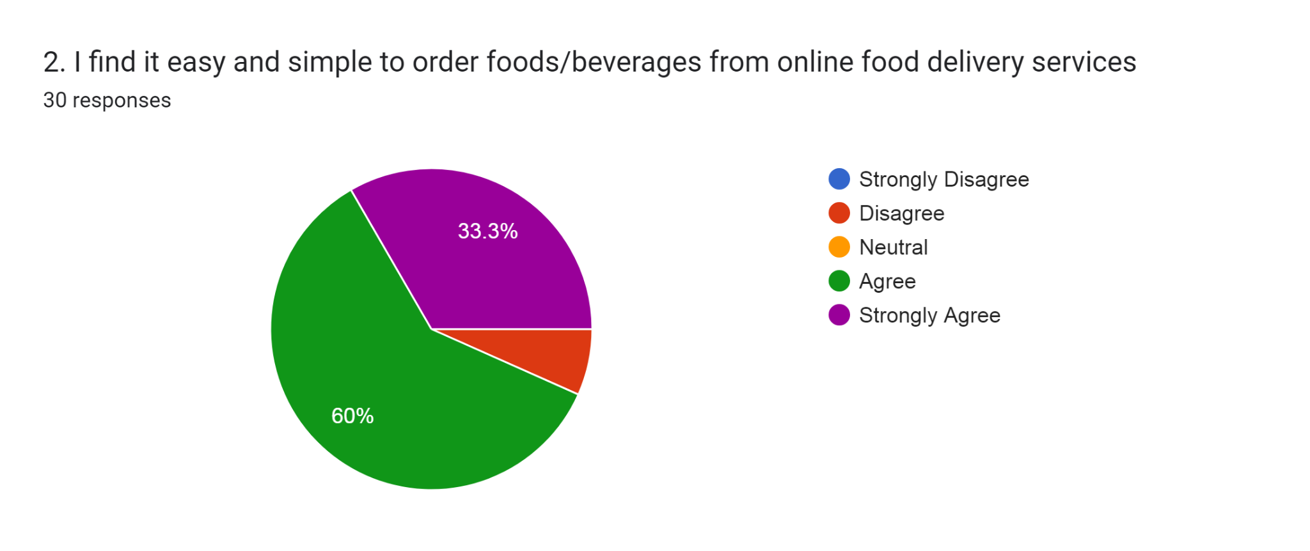
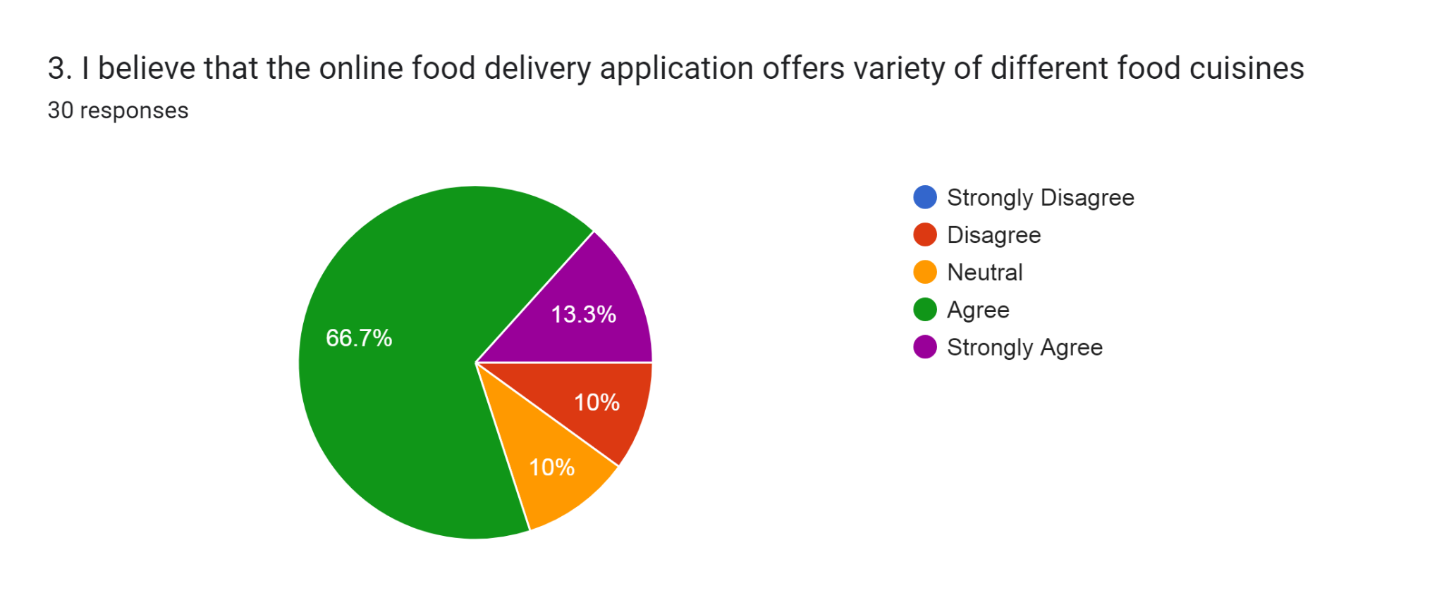
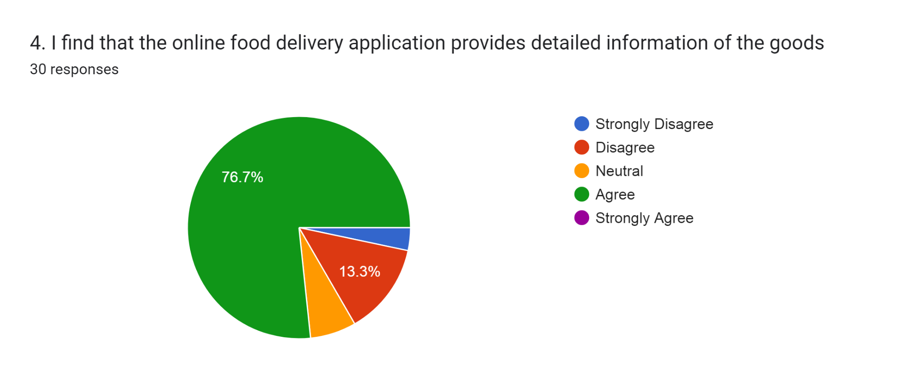
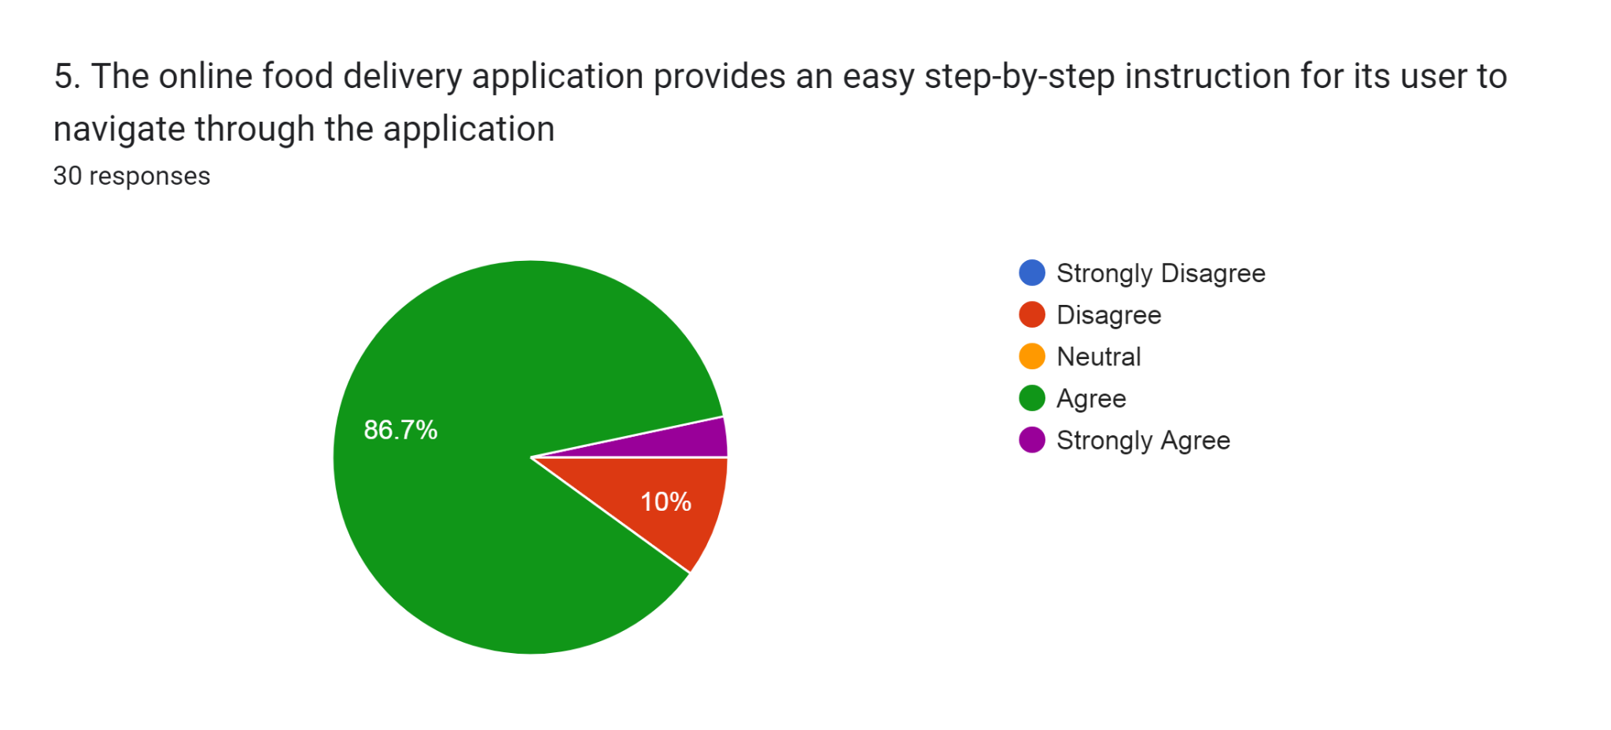
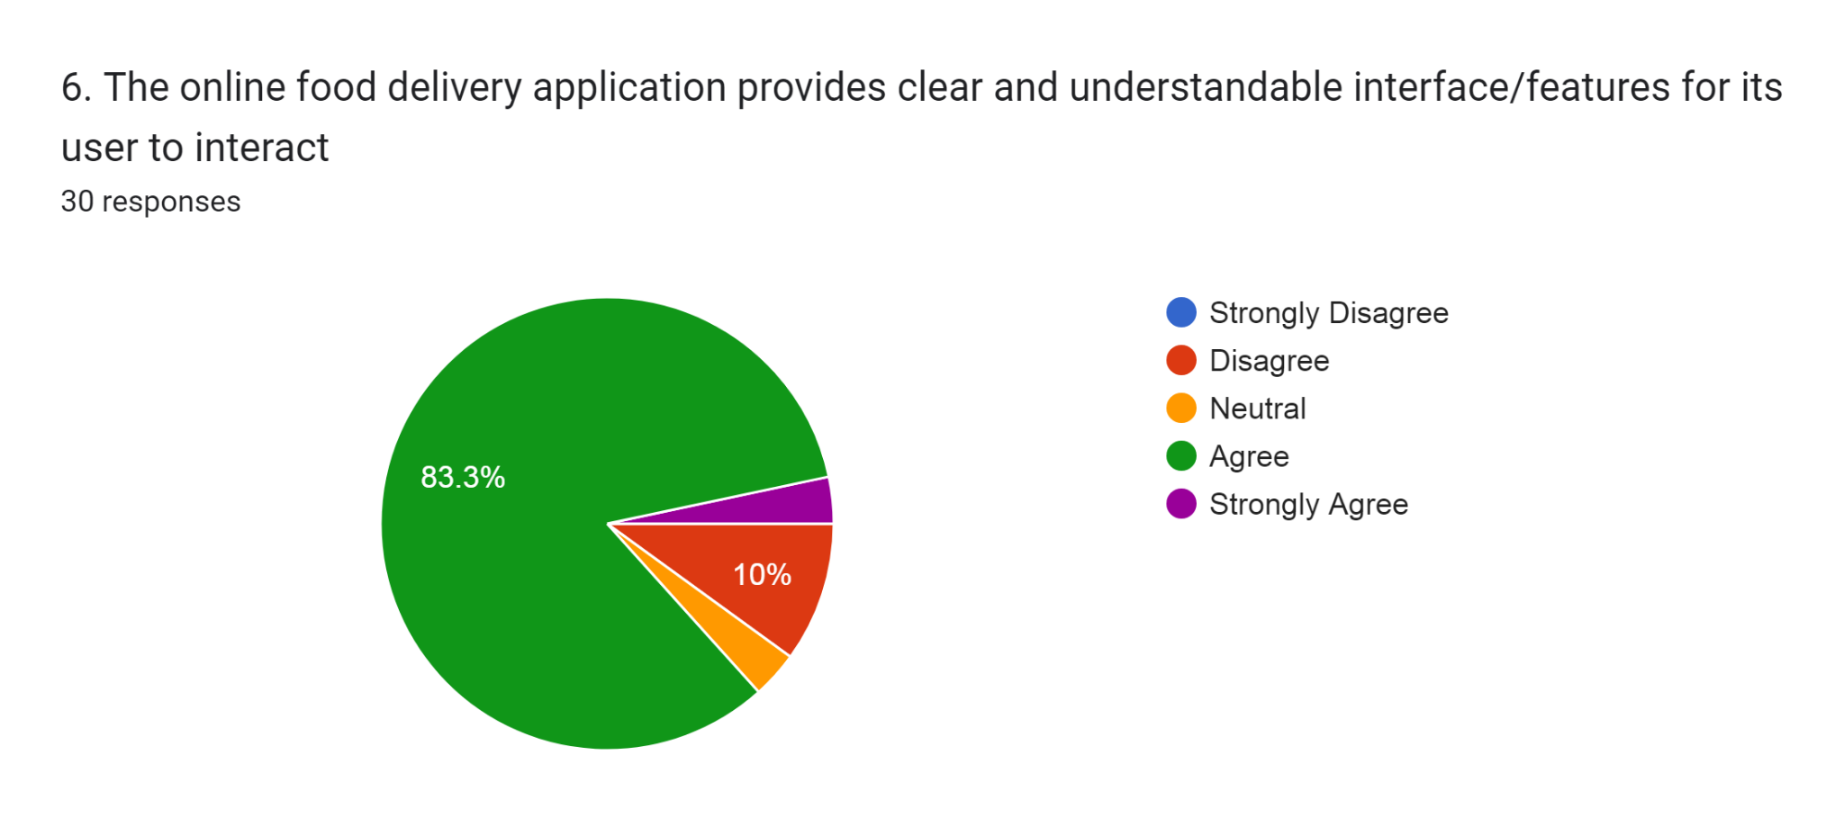

SECTION C: FULFILMENT
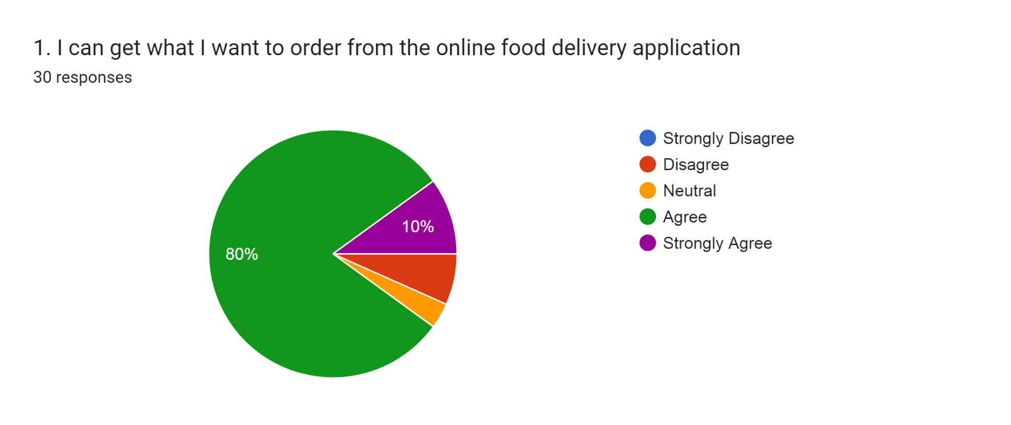
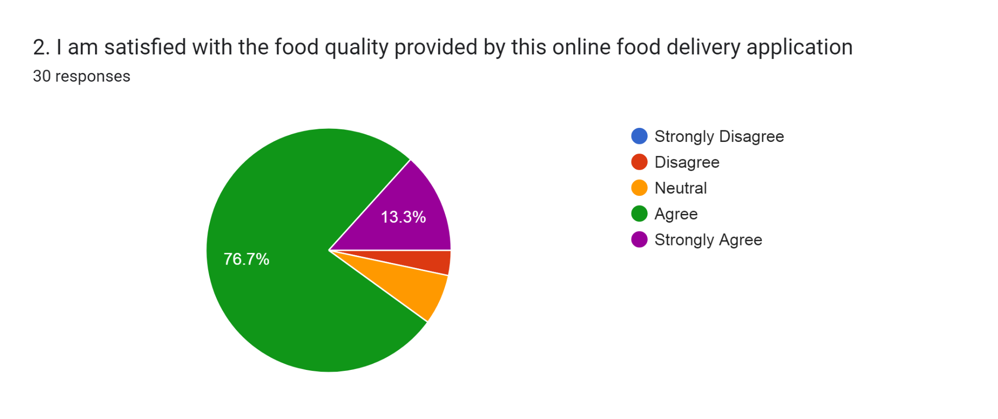
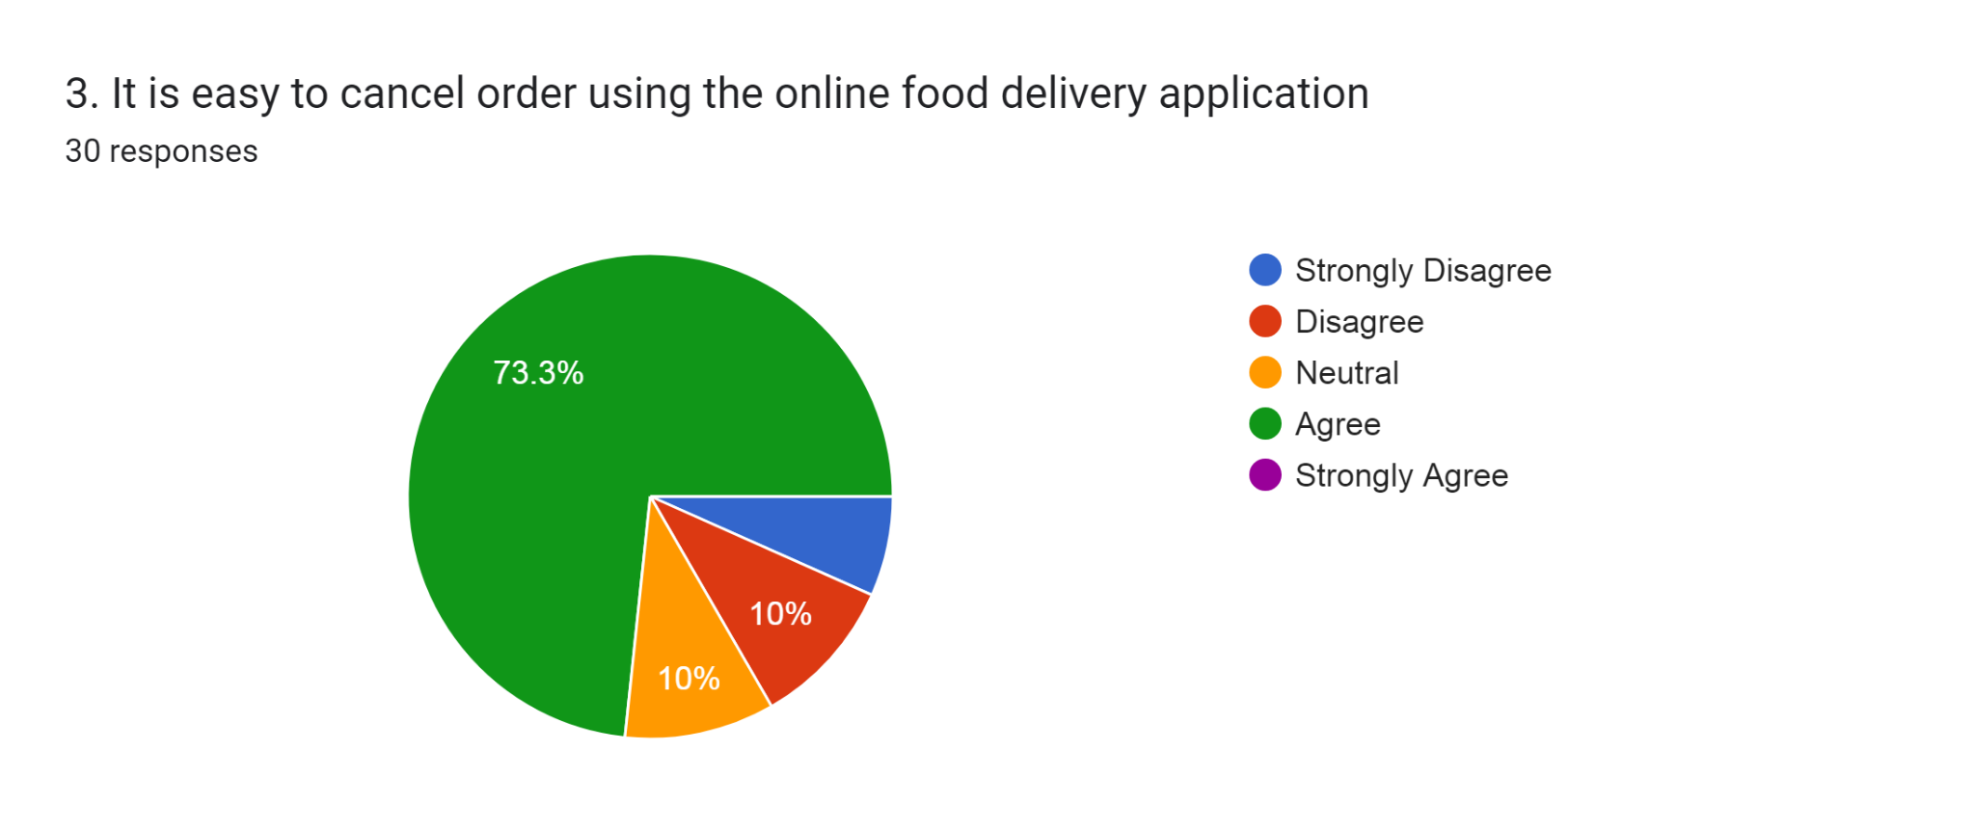
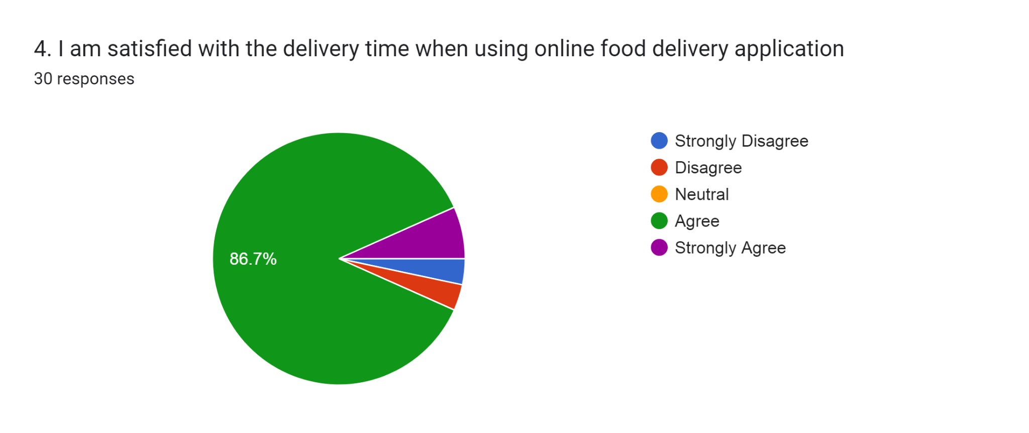
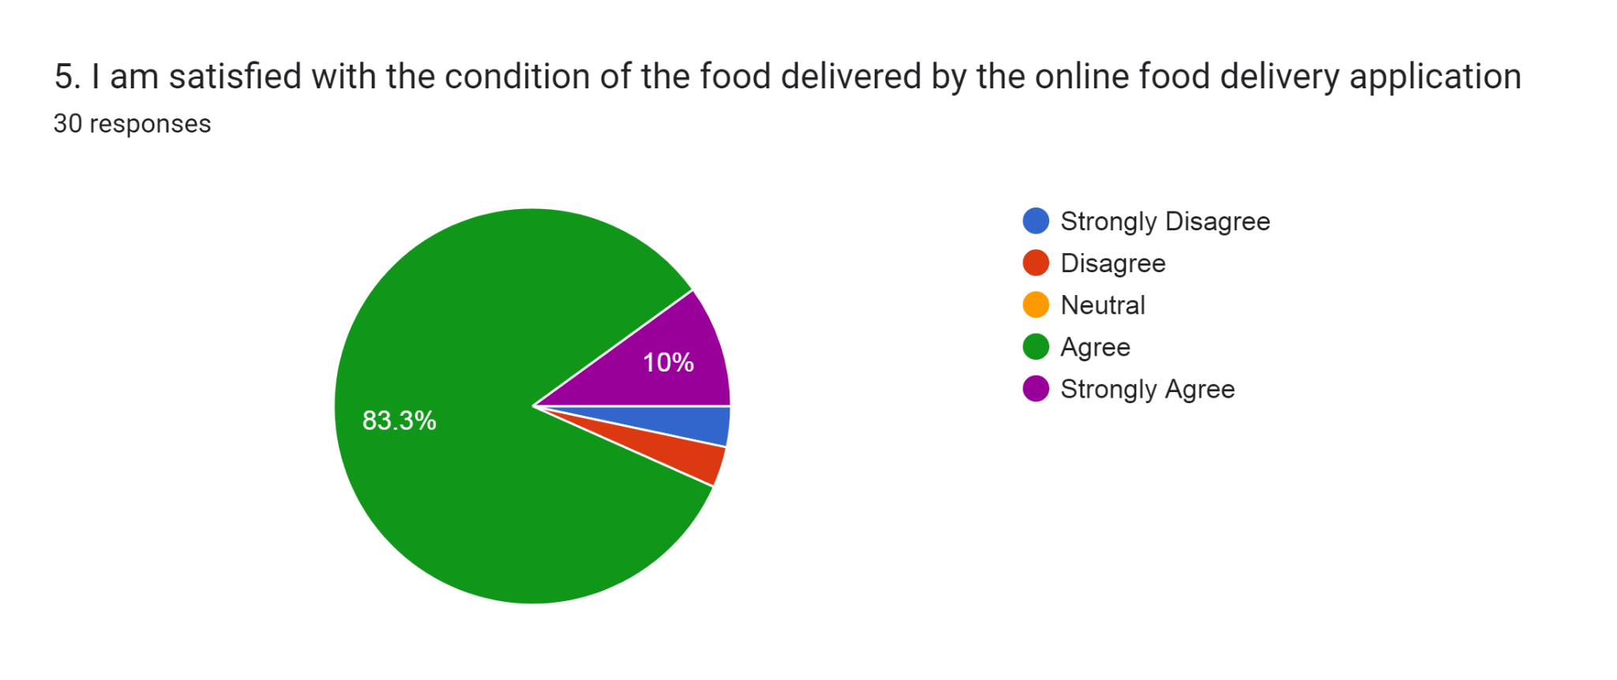
SECTION D: PRIVACY
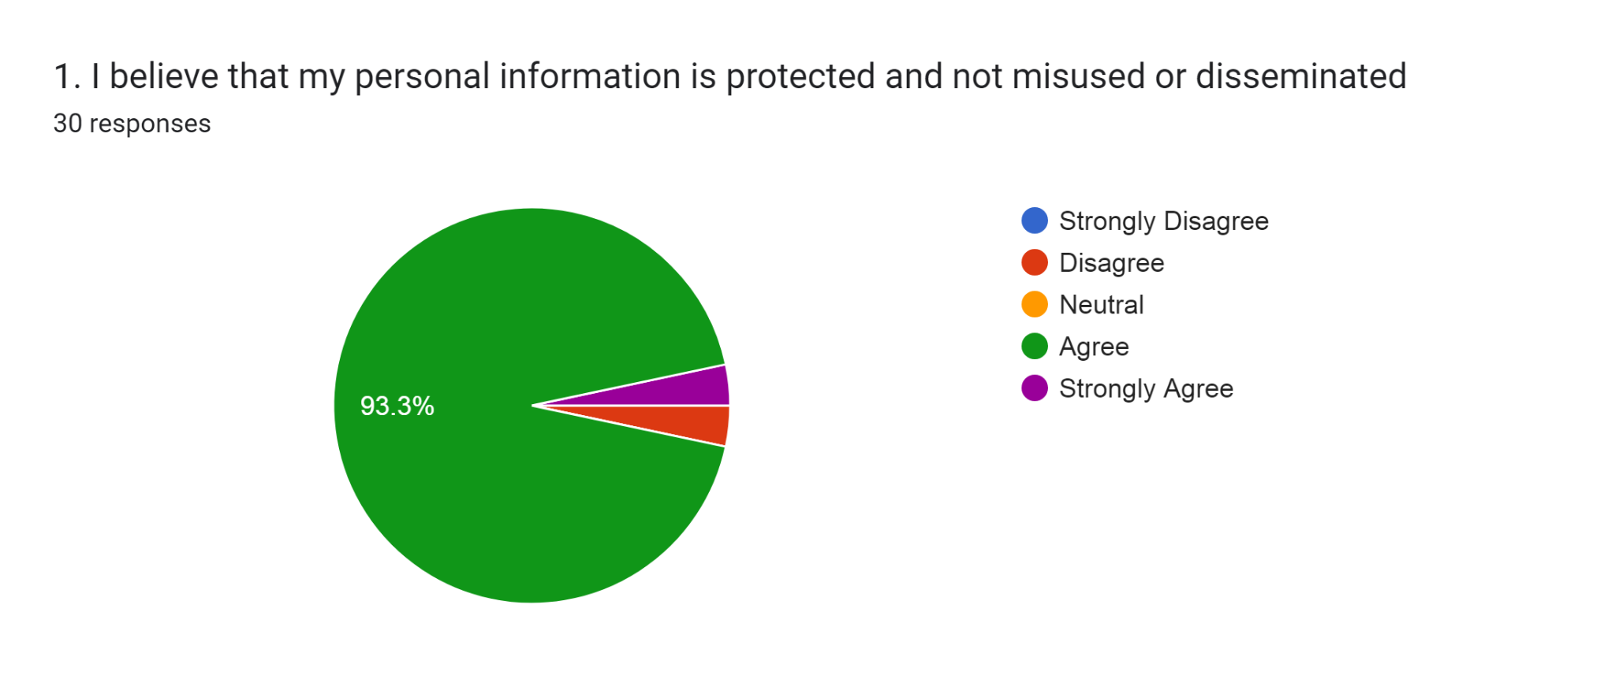
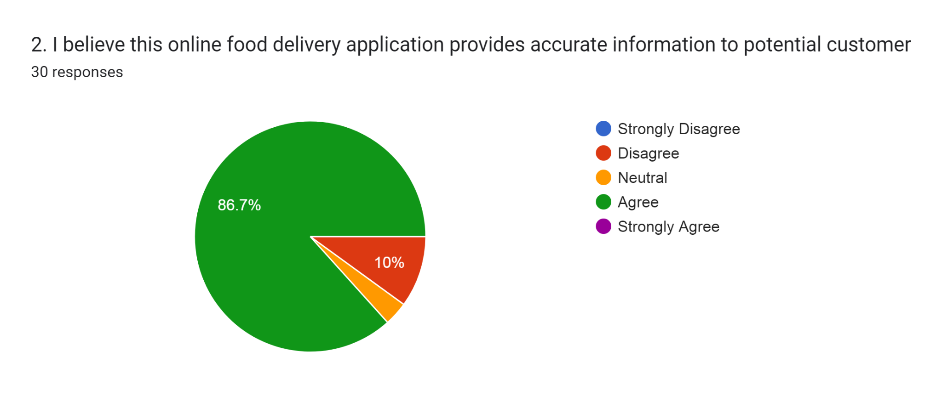
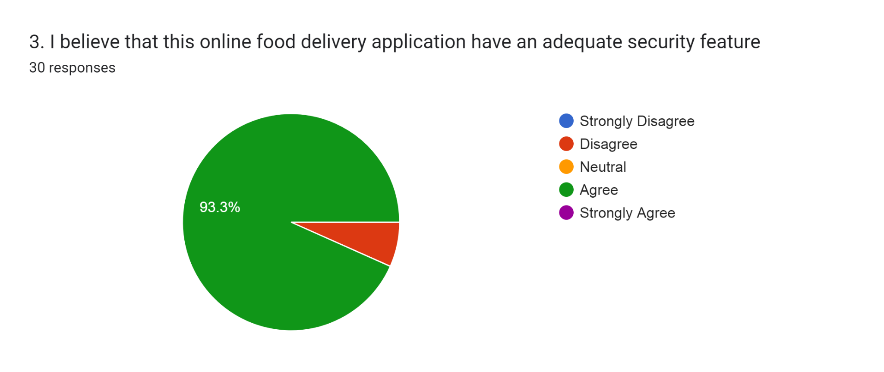
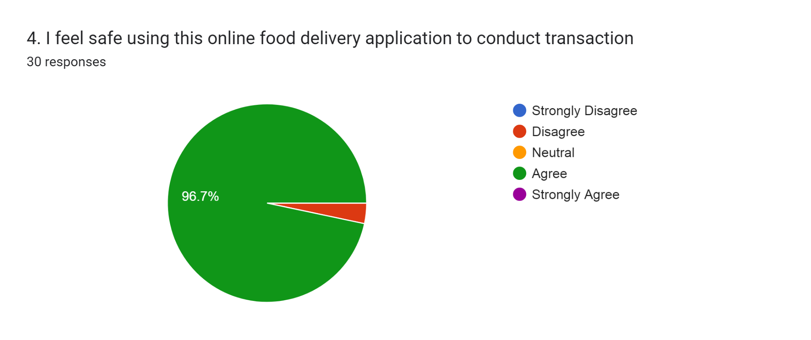
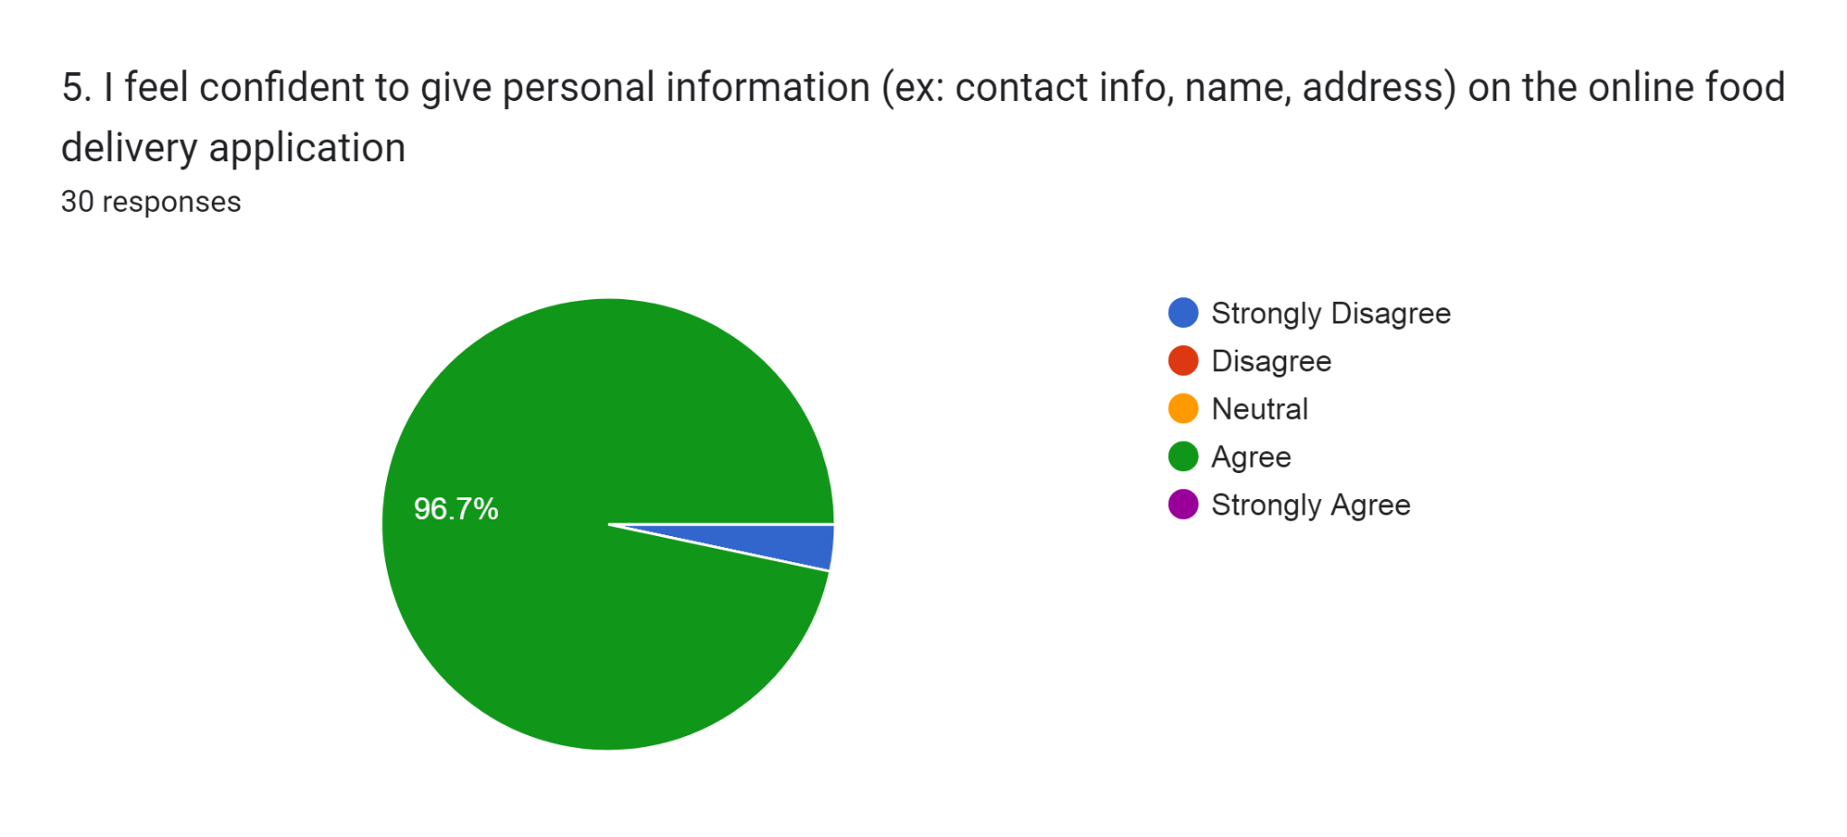

SECTION E: RESPONSIVENESS
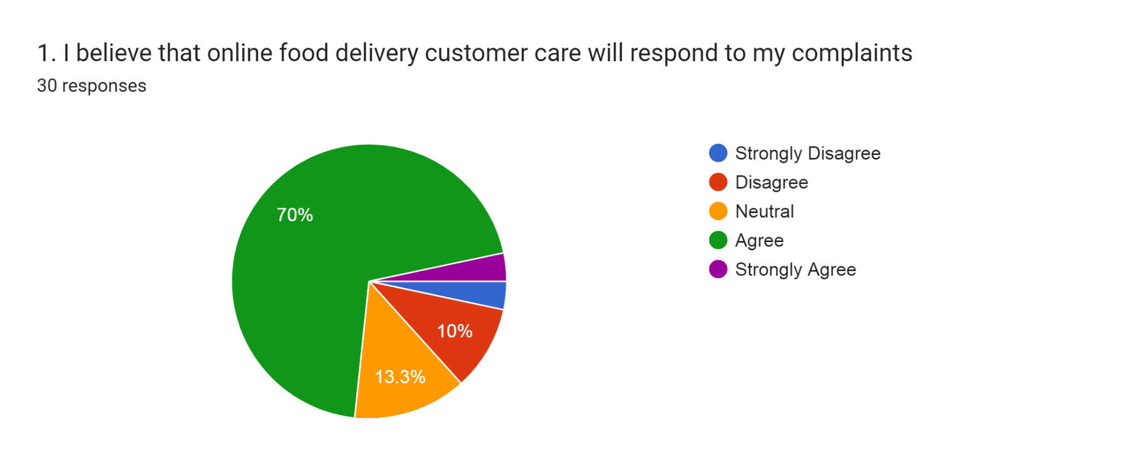
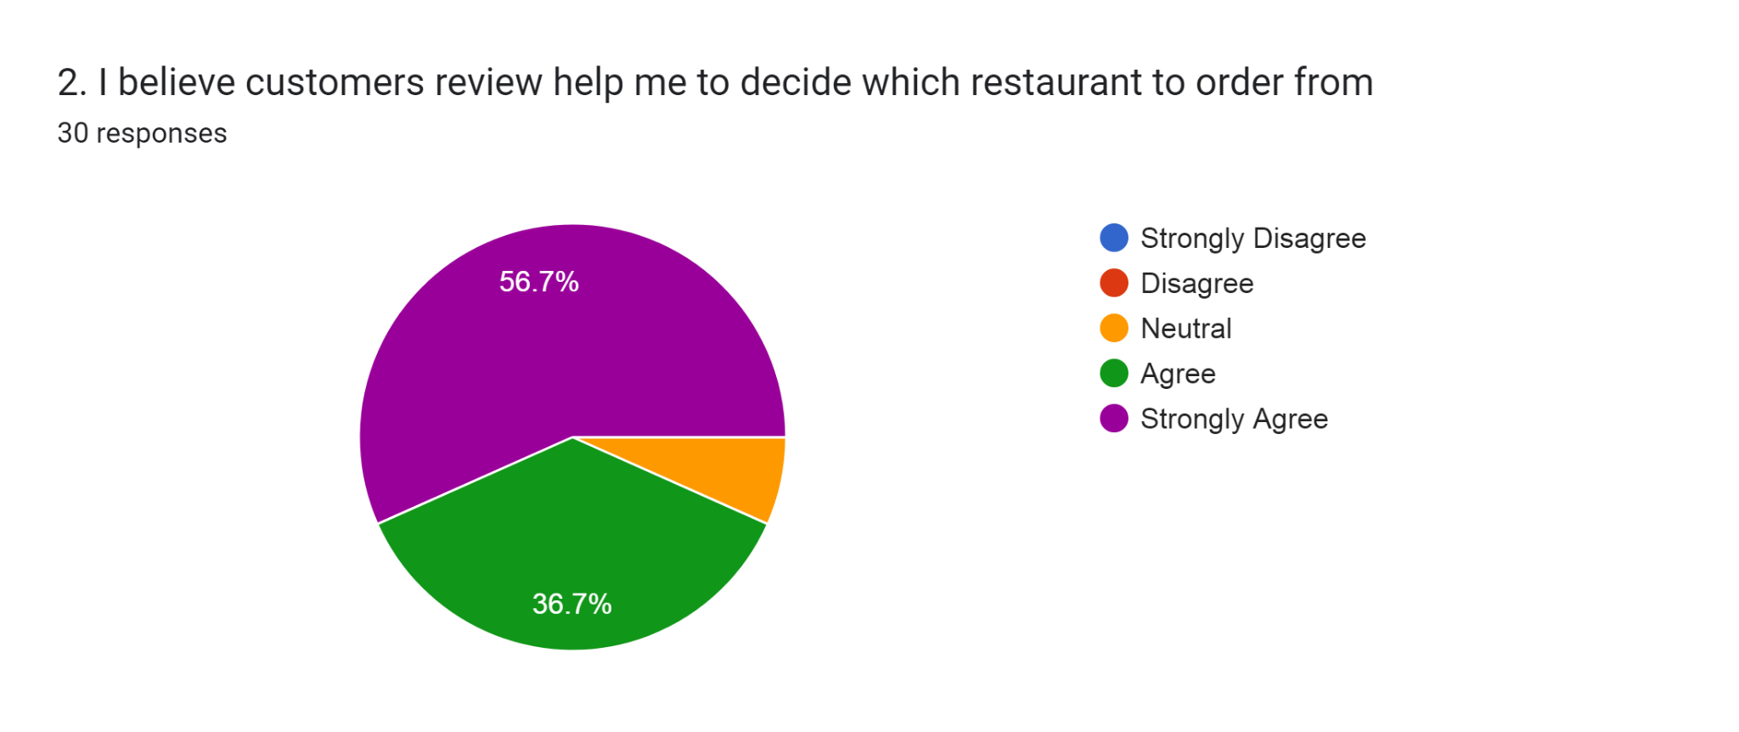
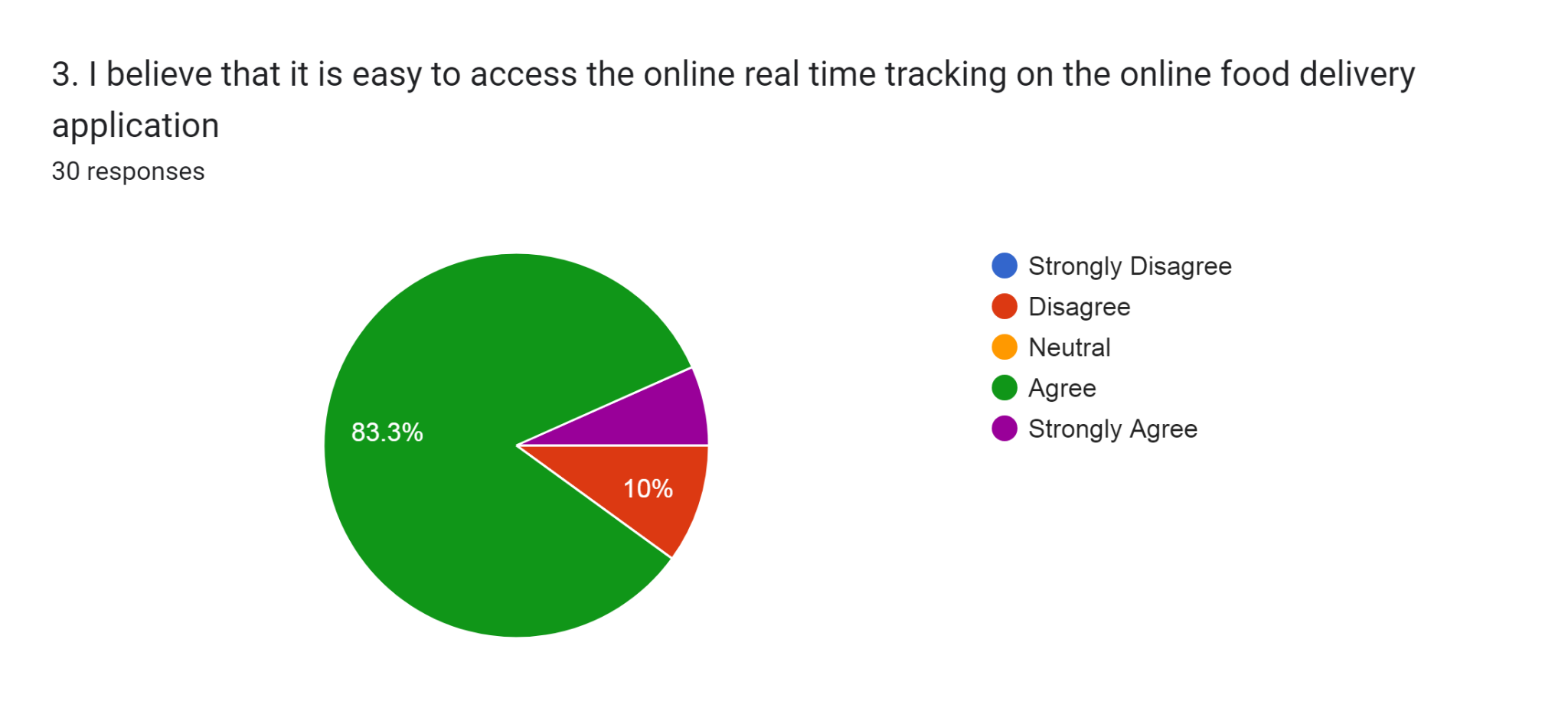
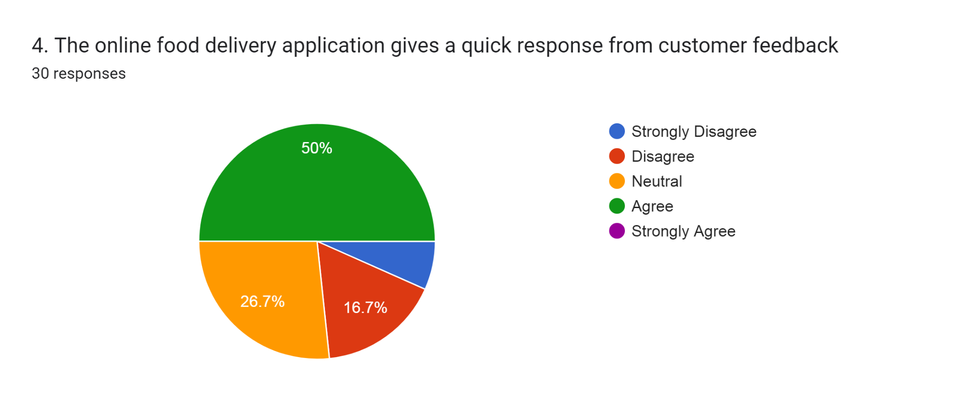
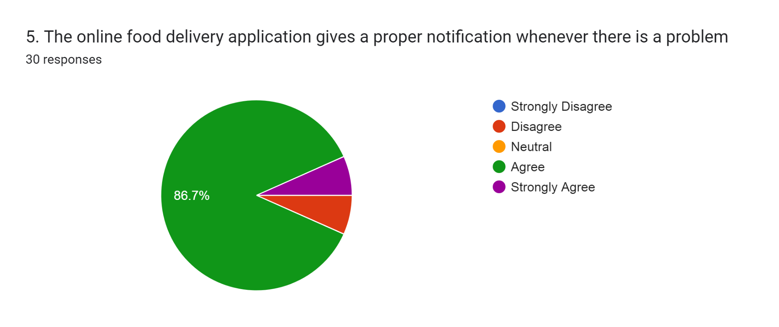

SECTION F: CUSTOMER SATISFACTION


