Marketing Fundamentals Analysis and Evaluation
Assessment 2

ZARA-Marketing Analysis



Yani Yanakiev
1920744
BABM LEVEL 4 GROUP 1
Lecturer: Tushara Balendran
30.08.2020

Contents:

- The role of the marketing increating the value of customers ……………….……... 3
  - Definition of the societal marketing concept…………………………...….... 3
  - Definition of Branding…………….…………………………………….….. 3
  - Ansoff Matrix …………………………………..……...………………....… 4
  - Relationship Marketing…………………………………………………...… 6
- Stakeholder engagement and their impact on the marketing activities of Zara…..... 6
  - Stakeholders Definition …………………………………..………………... 6
  - Internal and External Stakeholders ………………………….…….……….. 7
  - Stakeholders communication …………………………………………...….. 8
Conclusion and recommendation ………………….…………………………..…….. 8 References …………………………………….………………………………..…….. 10

- The role of the marketing increating the value of customers
1.1 Definition of the societal marketing concept
Social marketing, also called the social responsibility of marketing, refers to the "obligation of marketing obligation to do no harm to the social environment and, wherever possible, to use their skills and resources to enhance that environment.
In therefore follows that according to the societal marketing concept, the organisation should determine the needs, wants and interest of target markets. It should then deliver better value to customers in such a way that it maintains or improves the consumers and society's wellbeing. (Cant, Strydom, Jooste, Plessis, 2006, p.13)
Zara supports different organisations around the world, developing programmes for vulnerable groups. Since 2008 Zara start the project SALTA which is helping to hire people with a special need or in a vulnerable situation. In 2011 they began to support CARITAS which is promoting the creation and stabilisation of the social economy in sectors as tourism, restoration, graphic arts or agriculture. Zara started to work with WATER.ORG since 2015, which is providing access to water through affordable financing programmes. On the same time, the company begin to collaborate with EVERY MOTHER COUNT organisation, which is working to improve women's health and safety during pregnancy and childbirth. In 2019 Zara launched Organic Cotton Accelerator (OCA) Programme, which is a system giving micro-credits to the farmers.
Zara has humanitarian Aid programmes which are made to helps the people after natural disasters or armed conflicts. Those programmes were active in Siria, Cameron and Burkina Faso conflicts, after the Cyclone Idai in Mozambique and Rohingya community in Bangladesh. They support the Red Cross and Recovery Fund, which was helping the affected by Australian wildfires.
During the coronavirus pandemic, the company was producing a face mask which can help the medical staff in the fight with the virus.

  - Definition of Branding
Branding is a disciplined process used to build awareness, attract new customers, and extend customer loyalty. Positioning a brand to be irreplaceable requires a daily desire to be the best. To be successful brand builders need to stick to the basics, stay calm on the roller coaster of relentless change, and seize every opportunity to be the brand of choice. (Wheeler, 2018, p.6)

The Inditex group creates Zara brand, and as its creator, they want the brand identity and wishes to be visible on the market and different from the competitors. The brand physique is represented by the following features: fast reaction, high awareness, flexibility and market-oriented. Zara response of the customer need in 2 weeks time, or that's the time for which the brand creates a new collection which can reach the stores. Brand personality is satisfied, beautiful and stylish, which can be seen in Zara's collections, decorations, store organisations, store window and their locations. The brand is European (Spanish) which has an international orientation and good relation with customers based on affordable prices, trusted quality, style and individualism, and this is what the brand whats to provoke in customer's minds when they mention Zara.
At the beginning of 2019, Zara changed its logo for the second time in n their 46 company history and did it with a social purpose, to look more luxury, modern, premium and trying to attract more new and young customers.

  - Ansoff Matrix
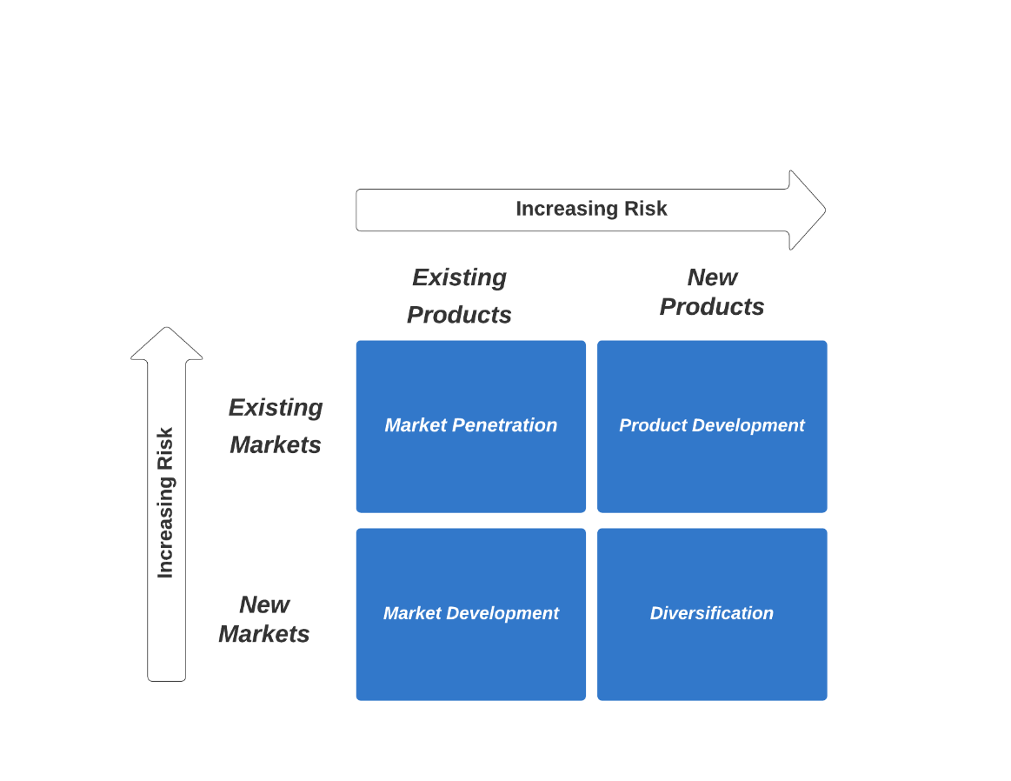
Fig.1 Source: Yani Yanakiev
- Marketing Penetration
Zara market penetration is focused and well understand from the company. Evidence for that is the opening of new stores around the world and their revenue, which allow to Zara to become one of the leaders in the fashion industry and stay competitive. For 2019 Zara has a collect income of 21.9 billion dollars which is strong evidence that they know how to penetrate into the fashion market. (Forbes 2020)
Zara is spending next to nothing for advertisement which is an example of an essential key for market penetration.

- Product Development
Zara believes that if they want to grow regularly, they have to develop new products and to improve the existing once. The company is focused on the information collected by surveys from the customers and competitors. The company fast reaction is the developing process which is one of the quickest in the world and which can offer to the customers what they want and need in 4 weeks. The company started as a clothing brand and which, with the time, extend the product lines. Zara starts to offer to the customer's shoes, perfumes, bags and a lot more accessories whit which they can attract the customers and make their stores more visited. The growth-oriented strategy is successful and stabilise the brand on the market and make the brand reputation stronger.

- Market Development
Zara started its business in Spain, then went to Portugal and after the success device to grow and develop the market. The company didn't stop to grow and open new stores not only in Europe but also in America and Asia. The marketing development provided stability for Zara and developed a strong international brand.
Zara is identifying potential customers groups in current sales areas, making market research and what the people like. After careful analyses, they are opening new stores in new locations and new markets.
Zara didn't have to invent a brand new product to become the worlds biggest fashion retailer. It just had to invent a new process. And process innovation is domaining the global economy. (The Atlantic 2012)

- Diversification
Diversification growth has sense when there is an excellent opportunity to expand the business outside of the existing one. A good opportunity is when the industry is extremely attracted, and the company has a mix of business strengths to be prosperous.
Zara expanding their brand and open new stores which are not related to the fashion industry. Zara Home Décor is a result of the company diversification strategy and in order to further organisation growing in terms of product and market development.

  - Relationship Marketing
Zara designed are close connection with their customers and continuing to attract new visitors and customers in their physical and online stores. Zara needs to follow and listen to the customers and their needs. They are offering different ways to the customers to be in touch with the company and get their products. Zara relationship marketing is straight connected with their customers via their online store or at the physical once. Since 2009 Zara have a social media account in different platforms such as YouTube, Facebook, Twitter, Pinterest and Instagram, which give the customers a new option to see and buy their new or existing product. Zara posts their current or upcoming product in those social platforms where can inform the customers what to expect, get customers feedback and build a strong relationship between them. Customers always can contact one of the Zara customer care employees by phone, email, website chat, forum or mail and to discuss their concerns, ask questions about their order, etc. Online activities help to Zara to focus on customers needs and to stay informed about their expectation from the brand.
In 2001 Zara offer to their clients a card called "Affinity" which was managed by 3rd party financial company. The customers used the card to make payments for their product and used by Zara as a communication tool. Zara stopped the card in 2010, and since then, they do not use any other customer loyalty cards.

- Stakeholder engagement and their impact on the marketing activities of Zara
  - Stakeholder Definition
A stakeholder is an individual, or any group or organisation that has a concern or interest in a company or organisation. Stakeholders are also those that are directly or indirectly affected by business or project.
Stakeholders can be people, organisations or groups that are affected by the activities of a business. Stakeholders are not necessarily the same as stockholders (shareholders).
Businesses have different kinds of external and internal stakeholders with diverse priorities and interests. (Market Business News, 2015)

  - Internal and external stakeholders
Zara internal factors are store staff, logistic staff, office staff and CEO.
Employees - Zara is training and promote their employees if they show their creativity, loyalness, open communication and professional skills to the company. Zara employees training is focused on the customers wants, needs, how the employees to identify the customer and to help the customer with the right choice. The communication between employees and customers support and develop Zara business strategy, which is with a consumer-oriented approach. To achieve excellent customers skills, the employees have regular courses to improve and maintain their professional customer skills. Zara employees have to be in close contact with the customers and to communicate and offer their products, to make recommendations, answer questions and customer complaints.
Zara external factors are clients, suppliers, community, society, government and creditors.
Customers – For Zara, the customers are the main power and the hearth of the company. The whole Zara business is concentrated and prioritised to develop an effective and strong Customer relation management (CRM). The company has a customer care model which ensure that their store employees are giving a positive shopping experience to all customers visiting their stores. The customer care model is applying everything that the employees learn from regular customer courses. The employees have to attract more walk-in visitors to become their customers and to stay loyal with the time.
In 2006 Zara launch their website (www.zara.com) with the idea to improve the customer's relations, inform the customers about new collections, to see and chaise what are the customer's interests and to expand the business. In 2009 Zara introduce their Android and iPhone application with which enable their customers to visit the website, inform themselves for new arrivals, collections, upcoming sales and take orders directly from their smartphone. That's mean that the customers can visit Zara website or open the application 24/7 and to stay informed about the new products without to visit the physical stores.
Zara is also getting its customers involved in the creative process. Their social media teams are checking and following what the customer's reactions are, suggestions and complaints. The retailer listening and paying attention to its customers, work as quickly as they can to provide the product which their customers deserve.

  - Stakeholder communication
Zara is determined a different relationship strategy with each stakeholder and to settle the objectives and communications to be used. The company identify and look at stakeholders relation closely on a contributing basis and determine which are priority groups according to their involvement. The company has to know and to collaborate with their stakeholders who have to know and specify their expectations. The communication with the stakeholders has to be transparency and supported by all members of the company. The dialogue has to be made with the idea and the focus to understand and improve the company key factors.
The internal communication strategies used by Zara are – emails, regular updates, meetings. During the pandemic situation, all meetings were made online.
The external communication strategies used by Zara are – social media such as Facebook, Twitter, Instagram, advertising and informational emails to the customers, face to face communication.
The corporate company website is the official communication bridge between the shareholders, the investors, the company and the markets. The corporate website (www.indentix.com) include information which can be in the interest of the investors and the shareholders. They can find management reports, annual financial statements, webcast presentation.

Conclusion and recommendation

In conclusion, Zara is one of the leaders in the clothing market. The positions of the brand are strong, and there is a huge potential to expand even more there business. They are customer concentrated, and the customers are the heart of the company. Customers are followed and closely observed from Zara with the idea to know what the clients want and need. Every customer feedback is vital for the company, and their employees are this part of the organisation which collect and sort all the information. Zara employees have training courses and meetings on how to manage all that information from the customers. The social media influence is significant in those days. Customers must have options on how to check the latest product 24/7 and how to buy them without to go in the physical stores and that what Zara does! Zara is not advertising their products in any magazines, and the social media platform and their website are one of the best options the product to be seen, to attract new customers and keep the existing once.
Zara is shown to their competitors that have to be careful and that the products developed by the company are with high quality and selling on affordable price. The physical stores of the company are looking luxury, well designed and professionally decorated.
I would recommend to Zara to concentrate on the expanding of their business in Asian and African market. The is no guarantee that Zara market development and diversification strategy will work in the Asia markets because of other factors such as new competitors and the people income. The company must use collaboration and penetration strategy with Asian companies and should advertise its product and brand to the Asian auditory. Asia and Africa are huge markets which can bring to the company incredible revenue and reaching new levels.
Zara can also invest in more luxurious raw material and to produce an entirely new luxury line which can attract a new range of customers – "posh customers."
The company can start to produce more sport clothes and shows which can offer to the sporty customers.
Zara must open more Home Décor stores whit which they can attract more people and people who are not following the latest trends. This is a huge niche when Zara can have success but have to be careful and to be price comparable with the other competitor on the market.
The company has to continue to expand its social business and make possible more online retailers to sell their clothes. Zara has to continue to work, develop and invest into its website and make it available in other countries which this option doesn’t exist up to know. In those pandemic times, online shopping is one of the main powers of every company, and they have to use this chance to expand and grow the company.

References
Cant M.C., Srydom J.W., Jooste C.J. and du Plessis P.J. (2006), Marketing Management, 5th edn., Cape Town, South Africa: Juta & Co.

Dr. Henning-Thurau T. and Prof. Dr. Hansen U. (2000), Relationship Marketing: Gaining competitive advantage trough customer satisfaction and customer retention New York: Springer-Verlag Berlin Heidelberg

Duczeminski M. (2018), PostFunnel by Optimove, 5th November
Available at: https://postfunnel.com/spotlight-zara-lessons-brand-spends-next-nothing-ads/
(Accessed: 26/08/2020)

Forbes (2020) Zara 27th July, Forbes
Available at: https://www.forbes.com/companies/zara/#e5c103d74877
(Accessed: 28/08/2020)

Gummesson E. (2008), Total Relationship Marketing, 3rd edn. Oxford: Elsevier Ltd.
Market Business News (2015), What is a stakeholder, 26th June
Available at: https://marketbusinessnews.com/financial-glossary/stakeholder/
(Accessed: 29/08/2020)

Retail in Asia (2019), Why has Zara changed its logo?, 24th April
Available at: https://retailinasia.com/in-telligence/why-zara-has-changed-its-logo/
(Accessed: 30/08/2020)

Thomson D. (2012) ‘Zara’s Big Idea: What the worlds top fashion retailer tells us about innovation’, The Atlantic, 13th November
Available at: https://www.theatlantic.com/business/archive/2012/11/zaras-big-idea-what-the-worlds-top-fashion-retailer-tells-us-about-innovation/265126/
(Accessed: 30/08/2020)

Wheeler A. (2018), Designing Brand Identity, 5th edn, Hoboken, New Jersey: John Wiley & Sons Inc.

Zara, Community Support
Available at: https://www.zara.com/uk/en/sustainability-social-action-l1663.html
(Accessed: 27/08/2020)

Zara/Inditex (2016), Annual report 2016
Available at: http://static.inditex.com/annual_report_2016/en/sustainable-strategy/stakeholder-relations/
(Accessed: 27/08/2020)

Zara/Inditex (2017), Annual report 2017
Available at: https://static.inditex.com/annual_report_2017/assets/pdf/b2_en.pdf
(Accessed: 27/08/2020)

ZARA LOGO
https://www.brandknewmag.com/zaras-new-logo-may-be-the-future-of-branding-love-it-or-hate-it/#prettyPhoto

