UNIVERSITY OF WALES TRINITY SAINT DAVID

Georgia Amman

BA (Hons) Surface Pattern Design

P150983

A critical investigation on the environmental damage caused by the fast fashion industry and the impact contemporary designers within Wales and internationally, are having on the way we consume fashion.

12th December 2018

Supervisor: Julia Lockheart

M6X01791

Word Count: 5994
Character Count: 32,315



Contents:

Acknowledgments

Introduction

Chapter 1: Fast Fashion

Chapter 2: Consumerism

Chapter 3: Class and Society

Chapter 4: Sustainability

Chapter 5: Contemporary Designers

Conclusion

Bibliography

Acknowledgments

This essay was developed by a series of inspirational lectures taken place at The University of Wales Trinity Saint David. I would like to sincerely thank my personal supervisor, Julia Lockheart, for her time, guidance and expertise knowledge at every stage during this process. I would also like to thank Jayne Barne and Louisa Moody for sharing their personal experiences and opinions with me, in order for me to complete this essay.
I would like to include a special note of thanks to Ryan Hill, for his wise judgements and encouragement throughout this whole journey.

Introduction

This essay will investigate the issues within the fast fashion movement and its sustainability. As a practicing sustainable Welsh designer, I am aiming to address the issues within the industry, to analyse who is at fault, to identify what our clothes communicate about ourselves, to raise awareness and to identify ways the consumer and designer can become more sustainable. I will be looking at contemporary designers and recent fashion graduates who are placing a value on environmental issues and are creating clothes in an eco-friendly way. Within society, it is becoming clear that the fashion industry contributes to 10% of global carbon emissions and remains the second largest industrial polluter (second to oil) (Conca, 2015). As a population, we are viewing fashion as a disposable, ever changing part of our lives, which urgently needs addressing (McCarthur, 2018). The value of the fashion industry is estimated to be worth 2.4 trillion pounds, which equates to 2 percent of the world’s Gross Domestic Product (Fashion United, 2016). I will also be looking into the impact of the pressure that is being put onto executives and industry leaders to change the cause of the problem.
I will be interviewing recent graduate Welsh designer, Jayne Barne, who showcased her collection at Graduate Fashion Week in London. As Jayne was nominated for the Vivienne Westwood Sustainable and Ethical Award, the opportunity to talk to her about her work and opinions will be valuable to my research. I will also be interviewing a designer named Louisa Moody, who does not openly address sustainability as a defining factor within her brand. The comparison between the two designers will be informative towards my investigation as I have a particular interest in the sustainable development within Wales and how the country is supporting an eco-friendly method for the future.
The term ‘fast fashion’ refers to cheap clothing collections that imitates current luxury fashion brands. It helps fulfil the desires of many young consumers in the industrialised world for luxury fashion (Joy, 2012). After studying Fletcher’s (2014) views surrounding sustainability within fashion, it is portrayed that within modern society, the whole fast fashion movement embodies unsustainability. Siegle (2011) suggests that the impact the industry is having on the planet is devastating, and argues that fast fashion is not free or cheap, as someone, somewhere is paying for it. Sweeny (2015) supports these views, suggesting that the fast fashion carbon footprint is tremendous, thus, a need for change is crucial.

Chapter 1: Fast Fashion
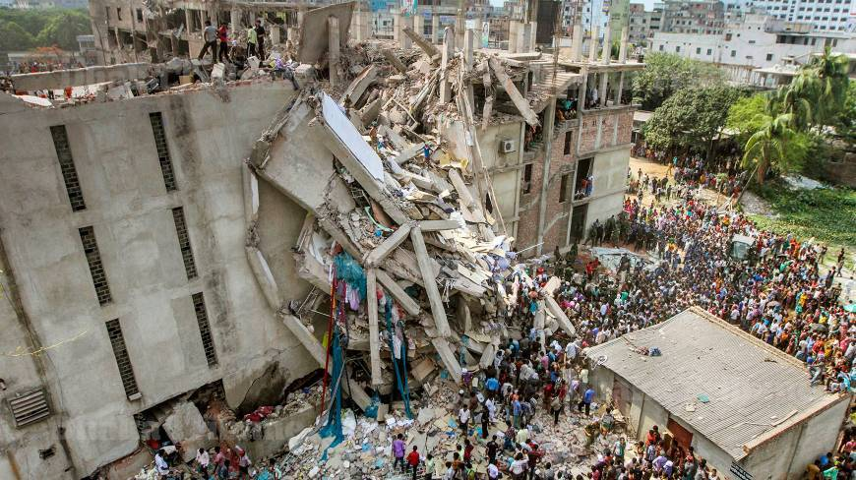
Figure 1. (Rana Plaza, 2013).

According to Green Style (2016), fast fashion can only be produced under inhumane conditions. The details within Figure 1 show the collapsed factory of Rana Plaza in Bangladesh, which killed more than one thousand people (Siegle, 2014). Siegle outlines that this disaster has put the spotlight on fast fashion and its devastating impacts, as the Rana Plaza collapsed due to poor regulations. She explains that the cracks were visible in the building the day before the collapse, but the authorities did not take any precautionary steps to tackle the problem. Furthermore, the employees were forced to work whilst being threatened with a month’s wage cut if they did not attend. This distressing story ratifies the significance and worries that the fast fashion industry is causing and has made the problems within the industry more accessible to the public eye.

This collision between the power of industrial civilization and the surprising fragility of the Earth’s ecosystem now poses a great danger that could even threaten the future of human civilization itself. (Gore, 2017)

Gore implies that the current way of living is going to have drastic implications on future generations. Neelis (2018) supports this, by outlining problems within fast fashion. According to Neelis, fast fashion garments are often worn less than five times, kept for roughly thirty-five days, and produce over four hundred percent more carbon emissions per item, per year, than ethical garments worn fifty times and kept for one year. This is an instant example that ratifies how fast fashion is having a harmful affect on the environment. The harmful effects began during the 20th century as the production of the fashion industry quickly escalated (Godley, 1997). Designers began experimenting with cheaper and quicker methods, such as synthetic fibres, with many taking hundreds of years to biodegrade (TrustedClothes, 2016). This means that as time and technology evolves, the fast fashion industry is becoming more polluting and dangerous. Due to the production of fashion now rapidly expanding and becoming more affordable, the industry is being driven into a crisis, with concerning demands being placed upon every collection that is made (Perry, 2018). This rapid production and careless design strategy is causing different crisis’ throughout the industry, one of which being the dyeing process (Rozas, 2017). Rozas explains how the dying process uses toxic chemicals that cause serious problems to the workers who are exposed to them, as well as causing an environmental issue due to the untreated effluent being disposed in the local water supply.

Another issue is with fierce high street rivalry, as Mansvelt (2011) indicates that brands are reducing their expenses by moving their production to Asia. However, the transportation of garments is adding to the negative carbon footprint of fashion (Sweeny, 2015). Perry (2018) reveals that polyester is the most common material used for fashion, although it has serious consequences. Perry explains how some of these consequences occur when the polyester is washed in a domestic washing machine, making the fabric shed microfibers that increase the levels of plastic in our oceans. The microfibers then pass through sewage and plants into our waterways, which causes a serious threat to aquatic life. Smaller aquatic animals then eat these microfibers, which are then consumed by fish and shellfish, which in turn are eaten by humans (Perry, 2018). This evidence implies that fast fashion is destroying the environment as well as causing harm to humans.

Cotton is another material which is causing problems, due to the substantial amounts of chemical fertiliser and pesticides used during production. This is causing pollution to both soil and water supplies (Gordon, 2015). The True Cost (2015), highlights the devastating impact of toxic chemicals used for growing cotton over the years, with the result being the death of a US cotton farmer, and serious birth defects of Indian cotton farmers’ children. Sweeny (2015) supports The True Cost, suggesting that the pollution from shipping cotton garments made in Asia around the rest of the world is causing a serious health risk, as those living in coastal and inland regions are being affected as most of the ships’ emissions are going unregulated. This magnifies the diverse and hidden dangers that are happening within the industry.

On the other hand, it is very misleading to determine the exact order of the polluting industries, as there are so many different research strategies and statistics towards it (Wicker 2017). Hill (2010) argues that pollution from mining is far more significant than that of the fashion industry and therefore, the impacts caused by fast fashion are part of a complex series of polluters. As well as this, Conca (2015) states that the fashion industry is the second most polluting industry on the planet, however, there is substantial evidence lacking on this statement as the topic is ever-changing. An example of this is during the Copenhagen Fashion Summit in 2017, ran by the Global Fashion Agenda in collaboration with the Boston Consulting Group. The aim was to analyse the statistics and data and collaboratively created the Pulse of the Fashion Industry Report (Wicker, 2017). The report examines figures from the fashion industry’s sustainability metrics, the numbers for carbon emissions and the chemical and water usage (SustainabilityPortal, 2018). The results show that the fashion industry is responsible for the emission of 1,715 million tons of CO2 in 2015. This places fashion, as an industry, less polluting than agriculture, road transportation, oil and gas production and electricity. According to the Pulse of the Fashion Industry Report (2018), the fashion industry is ranked the 5th most polluting industry in the world. The Report concludes that the fashion industry also involves elements of the other industries listed above, in order to run coherently. Therefore, the results support Hill (2010), by confirming that there are many industries contributing to global pollution.

However, Wrap (2017) argues that clothing has the fourth largest environmental impact, after housing, transport and food. The juxtaposing views prove that the evidence is deceiving and appears distorted as they each have different outcomes. Nevertheless, an exact figure within society should not be needed to stimulate a significant change within the fashion industry (The True Cost, 2015). This information reaffirms the power that the fashion industry holds and as these results display, the fashion industry can definitely be found within the top five most polluting industries in the world (Anguelov, 2015).
There are many companies attempting to lower their emissions (Bishop, 2008). H&M are a high street fast fashion company that are adopting various tactics to support the demand on improving the environment (Walter, 2010). Robertson (2017) declares that their 2016 Annual Sustainability Report, pledges to become 100% ‘climate positive’ by 2040, by using renewable energy and increasing energy efficiency in all its operations. This is a tremendous statement for such a popular company as they are a leader in high street fashion. He states that currently, the company launches up to sixteen collections annually. The process behind this entails a rapid design to retail speed, estimated to be completed within a few weeks to 6 months (Robertson, 2017). These products are delivered to the stores daily with 80% being sourced from Asia. However, presently European suppliers are only used for fashion-sensitive items and items requiring rapid replenishment (Walter, 2010). As a result of this, they aim to increase the use of European suppliers to limit carbon emissions from transportation. Datexcorp (2015) suggests that companies are investing in their supply chain to cope with customer demand and higher sourcing costs. According to Robertson (2017), they have also pledged to use 100% recycled or sustainable materials by 2030. Although these are only targets, other fast fashion brands will be encouraged to think more consciously about the planet and its future (Morgan, 2009). This research has evidently proven some of the problems the fast fashion industry is causing, showing that the industry is having an immensely damaging affect on the environment.

Chapter 2: Consumerism

Hallberg (1995), queries whether consumers are the main source of the problem within the fashion industry. This information has led me to research the power of consumerism, consumer behaviours and habits within the fashion industry as well as the power of the product. Consumerism is defined as the idea of buying items that fulfils a purpose, rather than just what is needed (Trentmann, 2016). It is created by businesses who have a desire to make more money by trying to manipulate society into buying more than what is needed. This results in a society working much harder to earn money in order to buy unnecessary items (Etkins, 1989). Perner (N.D), identifies that the study of consumers supports companies to develop their marketing strategies by understanding issues such as the psychology of how consumers feel, think, reason and select between different alternatives. Furthermore, Perner outlines that companies research how the consumer is influenced by the environment, their shopping behaviours, limitations in consumer understanding or information processing skills and how the decision strategies differ in the products’ level of importance or interest.

Consumer behavior includes the study of how people, either independently or in groups, obtain, use, experience, discard, and create decisions about goods (Smith, 2016). Yurchisin (2010), also implies that consumerism is a leading cause of problems outlined within the fast fashion industry. (Ableman, 2016) says that oxymoronic nature is a critique of eco-consumerism, as the emphasis should not be reliant on consuming eco-friendly products, but on consuming less. He states that the misperception is misleading and could send the wrong message to potential consumers. An example of this can be seen in Vogue (2013) “Go Green for Spring”. This article encourages people to buy from eco friendly collections in order to begin the new season with a guilt free conscience. It becomes evident that by consuming more, your responsibility as a consumer is caught in a false notion and is thought to be excused. Therefore, consuming less appears to be one of the most effective elements of sustainability.

One of the issues within consumerism and a consumer’s habits is impulse buying (Wallace, N.D). Graves (2013) states that buying on impulse is when your unconscious mind is often steering your behaviour as a consumer, leading you to purchase items that you often do not need, under the influence of evolutionary efforts and the clever methods of retailers. Graves declares that the very simple explanation of why we impulse buy is due to people receiving an immense amount of gratification from acquiring something new. In addition to this, the act of purchasing is an act of empowerment that people enjoy indulging in and furthermore, children are regularly becoming conditioned by their parents to feel wholesome about being handed something new. (Morgan, 2009). Ricker (2012) suggests that fast fashion companies are dependent on consumer behaviors as when we are trying to access the latest trends, we suddenly have a desire for many new items of clothing in our wardrobes. This results in corporations catering to our demands and putting pressure on manufacturers. Heuer (2018) suggests that if the customer was made more aware of the environmental impact their purchases were making, it would be extremely beneficial for the industry as they would make wiser consumption decisions. On the other hand, Campbell (2005) argues that if consumers become aware of their impacts, it would cause other economic problems such as loss of jobs and could lead to the collapse of companies.
This means that we, as the consumer, are the indirect driving force behind the fast fashion movement.

It is necessary for retailers to take an integrated business approach to social and environmental values, which should then be correctly communicated to customers who are then able to decide on a retailer, in preference to the compliant or non compliant product (Muthu, 2016). The customer therefore will understand the brands values, whilst making a choice on their purchase. Although, Campbell (2005) suggests that this does not happen in majority of high street stores, as the issues are not publicised. The consumer is instead enticed into a dreamy shopping experience, without the need to think about their ethical considerations and the values of the brand (Falk, 1997). Robbins (2015) proposes that by understanding the values of a brand, the value of an item can be determined by the consumer. Robbins continues, stating that after purchasing cheap clothing, consumers often treat that item poorly, compared to a well produced, sustainable item that is handled with better care. This shows that greater value could potentially be added to an item if it is from a sustainable company, leading to not only environmental benefits, but also an increase in company profits, which in turn will lead to a more sustainable future.

Entwistle (2009) counters this, stating that fashion is about aesthetics and that it is not solely about new clothes, but clothes that are promoted and popularised as ‘attractive’. Consequently, when we talk about fashionable dress, it is about the creation of the garment and the production of the aesthetic value around the garment. Entwistle explains that fashionable service value is always decreasing as most garments will soon no longer be ‘in fashion’. This means that the speed of fast fashion is making the consumer devalue their items as they are constantly wanting the new latest trend. This research made me question if fashion is a class issue and how our clothes communicate a visual language.

Chapter 3: Class & Society

Dress was capable of signifying one's culture, propriety, moral standards, economic status, and social power, and so it became a powerful tool to negotiate and structure social relations as well as to enforce class differences. (Medvedev, 2016)

Class is explained as a system of ordering society whereby citizens are allocated into sets based on perceived social or economic status (Oxford Dictionaries, 1884). According to State of Wales (2018), the class system in Wales is categorised into six different varieties, constructed on economic capital; meaning physical wealth and income, social capital; meaning the social status of friends, family and acquaintances, and cultural capital; meaning the type of cultural interests appreciated by the individual. They are described as the elite, the established middle class, the technical middle class, the new affluent worker, the traditional working class and the precariat. These range from people with very high to very low economic, social and cultural capital.
Levine (2006) implies that ethically produced clothes suggest that the consumer is proudly principled and is also proud to show it. Whereas, cheap fast fashion clothing suggests that the consumer has other priorities than investing in consciously crafted pieces. Levine continues, suggesting that fashion has always been a class issue, a symbol of wealth and status; mixed up with ideology. As well as this, Medvedev (2016) informs her audience that a display of wealth through dress became accustomed in Europe in the late thirteenth century and that a persons’ class could be discovered with relative ease. She makes it clear that dress was recognised as an expressive social distinction. However, in modern society it is argued that fashion is not necessarily always a class issue, so much as a sustainability issue and you can not always tell class by how people dress (Entwistle, 2009). Wilberg (2018) suggests the idea that many multimillionaires wear clothes that are years old, juxtaposed with many young people, such as social media influencers who are making a business out of flaunting wealth with expensive and ‘tacky’ looking, ‘wear once and throw away’ clothing. But how are you able to identify a sustainable consumer?

Ricker (2012) suggests that by closely analysing an ecofriendly consumer, there are many identifiable defining factors. Sustainable consumers appear to be wise in the sense of knowing what is going on in the world. They tend to reuse bags and bottles, often wear high quality clothing, campaign for animal rights and aim to live their lives around doing good (Wagner, 2003). Moreover, Chick (2017) explains that your clothes and presentation communicate efficiently about you as a person, and whether or not the consumer claims to care about fashion, it is always apparent that you are communicating intentionally or unconsciously through your fashion choices. While this presentation of fashion choices also means your accessories, hairstyle, fragrance, posture, body language, attitude, voice, and the level of energy with which you move and express yourself (Chapman, 2015). Ultimately, how you dress and present yourself is an expression of how you feel about yourself, and in modern times, is often differentiated from a persons social or economical status (Savelle-Foy, 2017). Therefore, this information means that whether you consider yourself fashion conscious or not, your fashion choices communicate to the world about you and your personality. How you dress yourself can define your character and represent your opinion of your awareness on the environment, and also means that within modern society you can not always identify a persons’ class through their dress.

Chapter 4: Sustainability

After exploring the factors of a sustainable designer, my research has been directed into sustainability within fashion and if there is an ultimate eco friendly design process.
The term sustainability is a movement and life style choice by avoiding harmful processes and instead using natural resources, in order to maintain an ecological balance (Fletcher, 2013). Sustainability is not a term young consumers typically associate with fashion, although they are very open to environmentalism, which is a contradictory that needs to be recognised in order to alter perceptions and attitudes (Joy, 2012). Joy continues, explaining that the customer needs to be made aware of the environmental impact their purchases have on the environment, as it is becoming vital for the future of the fashion industry to become more sustainable due to the extreme damage it is causing the planet. For a sustainable vision of the future, the fashion industry relies on fibre, material and product based innovations (Fletcher, 2013). It is encouraging to learn that sustainable fibres are becoming a new trend within the fashion market (Gardelli, 2016). Wrap (2018) informs the reader that by using more durable and less intensive fibres and materials in their merchandises, corporations can escalate their customer satisfaction rate through prolonging clothing life and increasing the rate of re-use in second-hand fashion.

This leads me onto sustainability within Wales. The Wellbeing of Future Generations Act is a Welsh Law that began in 2015 (Welsh Government, 2016). Nicholl (2012) suggests that the Welsh Government are continuously operating to ensure sustainable development is at the focus of decision making, hoping to position Wales at the forefront of helping individuals, communities and the environment thrive, whilst setting an example to other countries.
The Welsh Government (2016), declares that the principle of the law, is that we should perform in a way which seeks to confirm the needs of the present are assembled, without compromising the ability of future generations to meet their own requirements. They imply that there are three goals of significance. Firstly, aiming for a prosperous Wales, which is an original, productive and eco-friendly society which recognises the restrictions of the global ecosystem, which then uses resources efficiently and consistently, including encouraging to act on climate change. Secondly, intending for a resilient Wales, aiming for a nation which preserves and develops a biodiverse organic environment with beneficial working ecosystems that support social, economic and ecological strength and the ability to adapt to change. Finally, a globally responsible Wales, meaning to improve the social, economic, environmental and cultural wellbeing of the country, aiming to make a positive contribution to global wellbeing. The Well-being of Future Generations Act (2015) explains that the public bodies listed within it will have to think more about the long term prospects and development whilst avoiding complications and to take a more interconnected approach. Muinzer (2018) clarifies the significance the Act has on Welsh designers suggesting that it is a beneficial and ground-breaking fragment of legislation, which implements sustainability as the future of Welsh design. It also encourages other countries to focus on sustainable development. This is a remarkable opportunity for Welsh businesses as they have guidance and encouragement from their own country to become more sustainable. The act will enable a safer future for Wales and for fashion designers within the country.

As environmental problems and their possible solutions have evolved and become more accessible to discover, so has sustainable fashion (Business of Fashion, 2018). There are many ways a designer can become more sustainable within the fashion industry. Business of Fashion (2018) implies that the designer is able to have a framed approach for a sustainable design strategy that can help reduce specific environmental and social impacts that are associated with the life cycle of a garment, from the production, use, and disposal of it.
Many brands that are implementing a number of sustainable strategies across areas of design and production (Anguelov, 2015). Companies such as Marks and Spencer’s, Nike, Stella McCartney and Katherine Hamnett are continuing to respond to the issue, by using environmentally friendly materials and processes (Gwilt, 2014). Ndatira (2018) suggests that the designers have the power to make positive design changes and are able to transform the industry. It is estimated that 80% of a products’ environmental impact is decided at the design stage (Murray, 2013). A designer could become more sustainable by buying fabrics with a higher percent of recyclability, designing with a zero waste strategy, a garment having multi functional uses that the customer can enjoy in many different ways and the brand communicating to the customer how to care for the garment (Redress, 2018).

Sustainable fashion implements opportunities for new creative approaches to design and it is said that industry experts feel optimistic about the future (British Fashion Council, 2018).
They suggest that some companies are implementing sustainable ways by adjusting manufacturing practices, while others are completely changing the types of fabrics and materials used in their clothing to become eco-friendlier. According to ‘Greenpeace Detox Catwalk’ campaign (2016), there are three classifications of modification within a brand. They start with their avant-garde strategy, where companies lead the way in their toxic-free construction. Secondly, an evolution mode, where companies that are committed to adjusting their practices but still needing to be more cautious in meeting specified sustainable goals, and finally, a faux pass system, where companies are moving in the wrong direction of their toxic-free goals, not taking responsibility for their roles (Vicaire, 2017). Sustainable designers are generally working to optimise site potential, minimise non-renewable energy consumption, use environmentally preferable products, protect and conserve water, enhance indoor environmental quality and optimise operational and maintenance practices (Lynch, 2007).
Although, this is not essential, McCartney (2013) argues that you do not have to dramatically transform your life in order to support the changes, as everyone can do simple things to enable the transformation for a more sustainable planet.
It is again clear that the negative impact on the environment is devastating, however, there is an eco friendly design process that is available and accessible.

Chapter 5: Contemporary Designers

Conscious designers are designing and creating in many different eco friendly ways. Fletcher (2013) explains that this can be achieved by producing fewer garments of higher quality, examining the impact of its raw materials and manufacturing processes, dying fabrics in a natural way and pattern cutting more efficiently. Fletcher further implies that sustainable fashion design and luxury fashion design have always seemed worlds apart from each other. It has never had glamourous connotations; however, many graduate and contemporary designers are making sustainability the defining element of their brand (Yurchisin, 2010). New designers are building brands with a more conscious approach to fashion (Murray, 2013). Neelis (2018) suggests that we have to understand nature and how to relate to it, as well as understanding our body in order to make progress with sustainability.

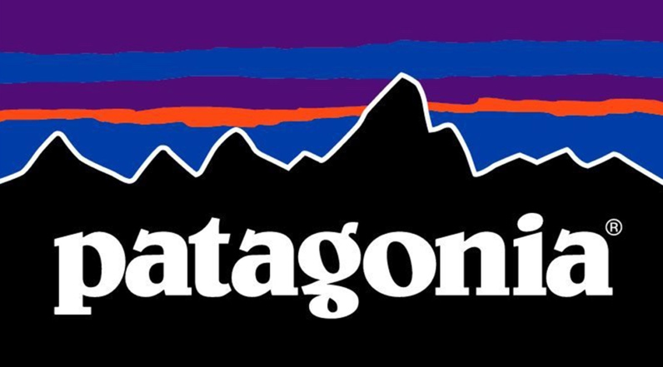
Figure 2. (Patagonia, 2018).

An example of a conscious brand would be Patagonia, who identify as a brand with a clear understanding of the relations between nature and the knowledge of dressing the body. This brand is relevant because although it is not Welsh, it is an international example of an eco-friendly establishment which relates to the ethos of Welsh culture. The business director of sportswear at Patagonia, Helena Barbour, states important information in regards to her opinions on what the term ‘eco-friendly’ really means:

It includes the way your clothing is dyed and how the waste water is handled. What are the working conditions in those factories? Are the workers who make your clothing paid a fair wage? Is your clothing high-quality or does it fall apart after a few wears? How transparent is the brand whom you purchase your clothing from? Does that company offer you a way to recycle or repair your garment? (Barbour, 2017)

The importance of her questions and statements are crucial to a future of sustainability.
Patagonia (1973) began by creating tools for climbers. They state that they cater for activities such as skiing, snowboarding, surfing, fly fishing, paddling and trail running. They are all said to be silent sports, without involving a motor, with no blaring crowds, that thrive off the interesting connections between them and nature. Patagonia declares that they are often involved in wild and beautiful places that require participation in the fight to save them and try to help contract the extreme decline in the overall environmental health of our planet. They are a sustainable and well recognised brand because at least 1% of their sales go towards hundreds of grassroots environmental groups around the world. As well as this, they recycle polyester and use organic fabrics (Patagonia, 2018). This is important as they are using their profit for a good cause.

Figure 3. (Maykher, 2017).

Maykher (2017) are another sustainable Welsh brand. I attended a lecture with the head designer, Heidi Griffiths, who explained the values about their profit-with-purpose ethos for their womenswear accessories. Within the lecture, she explained how the company actively supports ethical and sustainable fashion practices and encourages the optimistic social programmes facilitated by their associates, including women’s literacy, therapy, support groups and community wellbeing programmes. Maykher was established with the agenda to help tackle the recurrently discussed international social issues of education and inequality in the countries we work in. There are approximately 62 million young females out of education (Maykher 2017) who are more likely to fall victim to child marriage, slavery, trafficking and other major problems (Griffiths, 2018). Many of the artisans that they choose to work with have suffered in poverty, are victims of domestic violence and have lacked opportunities and an education. This is why they are dedicated to investing at least 10 percent profit into situating young girls in disadvantaged areas into school. In comparison to Patagonia who are giving 1 percent of their profits to environmental groups, 10 percent is a remarkable figure to put into placing disadvantaged girls in education. The difference in percentages could yet again suggest that large companies are using sustainability as a trend through their brand.

Griffiths (2018) believes that educating girls is a practical solution in order to end poverty completely, and is something that can empower young women to create a positive transformation for themselves and those around them. Hearing Griffiths (2018) explaining the values and processes used within her brand, is evidence that there are Welsh designers who are successfully executing sustainable design and consumer strategies.
After discovering this research of innovative and sustainable ways of designing, I wanted to directly speak to a graduate fashion designer who is promoting sustainability. I have asked Jayne Barne, a graduate fashion designer from University of South Wales, a series of questions regarding her design choices, opinions and thoughts.
I started by asking her what firstly made her passionate about fashion sustainability.
Barne confirmed that fashion design is one of the most polluting industry’s in the world. She explained how although passionate about fashion, she wanted to create beautiful garments but not add to the increasingly polluted industry. She challenges herself to create a collection from waste that she believes as a designer, should be helping to solve the industry’s problem. I then asked Barne how she would define the term fast fashion. Her reply is interesting as from my research and after talking to her, I have yet to find a positive comment about the term, as yet again it confirms that the fast fashion industry is dreadful.

Barne explains that fast fashion is fashion for now, it is a garment that the buyer has no connection with. It is fast manufacturing equating to cheap retail pricing and poor quality. She suggests that its likely that the consumer will also regard this item as throw away and not a staple part of their wardrobe, hence, the industry is creating such a negative environmental impact. After this truthful report, I wanted to learn if Barne thinks she is actually making a difference to fast fashion. She states that she is confident that she is not adding to the problem, and hoping that by designing beautiful garments from waste, it will hopefully inspire the consumer to shop differently. Barne aims for her garments to firstly be desirable, which in turn leads to the consumer connecting to the garment knowing that it is created from disregarded items that would usually be found in landfill. Fletcher (2013) supports this by suggesting that consumers have a stronger connection with sustainable goods.

A further interview conducted with Welsh designer Louisa Moody, who I met whilst working at London Fashion Week seemed to counter the views of Barne. After watching her clothes on the catwalk, I became interested to discover her views on the subject of sustainability. Moody explains how she thinks sustainability is more important than ever. She believes the change has to start with the designer, and they should begin with starting to consider the effects that the fabrics they choose have on the environment. I asked Moody if she considered her brand to be sustainable or if she thinks it falls into the fast fashion category:

As a designer who has just started my career, I would be lying if said it was top of my priority list. I do not like the idea of fast fashion; yes, as a consumer I have definitely bought into it. But as a designer who is finding their voice especially in the early stages of creating my brand, there is a pressure of always having something new for your customers, followers etc. Or they will lose interest. (Moody, 2018)

This is interesting because from a graduate designer’s perspective, the blame of fast fashion is being placed on the consumers who are expecting quality and quantity. This information portrays how you can quickly get caught up in the fast fashion cycle due to the pressures of the industry. Moody is interested to start working with sustainable fabrics, and has stated that she will be launching two collections per year instead of four. This means that Moody will be having less of an environmental effect on the fast fashion industry, helping to create an improved sustainable future.

The views of both contemporary designers prove that sustainability within fashion is a crucial movement. However, it is evident that not every brand has adopted new policies to ensure that their garments are becoming sustainable, but there are strategies in place to promote the change.
Conclusion

To conclude, it is evident that fast fashion is damaging the planet due to a variety of reasons. Siegle (2011) supports this, implying that the planet is paying for poor decisions being made within the fast fashion industry. Furthermore, Fletcher (2014) portrays the fashion industry as unsustainable due to the chemicals being used during production. Moreover, Neelis (2018) places the blame on the consumer as products are not being maintained or recycled.
However, The True Cost (2015) suggest that the damage is caused by production and transportation. This is also supported by Sweeny (2015).

As a result of this, Campbell (2005) argues that a change is needed. It is suggested that consumers must take responsibility of the damage being caused. Robbins (2015) supports this, insinuating that consumers need to understand what they are buying and how it is affecting the environment. On the other hand, Heuer (2018) states that it is the companies who must share information about the product with the customer to inform their decisions. Redress (2018) develops this viewpoint, stating that communication is a key factor in tackling the growing environmental problem. Redress believes a zero waste strategy will also encourage a healthier industry. In addition to this, developing garments with sustainable products will limit the environmental implications (Rozas, 2017).
Moreover, Fletcher (2013) and Gardelli (2016) argue that production must be made more sustainable to support the changes within the fashion industry.

The Welsh Government are developing strategies to improve sustainability. The Well-being of Future Generations Act (2016) aims to compromise the needs of today with the needs of the future. Barne (2018) is supporting this act by using waste to create her garments. However, Griffiths (2018) uses her products to promote education, which in turn will lead to a better understanding of sustainability.

Overall, current research suggests that the fast fashion industry is damaging the environment at an alarming rate. It is clear that some companies are beginning to deal with the problem, however, it is crucial that companies support government schemes and ensure that the consumer has a full understanding of the product that they are investing in.
In order to achieve a sustainable future, the public needs to learn the devastation to want to implement sustainable practices within their everyday lives.

Word Count: 5994
Character Count: 32,315

Appendix
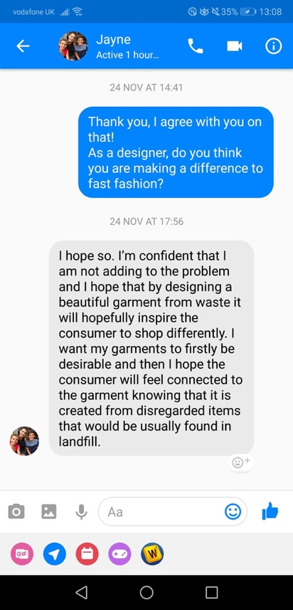
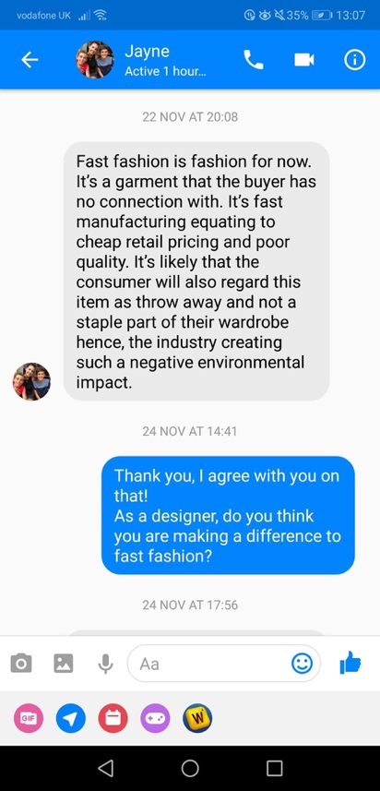
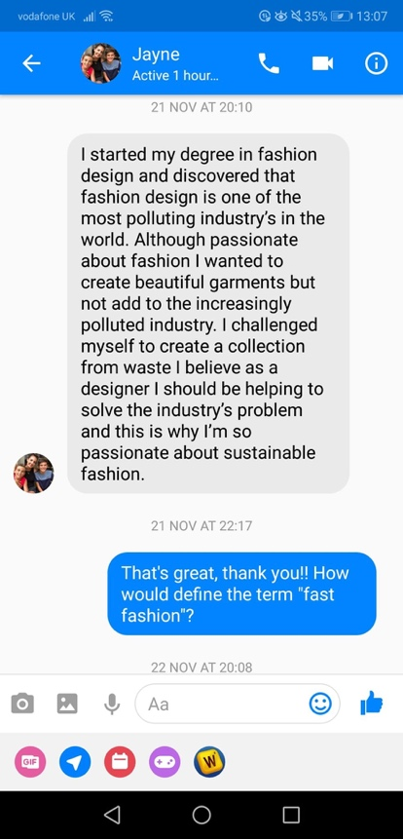

(Barne, 2018)
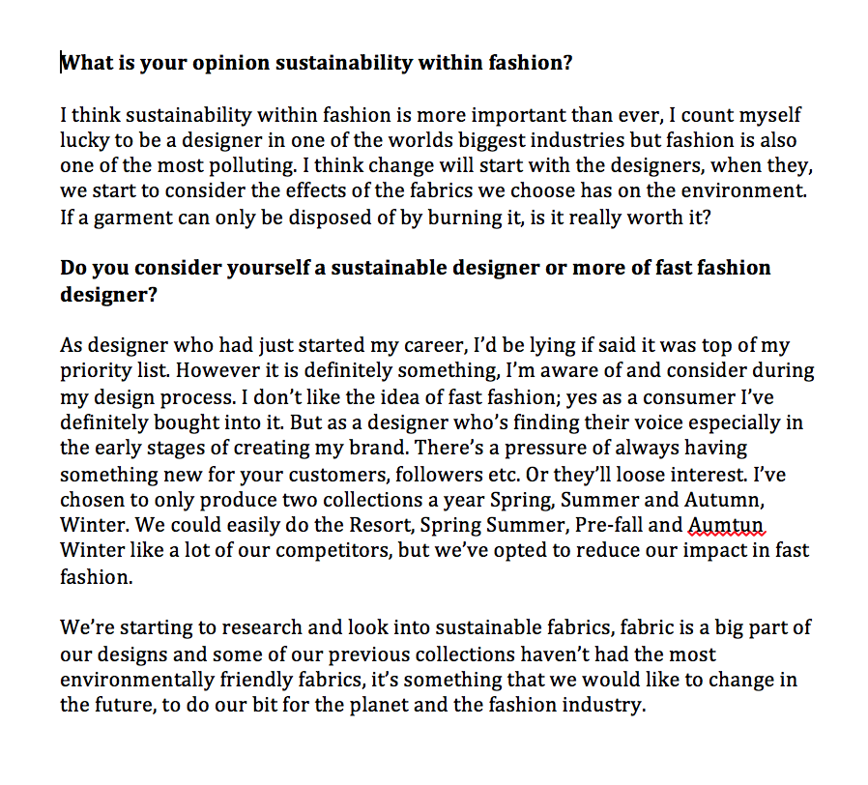

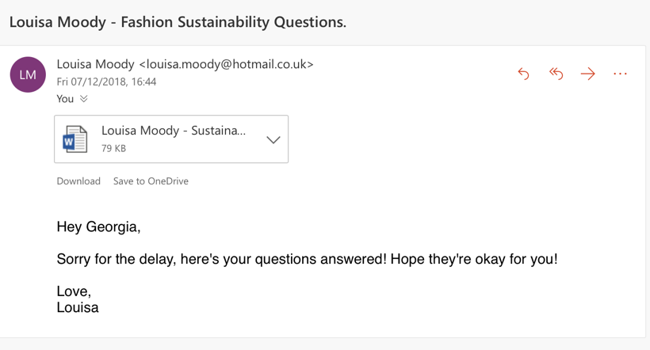

(Moody, 2018)

Bibliography

Ableman, M., 2016. Street Farm. Great Britain: Chelsea Green Publishing, pp. 62-63.

Aldridge, R., 2013. Stella McCartney. Great Britain: Infobase Learning, pp. 32-36.

Anguelov, N., 2015. The Dirty Side of the Garment Industry. Great Britain: CRC Press, pp. 32-36, 55-59.
Atwood, R., 2016. Living with Pattern: Color, Texture, and Print at Home. New York City:

Potter/Ten Speed/Harmony/Rodale, pp. 93, 113.

Barbour, H., 2017. [Website] Sustainability. Available at: https://www.patagonia.com/blog/2017/10/partnering-with-the-people-who-make-our-clothing/ (Accessed 4 November 2018).

Barnard, M., 2013. Fashion as Communication. Great Britain: Routledge, pp. 39, 49, 72, 79, 187.
Barnes, L., 2006. Fashion Marketing and Management. Great Britain: Emerald Publishing, pp. 39-40.
Bartholomew, J., and Rutherford, S., 2015. The Design Student’s Handbook: Your Essential Guide to Course, Context and Career. Great Britain: Routledge, pp. 11-19, 41-42.
Baumgartner, J., 2012. You Are What You Wear. Great Britain: Hachette, pp. 77, 113-114.
Bishop, A., 2008. How to Reduce Your Carbon Footprint? United States of America: Crabtree Publishing Company, pp. 24-30.
Blumer, H., Undated. [PDF] Fashion: From Class Differentiation to Collective Selection. Available at: https://onlinelibrary.wiley.com/doi/pdf/10.1111/j.1533-8525.1969.tb01292.x (Accessed: 12 November 2018).
Boston Consulting Group., 2017. [PDF] The Pulse of the Fashion Industry. Available at: https://globalfashionagenda.com/wp-content/uploads/2017/05/Pulse-of-the-Fashion-Industry_2017.pdf (Accessed: 3 September 2018).
British Fashion Council., 2018. Positive Fashion. Available at: http://www.britishfashioncouncil.com/About/Positive-Fashion (Accessed: 14 November 2018).
BSD Global., 2018. [Organisation] Who are the Green Consumers? Business and Sustainable Development Website. Available at: https://www.iisd.org/business/markets/green_who.aspx (Accessed: 2 November 2018).
Business of Fashion., 2018. [Article] Sustainability Credibility. Available at: https://www.businessoffashion.com/articles/intelligence/top-industry-trends-2018-8-sustainability-credibility (Accessed: 3 September 2018).
Campbell, C., 2005. The Romantic Ethic and the Spirit of Modern Consumerism. Great Britain: Writers Print Shop, pp. 20-24, 153, 232, 261.
Chapman, J., 2015. Emotionally Durable Design: Objects, Experiences and Empathy. Great Britain: Routledge, pp. 10, 43, 57, 66, 118.
Chick, A., 2017. Design for Sustainable Change. Great Britain: Bloomsbury, pp. 11-13, 32-36.
Chua, M, J., 2015. [Blog] Fast Fashion is an Evil Machine of Exploitation. Ecouterre Sustainable Fashion Website. Available at: https://inhabitat.com/ecouterre/livia-firth-fast-fashion-is-an-evil-machine-of-exploitation/ (Accessed: 8 October 2018).

Chung, S., 2016. [Article] Fast fashion is Drowning the World. Green Peace Organisation. Available at: https://www.greenpeace.org/international/story/7539/fast-fashion-is-drowning-the-world-we-need-a-fashion-revolution/ (Accessed: 3 September 2018).

Clayton, A., 2017. [Website] Alternative Clothing. Ethical Consumer Organisation. Available at: https://www.ethicalconsumer.org (Accessed: 4 October 2018).

Cline, L, E., 2012. Overdressed: The Shockingly High Cost of Cheap Fashion. New York City: Penguin, pp. 14-19, 53, 68.

Cole, R., 2018. [Website] MPS Launch Inquiry into Sustainability of the Fashion Industry. Resource Website. Available at: https://resource.co/article/mps-launch-inquiry-sustainability-fashion-industry-12701 (Accessed: 4 October 2018).

Conca, J., 2015. [Article] Making Climate Change Fashionable. Forbes Global Media Company. Available at: https://www.forbes.com/sites/jamesconca/2015/12/03/making-climate-change-fashionable-the-garment-industry-takes-on-global-warming/#380faaeb79e4 (Accessed: 13 October 2018).

Dael, N., Perseguers, M., Marchand, C., Antonietti, J., and Mohr, C., 2016. Put on that Colour, it Fits Your Emotion: Colour Appropriateness as a Function of Expressed Emotion. Great Britain: Routledge, Taylor & Francis, pp. 13-23.

Datex., 2018. Fast Fashion Retail. Datexcorp Marketing Website. Available at: https://www.datexcorp.com/fast-fashion-retail-success-in-todays-e-commerce-supply-chain/ (Accessed: 18 October 2018).

Day, L., 2013. Pattern Design. San Francisco: Courier Corporation, pp. 16, 47, 83, 104, 124.

Donovan, O., 2018. [Website] Wealth inequality and Classism. The State of Wales Website. Available at: https://stateofwales.com/2018/04/equal-wales-class-income-wealth/ (Accessed: 3 December 2018).

English, B., 2013. A Cultural History of Fashion in the 20th and 21st Centuries. Great Britain: A&C Black, pp. 186-190.

Entwistle, J., 2009. The Aesthetic Economy of Fashion. Great Britain: Berg, pp. 149, 168.

Etkins, P., 1989. Sustainable Consumerism: A New Consumerism: Theoretical Basis and Practical Applications. Great Britain: New Economics Foundation, pp. 11-15.

Falk, P., 1997. The Shopping Experience. Great Britain: SAGE, pp. 169-172.

Fashion United., 2018. [Website] UK Fashion Industry Statistics. Available at: https://fashionunited.uk/uk-fashion-industry-statistics (Accessed: 23 October 2018).

Ferreira, A., 2007. [Article]. How useful is semiotics as a method for analyzing works of art? Available at: http://artandperception.com/2007/02/how-useful-is-semiotics-as-a-method-for-analysing-works-of-art.html (Accessed: 13 April 2018).

Fletcher, K., 2013. Sustainable Fashion and Textiles: Design Journeys. Great Britain: Routledge, pp. 8-11, 36-40, 219-224.
Fletcher, K., 2014. Routledge Handbook of Sustainability and Fashion. Great Britain: Routledge, pp. 5-7, 64-66, 187-188.

Fletcher, K., 2016. Craft of Use: Post-Growth Fashion. Great Britain: Routledge, pp. 3-7, 49-53.

Fraquoh, F., 2013. [Article] Clothing As Symbols. The Attire Club Organization website. Available at: https://attireclub.org/2013/05/19/clothing-as-symbols/ (Accessed: 22 April 2018).

Fulton, H., 2012. Urban Culture in Medieval Wales. Great Britain: University of Wales Press, pp. 40-45.

Gardetti, A, M., 2015. Handbook of Sustainable Luxury Textiles and Fashion, Volume 2. New York City: Springer, pp. 45, 76, 122, 125.

Godley, A., 1997 The Development of the Clothing Industry: Technology and Fashion. Great Britain: Routledge, pp. 3-6.

Gore, Al., 2017. [Organisation] Education, Research and Communication. Available at: http://www.sustainableuni.kk5.org (Accessed: 14 November 2018).
Graves, P., 2013 [Article] Impulse Buying. Psychology Website. Available at: https://www.psychologytoday.com/gb/blog/consumer-behavior/201303/five-reasons-we-impulse-buy (Accessed: 16 October 2018).
Green Style., 2016. [Blog] Fast Fashion. Sustainable Fashion Blog. Available at: http://my-greenstyle.com/en/fast-fashion-ausstellungstipp-in-dresden/ (Accessed: 3 December 2018).

Griffiths, H., 2018. [Website] Maykher. Sustainable Retail Fashion Website. Available at: http://www.maykher.com (Accessed: 24 November 2018).

Griffiths, H., 2018. Maykher Enterprise Lecture. University of Wales Trinity Saint David. (13 November 2018).

Gwilt, A., 2012. Shaping Sustainable Fashion. Great Britain: Routledge, pp. 52-60, 102-105.

Gwilt, A., 2014. A Practical Guide to Sustainable Fashion. Great Britain: A&C Black, pp. 12-14, 137.

Gwilt, A., 2014. Fashion Design for Living. Great Britain: Routledge, pp. 141-142.

Hallberg, G., 1995. All Consumers Are Not Created Equal. United States of America: Wiley & Sons, pp. 55-58, 163-165.

Henninger, C., 2017. Sustainability in Fashion. Great Britain: Springer, pp. 161-164, 175-176.

Henrich, S., 2016. [PDF] The State of Fashion 2017. Available at: https://www.mckinsey.com/industries/retail/our-insights/the-state-of-fashion (Accessed: 4 November 2018).

Heuer, M., 2018. Eco-Friendly and Fair. Great Britain: Routledge, pp. 111-114.

High-tech Consumerism. 2015. [Website]. The conversation website. Available at: https://theconversation.com/high-tech-consumerism-a-global-catastrophe-happening-on-our-watch-43476 (Accessed: 6 May 2018).

Hill, M., 2010. Understanding Environmental Pollution. Great Britain: Cambridge University Press, pp. 428-430.

Jaffe, R., 2014. Green Consumption. Great Britain: Bloomsbury Publishing, pp. 97-99.

Johns, C., 2018. [Website] Style from Farm to Hanger. Clare Johns Website. Available at: https://www.clarejohnslabel.com (Accessed: 28 November 2018).
Joy, A., 2012. [PDF] Fast Fashion, Sustainability and the Ethical Appeal of Luxury Brands. Available at: https://www3.nd.edu/~jsherry/pdf/2012/FastFashionSustainability.pdf (Accessed: 8 October 2018).

Kidd, A., and Nicholls, D., 1999. Gender, Civic Culture and Consumerism: Middle Class Identity in Britain, 1800-1940. Great Britain: Manchester University Press, pp. 65, 93, 99, 186-190.

Klintman, M., 2008. Eco-Standards, Product Labelling and Green Consumerism. Great Britain: Springer, pp. 78, 193.

Levine, F, R., 2006. Social Class and Stratification. Great Britain: Rowman & Littlefield, pp. 3, 100, 131.

Lieber, C., 2017. [Article] Is British Fast Fashion Too Fast? Available at: https://www.racked.com/2017/5/16/15643246/asos-boohoo-british-fast-fashion (Accessed: 4 November 2018).

Lukacs, G., 1972. History and Class Consciousness. Great Britain: MIT Press, pp. 46, 48, 256.

Lynch, A., and Strauss, M., 2007. Changing Fashion: A Critical Introduction to Trend Analysis and Meaning. London: Berg, pp. 34, 49-53, 67-68, 91.

Macarthur, E., 2017. [Report] Ellen Macarthur Foundation. Available at: https://www.ellenmacarthurfoundation.org/assets/downloads/A-New-Textiles-Economy_Full-Report_Updated_1-12-17.pdf (Accessed: 4 October 2018).

Macnab, M., 2008. Decoding Design: Understanding and Using Symbols in Visual Communication. Mexico: HOW Books, pp. 2, 8, 124.

Mansvelt, J., 2011. Green Consumerism: An A-to-Z Guide. California: SAGE, pp. 33, 52, 142-143, 217, 319.

Mayker., 2018. [Website]. Sustainable Retail Fashion Website. Available at: http://www.maykher.com (Accessed: 24 November 2018).

McCarthur, E., 2018. [Organisation] A New Textiles Economy. Available at:

McLennan, J., 2004. The Philosophy of Sustainable Design. United States of America: Ecotone Publishing, pp. 3-7.

Medvedev, K., 2006. If This Dress Could Speak. United States of America: University of Minnesota, pp. 66-71, 209-211.

Medvedev, K., 2016. [Website] Social Class and Clothing. Fashion History Website. Available at: https://fashion-history.lovetoknow.com/fashion-history-eras/social-class-clothing (Accessed: 1 October 2018).

Morgan, L., 2009. [Online Library] An Investigation of Young Fashion Consumers’ Disposal Habits. Available at: https://onlinelibrary.wiley.com/doi/abs/10.1111/j.1470-6431.2009.00756.x (Accessed: 3 November 2018).

Muinzer, T., 2018. Climate and Energy Governance for the UK Low Carbon Transition. Great Britain: Springer, pp. 38-42.

Murray, B., 2013. [PDF] Embedding Environmental Sustainability in Product Design. Available at: http://www.wrap.org.uk/sites/files/wrap/Embedding%20sustainability%20in%20design%20%20-%20final%20v1.pdf (Accessed: 4 October 2018).

Muthu, S., 2016. Sustainable Fibres for Fashion Industry. Great Britain: Springer, pp. 45-46.

Ndatira, W., 2018. [Website] Next Season’s Must-Have is Not a Handbag, it’s a Conscience. Available at: https://i-d.vice.com/en_us/article/vba7ad/next-seasons-must-have-isnt-a-handbag-its-a-conscience (Accessed: 15 November 2018).
Neelis, K., 2018. [Website] What is Fast Fashion and How does it Impact the Environment? Green Matters Sustainability Website. Available at: https://www.greenmatters.com/style/2018/08/28/ybXGX/fast-fashion-impacts-environment (Accessed: 3 November 2018).

New Consumerism. 2016. [Website]. Euromonitor International website. Available at: https://blog.euromonitor.com/2016/05/what-is-the-new-consumerism.html (Accessed: 5 May 2018).

Nicholl, A., 2012. Wales’ Central Organising Principle: Legislating for Sustainable Development. Great Britain: Institute of Welsh Affairs, pp. 17, 23-27.

O’Connor, T., 2017. [Article] Is Fashion a Class Issue? Business of Fashion Website. Available at: https://www.businessoffashion.com/articles/intelligence/social-goods-conflict-free-diamonds-is-fast-fashion-a-class-issue (Accessed: 14 October 2018).

Oxford University Press., 2018. [Website] Oxford English Dictionaries. Available at: https://en.oxforddictionaries.com/definition/class (Accessed: 12 November 2018).
Patagonia., (Unknown) [Website] Patagonia’s Mission Statement. Available at: https://www.patagonia.com/company-info.html (Accessed: 12 October 2018).
Perner, L., Unknown. [PHD] Consumer Behaviour: The Psychology of Marketing. Available at: https://www.consumerpsychologist.com (Accessed: 14 September 2018).

Perry, P., 2014. Fashion Retailing: Past, Present and Future. Great Britain: Taylor & Francis, pp. 103-109, 236-241.

Pierce’s Theory of Signs. 2006. [Website] Stanford Encyclopedia of Philosophy. Available at: https://plato.stanford.edu/entries/peirce-semiotics/ (Accessed: 22 April 2018).

Planalp, S., 1999. Communicating Emotion: Social, Moral, and Cultural Processes. Great Britain: Cambridge University Press, pp. 33, 41-44, 70, 72, 125, 196.

Plutchik’s Wheel of Emotion. Undated. [Website]. The Interaction Design Foundation website. Available at: https://www.interaction-design.org/literature/article/putting-some-emotion-into-your-design-plutchik-s-wheel-of-emotions (Accessed: 13 April 2018).

Rees, M., 2016. The Little Book of Welsh Culture. Great Britain: History Press, pp. 27-31, 67.

Remson, N., 2014. [Website] Go Green For Spring. Vogue Website. Available at: https://www.vogue.com/article/most-wanted-go-green-for-spring-saint-patricks-day-eco-conscience ?(Accessed: 16 November 2018).

Ricchetti, M., 2012. The Beautiful and the Good. United States of America: Rizzoli International Publications, pp. 72, 189-192.

Ricker, S., 2012. The Maine Conscious Consumer. Great Britain: Just Write Books, pp. 51-55.

Ritberger, C., 2009. What Colour Is Your Personality? California: Hay House Inc, pp. 26, 145.

Robbins, K., 2015. [Organisation] How can you Shop for Fashion Sustainability? British Council Organisation. Available at: https://www.britishcouncil.org/voices-magazine/how-make-sustainable-fashion-choices (Accessed: 5 October 2018).

Robertson, L., 2017. [Website] How Ethical is H&M? Fashion Without Harm Good on You Website. Available at: https://goodonyou.eco/how-ethical-is-hm/ (Accessed: 4 October 2018).

Rozas, A., 2017. [Article] Textile Toxicity. Fashion United Website. Available at: https://fashionunited.uk/news/fashion/textile-toxicity-what-lurks-in-your-clothes/2017061424828 (Accessed: 3 September 2018).

Savelle-Foy, T., 2012. Untangle. United States of America: Terry Savelle-Foy Ministries, pp. 142-147.

Schneider, S., 2018. Sustainable Fashion. Great Britain: Springer, pp. 132-136.

Semiotics. 2017. [Website]. The history graphic design website. Available at: http://www.historygraphicdesign.com/the-age-of-information/the-international-typographic-style/734-semiotics (Accessed: 22 April 2018).

Semiotics. Undated. [Website]. Visual Memory website. Available at: http://visual-memory.co.uk/daniel/Documents/S4B/ (Accessed on: 13 April 2018).

Siegle, L., 2011. To Die For: Is Fashion Wearing Out The World? Great Britain: Harper Collins, pp. 212-115, 329-333.

Siegle, L., 2014. We Are What We Wear. Great Britain: Guardian Books, pp. 3-6, 26-30, 34-35.

Singh, A., 2013. Managing Emotion in Design Innovation. United States: CRC Press, pp. 45-50.

Speight, S., 2017. On The Horizon. Great Britain: Emerald Publishing Limited, pp. 43-44.

Sustainability Portal., 2018. [Article] Pulse of the Fashion Industry 2018 Report. Sustainability Portal Website. Available at: http://www.sustainabilityportal.net/blog/pulse-of-the-fashion-industry-2018-report (Accessed: 4 October 2018).

Sustainable Brands. 2018. [Website] Replenish the World Through Better Brands. Available at: https://www.sustainablebrands.com (Accessed: 21 November 2018).
Sweeny, G., 2015. [Organisation] It’s the Second Dirtiest Thing in the World – And You’re Wearing It. Available at: https://www.alternet.org/environment/its-second-dirtiest-thing-world-and-youre-wearing-it (Accessed: 3 October 2018).

Tham, M., 2008. [PDF] A Systemic Futures Perspective on Fashion and Sustainability. Available at: https://research.gold.ac.uk/11301/1/Tham_PhD%20reduced.pdf (Accessed: 12 October 2018).

The Impact of Ethical Concerns on Fashion Consumerism. 2016. [Article]. A Review. Available at: http://digitalcommons.uri.edu/cgi/viewcontent.cgi?article=1019&context=mgdr (Accessed: 8 May 2018.)

The Thoughtful Closet., 2018. [Blog] Sustainable Shopping. Available at: https://thethoughtfulcloset.com/blog/2017/1/9/what-is-sustainability (Accessed: 12 November 2018).

The True Cost., 2015. The True Cost. Available at: https://truecostmovie.com (Accessed: 25 October 2018).

Trentmann, F., 2016. Empire of Things. Great Britain: Penguin, pp. 468-471.

Trusted Clothes., 2016. [Website] Help Us Eradicate the Abuses in the Garment Industry. Available at: https://www.trustedclothes.com (Accessed: 4 October 2018).

Vicaire, Y., 2017. [PDF] The Greenpeace Detox Campaign. Available at: https://echa.europa.eu/documents/10162/22979590/230217_substitution_webinar_greenpeace_detox_en.pdf/fa71a525-12df-6978-dadf-2e3ed392d746 (Accessed: 3 September 2018).

Vuletich, C., 2016. [Video] How to Engage with Ethical Fashion. Tedx Talks. Available at: https://www.youtube.com/watch?v=WXOd4qh3JKk (Accessed: 14 October 2018).

Wagney, S., 2003. Understanding Green Consumer Behaviour: A Qualitative Cognitive Approach. Great Britain: Psychology Press Limited, pp. 34-39, 221-222.

Wallace., Unknown. [PDF] Modern Consumer Behaviour. Available at: https://grow.bigcommerce.com/Square-Omnichannel-cdl-guide.html?_ga=2.132660619.429803510.1544440927-667075216.1543180216 (Accessed: 3 October 2018).

Walter, S., 2010. Expansion Opportunities for H&M in Asia – Market Analysis. Germany: GRIN Verlag, pp. 34-37, 49, 52-53.

Welsh Government., 2015. [Website] Well-being of Future Generations (Wales) Act 2015. Welsh Government Website. Available at: https://gov.wales/topics/people-and-communities/people/future-generations-act/?lang=en (Accessed: 28 November 2018).

Wheatley, R., 2015. [Website]. Origins of Symbols And Patterns – The Japanese Seigaiha Symbol In The Modern Context. Available at: https://blog.designcrowd.co.uk/article/710/origins-of-symbols-and-patterns--the-japanese-seigaiha-symbol-in-the-modern-context (Accessed: 6 May 2018).

Wicker, A., 2017. [Website] Sustainable Fashion. EcoCult conscious women Website. Available at: https://ecocult.com/now-know-fashion-5th-polluting-industry-equal-livestock/ (Accessed: 2 November 2018).
Wicker, A., 2018. [Website] Sustainability. Alden Wicker Website. Available at: www.aldenwicker.com (Accessed: 12 November 2018).
Wilberg, A., 2018. [Website]. How Social Media and its Influencers are Driving Fashion. The Digital Marketing Magazine Website. Available at: http://digitalmarketingmagazine.co.uk/social-media-marketing/how-social-media-and-its-influencers-are-driving-fashion/4871 (Accessed: 22 October 2018).
Willow, F., 2018. [Blog] Sustainable Living and Social Justice. Available at: https://ethicalunicorn.com/2018/02/01/fashion-is-not-the-second-highest-polluting-industry-here-are-the-real-numbers/ (Accessed: 14 October 2018).

Wilson, R., 2012. The Fashion Industry. Great Britain: Hachette Children’s Group, pp. 62-64.

Wrap., 2017. [Website] Valuing Our Clothes. Wrap Website. Available at: http://www.wrap.org.uk/sustainable-textiles/valuing-our-clothes%20 (Accessed: 1 December 2018).

Yurchisin, J., 2010. Fashion and Consumerism. Great Britain: Berg Publishers, pp. 87-91.

Appendix

Barne, J., 2018. Sustainability Interview on Facebook Messenger. (21, 22, 24 November 2018).

Moody, L., 2018. Sustainability Interview through email. (7 December 2018).

Images

Dhaka Tribune, 2013. [Website] Rana Plaza. Available at: https://www.dhakatribune.com/bangladesh/court/2017/04/19/rana-plaza-charge-framing-may-8/ (Accessed 1 December 2018).

Mayker., 2018. [Website]. Retail Fashion Website Logo. Available at: http://www.maykher.com (Accessed: 24 November 2018).

Patagonia., 2018. Patagonia Website Logo. Available at: https://eu.patagonia.com/gb/en/home/ Accessed: 3 November 2018.

