Financial Management for the Hotel Industry
BMIH5007
Business Report - Comparison of Two Hospitality Organisations

Module lead: Tristan Hawkins
Student id: 2126974
Student name: Gabriela Iuliana Matei
Word count: 1982

I confirm that I have not used any AI tools in the research and creation of this assignment. I confirm that I have not presented any AI generated materials as my own work. I confirm I have copies of my drafts, notes, and other resources I used, which I may be asked to provide in evidence.

- Executive summary
This report assesses the financial management methods of Premier Inn and Shangri-La Hotels, paying attention on revenue generation, market positioning, growth potential, and dedication to corporate social responsibility (CSR). Premier Inn focusses on cost leadership, allowing it to dominate the UK budget hotel market and expand into Germany. The analysis indicated that Premier Inn's strong occupancy rates and efficient cost management contribute to its continued profitability. Shangri-La employs a strategy of differentiation, focussing on luxury travellers by offering premium services and customised experiences. Shangri-La enjoys high gross margins due to premium pricing, but its net profitability is impacted by significant operational costs. Both brands have demonstrated significant CSR initiatives, with Premier Inn’s sustainability efforts aligning more closely with its business model compared to Shangri-La’s resource-intensive operations.

Contents
1. Executive summary 3
2. Introduction 5
3. Overview of the companies 5
3.1. Premier Inn 5
3.2. Shangri-La Hotels 6
4. Revenue Streams and Profitability 7
4.1. Financial comparison in the year 2023 7
4.2. Analysis 7
4.3. Factors driving growth/decline 8
5. Market positioning 9
6. Growth potential 9
7. CSR initiatives 10
8. Conclusion 11
9. Recommendations 11
References 11

- Introduction
The hospitality industry is large and competitive, with hotel companies using different cost-saving strategies to stay in business and grow (Walker, 2021). Premier Inn is a budget hotel chain in the UK, owned by Whitbread PLC. It is known for being affordable and having a strong presence in the UK market, with over 800 hotels. Premier Inn stands out in the budget hotel market, drawing a wide range of guests by focussing on quality and value (Premier Inn, 2024). Shangri-La Hotels and Resorts is a luxury hotel group known for its high-quality service and global locations. The company offers premium, tailored experiences at its 100 hotels in Asia, Europe, and the Middle East (Shangri-La, 2019). This study offers Premier Inn and Shangri-La Hotels a key evaluation of their financial management strategies. It looks at their revenue generation, market positioning, growth expectations, and commitment to corporate social responsibility. The study will look at their financial management and how these decisions affect long-term growth and business sustainability. It will offer both businesses advice on improving their financial management.

- Overview of the companies
  - Premier Inn
Premier Inn, a division of Whitbread PLC, is the largest budget hotel brand in the UK, offering over 85,000 rooms across more than 850 hotels. The business model emphasises providing affordable, high-quality accommodations for both leisure and business travellers. The brand emphasises domestic travel in the UK, offering affordable stays that appeal to various guests (Premier Inn, 2024). Premier Inn has put more money into technology, including its own revenue management system and a focus on direct bookings through its website, which has reduced customer acquisition costs (Premier Inn, 2023). The chain is growing in Germany, seeking to achieve its UK success in a market with fewer independent hotels. Premier Inn has performed well financially, overcoming challenges like rising operational costs and inflation, achieving record profits due to high occupancy rates and increased average room rates (Premier Inn, 2016).
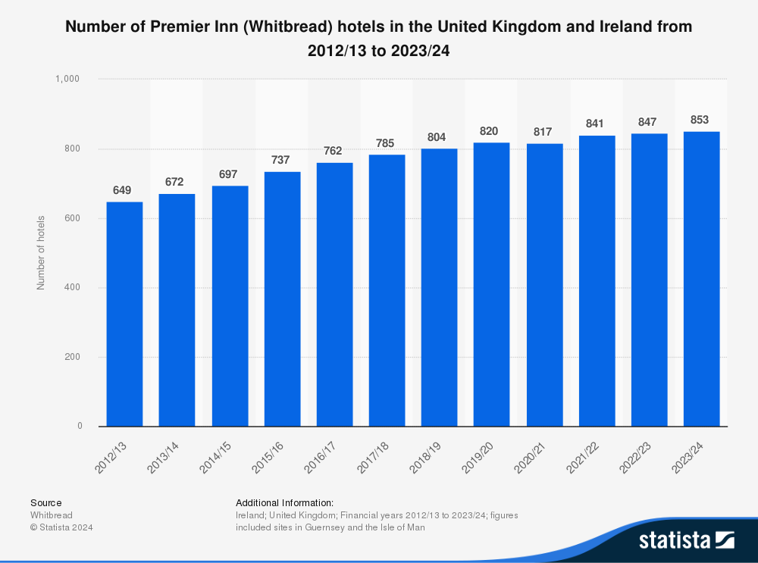
Statista (2024). Number of Premier Inn hotels in United Kingdom and Ireland

  - Shangri-La Hotels
Shangri-La Hotels and Resorts operates within the luxury segment of the hospitality industry. Founded in 1971 and located in Hong Kong, the chain is known for providing high-quality, customised services in prestigious areas. Shangri-La has over 100 hotels globally, primarily in Asia and the Middle East (Shangri-la Group, 2020). The business model emphasises high-quality service, upscale accommodations, and various amenities, including fine dining and wellness options. Shangri-La has faced financial difficulties in recent years, even with its well-known brand. The COVID-19 pandemic significantly impacted revenue, resulting in profit declines. By 2023, the company has demonstrated recovery, with higher revenue and a slight return to profitability. Shangri-La seeks to maintain its luxury standards while exploring mixed-use developments and capitalising on opportunities in emerging markets (Shangri-La, 2023).

- Revenue Streams and Profitability
  - Financial comparison in the year 2023

Metric | Premier Inn | Shangri-La
Revenue (GBP) | £2,960 million | £47.45 million
Cost of Revenue (GBP) | £1,845 million | £14.89 million
Gross Profit (GBP) | £1,115 million | £32.56 million
Net Income (GBP) | £452 million | £3.04 million
Gross Profit Margin (%) | 37.67% | 68.61%
Net Profit Margin (%) | 15.27% | 6.40%

  - Analysis
Premier Inn targets business and leisure travellers looking for affordable accommodations. The business model promotes high-volume bookings to maximise economies of scale and spread fixed expenses. Premier Inn, a major player in the UK hotel sector with over 85,000 rooms, needs this technique to stay profitable (Premier Inn, 2023). Premier Inn relies on hotel bookings rather than food and drink. Low operational costs result from this strategy (Guilding, 2014). Premier Inn's Gross Profit Margin was 37.67% in 2023, demonstrating cost control and profitability (Premier Inn, 2023). Premier Inn's 15.27% Net Profit Margin shows operational efficiency. Its performance derives from cost optimisation and strong occupancy rates despite inflation and growing energy costs (Seal, 2019). The inexpensive hotel chain excels by prioritising high booking volumes above premium prices. Premier Inn manages expenses and ensures operational efficiency to boost profits. This strategy helps the organisation handle economic shocks in the market (Premier Inn, 2023). Shangri-La Hotels targets wealthy tourists wanting luxurious lodgings and unique services with premium prices. Room bookings, gourmet dining, wellness, and event hosting generate revenue (Shangri-La, 2023). The brand's large revenue base allows a Gross Profit Margin of 68.61% in 2023, demonstrating its ability to turn high-priced services into significant profit despite a complex cost structure. Shangri-La's Net Profit Margin was 6.40% in 2023, reflecting premium service issues and pandemic financial recovery. Hospitality costs including staff, maintenance, and services reduce profitability (Walker, 2021). The brand has excellent gross margins but lower net profitability due to continual expenditures in quality and service in high-end operations (Shangri-La, 2023). Premier Inn enhances operations with inbound logistics, room management, and digital bookings. Premier Inn profits from economies of scale and economical properties and services. This technique follows cost leadership concepts, emphasising on cost containment and efficient operations to compete in the budget market (Drury, 2021). Shangri-La prioritises customer service and luxury. Prime property sites, tailored customer service, and luxury traveller marketing are the company's value chain. Shangri-La can charge greater prices, but operational issues and high service demands limit net profits compared to Premier Inn (Tranter, Stuart-Hill and Parker, 2014). Shangri-La's high gross margins demonstrate pricing strength, but high operational costs reduce net profitability. Premier Inn's Gross Profit Margin of 37.67% indicates good cost control and high occupancy compared to the other chains. Due to economies of scale and cost reduction, the Net Profit Margin is 15.27%. Due to its pricing strategy and premium services, Shangri-La has a 68.61% Gross Profit Margin. Luxury standards entail significant operational expenditures, as shown by its 6.40% Net Profit Margin.
  - Factors driving growth/decline
Jagels (2007) claim that revenue changes in the hospitality industry are influenced by various internal and external factors. Premier Inn's revenue growth is driven by its cost-leadership model, high occupancy rates, and expansion into new markets like Germany, where it saw significant growth in 2023 (Premier Inn, 2023). Direct online bookings, economies of scale, and operational efficiency enhance revenue. Increasing operational costs, including inflation and energy prices, pose challenges for sustaining profit margins (Guilding, 2014). Shangri-La's revenue growth is driven by its premium pricing strategy, diverse revenue sources such as dining, events, and spa services, along with its global market presence. Luxury hotels incur higher operational costs, which can lower net revenue, particularly during economic downturns or periods of reduced travel demand. Post-pandemic recovery and rising consumer interest in personalised luxury experiences are boosting demand in the global market (McKinsey, 2024).
- Market positioning
Premier Inn dominates the UK budget hotel market with 22% market share in 2023. It dominates because of its cost-leadership strategy of supplying affordable rooms for leisure and business tourists. Premier Inn has survived inflation and rising operational costs by using economies of scale (Premier Inn, 2023). International expansion, notably into Germany, boosts Premier Inn's competitiveness. UK parent firm Whitbread wants to boost its market share to 25% by 2027, demonstrating the brand's growth potential. Premier Inn's German operations grew 57% in 2023, demonstrating the brand's capacity to duplicate its UK success abroad (Whitbread, 2023). Premier Inn dominates the budget market by targeting price-sensitive clients and business travellers seeking economical and reliable hotels. Luxury hotel Shangri-La attracts wealthy guests with superior services. Shangri-La has properties in major cities worldwide. Luxury offerings like personalised attention, fine food, and wellness amenities attract wealthy clients prepared to spend more. Even as operational costs rise, Shangri-La remains a worldwide player. Luxury events, spas, and dining account up most of its earnings (Shangri-La, 2023). Due to rising disposable incomes and demand for tailored travel experiences, Shangri-La's luxury hotel industry is predicted to rise 9.43% from 2024 to 2029 (Forbes, 2024). Due to its concentration on luxury services and amenities, Shangri-La's operational costs are higher than budget hotels, but its RevPAR is higher. Premier Inn's cost leadership philosophy of standardised services at reduced pricing is helping them dominate the budget market. Premier Inn hopes to emulate its UK success across Europe. Maintaining cost efficiency and quality is key to market success. Shangri-La differentiates itself to charge premium pricing on its unique, high-end offerings. Customised experiences and prime locations set the brand apart in luxury. Rich visitors like Shangri-La despite its greater costs.
- Growth potential
Premier Inn's growth potential depends on geographic expansion, particularly in Germany, where the brand is rapidly expanding. In 2023, Premier Inn experienced a 57% increase in revenue from its European operations, including Germany, due to strong demand and effective implementation of its UK model (Premier Inn, 2023). Whitbread intends to increase its investment in Germany, aiming to open 60 hotels by 2025, marking it as a key growth market outside the UK. The German hotel market presents Premier Inn an opportunity to expand its cost-leadership model outside the UK, targeting the mid-scale and budget segments while leveraging economies of scale and operational efficiency (Whitbread ESG, 2023). Shangri-La plans to expand by entering new markets and developing mixed-use properties. The brand is investing in properties in Asia and the Middle East due to rising demand for luxury services. Shangri-La focusses on mixed-use developments that integrate hotels with residential, office, and retail spaces, generating diverse revenue streams beyond typical hotel operations (Shangri-La, 2020). This strategy helps Shangri-La attract more high-end clients and reduce dependence on room occupancy alone. Premier Inn emphasises geographic consolidation and expansion, particularly in cost-sensitive markets like Germany, where its budget model works well. Shangri-La employs diversification through mixed-use developments, targeting luxury segments in emerging markets to enhance growth potential and broaden its revenue base beyond conventional hospitality.

- CSR initiatives
Premier Inn, part of Whitbread, has incorporated Corporate Social Responsibility into its operations via the Force for Good program. The company has put resources into sustainability and social initiatives, cutting carbon emissions by 46% since 2019 and targeting net-zero emissions by 2040. It will use 100% renewable energy in all its UK operations. Whitbread has invested in community initiatives like job creation and development programs for disadvantaged groups, demonstrating its commitment to long-term social value (Whitbread ESG, 2023)​. Shangri-La demonstrates its financial commitment to CSR through its sustainability initiatives, which focus on environmental conservation, community engagement, and employee welfare. The brand faces challenges in fully integrating CSR into its luxury operations. Shangri-La has put money into sustainable hotel designs and renewable energy sources. Its emphasis on high-end services, which usually need more resources, might be viewed as counterproductive to its sustainability goals (Shangri-La, 2023)​.

- Conclusion
In conlusion, Premier Inn and Shangri-La Hotels exhibit distinct financial management strategies that align with their market positions. Premier Inn's success in the budget hotel market is due to its focus on cost leadership, operational efficiency, and geographical expansion, particularly in Germany. This method enables it to maintain strong profits despite economic difficulties. Shangri-La targets wealthy travellers through its luxury strategy, offering high-end services and distinctive experiences. High operational costs impact net profitability. Both companies emphasise CSR, but Premier Inn's sustainability initiatives align more closely with its business model, while Shangri-La finds it challenging to integrate CSR into its resource-intensive luxury operations. Each strategy reveals the company's market and customer base.

- Recommendations
- Premier Inn can enhance operational efficiency and customer engagement by focussing on digital transformation. Incorporating AI and automation into booking systems and customer service can assist Premier Inn in reducing expenses and improving customer satisfaction (Jiwnani, 2024). Expanding eco-friendly initiatives, such as using sustainable building materials and energy-efficient technologies, can address consumer demand for sustainability and provide long-term cost savings.
- Shangri-La should adopt a firmer approach to CSR by reducing resource-intensive luxury operations while maintaining service quality. Energy-efficient technologies and sustainable supply chain practices can create a balance between luxury and sustainability (Font and Lynes, 2018). Expanding into emerging markets and focussing on culturally immersive experiences could help Shangri-La attract more customers and diversify its revenue sources.

References

Drury C (2021) (11th Ed) Management and Cost Accounting, London, Prentice Hall
Font, X. and Lynes, J., 2018. Corporate social responsibility in tourism and hospitality. Journal of Sustainable Tourism, 26(7), pp.1027-1042.
Forbes (2024). Elevated Experiences: 2024 Global Trends In Luxury Travel And Hospitality. [online] Forbes. Available at: https://www.forbes.com/sites/forbes-global-properties/2024/03/14/elevated-experiences-2024-global-trends-in-luxury-travel-and-hospitality/.
Guilding, C.(2014) (3rd Edition) Accounting Essentials for Hospitality Managers, London, Routledge
Jagels, M. (2007) Hospitality Management Accounting, London, Wiley.
Jiwnani, L. (2024). AI’s transformative role in the hospitality industry | Deloitte UK. [online] www.deloitte.com. Available at: https://www.deloitte.com/uk/en/Industries/consumer/blogs/embracing-the-future-ais-transformative-role-in-hospitality.html.
Mckinsey. (2024). Updating perceptions about today’s luxury traveler | McKinsey. [online] Available at: https://www.mckinsey.com/industries/travel-logistics-and-infrastructure/our-insights/updating-perceptions-about-todays-luxury-traveler.
Premier Inn (2016). International development. [online] Premier Inn. Available at: https://www.premierinn.com/gb/en/business/international-development.html.
Premier Inn (2024). Building on our advantages. Annual Report 2023. Available at: https://cdn.whitbread.co.uk/media/2024/05/Whitbread-PLC-Annual-Report-and-Accounts-2023_Single_pages-1.pdf
Premier Inn (2024). Why We’re Premier. [online] www.premierinn.com. Available at: https://www.premierinn.com/gb/en/why.html.
Seal W (2019) (6th Ed) Management Accounting, London, McGraw Hill
Shangri-La (2023). Annual Report 2023. Available at: https://sitecore-cd.shangri-la.com/-/media/Project/Shangri-La-Group/Investor/Files/Public-Disclosures/Latest-Top-Publications/2023_Annual_Report_E.pdf
Shangri-La (2019). Luxury Hotels and Resorts | Official Site Shangri-La Hotels and Resorts. [online] Shangri-la.com. Available at: https://www.shangri-la.com/.
Shangri-la (2020). Investment properties. Available at: https://www.shangri-la.com/group/our-businesses/investment-properties.
Shangri-La (2023). Sustainability Report 2023. Available at: https://www.shangri-la.com/group/sustainability/report
Shangri-la Group (2020). Welcome: Shangri-La Group. [online] Shangri-la.com. Available at: https://www.shangri-la.com/group/our-businesses/hotels-and-resorts.
Tranter, K. Stuart-Hill, T. Parker, J. (2014) Introduction to Revenue Management for the Hospitality Industry, London, Pearson
Walker J (2021) Introduction to Hospitality, Harlow, Pearson
Whitbread (2023). Why invest? [online] Whitbread PLC. Available at: https://www.whitbread.co.uk/investors/why-invest/.
Whitbread ESG (2023). Enabling people to live and work well. Available at: https://cdn.whitbread.co.uk/media/2024/05/Whitbread-PLC-ESG-Report-2023.pdf

‌

