

LOCATION: Swansea | LLEOLIAD: abertawe
LEVEL 6 | LEFEL 6
EXAMINATION PERIOD | CYFNOD ARHOLIADAU
APRIL 2025 | 2025

MODULE CODE: ACDA6019
Advanced Radio Frequency Systems

Programme:
B.Eng.(Hons.) iN Embedded Electronic Systems

TIME: 2 HOURS
answer ALL questions

Equipment or materials required – Calculator, Formula sheet
Adnoddau neu ddefnyddiau sydd eu hangen - Cyfrifiannell

ANSWER ALL QUESTIONS
Question 1 [25 marks]
- Discuss the impact of side lobes and back lobes on antenna performance. [5 Marks]
- A 3-element Yagi-Uda antenna is to be designed for operation at a frequency of 150MHz. Apply the knowledge of antenna design principles to calculate the lengths of the driven element, director, and reflector. Also, calculate the spacing between antenna elements, if the distance from the driven element to the reflector is 0.15λ, and the distance from the driven element to the director is 0.2λ. Assume a 5% difference in length between adjacent elements. [10 Marks]
- A Monopole antenna resonates at a frequency of 1GHz, calculate the operating wavelength and the length of the antenna. [5 Marks]
- What is a phased array antenna? How does it operate? [5 Marks]
Question 2 [25 marks]
- A helical antenna is designed for satellite communication and operates at a frequency of 5 GHz. It has a diameter of 10cm and a pitch of 3cm. Calculate the transition distance from the near field to the far field for this helical antenna. [4 Marks]
- Formulate the S-Matrix for a two port network, with two ports are perfectly matched. [3 Marks]
- A two port network is known to have the following scattering matrix. Determine the following.
$$\left[S\right]=\left[\begin{matrix}0.15∠0^{o} & 0.85∠{-45}^{o} \\ 0.85∠{45}^{o} & 0.2∠0^{o}\end{matrix}\right]$$
- Analyse if the network is reciprocal. [2 Marks]
- Evaluate if the network is a lossless network. [3 Marks]
- Calculate the return loss at port 1 when port 2 is terminated with a load that matches the network's impedance. [4 Marks]
- Identify the antennas listed in table 1. [5 Marks]
Table 1: List of antennas
Question Number | Antenna
 | 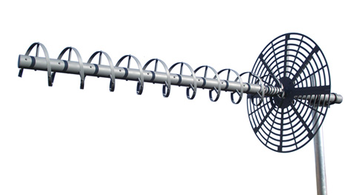
 | 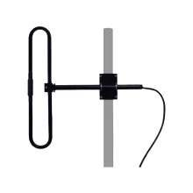
 | 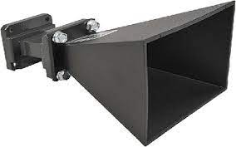
 | 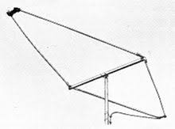
 | 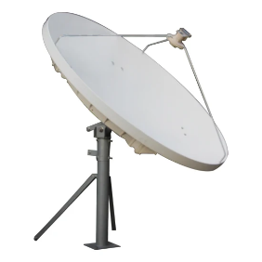
- Differentiate between a Broadside Array and an End Fire array Antenna. [4 Marks]
Question 3 [25 marks]
- A transmission line working at radio frequencies has the following constants $L=9μH/m,$ $C=16pF/m$. The line is terminated with a resistive load of $R_{L}=1000Ω$. Calculate the reflection coefficient and standing wave ratio. [6 Marks]
- An antenna has a Radiated power density given by $W_{rad}=2{Sin}^{2}θ$ W/$m^{2}$, in the far field. The radiation is over a spherical surface with radius 5cm. Calculate the total radiated power. [14 Marks]
- An antenna radiates energy. At a distance of 10 meters from the antenna, the radiated power density in a specific direction is measured to be 0.05 W/m². Calculate the radiation intensity U in that direction, solve step by step. [5 Marks]
Question 4 [25 marks]
- A 50 $Ω$ transmission line operates at 500MHz and is terminated with a load impedance of $Z_{L}=25+j50Ω$. Calculate the following to design a open circuited series single-stub tuner to match the impedance.
- Normalised load impedance [2 Marks]
Using Smith chart determine the following
- SWR [2 Marks]
- Return Loss [2 Marks]
- Normalised Load Admittance [3 Marks]
- Distance of the stub from the load ($d_{A})$ using smith chart [10 Marks]
- Length of the Stub ($l_{A})$ using smith chart [6 Marks]
Diwedd/End

