Software development

Student Name: Horatiu Lucian, Butunoi
Student Number: 1918671
Lecturer name: Suneth Fernando

SECTION-1
Part A
Introduction
The report main aims to describe the concept of programming through analyzing and build the best solutions for different problems. Firstly, this report explained the difference between the set variables to a constant number through using the keyword CONST in C#. Thus, it also explained different kinds of data as the needs of the report. Through, considered an appropriate example, a discussion on how to convert a single kind of data into another. In the end, the report has explained different kinds of control structures of programming. Thus, it refers to repletion, compare and contrast the various kinds of loops in programming are discussed in this report.
- Difference between setting a variable to a constant number and using the keyword CONST to define a constant in c#.
Variable in programming system is nothing but a name provides to a storage place, that programmers can easily operate. Generally, the each and every variable in programming has particular kind that helps to identify the size and layout of the different memory along with range of number that can be stored within the memory. It considered a group of activities that can implement to the variable. In the term programming, the name of the variable should be composed of numbers, letters and underscore character. As C is a case sensitive, if the lowercase and uppercase has distinct. It also explained about the main role of variable that tell about complier where and how much storage space is needs to create variable. The five kinds of variable are their as char (a single octet (one byte and is an integer type)), int (most natural size of integer for the machine), float (having a single-precision floating point value), double (double precision floating point value) and void (represents the absence of type). In variable, the value should be varying and assigned at any time and it can be used without assigning the value.

Examples of variable:
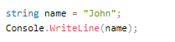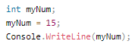
VARIABLE ANALYSE PROGRAM
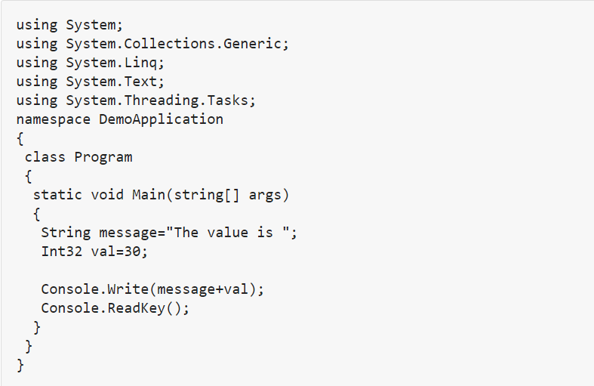
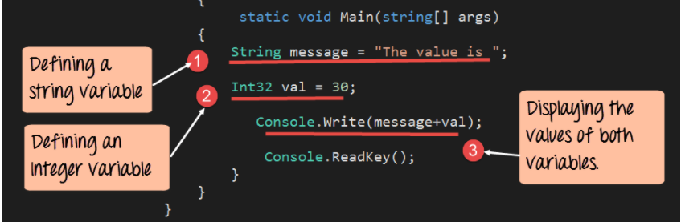
Furthermore, a constant variable is known as variable whose value cannot vary during the execution of the plan or program. Thus, the value cannot be varying, because the compiler or the programmer cannot assign the value to the constant variable throughout the run time. Somewhat, it also require to assign only at the compile time. Compile run time and runtime constant are the two kinds of Constant. The Compile time constant are stated through using the ‘const’ keyword. This way, the value should be varying while executing the program. Moreover, the runtime constant are stated through use the ‘Read-only’ Keyword, that value cannot be changes throughout the program execution. Therefore, the constant name is providing to a particular variable or value in the C programming language that cannot be changes if once stated. In the program, they consider as fixed value. Each and every constant has different range that varies from unsigned to singed bits. In the signed bit, the range of an int ranges from -128 to + 127 and below the unsigned bit; it diverse from 0 to 255.
Example:
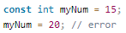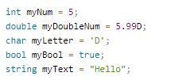
CONSTANT IN C# PROGRAM
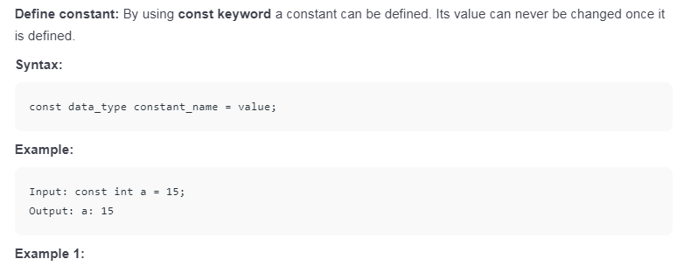
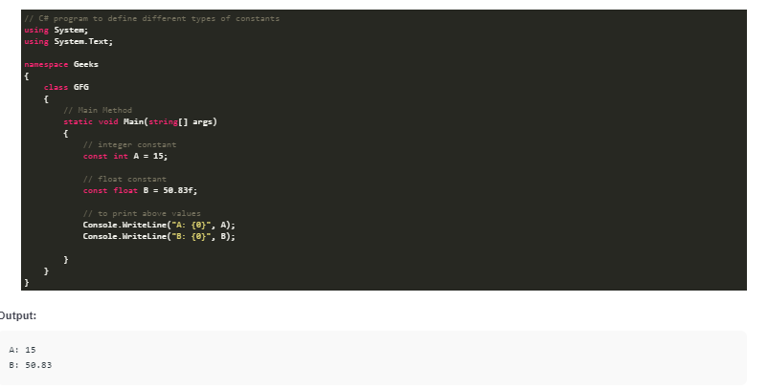
In C#, variable should be stated as constant by using the const keyword or through the #define pre-processed direction. Variable should be stated through using the main word but before the data kinds of the variable. The Constant variable can be initialed only once. In C#, the default value for the constant variable is known as zero. The following is the example that explained the declaration of the constant variable in C# used the cosnt keywords:
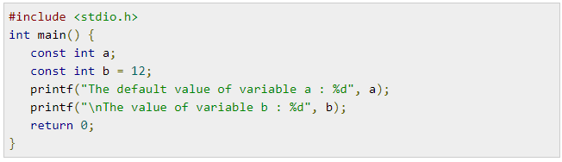
The program Output is discussed as follows:
Through using the # stated pre-processed direction, a variable can be stated as constant as it declares an alias for different value. These programs show the statement of the constant variable in C by using the # defined the preprocessor directive:
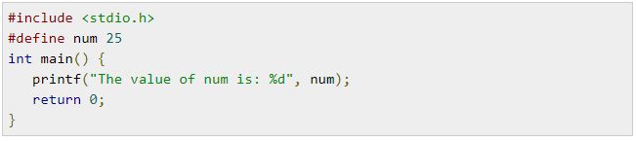
The result of the program is as under:
Difference between variable and constant
Variables | Constant
A storage place all along with a connected symbolic name that has value | If the value given, it cannot be modified during the program.
The storage place also hold data | It is alike to variable although with a distinct value
It can be change as per the requirement of programmer. | It cannot changed
Value can confirm | Value is Fixed

2. Data types and why they are necessary?
The Date that is used for programming purpose is called as data type. It also discuss about several kinds of data that is process in the programming (Walker et al., 2018). Data type is generally used for the critical kinds of data; some are useful for storing text or letter, and some data types is use for storing value or number (De Sousa et al., 2012). Data types are also divided into sub parts such as Boolean, integer, float and string. The Boolean types of information is used either for Yes and No or true and false. Integer type of data is depiction of numbers. Float types of data is the real number which shows that data in point format such as 10.3. String is the symbol of the name or title.
Data types are very essential tool in programming language as it is strongly type’s language. On behalf of the compatibility, all the activities are type- checked through the compilers by using the data types. It also helps to reduce the problem related to compiling illegal activities and also helpful in improving the reliability and prevent mistakes (Verma, 2020). Presently, the data types enable to strong type-checking, values, expressions and variables. The feature of data that tell the interpreter or compliers how the information is intended to use is called as a data type. The data types are very important since each programming language needs to working on various kinds of data such as strings and integers and so they can be stored as that data types.
Program of data types

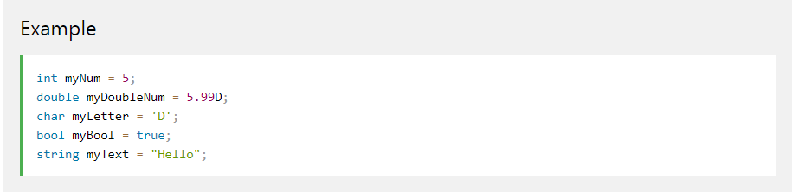

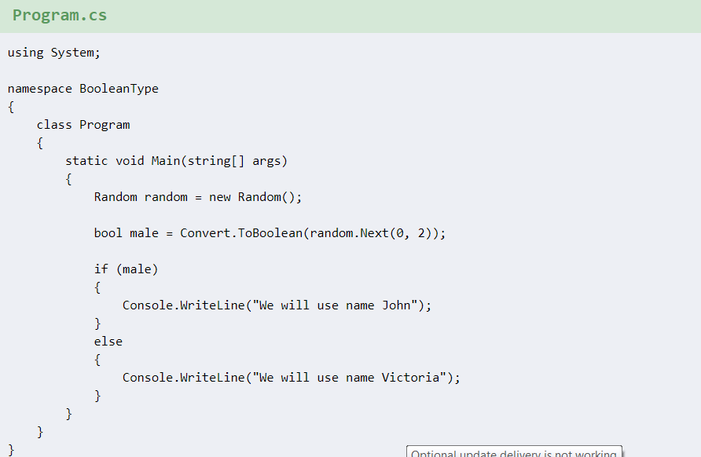
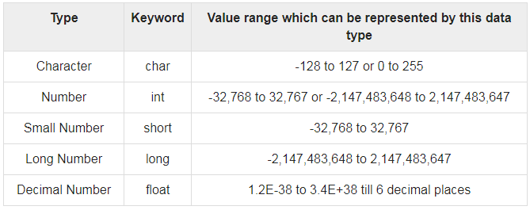
Figure 1 types and keywords of data types (Verma, 2020)
The bool type: it represents yes/no or true/false values. By the use of set aside words true and false, the true and false values are represent in the programming (Walker et al., 2018). The bool value can be recognized in the out by “False”, “True”, or WriteLine ().
Characters: a set that can stand for the entire font found in all human languages is term as a character (De Sousa et al., 2012). It cannot be freely mixed with integers in all cases for the reason that there is no mechanical type change from integer to character.
Float: a number that has a fractional element is representing by float numbers.
Implicit type of conversion: Generally, it is known as automatic types of conversion done through the compiler in the case of intermixed data types or when the data from distinct types is intermixed (Szalay et al., 2020). It result in the change of the value to the equivalent value in the new kind and it also reinterpretation of the value of the expression. In example, a variable data types store a long value that an integer can also stores.
Example: -
// Implicit conversion. A long can
// hold any value an int can hold, and more!
int num = 2147483647;
long bigNum = num;
In the above example the complier has absolutely transformed the value of ‘num’ on the right to a type ‘long’ before transfer to ‘big number’.
Explicit conversion: It is a kind of transformation that is clearly stated within a program a runtime check is finish if the destination kind can hold the source value before the conversion can performed effectively (Szalay et al., 2020). This is also known as unique programming instruction that particular what information type has to treat the variable as in provide in equation. The Compiler used explicit types of transformation if the conversion cannot be made without ant problem losing the data.
Example:
If the compliers exchange a higher numeric value into a lower one:
doubled = 69.69:
int I;
I = (int)d;
Now, if ‘I’ will be on paper by the complier then the result should be 69 and the values after the decimal point will be lost in the change.
3. Different types of control structures in programming. Compare and contrast different types of loops in programming
The control structure is the way to specify the flow of controls in the programs. If the user used the control structure, it helps in the program to understand the program or other algorithm. Control structure is helpful to evaluate and select that direction a program flows connected on the specific situation or condition. Control structure is divided into three common structures are as under:
a) Sequential flow:
It is kinds of structure follow chronological or serial flows anywhere the flows mainly based on the series of instruction provide to the computer (Choe, 2016). The method are executed in the clear order unless they follow new instruction are provided. Through the use of explicit exchange method the order are provide through the mean of the numbers. This way, the control structure the statement is follow chronological order in the same way in that they show in the script.
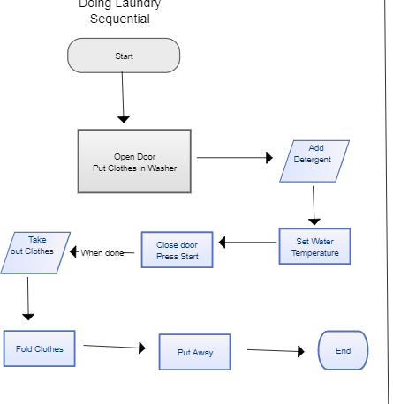
b) Conditional flow:
It includes server parameter or conditions that decide one out of server written modules. The structure fully based on the condition either it’s true and false (Szalay et al., 2020). For example, the result of the questions will be either true or false; where the questions are ‘Is the result less than 10?’ the result of control structure is described as under:
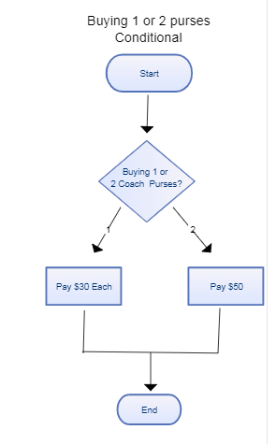
c) Repetitive flow:
A loop, that includes a repeat declaration follow by a module, is called as repetitive flow (De Sousa et al., 2012). In this type of control structure allow the implementation of a block of statement multiple times until a particular circumstance is met.
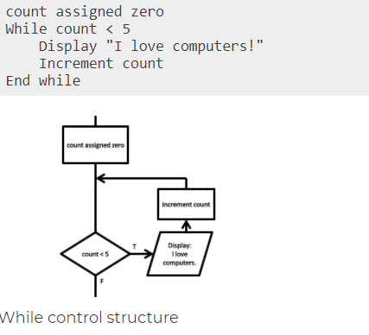
Figure 4 Repetitive control structure (Szalay et al., 2020)
Loops
Loops are a series of instruction that is repeated the certain condition until it reached in the computer programming. The loop statement is needs to be in written only once and it should be executed 10 times. In programming, the two types of loops are explained such as entry control loop and exit control loop. Mainly the two entry controlled loops are FOR and WHILE loops (De Sousa et al., 2012). Therefore, the entry controlled loops of the test condition are tested before enter into the late body. Generally, in the exit controlled loops, the test condition are tested n the end of the loop body. Do-while loop is the kind of exit controlled loop.

A loop is a replication control structure that allows a programmer to mark a loop that is execute to a particular number of times. The loop is unable the programmer to perform the number of steps with each other in a single line. ‘While loop’is helped the programmer cannot know the clear number of iteration of loop execution earlier (Choe, 2016). The main basis for the test conditioned of termination of the execution of loops. The execution loop is also change based on the test situation is also ended based on the test situation in the do-while loop but in the loop the test condition is tested in the end of the loop body.

PROGRAM OF LOOP
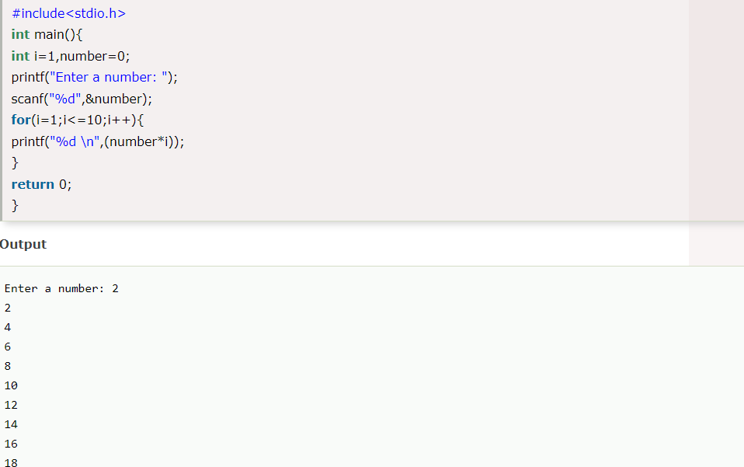
Comparison of entry controlled and exit controlled loops:
Entry controlled loop | Exit controlled loop
These are used when the checking of test situation is compulsory before execute the loop body. | These are used while inspection of test condition is compulsory after execute the loop body.
While and for loops are the examples of this type of loop | Do-while loop is the example of this kind of loop.
Loop body will not execute in the casing of false test situation | Loop body will be executed in the case of false test situation
The loop body is execute after examination the test circumstances | The test situation is checkered after the completing of loop body.
This loop will be execute if and only if the situation is evaluate as true | This loop forever execute at smallest amount once, in spite of of situation (De Sousa et al., 2012).

PART B
This section will converse about a variety of steps that are necessary to develop the program that was known as the part of the task.
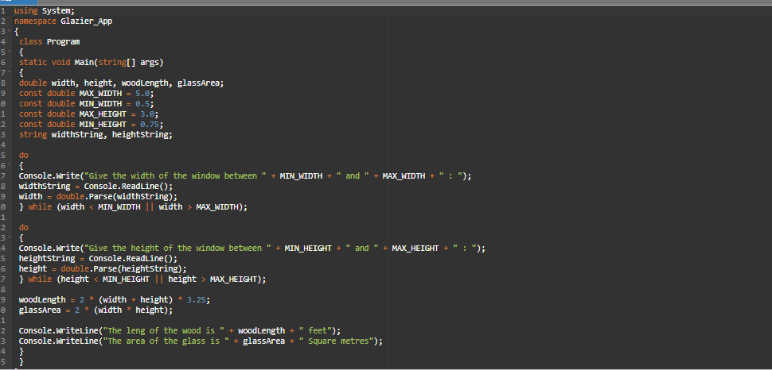

FLOW DIAGRAM
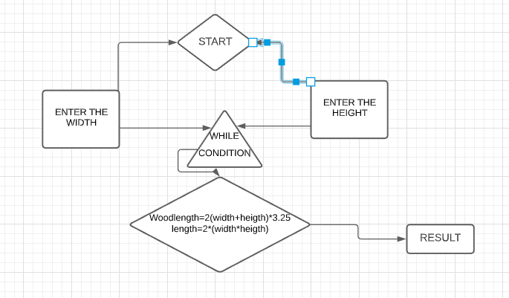
1-In the C# we are with system to describe the purpose for the program
2- Name space is used to divide the codes and course from each other in C#
3 The third step is to devise the class for influence to pass that are taken as parameter
4 Double is worn to obtain classify the float and integers data type
5 After that, constant variables are provided with a variety of values along with cord inputs
6 Do along with console. Write to ask user exact input and thereafter, using console. read command to permit user to type and after that it is parse to make sure while situation that has essentially two situation of greatest and least, this do purpose should job for the width
7 second do function is used for the height with the same login as used above in width
8 At last wood length data kind is used to gather the data after computation as used in logic
9 Same data type is second-hand to amass the area intended.
10 In the end, the outcome are bare as on paper with use of the power console. Write line that is used to demonstrate the outcome to users in a string format.
11 The whole program is build to focus on user contribution as width and height and give relevant results as per the data composed by it and then doing the assessment that is done by the even as loop condition that is based on true and false, if the situation is true, outcome should be provide and if the state is false, the result is not shown or the user will get the query of writing the right data flanked by the minimum and utmost width and height.
PART C
Excercise-1
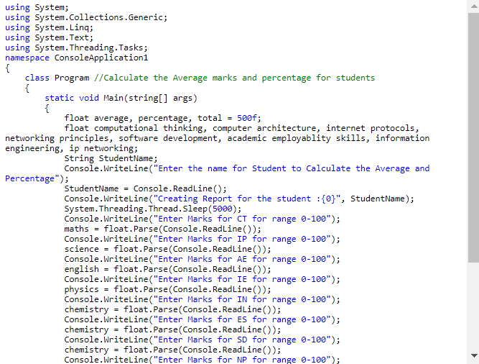
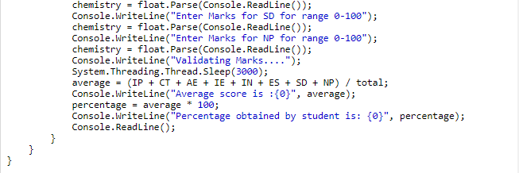

Excercise-2
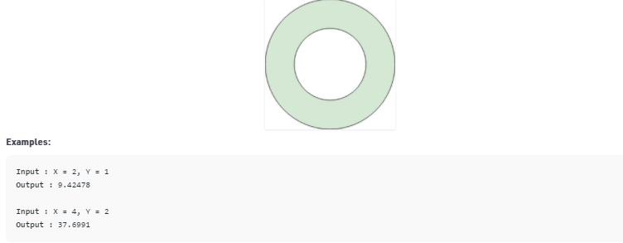
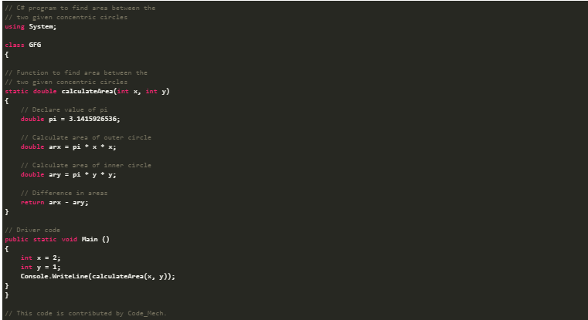
Excercise-3

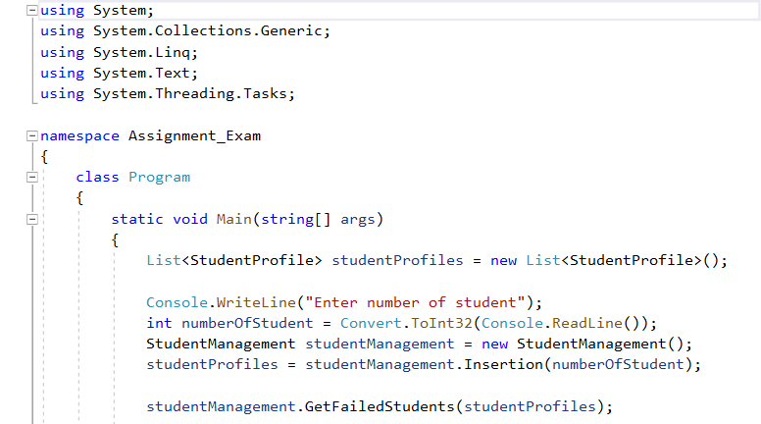
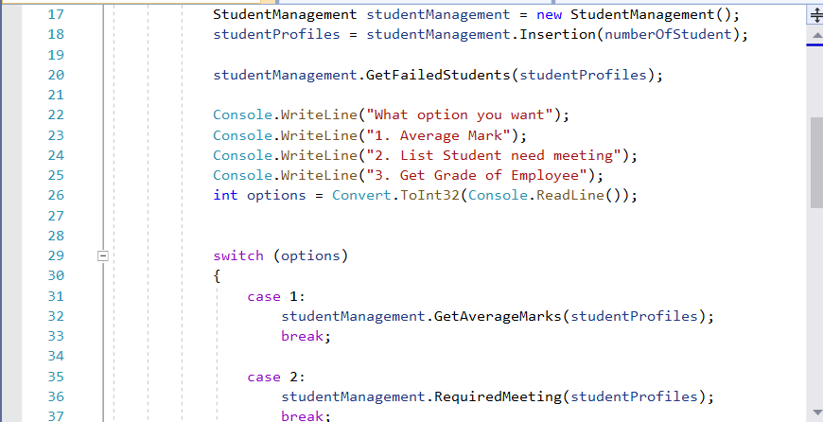
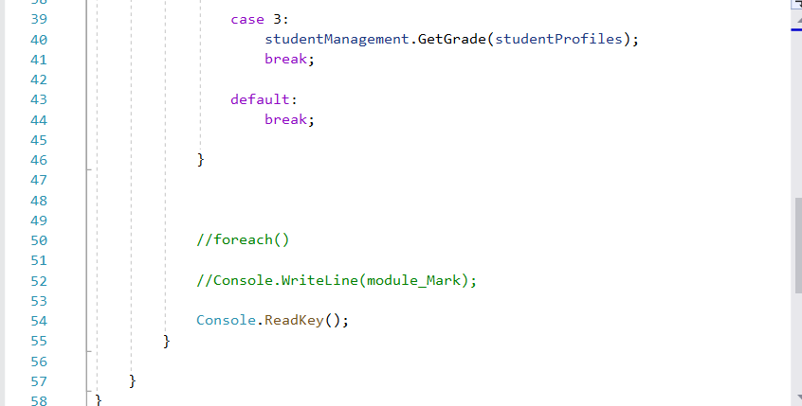
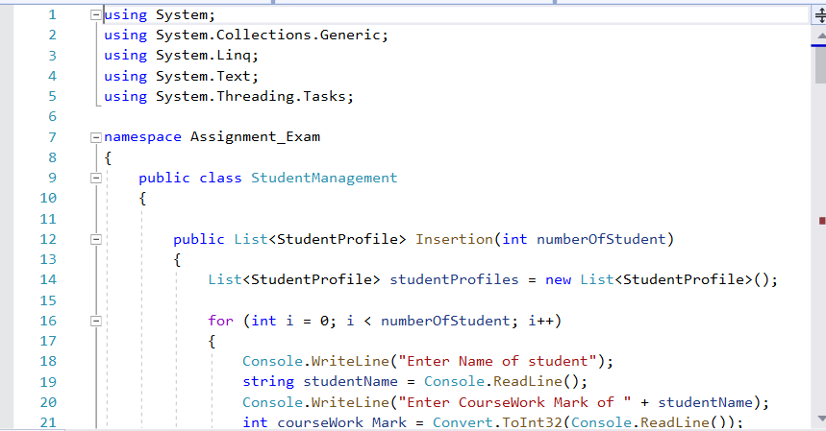
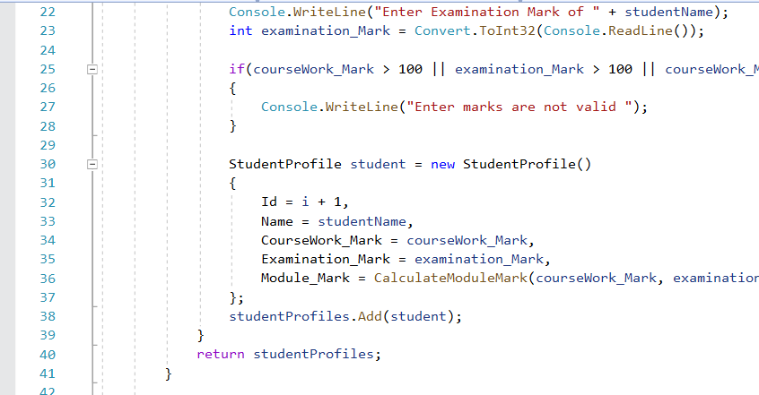
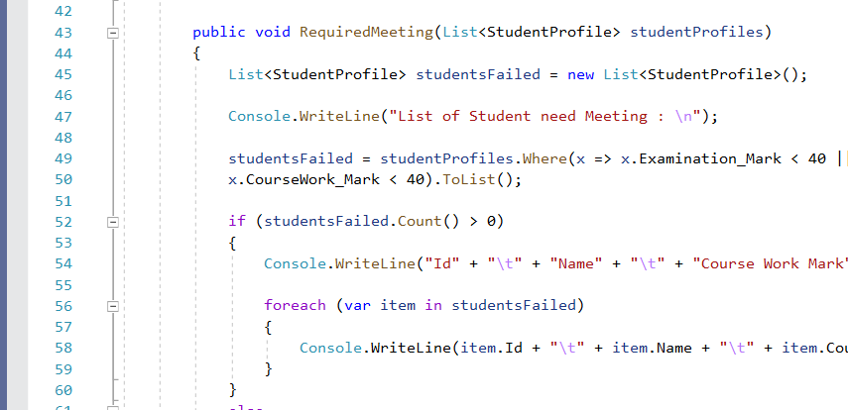
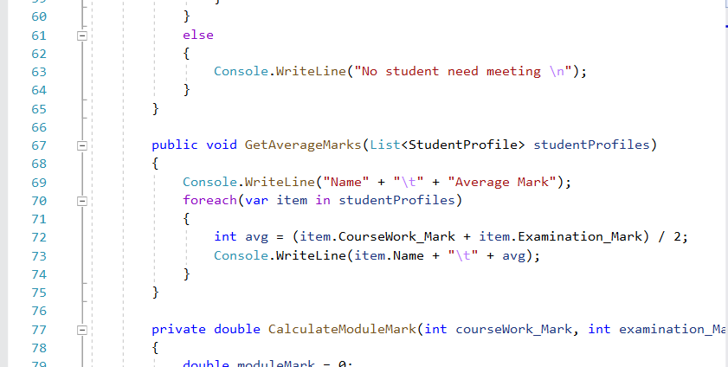
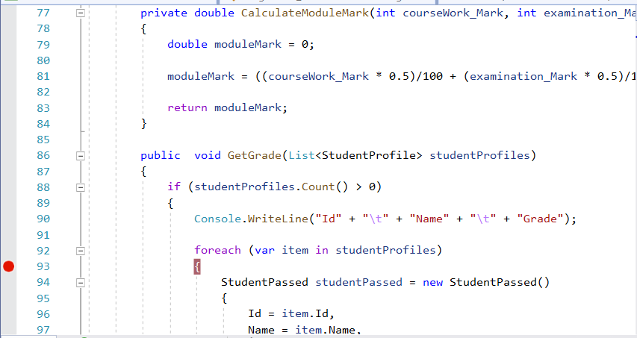
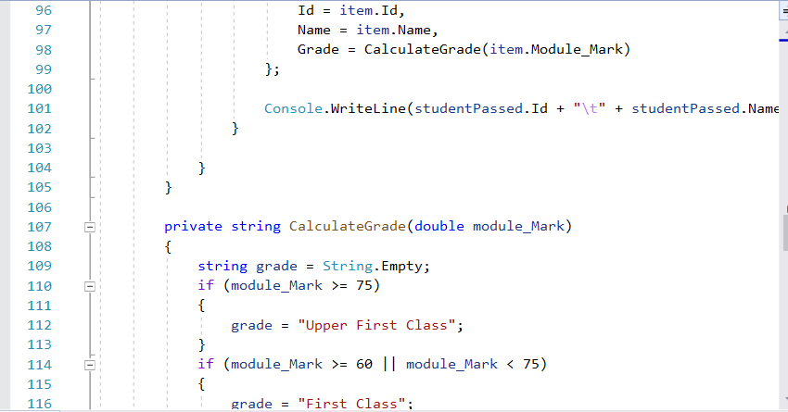
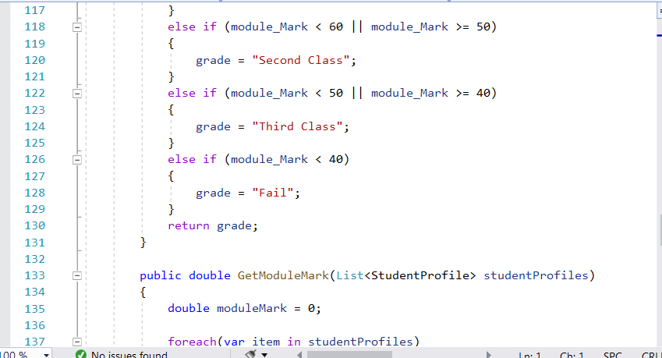
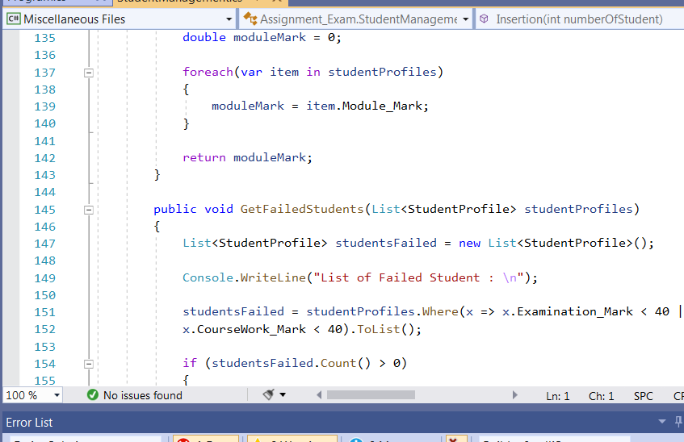
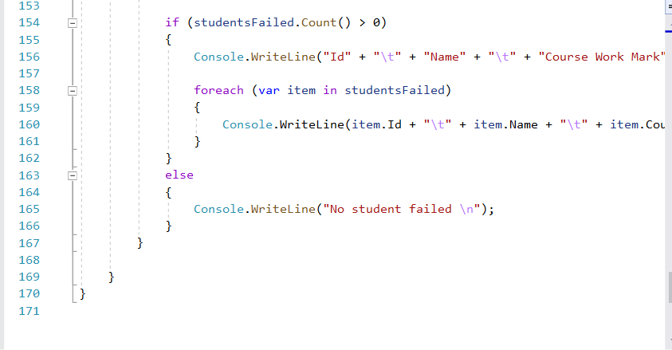
CONSOLE OUTPUT

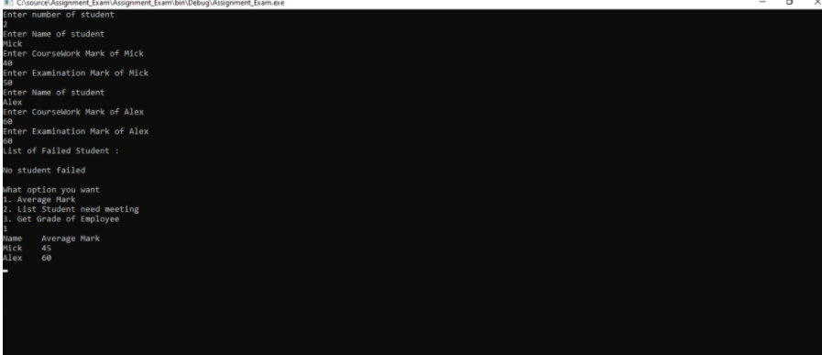
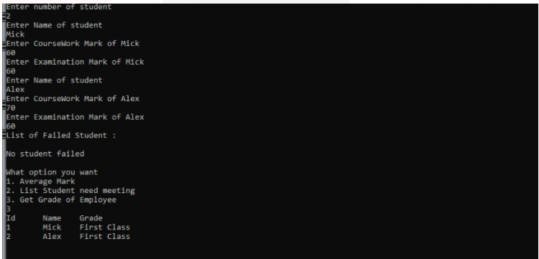
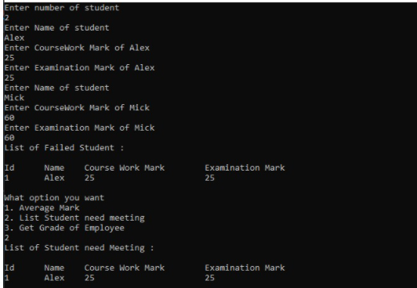

EXCERCISE-4

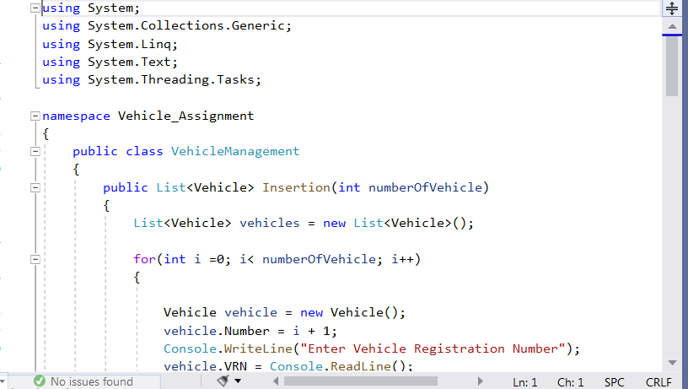
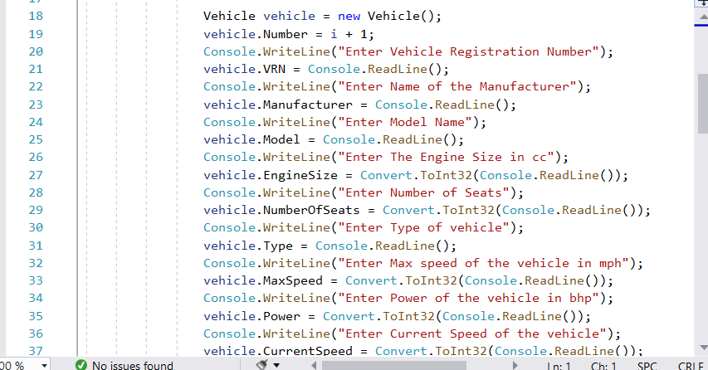
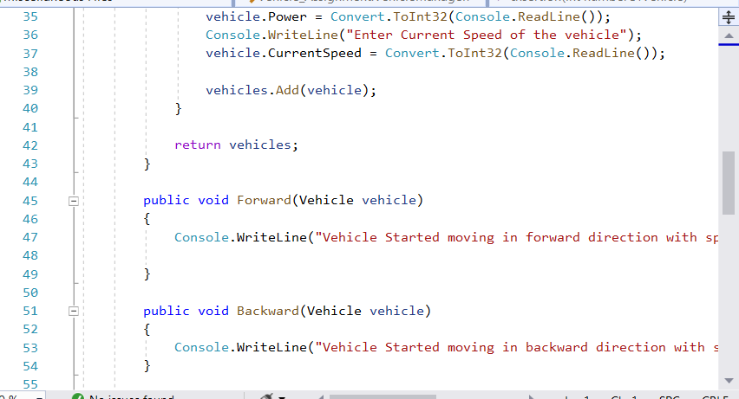
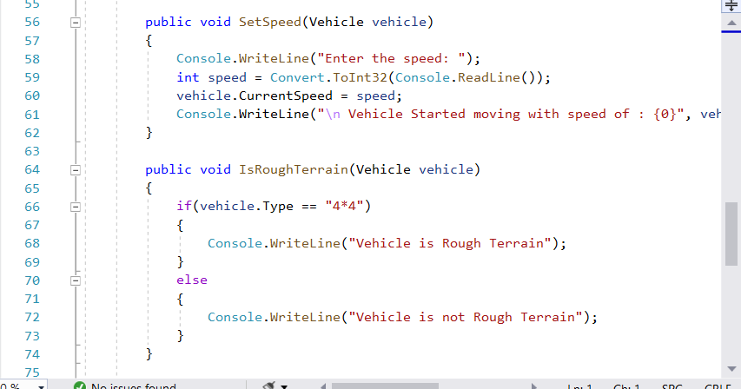

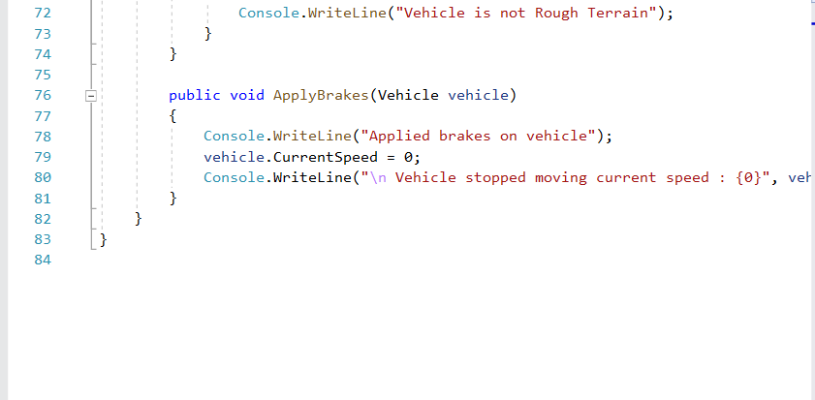
CONSOLE OUTPUT
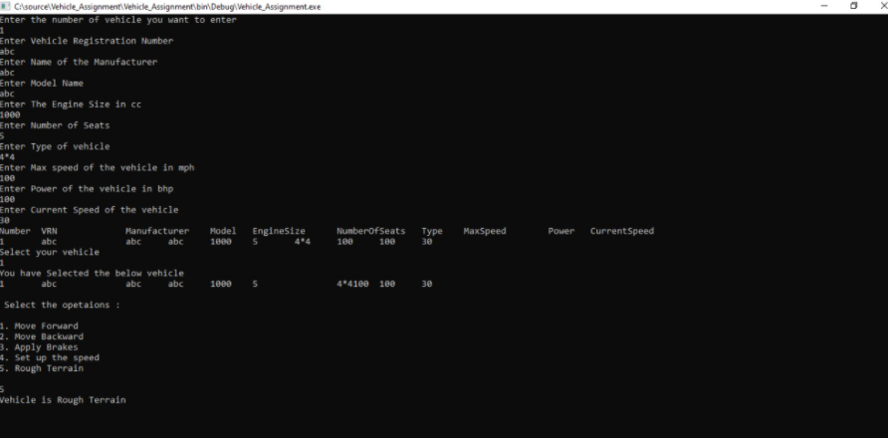

SECTION-2
PART A

Define Arrays and explain the importance of arrays in programming. Give relevant examples to support your answer.
An array is referring as collection or set of same kind of data. In an array is termed as the integrated kind of data structure that mainly designed for store a set of different goals of the same or different types of data. An array can hold both primitive and reference (Narayanan and Shan, 2017). It is best effectual and effective data type’s structure use to manage and access the series of objects. Generally, the array used for copying, clone, placing, removal, incisive, and sorting. Instantly, component of int types are held int array as component of float kinds are held in float arrays.
An array mostly stated various data items of the same kind through using the one name. In arrays, through using the index number users can erratically access the component. Generally, the array used to distribute memory in a continuous memory place for several types of component. It shows there is less or no chance of more memory for distribution. This comparatively reduces the overflow of memory or shortage of memory in the arrays. In the arrays, the entire components store in the array must be called in advance. It is the static structure that explained it as a fixed size. Thus, the size of array is stated it cannot be adopted. The memory that is allocated in the array will be reduce or increase. It is very complex to insert and delete component in the array as the component are mainly stores in the consecutive memory place and shift its operation is very expensive (Åkerblom et al., 2019). If the users allocate more memory place than the actual needs then it may leads to reduce the memory space while if less memory is distributed among it may lead to an issue. Similar data kind component are stores in arrays.
An array is the traditional or most essential data structure is used in the every program. They can be used to implement other data structure such as strings and list. An array is used to exploit the address logic of the systems. It helps to stored in such a way that maintain the position of each component can relatively be compute form index kind by a mathematical formula. It is simple kind of data structure is known as linear array that is called as a one-dimensional array. An array has implement through array structure but using the same language, it is apply by search trees, connected lists and hash tables (Tan and Kaiser, 2016). It is also helpful for implement mathematical matrix and vectors or different kinds of rectangular tables. This is useful when they require several variables of the same kinds arises. This is called as the order of objects with the similar data types. This can be stated and use by system. An array sized will be higher than zero and an integer constant. An array has been passed to operation or can be return from the different functions. An array can be passed to function or can be return from the function. Important of array can be explained through following points are:
The array is used to save memory: In an array, memory will be energetically distributed. It also helps to save the memory of the system. This may also lead by the creation of enough space when inadequate memory is help through predefined array. Memory can be billed throughout run time physically at runtime recollection. The quantity is storage space classically based on the type and size of the data.
Cache friendly: An array, values are mainly distributed near each other in the memory. It can be assess easily form CPU to cache. It shows that iteration in the array is faster than any other iteration. It passed the array for reference (Kent et al., 2019).
Predictable timing with Array: In both arrays as well as hash table, access time can be given. The hash table is difficult as it comprise number of steps where the cache misses are include and memory is reloaded. An array taken as deliberation then the system knows the concise address of the array in that memory can store and distribute data.
Easy debugging: This method consume more time to monitor whether the index is valid or not when an array is taking into contemplation of the connected list. Likewise, it is very complex to monitor it in the hash table. But in the arrays, it has particular indexes and is very optimal to use.
An array frequently maintains numerous variables through using only an only name. This also helps user to contain a large amount of data into a single variable name. It leads to reduce confusion even as using different variables. An array can also be use for sorting distinct data components. Various method of sorting such as insertion, selection and bubble sort typically use an array to keep as well as sort the component quickly and easily. This can be used to manage the matrix operation. Different small or large database include one or two dimensional arrays whose components are termed as records (Pivarski et al., 2020). For CPU scheduling an array is used by them. It is also used to apply other kinds of data structure such as Hash tables, Queues, heaps, and Stacks.
Instantly, to find out the average of 100 integer numbers enter through the users. Since in the scenario, Firstly 100 variable are refer as int data kinds and then 100 scanf() activities should be performed to keep values in the variables and then, at last, compute the average of all. After that, a single integer array is useful to stores all values and then the array is loop has keep entered values in the array and the compute the average. Therefore, the given scenario, the second solution is more suitable in that the same data types can be store in a single variable and after that it can be manage through using the array index.
PROGRAM ON C# OF ARRAY DECLARTION
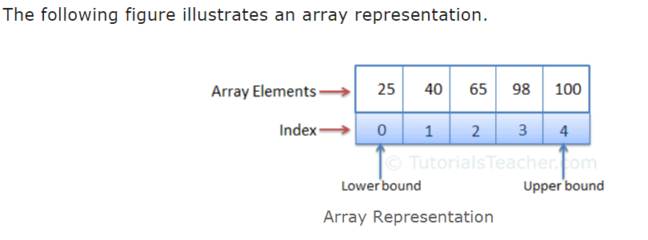
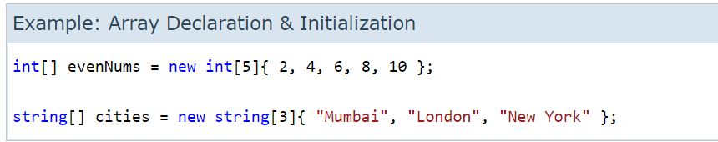
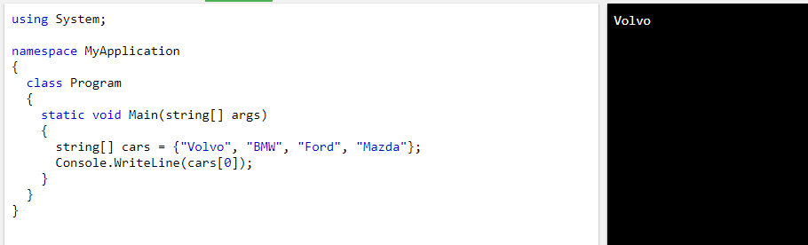

In OOP define inheritance, use suitable coding examples to demonstrate your answer.

Inheritance is mainly referred as the term while a group is resulting from an additional class. Inherited class is refer through extend keyword. In the year 1969, this termed was invented by the Simula and it is now used in various programming language such as C++, Python, or Java. Thus in OOP, inheritance is referring as the device based on class or object ahead on other object or class through retain same application (Tan and Kaiser, 2016).This is also refer as derive new classes or subclasses from current ones such as superclass or base class and the it later forms as a chain of command of class. This also allows to user to develop classes that are mainly develop above other classes for particular the implementation since maintain same behavior. The directed graph increase with maintain connection of classes or objects by inheritance.

Inherited class is the subclass of the great or parent class. It is used for both class based and prototype programming. It is mainly use instruments to maintain a subclass relationship. It also applies inheritance or different code of inheritance. Generally, it contrasts with the object masterpiece in that another object is containing through single object (Jones et al., 2016). Several kinds of Inheritance based on a particular language or paradignm are:

Single Inheritance: This feature of one super class is innate in subclasses. A class wants the property of another class.

Multiple Inheritances: In this, more than one super class is held in one class and it inherit character from all parent classes. In Inheritance is very complicated to execute resourcefully (Chakravathi, 2016).

Multilevel Inheritance: In this, the subclass is innate from other subclasses.

Hierarchical Inheritance: Under this, super class or base class is serving by one group for more than one subclass.

Hybrid Inheritance: In this, a mix of two or more kinds of legacy takes place. Instantly, when A has subclass B and B has subclass C and D. It shows the combination of both hierarchical and multilevel inheritance.

Inheritance (Derived and Base Class) example

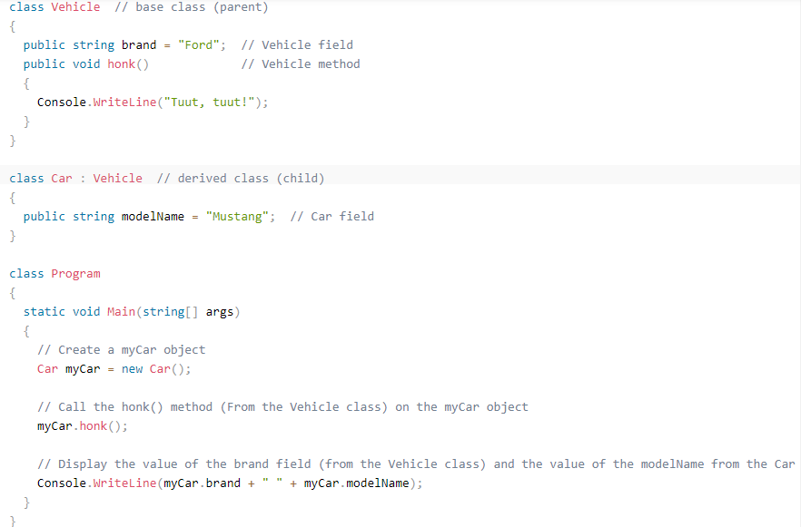

Inheritance is use to optimize the job of programmers. It is used to develop class hierarchies in that objects and classes inherit behaviors and properties from the high-class or parent class. Several kinds of objects have something in the similar with each other. This also provides classes to innate mainly for inaction for stated behavior from different classes. It is give an instrument to maintain connection or develop hierarchies of class in object composition. It demonstrates the use of code that is develop lastly or is pre-written. The function and method is refer in one class are used to exploit data members of the other class. It is also referring as inclination of single class use for derives properties and character and then implied it to another classes. During the OOP, when the class is developing, data and data users are designated. Data members are the variables that are related in the single class (Dmitrović, 2020). Data operation is referring as the function or method is show in the single class. Furthermore, these functions are used to influence the data members.

During Inheritance, members require not to explain or develop data members or functions recursively. All features helps to develop an effective dynamic programming. It is the frequent use of coding that helps in written and show the code reusability. In inheritance, one superclass can be use for various subclasses in the given hierarchy. Furthermore, no changes in all sub class and base classes only the changes in the parent class. It is useful for creating more dominant things. It also helps to reduce the data idleness and deception. It helps to reduce space and complexity of time (Tan and Kaiser, 2016). It is very essential in programming since of code has reusability. Thus inheritance, members can reduce duplicate redundancy and data from the other program. Primarily, it is used by the user can a particular portion of code and then particular features can be changes based on require and it can be done without difficulty considered to time and space. The elasticity is reuse code from the super class for the derive class is needed by inheritance. Thus, it is also used to write, apply, and reuse the code. In hierarchical programming paradigm it is very easily and simple. It is also known as assets in object-oriented programming. The members can relatively reuse the code when they write once and then it can save in the memory of code and location. The developer invests time or effort by using to decrease with the help of inheritance. It gives better to understand the code to other users. Thus inheritable, the properties of the base class can relatively be innate and then it can make to code effortless.
Instantly, two classes are their teacher and math class. Teacher class is innate from math teacher class that refer the teacher is the parent class and math teacher is the class. The college Name of the parent class can be used by the child class.
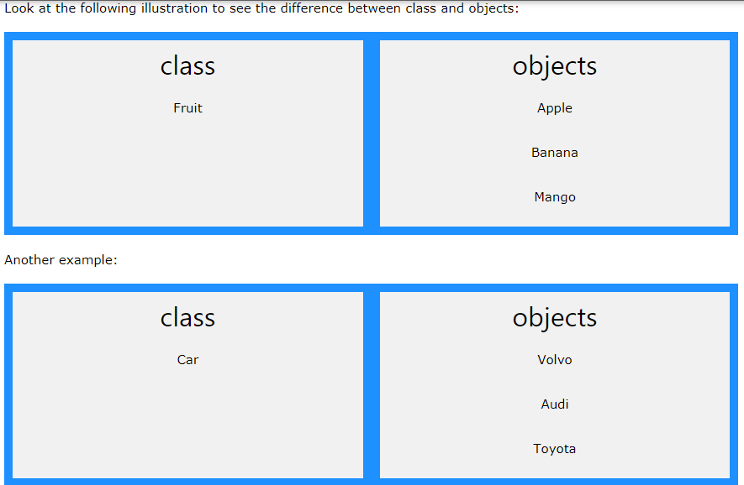
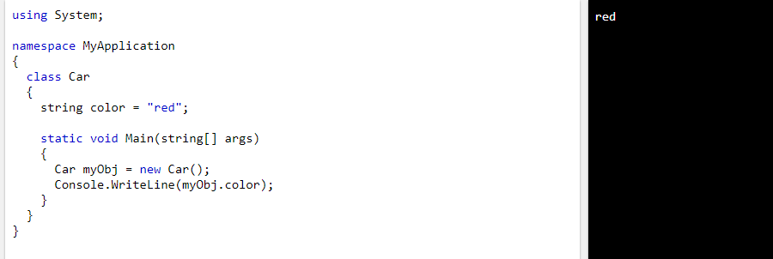
#include<iostream>
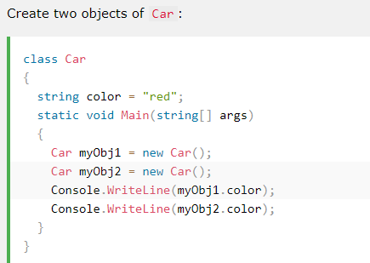
MULTIPLE CLASSES
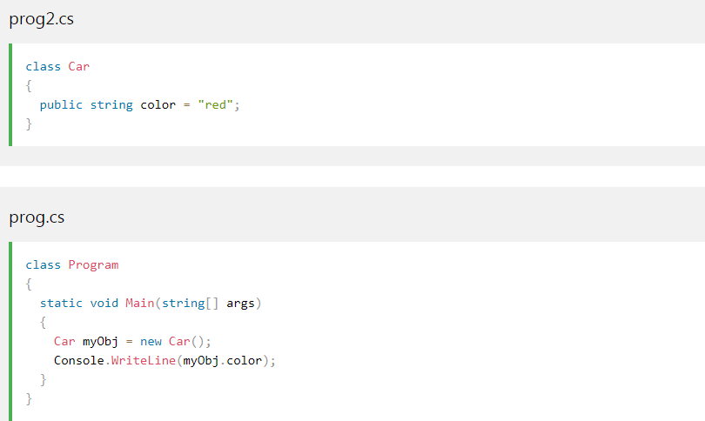

PART B
Testing models
This model is mostly intended for execute artifacts to achieve system testing. Several testing models in C# are the agile model, spiral model, iterative model, Waterfall model, and the V model.
In the Waterfall model, a progression of process is following through developers to accomplish ultimate goals. It also includes numerous stages like obligation analysis, analysis phase, software design, program execution, testing, and protection.
In the V model, the carrying out of growth and testing initiate side by side and is increase towards the addition of the whole system. It is very simple to use as test planning and deceitful is done before coding.
In the agile model, solution and necessities are largely present by association amongst several functional teams. It ensures users' approval with the incessant and rapid expansion of deliverables.
In the spiral model, user lay more importance on analyze the danger. This model involves various stages such as planning, analyzing risk, or engineering, and at last evaluation. It is more appropriate for large and multifaceted systems. The procedure of testing is recurring and it allows new versions of product growth. With this model, danger can be simply controlled as tricky tasks are complete first.
In the iterative model, there is no obligation for a full list before preliminary the project. The procedure of growth primarily starts with the essential requirements of the practical part that can be extended later.

References
Choe, H., 2016. Analysis on Types of Errors in Learning about Control Structures of Programming Using Flowchart. The Journal of Korean Association of Computer Education, 19(1), pp.101-109.
De Sousa, J.T., Martins, V.M.G., Lourenco, N.C.C., Santos, A.M.D. and Ribeiro, N.G.D.R., Coreworks SA, 2012. Reconfigurable coprocessor architecture template for nested loops and programming tool. U.S. Patent 8,276,120.
Szalay, R., Sinkovics, A. and Porkoláb, Z., 2020, September. The Role of Implicit Conversions in Erroneous Function Argument Swapping in C++. In 2020 IEEE 20th International Working Conference on Source Code Analysis and Manipulation (SCAM) (pp. 203-214). IEEE.


