

LEVEL 4 ASSESSMENT SPECIFICATION

Student name: | Dominic Sidoli | Student ID number: | 2413945
Programme: | DA Program in Logistics and Supply Chain Management
Module: | Sustainability
Module code: | ACMA4023 | Contribution to Overall Module Assessment (%): | 100%
Lecturer: | Dr Irina Neaga | Internal Verifier: | Dr Moutushi Tanha
Assignment Title: | The development of a circular economy strategy to support achieving NetZero | Word count (or equivalent): | 1500words(+/- 10%)
Submission deadline: |  | Return date of provisional marks & written feedback:
Submission method: | All written assessments, where practical and possible, must be submitted via Turnitin unless otherwise instructed by the Lecturer. (Please DO NOT put this assessment specification into Turnitin or it will match many similarities with other students’ submissions.)  Alternative submission method (if applicable):  Late submission of the assessment will result in a late penalty mark. Penalties for late submission: Up to one week late, maximum mark of 40%. Over one week late, 0%. Only the Extenuating Circumstances Panel may approve a change to submission dates.
Academic honesty / referencing: | Academic honesty is required. In the main body of your submission, you must give credit to authors on whose research and ideas your work is based. Append to your submission a reference list that indicates the books, articles, etc. that you have used, cited or quoted in order to complete this assessment.

Sustainability ACMA4023
By Dominic Sidoli

Introduction –
This report will look at the development of a circular economy that can help with Safran seats climate strategy to be part of the aviation sector’s ambition to transition to net zero CO₂ emissions for global civil aviation by 2050. (Safran, 2023). This shift represents a critical opportunity to integrate sustainability at the core of its business operations

What is sustainability?
Sustainability is a hugely important topic in today’s world with many global business and governments putting a huge importance on it. Sustainability itself refers to the ability to maintain or support a process continuously over time. In business contexts, sustainability seeks to prevent the depletion of natural or physical resources, so that they will remain available for the long term. (Mollenkamp, 2023). It could also be about striking and creating a balance between economic growth, environmental protection, and social well-being, these can often be described as the three pillars of sustainability. (Rinalducci, 2024)
- Environmental sustainability – protecting natural resources and tying to reduce pollution, emissions, and waste to preserve ecosystems.
- Economic sustainability – supporting long-term economic growth without causing negative social or environmental impacts.
- Social sustainability – promoting diversity, fair working conditions, and supporting local and global communities.

What is Net Zero?
Net zero is the aim of balancing the amount of greenhouse gases (methane, carbon dioxide etc) that are being released into the atmosphere, with the same amount being removed from the atmosphere. What we put in = What we take away.
Net zero first focuses on the reduction of emissions, with countries, companies or individuals trying to reduce greenhouse gas emissions as much as possible.
The ability to reach net zero emissions from homes, transport, agriculture and industry will need to be cut completely. These sectors will have to reduce the amount of carbon that’s released and put into the atmosphere, but this can be more difficult for certain sectors like aviation that the company I work for deals with, as it’s a lot more complex and expensive to cut emissions altogether. (Energy saving trust, 2021)

What is a circular economy?
A circular economy is an economic system designed to help in the elimination of waste and keeping resources in use for as long as possible. This is instead of using the traditional linear economy, this is where products are made, used and if not required discarded. Products and materials are usually not used to their full potential in a linear economy and tend to move in one direction – from raw material to waste. (Ellen MacArthur Foundation, 2023).
There are a few main goals of a circular economy, these are too:
- Design out waste and pollution – this involves the creation of products and processing the minimize waste from the start.
- Keep materials and products in use – this can be from refurbishment, remanufacturing and recycling allowing products to be reused.
- Integrate and use natural systems – making sure that economic activity support and restores the environment used, rather than depleting it.
By using the circular economy, it helps a business shift towards sustainable design, closed-loop manufacturing and become more resource-efficient. All of which support the process of reaching Net Zero target.
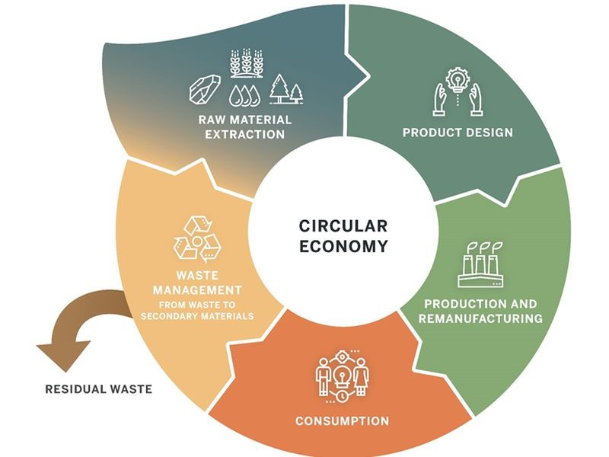
(hotcore.info, 2024)

Benefits of a circular economy
A circular economy can offer many benefits to a business, some of the key benefits are it helps reduce waste, meaning less landfill and incineration, a focus on reusing, recycling and remanufacturing, this then ultimately can help address global waste challenges with plastics, electronics and textiles. Linked to this it can help conserve natural resources, as fewer raw materials are used, helping reduce pressure on finite resources like metals, water and fossil fuels, a circular economy can also encourage regenerative practices. A circular economy can also help cut greenhouse gas emissions, from the lower energy use from producing new materials, reducing pollution and carbon footprint, helping companies and countries meet climate goals. For Safran a circular economy can also help boost economic opportunities, this could be from the creation of new jobs in repair, recycling and sustainable design. It can also help reduce the overall costs for the business through efficient resource use. One major positive for Safran with a circular economy is it can enhance supply chain resilience, with less dependence on imported raw materials, meaning there is more stable production through local reuse and recycling systems. Finaly, and very importantly, it helps protect the environment by reducing pollution and lowering environmental degradation. (Lacy and Rutqvist, 2015)
A circular economy offers many befits for a business, by shifting from traditional methods of “take-make-dispose” model and instead keeping materials and products in use for as long as possible, helping reduce waste lower greenhouse emissions and help reach the overall goal of net zero emissions. (Ellen MacArthur Foundation, 2023)
Challenges of a circular economy
Safran Seats Gb faces many challenges in adapting to a circular economy. The aerospace industry has very strict certification processes and requirements, making it difficult to reuse or incorporate recycled materials without undergoing very costly and lengthy re-approval processes. Aircraft business and first-class seats are also made of very complex, tightly integrated materials, metals, foams, composites fabrics and electronics. This mix of materials are hard to disassemble and recycle effectively. Additionally recycling infrastructure for aerospace-grade materials is still limited, old seats are typically discarded, creating tens of thousands of tons of waste material lying in ‘aircraft graveyards. (Amrc.co.uk, 2025). Also, the airline business model heavily focuses on customization and frequent cabin updates, this again reduces the opportunity for a standard seat to be reused.
Another issue is implementing a global take-back or refurbishment program is challenging due to logistics of airlines that are situated all over the world, so this can be very expensive. Circular solutions tend to be more expensive to set up in the short term, and weight-reduction priorities may conflict with an airlines or seat manufacturer priority. (Reuter et al., 2019)

12–24-month implementation roadmap

Months 0-3 – Foundations
- An internal circularity task force within Safran Seats ( a design team, Procurement and legal compliance
- Create material flows, the top 10 parts that create the most emissions, this could be used by supplier data and an initial LCA. These could be from quick wins lime shells, cushions and plastics.
- Launch SeatLife 2.0 - a project to formalize a take-back policy and airline credits. (Safran, 2025)
Months 3-9 – pilots/testing
- Collect 100 used/retired seats or a high-volume module. Validated time it takes to dissemble, refurbishment steps and certification routes.
- Closed loop recycling.
- Supplier engagement for design and recycled content sourcing
Months 9–18 — Scale
- Regional remanufacturing hubs, that can scale take-back contracts with 3-4 airlines, also the rolling out of repair training for MRO partners.
- The integration of recycled parts for non-safety critical parts
Months 18–24 —Roll out & reporting
- The launch of formal remanufactured seat products, along with warranty and certification.
- Safran seats’ sustainability reporting, this could be developed site wise in sister sites and group reporting.

Development of a circular economy for Safran Seats GB
Developing a circular economy will be essential for Safran seats to support its sustainability goals and contribute to the overall aviation sectors Net Zero ambitions, The transition of air transport toward net zero carbon dioxide (CO₂) emissions by 2050 is a primary goal of the aviation industry, governments, and regulatory agencies. (Braun, Grimme and Oesingmann, 2024)
This can be achieved by implementing a few factors, firstly by designing seats so they can be disassembled, repaired and refurbished easier. This could allow seats to have an extended product lifestyle and reduce the demand for virgin materials; this again lowers embedded carbon emission. By implementing and incorporating recycled and bio-based materials, certification helps to further reduce the environmental footprint while also supporting closed-loop material flows.
Other circular practices such as modular designs, standardized components and take-back programs help enable more efficient upgrades, minimize waste whilst also decreasing the energy consumption that is required to create and manufacture new products. Digital tools, for example material passports, this is a digital record that captures all essential data about a material’s composition, life-cycle impact, and reuse potential. (UKGBC, 2025). Lifecycle tracking will be able to enhance traceability and will ensure materials and components are reused or recycled at end of life.
By implementing all these strategies this can help Safran Seats GB cut manufacturing emissions, divert waste from ending up in landfills and importantly reduce overall carbon impact of aircraft interiors, helping support both company level sustainability and the overall industry wider net Zero trajectory.
Conclusion
The shift towards a circular economy represents more than just an environmental initiative for Safran Seats, it’s an important pathway that can align its customers’ expectations, operational performance and climate ambition. By developing and embracing new design idea principles that allow for easier recycling and reuse, and developing a closed-loop material flows Safran can reduce the life-cycle footprint of its seating products. By implementing these new principles, will not only support Safran’s goals and net-zero, but also strengthen resilience against the constant resource constraints and market volatility that many manufacturers now face.
Airlines are increasingly going to prioritize sustainability, and being committed to a circular economy can give Safran Seats a competitive edge and help the company contribute to a more efficient and climate-responsible avaiation ecosystem.

References –
Amrc.co.uk. (2025). Available at: https://www.amrc.co.uk/news/sustainability-in-aerospace-supply-chains-recycling-fleet-seats.
Braun, M., Grimme, W. and Oesingmann, K. (2024). Pathway to net zero: Reviewing sustainable aviation fuels, environmental impacts and pricing. Journal of Air Transport Management, 117, pp.102580–102580. doi:https://doi.org/10.1016/j.jairtraman.2024.102580.
Ellen MacArthur Foundation (2023). What Is the Linear economy? [online] Ellen MacArthur Foundation. Available at: https://www.ellenmacarthurfoundation.org/what-is-the-linear-economy.
Ellen MacArthur Foundation (2023). What Is the Linear economy? [online] Ellen MacArthur Foundation. Available at: https://www.ellenmacarthurfoundation.org/what-is-the-linear-economy.
Energy saving trust (2021). What Is Net Zero and How Can We Get there? [online] Energy Saving Trust. Available at: https://energysavingtrust.org.uk/what-is-net-zero-and-how-can-we-get-there/.
Energy saving trust (2021). What Is Net Zero and How Can We Get there? [online] Energy Saving Trust. Available at: https://energysavingtrust.org.uk/what-is-net-zero-and-how-can-we-get-there/.
hotcore.info. (2024). Edit image, resize image, crop pictures and appply effect to your images. [online] Available at: https://hotcore.info/act/kareff-102024p.html.
Lacy, P. and Rutqvist, J. (2015). Waste to Wealth : the Circular Economy Advantage. New York: Palgrave Macmillan.
Mollenkamp, D. (2023). What is Sustainability? How Sustainabilities Work, Benefits, and Example. [online] Investopedia. Available at: https://www.investopedia.com/terms/s/sustainability.asp.
Reuter, M.A., van Schaik, A., Gutzmer, J., Bartie, N. and Abadías-Llamas, A. (2019). Challenges of the Circular Economy: A Material, Metallurgical, and Product Design Perspective. Annual Review of Materials Research, 49(1), pp.253–274. doi:https://doi.org/10.1146/annurev-matsci-070218-010057.
Rinalducci, S. (2024). The Three Pillars of Sustainability EXPLAINED - Sustainability Success. [online] sustainability-success.com. Available at: https://sustainability-success.com/three-pillars-of-sustainability/.
Safran. (2023). Decarbonizing aeronautics. [online] Available at: https://www.safran-group.com/sustainability/decarbonizing-aeronautics.
Safran. (2025). SeatLife: A comprehensive solution to support every stage of the seat life cycle. [online] Available at: https://www.safran-group.com/products-services/seatlife?utm_source=chatgpt.com [Accessed 25 Nov. 2025].
UKGBC. (2025). EPDs and Materials Passports in Circular Construction | UKGBC. [online] Available at: https://ukgbc.org/news/epds-and-materials-passports-in-circular-construction/.

