Construction Detailing

HND Quantity Surveying

Harri Morgan

1908064

Contents

- Introduction
- Ground Floor Construction
- 1st Floor Construction
- Openings
- Roof Structure
- References

- Introduction
The aim of this assignment is to define and produce annotated sketches that illustrate a break range of common construction forms, demonstrating understanding of their potential defect and repair needs. This assignment will be based on the assumption that we have been given planning consent for a single, two storey detached domestic building with a loft room. I will firstly start the assignment by solving the ground floor details, explaining the construction methods and techniques used. Secondly, I will look at the first floor construction, details and junctions with external walls and restraints. Next, I aim to provide solutions for openings in regard to lintels, sills and jambs. Finally, I will complete the assignment by solving the roof structure details, how it is constructed, fitted, indicating the appropriate weathering in laps. I will support each detail with sketches noting all elements included.
- Ground Floor Construction
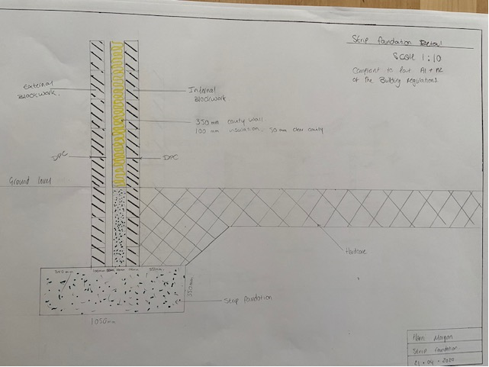
Following research into the different types of foundation used in small rise construction. I would recommend a strip foundation for this project. I have come to this conclusion because strip foundations can be used on most soils, and are widely used in low rise or medium rise domestic buildings. This type of foundation is constructed by firstly digging a trench around the perimeter of the building, and all load-bearing walls. Concrete is then poured into the trench until it reaches the ground floor level.

Most building built today have a cavity wall, which is a two skinned wall with a cavity between. The internal skin is usually blockwork, in comparison to the external wall which can be either brickwork or blockwork dependant on planning consent or clients preference. External walls on a building have many purposes such as;
- Weather protection
- Fire resistance
- Thermal resistance
- Noise insulation
- Strength and durability.
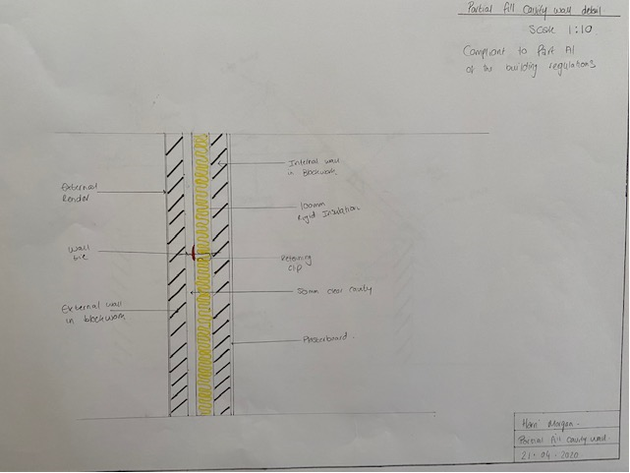
There are a few techniques used in construction to achieve a walls desired durability, and moisture resistance. Firstly, when constructing a cavity wall it is essential that the walls are tied together using wall ties. This allows both skins to act as one single unit, ensuring the buildings stability. Wall ties should be spaced at a maximum of 750mm horizontally and 450mm vertically based on a 100mm cavity. They are fitted by placing the tie between the blockwork joints on both skins. In addition to this, weep holes are usually added above flashings of the outer skin wall. This technique allows any moisture that collects in the cavity to escape through the weep holes, minimizing the moisture that penetrates the building. Also, another item used in wall construction is damp proof courses, which is usually fitted 3 courses above ground level. This DPC prevents groundwater being absorbed through the wall, reducing the moisture further. In cold climates, such as ours, a further control measure can be added to a wall to increase thermal conductivity. This is a vapour control barrier, which blocks the warm moisture in a room from escaping into the fabric of the building. It is essential that this is fitted in the correct place, if fitted incorrectly it can cause more harm than good to the building. This should be fitted between the insulation and the internal blockwork.

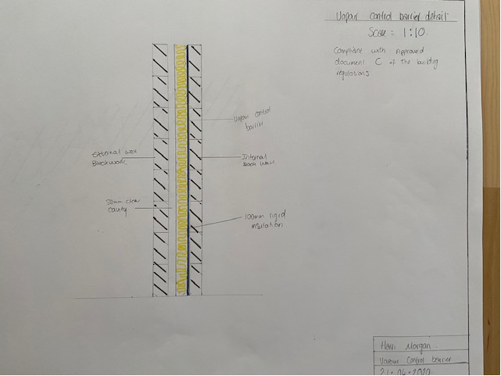
“Exterior House Rendering is the process whereby an external wall covering, applied by hand and tools, is applied by a plasterer to protect the bricks or blocks from which the building is constructed from. It is normally covered with paint or a wall coatings to protect the render surface from cracks or erosion.”(What is exterior wall rendering & What are the benefits? | Never Paint Again, n.d.) The standard choice for render is cement render which can be mixed on site. The material for this is rather cheap but does need frequent repainting. Render is aesthetically pleasing finish, that is easily altered by repainting.

Within houses there are two techniques used to install insulation into a cavity wall. They are blown insulation and partial fill. Blown insulation takes place after the building has reached wall plate, it begins by fitting a cavity barrier at the top of the building to seal the cavity. Injection hole are then drilled into the wall ready for the installation. Wool is then pumped into the cavity through a hose, once the cavity is full, the injection holes will be made good to match the existing finish, which also seals the insulation. In comparison, partial filled cavity’s are insulated as the building is erected. You would fit insulation boards between the wall ties as you construct the blockwork. On a standard 150mm cavity, you would fill 100mm with the insulation board, leaving a 50mm clear cavity. This clear cavity between the outer leaf and the insulation acts as a barrier to external moisture, stopping it from reaching the inside of the building. The fundamental purpose of insulation is to reduce the heat loss through the cavity, there are many different types of insulation that can be used in a partial fill cavity, some of them include;
- Rock mineral wool
- Glass mineral wool
- Polyurethane foam
- Phenolic foam
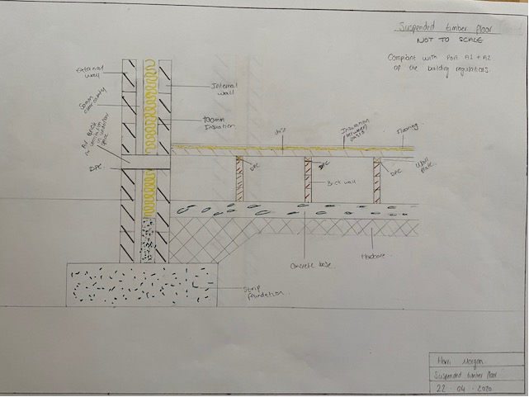
Suspended Timber Floors consist of the finished floorboards being attached to floor joists, suspended above the foundation. The floor joists are raised above the foundation on small supporting walls, called sleeper walls. A wall plate is then attached to the top of the sleeper wall, where the floor joists rest. Suspended timber floors prevent moisture gathering between the timber and the foundation by installing vents in the external wall to ensure adequate ventilation, stopping the moisture damaging the timber. Insulation is inserted between each joist to maintain as much heat in the building, preventing it escaping through the floor causing a cold bridge. A damp proof course must be fitted at the top of the sleep wall between the blocks and the timber, this ensures that rising moisture does not decay the timber joists.

- 1st Floor Construction
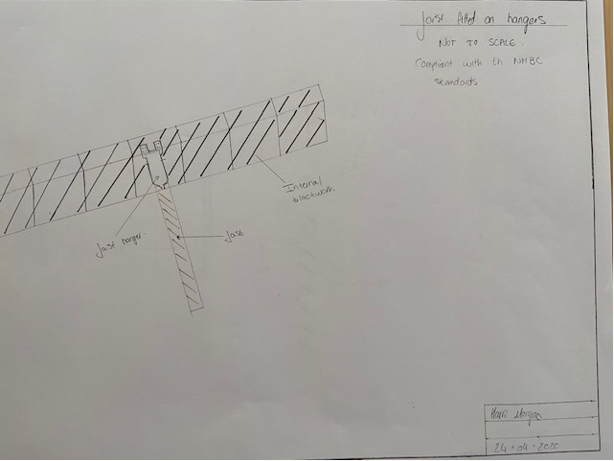
Joists are lengths of timber that span between the walls or foundations of a building. Their main purpose is to provide support for ceilings and floors. Holes and notches are made in joists so that pipes and wiring can be run through, without significantly weakening the joists. They can be fitted in many ways, the most common on domestic buildings is on joist hangers. These are metal anchors that are fixed to the internal skin of the wall and wrap around three sides of the timber and screwed for support.

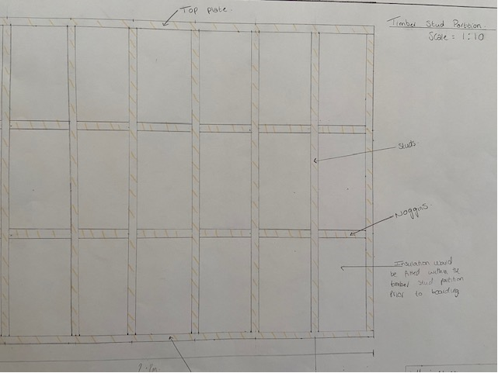
A partition within a building is a non-load bearing wall or division with the purpose of dividing a room or a space. You can see partition walls made from various materials such as brick, clay, glass, metal and timber. Timber is the most popular within domestic buildings. There are many advantages to a timber partition wall, firstly they are cheap and easy to construct, as they are simply a timber frame with supporting noggins for stability. Due to their easy erection, partition walls are also very adaptable. Because they are non-load bearing, they can be demolished and reconstructed to give different room options with ease. It is essential that a partition is strong enough to support sanitary fittings and heavy fixtures. In addition to this, it must comply with regulations to provide enough resistance to fire, heat and dampness. Stud framework should be placed at 600mm or 400mm centres for maximum strength, with noggins to provide support for plasterboard and fixing points. To hide the timber partition, it is usually covered by plasterboard or OSB plywood, which is drilled into the noggins.

- Openings
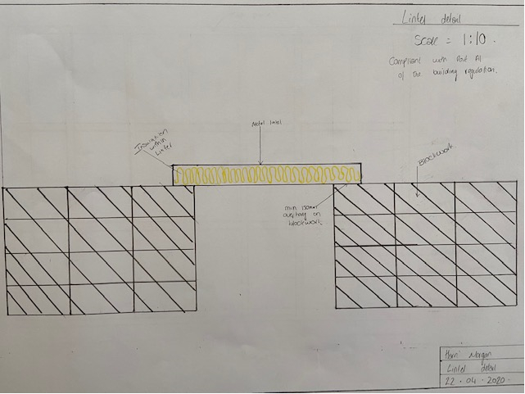
A lintel is a form of beam used in buildings to support a wall above an opening such as windows or doors which cans be formed from various materials. They can be timber, metal, stone, pre cast or cast in-situ concrete. “The main function of the lintel is to take loads coming from above wall and transfer its load to the side walls.” (Function of Lintel Beam - Civil Engineering, 2017) Lintels are fitted above an opening with a minimum end bearing of 150mm, which is bedded on mortar and levelled to transfer the weight evenly over the side walls, and give a good level for the laying of blockwork above. Most domestic buildings are fitted with metal lintels, but this can cause some issues. You must ensure to install correctly and insulate the lintel to prevent cold bridging. Cold bridging is an area in a building with little or no insulation, making it colder than the rest of the house. This can raise the risk of condensation.

- Roof Construction
A roof truss is made up of a number of factory made frames, combining the joists, rafters and struts. Each truss is designed and made for a specific part of the roofs structure, therefore they should never be altered or cut. This includes changing the roof coverings without consulting an engineer, as the trusses are designed for a specific purpose, weight load and covering. Trusses are used in the roof structure to distribute the weight evenly and to handle the change of tension and compression without bending or shearing. Following the design and manufacture of trusses in a factory, they are delivered to site and craned into position. Once fixed to the wall plate and secure the trusses would be covered by sheathing plywood ready for the membrane and covering to be fitted. The next process in constructing a roof is laying felt membrane onto the roof for waterproofing and fitting the roof battens. The batten is a length of timber used to secure the roof coverings. The final step would be to install the roof coverings. Roof coverings are essential to the roofs purpose of waterproofing, and protection from severe weather and wind. When using slate roof tiles, they are to be lapped over each other to ensure when rain water gets into the joint, it runs onto the next slate and down the roof to the gutters.
Item in roof | Description and use
Eaves | Eaves are the part of the roof that over hang over the building. They are made up of fascia and soffit. They are used to ensure water runs off the building and not directly down. This also provides shading to windows for a comfortable internal temperature.
Dry Verge | “'Dry fixing' is an increasingly popular roofing option which allows for the weather and pest-proofing of your roof without the need for mortar. Dry verge roofing makes use of interlocking caps that fit over the edge of your roof tiles” (What Are The Advantages of Dry Verge Roofing? | Plastic Fantastic, 2012)
Ridge | A horizontal line at the top of the roof, which is covered to prevent water ingress into the building.
Valley | The valley is the part of the roof where two slopes meet together, this allows rainwater to be channelled downward into the gutters.
Abutment | An abutment is where a side roof is connected to the building. The abutment ensures that the area under the lower roof is protected form weather
Velux Windows | Velux windows are windows inserted into the roof that allow natural light into the loft room, to avoid the use of artificial lighting.
Insulation | Insulation is fitted into the roof between the trusses, behind the OSB boards to trap heat into the loft room for a comfortable temperature.
Membrane | “A roofing membrane acts as an initial roofing layer. It improves tightness of the roof, protects insulation against moisture and constitutes an important element of insulation systems used in pitched roofs.” (products and underlays, 2018)
Roof Vents | Roof vents moderate the temperature in a roof space, stopping the room getting too warm or cold. Also, allowing air into the property for circulation
Flashing | A roof flashings purpose is to direct water away from areas of the roof
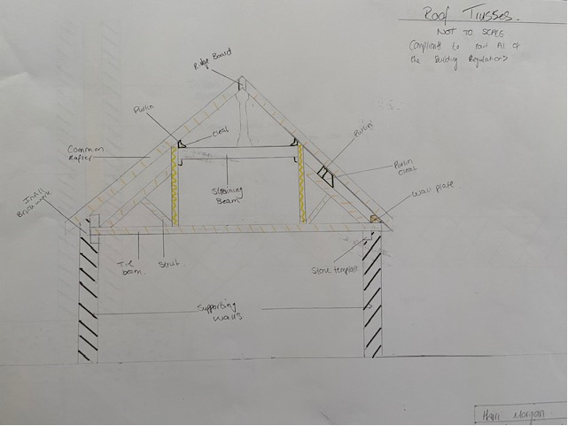
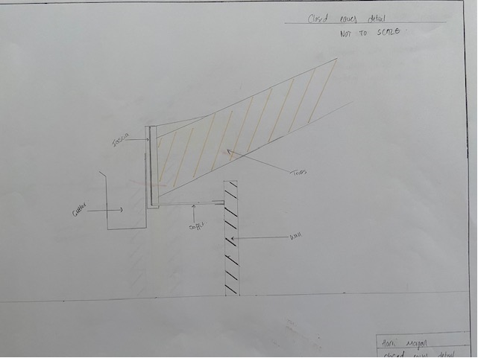
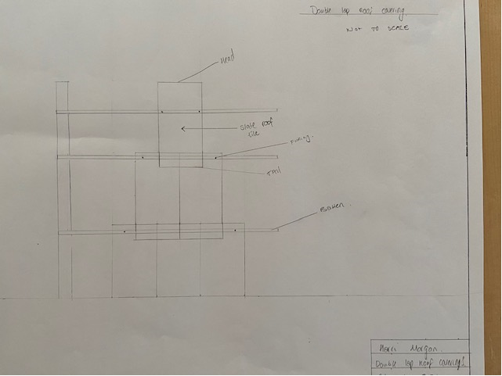
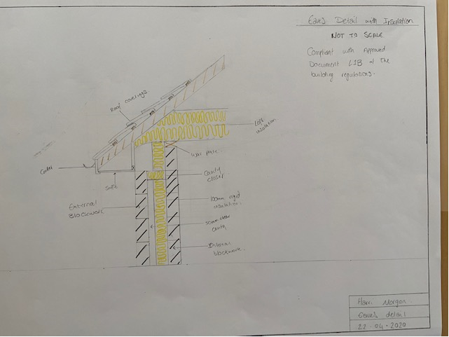

- References
Designingbuildings.co.uk. 2020. Strip Foundation. [online] Available at: <https://www.designingbuildings.co.uk/wiki/Strip_foundation> [Accessed 13 March 2020].
Never Paint Again. n.d. What Is Exterior Wall Rendering & What Are The Benefits? | Never Paint Again. [online] Available at: <https://www.neverpaintagain.co.uk/blog/house-rendering/> [Accessed 17 March 2020].
Portal, P., 2016. Building Regulations: Flooring | Extensions | Planning Portal. [online] Planningportal.co.uk. Available at: <https://www.planningportal.co.uk/info/200130/common_projects/17/extensions/4> [Accessed 21 March 2020].
Diydata.com. 2015. Pitched Roof Types Explained - Cut And Truss Roofs. [online] Available at: <https://www.diydata.com/general_building/roof_construction/roof_construction.php> [Accessed 12 March 2020].
Marley. 2016. What Are The Different Parts Of A Roof? | Marley. [online] Available at: <https://www.marley.co.uk/en/blog/what-are-the-different-parts-of-a-roof> [Accessed 10 March 2020].
Plasticfantastic.uk.com. 2012. What Are The Advantages Of Dry Verge Roofing? | Plastic Fantastic. [online] Available at: <http://www.plasticfantastic.uk.com/news/what-are-the-advantages-of-dry-verge-roofing/> [Accessed 20 March 2020].
products, A. and underlays, R., 2018. Roofing Membrane Characteristics - FAKRO. [online] Fakro.co.uk. Available at: <https://www.fakro.co.uk/products/all-products/roofing-membranes-and-underlays/characteristics/> [Accessed 4 March 2020].
Civiltoday.com. 2017. Function Of Lintel Beam - Civil Engineering. [online] Available at: <https://civiltoday.com/construction/building/222-function-of-lintel> [Accessed 26 April 2020].
Designingbuildings.co.uk. 2018. Joist. [online] Available at: <https://www.designingbuildings.co.uk/wiki/Joist> [Accessed 3 March 2020].

