

Business Report – Comparison of Shangri-La Hotels and Travelodge Hotels.

Student Name

Rebeca A. Baccela

Student ID number
2230716

Financial Management for the Hotel Industry (BMIH5007,BMIH5002)
Module Lecturer:Tristan Hawkins

Contents
Executive Summary: 2
Introduction 3
Overview of Shangri-La Hotels 4
Overview of Travelodge Hotels 5
Revenue Generation Strategies 5
Market Positioning: 7
Growth Potential: 9
Corporate Social Responsibility (CSR) 10
Conclusion 11
Recommendations: 11
References: 12

Executive Summary:

This report presents a comprehensive analysis of two hospitality industry giants, Shangri-La Hotels and Travelodge Hotels, examining their strategic approaches, operational frameworks, and market positioning. Shangri-La excels in the luxury segment with diversified revenue streams, while Travelodge dominates the budget-friendly sector with a focus on room bookings. Both prioritize revenue growth and corporate social responsibility (CSR) but differ in investment levels. Strategic recommendations include enhancing CSR and innovating guest experiences for Shangri-La and diversifying revenue streams and pursuing international expansion for Travelodge.

Introduction
In an era where travel transcends mere necessity to become a lifestyle choice, the hospitality industry stands as a vibrant and ever-evolving domain, catering to the diverse needs and preferences of travellers globally (George, 2021). Among the prominent figures shaping this landscape are Shangri-La Hotels and Travelodge Hotels, each employing unique strategies to carve their niche in the market. By understanding the intricacies of these industry giants, we gain valuable insights not only into the competitive dynamics of hospitality but also into the evolving expectations of today's discerning travellers, as highlighted by George (2021).

This report delves into a comparative analysis of the strategic choices and operational paradigms of Shangri-La Hotels and Travelodge Hotels, unravelling a narrative characterized by innovation, resilience, and an unwavering commitment to hospitality excellence. From revenue generation strategies to market positioning, growth potential, and corporate social responsibility initiatives, this examination sheds light on the triumphs, challenges, and aspirations of these hospitality powerhouses in a landscape of perpetual evolution, as cited by various sources (Kushniruk, 2023; Lin and Sykuta, 2022; Ning, 2021; Page and Connell, 2020).

Purpose and Structure

This report aims to furnish stakeholders and researchers with a comprehensive understanding of the strategic landscape within the hospitality industry, offering actionable insights to navigate the complexities of the market effectively, as articulated by Kushniruk (2023), Lin and Sykuta (2022), Ning (2021), and Page and Connell (2020). Structured as a roadmap to enlightenment, our exploration encompasses four key waypoints:

Revenue Generation Strategies: Unveiling the financial engines driving Shangri-La Hotels and Travelodge Hotels and exploring their approaches to sustaining growth and profitability in a competitive market, as outlined by Shangri-La Hotels (2023), Travelodge (2023), Aroul et al. (2023), and Lin & Sykuta (2022).
Market Positioning: Navigating the intricate web of market dynamics as we dissect the target demographics, brand perception, and competitive standing of these hospitality titans, as described by George (2021), Giousmpasoglou & Hua (2020), and Aroul et al. (2023).
Growth Potential: Peering into the crystal ball of prospects as we assess the expansion strategies, market opportunities, and potential barriers to growth shaping the trajectory of Shangri-La Hotels and Travelodge Hotels, as analysed by Shangri-La Hotels (2023), Travelodge (2023), Ahmad (2024), and Filimonau & Magklaropoulou (2020).
Corporate Social Responsibility (CSR): Embarking on a journey of social impact and sustainability, exploring the CSR initiatives that define the corporate ethos and values of these industry leaders, as highlighted by Shangri-La Hotels (2023), Travelodge (2023), Yasir et al. (2021), and Ahmad (2024).

Overview of Shangri-La Hotels
According to sources such as Shangri-La Hotels (2023) and Baxter and Srisaeng (2020), Shangri-La Hotels was established in 1971 and has since become a renowned symbol of luxury hospitality on a global scale. It offers lavish accommodations, fine dining experiences, and unparalleled amenities, catering specifically to discerning travellers in search of personalized and extravagant stays. Despite the challenges presented by the pandemic, Shangri-La Asia Limited demonstrated exceptional resilience, with its revenue for fiscal year 2023 rebounding impressively to 95% of pre-pandemic levels, while its EBITDA exceeded 101%. This resilience is seen as a testament to the company's commitment to sustainability and strategic investments, underscoring its dedication to a prosperous future. With a portfolio boasting over one hundred hotels worldwide, Shangri-La maintains its position as a leading developer, owner, and manager of hotel properties, driving innovation within the hospitality industry.
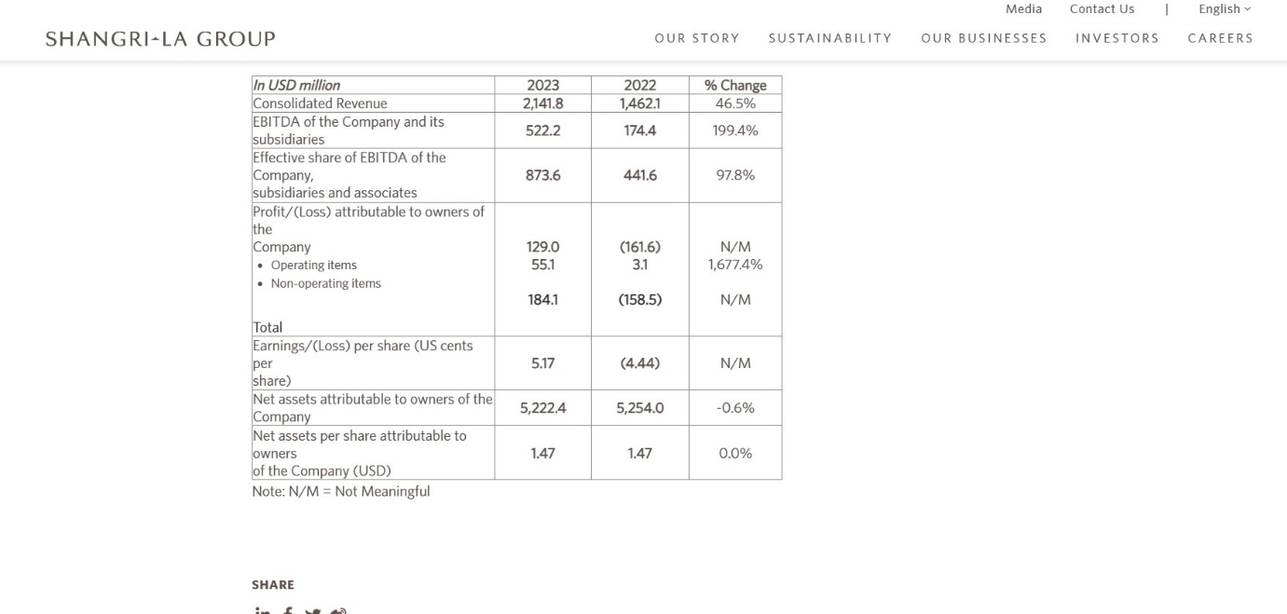
(Shangri-La Hotels, 2023).

Overview of Travelodge Hotels
According to information provided by Travelodge (2023), the hotel chain was established in 1985 and has since become a prominent name in the budget-friendly accommodation sector, originating from the United Kingdom. It specializes in offering affordable lodging options with essential amenities, targeting primarily budget-conscious travellers, families, and solo adventurers. Synonymous with affordability, accessibility, and reliability, Travelodge maintains a wide network of conveniently located hotels at competitive rates.

As of December 31, 2022, Travelodge boasts an updated portfolio comprising 598 hotels and approximately 46,000 rooms across the UK, positioning it as one of the country's largest hotel brands in terms of both the number of hotels and rooms. Operating on a low upfront capital expenditure (capex) model, the company strategically leases, manages, and owns hotels to optimize efficiency and profitability.

Serving a diverse client base of approximately twenty-one million business and leisure customers annually, Travelodge achieves an impressive 81.8% occupancy rate and generates substantial revenue of £910 million, with an EBITDA of £213 million. Additionally, Travelodge has expanded its presence beyond the UK, establishing a robust foothold in international markets such as Spain and Ireland, contributing significantly to its overall room inventory.

Through its steadfast dedication to delivering high-quality service and its strategic positioning within the hospitality sector, Travelodge has cemented its reputation as a reliable option for travellers seeking value-driven accommodations.
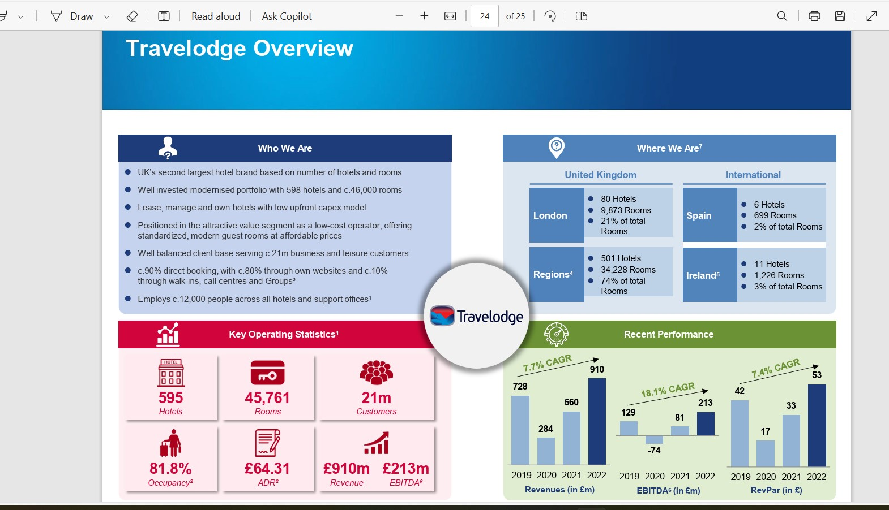
(Travelodge, 2023).

Revenue Generation Strategies

Shangri-La Hotels and Travelodge Hotels deploy distinct revenue generation strategies tailored to their respective market positions and customer demographics.

Shangri-La Hotels:

Shangri-La Hotels adopts a diversified approach to revenue generation, leveraging multiple services such as room bookings, dining, spa treatments, and event hosting (Shangri-La Hotels, 2023). This multifaceted portfolio contributes to revenue stability and growth. According to the 2023 Full Year Results, Shangri-La exhibited consistent revenue trends, with revenue rebounding to 95% of pre-pandemic levels and achieving an impressive EBITDA margin of 31.5%, marking a decade-high performance (Shangri-La Hotels, 2023).

Travelodge Hotels:

Travelodge Hotels primarily relies on room bookings as its main revenue source, supplemented by ancillary services like breakfast offerings and parking fees (Travelodge, 2023). Operating within the budget-friendly segment, Travelodge's revenue trends may experience variability due to seasonal travel fluctuations. Nonetheless, with a modernized portfolio comprising 598 hotels and approximately 46,000 rooms, Travelodge stands as the UK's second-largest hotel brand (Travelodge, 2023).

Analysis of Stability and Growth Potential:

A closer examination of revenue stability and growth potential reveals distinct trajectories for Shangri-La Hotels and Travelodge. Shangri-La demonstrates resilient revenue growth, reaching USD 2.8 billion in 2023, propelled by its esteemed brand reputation, consistent patronage from affluent clientele, and strategic global positioning (Shangri-La Asia Limited, 2023).Conversely,Travelodge's revenue growth, influenced by economic conditions, competitive pricing strategies, and shifts in consumer preferences, reached £910 million in 2022(Travelodge, 2023).

Shangri-La's revenue resilience emanates from its diversification strategy and emphasis on premium services, evidenced by robust revenue streams including room bookings, dining, spa treatments, and event hosting (Shangri-La Asia Limited, 2023). Conversely, Travelodge's revenue volatility is accentuated by its heavy reliance on room bookings, as evidenced by strong forward booking patterns but limited forward visibility (Travelodge, 2023).

Both entities actively pursue revenue growth through strategic initiatives such as enhancing guest experiences, expanding into new markets, and implementing innovative marketing strategies (Ning, 2021). Nevertheless, Shangri-La's comprehensive approach, including the revamp of its loyalty program Shangri-La Circle, underscores its commitment to sustaining revenue growth amidst market challenges (Shangri-La Asia Limited, 2023).

In summary, Shangri-La Hotels benefit from a stable revenue base supported by premium offerings and a global presence, while Travelodge encounters greater revenue volatility due to its reliance on room bookings and market dynamics(Travelodge, 2023).Nonetheless, both organizations prioritize revenue growth through strategic manoeuvres and customer-centric initiatives, displaying their adaptability in navigating evolving market landscapes.

Market Positioning:
Travelodge Hotels:

Travelodge Hotels primarily serves the budget-friendly segment, appealing to budget-conscious travellers, families, and solo adventurers (Giousmpasoglou & Hua, 2020). Although Travelodge may not hold the same market share as Premier Inn in the budget segment, it maintains a notable presence, particularly in the UK market (Travelodge, 2023). Recognized for its affordability, accessibility, and reliability, the brand emphasizes providing value-for-money accommodations to its guests.

Shangri-La Hotels:

Shangri-La Hotels commands a significant market share in the upscale hospitality segment, renowned for its opulent accommodations and premium services. Targeting an international clientele comprising affluent business executives, leisure travellers, and high-net-worth individuals, Shangri-La has established a strong foothold in key global markets (Shangri-La Hotels, 2023). Synonymous with luxury, elegance, and sophistication, the brand is comparable to Six Senses, offering discerning travellers exclusive and personalized experiences (Tam, Fong, & Law, 2022).

Influence on Competitive Standing:

The distinct market positions of Shangri-La Hotels and Travelodge Hotels significantly influence their competitive standing within the hospitality industry. Shangri-La's dominance in the luxury segment allows it to differentiate itself based on exclusivity, personalized service, and premium amenities, attracting clientele willing to pay a premium for exceptional experiences. Conversely, Travelodge's focus on affordability resonates with budget-conscious travellers, positioning it effectively against competitors like Premier Inn in the budget-friendly segment (Giousmpasoglou & Hua, 2020; Travelodge, 2024; Shangri-La Hotels, 2023; Tam, Fong, & Law, 2022).

While Shangri-La Hotels and Travelodge Hotels cater to different customer segments with distinct value propositions, both organizations have strategically positioned themselves to appeal to their respective target demographics. Understanding their market share, customer demographics, and brand perception enables stakeholders to assess their competitive positioning and tailor strategies to meet the evolving needs of travellers.

Growth Potential:
Shangri-La Hotels and Travelodge Hotels pursue distinct expansion strategies tailored to their respective market segments. Shangri-La aims to open six new hotels in 2024 and has identified three hundred target locations in the UK, focusing on global expansion despite potential challenges like intense competition and economic volatility (Shangri-La Hotels, 2023). Conversely, Travelodge concentrates on domestic growth, with plans to open six new hotels in 2024 and has identified potential international markets in Spain, despite facing obstacles such as market saturation and rising operating costs (Travelodge, 2023; Filimonau & Magklaropoulou, 2020; Kushniruk, 2023). Shangri-La capitalizes on luxury hospitality demand, especially in emerging markets, while Travelodge leverages affordability and accessibility for budget-conscious travellers, enhancing their competitive positions (Shangri-La Hotels, 2023).

Overall, both companies navigate market challenges to capitalize on expansion opportunities driven by evolving consumer preferences. Strategic alignment of their expansion strategies with market trends and consumer needs is crucial for achieving sustainable growth and enhancing competitive positioning in the hospitality industry.

Corporate Social Responsibility (CSR)
According to Franco et al. (2020), the commitment to Corporate Social Responsibility (CSR) varies between Shangri-La Hotels and Travelodge Hotels, exerting major influence on sustainability efforts, community welfare, brand perception, and corporate ethos.

Shangri-La Hotels annually allocates approximately £10 million to CSR initiatives, highlighting a robust dedication to environmental stewardship, community development, and employee well-being. Their "Embrace" initiative specifically targets reducing carbon emissions, conserving natural resources, and providing support to local communities through educational and disaster relief programs (Shangri-La Hotels, 2023).

In contrast, Travelodge Hotels, as per Franco et al. (2020), earmark around £2 million annually for CSR efforts, focusing on sustainability and community engagement. While not as extensive as Shangri-La's initiatives, Travelodge actively collaborates with local communities through charity partnerships and employee volunteer programs, in line with its operational capacity (Travelodge, 2023).

This divergence in CSR investment significantly affects brand reputation and corporate values. Shangri-La's substantial commitment reinforces its position as a sustainability leader and corporate citizen, whereas Travelodge's more conservative approach reflects its emphasis on operational efficiency (Shangri-La Hotels, 2023; Travelodge, 2023; Franco et al., 2020).

In summary, both hotel chains prioritize CSR, with Shangri-La's larger investment underscoring its dedication to environmental and social responsibility. By embedding CSR into their strategies, both entities enhance their reputations as responsible corporate citizens, contributing to sustainable development and community welfare (Franco et al., 2020; Yasir et al., 2021).

Conclusion
Shangri-La Hotels stands out in the luxury segment, offering premium accommodations and services tailored to affluent travellers, while Travelodge Hotels focuses on budget-friendly options for price-conscious guests (George, 2021). Shangri-La's diversified revenue streams and stable growth reflect its strong brand reputation and global expansion plans, whereas Travelodge's revenue heavily depends on room bookings, making it vulnerable to market fluctuations (Shangri-La Hotels, 2023; Travelodge, 2023).

With Shangri-La commanding a significant market share in upscale hospitality and Travelodge maintaining a notable presence in the budget-friendly sector, both chains demonstrate distinct market strategies (George, 2021; Giousmpasoglou & Hua, 2020).

Shangri-La's robust commitment to Corporate Social Responsibility (CSR), allocating substantial funds to sustainability and community initiatives, contrasts with Travelodge's more modest investment, focusing on operational efficiency and community engagement within its means (Shangri-La Hotels, 2023; Travelodge, 2023; Franco et al., 2020).

Recommendations:
For Shangri-La Hotels:

Expand into Emerging Markets: Prioritize strategic expansion in emerging markets to attract affluent travellers and capitalize on growth opportunities.
Enhance CSR Efforts: Strengthen initiatives focusing on environmental sustainability, community development, and employee welfare to reinforce corporate citizenship (Franco et al., 2020).
Innovate Guest Experiences: Maintain competitiveness in the luxury segment by offering innovative guest experiences and personalized services (Shangri-La Hotels, 2023).
For Travelodge Hotels:

Diversify Revenue Streams: Explore enhancements beyond room bookings to mitigate revenue volatility and enhance financial stability.
Pursue International Expansion: Strategically expand internationally while addressing challenges like market saturation and rising operating costs.
Increase CSR Engagement: Boost participation in CSR activities, emphasizing sustainability and community partnerships to enhance brand reputation and social impact (Travelodge, 2023).

References:
Ahmad, A.A., 2024. Corporate Governance and Its Determinants: A Study on Shangri-La Hotel (Malaysia) Berhad. Available at SSRN 4694743.
Aroul, R.R., Hodari, D., Bianchi, G. and Martignoni, G., 2023. The impact of brand affiliation on asset values: the case of UK hotels. Journal of property research, 40(2), pp.157-187.
Baxter, G. and Srisaeng, P., 2020. Environmentally sustainable hotel operations: The case of the Shangri-La Group. วารสาร เพื่อ การ พัฒนาการ ท่องเที่ยว สู่ ความ ยั่งยืน, 2(2), pp.1-26.
Bian, J., Liao, Y., Wang, Y.Y. and Tao, F., 2021. Analysis of firm CSR strategies. European journal of operational research, 290(3), pp.914-926.

Filimonau, V. and Magklaropoulou, A., 2020. Exploring the viability of a new ‘pay-as-you-use’energy management model in budget hotels. International journal of hospitality management, 89, p.102538.
Emmanuel, A.U., Hilda, O.O. and Adenubi, A., 2024. The Application of Eco-Aesthetic Principles into the Design Proposal of Hotels.
Franco, S., Caroli, M.G., Cappa, F. and Del Chiappa, G., 2020. Are you good enough? CSR, quality management and corporate financial performance in the hospitality industry. International Journal of Hospitality Management, 88, p.102395.
George, R., 2021. Market Segmentation, Targeting, and Positioning. In Marketing Tourism and Hospitality: Concepts and Cases (pp. 221-246). Cham: Springer International Publishing.
George, R., 2021. Tourism and Hospitality Products, Branding, and Pricing. In Marketing Tourism and Hospitality: Concepts and Cases (pp. 249-283). Cham: Springer International Publishing.
Giousmpasoglou, C. and Hua, T.T., 2020. The use of self-service technologies in budget hotels: the case of Bournemouth. European Journal of Tourism, Hospitality and Recreation, 10(3), pp.251-261.
Kushniruk, H., 2023. A STRONG BRAND AS A COMPETITIVE ADVANTAGE IN THE HOTEL BUSINESS. Publishing House “Baltija Publishing.”
Lin, S.C. and Sykuta, M.E., 2022. Maximum or Minimum? Strategic Patterns of the Lodging Industry. Strategic Patterns of the Lodging Industry (May 18, 2022).
Ning, Y., 2021, December. Research on the Development Path of Wuhan International Brand Hotel Based on the Interpretive Structure Model Method. In Proceedings of the 2021 4th International Conference on E-Business, Information Management and Computer Science (pp. 435-443).
Page, S.J. and Connell, J., 2020. Tourism accommodation and hospitality services. In Tourism (pp. 216-241). Routledge.
Su, Z. and Zabilski, A., 2022. What is the relationship between quality of working life, work–life balance and quality of life?. Worldwide Hospitality and Tourism Themes, 14(3), pp.247-260.
Tam, S.S., Fong, L.H.N. and Law, R., 2022. Management response to online review: The case of Hong Kong luxury hotels. In Information and Communication Technologies in Tourism 2022: Proceedings of the ENTER 2022 eTourism Conference, January 11–14, 2022 (pp. 123-133). Springer International Publishing.
Wilson-Mah, R. and Bernardes, D., 2023. A Sudden Inhospitable Situation: The Everglade Hotel. In Tourism and Hospitality Management in Practice (pp. 42-51). Routledge.
Yasir, M., Majid, A., Yasir, M., Qudratullah, H., Ullah, R. and Khattak, A., 2021. Participation of hotel managers in CSR activities in developing countries: A defining role of CSR orientation, CSR competencies, and CSR commitment. Corporate social responsibility and Environmental Management, 28(1), pp.239-250.
Shangri-La Hotels. (2023). Shangri-La Group Releases 2023 Full Year Results. Retrieved from https://www.shangri-la.com/group/media/media_post?post=Shangri-La%20Group%20Releases%202023%20Full%20Year%20Results [Accessed 30.04.2024]
Travelodge. (2023). 2023 Q3 Financial Results Presentation. Retrieved from https://www.travelodge.co.uk/nw/sites/default/files/2023_Q3_Financial_Results_Presentation_FINAL.pdf[Accessed 29.04.2024]

