Geographical Information Systems
Geographical Information Systems report
M6X01098

Student: David Price
Student number: P131188
Lecturer: Beverley Holland
Table of Contents
List of Tables and Figures 3
Introduction 4
GIS literature review 4
Case Study 5
Hypothesis 5
Introduction 6
Middle Super Output Areas 8
Age 1 dose 2 between years of 2014-2016 8
Age 1 dose 2 between years of 2016-2018 9
Age 2 dose 3 between years of 2014-2016 10
Age 2 dose 3 between years of 2016-2018 11
Lower Super Output Areas 12
Age 1 dose 2 between years of 2014-2016 12
Age 1 dose 2 between years of 2016-2018 13
Age 2 dose 3 between years of 2014-2016 14
Age 2 dose 3 between years of 2016-2018 15
Case study conclusion 16
Types of data involved in Geo-information systems 16
Conclusion 19
References 20

List of Tables and Figures
Figure 1 - Middle super output area of Swansea 6
Figure 2 - Lower super output area of Swansea 7
Figure 3 – MSOA, Age 1 second dose between 2014-2015 and 2015-2016 8
Figure 4 – MSOA, Age 1 second dose between 2016-2017 and 2017-2018 9
Figure 5 – MSOA, Age 2 third dose between 2014-2015 and 2015-2016 10
Figure 6 - MSOA, Age 2 third dose between 2016-2017 and 2017-2018 11
Figure 7 – LSOA, Age 1 second dose between 2014-2015 and 2015-2016 12
Figure 8 – LSOA, Age 1 second dose between 2016-2017 and 2017-2018 13
Figure 9 – LSOA, Age 2 third dose between 2014-2015 and 2015-2016 14
Figure 10 – LSOA, Age 2 third dose between 2016-2017 and 2017-2018 15
Figure 11 – Difference between Vector image vs Raster image 17

Introduction
Geographical information systems (GIS) are systems used to capture, store, analyse and present data this is very important as it provides a detailed overview with precise and significant data to present results. There are GIS applications used to achieve this, these applications provide utensils to cooperate with the data and to have the ability to produce a visual concept and a more well-rounded summary of results. By retrieving data that has been collected over a duration of years can give geographers a greater understanding of topic areas, such as relationships and trends to pinpoint the underlying causation of certain topic areas. By analysing data can prevent or solve possible unforeseen changes, to identify changes in an area.
This report will look at Pneumococcal vaccinations for young children aged between 1-2 years old who are receiving their second and final vaccination dose within the Swansea area. The Welsh government has a minimum requirement of how many young children must be vaccinated each year, to investigate the required results for each region within the Swansea area, this report will use a GIS software called MapInfo to visually present the results. The sociodemographic data being used in this report will be acquired from the Census 2011, this will give precise representation on what could be the potential causing factors of insufficient vaccinations and the correlation of the results between output areas in Swansea.
The data acquired is from Census which is a reliable source and will be presented in MapInfo by layering sociodemographic data to match deprivation areas. By accomplishing this it will provide an overview of the current state of vaccinations of young children taken place over a duration.

GIS literature review
Computerised geographic information systems (GIS) came to prominence when an English geographer named Roger F. Tomlinson conceptualised a software that would be GIS, he came about this during his time at an aerial surveying company based in Ottawa called ‘Spartan Air Services’, he is considered the ‘Father of GIS’[1]. Geovisualisation is used to present an interactive visualisation of geographical or spatial data, these can be achieved by using tools such as MapInfo which will be the GIS software used in this report. Geovisualisation is “the use of concrete visual representations – whether on paper or through computer displays or other media – to make spatial contexts and problems visible”[2]. These tools can be ideal for monitoring change within an area, whether it be environmental or social based, with this information easily obtained and presented clearly with these tools they can be used to identify patterns and determine the need for change or action depending on the data analysed.
GIS has been adopted and relied upon more so in public health sector in recent times, this is important as GIS can be used for “epidemiological surveys/investigation, implementation research, program/policy decision making and dissemination of information.”[3]. GIScience(Geographic Information Science), is the “basic research field that seeks to redefine geographic concepts and their use in the context of geographic information systems.”[4], this field usually works in tandem with GIS (Geographic Information Systems) which use software applications and tools to represent data.
Visual perception is vital to GIS as it allows individuals to interpret the data to, therefore, represent it in a clear manner. By representing data as a visual representation, it is important that certain objects and other environmental attributes are displayed clearly and understood by everyone, it allows the individual to make sense of what they see when shown a visual representation. “Visual perception is defined as the mental organization and interpretation of the visual sensory information with the intent of attaining awareness and understanding of the local environment”[5]. Some individuals may struggle to become accustomed to certain objects and what they represent, this must be taken into consideration when using GIS and how to present the data. Cartography “can be characterized as the scientific discipline that investigates the principles of correspondence based on mathematical as well as empirical sciences”[6]. Cartographic visualisation is the premise of converting spatial data into a visual representation, they encompass computers’ graphics cards[7] to provide a graphical representation.
Cartographic representation is map-based symbols which can be re-used, they are created to represent their purpose in relation to a map-based software. They are used to modify and manipulate the appearance and aesthetics of data, they are there to improve the overall display. They are a set of tools and features which can be symbolised dependant on the users’ needs and what they require to represent on a geographical map, “Individuals and citizens’ groups without access to GIS and its cartographic capabilities may find it difficult to challenge such official reports”[8].
GIS is used in many fields to represent data that isn’t aesthetically pleasing to look at which GIS helps to overcome that by showing data in a way that is easily understood for individuals. GIS allows the individual to look at a certain area in much more detail and allow them the ability to manage and manipulate the data. Each of these fields all aims to analyse, manage and represent the data in a way that GIS allows them to achieve. The data can be used for many different purposes in several different fields such as:
- Environmental geography – impact on the environment
- Physical geography – analyse atmospheric attributes
- Emergency and health geography – represent and analyse health data of different areas
- Economic geography – analyse growth and differences in the economy of different areas/countries [9]

Case Study

Hypothesis
This report will look at the Pneumococcal vaccinations to understand and identify the underlying causation for the insufficient vaccination of young children by the ages of 1-2 years old between the year 2014-2017. The author of this report will look primarily at unemployment within the Swansea area and whether it plays a role in the insufficient vaccinations of young children being treated with Pneumococcal vaccinations. The author of this report believes that overcrowding in areas of Swansea is a factor of the inadequate number of vaccinations being adhered to.
There will be evidence given that will compare this data to other regions and what changes have occurred over the years, there will be evidence of matching the health data to deprivation to find out whether more deprived areas worse off and what factors could be the cause of this. The evidence provided will be a visual interpretation within MapInfo of how the regions differ and what factors could have caused this, whilst providing a comparison against other causing factors.

Introduction
This report is based on the Pneumococcal vaccinations of young children between 1-2 years old receiving the second and final vaccination dose, this is a new initiative by the Welsh Government for a new digital health and care strategy, this case study will look at the data of how many young children were vaccinated for each year between 2014-2017 and to then analyse the data to find out the main fundamental factors of inadequate number of vaccinations in different areas around Swansea. During the years of 2014-2017 in Swansea, there were numerous outbreaks of measles[10], [11], with these outbreaks it has shed a light on the severity of the MMR virus and another similar virus which if left untreated can be lethal, this can be managed to an extent with the help of a GIS system involved.
This case study will look at sociodemographic data for two super output areas of Swansea, Middle, and Lower. These output areas look at data relevant to an area in more precise detail, by zooming in on specific areas with more accurate data to present an accurate result or outcome.
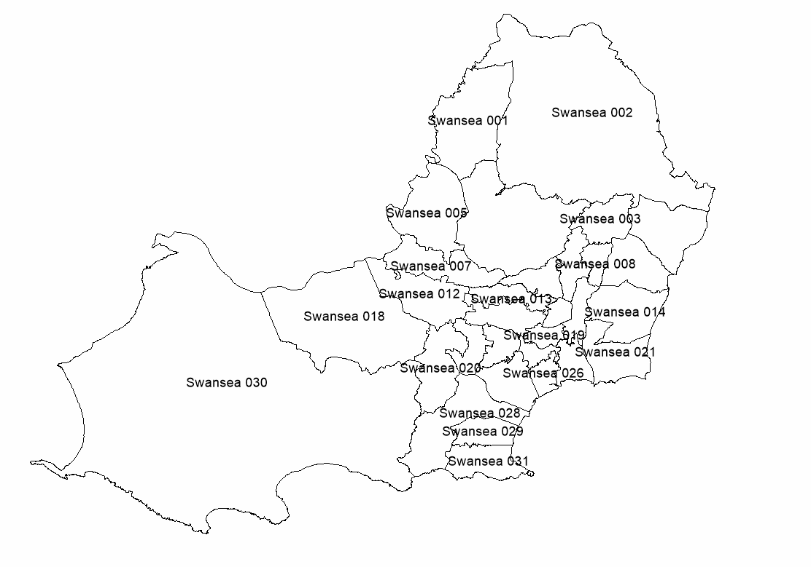
Figure 1 - Middle super output area of Swansea

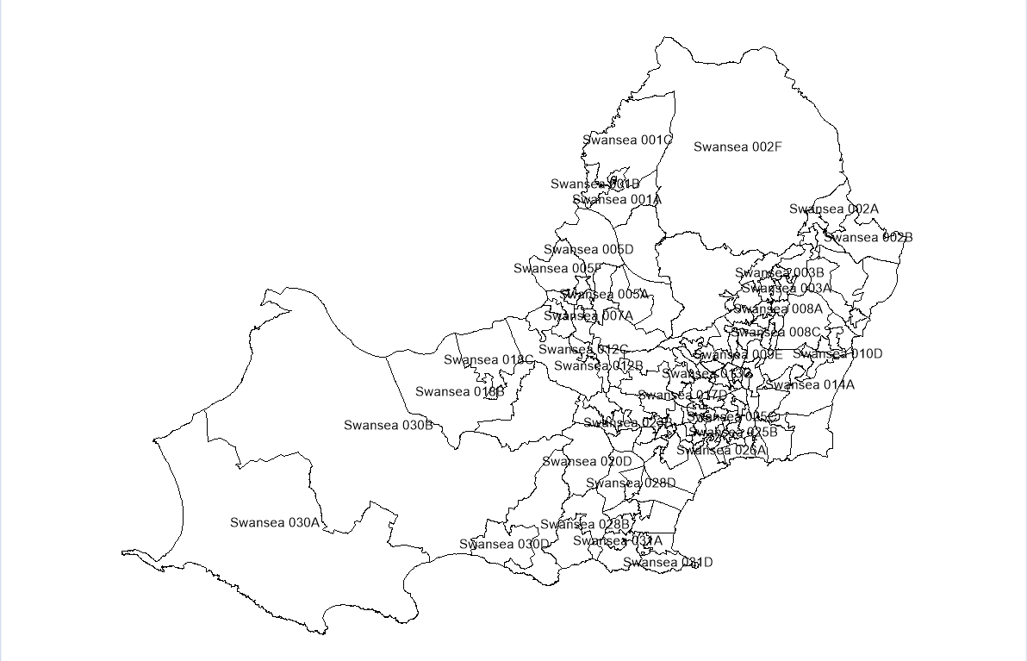
Figure 2 - Lower super output area of Swansea
As shown in Figure 1 and Figure 2, the output areas provide an overview of Swansea in varied detail. The contrast between middle and lower super output areas is that the further you investigate an area, it provides a clearer picture of the possible factors affecting a certain area with the Swansea region.

Middle Super Output Areas

Age 1 dose 2 between years of 2014-2016
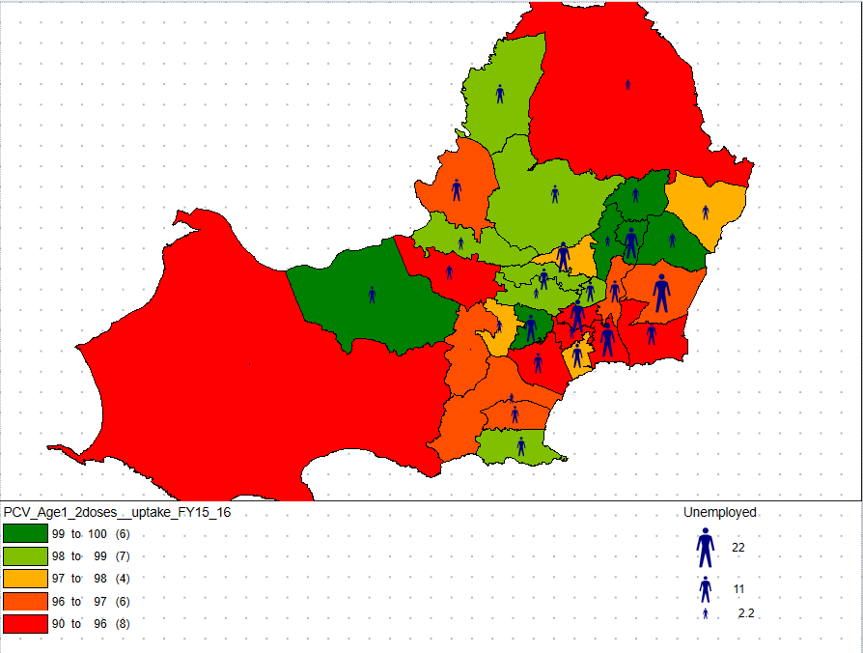
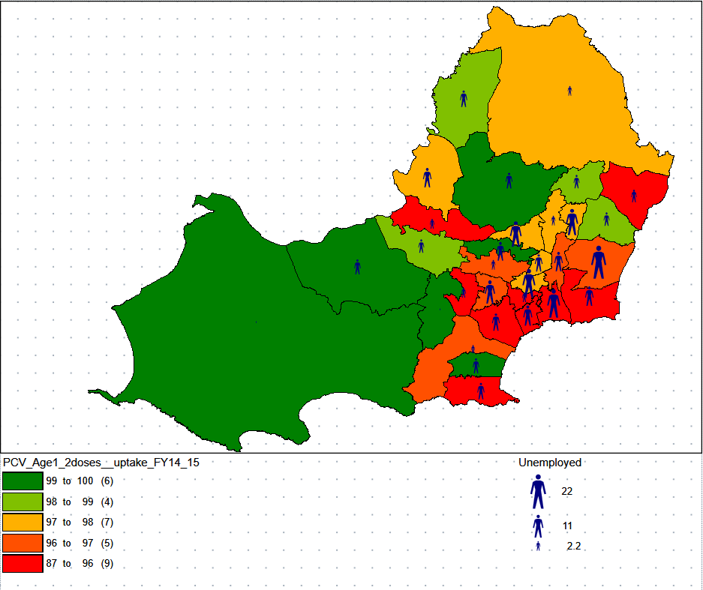
Figure 3 – MSOA, Age 1 second dose between 2014-2015 and 2015-2016
As shown in Figure 3, the colour ranges are indicating that the higher unemployment areas in Swansea, which is near the city centre and tends to be more people situated here show that fewer kids are getting vaccinated for PCV in these areas. The comparison between the years of 2014-2016 shows that drastic deteriorations had happened in the vaccinations on PCV for children aged 1. In this comparison, unemployment may have affected the vaccinations during this period, along with other factors may have caused the deteriorations over the duration of 2 years. Even though the overall vaccination rate percentage increased from 87% to 90% from 2014-2016, as you look at the higher percentage of vaccinations it shows that roughly the same number of areas have stayed with their range over the course of 2 years.

Age 1 dose 2 between years of 2016-2018
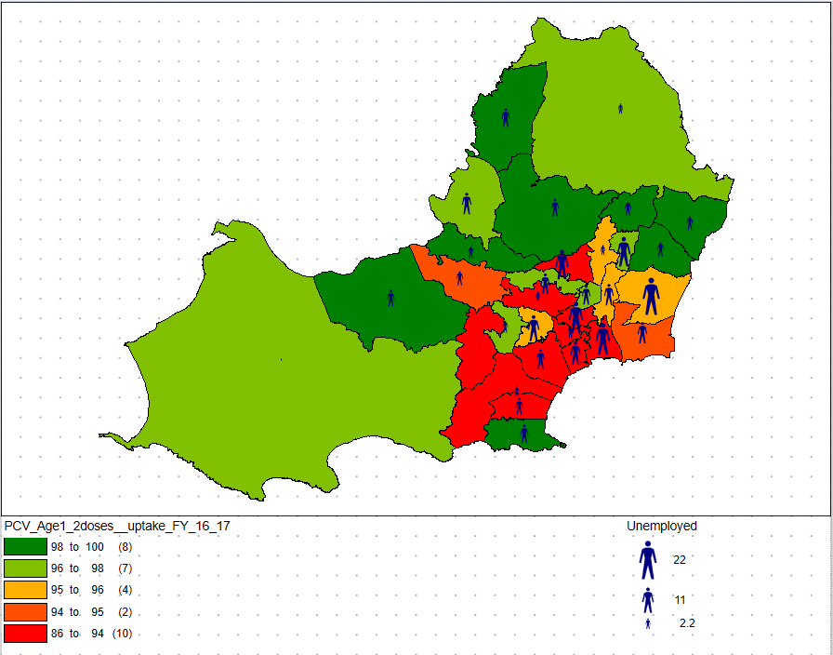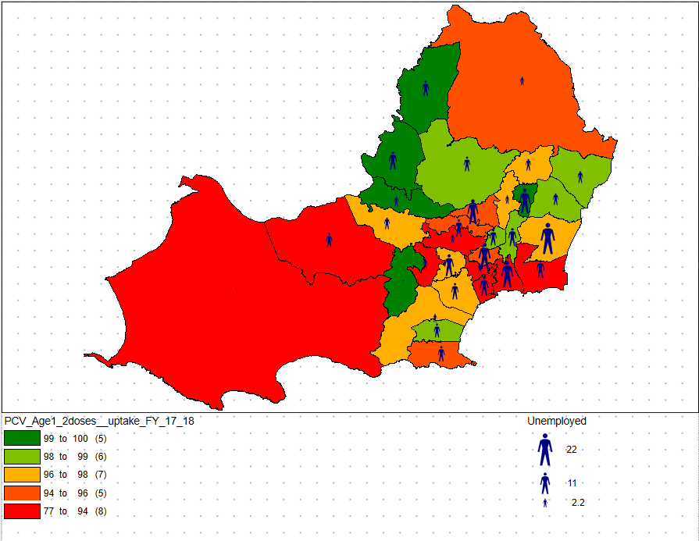
Figure 4 – MSOA, Age 1 second dose between 2016-2017 and 2017-2018
As shown in Figure 4, between the years of 2016-2018 the evidence shows that areas have headed for lower vaccinations for kids aged 1. Where there is high unemployment over this duration has shown consistency in the number of vaccinations being received, the overall percentages of vaccinated children Aged 1 receiving their second dose has decreased with the more areas in the lower two percentage ranges. In the year 2016-2017 the lowest area percentage was 86% whereas in 2017-2018 the lowest was 77%, this decrease shows the number of children being treated for PCV has decreased, the high unemployment rate could be a causing factor.

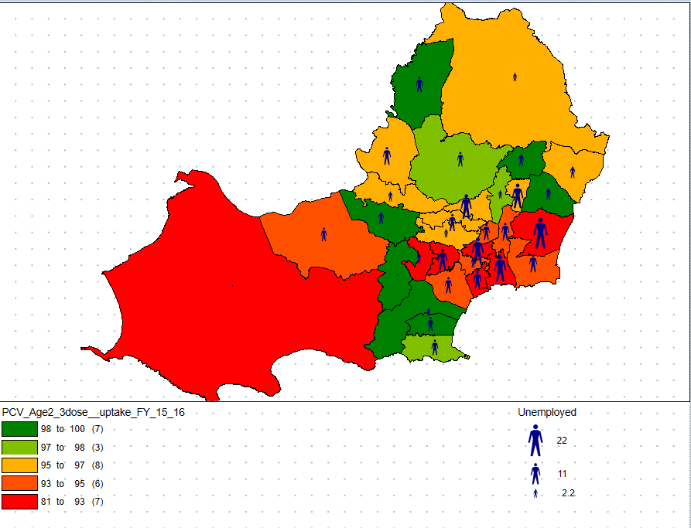
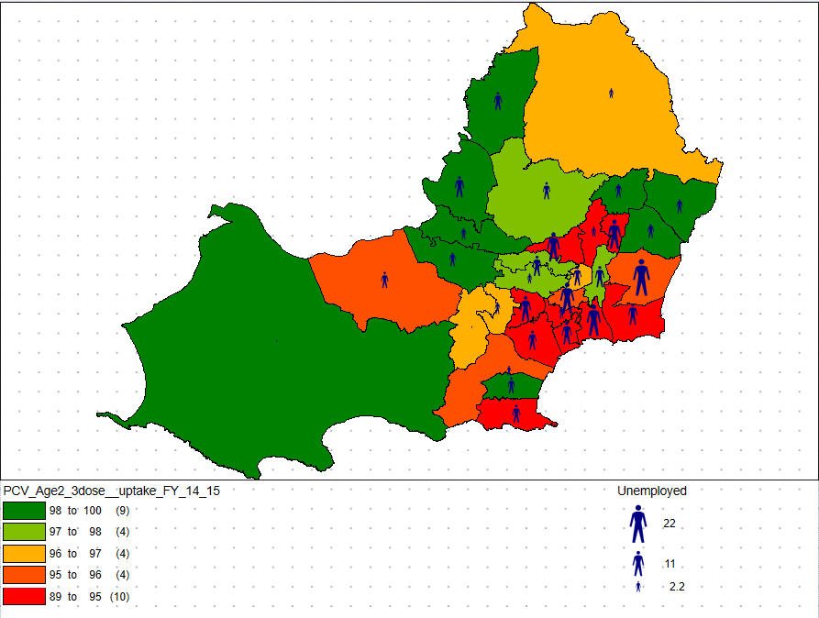
Age 2 dose 3 between years of 2014-2016

Figure 5 – MSOA, Age 2 third dose between 2014-2015 and 2015-2016
From figure 5, it shows that over the period of two years the difference of vaccination percentages. In the year 2014-2015, there were more areas in the lower percentile of children being vaccinated for PCV, but this has improved in 2015-2016, but the areas with higher percentiles in 2014-2015 have deteriorated and more areas are now lower percentile of children Aged 2 being vaccinated for PCV. In lowest percentage rate over these two years was 81% in the year 2015-2016, whereas in 2014-2015 it was as high as 89%, this is an 8% decrease in overall vaccinations for PCV this evidence shows that there had been a causing factor for the reduction of treated children for PCV during two-year span, one of these factors may have been high unemployment rates.

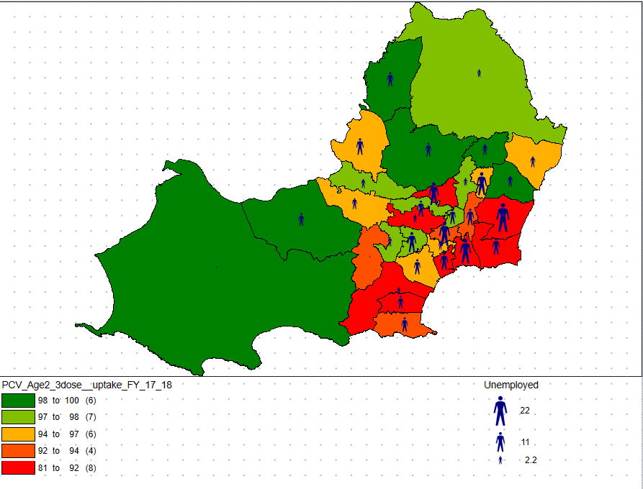
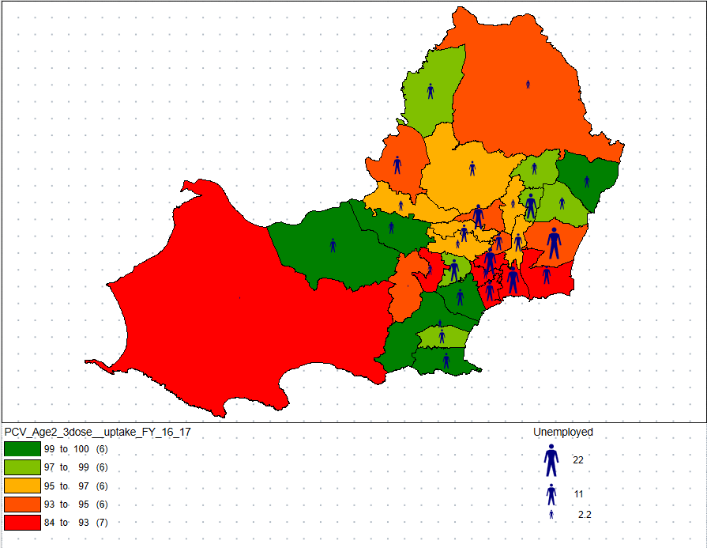
Age 2 dose 3 between years of 2016-2018

Figure 6 - MSOA, Age 2 third dose between 2016-2017 and 2017-2018
This figure shows the comparison of PCV vaccinations of children aged 2 between 2016-2018, the figure shows the influence of the high unemployment of areas in Swansea over a two-year span. The contrast over these two years is that more areas have fallen in the lowest percentile in which the lowest vaccinated area was 84% in 2016-2017, it has decreased to 81% in 2017-2018. There had been more areas in the bottom 20% of vaccinations but an increased in the other 80% of areas. Where the city centre is in Swansea, there is still a consistency of low vaccination rate this could be due to high unemployment rates.

Lower Super Output Areas

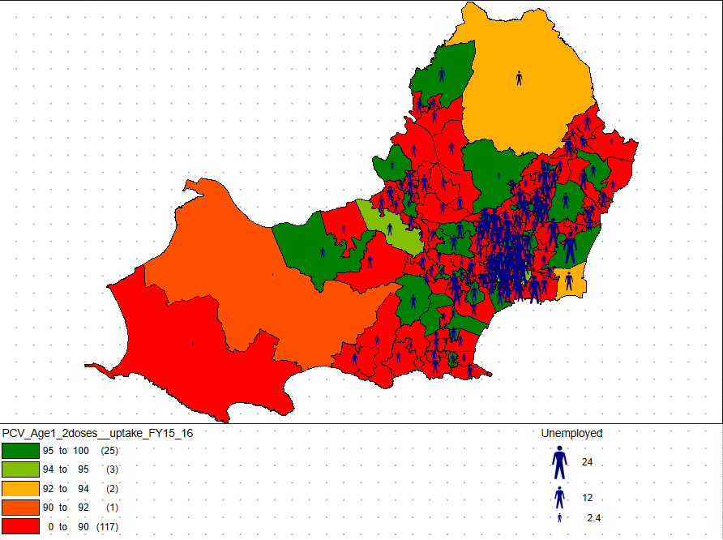
Age 1 dose 2 between years of 2014-2016
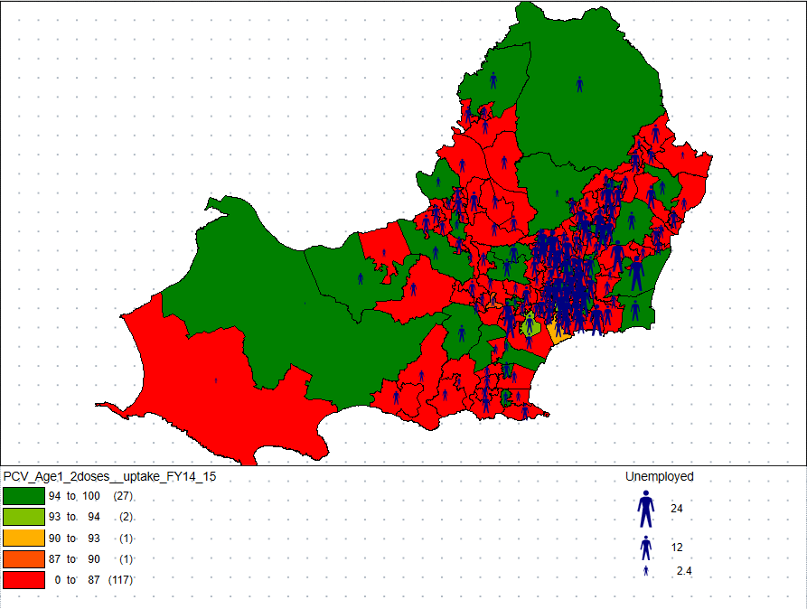
Figure 7 – LSOA, Age 1 second dose between 2014-2015 and 2015-2016
This figure provides an overview in more detail of the areas of Swansea, over the two-year span is shows that the majority of areas in Swansea are in the lowest percentile of children vaccinated for PCV aged 1. Between 2014-2016, there has been a decrease in areas in the highest percentile from 27 to 25, and more slight changes in the top 60% of vaccinated areas in Swansea. Where there is the highest rate of unemployment has the lowest rate of vaccinated children aged 1 receiving their second dose for PCV.

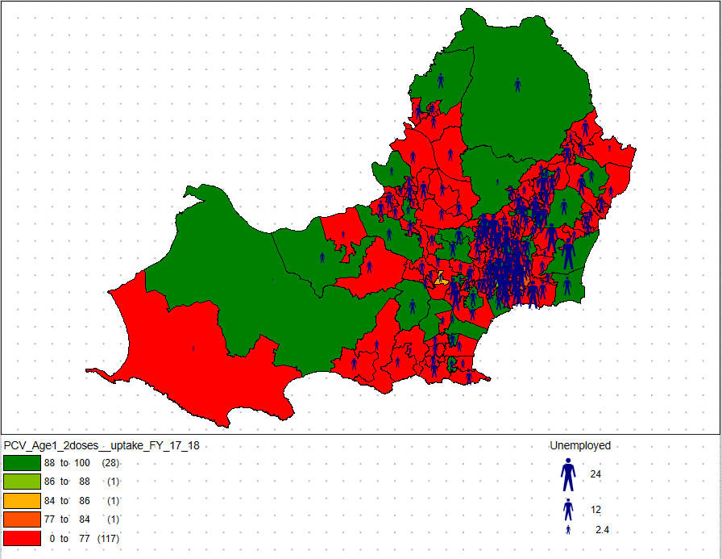
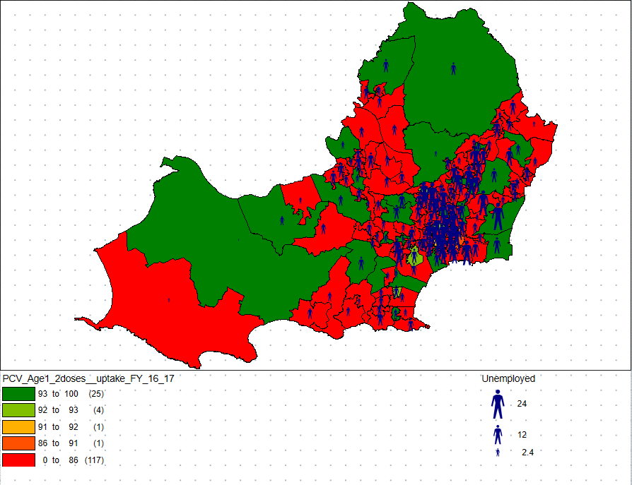
Age 1 dose 2 between years of 2016-2018

Figure 8 – LSOA, Age 1 second dose between 2016-2017 and 2017-2018
In this figure, it shows the changes that have been made over the years of 2016-2018. The highest percentile ranges had changed, which allowed more areas to be in the higher percentile. The consistency with these maps over the many years is that the highest unemployment rates tend to have the lowest vaccinations.

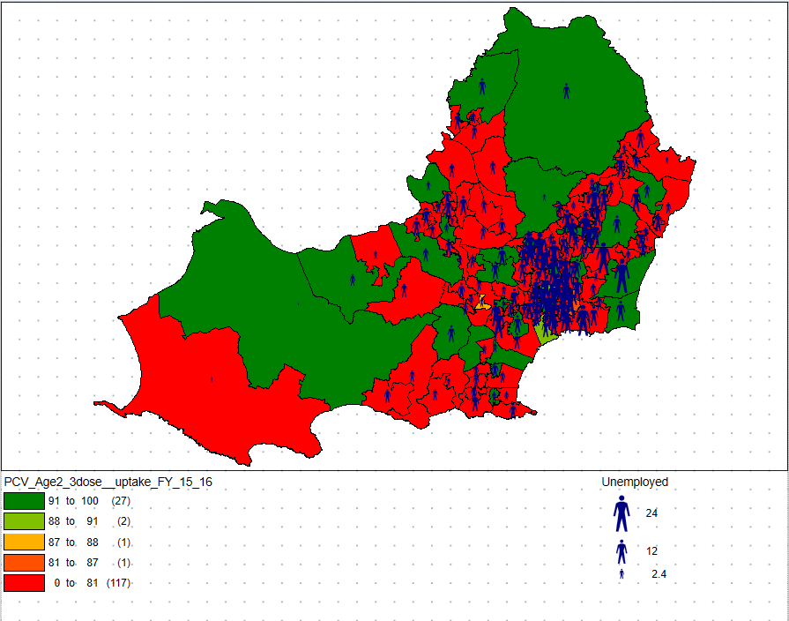
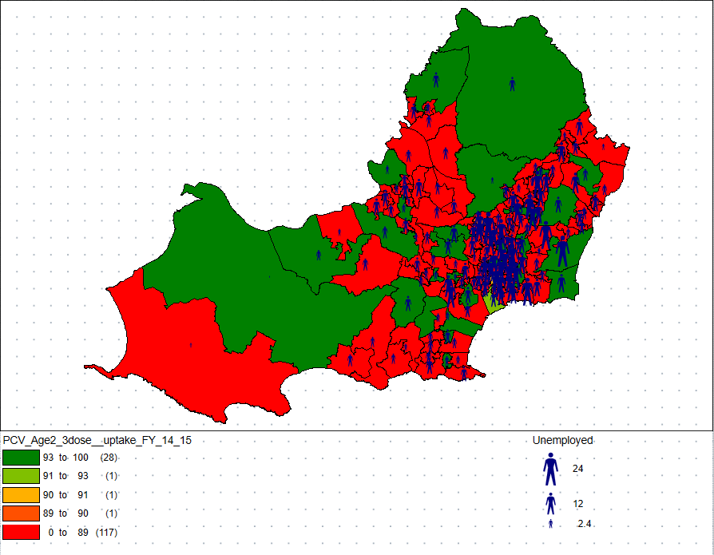
Age 2 dose 3 between years of 2014-2016

Figure 9 – LSOA, Age 2 third dose between 2014-2015 and 2015-2016
Over this duration there wasn’t much of a change of vaccinations rate and the high unemployment rate, the data show that during this period there was no correlating effect shown to conclude that high unemployment rates had an impact of the vaccinations during this two-year period as the unemployment rate was consistent so were the vaccination rate.

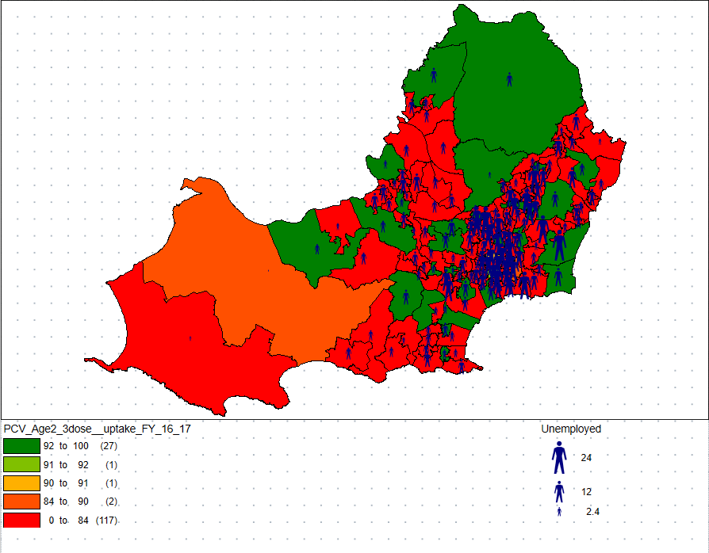
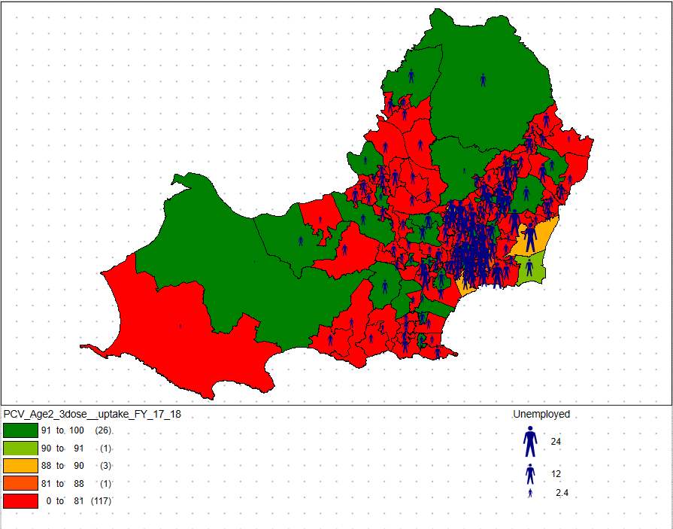
Age 2 dose 3 between years of 2016-2018

Figure 10 – LSOA, Age 2 third dose between 2016-2017 and 2017-2018
Figure 10 shows that the number of areas in the highest percentile had increased but some of the areas in high percentile from 2016-2017, decreased and went into the lowest 60% percentile range. This could be due to the high unemployment rate in these areas, the areas affected by this are near the city centre where most jobs and people are situated, this is a conclusion that can be identified by examining the difference in these maps over the two-year duration.

Case study conclusion
As shown from the figures above, that low vaccination rates were consistent across both MSOA and LSOA when looking at the city centre of Swansea. The city centre where most people live with unemployment rates in the higher percentile were always in the lower percentile for vaccination rates, the correlation between high unemployment rates and low vaccination rates show that where there are high unemployment rates there will always be lower vaccinations rate for children receiving the PCV treatment. Swansea youth unemployment rate was among the highest in the UK in 2016 with 27.3%[12], this played a factor on the possible changes in vaccinations during this time whereas in 2017-2018 just looking at Swansea, there were 6% were unemployed[13].
After comparing the MSOA and LSOA maps by providing contrast shows the correlation between the maps at different levels of details provides the same expected outcome, that high unemployment is a high possible causing factor.

Types of data involved in Geo-information systems
GIS data is usually represented as spatial data, this data refers to a location, dimensions, attribute and time[14], there are two mains types of spatial data:
- Vector
- Raster
These data types provide different representations of information in the GIS software, the way it is presented for different purposes. Vector data in GIS, “the adjacency information is typically stored explicitly and may be accessed by means of a simple query.”[15]. Whereas Raster data is “composed of a regular grid of cells in specific sequence and each cell within a grid holds data.”[16]. You would use these different data structures depending on what the intended purpose would be in what the individual would be trying to convey or represent.
Vector data is primarily represented in three different types:
- Lines
- Points
- Polygons
“Vector data models use points and their associated [X and Y] coordinate pairs to represent the vertices of spatial features, much as if they were being drawn on a map by hand”[17]. Vector data is used more so to represent human activity whereas raster is mainly used for environmental applications[18].
Raster data is primarily represented:
- Surface data
Raster data structure has two types, Discrete and continuous. Discrete rasters represent objects as collections of one or more cells[19], this type has themes or categories in which a thematic class can be applied and be defined the parameters of that thematic class to represent the data. The discrete data can represent certain objects like integers, so 1 is a park, 2 a river etc. Continuous rasters are “analysing relations between continuous phenomena taking place on the same geography.”[20].
The main difference between using these different types of data structures is the quality of graphics when geographical representations are enhanced and looked more closely at in detail, as you can see from Figure 11, the quality of the imagery stays at a high quality when you look at maps more closely which is preferred but comes at a cost.
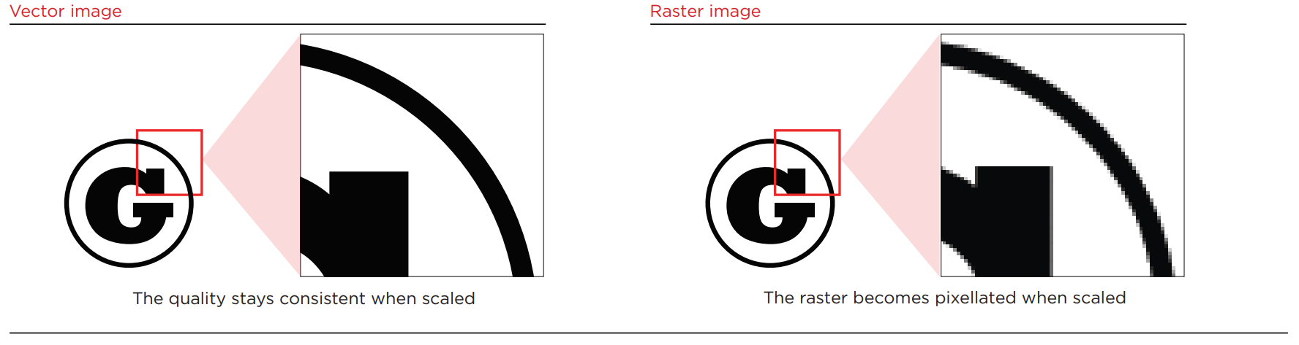
Figure 11 – Difference between Vector image vs Raster image
Advantages of Vector data:
- More aesthetically pleasing to represent data
- More accurate representation of data
- Easy to manage and edit
- No data conversion is required
- Can be scaled to any size, quality remains the same
- Doesn’t rely on the resolution, can adapt to any size requirements and restrictions
Disadvantages of Vector data:
- Poorly stored
- Continuous data is more difficult to represent
- Harder to manage and edit the data
- Technology tends to be more expensive to represent more sophisticated and detail topic areas
Advantages of Raster data:
- Easier and quicker to perform due to storage of the data
- Represents continuous data
- Less complex than Vector data
- The technology used for Raster data is far cheaper than Vector data
- More user-friendly
Disadvantages of Raster data:
- Difficult to illustrate, features and paths are more demanding to display
- The geographical representations are not as aesthetically pleasing compared to Vector data
- Non- scalable
- Resolution dependent

Conclusion
This report has provided evidence of the importance of GIS in providing a visual representation of data. GIS is allowing individuals and organizations to examine data to determine and represent change or planning future projects, it can be used to analyse and manage data which allows better overall monitoring. The case study used for this report represented the change and potential influencing factors of a topic area of a specified duration, with this, the report was capable of analysing and managing the data to conclude the outcomes of the data. This report can determine the types of data that GIS can represent and how that is achieved with the boundaries and restrictions that some spatial data is limited to.

References
[1] L. Greiner, “Putting Canada on the Map,” The Globe and Mail, 2007. [Online]. Available: https://www.theglobeandmail.com/technology/putting-canada-on-the-map/article1092101/. [Accessed: 27-Jan-2019].
[2] A. M. Maceachren, M. Wachowicz, R. Edsall, D. Haug, and R. Masters, “Constructing knowledge from multivariate spatiotemporal data: Integrating geographical visualization with knowledge discovery in database methods,” Int. J. Geogr. Inf. Sci., vol. 13, no. 4, pp. 311–334, 1999.
[3] S. Yasobant, K. Suresh Vora, C. Hughes, A. Upadhyay, and D. V Mavalankar, “Geovisualization: A Newer GIS Technology for Implementation Research in Health,” J. Geogr. Inf. Syst., vol. 7, no. 7, pp. 20–28, 2015.
[4] M. F. Goodchild, “Twenty years of progress: GIScience in 2010,” J. Spat. Inf. Sci., vol. 1, no. 1, pp. 3–20, 2010.
[5] J. E. Capó-aponte et al., “Visual perception and cognitive performance,” Helmet-Mounted Displays Sensation, Percept. Cogn. Issues, pp. 335–390, 2009.
[6] M. Duckham, M. F. Goodchild, and M. Worboys, Foundations of Geographic Information Science. CRC Press, Inc, 2014.
[7] S. Franges, V. Posloncec-petric, and R. Zupan, “Continuous development of cartographic visualization,” Contin. Dev. Cartogr. Vis., pp. 1–9, 2007.
[8] N. J. Obermeyer, “PPGIS: TheEvolution of Public Participation GIC,” J. Chem. Inf. Model., vol. 53, no. 9, pp. 1689–1699, 2013.
[9] Jurovich Surveying, “WHAT IS GIS?,” Jurovich Surveying, 2018. [Online]. Available: https://www.jurovichsurveying.com.au/faq/what-is-gis. [Accessed: 27-Jan-2019].
[10] M. Smith, “Uptake of the measles, mumps and rubella (MMR) vaccine has reached its highest level in Wales,” WalesOnline, 2015. [Online]. Available: https://www.walesonline.co.uk/news/health/uptake-measles-mumps-rubella-mmr-10158716. [Accessed: 28-Dec-2018].
[11] S. Morrison, “Worldwide, 20 per cent of children go unvaccinated,” Independent, 2013. [Online]. Available: https://www.independent.co.uk/life-style/health-and-families/health-news/worldwide-20-per-cent-of-children-go-unvaccinated-8581495.html. [Accessed: 28-Dec-2018].
[12] S. Barry, “Wales has one of the highest youth unemployment rates in the UK,” WalesOnline, 2016. [Online]. Available: https://www.walesonline.co.uk/business/business-news/wales-one-highest-youth-unemployment-11814536. [Accessed: 27-Jan-2019].
[13] Nomis, “Labour Market Profile - Swansea,” Nomis official labour market statistics, 2018. [Online]. Available: http://www.nomisweb.co.uk/reports/lmp/la/1946157393/printable.aspx. [Accessed: 27-Jan-2019].
[14] D. Mcinerney, “Introduction to Spatial Data Types,” no. June 2009.
[15] L. Anselin, “Spatial Data Analysis with GIS: An Introduction to Application in the Social Sciences,” Natl. Cent. Geogr. Inf. Anal., vol. 92, no. 10, pp. 1–53, 1992.
[16] K. Rao, “UNIT 5 GIS DATA MODELS AND SPATIAL,” pp. 19–36, 2017.
[17] S. Aronoff, Geographic Information Systems: A Management Perspective. Ottawa: WDL Publications, 1989.
[18] I. N. Gregory, “A Place in History: A Guide to Using GIS in Historical Research (AHDS Guides to Good Practice) (Ahds Guides to Good Practice) (Ahds Guides to Good Practice),” 2003.
[19] Y. Murayama, “Representing Geography for GIS Data Processing Geographic Phenomena and GIS.”
[20] T. Sapic, “Lecture 1 Intro to GIS and GIS Vector and Raster Data Models.”

Bibliography
http://www.geografie.webzdarma.cz/GIS-skriptum.pdf
https://www.esri.com/en-us/what-is-gis/overview
https://web.mst.edu/~rogersda/gis/History%20of%20GIS.pdf
https://download.osgeo.org/qgis/doc/manual/qgis-1.0.0_a-gentle-gis-introduction_en.pdf
https://assets.publishing.service.gov.uk/government/uploads/system/uploads/attachment_data/file/61203/gis_guide_acro6.pdf
http://www.gishydro.eng.umd.edu/documents/train_manual/old/vector-raster.pdf
http://gif.berkeley.edu/documents/GIS_Data_Formats.pdf

