Impact on the business – energy sector price
By
Asen Asenov
Student ID:2028526
Course: Business and Management
Module: Managing Economics (LCBB _5003)
Module leader: Vasilios Tavlaridis
UWTSD Birmingham



Contents
Executive summary 3
Overview of the energy sector – price, consummation, reasons 3
Political decisions/ events and the impact to world economies- energy sector 6
Impact of the energy sector prices in the United Kingdom economy – business and households 7
Impact of the energy sector prices on the small and large organizations in United Kingdom 10
Conclusion 12
References 13

Executive summary

The paper assesses the effect of the price increase in the energy sector on firms, households, and the economy as a whole in the United Kingdom using the applicable economic sources. The paper demonstrates how political decisions and occurrences occur after the term economy. It describes how this price increase influences managerial decisions within small and large organisations.

Overview of the energy sector – price, consummation, reasons

Energy in Britain
Energy is a wide phrase that encompasses a variety of fuels and applications. Electricity, heating fuels, and transportation fuels are utilised by all sectors of the UK economy, including the residential, commercial, and industrial sectors. The energy consumed in the United Kingdom is produced using a variety of fuels and technologies, including both domestic production and imports. (Hinson S., 2020)
Energy includes a variety of fuels and applications. Electricity, heating fuels, and transportation fuels are utilised by all sectors of the UK economy, including the residential, commercial, and industrial sectors. Various fuels and methods are utilised to generate the energy used in the United Kingdom. The United Kingdom is an energy producer, producing oil, gas, and electricity from a variety of domestic sources. Although the United Kingdom exports some oil, gas, and electricity, it imports a higher amount to meet its energy demands, making it a net importer of energy. (Hinson S., 2020)
The graph below illustrates the fuels used for final energy consumption across all industries in the United Kingdom. Natural gas is frequently utilised for heating, while petroleum is commonly used for transportation. As seen in the following graph, several technologies generate the power used in the United Kingdom. (Hinson S., 2020)
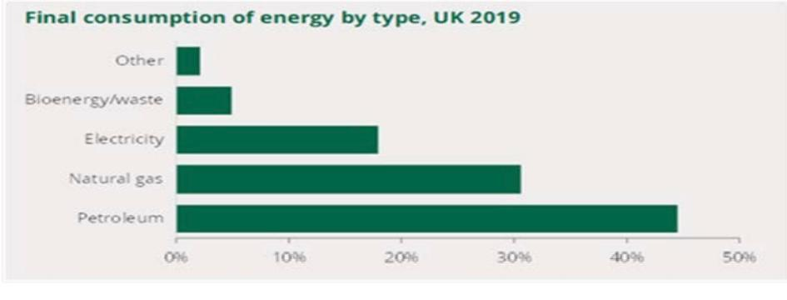
(Hinson S., 2020)
Fuel price indexes for the commercial sector, 1990 through 2021

Since the mid-eighties, industrial prices have fallen steadily in real terms, reaching their lowest point in two thousand twenty-three. The industrial price index subsequently increased again, reaching a peak in 2013, before declining slowly and then climbing to a new top in 2019. In 2021, the cost of coal, electricity, natural gas, and heavy fuel oil will all rise. In actual terms, industrial electricity rates in 2021 increased by twelve percent compared to the previous year and reached an all-time high. The price of gasoline rose forty-four%. The business paid a 36% premium for coal. Industrial heavy fuel oil is used less often than other fuels affected by bulk purchasing and stockpiling, and real costs increased by eleven %. The real price of industrial gas has climbed by thirty-seventh % over the past five years, while the real price of electricity has increased by 31%. (National Statistic, 2022)
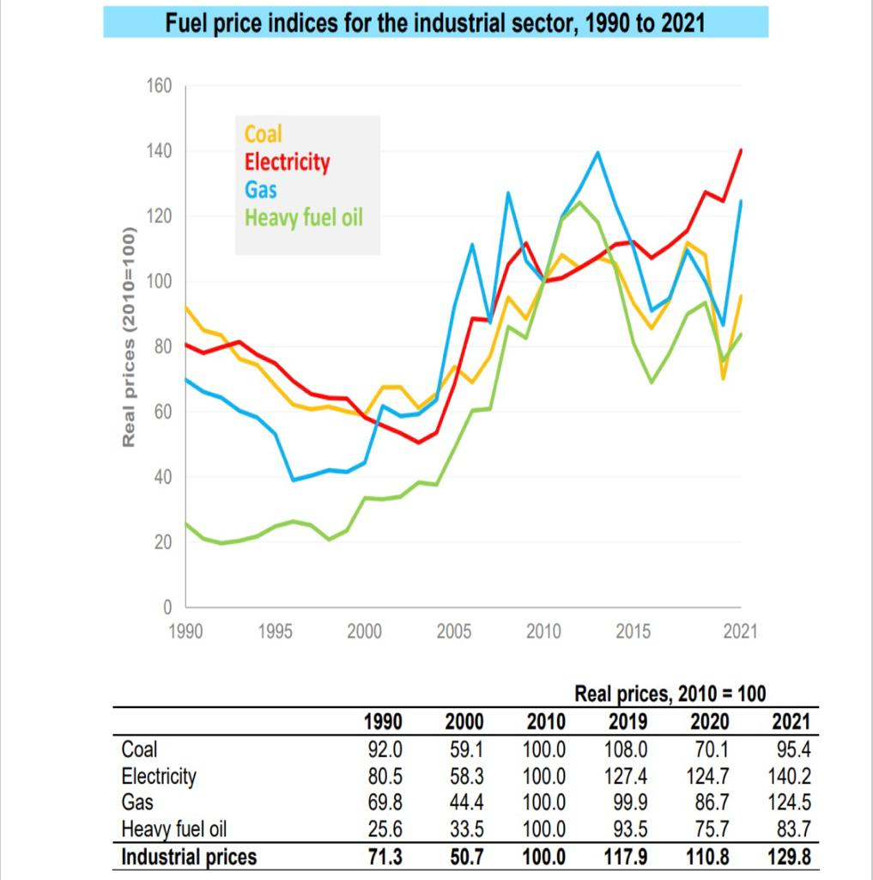
(National Statistic, 2022)

Domestic fuel price indices, 1996-2021
Total domestic energy prices in 2021 were 4.4% higher in real terms than in 2020. Over the same time period, the price of liquid fuels climbed by thirty-one %, the price of gasoline declined by 0.1%, the price of electricity rose by 6.3%, and the price of solid fuels rose by 2.9%. (National Statistic, 2022)
Comparing the cost of domestic fuels in 2021 to those of a decade earlier, the real prices grew by 7.8%. The real price of electricity rose by 31%, while the real price of solid fuels rose by 3.8%. However, the true price of gasoline declined by fifteen%, while the real price of liquid fuel decreased by 34%. (National Statistic, 2022)

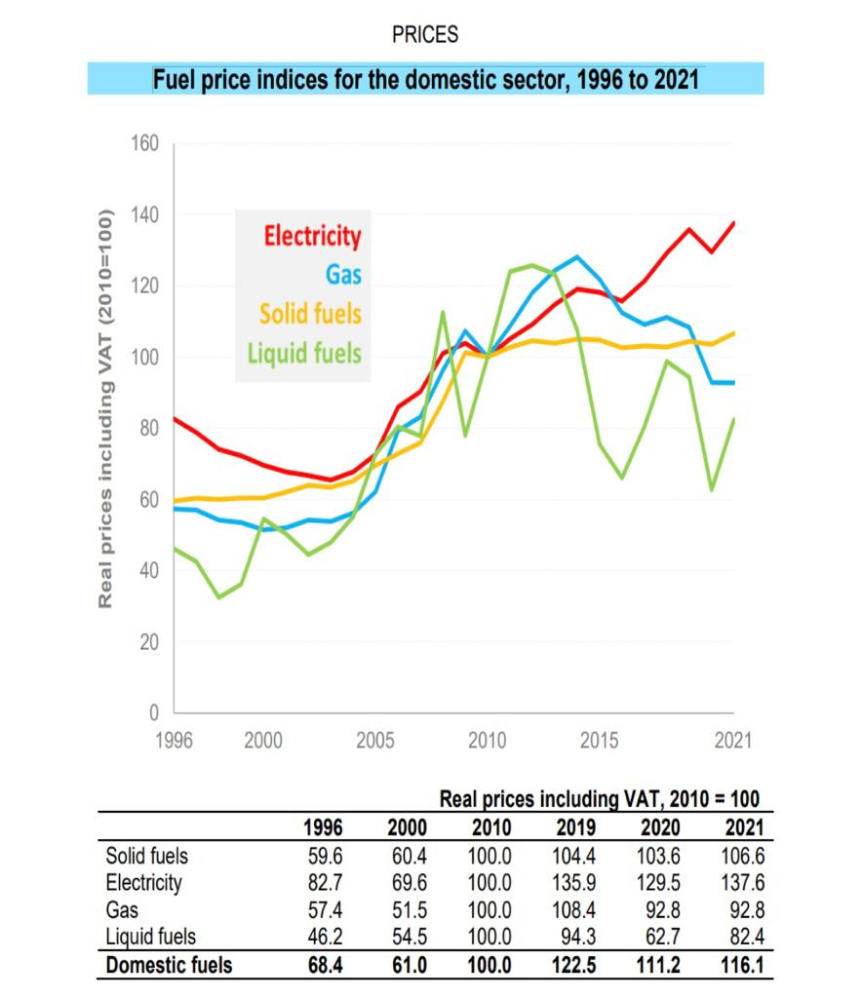
(National Statistic, 2022)

Reason for the increase in energy prices
- As a result of the situation in Ukraine, Russian gas supplies have decreased, resulting in a significant increase in energy prices. Since Covid limitations were lifted, the demand for energy has skyrocketed, driving up prices as well. (BBC News, 2022)
- Europe saw a very frigid winter in 2020/21, which put a strain on supplies. (Rochell H, 2022)
- Summer 2021 was less windy than average, resulting in a decrease in wind energy production. (Rochell H, 2022)
- Earlier COVID-19 lockdowns resulted in a global decrease in energy consumption; when lockdowns are lifted, the demand for energy increases. (Rochell H, 2022)

Political decisions/ events and the impact to world economies- energy sector

Gas and war the impact of Russia's war on Ukraine on energy prices and the environment

Since Russia invaded Ukraine, the price of gas and oil at the wholesale level has gone up around the world. According to Fatih Birol, the executive director of the International Energy Agency, "Russia's use of its natural gas resources as an economic and political weapon demonstrates that Europe must act swiftly in order to be prepared for next winter's significant uncertainty over Russian gas supply." Shell has not renewed long-term contracts with Russia and has withdrawn from the Nordstream two pipeline between Russia and Germany, while Finland has stated that it will invest up to £seven hundred million to expedite its transition away from energy dependence on Russia. That event has a massive negative impact in the economy and the energy sector negatively. (Rochell H, 2022)

The price of a barrel of oil (or a barrel of Brent crude oil) went over $120 in March, just days after the Russian-Ukrainian war started. This is more than a fifty % increase from the price in November 2021. The price of natural gas has gone up and down a lot in 2021. Prices have stayed high because of how important Russian gas is to Europe and how the war has disrupted supplies to the continent. The gas pipeline called Nord Stream two that was going to Europe has been put on hold. (Rasanah, 2022)

Liz Truss- decision
To avert widespread hardship, the incoming prime minister, Liz Truss, will restrict energy bill increases for all households for two years. Up until 2024, the average annual home energy bill will be capped at £ two thousand. Ms. Truss refused to provide a cost estimate for the massive support programme, stating that "exceptional circumstances call for extraordinary measures." The programme might cost up to £150 billion. With a six-month price cap, businesses will receive assistance. This is less protection than many had hoped for. Everyone in England, Scotland, and Wales will receive support, while Northern Ireland will receive a similar amount. This political decision (Thomas D., 2022)

Impact of the energy sector prices in the United Kingdom economy – business and households

Energy sector affecting the UK economy
The UK economy is impacted by the energy prices in a major and wide-ranging way. To prevent a major and far-reaching damage to the UK economy, five influential business groups have asked the government to intervene against rising energy prices. The group claimed that because both people and businesses will experience financial hardship, the economic recovery from COVID-19 would be slowed down by increased expenses. The regulator Ofgem will review the energy price cap on February 7, and it is expected to increase by up to 50%. This will take effect at the beginning of April and result in the average household paying roughly £2,000 in annual bills. (Dinsdale R., 2022)
In a letter to Chancellor of the Exchequer Rishi Sunak, leaders of the British Chambers of Commerce, Confederation of British Industry, Federation of Small Businesses, Institute of Directors, and Make UK demanded immediate action. According to them, the higher cap raised inflation by one to two percentage points, which is currently at a thirty-year high of 5.4%. (Dinsdale R., 2022)
The Energy Crisis Impacts British Businesses
Businesses are seeing dramatically higher energy costs, similar to most consumers. Business energy bills are already substantially greater than those of the typical household due to the operational needs that they must meet. Additionally, since they are not eligible for the benefits of the energy price ceiling, both large and small enterprises have less protection than residential customers. (Richards C., 2022)
Despite this, some companies won't yet be impacted by growing energy costs because they often have long-term commercial energy contracts that may even outlive the crisis. Not as fortunate are those whose contracts need to be renewed or who have changeable tariffs. (Richards C., 2022)
It is certain that firms will feel the effects of these additional pressures in the form of growing operating expenses, supplier price hikes, and dwindling profit margins. Many argue that the impact on business strengthens the case for increasing investment in cleaner kinds of energy. (Tansley E., 2022)
The average yearly gas and electricity use by enterprises in the United Kingdom (UK) as of 2019 is shown in this data. It demonstrates that, on average, medium-sized firms used thirty-five thousand kilowatt hours of gas and electricity. The average annual use for large firms was seventy-five thousand -kilowatt hours of gas and ninety thousand kilowatt hours of electricity. (Statista, 2022)
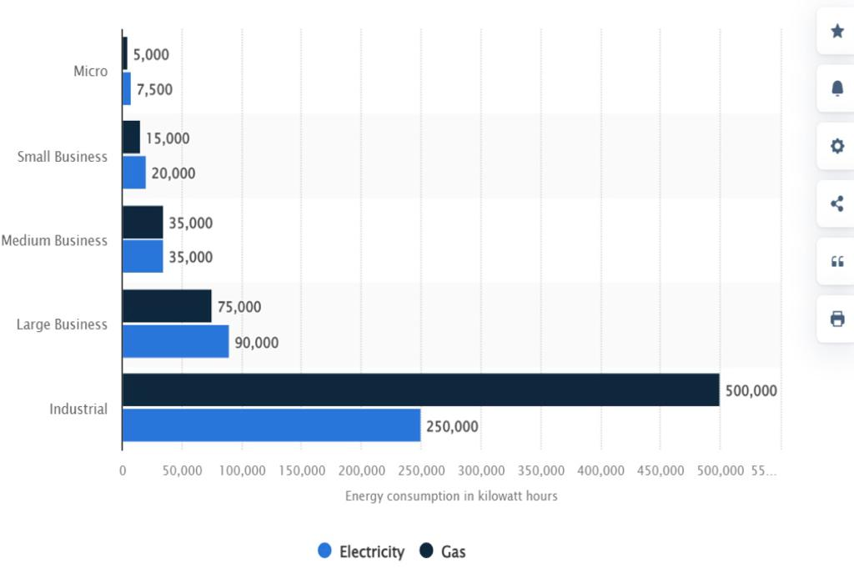
(Statista, 2022)

Here is the typical business electricity pricing per KWh for each type of business based on Q2 2022 statistics and excluding CCL, according to the most recent UK Government energy prices:
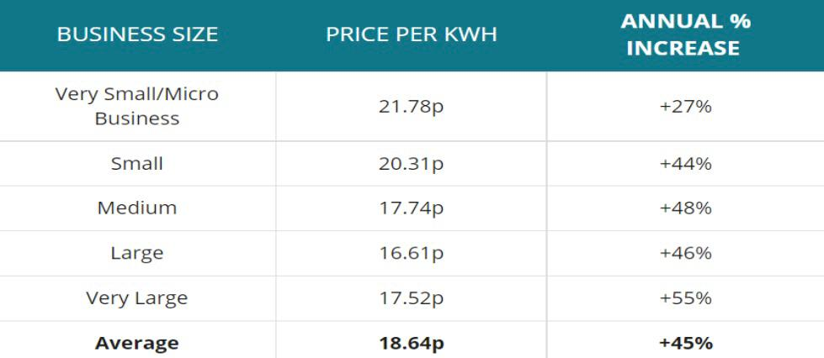
(Business Electricity Prices, 2022)

The energy crises affecting the British households

The current energy situation is unheard of. 4.5 million families in the UK experienced fuel poverty in October. 6.7 million, according to National Energy Action. A fresh price freeze of £two-thousand per year for typical households was announced by the government on September 8 and would take effect in October 2022. This would result in fuel poverty for 6.7 million families. Originally intended to run for two years, the Energy Price Guarantee will now only endure for six months, terminating in April 2023, as the Chancellor stated on October 17. After that, "targeted support" would take the place of the Energy Price Guarantee. The design of the support is currently being reviewed by the Treasury. (NEA, 2022)

The government unveiled a new plan on September 8th to freeze household bills at an average of £two-thousand five hundred per year. (NEA, 2022)
According to the plan, an average annual energy expenditure for a typical household won't exceed £2,500 starting on October 1 (this will last until April 2023, as revealed on 17 October 2022). Please be aware that only the price per unit, not the total energy bill for a family, has been capped. People usually mean the average annual cost of £2,500, which includes consuming 2,900 kWh of electricity and twelve-thousand kWh of gas. The amount of energy a home uses will determine how expensive their annual energy bill is. This amount replaces the current energy price cap and takes into account the elimination of green taxes (worth about £one-hundred fifty per household). (NEA, 2022)
Households in Britain are covered by the policy, but those in Northern Ireland—where there is a different energy regime—will receive the same level of assistance. (NEA, 2022)
Families who don't purchase gas or electricity directly from the utility company will receive assistance from a fund and won't suffer any financial hardship. (NEA, 2022)
The table below shows the typical household energy bill for 2020-2024, which is increasing sharply for 2022-2024:
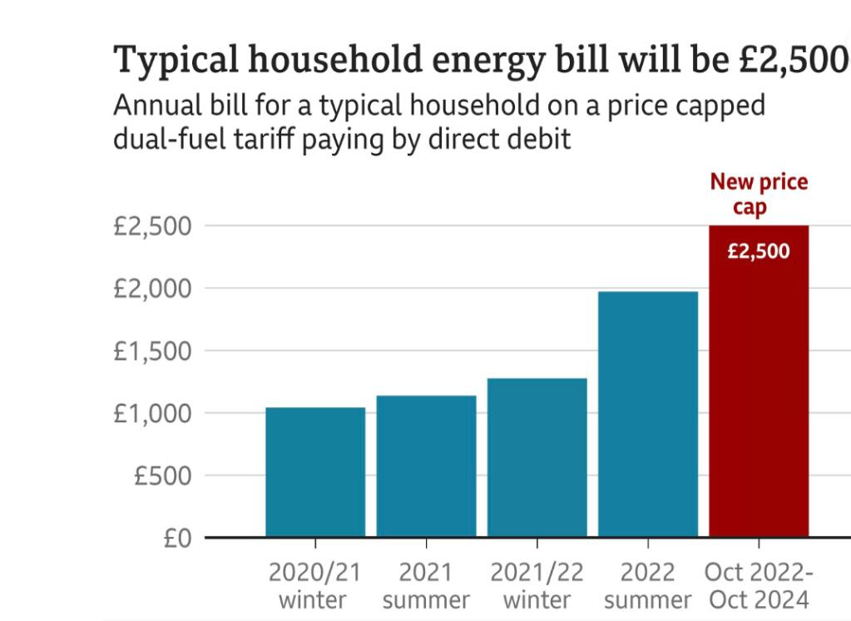
(Thomas D., 2022)

Impact of the energy sector prices on the small and large organizations in United Kingdom

Impact on small businesses due to overcome growing energy costs in the United Kingdom

Sadie Shard, the proprietor of the Crescent Hotel in Scarborough, has endured the financial misery caused by the epidemic and now faces a new threat to her business: sky-high energy bills. Since 2014, Shard has purchased the hotel in the northern English coastal town, for which it previously paid between £1,000 and £2,000 per month to power its 20 guestrooms and restaurant. However, her supplier, CNG, went out of business in November, just before the expiration of her most recent energy contract. As a result of wholesale price increases, the business selected by the regulator, Ofgem, to acquire CNG's customers stated that her power rate will climb by more than fivefold. This would have resulted in a monthly energy bill of up to £10,000. CNG, which had 41,000 corporate clients, is one of 26 energy suppliers that have filed for bankruptcy in the last five months, as rising wholesale gas and electricity costs have sparked the worst crisis in Britain's energy supply sector in two decades. (Forsyth I., 2022)

Energy prices impact on big organisations
The Centre for Economics and Business Research (CEBR), which compiles the research on behalf of Asda, predicts a monthly decline in disposable income throughout 2022, reaching a new low in the fall as energy prices rise. (Corporate Asda, 2022)
As inflation increases strain on household budgets, Asda customers are already changing their behaviour. According to a recent survey, 44% of respondents are buying more during discounts. (Corporate Asda, 2022)
According to Asda's Income Tracker, household discretionary income has decreased by a record £41.94 each week, or £167.76 per month. For the seventh straight month, the average UK household saw a decline, and twenty% of households now have "negative discretionary income," meaning their income does not cover necessities. (Corporate Asda, 2022)
To assist customers, stretch their finances further, the company has "Dropped and Locked" the price of over a hundred family favourites. The Grocer's annual 'Grocer Gold' industry awards recognised Asda as the UK's cheapest large supermarket for the past twenty-five years. (Corporate Asda, 2022)
The table below shows the household income in UK for May 2022:
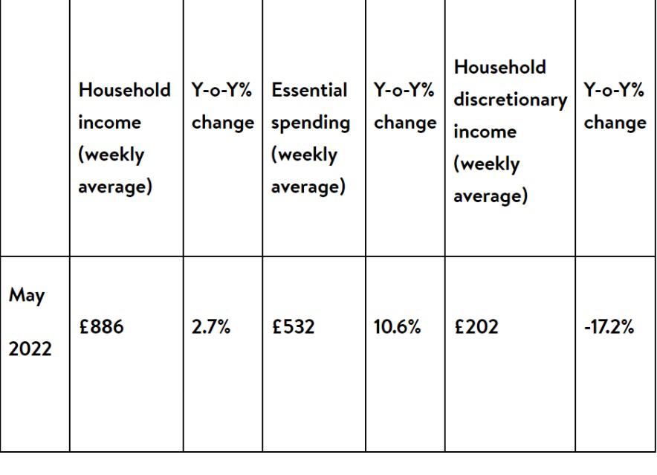
(Corporate Asda, 2022)

For the first quarter (Q1) of the fiscal year 2022 (FY22), British grocery giant Asda reported revenue of £4.641bn ($5.86bn), excluding fuel, down by 9.2% from a year earlier and impacted by the costs in the energy sector. (Retail Insight Network, 2022)

Energy Bill Relief Scheme: assistance for companies
The British government has a programme that provides energy bill reduction for non-residential clients. Initially, discounts would be applied to energy use between October 1, 2022, and March 31, 2023. (Department for Business, Energy & Industrial Strategy, 2022)
The programme will be accessible to all non-domestic contract holders, including:
- businesses in the voluntary sector, such as charities. (Department for Business, Energy & Industrial Strategy, 2022)
- On or after 1 December 2021, public sector organisations such as schools, hospitals, and nursing homes will be required to sign new fixed price contracts on deemed/out-of-contract or variable tariffs on flexible purchase or similar contracts. (Department for Business, Energy & Industrial Strategy, 2022)

Decisions making
The organisation
- Improving the energy efficiency of the structures and operations should now be a top priority. Building optimization is the quickest measure a company can take to mitigate the impact of impending energy shocks. (Melville G., 2022)

- Intervention at the asset level and having a clear perspective of energy hotspots across a portfolio will strategically inform the company's disposal and refit plan, as well as prevent energy expenditures and reduce carbon emissions by implementing urgent, essential operational improvements. Building optimization is the quickest measure a company can take to mitigate the impact of impending energy shocks. (Melville G., 2022)

- The corporation should make significant decisions regarding the reduction of energy expenses, the reduction of employee working hours, and the enhancement of their products and services. (Melville G., 2022)

Conclusion
Utilizing relevant economic theories, the article analysed the impact of the price increase in the United Kingdom's energy industry on businesses, households, and the economy. The research illustrated how political decisions and events occur afterwards to the term economics. It describes how this price increase affects the managerial decisions of small and large firms and provides an overview, causes, and use of the energy industry.

References

BBC News (2022), What is the energy price cap and what will happen to bills?, 5th November 2022, Available at: https://www.bbc.co.uk/news/business-58090533 (Accessed: 6th November 2022)

Business Electricity Prices (2022), Compare business electricity prices, Available at: https://www.businesselectricityprices.org.uk/#:~:text=The%20average%20business%20electricity%20unit%20price%20in%202021,pence%20per%20kWh.%20What%20are%20deemed%20contract%20rates%3F (Accessed: 6th November 2022)

Corporate Asda (2022), Inflation drives disposable income to its lowest ever level as shoppers find ways to spend less, Available at: https://corporate.asda.com/newsroom/2022/06/24/inflation-drives-disposable-income-to-its-lowest-ever-level-as-shoppers-find-ways-to-spend-less#:~:text=The%20Centre%20for%20Economics%20and%20Business%20Research%20%28CEBR%29,low%20in%20the%20Autumn%20when%20energy%20prices%20increase. (Accessed: 7th November 2022)

Department for Business, Energy & Industrial Strategy (2022), Energy Bill Relief Scheme: help for businesses and other non-domestic customers, 21st September, Gov.uk, Available at: https://www.gov.uk/guidance/energy-bill-relief-scheme-help-for-businesses-and-other-non-domestic-customers (Accessed: 7th November 2022)

Dinsdale R. (2022), Rising energy prices will have ‘significant and far-reaching impact’ on UK economy, business groups warn, 22nd January, Available at: https://inews.co.uk/news/rising-energy-prices-significant-impact-uk-economy-business-groups-warn-1417435 (Accessed: 7th November 2022)

Forsyth I. (2022), Small businesses struggle to survive soaring UK energy prices, 10th January, Available at: https://www.ft.com/content/d07797e7-2eb7-4240-b15d-692b39510def (Accessed: 6th November 2022)

Hinson S. (2020), Energy policy: an overview, 22nd December, Available at: https://researchbriefings.files.parliament.uk/documents/CBP-8980/CBP-8980.pdf (Accessed: 5th November 2022)

Melville G. (2022), Energy crisis 2022: Impact on business and practical steps you can take, 16th March, Available at: https://carbon.ci/insights/energy-crisis-2022/ (Accessed: 8th November 2022)

National Statistic (2022), UK ENERGY IN BRIEF 2022, Available at: https://assets.publishing.service.gov.uk/government/uploads/system/uploads/attachment_data/file/1094025/UK_Energy_in_Brief_2022.pdf (Accessed: 5th November 2022)

NEA (2022), The energy crisis is unprecedented. Last October, 4.5 million UK households were in fuel poverty. Now National Energy Action estimates there are 6.7 million, October 2022, Available at: https://www.nea.org.uk/energy-crisis/#:~:text=Energy%20Crisis%20The%20energy%20crisis%20is%20unprecedented.%20Last,National%20Energy%20Action%20predicts%20there%20are%206.7%20million. (Accessed: 6th November 2022)

Rasanah (2022), The Economic and Political Effects of Energy Price Rises, 22nd March, Available at: https://rasanah-iiis.org/english/position-estimate/the-economic-and-political-effects-of-energy-price-rises/ (Accessed: 6th November 2022)

Retail Insight Network (2022), Asda reports 9.2% decline in like-for-like sales in Q1 2022, Available at: https://www.retail-insight-network.com/news/asda-sales-q1-2022/#:~:text=British%20supermarket%20chain%20Asda%20has%20reported%20revenue%20of,%28FY22%29%2C%20down%20by%209.2%25%20from%20a%20year%20earlier (Accessed: 7th November 2022)

Richards C. (2022), How Is the Energy Crisis Impacting UK Businesses? 31st August, Available at: https://www.utilitysavingexpert.com/energy/business/how-is-the-energy-crisis-impacting-uk-businesses/#:~:text=How%20The%20Energy%20Crisis%20Is%20Affecting%20UK%20Businesses,are%20already%20much%20higher%20than%20an%20average%20household. (Accessed: 5th November 2022)

Rochell H. (2022), WHY DOES THE WAR IN UKRAINE MAKE ENERGY MORE EXPENSIVE?, 13th April, Available at: https://togetherband.org/blogs/news/ukraine-war-energy-prices (Accessed: 6th November 2022)

Statista (2022), Average gas and electricity consumption of businesses in the United Kingdom (UK) as of 2019, by business type (in kilowatt hours) *, 5th July, Alves B., Available at: https://www.statista.com/statistics/972409/business-energy-consumption-united-kingdom/#:~:text=It%20shows%20that%20on%20average%2C%20medium%20sized%20businesses,per%20year%2C%20and%2075%2C000%20kilowatt%20hours%20of%20gas. (Accessed: 6th November 2022)

Tansley E. (2022), The UK Energy Crisis and its Impact on Businesses, 10th February, Available at: https://www.twinfm.com/article/the-uk-energy-crisis-and-its-impact-on-businesses (Accessed: 7th November 2022)

Thomas D. (2022), Energy bills to be capped at £2,500 for typical household, 8th September 2022, Available at: https://www.bbc.co.uk/news/business-62831698 (Accessed: 5th November 2022)

