

Digital Transformation in the Health and Care Professions (BMHP6026)

Component 1: Written Report

Student name: Kati Nehme
Student number: 2224741
Lecturer’s name: Laila Surani

Submission: 17th November

Table of Contents

Introduction 3
Impact on work force 3
Impact on service delivery 4
Impact on patients 5
Impact on community 6
Conclusion 7
References 8

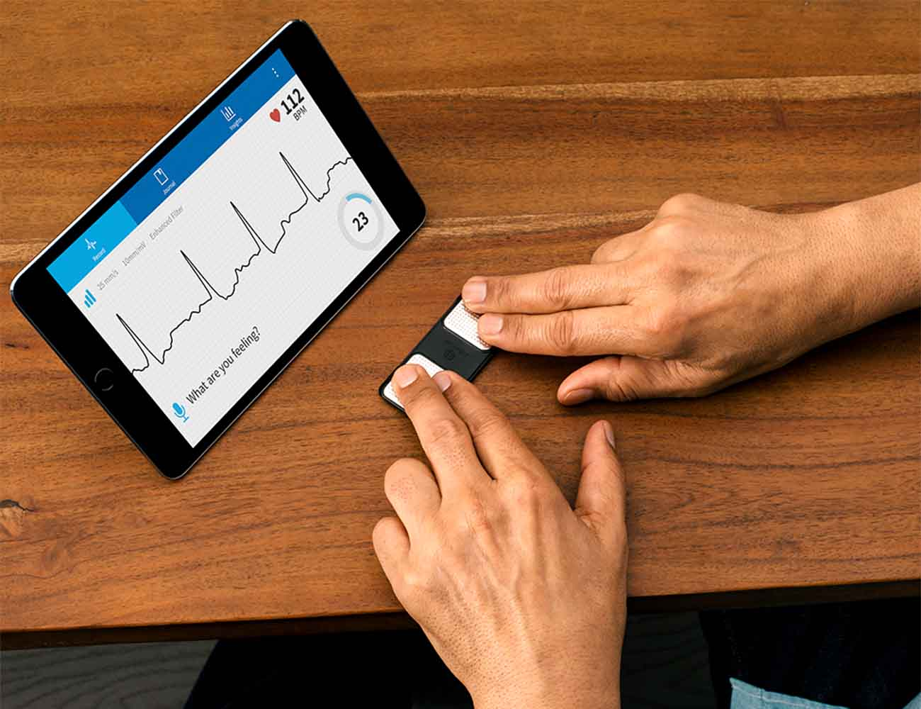 (AliveCor,2025)

Introduction
This report talks about one of the digital heath care innovations which is Kardia Mobile. Patient care has been transformed by the digital transformation of health and social care, with advancements improving accessibility, effectiveness, and personalisation. One such development is the portable electrocardiogram (ECG) gadget Kadia Mobile, which was created by AliveCor and released in 2014 (GOV.UK,2023). Quick single-lead ECGs can be performed at home or on the go with this smartphone-connected device, which sends real-time data to medical professionals for examination. For atrial fibrillation screening, remote cardiac monitoring, and post-discharge care specifically in primary care and cardiology services it has been incorporated into the National Health Service in the United Kingdom (GOV.UK,2023). Kadia Mobile is a prime example of how telemedicine can move care from hospitals to communities by decentralising diagnosis (Mavrgani et al.,2023). Through a critical analysis of its implementation, this evaluation looks at how it has affected patient experiences and perceptions, workforce roles and competencies, service delivery procedures, and wider community effects like location-based access, family involvement, co-production, and public health outcomes (Mavragani et al,.2023). For a fair perspective, both advantages and disadvantages will be considered.

Impact on workforce
Kardia Mobile has introduced remote monitoring capabilities that have changed job responsibilities and necessary competencies, hence transforming workforce dynamics in UK health and social care, especially in primary care and cardiology settings (NIH,2025). On the plus side, it has broadened the range of responsibilities for nurses and general practitioners GPs, allowing them to do rapid triage and preliminary evaluations using ECG data sent by smartphones. Cardiologists can now perform more complex therapies since practice nurses in general practitioner offices, for example, regularly perform atrial fibrillation screenings at home or in clinics, decreasing the need for in-person consultations (NIH,2025). With staff members receiving training in digital health tools, app navigation, and data interpretation, this change has improved role skills and generated a 20 to 30% boost in screening capacity. Technology enables nurses to provide proactive care, such as remotely monitoring patients after discharge, which reduces hospital readmissions and maximises time management (NIH,2025). As a result, nurses report feeling more freedom and job satisfaction. It promotes professional growth and efficiency in day-to-day operations by creating a more collaborative atmosphere where interdisciplinary teams incorporate tech-savvy techniques.
Nonetheless, adverse effects are noticeable, especially regarding inequalities in competency and deskilling. Due to automated readings reduction in the requirement for manual processes, traditional ECG professionals may have less practical experience, which could eventually result in skill atrophy (WHO,2020). Not every employee has the requisite digital literacy, which leads to competency gaps that cause mistakes like incorrect data interpretation that could jeopardise patient safety. In regions with limited resources, such as rural NHS trusts, this makes workload mismatches worse (WHO,2020). Burnout has been reported as a result of handling remote data inflows without enough staffing or assistance. Adoption resistance or increased attrition may result from junior employees or individuals who are reluctant to change feeling overburdened. The technology also necessitates constant upskilling, which puts a strain on training funds and time and may increase disparities between tech-savvy metropolitan teams and resource poor rural ones (WHO,2020). Although these difficulties empower many, they also show how important it is to have fair training programs so that all employees may adjust well and continue to provide high-quality service.

Impact on service delivery
Kardia Mobiles transition from traditional hospital-based diagnostics to more decentralised, patient-centered models has significantly changed the way health and social care services are delivered on a daily basis (Digital Health London,2016). One benefit is that it allows patients to perform electrocardiograms (ECGs) remotely or at home, sending the data right away to doctors through smartphone apps. This enables medical professionals to act quickly by accelerating diagnosis, such as identifying atrial fibrillation in minutes as opposed to days. It frees up resources in crowded GP offices and emergency rooms by cutting the number of outpatient sessions in primary care settings by up to 15%. With nurses and physicians using the data for prompt triage, services are now better able to prioritise urgent cases, which results in more efficient workflows and quicker treatment plans (Digital Health London, 2016). All things considered; by reducing needless hospital stays and incorporating remote monitoring into standard care, this invention increases efficiency.
However, drawbacks include the possibility of service interruptions due to technical problems, such as malfunctioning apps or inadequate internet access in remote locations, which can postpone urgent medical attention (Digital Health London,2016). Increases in false positives frequently lead to needless follow-ups, which puts additional strain on already scarce resources and creates administrative headaches (Digital Health London,2016). Inconsistent integration with current electronic health record systems can also result in data silos, which can cause inefficiencies like lost or duplicate information. These difficulties show how important it is to have a strong infrastructure in order to guarantee consistent service continuity.

Impact on patients
Positive Results: By enabling people to actively participate in their own health management, Kadia Mobile greatly improves patient perceptions and experiences. Electrocardiograms (ECGs) can be performed at home, which is convenient and lessens the need for frequent hospital visits (NHS,2020). This is especially advantageous for elderly or immobile patients who might otherwise have mobility issues. Self-monitoring helps people feel more in control and less anxious since it provides prompt input on conditions like atrial fibrillation, which enables prompt intervention or reassurance (NHS,2020). Many patients express a greater sense of involvement in their care, valuing the technology's accessibility and personalisation, which is in line with contemporary demands for responsive healthcare.
Negative Effects: On the other hand, technological advancements may have a detrimental impact on the lives of people with impairments or low levels of digital literacy. This could lead to dissatisfaction with the device or app, which could lead to false readings and a failure to follow monitoring procedures (DHSC,2018). Sharing private health information through apps gives rise to privacy issues and data breaches that could undermine system confidence. Technical issues or device malfunctions might prolong care, increasing anxiety and dissatisfaction (DHSC,2018). Additionally, patients in underprivileged or rural locations might not have access to dependable internet or the financial resources to acquire the equipment, which results in unequal access and lower opinions of the quality of care. Ultimately, even if it empowers some, it runs the danger of alienating vulnerable groups and making their healthcare journey more difficult.

Impact on community
By encouraging broader engagement and decentralising services, Kadia Mobile has had a considerable impact on community level health and social care, both positively and negatively. By shifting diagnostics from centralised hospitals or clinics to more accessible, daily settings, it has the positive effect of changing the locations of patients and services (BHF,2020). Electrocardiograms (ECGs) can now be performed at home, at neighbourhood pharmacies, or at community health events, removing the need for patients to travel long distances to urban medical facilities. In isolated areas of the UK, such the Scottish Highlands or rural English communities, where access to cardiac care was previously restricted by transportation hurdles, this is particularly beneficial. Elderly or disabled people can obtain timely monitoring without interfering with their daily life because to the logistical problems that are lessened when services are brought closer to their homes (BHF,2020). By making it possible to test for atrial fibrillation widely, this change helps to identify risks early and prevent complications like strokes, which promotes public health goals. As screenings are incorporated into neighbourhood gatherings, community programs have seen increased participation, encouraged preventative care and possibly reduced overall healthcare expenditures by reducing emergency room visits.
Family members are profoundly impacted and frequently take on important roles in the care process. In order to improve co-production, the collaborative effort of patients, families, and physicians in managing health they might help with device operation, app navigation, or result interpretation. In line with social care goals of inclusivity, this cooperative method fortifies family ties and gives families the authority to take charge of health decisions (BHF.2020). To promote intergenerational support and lessen feelings of loneliness in ageing populations, adult children should, for instance, keep an eye on their parent’s readings. As families exchange information and promote screenings among neighbours, this improves public health on a larger scale by promoting healthier behaviours and community-wide awareness.
On the other hand, adverse effects manifest in communal settings. In metropolitan or densely populated places without strong family networks, the move of services to homes may increase loneliness by separating patients from traditional communal health hubs, where peer support and social contacts are widespread. In multigenerational households, family members may experience excessive stress, be unskilled carers, and balance this with their own obligations, which can result in burnout or broken relationships (BHF,2020). Families with limited digital abilities, time, or resources find it difficult to fully participate in co-production, which exacerbates social divides and makes it unfair. When screenings exclude underserved populations, such as those living in underprivileged areas with limited access to smartphones or the internet, public health initiatives suffer, and health disparities are maintained. Furthermore, placing too much focus on self-monitoring could deter professional consultations in the community, postponing remedies for problems that have not yet been identified (BHF,2020). Technical malfunctions could further marginalise communities and impede equitable access in areas with poor infrastructure. Strategies must address these differences in order to maximise benefits and guarantee that Kadia Mobile improves community health without creating new gaps.

Conclusion
With its smartphone-integrated portable ECG gadget, Kadia Mobile is a game-changing digital breakthrough in UK health and social care that is transforming cardiac care. It has effectively moved diagnostics from hospital-centric methods to patient-empowered, community-oriented techniques within the NHS since it was adopted ten years ago (NHS. Digital,2019).
Significantly positive outcomes are revealed by the critical evaluation: communities benefit from decentralised services, which promote public health through accessible screenings, family involvement in co-production, and reduced travel burdens, patients gain empowerment, experiencing greater convenience and control over their health, which boosts satisfaction and engagement, and workforce roles have expanded, with nurses and general practitioners improving competencies in remote monitoring and triage, leading to more efficient operations, and service delivery has improved, reducing outpatient visits and enabling quicker interventions for conditions like atrial fibrillation (NICE,2023). However, there are certain issues with the implementation that need to be addressed. Community impacts highlight potential isolation, family burdens, and inequities that widen health gaps, patients may face barriers related to digital literacy, privacy, and access disparities, and workforce challenges include risks of deskilling and burnout in settings with limited resources, and service delivery may be plagued by technical difficulties and data integration issues (NICE,2023). These drawbacks highlight how crucial it is to close the digital gap in order to guarantee benefits are distributed fairly (NICE,2023). Kadia Mobile is essentially a prime example of how digital health may improve care quality and accessibility, meeting the expectations of contemporary healthcare for efficiency and personalisation (NICE,2023). To realise its full potential, though, preventative steps like thorough training, inclusive infrastructure, and moral data practices are needed to reduce dangers and advance equity. Innovations such as these must be prioritised as health and social care change.

References

British Heart Foundation (2020) Atrial Fibrillation Screening: The Role of Digital Tools. London: British Heart Foundation.
Available at: https://bjcardio.co.uk/2025/03/screening-for-atrial-fibrillation-a-narrative-review/
Accesses: 27th October 2025

Department of Health and Social Care (2018) NHS Long Term Plan. London: HM Government.
Available at: https://www.gov.uk/government/news/nhs-long-term-plan-launched
Accesses: 20th October 2025

Digital Health London, (2016) Challenges affecting the delivery of care
Available at: https://digitalhealth.london/alivecor-kardia
Accesses: 10th November 2025

KardiaMobile, (2025) Take an EKG anytime, anywhere
Available at:https://kardia.com/products/kardiamobile?srsltid=AfmBOor7icC3jbe5XIMXwrfo0K4hrHxOBIQZYXsd5ZUCNdeYMZHZZavG
Accesses: 11th November 2025

NIH, (2025) Kadia Mobile 6L for measuring QT interval in people having antipsychotic medication to inform early value assessment: a systematic review.
Available at: https://www.ncbi.nlm.nih.gov/books/NBK602310/
Accesses: 10th November 2025

NICE, (2023) KardiaMobile for detecting atrial fibrillation
Available at: https://www.nice.org.uk/guidance/mtg64/chapter/3-Evidence
Accesses:10th November 2025

NHS England (2022) Digital Health and Care Strategy. London: NHS England.
Available at: https://www.england.nhs.uk/patient-safety/patient-safety-systems/digital-clinical-safety-strategy/
Accesses: 20th October 2025

NHS Digital (2019) Evaluation of Kadia Mobile in Atrial Fibrillation Screening Pilots. Leeds: NHS Digital.
Available at: https://www.nice.org.uk/guidance/mtg64/resources/kardiamobile-for-detecting-atrial-fibrillation-pdf-64372176710341
Accesses: 23rd October 2025

Mavragani et al. (2023) Diagnostic Accuracy of Single-Lead Electrocardiograms Using the Kardia Mobile App and the Apple Watch 4: Validation Study
Available at: https://pmc.ncbi.nlm.nih.gov/articles/PMC10704323/
Accesses: 10th November 20225

World Health Organization (2020) Digital Health for the Sustainable Development Goals.
Available at: https://www.who.int/publications/b/53778
Accesses: 20th October 2025

