
Assignment 2:
Operating Systems
CertHE Computing Skills for Workplace

Computer Architecture and Operating Systems. ACCA4022_LON
DR. Redhwan Al-Amri (Lecturer)
University of Wales Trinity Saint David
(London Campus)
Student Name: Joseph E Okonkwo
Student Number:2351465
Group: 01
Date: 12/08/2026

Table of Contents
Introduction 1
1. Key functions of general Operating Systems 1
Systems 1
1.1 Process and Processor Management 1
1.2 Memory Management 3
1.3 File System Management 4
1.4 Security and Protection 5
2. Use of Windows OS CLI commands. 7
3. Use of Linux OS CLI commands. 15
4. Use of Windows OS scripts. 20
Script: System Health Check 20
Key Features Demonstrated 22
5. Use of Linux OS scripts. 23
Script: Log File Analyzer 23
Key Features Demonstrated 25
Conclusion 26
References 27
Appendices 29
Tutorial Activity on OS Types from OS Tutorial 1 29
1. LinkedIn Learning course: 29
2. Cisco Network Academy: 30
3. Cisco Network Academy : Operating Systems Basics 32

Introduction
For this report I will discuss the OS (operating system) for windows 11. I will show examples of the OS and its functions such as managing software and hardware or how it may manage devices and store data. An OS allows users to view data and get information to better understand the status of its CPU (central processing unit), RAM (Random-access memory) or GPU (Graphics processing unit) usage and more. The OS software will give users an overview of the software programs and their usages status and hardware and overall computer architecture. Task Manager gives you real-time information about your computer and control over applications such as troubleshooting applications or force stop without having to re-start your whole computer.

1. Key functions of general Operating Systems

1.1 Process and Processor Management

The processor management system can be found in “Task Manager” this is a software interface that allows users to get visual and detailed representations of information about applications that are being used.
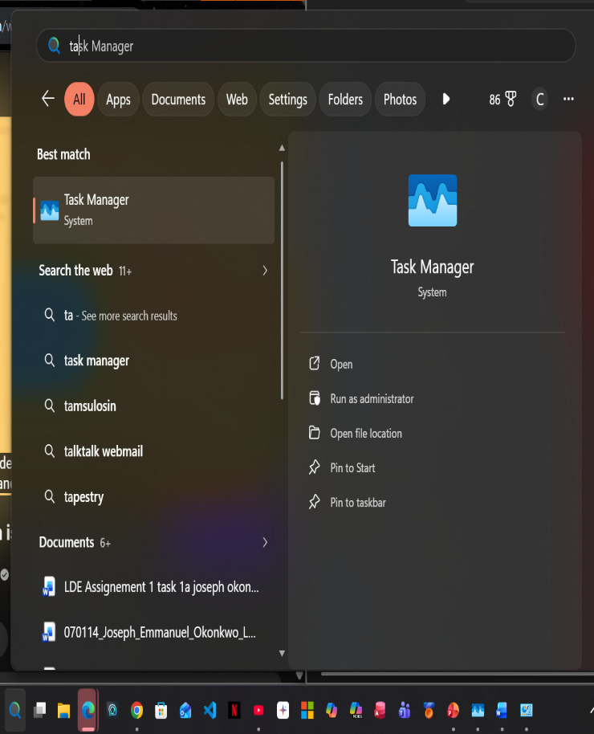
Figure: search for Task Manager in search bar.

CPU, RAM, DISK AND NETWORK

Because an OS (Operating system) can display or run multiple applications simultaneously, therefore the CPU (Central Processing Unit) will then need to process data and supply each application with enough power to complete its function. RAM (Random Access Memory) is also displayed to show how much memory is being used by each application, this allows users to move between multiple applications more freely and can input and output data at the same time. RAM may increase along with CPU depending on how many applications or the type of application that is being used this is because if a user was streaming a game that required high graphic resolution this will require more data than the average YouTube video.

“Disk” is the reading and writing of data such as downloads or watching movies and will represent the computer’s hard drive, HDD (Hard Disk Drive) or SDD (Solid State Drive) which is the data storage device and is “non-volatile” and can write, store and retain data for long periods of time when the computer is turned off, unlike RAM which is “volatile” and will data once the computer is turned off.

“Network” is the network performance and will give real-time statistics and will give an overview of each applications usage. This is the data usage from your network data and may change from different network/internet providers, but each application requires a certain amount of data to function.

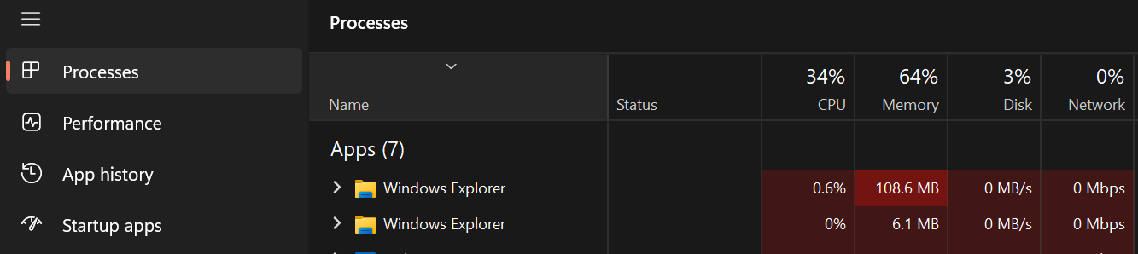
Figure: Usage is measured/calculated in percentage, 100% would mean maximum capacity in regard of CPU. MB (megabytes) for memory, MB/s (megabyte speed) for disk and Mbps (megabytes per second) for network.

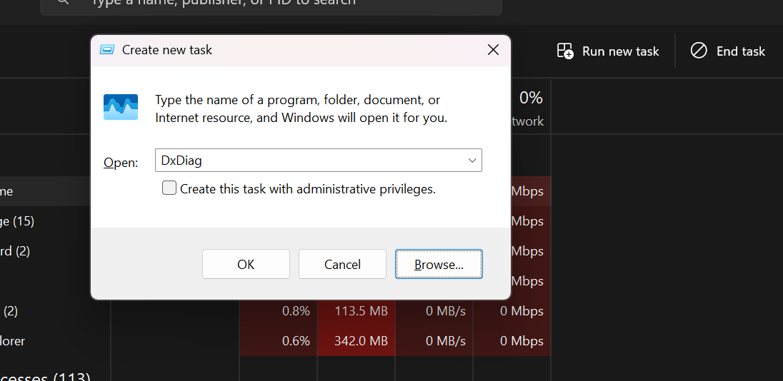
Figure: New tasks can be open or from file explorer.

Performance function can also give more insight into overall usage of each task component users are able to see how much power and data is being used, with a real-time animated graph that will help indicate usage. 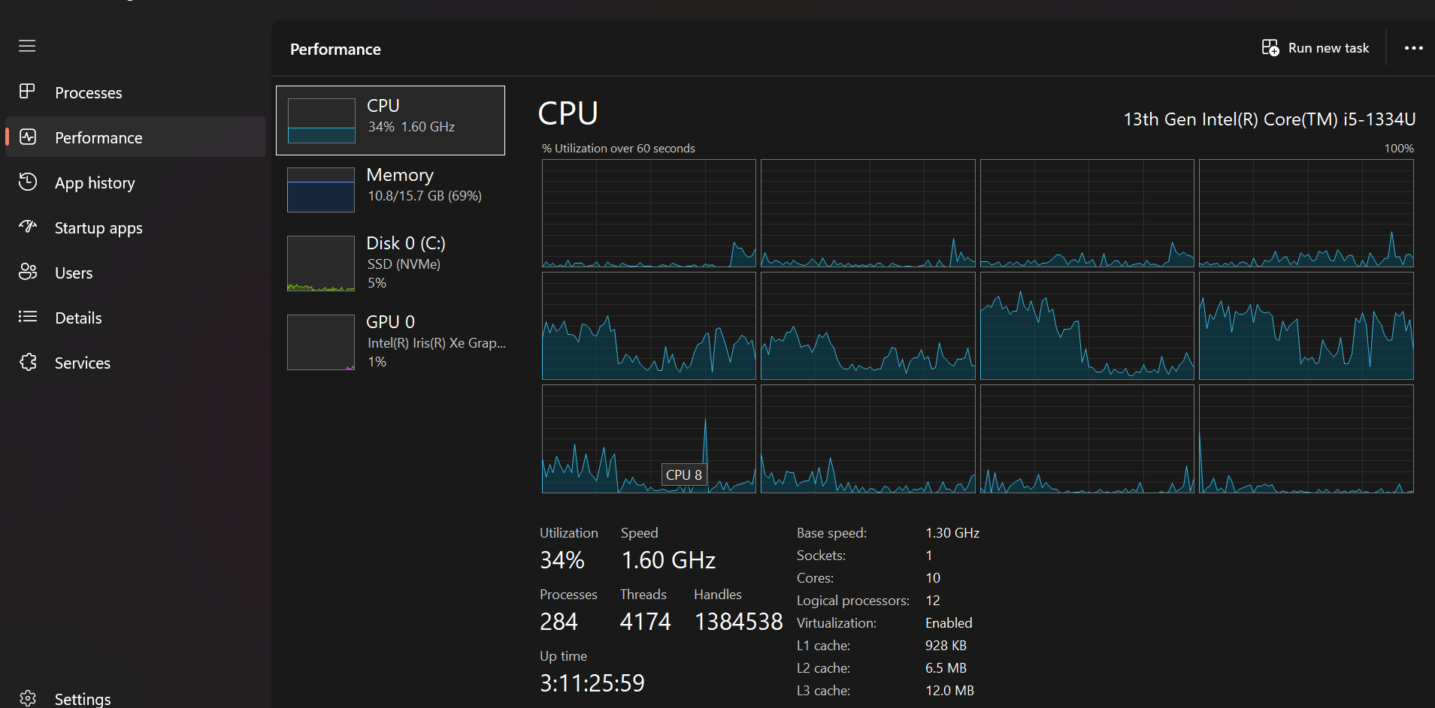
Figure: In performance users may see the overall status as the CPU is calculating and allocating data to each application. Here within the boxes are the usage lines, the higher the line the more the CPU is being used.[1]

The CPU performance show a more in-depth look at how this central processing unit is performing and provides information of such as GHz (Giga hertz) with clock speeds of 1.6 billion “clocks” per second. With details of location of the socket and cache calculations and other specs are visible.

1.2 Memory Management
Task manager also shows real-time memory usage and gives overall Insite this gives users a clear visual of how much RAM (random access memory) is being used by applications that are currently running and being used and running in the background. Because RAM is volatile memory may be lost when the device is turned off, RAM acts as a buffer for the HDD and allows the CPU to process data without having to wait on the disk memory to write or read data. RAM allows your computer to respond quicker due to its higher frequency than disk and allows files to be saved faster but temporarily, RAM comes in several sizes 4GB,8GB,16GB,32GB and 64GB.
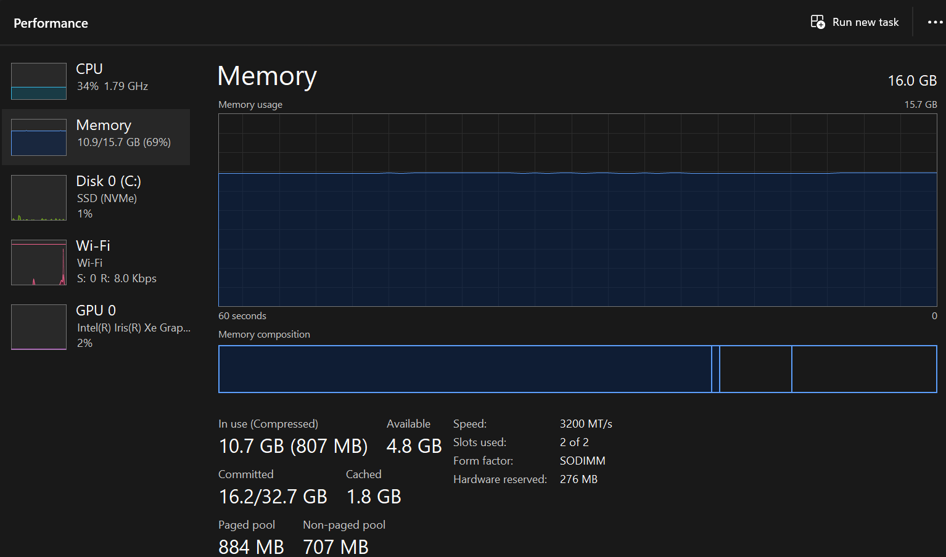
Figure: This is the task manager memory the line indicates how much is being used memory usage is every 60 second increments. Memory composition is actual memory being used.[2]

1.3 File System Management

In windows file explorer is an interface that allows users to manage all files that have been saved in the device videos, PDF, images and documents can be organized into folders. This is where you can also download files to USB or other devices and this software interface allows a more visual aspect to managing files.[3]
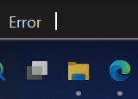
The file icon indicates the application that will hold saved files.

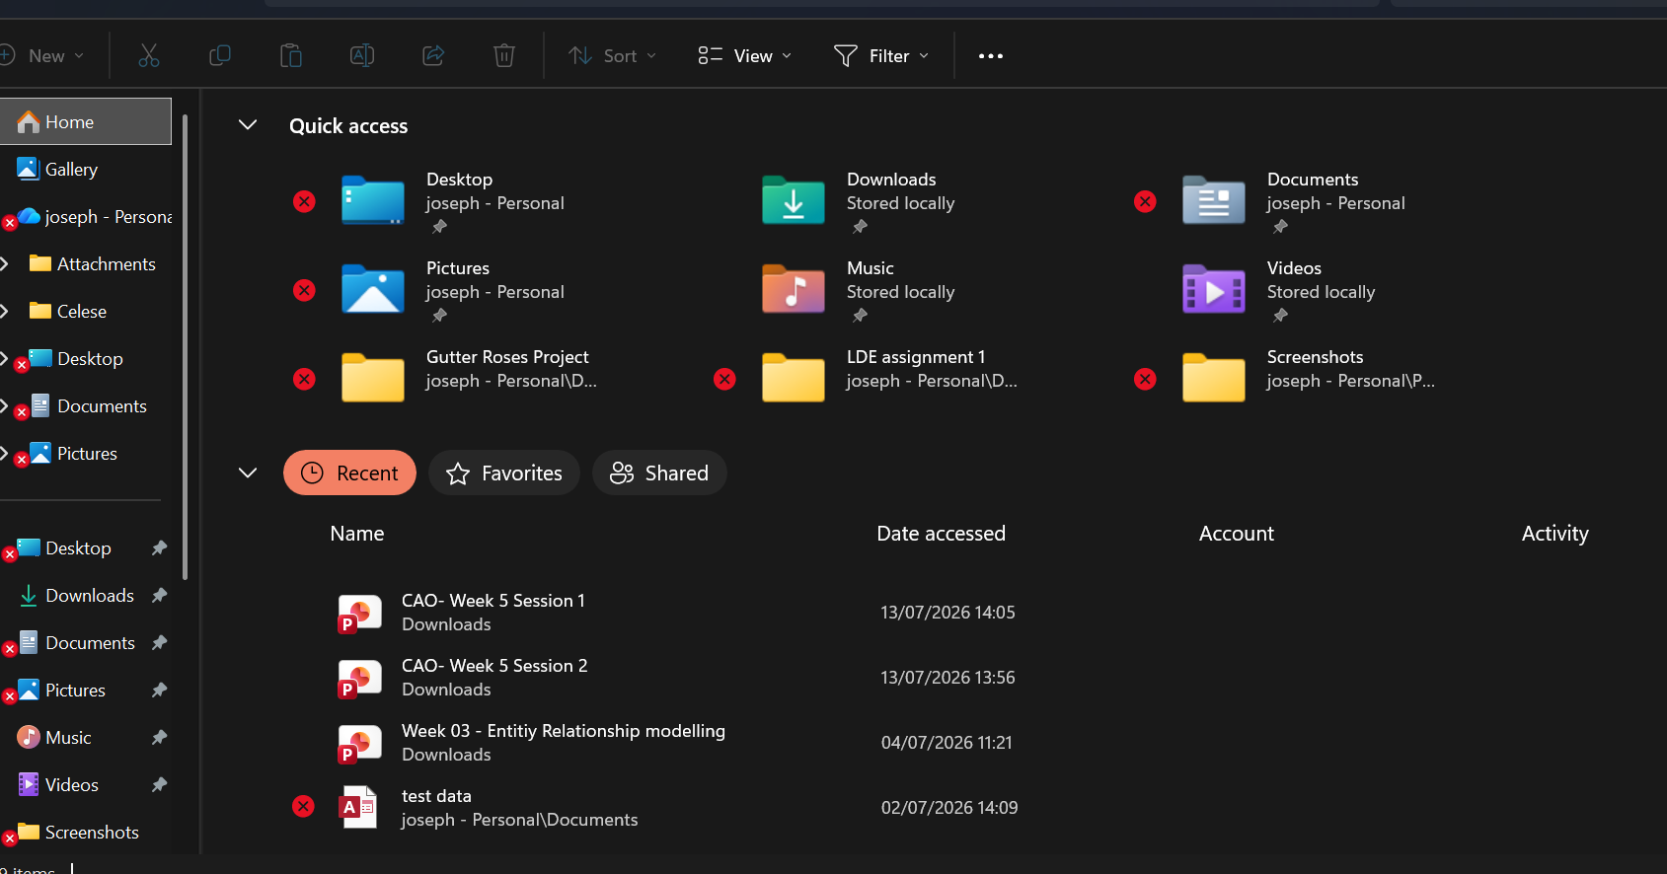
This is the main interface of file manager

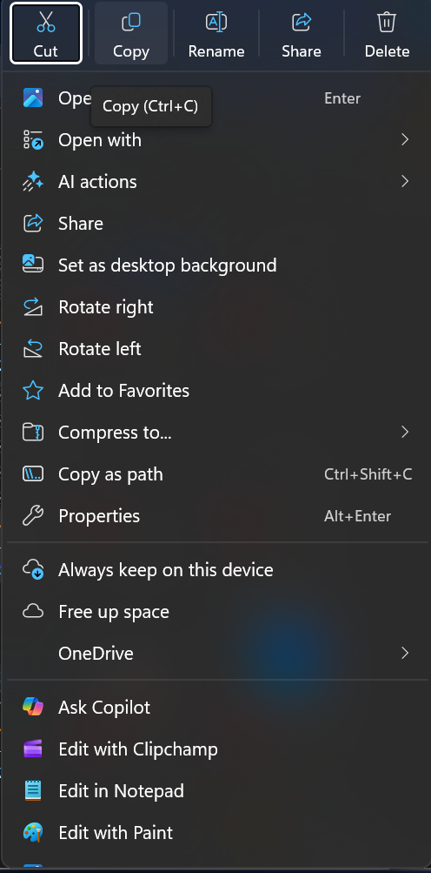
To right click on a files, give various options
When managing a file, you have many options that may help with organizing users can copy files and this is useful when creating duplicate copies of a file such as images and documents. You may rename share and delete from this drop list; you can also open files in different applications.

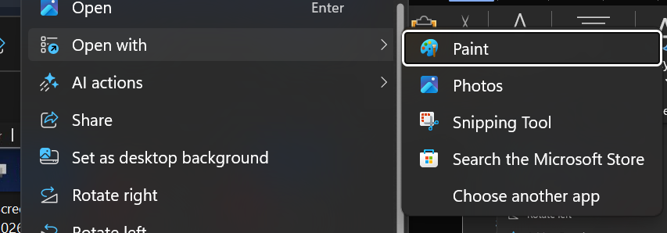
Open with allows files to be open within other applications
For example if you have a photo or a video that you would like to edit you can select what editor you wish to use just by having the application on your device and open the file directly from the file manager to the chosen application. This feature may not only save time but is a great way to give a more accurate and visual when choosing a file to edit.
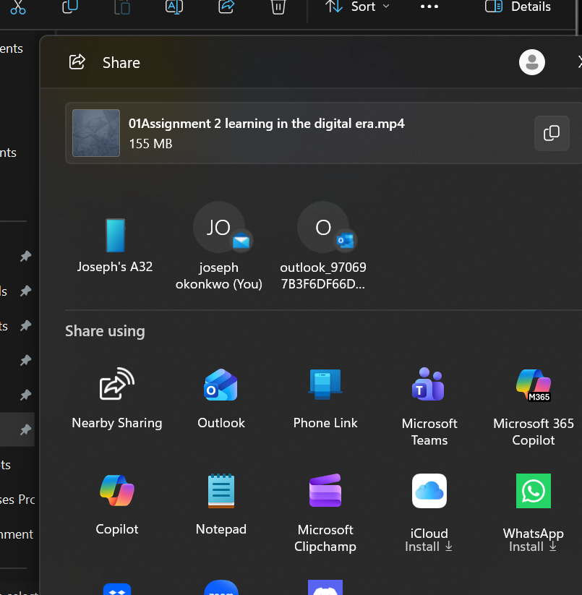
Share files from file explorer

You will be able to share files using the application interface by right clicking on a file or folder this makes it easier and quicker but will also give users a collection of all the applications that may be stored in the device that gives the option to send information.[4]

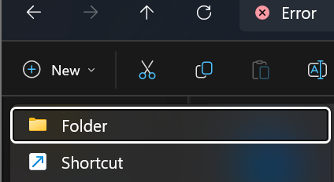
Creating new folders
When organizing files you can easily create folders to give a more manageable

1.4 Security and Protection

For Microsoft windows several steps have been taken to ensure the protection of the device this then allow further insight in the setting option. This OS has focuses on several aspects of the device security using a clear and easy to understand interface.

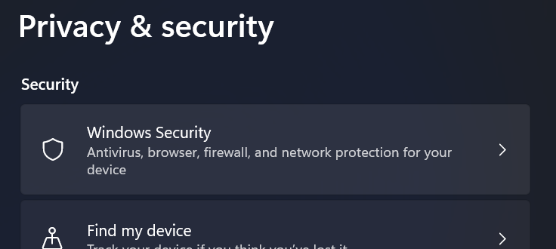
Screenshots of pre-installed security software programs

Windows security allows privacy and security for the device hardware and software to ensure safety from outside threats or untrusted sources.[5]
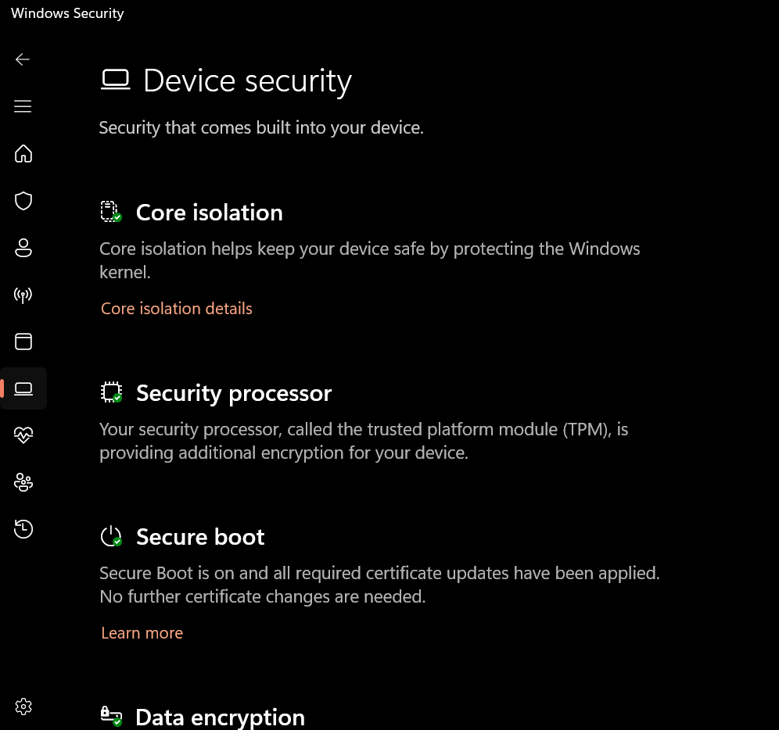
“Figure” device security

Windows core isolation is an isolation of core processors this security feature will help protect the device from malicious software. When you try to download and application to your device it provides a layer of protection by first analyzing the application to the core isolator to check for any malware or code that may harm the device. Then will allow the device to download the application or program. This is a great feature as most applications are downloaded from the internet.[6]
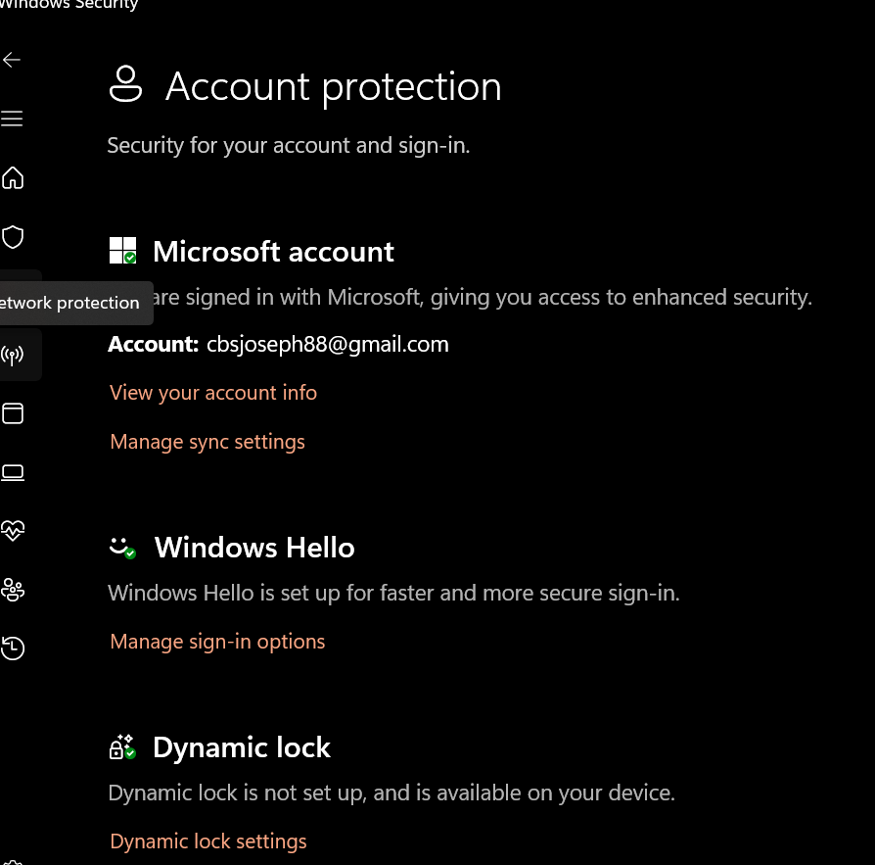
“Figure” account protection

Windows Hello is a more secure and personal way to access your account by using digit pins, facial recognition and fingerprints known as bio metric security. Because a user’s face or fingerprint is so personal and this makes it a great way to access an account as it uses unique attribute that makes it hard to replicate. Using a fingerprint makes this security feature perfect as you always have your fingerprint with you and it’s not something you can typically lose or forget. This feature means you must be present and can’t be stolen or replicated as easily.

2. Use of Windows OS CLI commands

• Process management
Task list
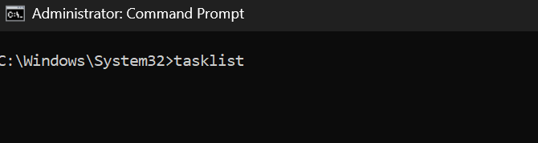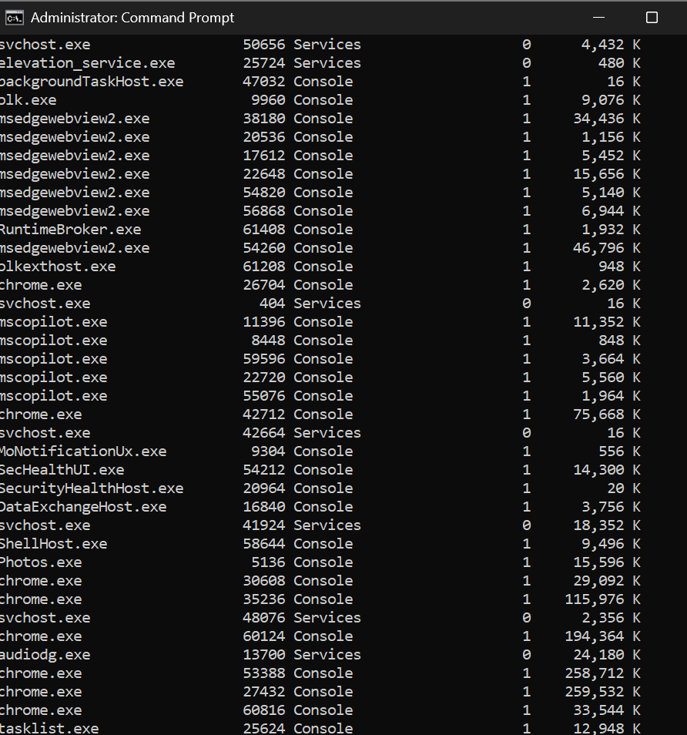
“figure” of cmd

Task list allows users to navigate task manager and will give all applications that may be currently running.[7]

Task kill
“figure” of cmd

Applications can be kill/stopped by using command prompt task>kill /im (name of application).exe.

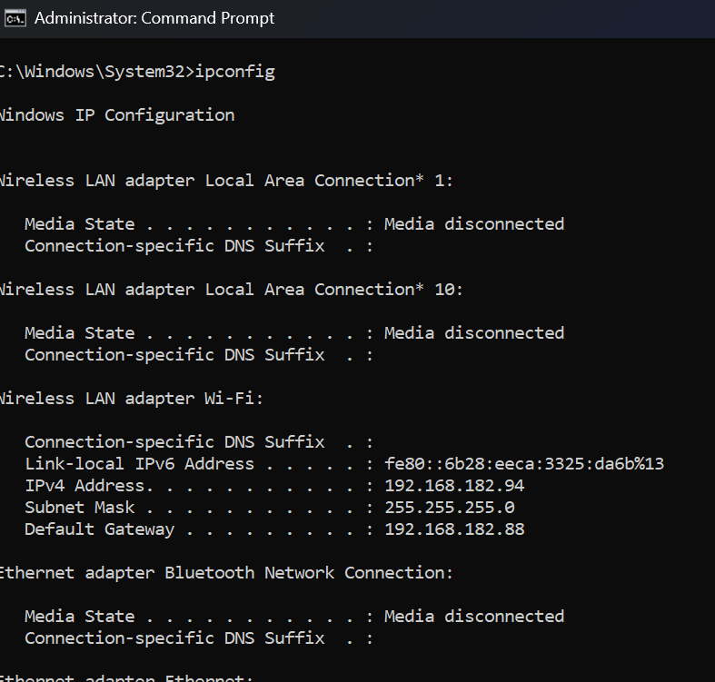
“figure” of cmd

Ipconfig allows users to see all network details such as IPv4 Address.[8]

• Network testing/monitoring

Ipconfig /all
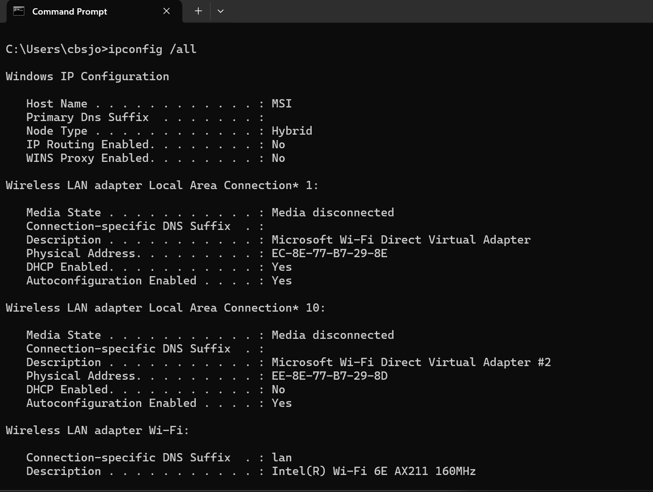
“figure” of cmd

Ipconfig /all allows you to see all network connections and adaptors e.g. Bluetooth, LAN and ethernet.[9]

System info
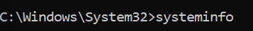

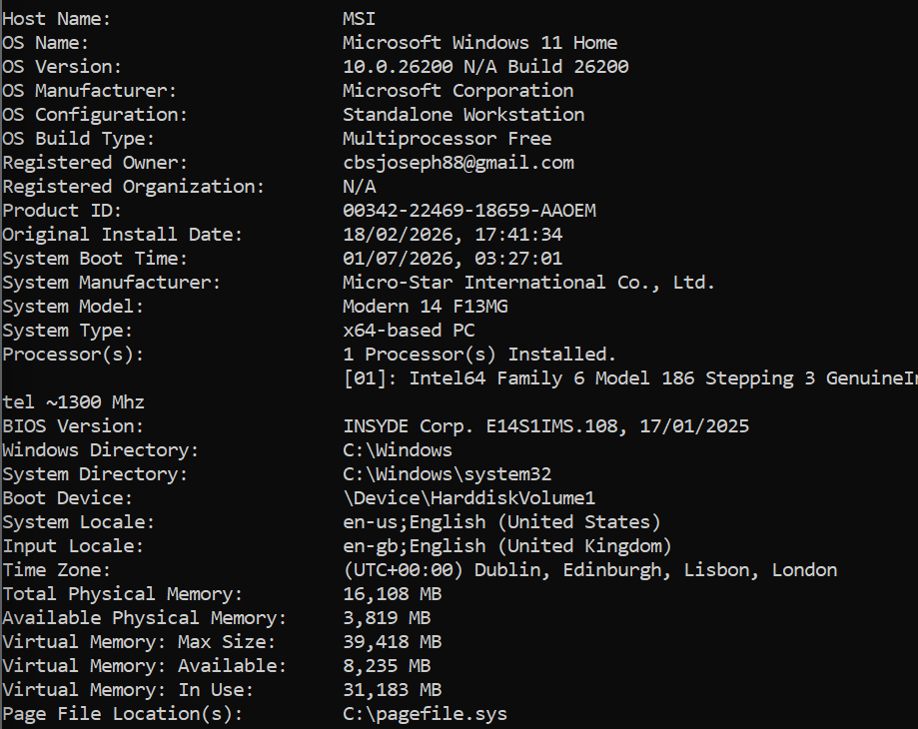
“figure” of cmd

System info cmd allows you to see full details about the OS such as the OS version, OS name, processor and memory details.

• File & directory management
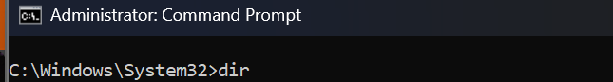

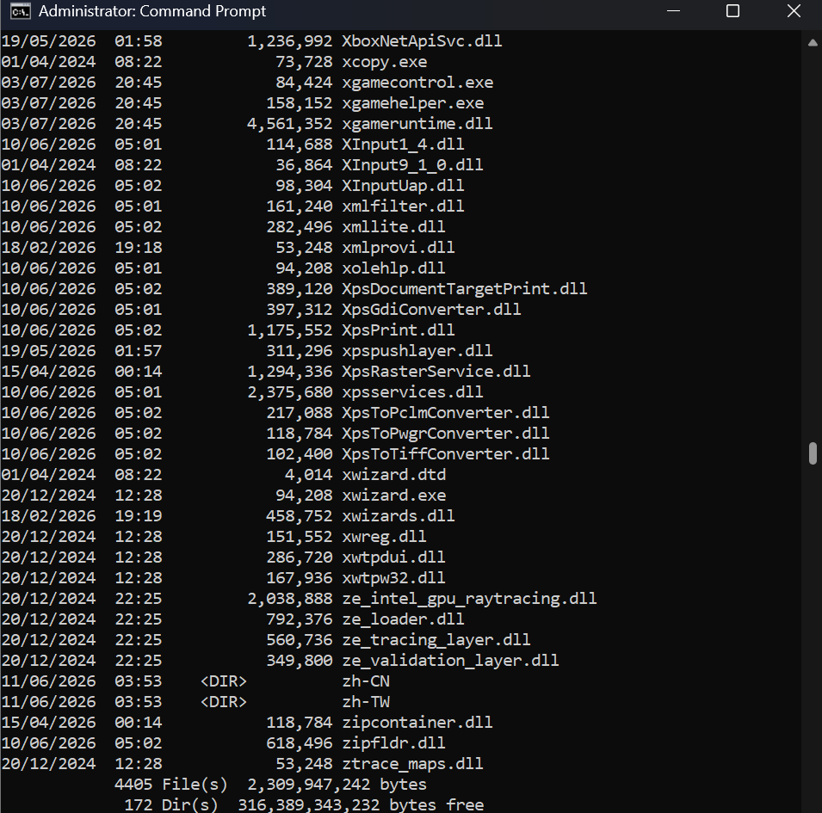
“figure” of cmd

The dir cmd allows you to see a list of all files and subfolders within the system but is just text based.

dir /b
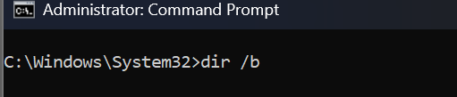
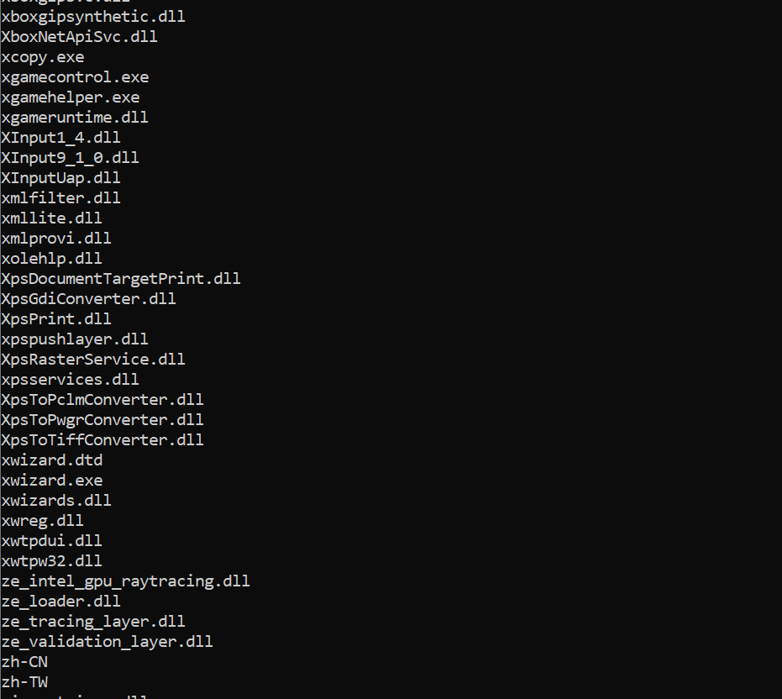
“figure” of cmd

The dir /b just provides a list of the file names.

Dir /b /s

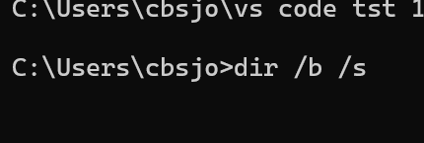
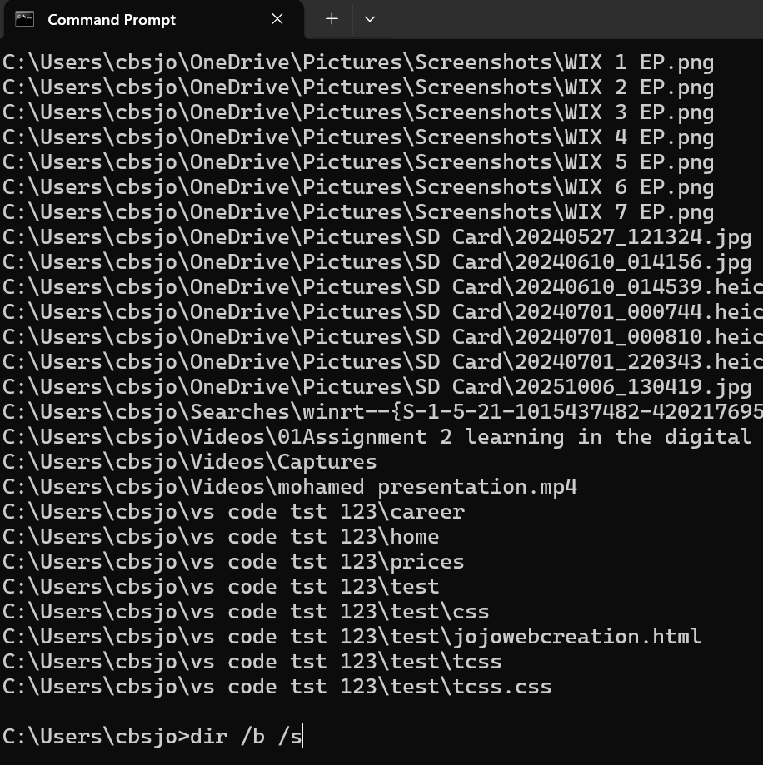
“figure” of cmd

The dir /b /s will allow all files and the pathways to the file to be displayed.

• User management

Net users
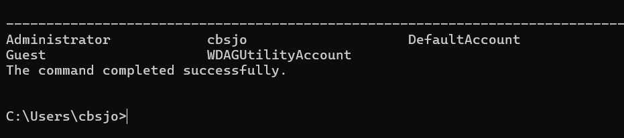
“figure” of cmd

The net users command allows you to see all user account on the device.

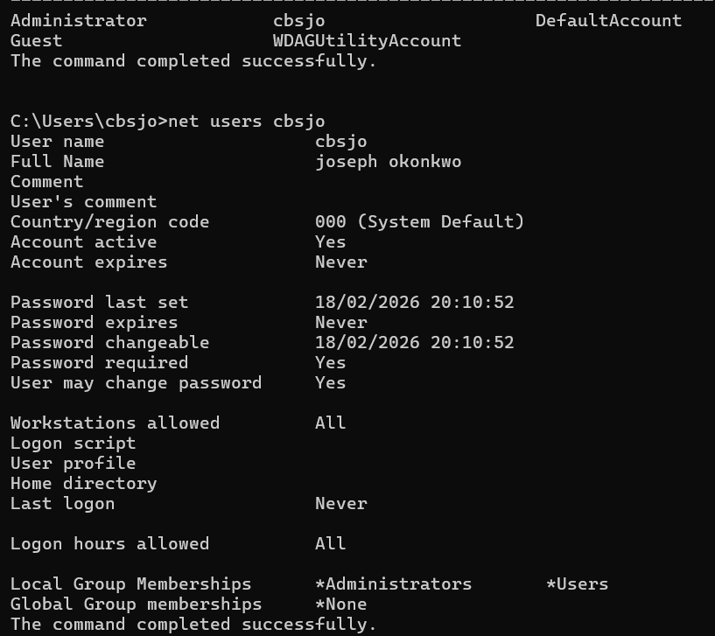
“figure” of cmd

The net users [account name] will give more detail regarding the account.

• Task scheduling.

Creating a task
“figure” of cmd

You can schedule application or scripts to boot automatically this “schtasks /create” command allows you to start programs automatically.

Delete a task
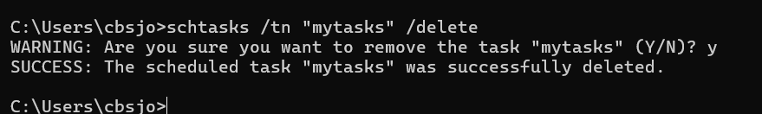
“figure” of cmd

The “schtasks /tn [task name] /delete” will allow you to delete the task and shows warning for the deletion
Y = yes N = no if yes success message will appear.

3. Use of Linux OS CLI commands.

Find files
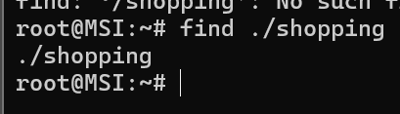
“figure” of linux cmd

The “find ./filename”[10]

List files
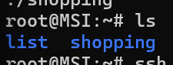
“figure” of linux cmd

The “ls” command will list all files in your directory.[11]

Create a file
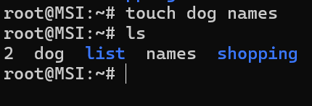
“figure” of linux cmd

The “touch” command will allow you to create a file.[12]

Add to file
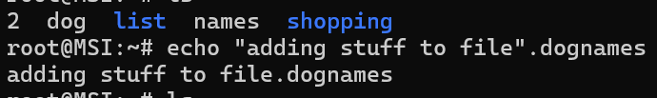
“figure” of linux cmd

The echo command allow you to add to file by using “echo [“your text”]> [file name]” this will then add text to a file.

Trace route
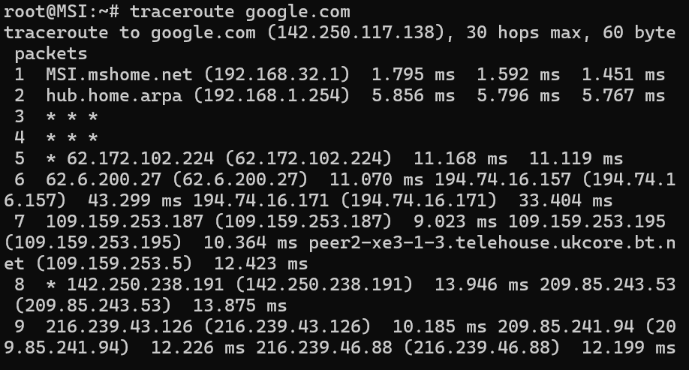
“figure” of linux cmd

The “traceroute” command will allow you to see the path you take to get to a particular website.

Ping
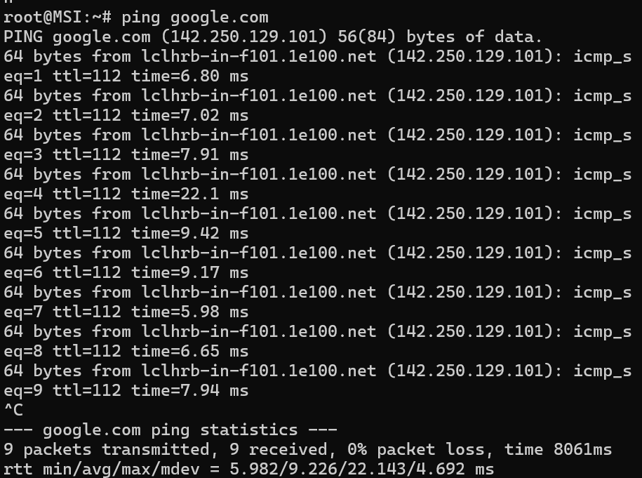

Check the ping of a website by entering “ping [websitename/webaddress]” and ctrl+c to stop pings.

Socket statistics
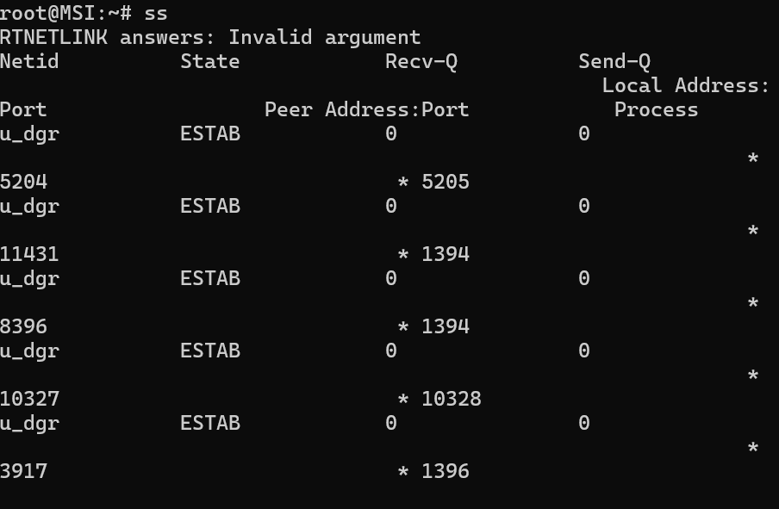
“figure” of linux cmd

The command “ss” allows you to get information of connection and packets of data.

System information
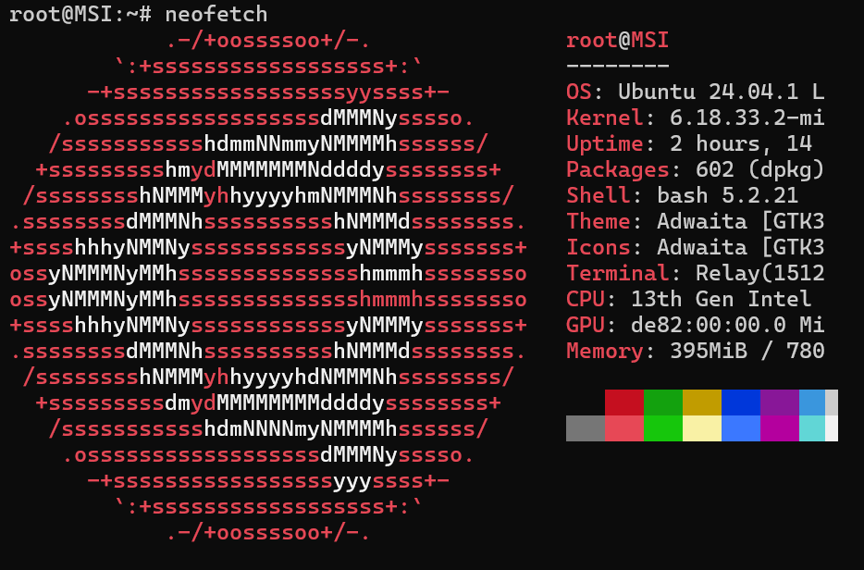
“figure” of linux cmd

For system information you can use the command “neofetch”.

Calculator

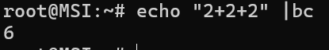
“figure” of linux cmd

To solve equations, enter command “echo [your equation] |bc”.

Check memory

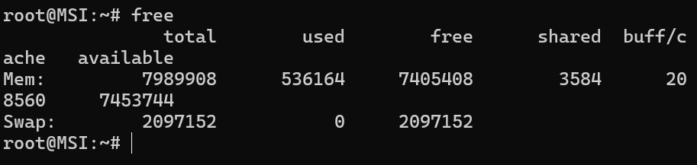
“figure” of linux cmd

To check on available memory enter command “free”.

4. Use of Windows OS scripts.

Deleting files

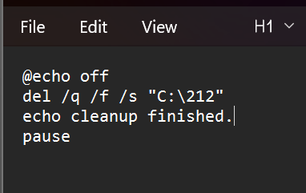
Figure notepad script

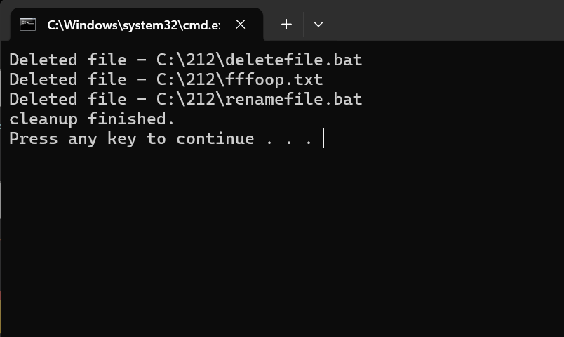
“figure” cmd

You are able to create scripts for deleting files.

Website search

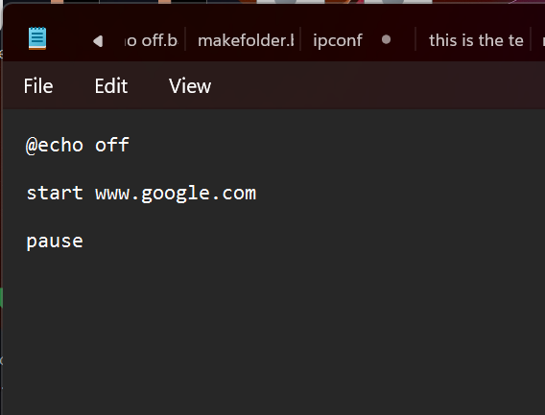
“Figure” notepad script


“figure” webpage

This script can be used for any we address and opens page directly from desktop.

colour
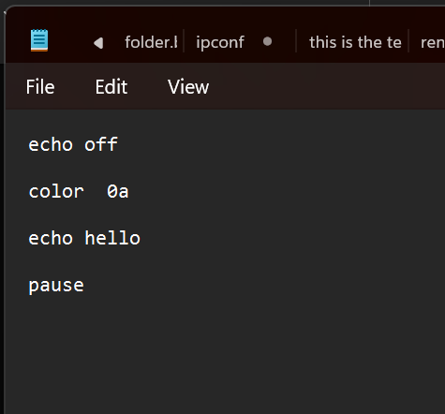
“Figure” notepad script
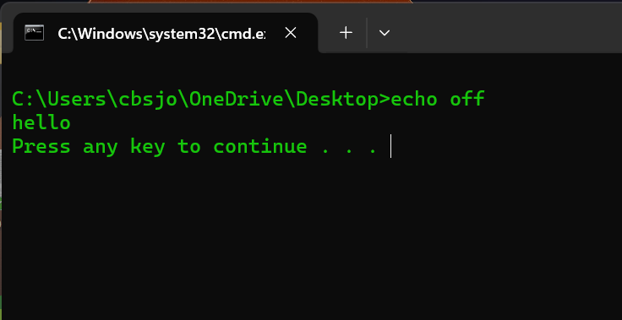
“figure” cmd
The terminal is customizable as you have several colors to choose from using command “color /?”
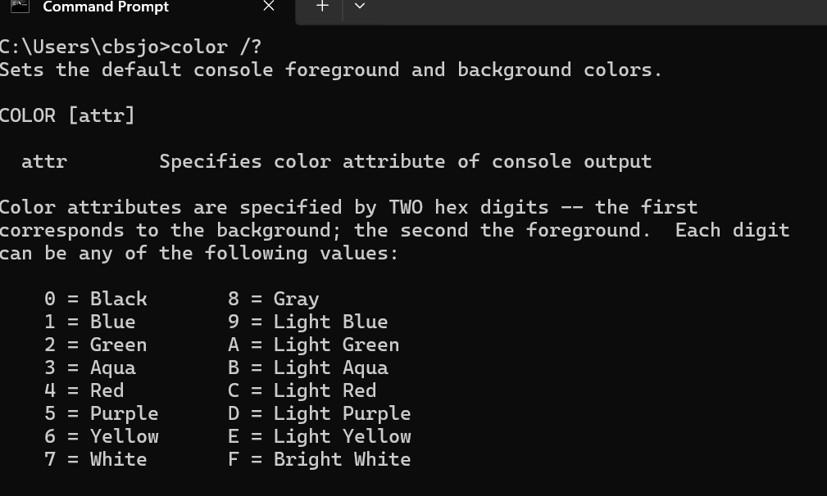
“figure” list of colors.

Loop
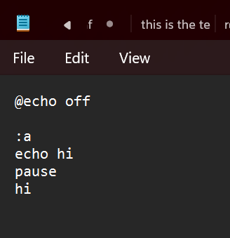
“figure” notepad script
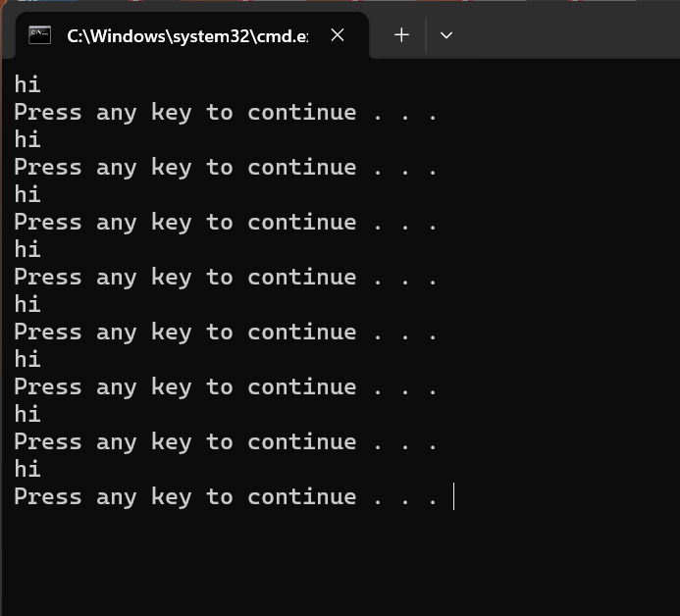
“figure” cmd
This loop script will repeat a message every time you press enter.[13]

Constant loop
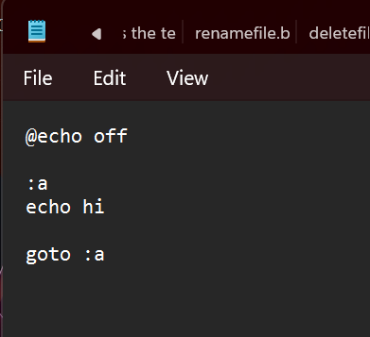
“figure” notepad script
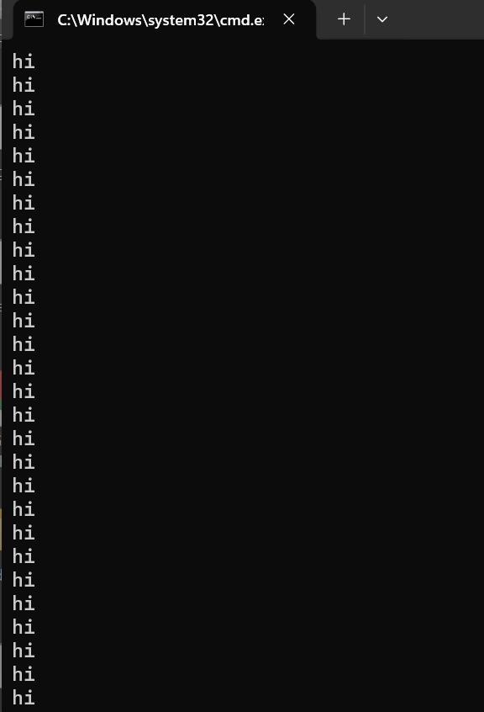
“figure” cmd

This script is similar to the loop but by removing “pause” from the script you get a continuous stream of repeated message/data.

User input
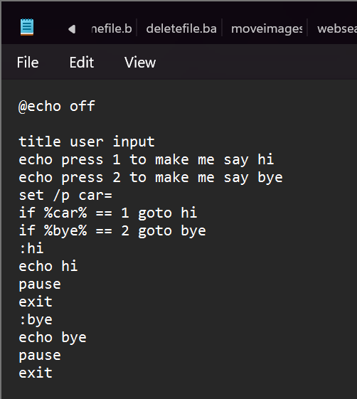
“figure” notepad

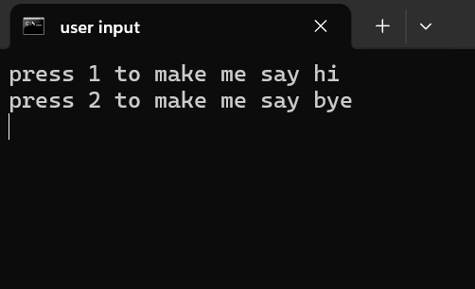
“figure” cmd
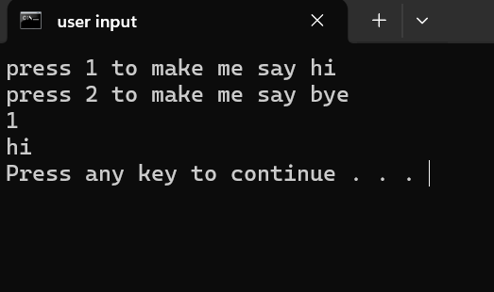
“cmd”

This command script allows users to interact with the script and script writers can give options or ask questions.[14]

Director

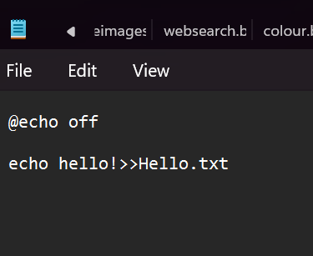
“figure” notepad
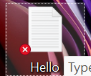
“figure” txt file is found on desktop.

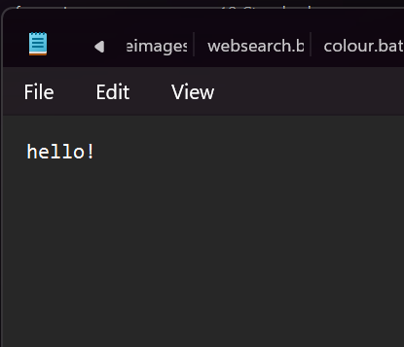
“Figure” text file has been created.

Allows you to create a txt file from script.

Delete text file

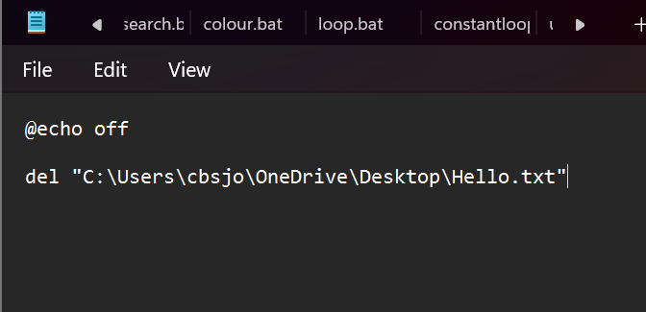
“figure” notepad script

This command will delete the text file just created.

Rename
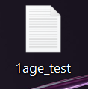
“figure” file name I will change

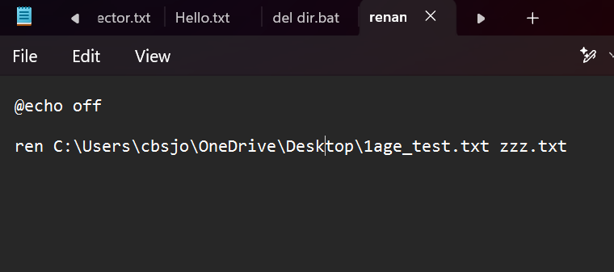
“notepad” script
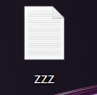
“Figure”

By running this script, I was able to change the name of the file.

IF

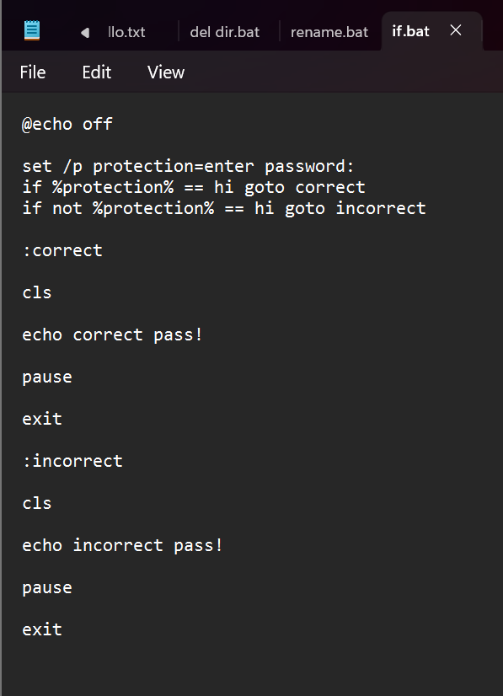
“Figure” notepad script

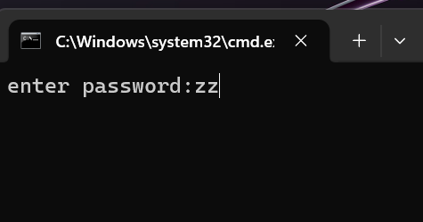
“figure” I have set password as “hi” if not hi then password is incorrect.

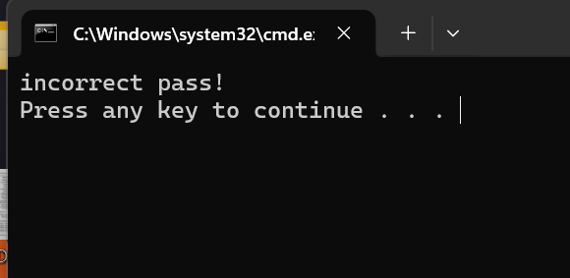
“figure” password was incorrect.

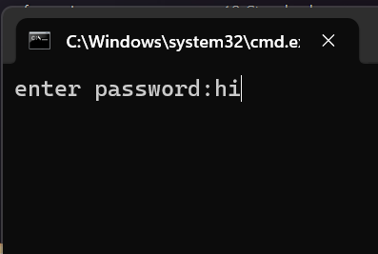
“figure” “hi” was entered

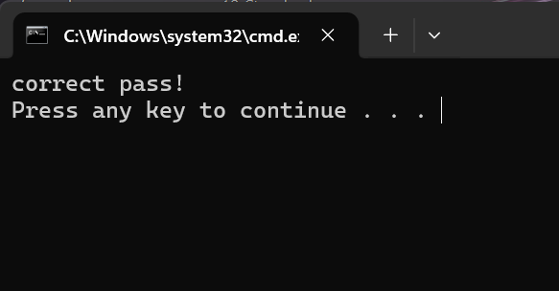
“figure” password was incorrect.

This script allow you to make an if function script.

5. Use of Linux OS scripts.

Variable’s

Echo
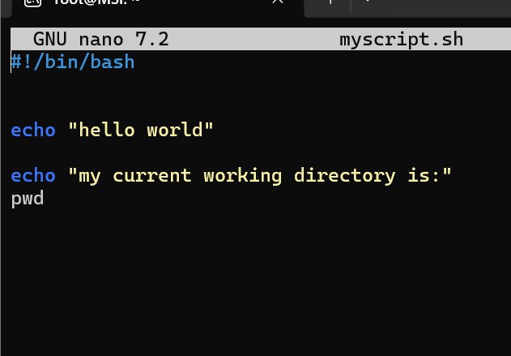
“figure”
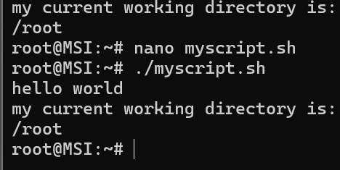
“figure”
Script message’s and note with script[15]

Name

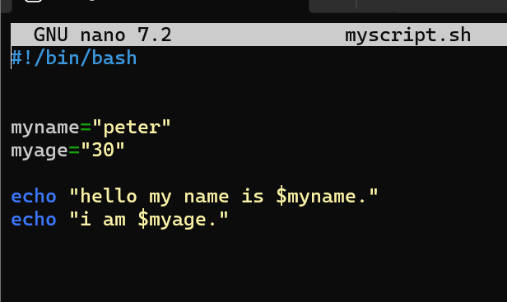
“figure” linux script
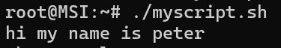
“figure”
This scripts allow you to use the = to command of a $(name/statement)[16]

Editing words
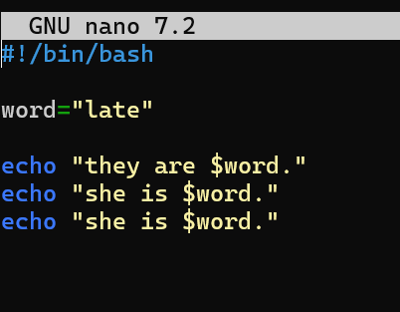
“figure” linux script
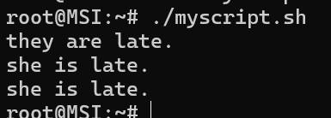
“figure” linux script
This script will allow you to change multiple word using the = of an $ statement.

If
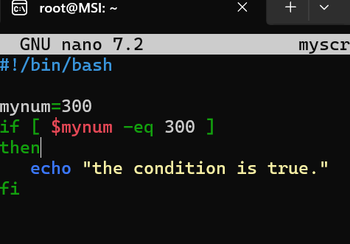
“Figure”
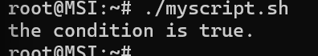
“figure”
Use if statement to get the greater then or equal to > with the $mynum command

If file
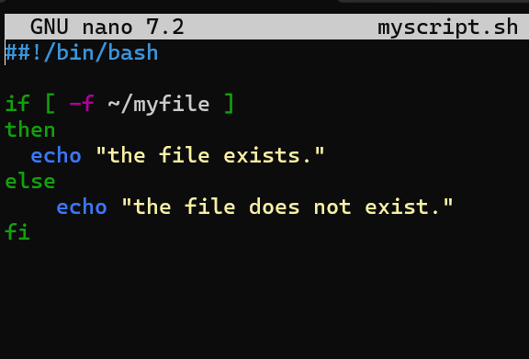
“figure” linux script
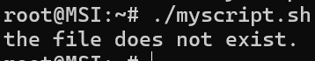
“figure”
IF statements can be used to script to see if a file is present within a directory.

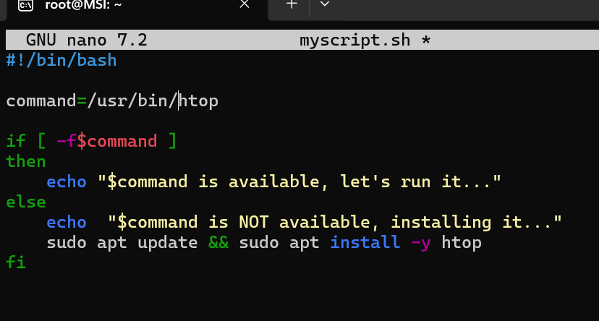
“figure” linux script

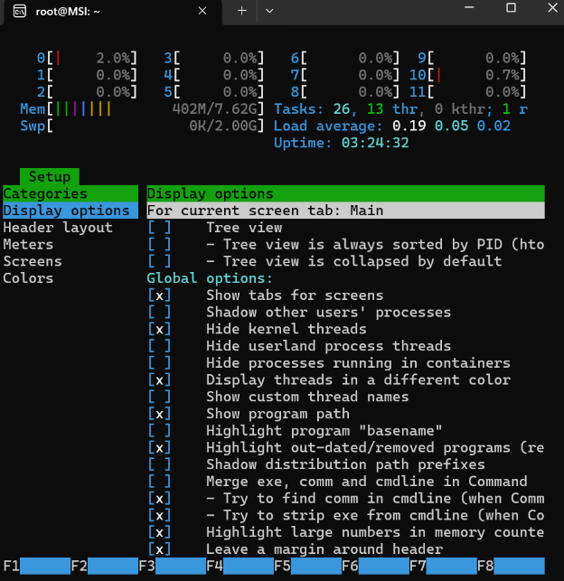
“figure”
Update or install sudo apt with script using if statement
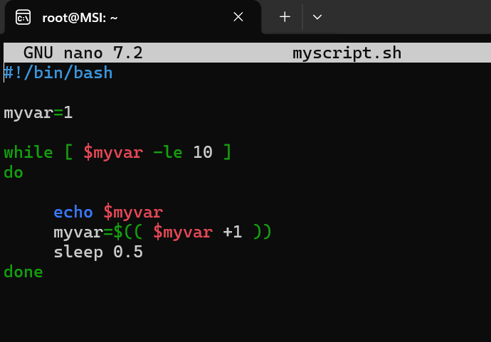
“figure” script
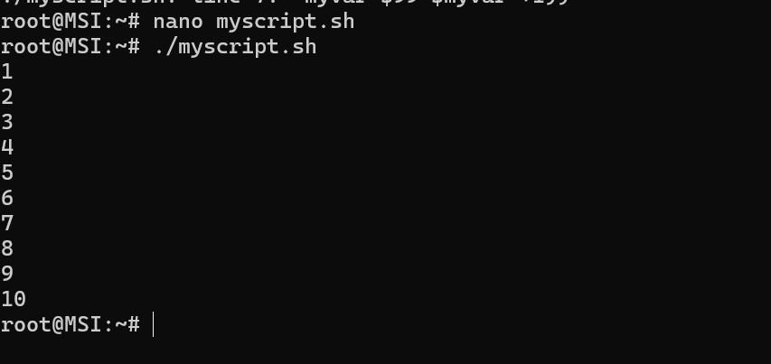
“figure”
As the script sunt you can create loops and count using script.

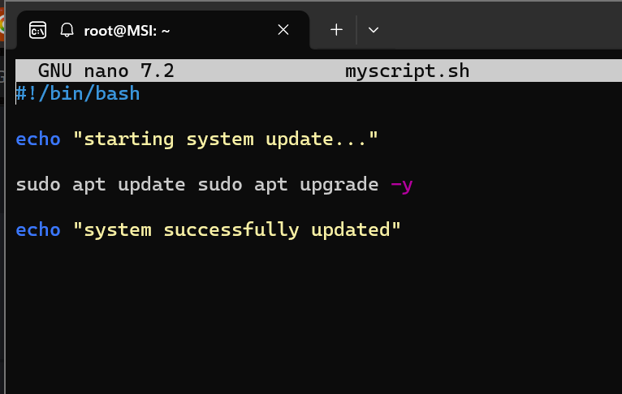
“figure”
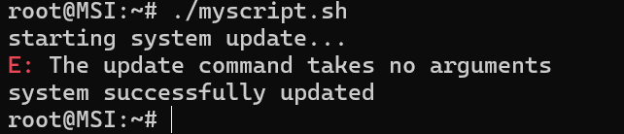
“figure”
System update script

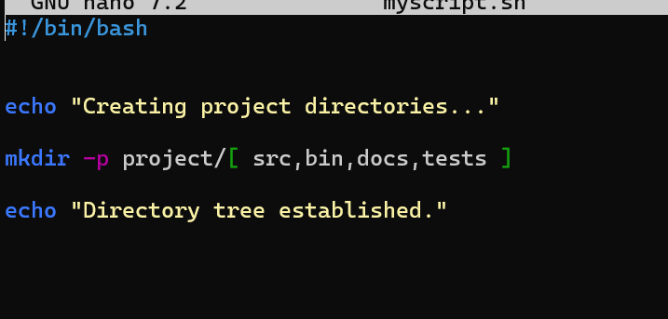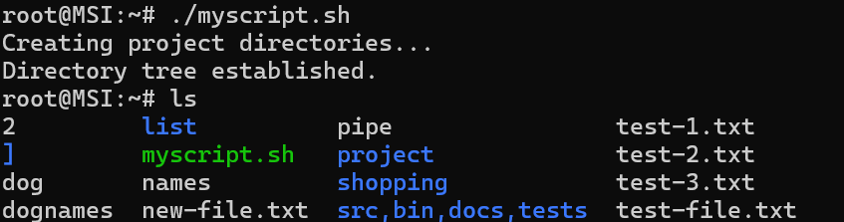
“figure”
A script to created multiple sorted directories at one time.

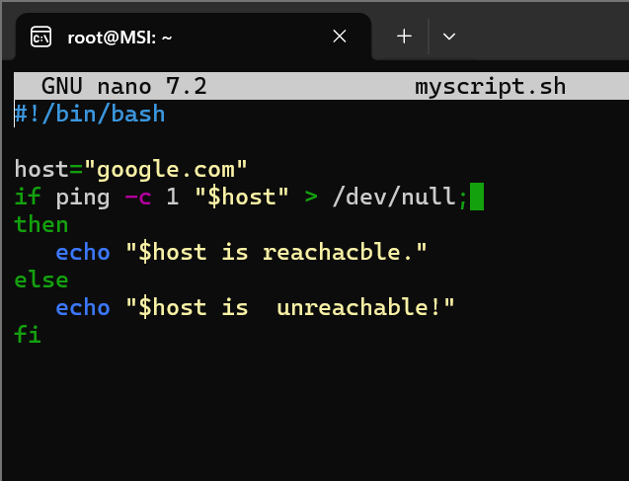
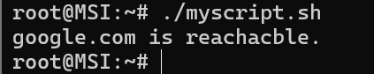
“figure”
This script will check if a server or website is reachable or not.

Conclusion
OS is the medium between the CPU and the user as allow you to speak to the CPU with understanding of cmd the OS can translate command and scripts to generate results and organize files. The standard interface of an OS is great for visually understanding the inner workings of a device, however learning scripts and command prompts allow users to really get an understand of the language and structure of a computers architecture.

References

References
[1] A. Simpson, Windows 11 for Dummies, John Wiley & Sons, 2024.
[2] P. Yosifovich, A. Ionescu, M. E. Russinovich and D. A. Solomon,Windows Internals: System architecture, processes, threads, memory management, and more, Part 1, Microsoft Press, 2017.
[3] J. Moran, File management made simple, windows edition, Springer, 2015.
[4] C. Panek, Windows Operating System Fundamentals, John Wiley & Sons, 2019.
[5] N. Hassan and R. Hijazi,Digital privacy and security using Windows: A practical guide, Apress, 2017.
[6] D. Gibson, Microsoft Windows Security Essentials, John Wiley & Sons, 2011.
[7] J. P. Mueller, Windows Administration at the Command Line for Windows 2003, Windows XP, and Windows 2000: In the Field Results, John Wiley & Sons, 2006.
[8] P. K. Bhardwaj, How to Cheat at Windows System Administration using command line scripts, Elsevier, 2006.
[9] W. Stanek, Windows Command Line: The Personal Trainer for Windows 8.1 Windows Server 2012 and Windows Server 2012 R2, Stanek & Associates, 2015.
[10] E. Siever, A. Weber, S. Figgins, R. Love and A. Robbins,Linux in a Nutshell, " O'Reilly Media, Inc.", 2005.
[11] M. G. Sobell, A practical guide to Linux commands, editors, and shell programming, Prentice Hall, 2013.
[12] M. G. Sobell, A Practical Guide to Linux® Commands, Editors, and Shell Programming, Pearson Education India, 2006.
[13] L. Holmes, Windows PowerShell Cookbook: The Complete Guide to Scripting Microsoft's Command Shell, " O'Reilly Media, Inc.", 2012.
[14] J. M. Torres, Windows Admin Scripting Little Black Book, Paraglyph Press, 2004.
[15] R. Blum, Linux command line and shell scripting bible, John Wiley & Sons, 2008.
[16] S. K. Singh, Linux yourself: concept and programming, CRC Press, 2021.

Appendices
1.
Activity in lecture
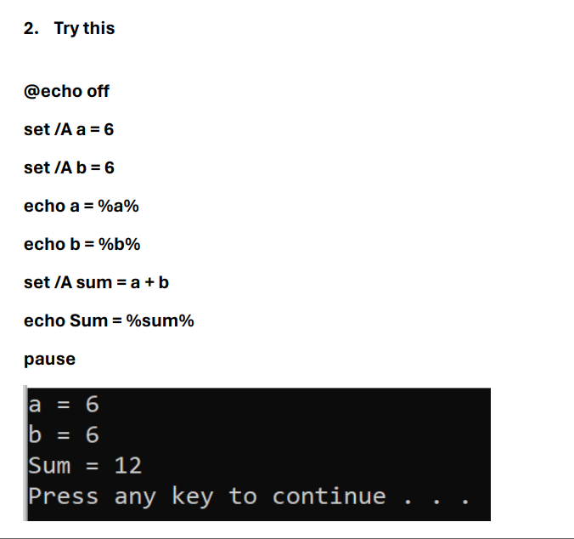
“figure of the activity”
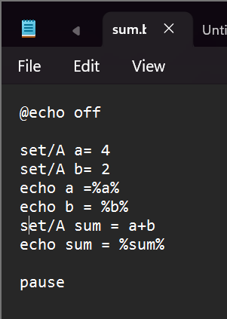
“figure of the activity”

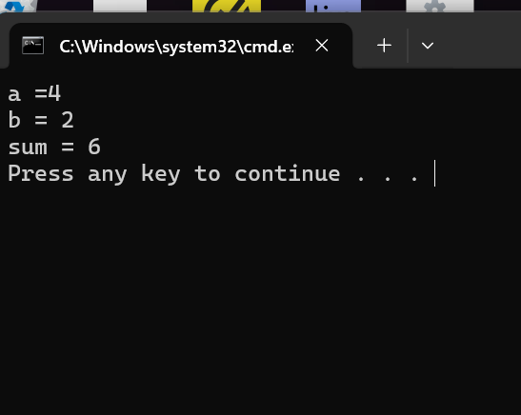
“figure of the activity”
Activity done in lecture for windows OS script creation.

Online course
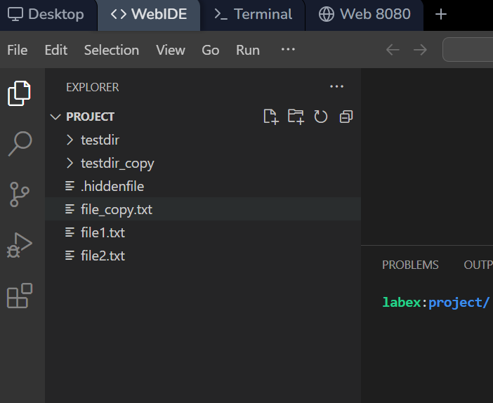
“Figure” online course with LabEx
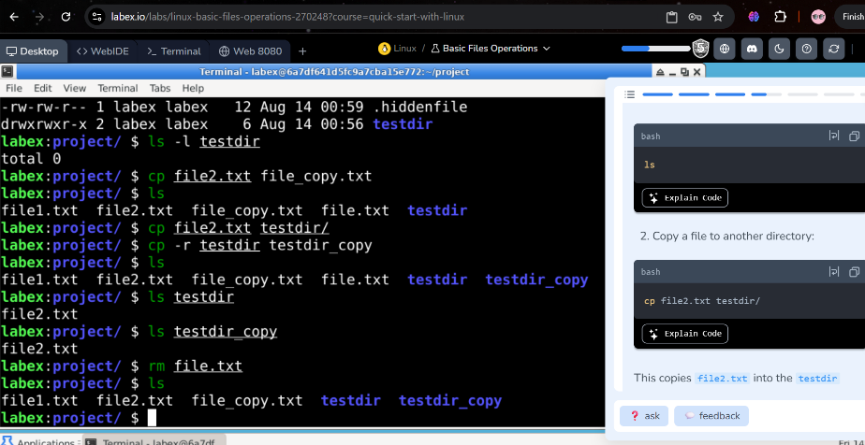
“Figure” online course with LabEx

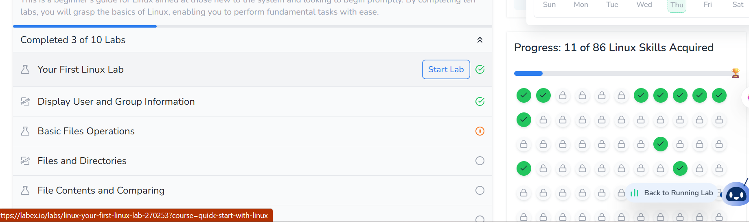
“Figure” online course with LabEx

