Joseph Evans
2216851@student.uwtsd.ac.uk

Computer Networks & Cybersecurity BS-Hons
Changemakers: Creativity and Value Creation

Module: ACCA5033

E-portfolio information
I have created an E-portfolio containing the work for this assignment, it is accessible at: https://koala-orchid-88pf.squarespace.com/
The site password is: 123
The site will remain accessible until Sunday 9th July 2023. The contents of the site are also in this document below.
Task 1
I created the below mind map exploring innovation and its modern day implications, as well as some ideas to potentially be the focus of this project - after mapping it out I settled on perusing the smart access door control system.
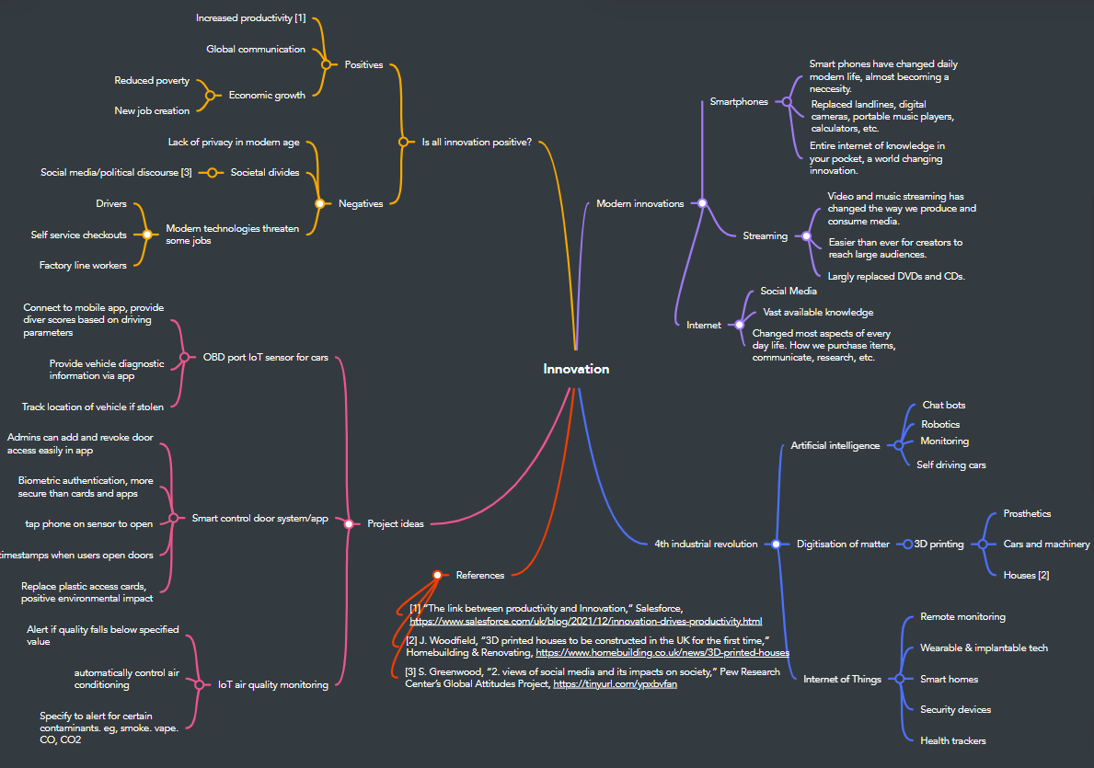

Task 2
For this project I have chosen to explore the idea of a smart door access control system, in which users unlock doors in buildings with a mobile app rather than keycards or fobs. For this scenario I will be adopting a pragmatic research philosophy, focusing on the systems practical implementation, environmental impacts, and usability. Pragmatism is focused on real world implications rather than strictly sticking to philosophical paradigms, allowing for decisions to be made based on situations that occur [1]. A pragmatic view of the door access control scenario accepts that whilst the use of fobs and keycards have been a suitable solution for many years, the practical benefits of a smart controlled system such as user convenience, security and scalability justify a change in approach. These positives, as well as cost and sustainability benefits could produce real world tangible differences to users.
To conduct research on this topic I will make use of a variety of databases including the UWTSD library database, JSTOR, IEEE Xplore and Google Scholar; I have also linked Google Scholar to the UWTSD library to return results that would otherwise be inaccessible. These databases contain useful primary sources of information such as conference papers, reports, journals, and so on – these sources carry more merit that websites returned by the standard Google search engine. To search for quality research materials, I will be using keyword searches removing any superfluous words, containing multiple words in speech marks, and placing an asterisk to search for wildcards where there could be variation on the word returned. In addition to this, Boolean operators such as AND, OR and NOT will be used to further refine search results [2]. These parameters will dictate what results are returned by the search engine, for example “plastic AND environment” will return results containing both words, whereas “plastic NOT environment” will return results containing the keyword plastic, but no mention of environment. All research and data collection will be aligned with the hypothesis that a smart door access control system is more convenient for users and has a lesser impact on the environment than other methods. Trüggelmann writes in a feature story for the International Card Manufacturers Association that markets excluding credit cards etc, such as access control cards and public transport cards account for approximately 40,000tons of CO2 [3]. This provides us an incentive to change behaviour to a plastic-free solution.

Asides from reviewing existing resources and research, there are various methods of data collection that would be suitable for this task including interviews, focus groups, and questionnaires. Given the scope of this project being the implementation of a smart door access control system, it is going to be important to gather both quantitative and qualitative data, therefore the primary method of data collection will be a questionnaire containing open and closed questions in order to capture both data types [4]. A questionnaire can easily be shared to a large number of people, and if kept reasonably brief and appropriate to the topic will have a high return rate. In addition to this, interviews will be undertaken with people who work in access-controlled buildings to get their thoughts and feedback on a smart door access control system. In interviews that have already taken place, respondents have agreed that access via a smartphone would be more convenient than a PIN, plastic card or fob. The main pushbacks were around security; however these concerns were alleviated by the integration of biometric authentication (fingerprint, FaceID, etc.)
Task 3
There are various research strategies for collecting both quantitative and qualitative data, and for this project both kinds will need to be incorporated. Quantitative data refers to mainly numerical based information usually collected via questionnaires with closed questions or experiments; qualitative data on the other hand is word-based information obtained via interviews, open questions on questionnaires, and focus groups. Whilst quantitative data provides an objective result that is easy to represent with numbers and graphs, it can lack context and does not give the respondent an opportunity to tailor their answers with extra information [5]. Whilst qualitative research methods do allow for this, they are more resource heavy to carry out and therefore tend to have significantly smaller sample sizes. For the scope of this project, the most appropriate research strategies would be interviews, questionnaires and focus groups. There are all practical to carry out and combined give a balance of both quantitative and qualitative data. A questionnaire could be sent to a large sample to collect quantitative data to be analysed, whilst interviews and focus groups could be held to collect qualitative data, and get a solid idea of the respondents’ thoughts, expectations and concerns.
To maintain validity and reliability throughout the data collection process, it is important to ensure that those taking part in interviews and surveys are relevant to the scope of the project, and that there is a fair distribution of the demographic represented. In this instance, the views of normal people using door access control systems are required, and as the sample size will not be particularly large, typical case sampling will be appropriate to find the opinion of the average user [6]. In addition to this, for quantitative data collection random sampling would be appropriate to avoid any bias in the selection; selecting participants at random should provide a fair and balanced subset of the wider demographic [7].
For this project a mix of qualitative and quantitative data is required, so the best approach would be a questionnaire. The questionnaire that has been created for this project and is linked below contains both closed and open questions, including multiple choice, text boxes and Linkert scales, offering a range of qualitive and quantitative responses. The first three questions serve to get an image of the demographic responding to the questionnaire, whilst the following questions are based around their opinions on their current systems, and thoughts or concerns on converting to a smartphone-based solution. These questions will help to capture the general consensus on a smart door access solution, and the populations willingness to adopt a new system.
Questionnaire link: https://forms.gle/QiqmpkCYgmYif9ak9

Bibliography
[1] M. Q. Patton, in Qualitative Research & Evaluation Methods: Integrating Theory and Practice, Thousand Oaks, CA: SAGE Publications, Inc., 2015, p. 153
[2] S. Burns, “What is Boolean Search?,” The New York Public Library, https://www.nypl.org/blog/2011/02/22/what-boolean-search
[3] U. Trüggelmann, “Carbon Footprint of the card industry,” ICMA, https://www.icma.com/ArticleArchives/CarbonFootprint_SE2-12.pdf
[4] J. Dudovskiy, “Questionnaires,” Research, https://research-methodology.net/research-methods/survey-method/questionnaires-2/
[5] L. Hoover, “What is qualitative vs. Quantitative Study?,” GCU, https://www.gcu.edu/blog/doctoral-journey/what-qualitative-vs-quantitative-study
[6] S. Glen, “Typical case sampling,” Statistics How To, https://www.statisticshowto.com/typical-case-sampling/
[7] A. Hayes, “Simple random sampling: 6 basic steps with examples,” Investopedia, https://www.investopedia.com/terms/s/simple-random-sample.asp

Abstract
E-portfolio screenshots:
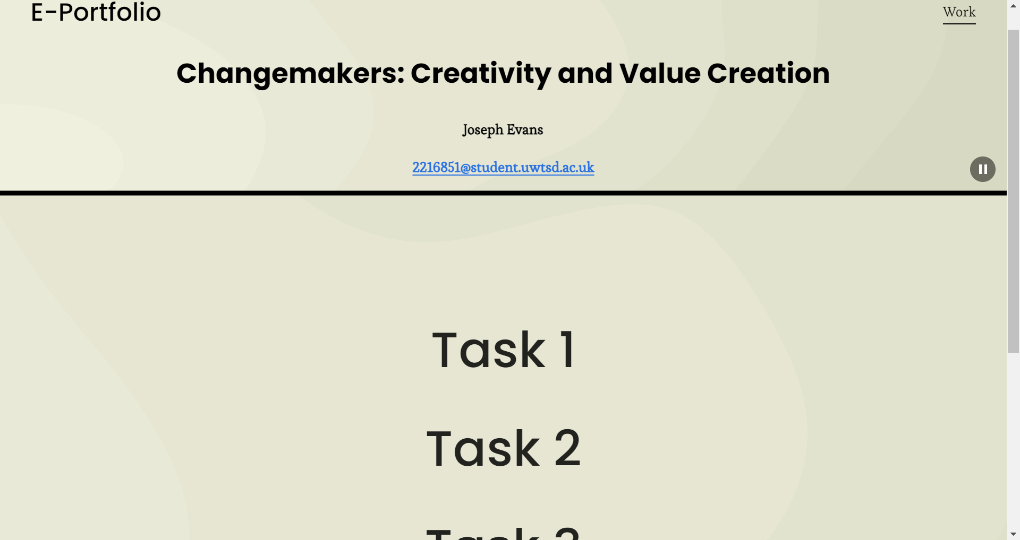
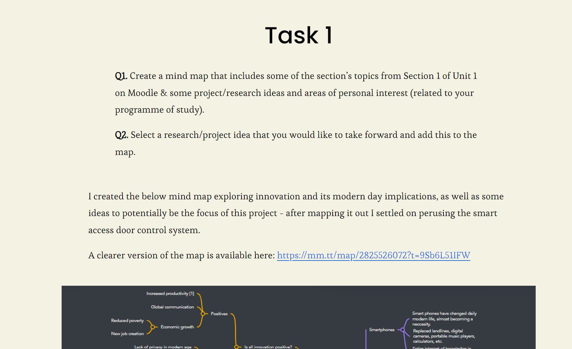
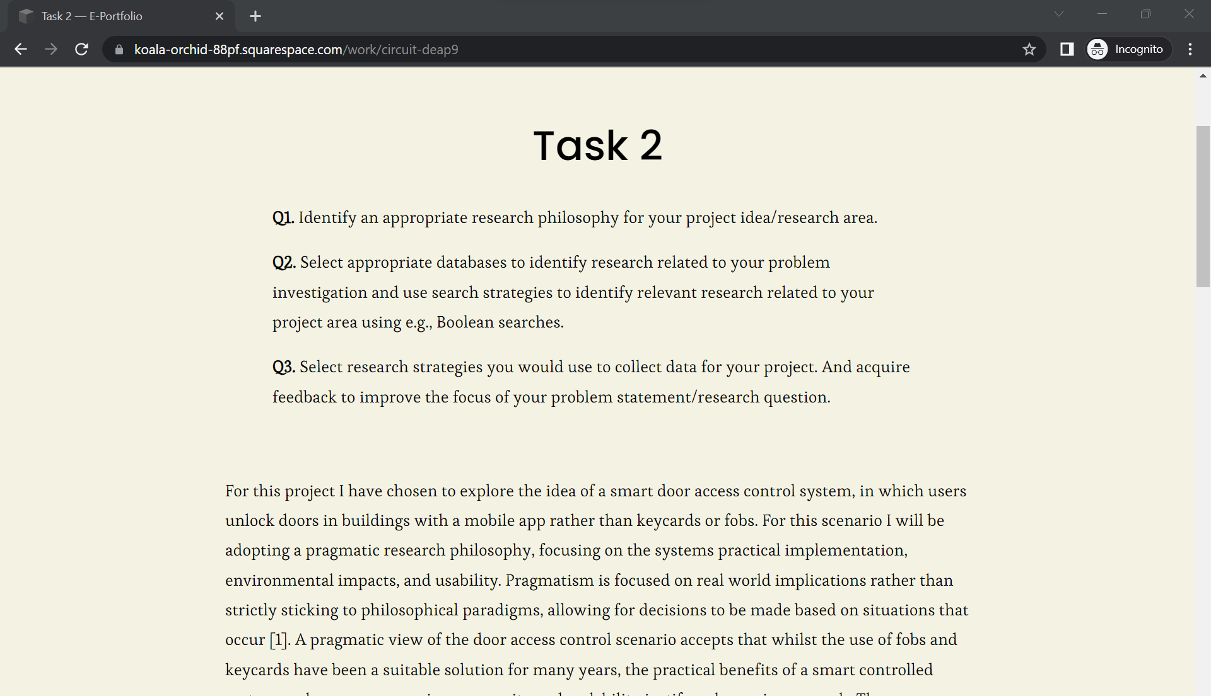


Moodle participation:





