

LEVEL 7 ASSESSMENT SPECIFICATION

MBA – Master of Business Administration

LCMB7003
Strategic Management

Name : Priti chhabda
Student Id :2208700

Module Leader: Amera desta

Word Count: 6019

Table of Contents

Introduction 3
Background of the Company - Google 3
Mission Statement and Objectives of Google 5
Macro Environment Analysis 6
PESTEL Analysis 6
Micro-Environment Analysis 9
Industry Life Cycle 9
Poster’s Industry Five Forces Analysis 11
Porters Five Forces 11
Google’s Strategic Resources and Capabilities 14
Levels of Strategy 14
Corporate Level 14
Business Level 16
Functional Level 17
Value Chain Analysis 18
Primary Activities 18
Secondary Activities 19
VRIO Analysis 20
Internal Analysis 21
SWOT Analysis 21
Achievement of Competitive Advantage through the Strategies 26
Ansoff Matrix 26
Financial Performance 29
Ethical Behaviour 30
Conclusion and Recommendations 32
References 33

Introduction
The goal of this study is to carry out a strategic analysis of the chosen company and case study, Google Inc. By employing diverse strategic tools and frameworks like Ansoff Matrix and Porter’s Five Forces, an analysis of Google's competitive position and strategic decisions will be conducted, followed by the provision of recommendations for the company's future triumph. Through an exploration of the intricate and ever-evolving realm of Google Inc., our aim is to acquire a more profound comprehension of the factors that have contributed to the organization's prosperity, as well as the obstacles that it may encounter in the future.

Background of the Company - Google
Google Inc. is a globally renowned company that is widely recognised for its significant market share in the search engine industry and its pioneering role in technological advancements. Google Inc. is a technology conglomerate headquartered in the United States that was established by Larry Page and Sergey Brin, both of whom were doctoral candidates at Stanford University at the time. The corporation's principal office is in Mountain View, California, United States of America (Levy, 2021). Since its establishment in 1998, Google has experienced significant growth and diversification, venturing into multiple sectors such as advertising, cloud computing, and mobile operating systems.
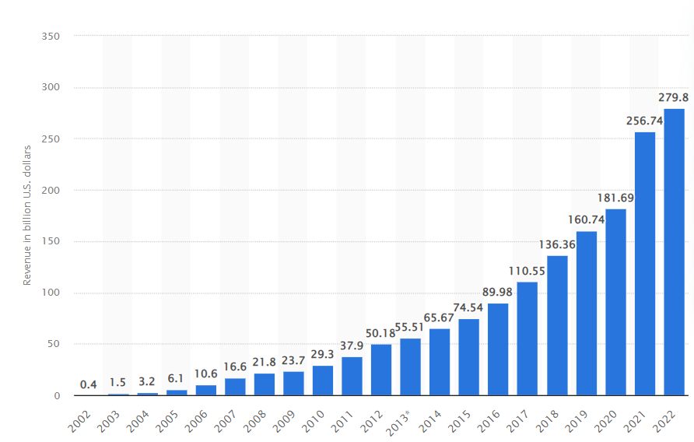
Fig. 1: Annual revenue of Google from 2002 to 2022
(Source: Bianchi, 2020)
Google is primarily recognised for its search engine, which is extensively utilised globally. Google provides a diverse array of products and services, which includes a search engine, email platform (Gmail), online advertising platform (Google Ads), video sharing platform (YouTube), cloud storage solution (Google Drive), and mobile operating systems (Android). The principal means of generating income for the organisation is via advertising facilitated by its AdWords initiative. AdWords is a platform that enables enterprises to display advertisements on Google's search engine results pages and other websites that employ Google AdSense. Google is a significant participant in the realm of artificial intelligence and machine learning. The corporation has created a variety of artificially intelligent products such as Google Assistant, Google Translate, and Google Photos. Google's corporate culture places significant emphasis on innovation, creativity, and a dedication to creating a beneficial impact on society (Gvili, 2020).

Mission Statement and Objectives of Google
As per the information gathered from the case and company profile of Google, the mission statement of the company is to “Organize world information and make it universally accessible and usable”. Google, with the objective of arranging the world's information and rendering it widely accessible and beneficial, has emerged as a ubiquitous entity and a propelling influence in the era of digital technology. On the other hand, the vision statement of the company is directed to provide access to world’s information in just a click. Google's objective is to arrange all the information present in the world and ensure its accessibility and usefulness to everyone (Jean-Baptiste, 2020).

Macro Environment Analysis

PESTEL Analysis
Political | Currently, the primary political influence impacting Google pertains to the ongoing geopolitical tensions between the United States and China. Under the current administration of President Trump, the bilateral relationship between the two nations has become increasingly contentious, leading to the imposition of significant trade tariffs on imported goods. The heavy reliance of tech-based companies like Google on imports to the Chinese market for their revenue is adversely impacted (Hong et al., 2020). Furthermore, it is noteworthy to explore the top competitors of Google. Additionally, examining the partnerships established by the company is also of interest. Google has established a collaborative relationship with the Chinese corporation Huawei.
Economic | The economy of the United States is widely regarded as one of the most robust and successful economies globally, exhibiting a notable GDP growth rate. This presents a significant opportunity for Google to broaden its presence in emerging markets and enhance its revenue streams. Moreover, this facilitates a consistent expansion of buying capacity for both individuals and corporations, thereby facilitating increased utilization of technology (Isabelle et al., 2020). In the current decade, Google has the potential to introduce high-end technological products to the market that may not have been viable in previous years. Google's global expansion is being facilitated by the force of globalization, as it extends its reach beyond the American market to nations with emerging economies. The economic growth in these countries has resulted in a steady increase in the purchasing power of consumers.
Social | A significant portion of Google's earnings is derived from advertising across its various platforms. The increasing apprehension among internet users regarding the collection of their personal data for targeted advertising has led to a growing inclination towards ad-free browsing. The utilization of ad-blocking features by internet browsers has resulted in the removal of advertisements from Google platforms, thereby causing a decrease in the number of brands interested in advertising on said platforms. Until a certain juncture, Google held an unequivocal position as the dominant force in the realm of the internet. The emergence of social media platforms like Facebook and Twitter has introduced market competition that was previously absent, thereby necessitating Google to address this new challenge (Brickley et al., 2019).
Technological | With the increasing accessibility of the technological landscape to both private users and businesses, Google has been able to incorporate a greater range of functionalities onto its various platforms. The brand has experienced a notable advantage from the increased utilization of artificial intelligence, as its level of AI-based innovations is notably elevated. In addition to Amazon, Google is a prominent player in the market for integrated AI and Cloud services (Walker et al., 2020). This industry is anticipated to experience significant growth soon. The recent collaboration between Google and Android has facilitated a substantial market expansion, given the prevalence of smartphone usage surpassing that of any other device. Although Google has not been able to enter this market directly through its smartphone, its collaboration with Android has been highly lucrative, as it is now perceived as an integral component of every Android-based smartphone.
Environmental | It is imperative for Google as an entity to acknowledge and tackle environmental concerns that are currently afflicting the global community. It is anticipated that all corporations will undertake measures to decrease their carbon emissions, and as a prominent IT industry leader, Google is expected to take a leading role in this endeavour. The corporation has established a partnership with the United Nations to implement environmentally conscious measures that will integrate technological advancements (Marmol, 2019). The corporation intends to furnish information to governmental bodies, institutions, and the general populace by means of its orbiting satellites, thereby enabling them to make more informed judgments pertaining to ecological matters.
Legal | Google's operational methods have been challenged by a series of recent legislations pertaining to data privacy. As previously mentioned, the organization heavily relies on the implementation of focused advertisements on its various platforms as a primary source of income. In order to achieve this objective, it is necessary to gather confidential information. With the increasing implementation of data privacy laws in various countries, Google is facing challenges in running its targeted advertising campaigns. Several new regulations are being implemented to limit the dissemination of copyrighted content on Google's platforms, including YouTube (In, et al., 2021). This phenomenon has the potential to impact the comprehensiveness of the material accessible on said platforms, consequently leading to a reduction in user engagement.

Micro-Environment Analysis

Industry Life Cycle
The framework of Industry Life Cycle Analysis functions to examine the different stages of development and evolution of an industry over a specific period of timeline. The assessment of industry life cycle for Google’s processes are discussed below:
- Introduction Stage – In the late 1990s, Google began to operate as a startup search engine. The business was characterised by the quick development of technology and the rise in popularity of online search. Innovative algorithms and a user-friendly interface were launched by Google, which immediately became well-liked.
- Growth Stage – During this phase, Google significantly expanded and took control of the online search market. The business increased the number of services it offered, among them Gmail, Google Maps, Google Ads, and Google Docs. Investors and marketers took notice of Google's rapid growth in both revenue and user base.
- Maturity Stage – Online search is now in its mature stage as a result of greater market saturation and increased competition. Other search engines like Yahoo and Bing, as well as cutting-edge technologies and social media platforms, were competitors to Google. Google's primary focus was on diversifying its product offerings and entering new sectors, such as mobile operating systems for mobile devices (Android) and cloud services (Google Cloud).
- Decline Stage – The online search market is currently not in the decline stage because search engines continue to be crucial resources for internet users. However, as technology advances, people's methods of searching for information can alter, and fresh disruptive inventions might appear, possibly causing the traditional search engine business to contract.
Through the assessment of the industry processes, it can be directed that change in industry greatly influences the change in market size and business conditions. Google is already a market king in search engine, Yet, the company needs to align the processes of changing market practices to grow in the fractions of the search engine and Ai practices for future management and growth.

Poster’s Industry Five Forces Analysis

Porters Five Forces
Competitive Rivalry | The advertising industry is characterised by a high level of competitive rivalry, as a multitude of firms compete to secure a portion of the market. Google holds a prominent position in the digital advertising industry, as its AdWords platform constitutes a substantial share of the overall expenditure on digital advertising (Isabelle et al., 2020). Google's dominance in the mobile advertising arena is attributed to its Android operating system and mobile advertising platforms. Therefore, Google experiences a decrease in competitive rivalry. | HIGH
Threat of Substitutes | The advertising industry faces a significant risk of substitutes, given the diverse array of alternatives available to advertisers and content creators for promoting their offerings. Google possesses an advantage in this domain owing to its sophisticated targeting and analytics capabilities, which empower advertisers to efficiently reach their intended audience (Baxter, 2019). Furthermore, Google's search engine and YouTube platform are among the most extensively utilised online platforms, thereby mitigating the risk of potential substitutes. | HIGH
Threat of New Entrants | The advertising sector exhibits a comparatively low level of barriers to entry, thereby facilitating the ease with which new firms can penetrate the market. Nonetheless, this circumstance does not inherently present a noteworthy menace to Google, given its established dominance as the primary contender in the realm of internet-based advertising (Anastasiu, et al. 2020). The search engine operated by Google is globally recognised as the most extensively utilised, while its AdWords platform is the most substantial digital advertising platform, providing it with a notable edge over possible contenders seeking to enter the market. | LOW
Bargaining Power of Buyers | The advertising industry is characterised by a significant bargaining power of buyers, given the diverse range of options available to advertisers and content creators for advertising their products and services. Nonetheless, Google possesses a competitive edge in this domain owing to its extensive user base and the expansive scope of its advertising platform. Marketers are highly motivated to expand their consumer base, and Google's AdWords platform provides them with an efficient means of achieving this objective (Haseeb et al., 2019). Therefore, the bargaining power wielded by buyers is somewhat diminished. | HIGH
Bargaining Power of Suppliers | The advertising industry exhibits a low degree of supplier bargaining power, owing to the presence of numerous suppliers offering advertising services and products. The digital advertising platform known as Google is not dependent on any singular supplier, thereby diminishing the bargaining power of said suppliers (Cleberg, 2019). Nonetheless, Google must confront the expenses associated with procuring and retaining top-notch content producers and advertisers, which may influence its profitability. | LOW

Despite encountering certain challenges within the advertising sector, Google Inc. is fortified by its preeminent market standing and robust brand image, thereby rendering it arduous for potential competitors to penetrate the market and establish a competitive foothold. Moreover, Google's superior targeting and analytics functionalities, coupled with its extensive user population, confer upon it a notable edge vis-à-vis its rivals. Nonetheless, it is imperative for the organisation to maintain a state of constant awareness and preparedness in response to evolving market dynamics and the potential emergence of novel technological and commercial frameworks that may pose a risk to its advertising operations.

Google’s Strategic Resources and Capabilities

Levels of Strategy

Corporate Level
Google has implemented a diversification strategy by expanding its business operations into various sectors, including but not limited to hardware, software, and advertising. The diversification of the company's operations into these sectors has enabled it to exploit its fundamental strengths in search engine technology for the purpose of generating fresh sources of income and attaining a position of superiority in the market (Fainshmidt et al., 2020). Google has a track record of procuring other enterprises that are in line with its strategic objectives. An instance of Google's strategic expansion is its acquisition of YouTube in 2006 and Nest in 2014, which enabled the company to broaden its presence in the video streaming and smart home sectors, respectively. Furthermore, Google has established collaborative relationships with other corporations, including Apple and Samsung, to incorporate Google software into their products prior to their release. Google prioritises innovation and places emphasis on the creation of novel products and services in order to maintain a competitive edge over rival companies (Sahut, et al. 2019).
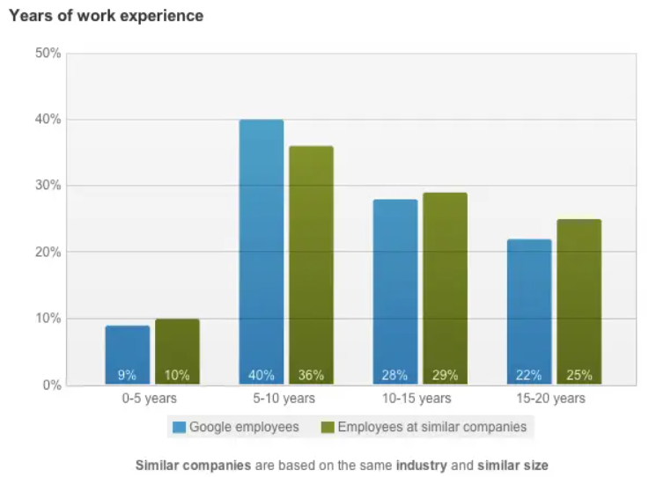
Fig. 3: State of Google Employees (Experience Years)
(Source: Lynley, 2019)
Google has a global presence with operations in numerous countries, and it has implemented a strategic approach to penetrate new markets through global expansion efforts. The corporation has implemented a strategy of product and service localization to address the unique demands of diverse regions. Additionally, it has established regional offices in various countries to enhance its capacity to provide optimal customer service to local clientele (Ziyadin, et al. 2019). The corporate-level strategy of Google is centred on prioritising the delivery of value to its customers through a customer-centric approach. The organisation consistently endeavours to enhance its offerings and amenities by leveraging customer feedback and conducting data analysis. The strategy has enabled Google to uphold elevated degrees of patron contentment and allegiance.

Business Level
The tech company, Google Inc., has achieved notable success within its industry, with its business-level strategy being a key factor in its accomplishments. The organization's principal business-level approach is differentiation, whereby it endeavours to furnish its clientele with exceptional and advantageous commodities or amenities. Google has implemented various strategies to achieve differentiation (Moriuchi, 2019). Initially, the company has prioritised delivering an optimal search engine encounter for its clientele. The task at hand entails a perpetual enhancement of search algorithms and furnishing users with the utmost pertinent and advantageous outcomes. Google has established a unique identity by prioritising innovation. The corporation allocates significant resources towards research and development endeavours aimed at generating novel products and services that cater to the demands of its clientele. The technological advancements have resulted in the creation of various products, including but not limited to Google Maps, Google Drive, and Google Translate (Contractor et al., 2018).
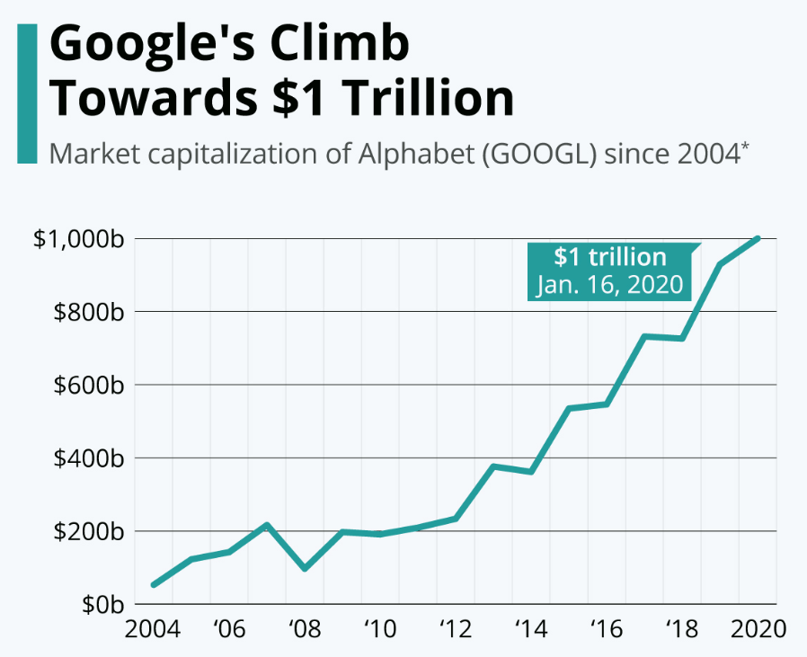
Fig. 4: Market Capitalisation of Alphabet (GOOGL) since 2004
(Source: Statista, 2020)

Functional Level
As per Sturgeon (2019), Google allocates significant resources towards research and development endeavours aimed at innovating novel products and enhancing pre-existing ones. The research and development endeavours of the organisation are centred on state-of-the-art technologies, including artificial intelligence, machine learning, and cloud computing. Google's marketing strategy revolves around its search engine and digital advertising platforms. The marketing endeavours of the organisation are geared towards augmenting user involvement, directing traffic towards its online platforms, and generating income via focused promotional campaigns. Google is reputed for its robust organisational culture and employee welfare policies in the domain of Human Resources (Hauser, et al., 2019). Google's operations strategy is primarily focused on achieving efficiency and scalability. The organisation utilises automation and technological advancements to optimise its operational procedures and enhance efficiency (Munir and Rahim, 2023).
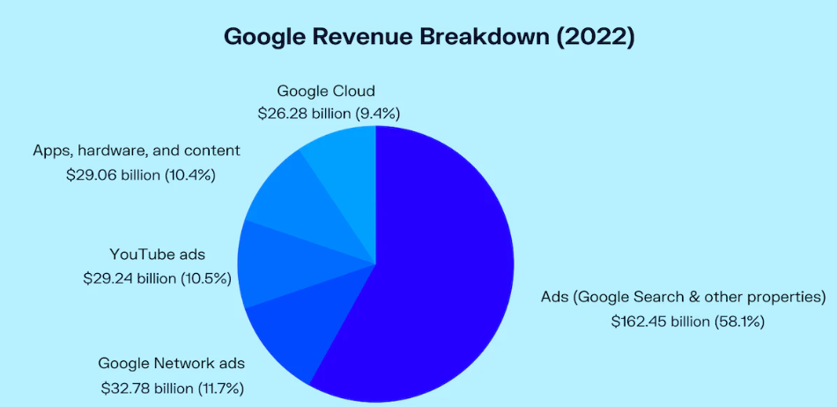
Fig. 5: Google Revenue Breakdown (2022)
(Source: Oberlo.com, 2022)

Value Chain Analysis

Primary Activities
The primary activities for Google to manage its effective value chain in the international market is based on five core processes of primary functions identified below:
- Inbound Logistics
- Operations
- Outbound Logistics
- Marketing and Sales
- Services
Based on the assessment of the five primary activities, the assessment can be illustrated through to enhance its search engine algorithms, Google's inbound logistics team gathers and examines data from various sources, including websites, social media, and user behavior. Google also invests in talent and technology through partnerships and acquisitions to improve its cloud computing and artificial intelligence capabilities. Creating, upkeep, and improving Google's search engine and other services are all part of its operations. A sizable group of engineers and developers at Google works tirelessly to enhance the company's goods and services. Delivering Google's services to users through its search engine, advertising networks, and other services is considered outbound logistics. Using its sizable data centers and cloud infrastructure, Google ensures quick and dependable service delivery.
Google's marketing and sales initiatives aim to emphasize customer satisfaction and user engagement while promoting operational services. Google promotes its services through targeted advertising, word-of-mouth marketing, and alliances with other businesses. To ensure user pleasure, Google's service activities include offering great customer assistance. To help users with any problems or inquiries, Google provides a variety of support channels, such as online help centers, forums, and customer care teams.

Secondary Activities
Based on the primary activities of functional processes for Google, the support or secondary activities are identified below:
- Human Resource Management
- Procurement and Purchasing
- Company Infrastructure
- Technological development
Hardware, software, and other resources required for Google's operations are sourced as part of its procurement activities. Google collaborates with several partners and suppliers to maintain a trustworthy supply chain. Hiring, training, and retaining elite talent across various industries, including engineering, data science, and marketing, are the main priorities of Google's human resource management. Google provides several perks and incentives to entice and keep employees, including flexible work schedules and high pay. Continuous research and development of new goods and services is a part of Google's technology development initiatives. Google invests significantly in cutting-edge technologies, including quantum computing, machine learning, and artificial intelligence. Google's infrastructure activities include managing and maintaining its data centers and cloud infrastructure. Google can use quick and dependable services because of having one of the biggest worlds and most sophisticated cloud infrastructures in the company.

VRIO Analysis
Resource/ Capability | Valuable? | Rare? | Inimitable? | Organized?
Google's search engine | Yes | Yes | No | Yes
Google's brand | Yes | Yes | Yes | Yes
Google's data centers | Yes | Yes | No | Yes
Google's algorithms | Yes | Yes | Yes | Yes
Google's talent pool | Yes | Yes | No | Yes
Google's patents | Yes | Yes | No | Yes

Based on the above VRIO Framework, it can be directed that Google’s Search Engine is extremely valuable, rare, and organized. The same cannot be inimitable as rival companies are expected to create their individual search engine. Additionally, Google’s Brand and Data Centers are based on all four approaches of the framework, while only the data centers are expected to be inimitable through the assessment. The algorithm of Google is very functional and flexible with well-structured approach to algorithm development and improvement. On the other hand, the talent pool of the company is expected to be inimitable, since other companies can also hire talented individuals. Lastly, the patent rights of the company is based on all three parameters with positive approach, and only the level of inimitability is concerned since other companies have the opportunities to hire talented individuals.

Internal Analysis

SWOT Analysis
Strengths | Weaknesses
- Google is a corporation that has consistently been a pioneer in the field of technological advancement. Google's search engine is widely regarded as a highly significant innovation, having achieved global popularity as the most widely used search engine.  - The brand image of Google is widely recognised globally. The corporate emblem of the organisation, showcasing the vividly hued alphabets ‘Google,’ is widely acknowledged as one of the most identifiable logos globally (Munir and Rahim, 2023).  - Google, being the most extensive search engine globally, possesses the authority to regulate the online content that individual’s access and discover.  - Google possesses a vast network of servers and data centres that enable it to provide its services with high speed and dependability, in addition to its extensive data. The enterprise's extensive assets have facilitated significant investments in research and development, leading to the creation of numerous pioneering products and services.  - Google Search, the primary product of the company, is utilised by a vast number of individuals daily. The corporation has diversified its operations into additional sectors, including hardware through the introduction of its Pixel smartphones and Nest gadgets (Rovetta and Bhagavathula, 2020). | - The company's revenue stream is predominantly derived from advertisements, constituting over 80% of its total revenue. This may potentially pose a vulnerability for the company (Marmol, 2019). Google is currently experiencing heightened competition from other technology firms, including Facebook and Amazon, who similarly rely heavily on advertising-generated income.  - The issue of privacy has emerged as a significant vulnerability for Google. Google has been subject to criticism regarding its privacy practises due to its collection of extensive personal data from its users.  - The dependence of Google's offerings on internet infrastructure may constitute a vulnerability (Sharon, 2020). The potential occurrence of an internet infrastructure disturbance, whether it be a cyber-attack or a natural calamity, may have a noteworthy effect on Google's capacity to provide its offerings and amenities to its clientele.  - The complexity of Google's business model may present a potential weakness. The intricate nature of the situation may pose challenges for Google in terms of concentrating on its fundamental strengths, resulting in suboptimal performance and escalated expenditures.  - Google's employee turnover is a notable area of weakness. Nevertheless, the enterprise has encountered difficulties in retaining skilled personnel over the past few years.
Opportunities | Threats
- Google has a significant prospect to sustain its supremacy in the search engine industry. Google has emerged as the primary search engine of choice for a vast majority of individuals across the globe. Google can secure its position as the primary search engine for the foreseeable future by enhancing its search algorithm.  - In recent years, Google has made significant investments in the field of AI. Google has developed several products and services that utilise artificial intelligence, including Google Assistant, Google Home, and Google Lens.  - Google is making significant investments in the field of cloud computing. The increasing number of businesses transitioning their operations to the cloud has resulted in a surge in demand for these services (Yaqoob and Omer, 2021).  - Google holds a dominant position in the realm of online advertising. The AdWords platform is utilised by a multitude of businesses globally for the promotion of their goods and services.  - Google has developed several healthcare-oriented products, including Google Health, Google Fit, and DeepMind Health (Zanjani et al., 2020). | - Certain individuals’ express apprehension regarding the influence of Google's search algorithm on the information they obtain and the likelihood of partiality in search outcomes (Sharon, 2020).  - The issue of cybersecurity poses a significant threat to Google. Google, being a technology enterprise, possesses substantial quantities of sensitive information pertaining to its users, encompassing personal data, search records, and geolocation data.  - Although Google holds a significant share of the search engine market, it encounters rivalry from other corporations such as Bing, Yahoo, and Baidu in different geographical areas. The level of competition is high, and corporations are consistently implementing novel approaches to attain a competitive advantage over Google.  - Google has been the focus of several antitrust inquiries due to concerns from regulatory bodies regarding the company's market dominance in the search and advertising sectors, which may result in an unjust advantage over its rivals (Syafii et al., 2020). Furthermore, Google has been subject to censure due to its data gathering methods, which certain individuals deem intrusive and infringing upon the privacy of its users.

Achievement of Competitive Advantage through the Strategies
Haseeb et al., (2019) opined that Google has consistently been a pioneer in the realm of innovation, regularly unveiling novel offerings and amenities to its clientele. The company boasts a robust research and development division that consistently endeavours to innovate novel technologies and products, thereby augmenting its competitive edge. Google's emphasis on machine learning and artificial intelligence has facilitated the development of consumer-oriented products, including Google Assistant and Google Home, that have gained widespread popularity. The practise of utilising data to make informed decisions has been a longstanding approach at Google. The corporation possesses extensive quantities of user data, which it leverages to enhance its offerings and amenities (Barlow et al. 2019). Google employs data to optimise its advertising strategy, resulting in superior efficacy and efficiency relative to its rivals.
Google has attained cost leadership through consistent enhancements in its operational efficiency. The organisation has implemented measures to enhance the efficiency of its data centres, resulting in decreased energy consumption and reduced expenses. The company has implemented several cost-cutting strategies, including the reduction of employee benefits, in order to sustain its competitive cost position. The brand of Google is widely acknowledged and esteemed as one of the most recognisable globally (Hamadamin and Atan, 2019). The company's emphasis on innovation, user experience, and customer satisfaction has facilitated the development of a devoted customer cohort. The robust brand image of Google has facilitated the company in imposing a higher price for its offerings, thereby augmenting its competitive edge.

Ansoff Matrix
In recent times, Google has encountered an escalating challenge from ad blockers and mounting apprehensions regarding consumer privacy. This circumstance has led to a reduction in advertising income, thereby motivating the organisation to investigate novel avenues for expansion.
Market Penetration: Market penetration is a business tactic that centres on augmenting a company's market portion by vending more of its extant commodities or amenities within its present marketplaces. Regarding Google Inc., the strategy of market penetration would entail augmenting its market share within the advertising sector by expanding the sales of its current advertising products to its present clientele. The strategy of market penetration entails the augmentation of the company's market share within the current market through the promotion of its products and services. Google might aim to mitigate the threat posed by ads is to concentrate on augmenting its advertising revenue within the current market. Enhancing the efficacy of its advertising algorithms, providing superior targeting alternatives, and refining ad formats are potential avenues for Google to pursue in achieving this objective (Martins, 2020).
For several years, Google Ads has held a position of dominance within the realm of online advertising. However, its market share has experienced a decline as a result of heightened competition. In order to address this issue, Google Inc. may consider enhancing the functionalities of Google Ads with the aim of augmenting its customer base and sustaining its current clientele (Cleberg, 2019). One potential strategy for enhancing the competitiveness of its advertising platform could involve reducing its pricing to increase affordability. Through this action, Google has the potential to augment its market dominance and uphold its status as the foremost player in the industry.
Market Development: Market development is a business strategy that entails the introduction of already existing products and services to previously untapped markets. One potential strategy for Google to mitigate the threat posed by ads is to broaden its advertising offerings to untapped markets. As an example, Google may consider prioritising the expansion of its advertising services into developing regions such as Africa and Asia. Furthermore, Google has the potential to investigate novel avenues for advertising, including social media platforms (Najaty and Alyamani, 2020). Google Ads has a widespread adoption among numerous businesses globally; however, there exist several unexplored markets that Google could potentially venture into. An expansion of its advertising platform into emerging markets such as India and Africa may present Google with substantial growth opportunities.
Product Development: The process of product development entails the introduction of novel products and services to the pre-existing market. Google may potentially mitigate the issue of ads threat by implementing novel advertising products and services. As an illustration, Google has the capability to introduce novel advertising formats, including interactive ads, video ads, and augmented reality ads (Zanjani et al., 2020). Furthermore, Google has the capability to introduce novel advertising services, including but not limited to native advertising, influencer marketing, and programmatic advertising. Google Ads provides a diverse array of advertising products, encompassing search ads, display ads, and video ads.
Diversification: Diversification is a strategic approach that entails the introduction of novel products and services to previously untapped markets. Google could potentially mitigate the challenge posed by the threat to its advertisements by pursuing a strategy of revenue diversification. Google has the potential to investigate novel business prospects, including but not limited to e-commerce, cloud computing, and artificial intelligence. Furthermore, Google has the potential to venture into novel industries such as healthcare, finance, or education. Google has expanded its operations into various industries such as cloud computing, hardware, and software (Yaqoob and Omer, 2021). Notwithstanding, there exists an opportunity for additional diversification, and Google may consider investigating novel markets such as healthcare, education, or transportation.
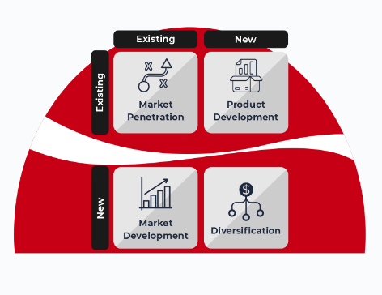
Fig. 6: Ansoff Matrix
(Source: Pallister, 2022)

Financial Performance
Since its initial public offering in 2004, Alphabet Inc. has consistently exhibited robust financial performance. The company's revenue increased from $161.9 billion in the prior year to $182.5 billion in fiscal year 2021. The net income of the entity in the year 2021 exhibited an increase to $61.9 billion as compared to the previous year's net income of $40.3 billion. This indicates a net income growth rate of around 43%. Alphabet generates the bulk of its revenue from advertising, with a particular emphasis on its primary offering, Google Ads. The company's total revenue in 2021 was primarily derived from advertising, which constituted 80% of the revenue (Syafii et al., 2020). The remaining 20% of Alphabet's revenue was derived from its other business ventures, including Cloud Computing, Google Play, and YouTube.
The primary source of Alphabet's revenue stems from its provision of advertising services. In 2021, Google's online advertising platform, known as Google Ads, constituted an estimated 71% of the organization's overall revenue (Hussein et al., 2020). Google Play is an online platform that provides a range of digital content, including applications, games, music, and other digital media. The revenue of the entity increased from $11.2 billion in 2020 to $13.1 billion in 2021.YouTube is a digital platform that enables individuals to upload, distribute, and access video content. The revenue for the year 2021 amounted to $19.7 billion, indicating an increase from the previous year's revenue of $15.1 billion.
Alphabet's supplementary business ventures, commonly referred to as Other Bets, encompass Waymo, Verily and Wing. The enterprises yielded a revenue of $1.2 billion in the year 2021, exhibiting an increase from $657 million in the preceding year of 2020. The topic under consideration pertains to the financial outlays and expenditures associated with a particular endeavour. The expenses and costs of Alphabet are comprised of the operating expenses and cost of revenue. The cost of revenue increased from $51.2 billion in 2020 to $60.3 billion in 2021 (Biju et al., 2023). The rise in figures was predominantly propelled by augmented traffic acquisition costs (TAC), referring to the remuneration provided to associates who assist in directing traffic to Google's assets. In 2021, Alphabet's operating expenses, encompassing research and development, sales and marketing, and general and administrative expenses, experienced an increase from $46.1 billion in 2020 to $49.7 billion.
In 2021, Alphabet's cash flow from operating activities increased to $81.4 billion, compared to $53.7 billion in 2020. The rise in figures can be attributed mainly to augmented net income and alterations in working capital. In 2021, the organisation made significant investments in capital expenditures (CAPEX), allocating $27.9 billion towards property and equipment, which represents an increase from the $19.6 billion spent in 2020 (Adiandari, 2022). The preponderance of this expenditure was allocated towards data centres, servers, and office infrastructures. Alphabet allocates a significant portion of its resources towards research and development, with a reported expenditure of $23.7 billion in 2021, representing an increase from the $21.4 billion spent in 2020. The research and development endeavours of the organisation are centred on.

Ethical Behaviour
The primary objective of Google Inc. is to arrange and systematise the entirety of the world's information in a manner that is widely accessible and beneficial. The company's values embody its mission, encompassing a dedication to prioritising the user, achieving optimal outcomes, and upholding transparency and responsibility. In recent years, the issue of data privacy and security has emerged as a major concern for users (Kudina and Verbeek, 2018). To address this concern, Google has implemented measures aimed at safeguarding user data. The privacy policy of Google delineates the procedures by which the corporation obtains, employs, and distributes user data, and the corporation has established comprehensive security protocols to safeguard this data from unapproved entry. Furthermore, Google offers its users various mechanisms to manage their data, including the option to erase their search history, location history, and other activity data (Arora et al. 2019). The adherence of Google to GDPR and CCPA, which are rigorous data privacy regulations, is indicative of its dedication to data privacy and security.
The issue of fair competition has been raised in relation to Google, which holds a significant market share in the search engine industry. There are apprehensions regarding the company's dominance and the possibility of engaging in anti-competitive practises. Google has implemented measures to ensure equitable competition and has modified its algorithms to prevent any bias towards its own offerings (Mohsin, et al. 2020). Google has endeavoured to maintain transparency regarding the functionality of its search algorithms and has furnished webmasters with directives to facilitate the optimisation of their websites for search engines. Furthermore, Google has implemented measures to adhere to antitrust regulations in various nations, including the European Union, to guarantee that its operations remain within the confines of equitable competition. The significance of Artificial Intelligence in technology is on the rise, and Google has made substantial investments in this domain. Nevertheless, ethical implications of AI have been raised, particularly with regards to the possibility of bias and discrimination.
Google has formulated a framework of AI principles that govern the implementation of AI technology in the company, in response to the concerns. The principles encompass the imperative of ensuring that Artificial Intelligence is conducive to the betterment of society, abstaining from the creation or perpetuation of inequitable biases, and maintaining transparency regarding the utilisation of AI. The values of diversity and inclusion hold significant importance for any organisation, and Google has undertaken measures to advance these values (Rovetta and Bhagavathula, 2020).

Conclusion and Recommendations
Google has made significant investments in research and development endeavours aimed at generating novel products and services. An instance of a company launching its own mobile operating system is Google's introduction of Android, which has achieved a significant market share. Google has made substantial investments in cloud computing and has created various tools and services to assist enterprises in effectively managing their data and applications. Google has recently revised its privacy policy to furnish its users with additional details regarding the information it gathers and the manners in which it is utilized. Google has collaborated with regulatory bodies to mitigate apprehensions regarding its business practices. In certain instances, the company has modified its operations to conform to regional statutes and guidelines. Google has instituted a variety of security protocols aimed at safeguarding the personal information of its users. The organization employs sophisticated encryption methodologies to safeguard user data both during transmission and while at rest. Furthermore, Google has instituted a variety of measures aimed at thwarting cyberattacks, such as the utilization of two-factor authentication, anti-virus software, and intrusion detection systems.

References
Adiandari, A.M. (2022). Financial Performance Innovation Since Digital Technology Entered Indonesian MSMEs. International Journal for Applied Information Management, [online] 2(1), pp.50–58. doi:https://doi.org/10.47738/ijaim.v2i1.29.
Anastasiu, L., Gavriş, O. and Maier, D. (2020). Is Human Capital Ready for Change? a Strategic Approach Adapting Porter’s Five Forces to Human Resources. Sustainability, [online] 12(6), pp.1–20. Available at: https://www.mdpi.com/2071-1050/12/6/2300.
Arora, V.S., McKee, M. and Stuckler, D. (2019). Google Trends: Opportunities and limitations in health and health policy research. Health Policy, [online] 123(3), pp.338–341. Available at: https://www.sciencedirect.com/science/article/abs/pii/S0168851019300016.
Barlow, M.A., Verhaal, J.C. and Angus, R.W. (2019). Optimal distinctiveness, strategic categorization, and product market entry on the Google Play app platform. Strategic Management Journal. [online] Available at: https://onlinelibrary.wiley.com/doi/abs/10.1002/smj.3019.
Baxter, G. (2019). A Strategic Analysis of Cargolux Airlines International Position in the Global Air Cargo Supply Chain Using Porter’s Five Forces Model. Infrastructures, [online] 4(1), p.6. Available at: https://www.mdpi.com/2412-3811/4/1/6.
Bhatt, I. and MacKenzie, A. (2019). Just Google it! Digital literacy and the epistemology of ignorance. Teaching in Higher Education, [online] 24(3), pp.302–317. Available at: https://www.tandfonline.com/doi/abs/10.1080/13562517.2018.1547276.
Bianchi, T. (2020). Google: revenue 2017 | Statista. [online] Statista. Available at: https://www.statista.com/statistics/266206/googles-annual-global-revenue/.
Biju, A.V., Aparna, A.S., Treesa, J. and Nikhil, N.K. (2023). Does Surveillance Capitalism Trigger the Financial Performance of Information Technology Firms? A Reflection from FAANG Business Models. [online] www.researchsquare.com. Available at: https://www.researchsquare.com/article/rs-2656233/v1 [Accessed 25 Apr. 2023].
Brickley, D., Burgess, M. and Noy, N. (2019). Google Dataset Search: Building a search engine for datasets in an open Web ecosystem. The World Wide Web Conference. [online] Available at: https://dl.acm.org/doi/abs/10.1145/3308558.3313685.
Cleberg, C. (2019). Strategic Success: The Ansoff Matrix vs. The Balanced Scorecard. Honors Theses, University of Nebraska-Lincoln. [online] Available at: https://digitalcommons.unl.edu/honorstheses/175/.
Contractor, F., Foss, N.J., Kundu, S. and Lahiri, S. (2018). Viewing global strategy through a microfoundations lens. Global Strategy Journal, [online] 9(1), pp.3–18. Available at: https://onlinelibrary.wiley.com/doi/abs/10.1002/gsj.1329.
Fainshmidt, S., Witt, M.A., Aguilera, R.V. and Verbeke, A. (2020). The contributions of qualitative comparative analysis (QCA) to international business research. Journal of International Business Studies. [online] Available at: https://link.springer.com/article/10.1057/s41267-020-00313-1.
Gvili, Y. (2020). Security Analysis of the COVID-19 Contact Tracing Specifications by Apple Inc. and Google Inc. [online] ePrint IACR. Available at: https://eprint.iacr.org/2020/428.
Hamadamin, H.H. and Atan, T. (2019). The Impact of Strategic Human Resource Management Practices on Competitive Advantage Sustainability: The Mediation of Human Capital Development and Employee Commitment. Sustainability, [online] 11(20), p.5782. Available at: https://www.mdpi.com/2071-1050/11/20/5782.
Haseeb, M., Hussain, H.I., Kot, S., Androniceanu, A. and Jermsittiparsert, K. (2019). Role of Social and Technological Challenges in Achieving a Sustainable Competitive Advantage and Sustainable Business Performance. Sustainability, [online] 11(14), p.3811. Available at: https://www.mdpi.com/2071-1050/11/14/3811.
Hauser, A., Eggers, F. and Güldenberg, S. (2019). Strategic decision-making in SMEs: effectuation, causation, and the absence of strategy. Small Business Economics. [online] Available at: https://link.springer.com/article/10.1007/s11187-019-00152-x.
Hong, Y.-R., Lawrence, J., Williams Jr, D. and Mainous III, A. (2020). Population-Level Interest and Telehealth Capacity of US Hospitals in Response to COVID-19: Cross-Sectional Analysis of Google Search and National Hospital Survey Data. JMIR Public Health and Surveillance, [online] 6(2), p.e18961. Available at: https://publichealth.jmir.org/2020/2/e18961/.
Hussein Jalil Mohsin, Sahbaa Abdulqader Ahmed and Streimikiene, D. (2020). Evaluating the Financial Performance by Considering the Effect of External Factors on Organization Cash Flow. Contemporary Economics, [online] 14(3), pp.406–415. Available at: https://go.gale.com/ps/i.do?id=GALE%7CA639153897&sid=googleScholar&v=2.1&it=r&linkaccess=abs&issn=20840845&p=AONE&sw=w&userGroupName=anon%7E94125665 [Accessed 25 Apr. 2023].
In, S.Y., Peterman, A. and Monk, A. (2021). Sustainable Competitiveness: Deploying Corporate Capital as Clean Energy Catalyst. [online] papers.ssrn.com. Available at: https://papers.ssrn.com/sol3/papers.cfm?abstract_id=3779234 [Accessed 25 Apr. 2023].
Isabelle, D., Horak, K., McKinnon, S. and Palumbo, C. (2020). Is Porter’s Five Forces Framework Still Relevant? A study of the capital/labour intensity continuum via mining and IT industries. Technology Innovation Management Review, [online] 10(6). Available at: https://www.timreview.ca/article/1366.
Jean-Baptiste, A. (2020). Building For Everyone: Expand Your Market With Design Practices From Google’s Product Inclusion Team. Google Books. John Wiley & Sons.
Kudina, O. and Verbeek, P.-P. (2018). Ethics from Within: Google Glass, the Collingridge Dilemma, and the Mediated Value of Privacy. Science, Technology, & Human Values, [online] 44(2), pp.291–314. Available at: https://journals.sagepub.com/doi/pdf/10.1177/0162243918793711.
Levy, S. (2021). In the Plex: How Google Thinks, Works, and Shapes Our Lives. Google Books. Simon and Schuster.
Lynley, M. (2019). 10 LinkedIn Charts That Show How Google Is Different Than The Rest Of The Tech Industry. [online] Business Insider. Available at: https://www.businessinsider.com/10-charts-that-explain-the-state-of-googles-employees-today-2012-3?IR=T [Accessed 24 Apr. 2023].
Marmol, E. (2019). ‘Fake News’: The Trojan Horse for Silencing Alternative News and Reestablishing Corporate News Dominance. [online] Available at: http://journres1.pbworks.com/w/file/fetch/147258423/Marmol_E_and_Mager_L_2019_Fake_news_The.pdf.
Martins, A.M.A.R.D.L. (2020). Scenarios and Ansoff Matrix. run.unl.pt. [online] Available at: https://run.unl.pt/handle/10362/104475.
Moriuchi, E. (2019). Okay, Google!: An empirical study on voice assistants on consumer engagement and loyalty. Psychology & Marketing, [online] 36(5), pp.489–501. Available at: https://onlinelibrary.wiley.com/doi/abs/10.1002/mar.21192.
Munir, M.B.B. and Rahim, N.B. (2023). Evaluation of Asset and Liability Management Strategies in Companies from an Islamic Perspective. Jurnal Masharif Al-Syariah: Jurnal Ekonomi dan Perbankan Syariah, [online] 7(4). Available at: https://journal.um-surabaya.ac.id/index.php/Mas/article/view/18038.
Najaty, R.R.Q.A. and Alyamani, P.D.A.A. (2020). Diagnose Real Estate Marketing Strategies By Adopting Ansoff Matrix: analytical study of a sample of real estate companies in the Kurdistan region/Iraq. Tikrit Journal of Administration and Economics Sciences, [online] 16(50 Part 2). Available at: https://www.iasj.net/iasj/article/182145.
Oberlo.com (2022). How Does Google Make Money? | Oberlo. [online] www.oberlo.com. Available at: https://www.oberlo.com/statistics/how-does-google-make-money.
PALLISTER, B. (2022). The Ansoff Matrix: How Coca-Cola Used It to Grow Into a Dominant Global Brand. [online] Available at: https://innovolo-group.com/misc/the-ansoff-matrix-how-coca-cola-used-it-to-grow-into-a-dominant-global-brand/.
Rovetta, A. and Bhagavathula, A.S. (2020). Global infodemiology of COVID-19: Focus on google web searches and instagram hashtags (preprint). Journal of Medical Internet Research, [online] 22(8). Available at: https://www.jmir.org/2020/8/e20673/.
Sahut, J.-M., Iandoli, L. and Teulon, F. (2019). The age of digital entrepreneurship. Small Business Economics. [online] Available at: https://link.springer.com/article/10.1007/s11187-019-00260-8.
Sharon, T. (2020). Blind-sided by privacy? Digital contact tracing, the Apple/Google API and big tech’s newfound role as global health policy makers. Ethics and Information Technology, [online] 23. Available at: https://link.springer.com/article/10.1007/s10676-020-09547-x.
Statista (2020). Infographic: Google’s Climb Towards $1 Trillion. [online] Statista Infographics. Available at: https://www.statista.com/chart/15326/google---alphabet-market-capitalization/.
Sturgeon, T.J. (2019). Upgrading strategies for the digital economy. Global Strategy Journal, [online] 11(1). Available at: https://onlinelibrary.wiley.com/doi/abs/10.1002/gsj.1364.
Syafii, M., Ulum, B., Rusdiyanto, Suparman, P., Rahayu, D.I. and Syasindy, N.B. (2020). The Effect Of Financial Performance On The Company’s Share Price: A Case Study Indonesian. European Journal of Molecular & Clinical Medicine, [online] 7(8), pp.1055–1071. Available at: https://www.ejmcm.com/article_3398.html.
Walker, A., Hopkins, C. and Surda, P. (2020). The use of google trends to investigate the loss of smell related searches during COVID-19 outbreak. International Forum of Allergy & Rhinology. [online] Available at: https://onlinelibrary.wiley.com/doi/full/10.1002/alr.22580.
Yaqoob, M.K. and Omer, H.A. (2021). The Role of Digital Marketing in Promoting Ansoff Matrix Strategies: A survey study in Al-Alamiah store in Mosul City. Muthanna Journal of Administrative and Economic Sciences, [online] 11(3). Available at: https://www.iasj.net/iasj/article/213723.
Zanjani, S., Iranzadeh, S., Khadivi, A. and Feghhi Farahmand, N. (2020). Designing a Corporate Growth Strategy Based on Ansoff Matrix Using Fuzzy Inference System. Innovation Management in Defense Organizations, [online] 3(2), pp.151–178. Available at: http://www.qjimdo.ir/article_111378.html?lang=en.
Ziyadin, S., Suieubayeva, S. and Utegenova, A. (2019). Digital Transformation in Business. Lecture Notes in Networks and Systems, [online] pp.408–415. Available at: https://link.springer.com/chapter/10.1007%2F978-3-030-27015-5_49.

