University of Wales Trinity Saint David



Progression of information displays on motorcycles
Workshop and practice

Benjamin Ellis-Jones
2204298
December 2022

Contents Page

Page 3 – introduction
Page 5 project description
Page 6 team structure
Page 7 references

Introduction

This technical report is all about the riding experience of super sport motorcycles.
My hypothesis is that you can improve the riding experience of a super sports motorcycle making it better suited for day-to-day use without compromise to its performance.

Volume of motorcycles sold in the United Kingdom in 2021, by motorcycle type
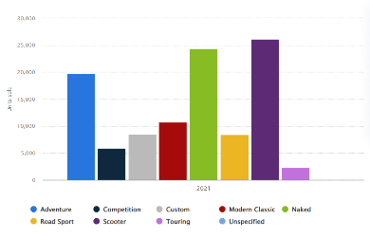

figure 1
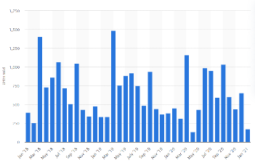
Volume of super sport motorcycle monthly sales in the United Kingdom between January 2018 and January 2021

Figure 2
The number of motorcycles sold in the UK by type
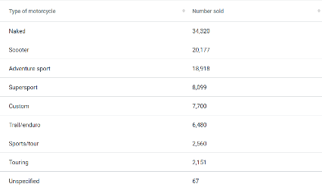

Figure 3

Sports bikes are not selling as well as they used to. There has been a steady decline in sales of sports bikes of 2% +- 0.05 since 2018. In the same time frame, the standard bike has been selling two to three times better.
Standard motorbikes have an ergonomic riding position which falls between the forward rotated position of a sports bike and refined arrangement of a cruiser putting the rider in a very natural position. These bikes offer a middle ground of performance and comfort.

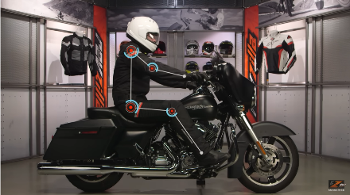
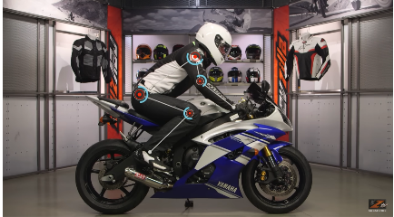
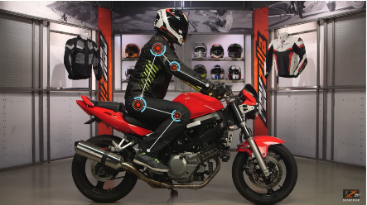
figure 4 figure 5 figure 6
The success of the standard bike tells me that the consumer sees the middle ground between performance and comfort as the perfect bike for the streets. This perfect bike would have the performance of a street bike and the comfort of a cruiser. In the real world this is impossible because the riding position which makes the cruiser so comfortable creates a lot of drag due to its upright nature and does not put enough weight over the front tier, these are both critical to the performance of the sport bike.
So the standard bike has changed the riding position and found a middle ground. I believe that technology can help make a bike better suited for day-to-day usage without compromising its performance.
The decline of sports bikes sales and the recent prosper of the standard bike sales tells me that customers who have previously owned a sports bike are now opting for a standard bike instead. A lot of these riders miss their sports bike and, in many cases, buy a new one or buy a track bike. I believe that if we can make a sports bike that is better suited to day-to-day riding not only would we dominate the sports bike competition, but we would win back some of the standard bike market.

The project
Specifically, new software in the information displayed to a rider. Sat nav systems have been in cars for decades and have been in cruiser bike such as the Honda gold wing. There is a large market for satnav systems for bikes. The technology exists and the demand exists, so I see this a massive opportunity to give the consumer what they want.

Engineering team structure
The team that I would need to complete this project would be as follows.
Sponsor (executive position acts a link between the project group and the company)
A Sponsor. The sponsor is my executive position on this project. They will be my link between the project and the company. This is the person that would have pitched the idea and is the person who gives the blueprints and timeframes to the project manager.
A Project Manager. The project manager would be a day-to-day operational management role. They would receive the plans and timeframes from higher up and their role is to make sure it all happens.
They Engineers. The engineers on this project are electrical engineers, there job is to get the work done in the time frame given to them by the project manager.
Health and safety. The heath and safety department are here to make sure the end product and everything before that is safe. They will do this by running risk assessments.
The Technical director. The technical director is bigger than this project, they oversee putting together the whole package. They will consult the sponsor and other projects to make sure that our project isn’t interfering in a negative way on any of the other projects and visa versa.

Health and Safety
There would be no touch screen to avoid distracting the driver. Directions would be displayed clearly alongside standard information such as revs, speed, range and the time.
The system would have apple car play and android auto connectivity which will enable the use of maps and audio playing services.
Tests should be done to work out the least distracting and easiest to use layout of the new buttons.
Some may say that it takes away from the authentic and raw experience of a sports bike but this is a easy issue to resolve with different modes we would have a wet mode a normal/commuting mode and a sports/track mode.

References

UK: Motorcycle types sold 2021 | Statista figure 1

Supersport motorcycle monthly sales 2018-2021 | Statista figure 2

Motorbike statistics (finder.com) figure 3

