Research in Context
(ADAD5003)
Rebecca Davies

Question 5: From the Lens-Based Image Making research strand lectures, choose a theme, movement, or selection of artists that relate to your practice or interests, and construct a 2,500-word essay. Critically assess primary themes, key writers, and relevant practitioners.

Has photography ever preserved memory, or has it always been a means of representation?

Word Count: 2500

Photography is often recognised as a tool for capturing memories, traces and moments that might otherwise disappear. However, many theorists argue that photographs do not record the reality around us, they create a new meaning whereby personal perceptions are seen as ‘truth.’ They act as representations that shape the way we understand experiences, identity, and the past. This essay will explore the tension between memory and representation, in which I will question whether photographs can ever function as traces of memory or whether they will always rely on cultural and social interpretations. To explore this theme, I will use three key theorists: Susan Sontag, Stuart Hall, and John Tagg. Each theorist discusses the relationship between photographs and society, arguing that images are seen as form of representation rather than ways of capturing historical remnants and personal memories. I will also analyse three artists: Sophie Calle, Christian Boltanski and Don McCullin.
Stuart Hall’s (1997) theory of representation explores why photographs cannot be described as direct traces of reality or memories, whereby he argues that meaning is produced rather than discovered within the images. As Hall states “images...are still signs. They carry meaning and this has to be interpreted” (Hall, 1997, p. 19). This suggests that while photographs may hold their own meaning, we as viewers can never truly know what the original meaning was. A photograph does not automatically communicate truth, as its meaning is entirely dependent on how viewers read and understand it. In summary, a photograph only communicates a constructed meaning which has been shaped by our individual experiences, culture, memory, and identity. This point is furthered by Hall stating that “representation...is not about a ‘true’ reflection or imitation of reality” (Hall, 1997, p. 59). This highlights how photographs display a meaning that is always constructed by society. For example, when we look at an image of someone that has passed, we are not directly seeing their presence, but we are viewing a representation of that person. This theory is key when understanding the themes of memory, grief, and loss, as this argues that historical photographs are just simply fragments of reconstructed meaning shaped by the viewers. This leads to the question; if representation always shapes memory, can a photograph ever be a true trace of memory?
While this could suggest that photographs emotional and symbolic significance is created by the viewer, it does not account for the fact that photographs still hold their own original meaning. However, an overwhelming number of interpretations can obscure that meaning, rather than reflect it, creating a distance between the photograph itself and the viewer. I believe that while interpretation may shape an image meaning, it does not entirely erase its connection to its original presence.
Susan Sontag (1977) strengthens this debate, whereby she argues that photographs freeze moments and separate them from the lived experience that is being photographed. Sontag explains that “photographed images do not seem to be statements about the world so much as pieces of it, miniatures of reality” (Sontag, 1977, p. 4). Sontag reduces the complexity of photographs themselves, whereby she states images offer only fragments of a genuine experience. She suggests images do not preserve memory, rather they simplify reality into one moment that is easier for viewers to digest. Sontag discusses how photographs have become trusted pieces of evidence, whereby she argues that “photographs furnish evidence...something we hear about but doubt, seems proven when we are shown a photograph of it” (Sontag, 1977, p. 5). This highlights how photographs have gained authority and power, despite only containing a single moment of the experiences. This means that images are subjective, changing their meaning based on context, personal views, and societies interpretations. It can be argued that constructed meaning will overtime replace the true memory, becoming the version that is remembered. Leading to the conclusion that no image holds true value, instead it becomes a symbol of false moments. This suggests that images are unreliable and cannot truly display traces of the past without viewers perceptions distorting its original meaning. Overall, Sontag’s critiques state that photography aims to replace lived memory with false representations rather than preserving the past itself.
This is argued against by Marianne Hirsch (2012), who explored the concept of postmemory to describe how memories of traumatic events can be experienced by those who did not directly live them. Hirsch states this is done through images, stories, and culture, whereby she explains “memory can be transmitted to those who were not actually there to live an event” (Hirsch, 2012, p. 106). This suggests that photographs can hold onto memory after the original moment is captured. In contrast to Sontag’s idea that representation creates emotional distance, Hirsch implies that photographs become everlasting vessels for memories that sustain emotional connections years later.
Furthermore, Roland Barthes (1980) offers another perspective. Whereby he famously describes photography as tools for proving something once existed. Barthes says, “every photograph is a certificate of presence” (Barthes, 1980, p. 87). While this suggests photography holds a strong connection to the past, it does not definitively argue that they preserve it. Instead, it highlights that images show something once existed, rather than holding onto emotions, meanings, and memories. Therefore, Barthes suggests photography is linked to the past rather than directly connected to it.
John Tagg (1988) extends this discussion by focusing on how the meaning of a photograph is shaped by institutions. Whereby he states that “This is not the authority of the camera but of the apparatus of the local state which guarantees the authority of its images” (Tagg, 1988, p. 150). This states that photographs only become evidence when institutions such as media, archives or governments deem them so, suggesting that photographic meaning is not only subjective to the viewer but is constructed by institutions. This argues that photographs are not a vessel for memories, they only represent the idea of a memory. Furthermore, Tagg challenges the idea of a photographs true meaning, whereby he states that “every photograph is a result of specific and , in every sense, significant distortions which render its relation to any prior reality deeply problematic” (Tagg, 1988, p. 2) This argues that meaning and memory are created rather than stored within the image itself. Further suggesting images cannot display a direct view of reality or moments, due to the fact they are shaped by contexts, institutions, and personal ideologies.
In comparison, Tagg and Benjamin show a clear tension between institutional control and emotional experience within photography. Walter Benjamin (1935) complicates Tagg's argument on institutional control, whereby he explores the idea that photographs meaning can sustain itself beyond the structures of control. Benjamin’s concept of aura suggests that it was the mass production of images that diminish the sense of authenticity and uniqueness that was maintained in the earlier forms of photography. Benjamin's focus is on the idea of ‘aura,’ which is tied to the photograph's connection to a specific moment or place. He explores the emotional aspects an image can carry. Despite this mass reproduction, he argues that photographs in a modern sense are still not entirely void of meaning, whereby he states certain images can evoke presence or memory without their original contexts.
Overall, these theorists display photography as a system of representation rather than a vessel for memories, whereby photographs are thought to only offer fragments of meaning distorted by society’s interpretations. Despite these convincing arguments, they do not recognise the idea that photographs still hold meaning within themselves. While I agree meaning can be shaped by culture, society, and contexts, this does not remove it embedded significance. A photograph can carry a trace, whether its presence is fragmented or not. However, there is still the question of whether an image can hold emotional, historical, and personal connections without giving viewers a direct link to the lived experience it records.
The tension between understanding photography traces of the past and viewing it as a form of representation raises important ethical and emotional questions. For instance, if photography is primarily viewed as being constructed images that are shaped by context, interpretation and institutional control, then there is the possible issue that experiences of trauma, loss and suffering become reduced to the idea of just being symbols rather than being recognised as documentation of real encounters. Therefore, disconnecting viewers from the emotional value of photographs. While theories of representation are essential for arguing how meaning is shaped and viewed, they could also overlook a photographer's responsibility within the act of photographing. In theory, if photographs cannot preserve memory exactly as it was, they can remain connected to the moments of presence, time, and experiences. To ignore this link means to risk detaching photography from true human experiences. Therefore, a photograph stays in-between that tension, whereby meaning is shaped by its viewers, but also remains connected to what it originally was. I will be exploring this idea through photographers such as Don McCullin, Sophie Calle and Christian Boltanski.

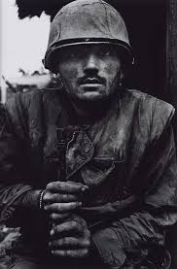
Shell-shocked US Marine, The Battle of Hue, 1968, Don McCullin.

A documentary photographer, Don McCullin (Klein, 2013), who is well-known for documenting war, poverty and human suffering, is often referred to as producing truthful images of conflict. However, within this essay we will question whether his work constructs meaning or simply preserves the captured event. His famous work of Shell-shocked US Marine, The Battle of Hue (McCullin, 1968), is described as a raw expression of trauma, whereby it captures a young US marine frozen in a moment of shock and vulnerability, using framing and contexts to capture trauma rather than action. This demonstrates how documentary photography can carry emotional memory and human presence.
McCullin explains “sometimes it felt like i was carrying piece of human flesh back home with me, not negatives” (O’Hagan, 2010). This highlights that images carry memory and emotional value, in which they transform lived experiences into visual traces. However, Tagg (1988) argues that McCullin’s images have only gain their significance from being published in newspapers and magazines, whereby they become symbols of war rather than personal or collective memories. Sontag's (1977) theory critiques war photography by arguing that repeated exposure to suffering can numb viewers rather than create empathy. McCullins adds “It’s as if you are carrying the suffering of the people you have photographed” (O’Hagan, 2010). This reinforces the idea that memory is rooted in both the act of photographing and the image itself. However, while he intended to witness these experiences by capturing the trauma around him, it could be argued that his images inevitably contributed to creating contexts rather than the recording of them.
McCullins work directly fall on the line between representation and holding traces, whereby it could be argued either way that while his work is a historical symbol of trauma, holds emotional value to McCullins himself, This suggests that memories embedded within photographs are only accessible to those connected to the traces themselves.

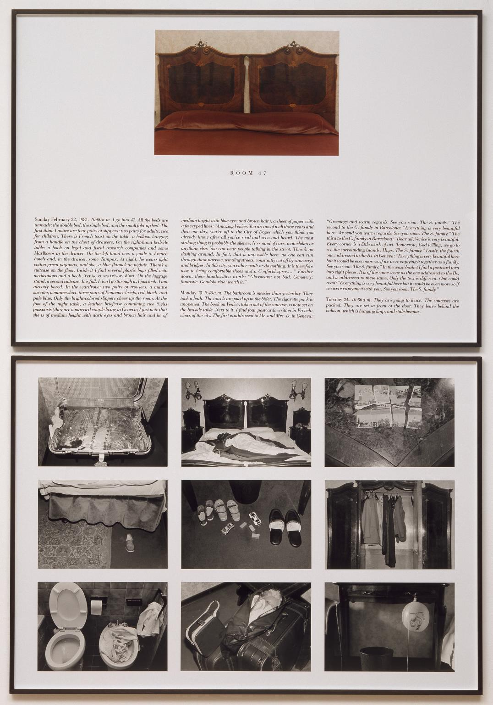
The Hotel, Room 47, 1981, Sophie Calle.

On the other hand, Sophie Calle’s (Rowlands, 2021) work demonstrates how memory is constructed through a more personal approach to photography. Calle’s photographs capture absence, whereby she uses objects and spaces to suggest emotional presence without a direct visual narrative. The Hotel (Calle, 1981) consists of photographs from hotel rooms while the guests are not present. This documents their personal belongings, used items and individual traces.
This process of work creates symbols that support imagined stories based on the viewers interpretations, rather than documenting lived moments. This is furthered by the quote, “Everything that Calle-or any of her viewers- see is always, inevitably shaped by what they ‘wished to find.’ Each room, in this sense, is the ‘empty room,’ a place in which we make something out of nothing” (Calle, 2009). Both photographers and viewers project their own assumptions, emotions, and narrative onto images, suggesting that memory is collaborative and fluid rather than fixed. This highlights how interpretation plays a key role in terms of photography and meaning.
This is explained further through Hall’s (1997) theory that photographic meaning is created through framing and context rather than truth. Calle’s careful selection and descriptions of her work transform them from ordinary rooms to emotionally charged spaces shaped by interpretation. Despite this view, some argue that “Rather than erase the residue of human presence, Calle ‘preserves every stain and scrap as a sign of symbol’” (Calle, 2009) This suggests that objects and spaces act as carriers of memory, whereby photography does not replace lived experiences, but preserves remnants of it. This leads to the idea that traces are only assumed to be absent or created from interpretations because the viewers are unable to see an photographs true value.

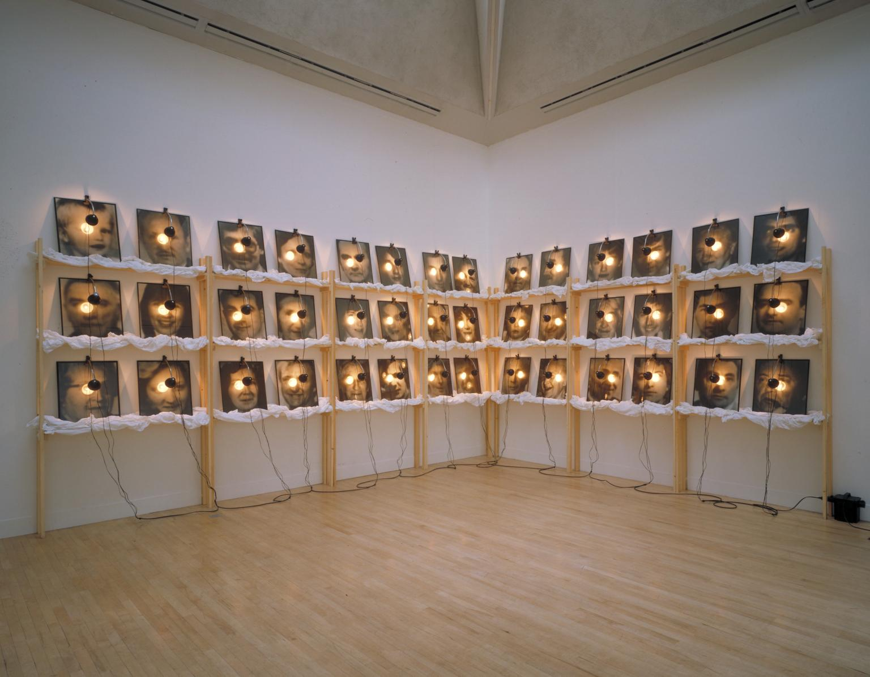
The Reserve of Dead Swiss, 1990, Christian Boltanski.

Christian Boltanski’s (The Dissertation Ramble, 2013) work explores memory, loss, and archival material, whereby he often uses photographs to explore how remembrance is constructed. He explores how photographs act as symbols of constructed memory rather than preserved moments. In his work, Reserve The Dead Swiss (Boltanski, 1990), he displays anonymous portraits through an installation. Whereby he removes all personal contexts, transforming individual experiences into collective traces of the past.
Boltanski’s work is a notable example of how photographs lose their individual identity when their original contexts are removed, whereby his way of presenting the work transformed the images into symbols of absence rather than traces of the individual presence. In which images become more a system of representation rather than a carrier of memories. Boltanski describes this process by stating that “they are simultaneously present and absent. They are both an object and a souvenir of a subject” (Boltanski, 1989). This explains how an image can act as a trace of human existence, as well as being an object of representation. Although, it also suggests that images can represent memory without directly holding fragments of it, but they can never hold memory without also becoming an object of representation.
This is supported by Marianne Hirsch’s (2012) concept of post memory, whereby she suggests that remembrance is shaped by images and stories rather than genuine experiences. Highlighting that viewers can form emotional connections to photographs because meaning is generated through symbolic memory rather than personal links. This strengthens the distance between a lived memory and its visual representation.
In conclusion, photography is undeniably a system of representation. There is a solid foundation within the idea that photographs will always function through interpretation, contexts, and cultural meaning. However, this does not discount what a photograph is or what it does. I believe that, regardless of how an image is interpretated, it still holds a direct connection to the moment it captures, whereby it preserves traces of time, presence, and memory. Although representation can shape how viewers perceive an image, it does not erase the significance within the photograph itself. I would argue that the difficulty of understanding a photographs true meaning mimics the state of memory itself rather than its absence, whereby like a memory, a photographs meaning is fragmented and personal. This highlights that images can hold onto past traces despite societal interpretations. Therefore, photographs work within the tension between being a representation and carrying historical remnants.

Reference List
Barthes, R. (1980). Camera lucida : reflections on photography. New York: The Noonday Press.
Benjamin, W. (1935). The Work of Art in the Age of Mechanical Reproduction. [online] New York: Schocken Books. Available at: https://web.mit.edu/allanmc/www/benjamin.pdf.
Boltanski, C. (1989). The White and the Black: an Interview with Christian Boltanski. [online] Parkett. Available at: https://static1.squarespace.com/static/5e614fa6565bfc04478be7be/t/5f7df1d7d9d99b75ccaf7999/1602089437026/Boltanski+Christian+conversation+Parkett+22.pdf.
Boltanski, C. (1990). The Reserve of Dead Swiss. [Online Image] Tate. Available at: https://www.tate.org.uk/art/artworks/boltanski-the-reserve-of-dead-swiss-t06605.
Calle, S. (1981). The Hotel, Room 47. [Online Image] Tate. Available at: https://www.tate.org.uk/art/artworks/calle-the-hotel-room-47-p78300.
Calle, S. (2009). Sophie Calle Interview. [online] Electronic Arts Intermix. Available at: https://www.eai.org/user_files/supporting_documents/calle_interview_0509_2.pdf.
Hall, S. (1997). Representation: Cultural Representation and Signifying Practices. London: Sage.
Hirsch, M. (2012). The Generation of Postmemory: Writing and Visual Culture After the Holocaust. New York, N.Y.: Columbia University Press.
Klein, R. (2013). Shellshocked US Marine, Hue, Vietnam – Don McCullin. [online] Camera Historica. Available at: https://histheoriculture.wordpress.com/2013/01/19/shellshocked-us-marine-hue-vietnam-don-mccullin/.
McCullin, D. (1968). Shell-shocked US Marine, the Battle of Hue. [Online Image] Tate. Available at: https://www.tate.org.uk/art/artworks/mccullin-shell-shocked-us-marine-the-battle-of-hue-ar01201/don-mccullin-on-shell.
O’Hagan, S. (2010). Shaped by War: Photographs by Don McCullin | Photography Review. [online] The Guardian. Available at: https://www.theguardian.com/artanddesign/2010/feb/07/don-mccullin-shaped-war-review [Accessed 7 May 2019].
Rowlands, L.O. (2021). Sophie Calle and the Art of Leaving a Trace. The New Yorker 100.
Sontag, S. (1977). On photography. New York: Picador.
Tagg, J. (1988). The Burden of Representation. London Macmillan Education Uk.
The Dissertation Ramble. (2013). Christian Boltanski, The Reserve of Dead Swiss, 1990. [online] Available at: https://thedissertationramble.wordpress.com/2013/10/13/christian-boltanski-the-reserve-of-dead-swiss-1990/.

