

UBER

MODULE: ENTREPRENURSHIP LCBB 5001
STUDENT: SILVIU MUJEA 2019254
LECTURER: VASILIOS TAVLARIDIS.

TABLE OF CONTENTS

1.INTRODUCTION ……………………………………………………………….. .3
2 THE FOUNDERS: VISION AND SKILLS……………………………………….3
3 UBER ‘S IMPACT ON THE UK ‘S ECONOMY…………………………….......5
A How Does Uber Work?............................................................................6
. B. Riders ………………………………………………………………………….7
C.Drivers ……………………………………………………………………….....8
D.Communities …………………………………………………………………..9
E. Economic Impact …………………………………………………………...10
4 CONCLUSION ………………………………………………………………….. 10
5.REFERENCES …………………………………………………………………..11

- INTRODUCTION
This report is going to present a short history of Uber, the entrepreneurial skills and motivation of the founders: Travis Kalanick and Garrett Camp in the first part and analyze the impact of the company on the economy of the United Kingdom.
- THE FOUNDERS : VISION AND SKILLS
Uber began its adventure in 2008 in France, Paris. Travis Kalanick and Garrett Camp were at LeWeb, an international technological conference described by The Economist as "where revolutionaries convene to anticipate the future." In 2007, both men sold their co-founded businesses for large amounts of money. Kalanick sold Red Swoosh to Akamai Technologies for $19 million, while Camp sold StumbleUpon to eBay for $75 million (EBAY).

Garrett Camp in 2018, Garrett Camp - Wikipedia
Garrett Camp is a native of Canada. In 1978 he was born in Calgary, Alberta, to a father who was an economist and a mother who was an artist. He completed his engineering education at the Faculty of Calgary after an uneventful adolescence. He was a decent student who didn't go out much and spent most of his time learning about collaborative information systems and the semantic web, sometimes known as "natural language."
Garett Camp has always been driven by his business mentality. His mind is buzzing with ideas, and he's started a project to build a smart web. It is a web in which all information is saved and selected without the need of keywords and is instead comprehended directly by the computer. After that, the latter can deliver a far more accurate response. It was the topic of his master's thesis. He came up with the idea for StumbleUpon while working on his thesis. StumbleUpon means "meet by chance." He moved to the United States after college, looking for investors to help him launch his own company. He is able to raise finances and grow the firm with the help of his buddies. In the years since its inception, StumbleUpon has grown to over 2 million members. The business was even included in a list of the top 50 websites. eBay is interested in society since its business is so profitable.

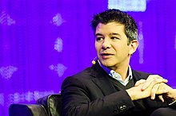
Travis Kalanick, former CEO of Uber , in 2013,
Travis Kalanick, the president, and Chairman of Uber identified "finding the magic" as one of eight attributes of successful founders in a crowded Wong Auditorium on Dec. 2. According to him, Uber gives "magic" to clients by providing tranquil, delightful experiences that save time and money. He said, "We get used to magic." "Once upon a time, running water was magical." "Customer expectations are constantly rising," Kalanick explained. "You have to continue to match those rising expectations for the enduring firm, for the enduring entrepreneur."
Purpose "It involves first figuring out who you are, what you're good at, and what you're not," Kalanick explained. "Then, when you come up with your concept, it takes on a greater significance for you." According to Kalanick, Uber's aim is much more than simply making money by carrying customers from place A To place B Uber, he claims, "celebrates the city," works to reduce traffic, and sees future cities where transportation is "push-button efficient" despite of economic status, while also providing lots of jobs.
Uber was founded on the following vision "I want to touch a button and receive a ride... and let's make it a classy ride." Initially, the creators regarded Uber as increasing their own way of living, but it quickly evolved into delivering a better transportation experience: according to Travis (the traditional taxi sector was strange and dull. Furthermore, at Uber's fifth anniversary, Travis envisioned the company assisting cities in having safer roads, less traffic, and being economically beneficial to them (Lashinsky, 2015). As a result, five years after the introduction, a vision is still relevant. There was also a personal touch.
The founders are described as "casual and passionate" by a former intern (Lashinksy, 2012). Travis is praised for his ability to listen to others, but he still has his own beliefs. Travis also appears should be competent at juggling his work and his personal life: "balance between strategy and execution" and "know when to work hard, when to play hard" are two examples (Kalanick, n.d., p. 1). Garrett is described as enthusiastic, unrealistic thinker, a partner, a talker, critical, upbeat, and people-oriented, and strategical by various people (Camp, n.d.). Garrett is a people person, according to Camp (n.d., p. 1), who says that he "motivates others... puts people first... makes staff happy." "A continual idea stream... full of ideas" is the foundation of becoming an idea generator (Camp, n.d., p. 1). Furthermore, strategical comes from the phrase "conscious of business difficulties... sets out to solve them."
- UBER ‘S IMPACT ON THE UK ‘ S ECONOMY
Since its introduction in the United Kingdom in 2012, Uber has expanded to over 40 cities around the country, including over 60,000 drivers as well as an estimated five million riders utilizing the platform on a regular basis. Aside from expanding its presence within UK, the business has also extended to look at new ways to boost mobility, such as e-bikes, automobile rentals, and real-time public transportation data integration.
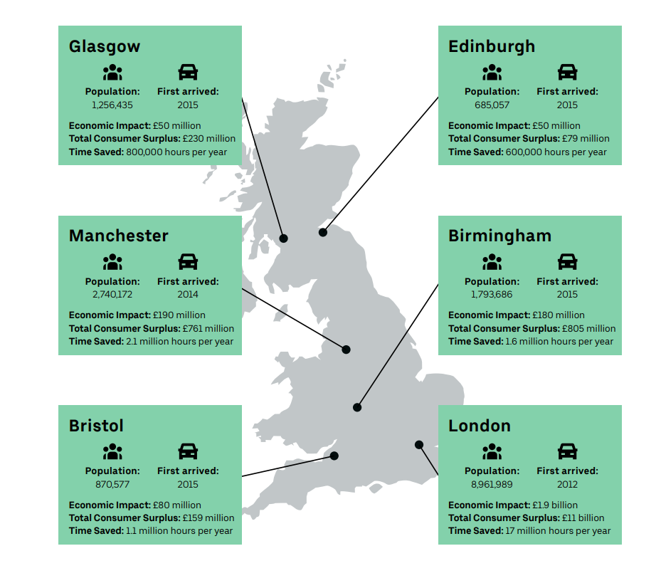
A.How Does Uber Work?
Uber is a transportation network that links drivers and passengers.

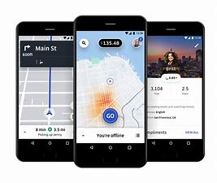
Source: Uber

The Uber app provides information about their chauffeur, containing their name, vehicle type, and registration plate. It helps in tracking your driver's location, evaluate the status of your trip, and share your exact location with companions and relatives.
Uber offers chauffeurs a network through which they may make extra cash when it is suitable for them. Self-employed professionals have the flexibility to set their own hours and work for a number of businesses or websites.
As soon as a journey is completed, costs are generated and billed to the rider's authorized form of payment.
The software saves time and generates new demand by making urban transportation more convenient and adaptable.
Thousands of drivers are employed in the entertainment and hospitality industries collaborating with Uber
• According to Public First, Uber generated more than three billion pounds in economic value in 2019.
• A million journeys in a city generate £12.5 million in local revenue.
• Uber is increasing the nighttime industry by making it simpler for clients to travel past midnight, bringing in £164 million.
• The time saved by taking Uber to get to work is projected to be worth £41 million.

B. Riders

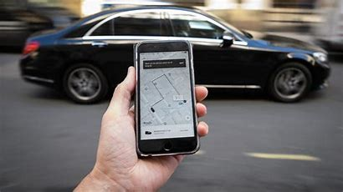
Source: ktsm.com

In England, the average person travels for almost 400 hours every year, making 986 journeys and traveling over 6,000 miles. That would be more hours than we dedicate to everything other than napping, working, and watching television. By doing travel faster and more comfortable, Uber makes it simpler for people to catch up with old friends with friends and family, do business, or go further for a career.
While many observers presume that the primary reason for utilizing Uber is to save money, users overwhelmingly stated that it is for convenience.
• People from many walks of life are utilizing Uber to assist them in their daily lives and work. In the last year, almost a third of riders (32%) claim they utilized Uber for occupational journeys. Uber was utilized by 49% of people when they were not home or overseas, and 19% when they needed to get to or from the doctor or hospital. 90% of Uber consumers say convenience is a big factor in their choice to use the service. Uber's total consumer surplus, or the amount you'd have to pay someone to give up an item or service in exchange for money, is around £13 billion, or 0.6 percent of GDP.
• Uber saves riders an estimated two billion minutes each year, which is about 80% of the value promised by High Speed 2. Uber saves round 1 / 4 of the time that the following great opportunity could have taken, consistent with riders.
• Since the launch of Covid-19, 85 percent of individuals who have used Uber have indicated they were satisfied with their experience, and 83 percent have said they experienced a feeling of safety, almost half of Uber riders (48%) saying they've utilized the service since the shutdown began.
C.Drivers

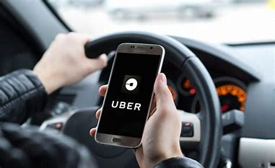
Source: andywins.com

When a driver transports a passenger to their destination, he or she is paid a fare. They are under no obligation to accept a trip given to them via the the app, and they have the option to ignore or reject any trips they do not wish to take at any time.
One of the main reasons why people prefer platform work is because it allows them to be more flexible. In the private rental industry as well as many other industries – such as delivery – drivers frequently earn money from various operators and applications.
As they work, drivers incur a variety of expenses. This covers the cost of purchasing or financing their vehicle, as well as ongoing expenses (such as insurance, gasoline, and repair) and any taxation or road fees.
Drivers largely choose Uber as a partner because of the freedom it provides, as well as the option to set their own hours. Seventy eight percentage of Uber drivers say they might propose the app to a chum looking for a comparable kind of bendy job.
Uber drivers earn an extra £231 million in total, or an average of 17% more than their next best alternative, according to Public First polling. 40% of drivers indicated they quit their previous employment because they wanted more flexibility or because they valued the chances Uber provided.
Working on the platform enables 79 percent of folks with caring obligations with much more freedom than their previous or other occupations. Flexibility was cited by 89 percent of drivers as the most critical factor in their decision to use the Uber app to drive. Even if the alternative was a 20% salary increase, the majority of drivers polled would prefer to keep their privilege to establish their own hours, parents accounting for 87 percent of all drivers. (Uber Opens Up Platform To Non-Limo Vehicles With 'Uber X,' Service Will Be 35% Less Expensive, n.d.) (Isaac, n.d.)
• Every day, 80,000 discussions take place in which a chauffeur and a customer learn something from one another. 75% of drivers stated they had fascinating talks with passengers on most days, and 66% said they learn something on most days.
• Over half of Uber's drivers are members of the minority community. Thirty percent of drivers are over the age of 45, and fifteen percent are over the age of 50.
D.Communities

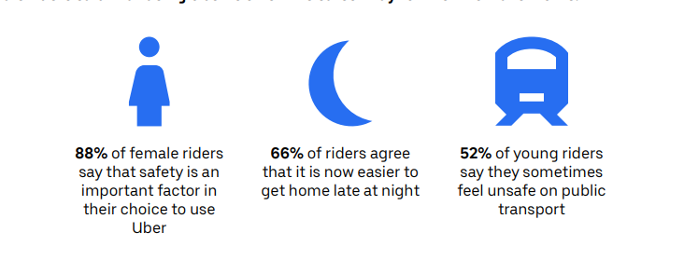
Source: Uber

Prior to Uber, getting a ride may be problematic, if not incredible hard finding a taxi or minicab late at night - and taking it. To get to public transportation, people had to walk a great distance in the dark.
Furthermore, cabs were frequently more difficult to come by in economically depressed areas or locations with a high level of social deprivation. Most riders (54%) agreed that. It would be different if services like Uber didn't exist.
After convenience, riders cited safety as the second most significant reason they valued Uber. sixty-five percent.
Uber is frequently the safest mode of transportation for female riders, according to them.
E. Economic Impact
This evaluation uses a procedure like Public First's consumer estimate of time saved, based on the proportion of recent journeys utilized for "Commuting to or from work," to arrive at an estimate of time saved the proportion of travels taken for business objectives.
The average of Web Tag’s values for leisure and working time is used to calculate time saved.
Economic Impact in Total
• Driver payouts are added together to get the total economic impact.
• Driver expenditure on vehicles has an indirect and induced impact.
• Increased driver income has a reduced influence.
- CONCLUSION
This is a rough estimate of the entire number of financial conceived as a way by Uber in the United Kingdom. It makes no attempt to estimate what would happen if Uber was no longer available. Making cities great places to live is just as vital as stimulating the economy. Uber, carpooling, and electric bikes are among the new technology that are making it simpler to move about and lowering traffic congestion.

5.REFERENCES

Andy Citrin Injury Attorneys. (2019). Who Is Liable When an Uber Driver Caused My Injuries? [online] Available at: https://andywins.com/blog/who-is-liable-when-an-uber-driver-caused-my-injuries/ [Accessed 1 Apr. 2022].
Blystone, D. (2021). The story of Uber. [online] Investopedia. Available at: https://www.investopedia.com/articles/personal-finance/111015/story-uber.asp. [Accessed 1 Apr. 2022].
Cohen, P., Hahn, R., Hall, J., Levitt, S., Metcalfe, R., Angrist, J., Chen, K., Doyle, J., Farber, H., Krueger, A., Lewis, G., Meer, J. and Weyl, G. (2016). NBER WORKING PAPER SERIES USING BIG DATA TO ESTIMATE CONSUMER SURPLUS: THE CASE OF UBER We are grateful to. [online] Available at: https://www.nber.org/papers/w22627.pdf. [Accessed 1 Apr. 2022].
Graham, D.J. and Gibbons, S. (2019). Quantifying Wider Economic Impacts of agglomeration for transport appraisal: Existing evidence and future directions. Economics of Transportation, 19, p.100121.

Hanley, S. (2019). $649 Million Fine For Uber In New Jersey As Gig Economy Faces Pushback From State & Local Governments. [online] CleanTechnica. Available at: https://cleantechnica.com/2019/11/16/649-million-fine-for-uber-in-new-jersey-as-gig-economy-faces-pushback-from-state-local-governments/ [Accessed 3 Apr. 2022].
KTSM 9 News. (2017). Uber offering ride discount for last minute shoppers. [online] Available at: https://www.ktsm.com/news/uber-offering-ride-discount-for-last-minute-shoppers/ [Accessed 1 Apr. 2022].
‌MIT Sloan. (n.d.). Uber CEO’s eight traits of great entrepreneurs. [online] Available at: https://mitsloan.mit.edu/ideas-made-to-matter/uber-ceos-eight-traits-great-entrepreneurs. [Accessed 1 Apr. 2022].
Uber Blog. (2019). Where does Uber operate in the UK? | Uber Blog. [online] Available at: https://www.uber.com/en-GB/blog/where-does-uber-operate-in-the-uk/.[Accessed 2 Apr. 2022].
‌ Wikipedia. (2022). Garrett Camp. [online] Available at: https://en.wikipedia.org/wiki/Garrett_Camp. [Accessed 1 Apr. 2022].

