

Ham Cutter - Role Play

Module Code: LCBB4002
Assignment Title: COMMUNITY ENGAGEMENT
Module Lecturer’s Name: Mohamed Kalam

Student Name: Simona Mocanu
Student ID: 1905164

Table of Contents
Introduction 2
Overall Scenario 2
Job Role 2
Understanding the Concept of Reflective Practice 3
Role Play 7
Script 7
Reflective Statement 8
Reflective writing……………………………………………………………………….…….9
Reference 10

Introduction
The aim of this report will be to prepare a role play for the post of ham cutter in order to explain the element of the role. The concept of reflective practice will be followed in this report, where a brief explanation of the role play will be provided. At the end, a reflective statement will be provided where the feedback received will be taken onto account, where what went well in the role play.

Overall Scenario
From the previous assignment, it can be stated that Enrique Tomas, the 40 year old outlet from Spain and specialised in providing different foods produced by ham, and are well known as the best ham providers in the regions where they operate their business. It has been widely found in various researches and studies that hospitality is one of the most competitive business sector among all other business sectors in the world. According to me, the competitive edge is gained over other institutions in the same business sector by providing superior quality ham to the customers in the market places where Enrique Tomas operates their business. This has attracted new people towards them and the prospects has turned to customers, and the management has successfully retained them to earn maintain the revenue darning of the company along with providing superior quality ham and meeting the needs and requirements of them. Apart from providing ham, the outlet also provides cheese, wine and other products. But from the previous assignment done by me, it can be stated that ham along with the cured meats are the most sought after products for the organization of Enrique Thomas.

Job Role
The selected job role for this assignment is the role of a ham cutter, who plays one of the most integral parts in this organization and probably the most important role among all other employees of this business house. It has been already said by me in the previous assignment that proper training is provided to the ham cutters of this organization, so that the meats cab is cut according to the requirements of the customers, and in this way they have successfully met the requirements of their customers.
Internal skills are very much important for a ham cutter to cut the meat into appropriate pieces and trim them properly, so that it will be able to satisfy the needs and requirements of the customers (Zheludkov and Akulenko 2014). This will help the organizations like Enrique Tomas, whose main attraction is to provide high quality ham to the customers of this 40-year-old organization. The overall packaging of the meat needs to be made attractive and this is only possible with properly trained ham cutters. Proper concentration is very much important in this job as usage of grinders, knives and other dangerous objects are required in the ham cutting process. Apart from this, excellent eye-hand coordination is required for this job role, which will help to cut the meat into perfect pieces and accidents may occur without losing the concentration and improper coordination between hand and eye. Customer service depends entirely on the overall cutting process of the meat, and the same is perfectly done by the ham cutters who work in the outlets of Enrique Tomas around the world (Walsh and Mann 2015).

Understanding the Concept of Reflective Practice
In this context, it can be said that reflective practice will be used in this paper, which will help to reflect the actions of the ham cutter along with other personalities, who all will be engaged in the role play, the details of which will be discussed in this paper. The reflective practice will help in the continuous learning (Pyles 2013). The principles of reflective practice helps to improve the critical understanding of the practices of their own along with the continuous improvements or development of the required knowledge, skills and approaches in order to acquire the best outcomes or results which will help to sustain in this global competitive market place, which includes the hospitality sector as well (Bulman and Schutz 2013).
There are many models of reflective practice that has been designed or created to provide guidance reasoning in the context of actions that are taken by the respective personalities in their respective fields.
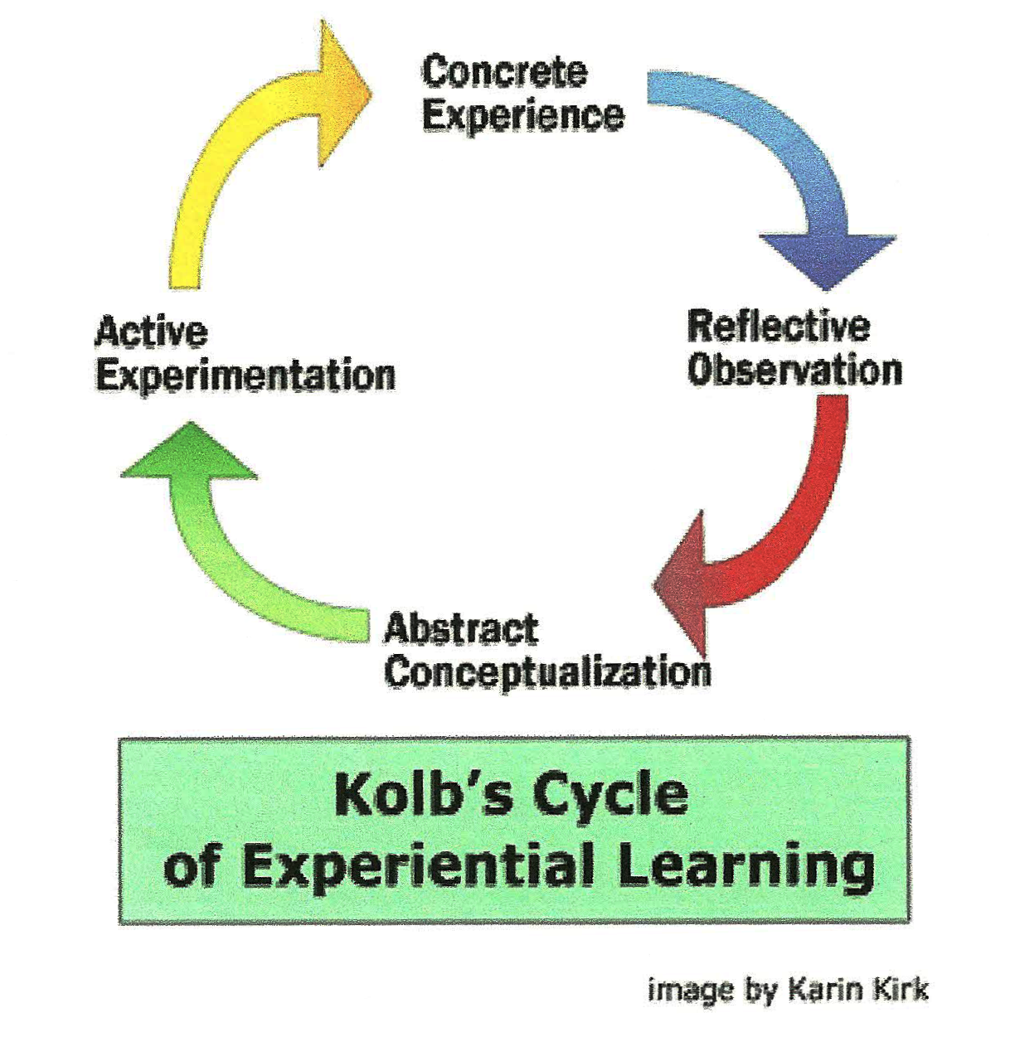

In the above diagram, it can be stated according to me that this model which is designed by David A. Kolb, highlights the overall concept and ideas of experimental learning. This is mainly centered or situated on the transformation of the overall information into knowledge (Atkins and Schutz 2013). Usually this happens after occurrence of a situation, and helps the practitioner who reflects all the actions based on the experiences gained by them, which involves the process of gaining a normal understanding of the overall concepts which are faced during the time of gaining the experiences. These general understanding are then tested in fresh situations or scenarios. The knowledge is thus formed from occurrence of a particular situation which is applied as well as reapplied on continuous basis, which are totally based on the knowledge and experiences that are gained by these practitioners on earlier basis (Malthouse, Roffey-Barentsen and Watts 2014).
Four distinct and different learning styles have been defined in this model. These are concrete experience, reflective observation, abstract conceptualization and active experimentation. Effective training strategies can be used by using this training style. It can be stated in this context that to gain the competitive edge over others, it is important to design effective training strategies so that the competitive advantage can be gained over the rival institutions of Enrique Tomas. The employees can be engaged in enhancing the skills through these active techniques and increase the responsibility factor of them. They are trained to take decisions by their own in complex situations, which will help to maintain the flow of the business operations that are followed by the management or owner of the business house of Enrique Tomas.
It can be stated in this context that the process of reflective practice is normally described as a semi-structured or unstructured approach which helps to direct the overall process of learning. According to me, it can also be stated that this a self-regulated approach or process which is mainly used in teaching and health related professions, though it can be said that this reflective practice can be applied in all the professions. A wide array of disciplines are used to teach the learning of reflective practice, which helps to improve the overall communication process and helps to take prompt decisions in the business environment, which, in turn, helps to possess the power to operate any kind of business operations in this modern global competitive world. The application of this reflective practice is gaining experience in this modern business environment as internal skills can be enhance during leaning of this process (Tsingos, Bosnic-Anticevich and Smith 2014).
It has been also seen that the use of reflective practice in the concept of environmental management has positive as well as negative implications in the business environment of an organization. The traditional environmental management has some drawbacks as it only focuses or aims on the problem which is on hand, and is unable to integrate the wider systems or processes into the overall decision making process of a business entity (Birhanu et al 2017). Sustainability can be maintained and followed by using the reflective approaches in all aspects of running a business, as it succeeds to gain the sustainable competitive advantage, which is very much essential for all the companies, especially the multinational organizations who has to operate their businesses in many regions of the world. Development opportunities are also provided in the positions of a leader, which helps the leaders to manage the overall business of their respective companies and improves the relationship between them and other colleagues and employees of those organizations (Schön 2017).

Role Play
The role play that will be played in this paper will involve the ham cutter and a client of a particular outlet. The examples which will be used to demonstrate the role play will involve managing a difficult customer.

Script
Client: Hello, good afternoon!
Ham Cutter: Welcome in our shop! How may I help you today?
Client: What is this ? I never see it in my life !
Ham Cutter: Let me introduce you the best ham in the world! We coming from Spain and this cured meet !
Client: Oh, Wow… Can I try it?
Ham Cutter: Yes, of course !
Client: Yes, is taste good, can I have 200 grams?
Ham Cutter: Yes, of course, but also you need to wait few minutes as it is hand carved
Client: No, I can’t wait, I want it now
Ham cutter: Oh, why you don’t take a look in our shop, for example on the wine’s , meanwhile iam cutting for you?
Client: No, no , I wanted right now!
Ham cutter: Ok for this we have fresh ham already packed if you like !
Client: Ok, give me two!
Ham cutter: Ok, there you go !
Client: Thank you, bye!
Ham cutter: Thanks to you, hope to see you soon!

Reflective Statement
According to me, the ham cutter try to offer a good customer service, be nice and have a nice conversation with an usual client without too much patience.

Peer evaluation Role Play Feedback Form

 | poor | ok | good | excellent
Introduction |  | # | + | *
presentation |  |  | + , # | *
conclusion |  |  | + | # , *
1.Good communication skills and listening skills towards clients needs and solving problem orientated. Showing more empathy to the client. (+)
2. Well done! Good introduction to the atmosphere of the store! Customer service good. (*)
3. Introduction could have been better, should have been front facingm but role was played very well as sales person because was trying to sell wine along with ham.
Any other comments

Reflective writing
In october last year, I start the studies being also a student who work full time. Was a pleasure for me to met new people and make new friends and share experience.
On Community Engagement we had to prepare two assignments with 2000 words each. In the second one we need to play a role and take feedback, wich I’ve found it stressfull being in front of class, but I think I was doing good in the end. I didn’t really wanted to do it and I didn’t find myself enough confident to do it this way I was choose to play the role with the back on my colleagues, even if they was not so happy . During the role play I get lost a little bit because who helped me to play the role was improvise all the questions.
Of course, finding time was also difficult to prepare all the work for the assignment as long as iam working 48 hours in 5 days. Was difficult, but not impossible! The experience was pretty nice for me and in the end I was surprised by my ability to focus on work and studies. I was thinking I will not gone do it until the end.
The first step is a little bit more difficult until you find the way, and after you will just gooooo !
Is like this for me, iam afraid in the begin, but after I see and I understand the concept is more easy to make baby steps.
In the future I will not push myself anymore to the limit, because more tired iam more stressfull iam feel and I will go on less hours to work also.
I can’t wait to start again ! I hope to do it better and improve myself more and more !

Reference
Atkins, S. and Schutz, S., 2013. Developing skills for reflective practice. Reflective practice in nursing, pp.36-63.
Birhanu, W., Weldegebriel, S., Bassazin, G., Mitku, F., Birku, L. and Tadesse, M., 2017. Assesment of microbiological quality and meat handling practices in butcher shops and abattoir found in Gondar town, Ethiopia. International Journal of Microbiological Research, 8(2), pp.59-68.
Bulman, C. and Schutz, S. eds., 2013. Reflective practice in nursing. John Wiley & Sons.
Lauren Caldwell RN, B.S.N., 2013. The importance of reflective practice in nursing. International Journal of Caring Sciences, 6(3), p.319.
Malthouse, R., Roffey-Barentsen, J. and Watts, M., 2014. Reflectivity, reflexivity and situated reflective practice. Professional Development in Education, 40(4), pp.597-609.
Pyles, L., 2013. Progressive community organizing: Reflective practice in a globalizing world. Routledge.
Schön, D.A., 2017. The reflective practitioner: How professionals think in action. Routledge.
Tsingos, C., Bosnic-Anticevich, S. and Smith, L., 2014. Reflective practice and its implications for pharmacy education. American Journal of Pharmaceutical Education, 78(1), p.18.
Walsh, S. and Mann, S., 2015. Doing reflective practice: a data-led way forward. Elt Journal, 69(4), pp.351-362.
Zheludkov, A. and Akulenko, S., 2014. Analysis of working parts for machines intended for fine meat raw material cutting. Ukrainian Food Journal–міжнародне, p.619.

