DSP: Digital Signal Processing

Gower College Swansea – UWTSD
IVE20857781
James Ivey
Date of Submission - 25/04/25

Table of Contents
Contents
DSP: Digital Signal Processing 1
Table of Contents 2
Abstract 3
Introduction 4
Task 1 5
Investigate Capacity Optimisation - 5
How is increased network capacity achieved? – 5
Compare Time Division Multiple Access (TDMA) and Wideband Code Division Multiple Access (WCDMA) Systems – 6
Frequency Reuse 6
Task 2 7
Analysis 9
Task 3 12
Part A 12
Analysis 13
Part B 14
Analysis 15
Task 4 16
Task 4 Analysis 20
Conclusion 21
References 22

Abstract
This report covers waveform generation using MATLAB software. It will show different applications and give a visualisation with graphs. Each part of work and code has been explained. The report explains the progression of mobile communications technology; With reliable evidence from reports and studies, this report shows how mobile network can meet the demands required to optimise capacity for users. Methods of capacity optimisation can include frequency reuse which is used in mobile communications now.

Introduction
This assignment provides extensive research of mobile communications, supported by reliable evidence. It explores waveform generation through MATLAB on a computer. It aims to explain each step of code. Inside the MATLAB code includes methods of noise generation and noise filtering. The report includes implementing FIR filters to noise signals to smoothen. The last task of the assignment shows the use of low and high pass filters used in a waveform.

Task 1

Investigate Capacity Optimisation -
Network Capacity: Defined as the capacity for handling a total number of simultaneous communications. To avoid collision and interference, these antennas limit themselves from connecting many users. (Vashisht, Jain and Aujla, 2020)

How is increased network capacity achieved? –
There are many methods for improving network capacity. Some include
spectrum optimization, densification, virtualisation, traffic management and automation.
Network density is the ratio of the number of actual links to the possible or potential links of a network. (Bhattacharya et al., 2023)
Network densification is the process of increasing the density of nodes in a wireless network. The goal for densification is to improve the networks capacity and coverage by reducing interference and increasing the signal-to-noise ratio (SNR). (Telcoma, 2025)

Compare Time Division Multiple Access (TDMA) and Wideband Code Division Multiple Access (WCDMA) Systems –
Both systems are used in wireless communication systems to allow multiple users to share the same frequency band. TDMA is used in 2G networks. WCDMA is used in 3G networks. Although this is outdated technology it still shares some characteristics used in mobile networks today. TDMA was primarily used for voice and text. WCDMA was developed for high-speed data. Both systems used different interference management methods. TDMA avoids it by isolating users in different time slots. WCDMA uses advanced signal processing to manage interference. (Emuoyibofarhe et al., 2012)
WCDMA in Universal Mobile Telecommunications System (UMTS). WCDMA uses a wide bandwidth of 5MHz unlike 2G technology. WCDME offers adaptive data rates (up to 2Mbps). Adaptive data gives an increased capacity for other users and higher data rates. (Priya Pedamkar, 2020)

Frequency Reuse
TDMA uses frequency reuse patterns to avoid interference. Avoiding interference gives the network more capacity. The method used combines frequencies instead of assigning unique frequencies to each cell, which would quickly hit bandwidth. Networks then can grow by adding more cells with reused frequency. (Rappaport, 2024)

Task 2
Results -
Reading the TMPRS .wav File
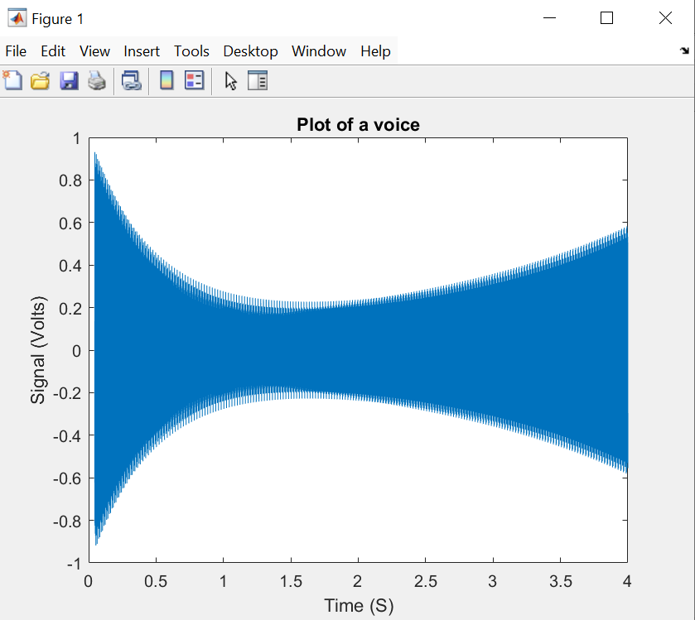
Identify the Frequencies
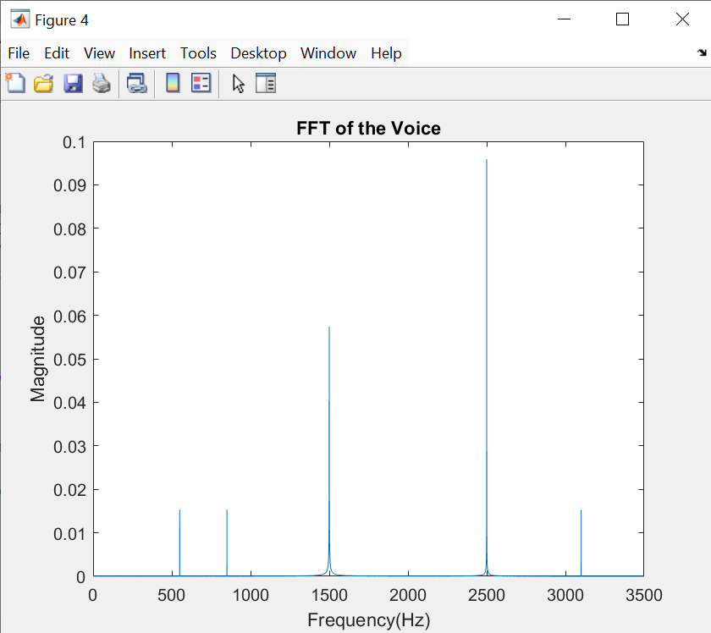
Design a filter to remove the sources of unpleasant sounds

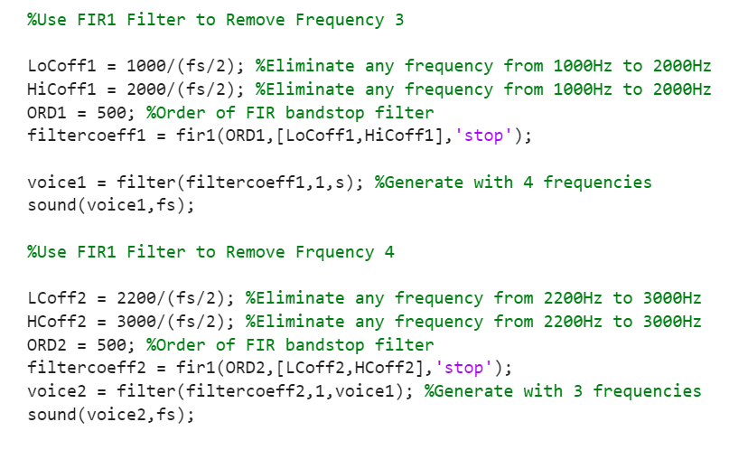

Filtered FFT for three frequencies

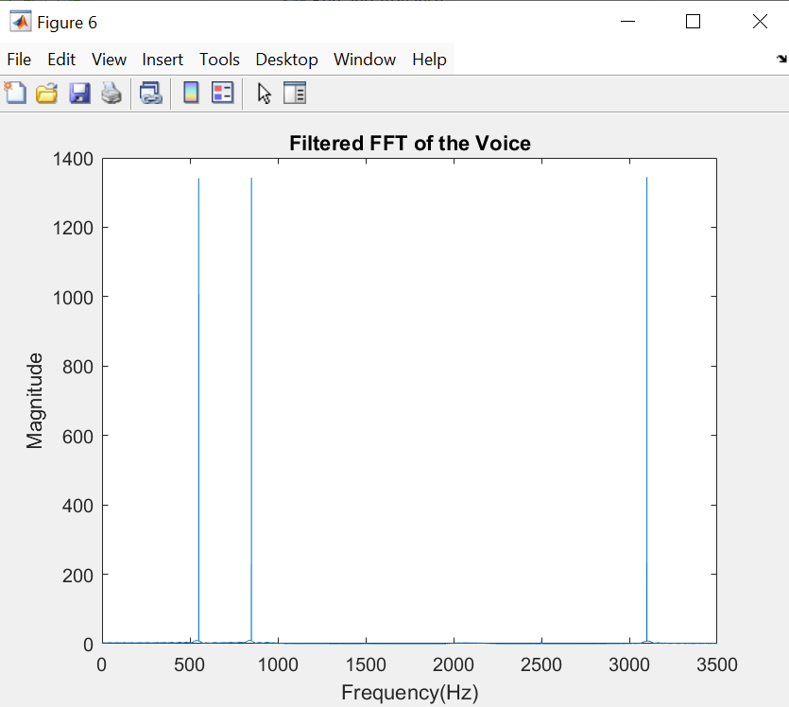
Generate new .wav form without corrupted tones
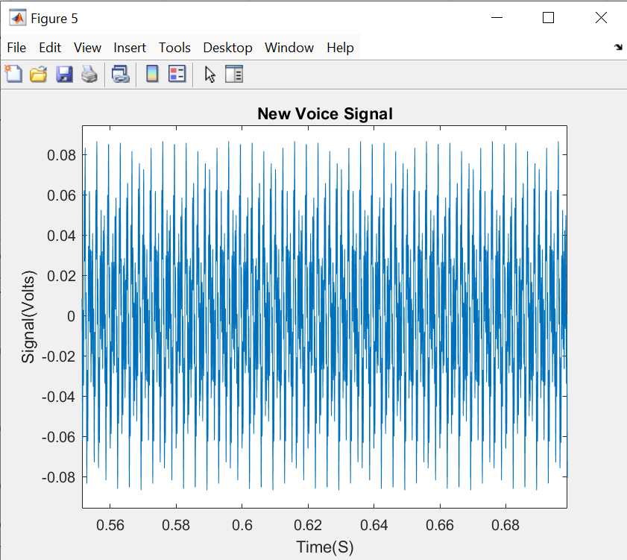

Analysis
The original voice does not appear like a normal voice signal. With the use of fast fourier transform in the second graph it shows the 5 different frequencies of the voice. Using filtering FFT I have taken out the higher magnitude frequencies of 1500 and 2500Hz. With these new parameters I have generated a new voice signal shown in the last graph. This final graph shows a much more controlled waveform with unpleasant sound cut out.
MATLAB Code
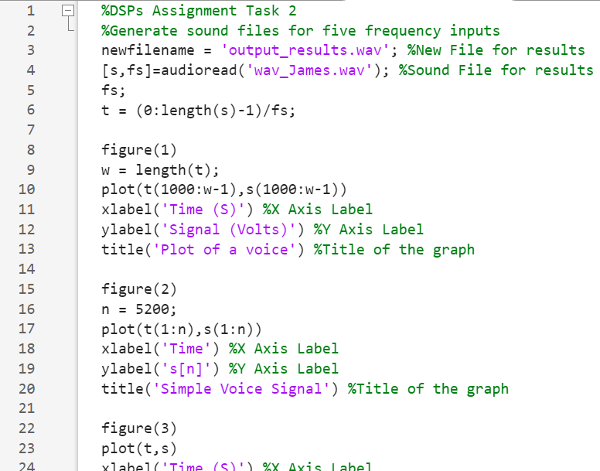
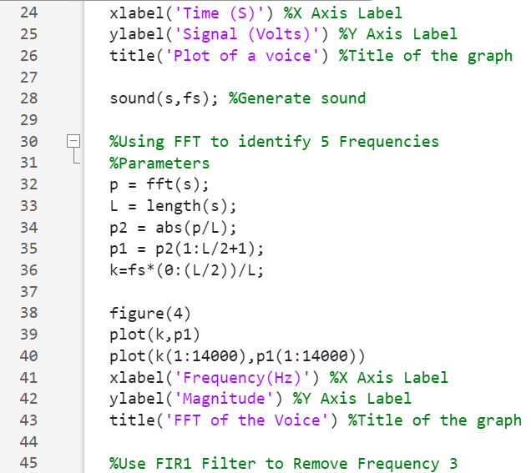
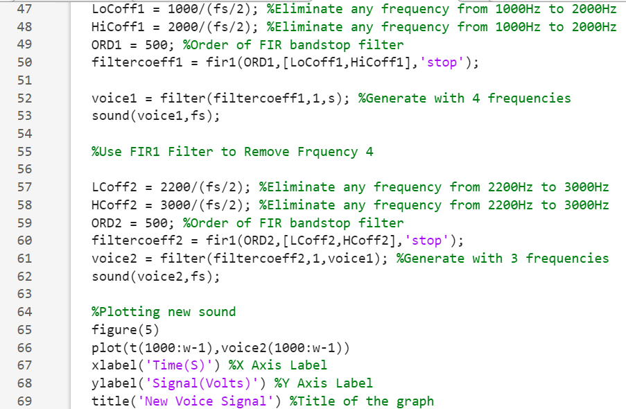
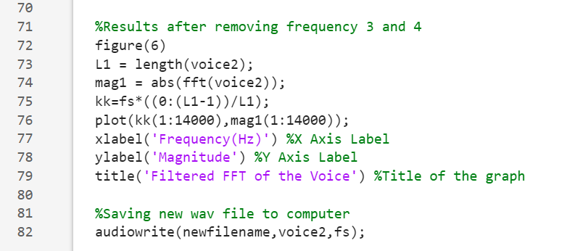

Task 3

Part A
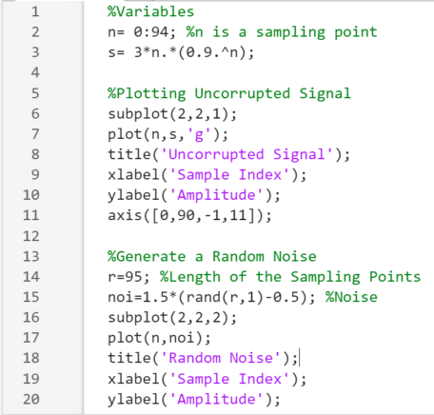
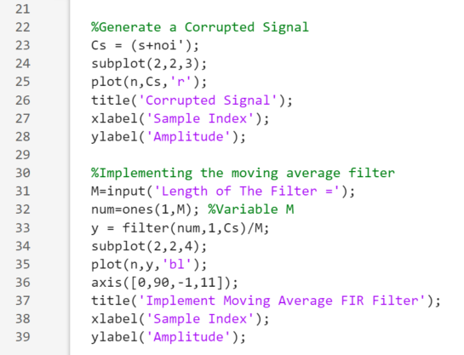
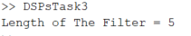
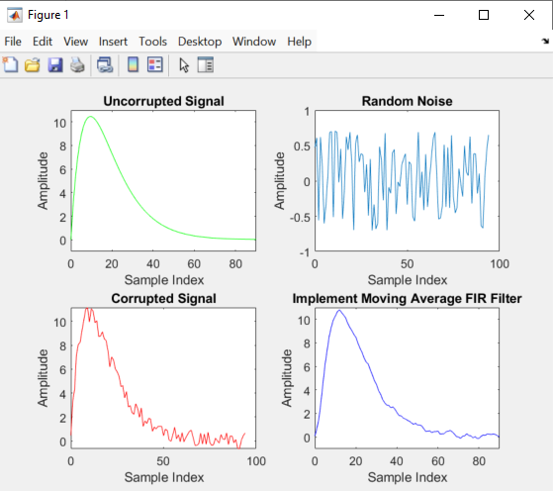

Analysis
The first graph “Uncorrupted signal” shows the plot of the original numbers given. Next, the random noise is given in the second graph. The third graph “Corrupted signal” shows both results added together with the goal of smoothing out this signal. Using a moving average FIR Filter I was able to almost fully recover the original signal,

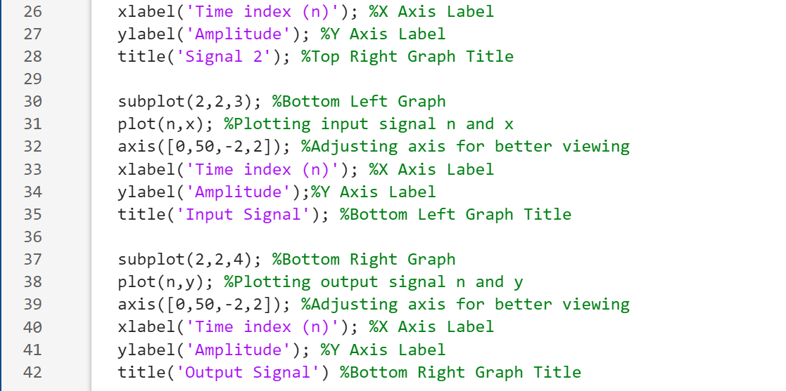
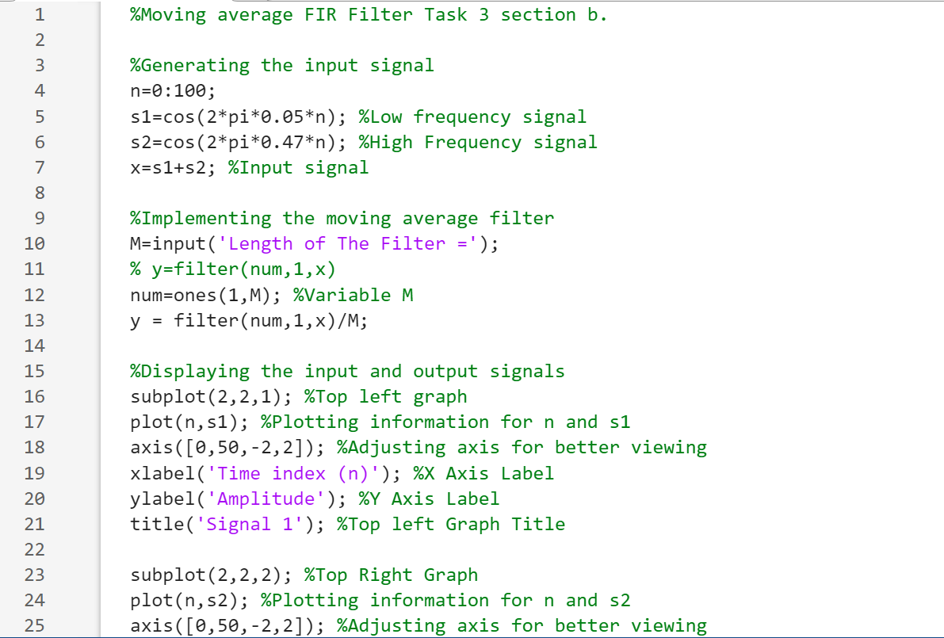
Part B

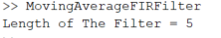
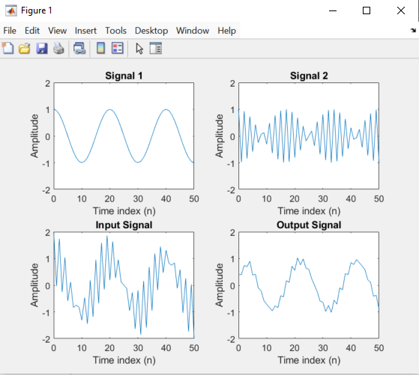

Analysis
Signal 1 represents the original signal, given in the question. The input signal is also given in the question, this is a complex signal. The aim for the question is to filter a complex signal. Implementing the FIR filter in MATLAB gives signal 2. Using different filter lengths and adjusting the axis gives the “Output Signal” shown in the last graph.

Task 4
Original signal (x)
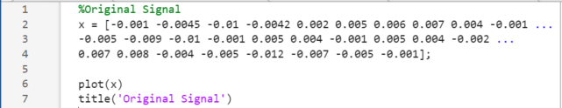
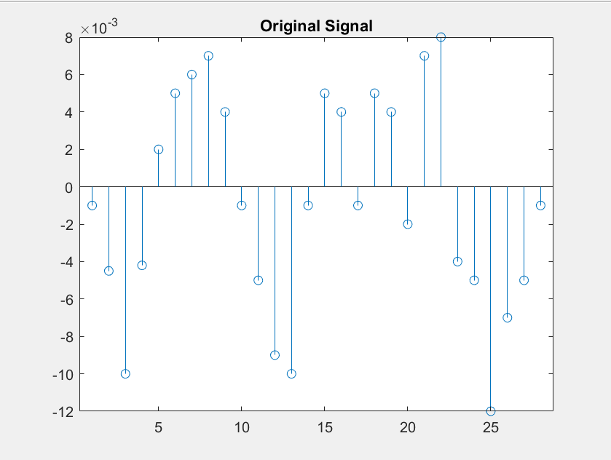
Analysis
The original signal shows similarities from a sinewave. The waveform shows consistent highs and lows.
Low Pass Impulse Response
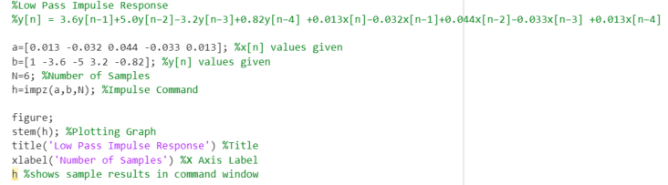
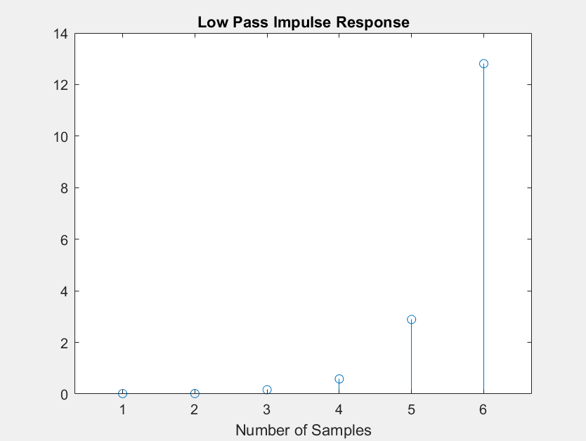
Analysis
The result of the impulse response shows the frequency only starts when the third sample is hit. It seems the higher the samples the more frequency is multiplied as shown in the high peak of the 6th sample.

Low Pass Output
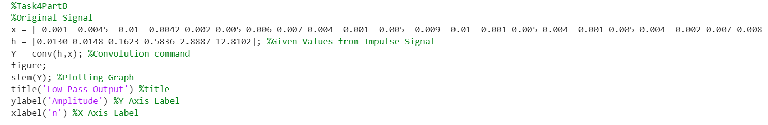
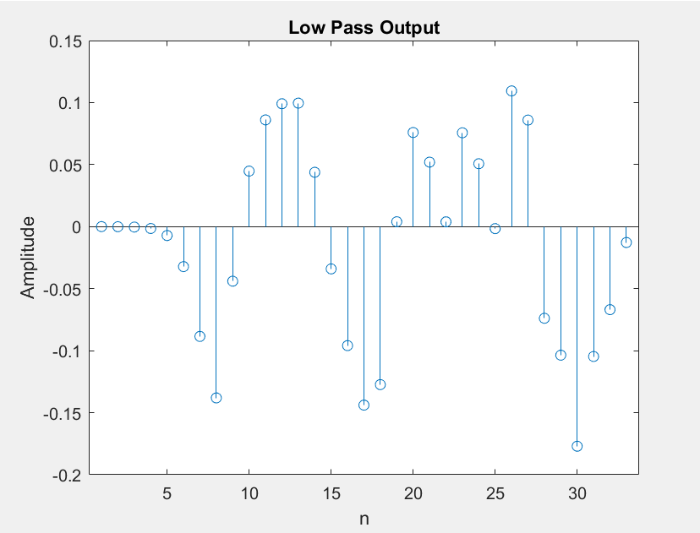
Analysis
The low pass output shows a big difference comparing to the original signal; It shows all low amplitude numbers being minimised. This is used to create a smoother frequency.
High Pass Impulse Response
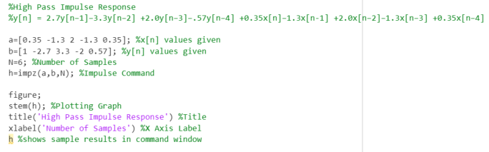
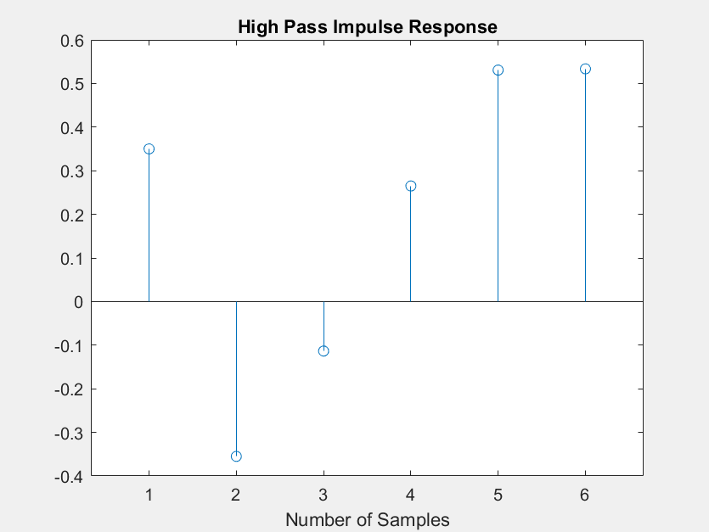
Analysis
The results of the impulse response show low amplitude, if more samples were used it would show very similar to the original signal but with lower peaks making the signal clearer and smoother.

High Pass Output
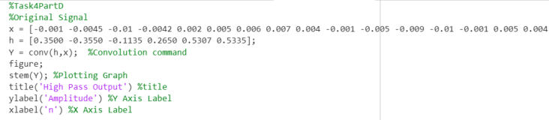
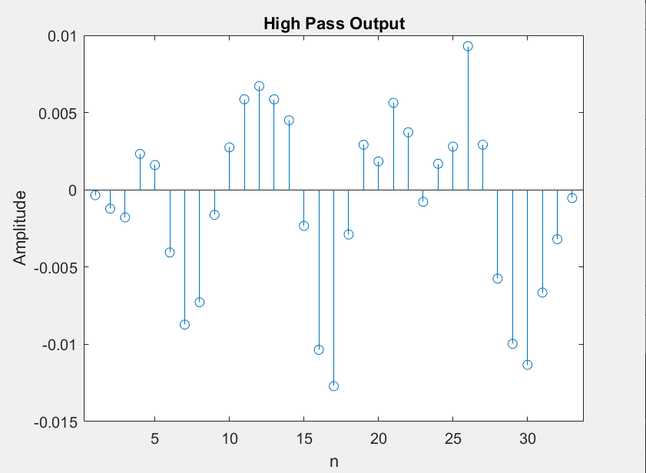
Analysis
The results of the output show lower peaks of amplitude throughout. This helps the resulting sound clearer because it cuts out sudden change of frequency.

Conclusion
This assignment has explored the fundamentals of waveform generation and signal processing using MATLAB; This report focuses on its application inside of mobile communication systems. Through reliable evidence, detailed explanation and visualisation each part of the code is clear. The report showcases techniques such as noise generation, noise filtering and implementation of filters to improve or modify signal quality. Inside the research, this report has explained how mobile networks control user demands through capacity optimisation. Additionally, the report shows the progression of mobile communication technology, with the use of digital signal processing.

Reference list
Bhattacharya, S., Sinha, S., Dey, P., Saha, A., Chowdhury, C., Roy, S., Das, D., Kumar, K.A., Basu, A. and Sarkar, S. (2023). Chapter 5 Online social network sensing models. In: Hybrid Computational Intelligence for Pattern Analysis and Understanding. [online] Academic Press, pp.113–140. doi:https://doi.org/10.1016/B9780323905350.000100.
Emuoyibofarhe, J., Oladosu, J., Ogunleye, O. and Alamu, F. (2012). Characterization of TDMA and WCDMA Performance based on their Key Performance Indicators (KPIs). International Journal of Information, 2(1).
Priya Pedamkar (2020). UMTS vs WCDMA. [online] EDUCBA. Available at: https://www.educba.com/umts-vs-wcdma/ [Accessed 26 Mar. 2025].
Rappaport, T.S. (2024). Wireless Communications. [online] Cambridge University Press. Available at: https://books.google.co.uk/books?hl=en&lr=&id=CRrxEAAAQBAJ&oi=fnd&pg=PA1&dq=+Theodore+S.+Rappaport&ots=FoaLurL-zN&sig=Ul2FN-mi32kiTvi1efciU6pQ_ks&redir_esc=y#v=onepage&q=Theodore%20S.%20Rappaport&f=false [Accessed 23 Apr. 2025].
Telcoma (2025). Network densification - Benefits, Challenges and Techniques. [online] telcomaglobal.com. Available at: https://telcomaglobal.com/p/network-densification-benefits-challenges-techniques [Accessed 26 Mar. 2025].
Vashisht, S., Jain, S. and Aujla, G.S. (2020). MAC protocols for unmanned aerial vehicle ecosystems: Review and challenges. Computer Communications, [online] 160(16), pp.443–463. doi:https://doi.org/10.1016/j.comcom.2020.06.011.

