
A reflective report on the Imeche line launcher design challenge – Group g

University of Wales Trinity Saint David
School of Engineering
Thomas Crocker
1801936
BEng Motorsport Engineering
5/3/20
Engineering Design
M4X01160
Throughout the design challenge the team worked incredibly well to create a viable design that would fit the brief and work well within the rules and regulations of the challenge. Despite this, there were areas of this project that we struggled in. Therefore, in this report I will be detailing aspects of the project that I believe the team thrived in and also where the team could improve for future projects.
In my opinion, the overall team dynamic was pretty good with the team working off of each other to get assignments and designs completed to a high standard. On top of this, I feel that I did well to work with individual members of the team to answer questions about the assignment and lending a hand to solve problems with designs and the prototype throughout the design and building process.
For the time management aspect of the project, I feel that we struggled. As a team we overestimated how long areas of the project would take leading to assignments being rushed out to get them handed in before deadlines. On top of this, I feel that as a whole team we struggled to keep on top of assignments and stay organised. This led to work being left until the last minute, which also contributed to issues with rushed assignments. If this project was repeated, I would try to plan out and set timeframes for each assignment as the project progresses. As well as this, I would try to bring up the assignments more often in meetings in order to push the other members of the team to get the work done.
During the project the group communicated pretty well, using Facebook Messenger and eventually Microsoft Teams to discuss assignments and meeting times. In hindsight, however, as a team we should’ve had more face to face meetings rather than relying on social media to have meetings. Using social media for meetings caused confusion about dimensions of parts, which meant at the prototyping and design phases issues arose which slowed the building progress and affected our testing of the line launcher. For future projects, meetings will be held much more often and all the dimensions will be available to the team so that all parts of the launcher will fit much more effectively, therefore leaving the team with less issues during building and prototyping phases.
The conceptualisation of the line launcher was relatively smooth. The basic concept of our launcher seemed to work well with the initial CAD drawings, shown in figure 1, showing the design to fit nicely within the regulations whilst also fitting the criteria we set out before the design phase. As the design developed however, more problems with the concept were found. I found that some areas of my parts relied too heavily on expensive high-powered motors, which brought the team well over budget. On top of the high price of the motors, I found it was difficult to find a motor that fit the requirements and could also be delivered within the timeframes of the assignments. This meant that for both presentation assignments the team did not have a working trigger system, which let the overall look of the launcher down and could have a negative impact on our marks. In the future, parts should be found and ordered well in advance to avoid any issues with postage. On top of this, I need to strive to find a much cheaper solution to the trigger system.
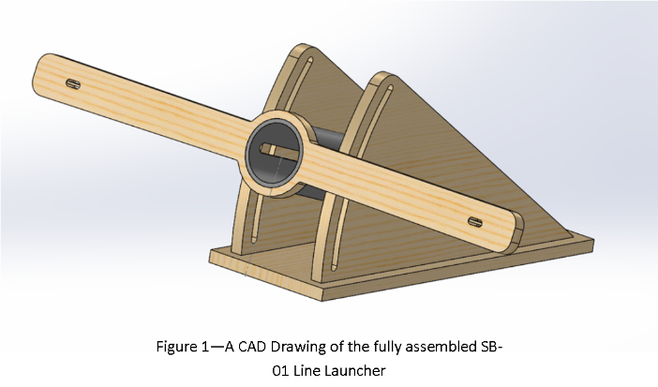

The prototyping and building phases of the project did not run smoothly. The team overthought the development of the design leading to an overengineered line launcher that created more issues than it fixed. The friction between the storage system and the barrel was not taken into account leading to issues in the firing process. The final material costs brought the launcher well over budget by at least 10 or 15 pounds. Finally, the build execution of the launcher was poor with sharp and rough edges being left and an overall poor craftsmanship. The holes were not drilled straight leading to build issues, such as the power generation being pitched over leading to accuracy problems. Another issue was that machinery the team had planned to use for the building process, like the laser cutter, were faulty and left the team rushing to find a new building process ready for the presentations.
Overall, I believe that as a team we worked well to tackle tasks and problems to our highest ability. Despite this, there is always room for improvement as we need to put more effort into keeping on top of the assignments in order to stay on track and avoid any mistakes due to rushing. Personally, I believe that I have worked well throughout the project to make the best possible line launcher. However, for future projects, I should take care to avoid using expensive and difficult to acquire parts for my designs to avoid any possible problems. As well as this, I need to keep things simple when creating designs to prevent problems during the building phases.

BEGINNING OF PROJECT SENTENCES
Don’t make your life difficult
Remember your budget restrictions
Keep it simple stupid

