Is there an association between gender and preference for working from home?

Abstract
The preference of the people is very much dependent on their personality and upbringing. Their personal experiences, their lifestyles, living environment all are influencing their preferences. When people are thinking about picking up an option in their workplace rather it is work from home or it is work at office, gender is not going to create significant problem. It is the personality and attitude of the people which influence the most in the mind of the people to pick up an option between these two. In this report, by the help of Chi Square Test, this relationship has been analysed, and at the end of the analysis there is no significant relationship found between these two variables. According to the calculation, the result of Chi Square is 0.0209 with Phi of 0.0229 of which is not very significant as well. The research has been done over the sample of 40 people with a mix of both male and female. But the limitation of this research is the large number of population can make some changes in the result because around the world of 7.7 billion people 40 is a very insignificant number to represent such a big population. Besides, there are other variables such as upbringing, environment, job type, family life so many other factors can easily create influence format the preference of work from home.

Introduction
Human being is a very unique natural creation. The preference of each human being is completely different from others. The upbringing, the culture, the family, and the condition where they have grown up are the key factors of their nature and attitude. In most of the countries of the world, there are several basic difference between male and female and their preferences (Marshall, et. al., 2021). These differences can be easily identified and understood. In 2019, COVID 19 as a global pandemic has changed the entire world completely. Organisations have enforced different kinds of regulations in keeping their employees in work without getting infected by this deadly virus (Eurofound, 2020). Work from home is the time that comes into play at that time. In this report, the analysis has been done to find out the relationship between the gender and the preference of work from home. It will give the Reader's appropriate idea about what people are feeling about work from home in this Global pandemic condition and what their difference is.

Method of Study

Number of Participants
40 people have been selected from both male and female in order to get necessary information about the research topic although the number of male and female is not same. Total number of male is 14 and total number of female is 26. Therefore, N = 40 in this particular study.

Design of the Study
This research has been designed in such a manner by which the relationship or the association between gender and their preference for work from home can be easily found (Gajerdran, et. al., 2007). Therefore, this research is going to be a very clear one where it is the target to find out the relationship between these two variables.

Elements of Study
As it has been said earlier that, the preference of male and female are completely different, therefore, their preferences are going to be different (Sia, et. al., 2004). But it is the motto of this report is to find out their relationship between their preferences and their gender. The preferences here refers to the opinion of the people to work from home or go to office and work in this global pandemic condition (Sullivan, 2020). The preferences can be different for different people which is the primary objective of the study to understand.

Method of this Study
This research is going to be thematic analysis by which qualitative information of the participants which turned into a quantitative information in order to make the information appropriate for using Chi square test as it is one of the best method to understand the relationship between two variables efficiently.

Analysis of the Study
For this particular analysis,
- Null Hypothesis, H₀: There is no significant association between Gender and preferences of work from home.
- Alternate Hypothesis, H₁: There is significant Association between Gender and difference of work from home.
Step 1: The placement of information in the contingency tables
According to the collected information, the placement of information in the Chi a square table is like the following.
Particulars | Home | Work | Row Frequency
Male | 4 | 10 | 14
Female | 8 | 18 | 26
Column Frequency | 12 | 28 | N = 40

Step 2: Calculation of Expected Frequency
Expected frequency can be calculated by the following formula and the expected frequency table by using the following formula is in the below of the formula.
Particulars | Expected Frequency
Male | 4.20 | 9.80
Female | 7.80 | 18.20
Step 3: Calculation of Chi Square
For the following information needs to be calculated.
Particulars | Observed | Expected
Male (Home) | 4 | 4.20
Female (Home) | 8 | 7.80
Male (Work) | 10 | 9.80
Female (Work) | 18 | 18.20
In order to calculate chi square the formula will be the following.
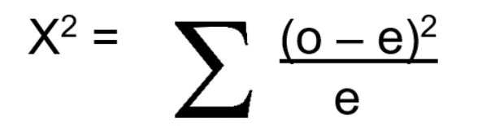
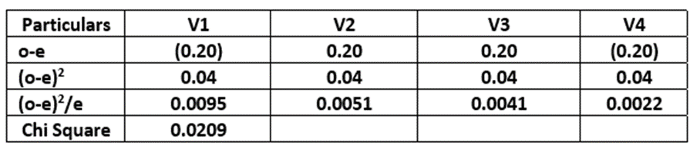
Step 4: Calculating Degree of Freedom (DF)
Degree of freedom refers to the particular number of Dhaka which are influencing the overall values of the given information. Degree of freedom can be calculated in the following manner.
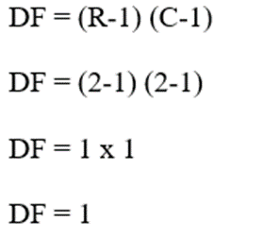
Where there are 2 rows and 2 columns in the given data table.
Step 5: Determining the level of significance from Critical Value table
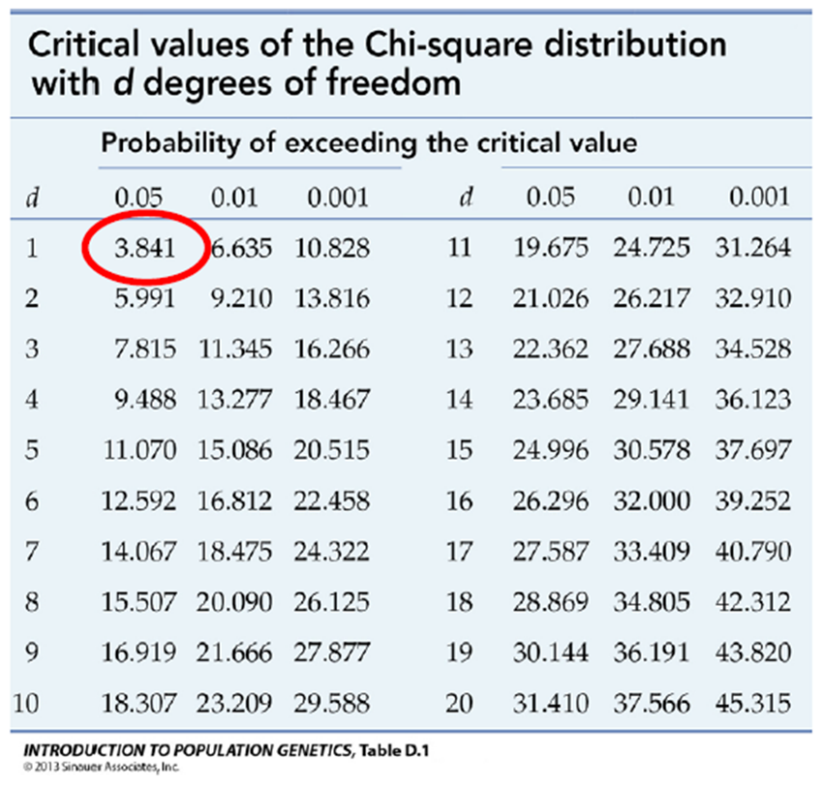
According to the calculated chi square from the given information which is 0.0209 is less than the critical value 3.841 which is the optimal significant level of 0.05. So, it can be easily say that the null hypothesis is accepted which indicates towards no relationship status between Gender and difference of work from home.
Therefore, the rejection of alternate hypothesis and the acceptance of null hypothesis shows lack of relationship between the two variable those have been selected in this particular analysis.
Step 6: the determination of Phi
According to our calculation for Phi, with the following formula the result is 0.0229 which shows less of significance of the relationship between this two particular variable showing the authenticity and accuracy of the calculation and the decision of accepting null hypothesis.
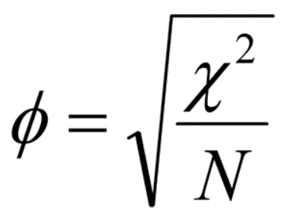

Results of the Study
The study has Chi Square of 0.0209 which is less than the critical value of the significance level 0.05 under degree of freedom 1. The study also determined the Phi of the given information which is 0.0229 slightly significant. The study also calculate the degree of freedom for the given information which is 1. Ultimately, at the end of the analysis, the null hypothesis which indicating towards no relationship between these two variables has been accepted as a decision of this calculation over the given information.

Discussion
If carefully look at the subject of the analysis it can be easily said that the two variables that have been taken are not significantly connected with each other. Because in most of the countries gender is not defining the preference of work from home (Holst, 2020). The situation through which the world is doing is creating the condition for enforcing rules and regulations off work from home for all types of employees. Moreover, because of intellectual and unique human being the difference of each and every single individual in both male and female can get different which definitely create significant impact in the relationship between the selected variables. For this reason, there was a huge chance for getting null hypothesis accepted from the beginning of the analysis.
After studying all the given information and after applying Chi square test over the given information, it has been found that the null hypothesis is accepted from all perspective of the result of the calculation which is completely accurate in context of the information (Feldman, et. al., 2008). It is defining one fact completely that the preference of human being is not depending on their gender rather they are bringing and their living condition create significant impact in their personality and attitudes which ultimately influencing their preferences and making the decision making process unique in comparison with others.
At the time of collecting information, the ages of the people have also been taken into count which are also not creating any significant impact over the given relationship between gender and preference of work from home. Therefore, the attitude and the thinking of the people are the key factors here and the method that has been taken for analysing the information is absolutely outstanding in giving appropriate result about the research to find out the relationship between the given variables.

Conclusion
According to the discussion, gender and preference of work from home is also very complex matter to sort out (Arnett, 1996). In the bare eyes, finding out the relationship between these two variable is very difficult and according to the calculation it has become completely clear that there is no significant relationship between this two variable which means it can be easily said that all the some of the people are preferring work from home to enjoy their family and personal life more but there is no determinant that can define the percentage of male or female who are preferring work from home more than others. For this reason, the acceptance of null hypothesis which indicating towards no relationship between gender and difference from work from home has been seen at the end of the calculation and analysis.
Appendix

References
Arnett, J. J. (1996). Sensation seeking, aggressiveness, and adolescent reckless behaviour. Personality and Individual Differences, 20(6), 693-702.
Corder, G. W.; Foreman, D. I. (2014), Nonparametric Statistics: A Step-by-Step Approach, New York: Wiley, ISBN 978-1118840313
Eurofound (2020) Living, working and COVID-19 First findings – April 2020
Feldman, I.; Rzhetsky, A.; Vitkup, D. (2008). "Network properties of genes harboring inherited disease mutations". PNAS. 105 (11): 4323–432. Bibcode:2008PNAS..105.4323F.
Gajendran, Ravi S.; Harrison, David A. (2007). "The good, the bad, and the unknown about telecommuting: Meta-analysis of psychological mediators and individual consequences". Journal of Applied Psychology. 92 (6): 1524–1541.
Holst, Arne (2020). "Change in remote work trends due to COVID-19 in the United States in 2020". Statista.
Marshall, Carrie; Weatherbed, Jess; Rae, Michelle (2021). "Best webcams 2021: top picks for working from home". TechRadar.
Ryabko, B. Ya.; Stognienko, V. S.; Shokin, Yu. I. (2004). "A new test for randomness and its application to some cryptographic problems" (PDF). Journal of Statistical Planning and Inference.
Sia, Choon-Ling; Teo, Hock-Hai; Tan, B.C.Y.; Wei, Kwok-Kee (2004). "Effects of Environmental Uncertainty on Organizational Intention to Adopt Distributed Work Arrangements". IEEE Transactions on Engineering Management. 51 (3): 253–267.
Sullivan, Bob (2020). "Coronavirus could be a tipping point (finally) for telecommuting". GeekWire.
Welch, Chris (2020). "Webcams have become impossible to find, and prices are skyrocketing". The Verge.

Appendix
Provided Data:


