MARKETING STRATEGIES PORTFOLIO
Brand Development Strategy for Apple Smart Health Hub
Programme:
Master of Business Administration (MBA)
Module:
Marketing Management
Module Code:
LCMB7024

Assignment Title:
Assessment Component 2 – Marketing Strategies Portfolio
Student Name: Jeel Bhratbhai Anghan
Student ID: 2522449
Lecturer:
Taonga Kaonga Sobere-Snithers
University:
University of Wales Trinity Saint David

Table of Contents
1. Introduction 3
2. Brand Extension Overview 3
2.1 The Company 3
2.2 Proposed Brand Extension 3
2.3 Market Opportunity 3
2.4 Sustainability Alignment 4
3. Segmentation, Targeting, Differentiation and Positioning (STDP) Analysis 4
3.1 Market Segmentation 4
3.2 Target Market 5
3.3 Brand Differentiation 5
3.4 Brand Positioning 5
4. Marketing Mix Strategy (7Ps) 6
4.1 Product 6
4.2 Price 7
4.3 Place (Distribution) 8
4.4 Promotion 8
4.5 People 9
4.6 Process 10
4.7 Physical Evidence 10
5. Reflection 10
5.1 Learning Experience 10
5.2 Poster Development Experience 11
5.3 Skills Developed 11
5.4 Future Improvements 11
6. Conclusion 11
References 13

1. Introduction
Apple Inc. is a highly influential technology firm in the world, whose products are highly innovative, well-known brand, and a unified ecosystem of products and services. Apple was established in 1976 and has created a range of products, including iPhone, MacBook, Apple Watch, and AirPods, which are intended to work in harmony with each other in a single digital ecosystem (Apple Inc., 2024).
This portfolio is aimed at creating a marketing strategy of a brand extension that will both facilitate the growth of Apple business and address new technological and consumer trends (Hazan, 2025). The brand extension expected to be suggested is the Apple Smart Health Hub, a home unit that is an artificial intelligence-driven device, which senses health data and gives personalised fitness information.

2. Brand Extension Overview

2.1 The Company
Apple Inc. is a multi-national technology firm that has an excellent brand ecosystem, excellent product design, and innovation. The products designed by the company are interrelated and work together in perfect coordination i.e. the iPhone, MacBook, Apple Watch and AirPods which have been created using Apple software and services. Apple has also become more oriented on health and wellness technologies. To illustrate, the Apple Watch already includes the functionality of the heart rate tracker, sleep tracking, and fitness analytics, suggesting that Apple is increasingly engaged in digital health solutions (Apple Inc., 2024).

2.2 Proposed Brand Extension
The new brand extension is the Apple Smart Health Hub which is a smart home health monitoring device that works with other Apple products such as iPhone and Apple Watch. The device would gather real-time health information and process information, including heart rate, sleep patterns, physical activity, and stress, and analyse it with artificial intelligence (Gomis-Pastor et al., 2024). It would inform people about their health specifically and enable users to share their health information with healthcare providers safely in case of need (Negash and Sarmiento, 2023).

2.3 Market Opportunity
The digital healthcare technologies are in demand because of the increase in health awareness and popularity of wearable devices. The consumers are also more concerned with preventive healthcare systems which enable constant monitoring of health. AI and data analytics are among the technologies that make personalised healthcare possible (Secara and Hordiiuk, 2024).

2.4 Sustainability Alignment
The Smart Health Hub is also in line with the sustainability plan of Apple. Energy efficient technology, recyclable materials and environmentally friendly packages would be applied in the product. Digital health monitoring may also help decrease the number of visits to the hospital, which would potentially help to mitigate the impact of emissions during travel and enhance the efficiency of healthcare (Apple Inc., 2024).

3. Segmentation, Targeting, Differentiation and Positioning (STDP) Analysis

3.1 Market Segmentation
Market segmentation assists organisations to define clusters of customers that have common needs and behaviour. In the case of Apple Smart Health Hub, analysis of segmentation can be based on geographic, demographic, psychographic, and behavioural factors.
Geographically, the key markets are formed by developed urban areas where consumers can access high-digital infrastructure and smart home devices (Machourek, 2025). The United States, the United Kingdom, Canada and other major European markets are some of the key markets where Apple already enjoys a customer base.
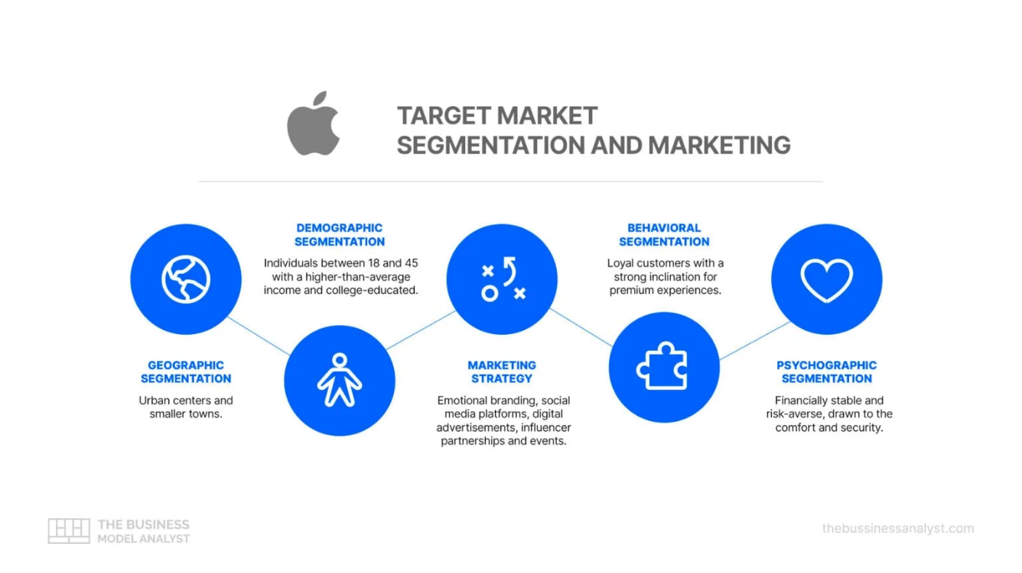
Figure: Target market and segmentation and marketing of apple
Source: (Business Model analyst, 2026)
Demographically, the product is primarily included in the segmentation of customers who are middle-to-high income earners between the ages of 25 and 55. Such people better tend to buy high-quality technology products and spend money on the devices that improve their health and lifestyle (Burma, 2025).
Psychographic segmentation is based on the lifestyle and the attitudes of the consumer. The Smart Health Hub is mainly offered to health-aware people, professionals who value wellness, and those who use new digital technologies actively.
Lastly, behavioural segmentation takes into account the technology use and monitoring of health by consumers. Current customers in the Apple ecosystem, especially those who currently own an Apple Watch or an iPhone, are also a prime market as they are already acquainted with Apple products and would be more willing to buy other ecosystem products.

3.2 Target Market
According to such segmentation, the major target market is an urban population that already utilizes Apple products and people who are interested in personal health-monitoration technologies. The appeal of these consumers is due to the fact that they possess a high purchasing power, they are loyal to the Apple ecosystem, and they appreciate convenient digital solutions in managing their health and wellbeing.

3.3 Brand Differentiation
The Apple Smart Health Hub is distinguished by the competitors like Fitbit and Samsung Health, including a smooth integration of the ecosystem, AI-based health insights, and high-quality data privacy. The high design and ease of use by the user makes Apple a further strong competitor.

3.4 Brand Positioning
The Smart Health Hub will be positioned as a high-quality digital health solution, which is a blend of innovative technology with customized health tracking.
Positioning statement:
Apple Smart Health Hub is a luxury AI-based home health system that offers personalised wellness guidance by integrating smoothly with the Apple system.

4. Marketing Mix Strategy (7Ps)
A strategic marketing mix strategy is necessary to make the successful entry of the Apple Smart Health Hub into the market (Shaikh and Vivek, 2025). The framework of the marketing mix assists organisations to position their products to the needs of the customer without losing their competitive edge and sustainability (Kotler et al., 2024). In the case of technology products like the Apple Smart Health Hub, the 7Ps marketing mix model including Product, Price, Place, Promotion, People, Process, and Physical Evidence is an inclusive approach to creating value to customers.

4.1 Product
Apple Smart Health Hub: This is a highly innovative device of home-based digital health monitoring that is capable of enhancing personal wellbeing by means of artificial intelligence and data analytics. The product is compatible with the Apple devices, including the Apple Watch and the iPhone allowing the user to receive real-time health information, including heart rate, sleep schedule, physical activity, and stress.
One of the main characteristics of the product is its health monitoring system based on AI that analyses the captured data and offers individual health insights and recommendations. Such data can be used to enable users to learn more about their health patterns and promote preventive health-related behaviors, including better sleep quality or a healthy life balance.
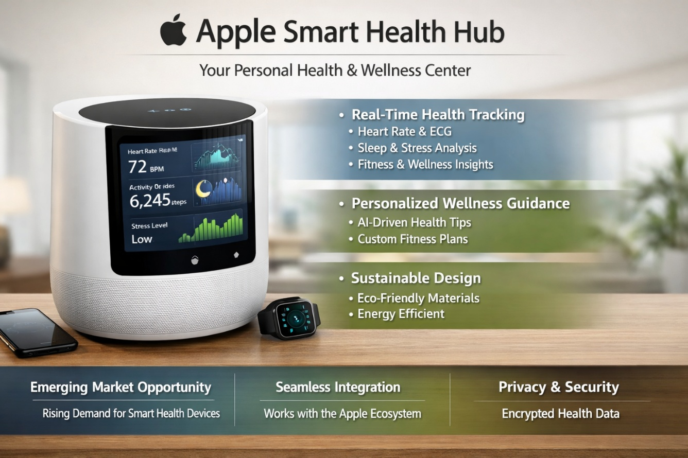
Figure: Proposed product
Source: Self developed
Health data analytics is another key characteristic as machine learning algorithms transform raw health data into valuable conclusions. The users will be able to obtain customised health report to manage their long-term wellness. Moreover, Smart Health Hub provides an opportunity to share confidential data with care providers and achieve full access to the selected health information by sharing it in encrypted systems (Gonzalez-Moral et al., 2025). The good reputation associated with Apple when it comes to privacy protection increases trust between the product.

4.2 Price
The strategy of pricing is significant to position Apple Smart Health Hub in the digital healthcare market. Apple as a company normally adopts the premium pricing strategy, which is based on the quality, innovation and brand name attached to its products. Thus, to a considerable extent, the Smart Health Hub will be sold at a premium price compared to several other similar health monitoring gadgets.
The value-based pricing strategy is appropriate in this case as customers do not only buy the physical hardware but also the value of the individual health feedback, high-tech and its connection to the Apple ecosystem. These are advantages warranting a high price and support the brand image of Apple.
The other key criterion is the Apple ecosystem value. A large customer base of Apple already possesses the iPhone and Apple Watch.
Pricing strategy might also involve adopting the hybrid format, whereby a customer will buy the device with the option of subscribing to extra functions like advanced health analytics, personalised health reports, or telehealth functionalities. This would enable Apple to have an ongoing revenue stream with the platform being constantly upgraded.

4.3 Place (Distribution)
Distribution decides on how the product is distributed to the customers. The advantage of Apple is that the company has a powerful distribution network all over the world, both in the physical retail stores and the digital sector.
The Smart Health Hub would have Apple Stores as one of its major distribution channels. These are the stores where the customers can directly interact with products and get demonstrations by the trained employees (Kumari, 2025). Trying the device in-store would enable the customers to know more about the health monitoring capabilities of the device.
The other significant medium is the Apple web page and online shop, where the customers are able to buy the product directly and get more details on the product. Online selling also assists Apple to access customers in areas where the physical stores are absent.
Moreover, the product would be distributed via trusted online vendors like Amazon and other technology stores. Such collaborations are useful in broadening the market of Apple and making it more accessible.

4.4 Promotion
The strategies of the promotion are needed to build awareness and convey the value of the Apple Smart Health Hub. The marketing strategy that is usually used by Apple involves a combination of online marketing, alliances, and product unveiling.
Digital marketing would be significant in the promotion of the product. Advertising via the web as well as online search engines and targeted advertising on the technology and health websites will reach consumers who believe in digital health solutions.
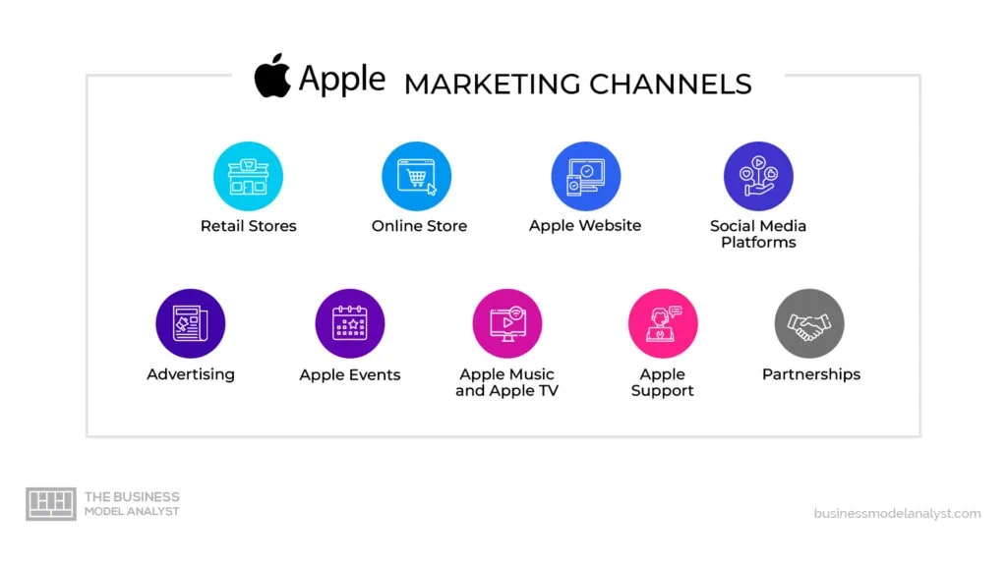
Figure: Marketing channels of Apple
Source: (Business Model Analyst, 2026)
Another most important promotional strategy is social media marketing. Instagram, YouTube, and X could be used to display the product feature in the form of demonstrations, testimonials, and informative content on digital health monitoring.
Influencer marketing is another method that Apple can employ by partnering with technology experts, fitness trainers, and medical professionals to show how the Smart Health Hub can help them achieve healthy lifestyles (Bao, 2025). The influencers can be utilized to enhance trustworthiness and persuade consumers to adopt it.

4.5 People
The component of people is devoted to employees and customer service contact that impacts the customer experience. Apple highly values the provision of quality customer service by employing well trained employees.
The Apple experts in retail stores are an influential part of the process of informing customers about the Smart Health Hub (Lievevrouw et al., 2023). They will be able to offer demonstrations and make customers realize how the device fits in their Apple ecosystem.
Technical support and software updates Customer support teams also support with technical problems, setting up devices, software upgrades. Customer satisfaction and long term brand loyalty are increased as a result of effective customer service.

4.6 Process
The process element is the way the product and its services are provided to the customers. In the case of the Smart Health Hub, the steps include gathering health information based on the linked Apple devices, interpreting the information with the assistance of artificial intelligence, and delivering personal health insights to customers via a manageable interface.
This is an uncomplicated process that is aimed at making the users monitor their health with ease using their Apple devices. Privacy and security of data are also significant components of the process. The implementation of strong encryption tools by Apple means that the personal health information is safely stored and only shared with the authorised healthcare professionals.

4.7 Physical Evidence
Physical evidence incorporates the physical aspects that reinforce the brand experience. The company has a premium brand image and its products are characterized in terms of high standard design, packaging, and user interface.
The Smart Health Hub would have the minimalist design that is synonymous with Apple, with top-grade materials that are complementary to the modern living rooms. The packaging would also adhere to the sustainability principles of Apple since it would be done with recyclable and environmentally friendly materials.
Also, Apple ecosystem interface can be used as a valuable physical piece of evidence. The brand promises simplicity, reliability, and innovativeness, and this is supported by the consistent design that is intuitive and present in all the Apple devices (Linz et al., 2024).

5. Reflection

5.1 Learning Experience
The process of creating the Apple Smart Health Hub brand extension gave a lot of experience in strategic marketing planning. Among the most important lessons gained in this project was the role of strategies of brand extension in helping the business to grow. Brand extension allows business organizations to utilize the brand recognition and customer confidence they already have in the market to venture into new markets and present new products. As in this case, Apple has a good reputation in terms of technological innovation and product design, it was possible to suggest a health-related device which fits very well in its current ecosystem.
The project also helped me develop better knowledge in the development of marketing strategy especially the significance of gaining an insight on the needs of the customers as well as the alignment of marketing outcomes with organisational goals. The use of marketing frameworks like segmentation, targeting, positioning, and marketing mix assisted in showing how theoretical marketing could be applied to the real-life business scenarios.

5.2 Poster Development Experience
The other useful learning experience was the designing of the poster presentation. It was necessary to introduce the brand extension concept in a succinct and convincing way with a limited space. The poster had to summarize the major information regarding the product idea, market, and sustainability areas (Yeo and Chew, 2025). This experience made me realize the significance of visual communication in marketing because a well-designed poster can attract the attention of people in a short time and convey complicated concepts to a population.

5.3 Skills Developed
The project contributed to training a number of significant skills such as marketing analysis, strategic thinking, communication, and presentation skills. The research on the market trends and consumer behaviour enhanced my analytical skills whereas the process of integrating the sources of knowledge enhanced my academic writing skills.

5.4 Future Improvements
I would also strive to incorporate more comprehensive market research in future undertakings, especially primary data of the prospective consumers. Also, the prospection of financial forecast and analysis of risks would enhance the main marketing plan and present a more thorough analysis of the proposed brand extension.

6. Conclusion
The current report analyzed the case of the Apple Smart Health Hub as a strategic brand extension aimed to help Apple enter the digital healthcare platform. The analysis showed the alignment of the product to the innovation strategy of Apple and how it reacts to the rising trend of using digital health monitoring technologies (Mitratza et al., 2022). By using the marketing mix and the STDP frameworks, the report has indicated the high potential of the market and market fit of the Smart Health Hub in the Apple ecosystem. Altogether, the new brand extension is an opportunity that Apple can use to reinforce its status in the changing digital health sphere.

References
Apple Inc. (2024). Investor relations. https://investor.apple.com/investor-relations/default.aspx
Bao, H. (2025). Health technology for all: examining health apps and wearables use through the lens of (in) equality. https://dr.ntu.edu.sg/bitstream/10356/183350/2/PhD%20Thesis_Huanyu%20Bao.pdf
BURMA, Z. A. (2025). THE IMPACT OF DIGITAL TRANSFORMATION AND ARTIFICIAL INTELLIGENCE ON DIAGNOSIS, DETERMINATION, AND TREATMENT PROCESSES IN HEALTHCARE. SCIENCES III, 81. https://www.researchgate.net/profile/Talip-Sahin/publication/399331260_Phytochemical-Based_Vaccines_Current_Status_and_Future_Perspectives/links/6956f637a1fd0179890fbeb6/Phytochemical-Based-Vaccines-Current-Status-and-Future-Perspectives.pdf#page=90
Business Model Analyst. (2026). Apple marketing strategy.
https://businessmodelanalyst.com/apple-marketing-strategy/
Business Model Analyst. (2026). Apple target market analysis.
https://businessmodelanalyst.com/apple-target-market/
Gomis-Pastor, M., Berdún, J., Borrás-Santos, A., De Dios López, A., Fernández-Montells Rama, B., García-Esquirol, Ó., ... and Comella, A. (2024, May). Clinical validation of digital healthcare solutions: state of the art, challenges and opportunities. In Healthcare (Vol. 12, No. 11, p. 1057). MDPI. https://www.mdpi.com/2227-9032/12/11/1057
Gonzalez-Moral, S. G., Addis, P., Sharma, O., Oliver, A., Johnson, E. E., Al-Assaf, A., ... and Meader, N. (2025). Innovative technologies for asthma and COPD management in the community: scanning the horizon using rapid systematic review methods. BMJ Innovations, 11(3). https://innovations.bmj.com/content/bmjinnov/11/3/133.full.pdf
Hazan, M. (2025). Strategic Positioning in Wearable Health Technology: Leveraging Consumer Centric Analytical Approaches for Market Leadership A Literature Review on Advanced Applications, Addressing Adoption Challenges, and Innovative Solutions for Healthcare Technology (Master's thesis, Universidade NOVA de Lisboa (Portugal)). https://run.unl.pt/bitstreams/88520275-440c-4694-b1ee-53ee17552daa/download
Kumari, R. (2025). The Role of Clinical Decision Support Systems in Type 2 Diabetes Management: A Scoping Review. https://drs.iihmrdelhi.edu.in:8443/jspui/bitstream/123456789/2440/2/Rupa%20Dissertation%20Report%20095.pdf
Lievevrouw, E., Van Hoyweghen, I., and Marelli, L. (2023). 'Moving Focus'. Understanding the Infrastructuring of digital health technologies through EU and US policymaking. https://lirias.kuleuven.be/retrieve/ff9ae234-7eb7-4899-a88a-3db35ac73b20
Linz, D., Gawalko, M., Betz, K., Hendriks, J. M., Lip, G. Y., Vinter, N., ... and Johnsen, S. (2024). Atrial fibrillation: epidemiology, screening and digital health. The Lancet Regional Health–Europe, 37. https://www.thelancet.com/pdfs/journals/lanepe/PIIS2666-7762(23)00205-3.pdf
Machourek, K. (2025). AI-Driven Business Model in Health Data Platforms: A Case Study of HippocrAItes. https://www.theseus.fi/bitstream/handle/10024/893119/Machourek_Kamil.pdf?sequence=2
Mitratza, M., Goodale, B. M., Shagadatova, A., Kovacevic, V., Van de Wijgert, J., Brakenhoff, T. B., ... and Downward, G. S. (2022). The performance of wearable sensors in the detection of SARS-CoV-2 infection: a systematic review. The Lancet Digital Health, 4(5), e370-e383. https://www.thelancet.com/pdfs/journals/landig/PIIS2589-7500(22)00019-X.pdf
Negash, Y. T., and Sarmiento, L. S. C. (2023). Smart product-service systems in the healthcare industry: Intelligent connected products and stakeholder communication drive digital health service adoption. Heliyon, 9(2). https://www.cell.com/heliyon/pdf/S2405-8440(23)00344-4.pdf
Secara, I. A., and Hordiiuk, D. (2024). Personalized health monitoring systems: integrating wearable and AI. Journal of Intelligent Learning Systems and Applications, 16(02), 44-52. http://community.sent2promo.com/id/eprint/2012/1/jilsa_2024032515540751.pdf
Shaikh, K., and Vivek, S. (2025). Artificial Intelligence in Healthcare in the UAE. In Healthcare in the United Arab Emirates (pp. 789-815). Singapore: Springer Nature Singapore. https://link.springer.com/content/pdf/10.1007/978-981-96-0523-1_49.pdf
Yeo, P. H. J., and Chew, K. H. (2025). A Framework for Inclusive Mobile Application Design: Insights from Singapore’s Visually Impaired Community. International Journal of Asia Digital Art and Design, 29(S1), 46-56. https://www.jstage.jst.go.jp/article/adada/29/S1/29_46/_pdf

