Research proposal

Emma Cloutman
1905800
Business and management
Business inquiry and research
Dr Roisin Mullins

Title : The effects Covid – 19 has had on gyms in the local county.
Introduction
This assignment will include the research behind the effects Covid – 19 has had on Gyms in the local county. The reason for this research is intriguing as the gyms were forced to close and I am interested to find out all the different alternatives the Gyms had in place for their clients through the devastating times of Covid – 19. The data gathered will hopefully set out some similarities in individuals coping mechanisms during the pandemic.
Mini Literature Review
A study of 22 participants was performed by (Kaur). This study found that Covid – 19 has resulted in a decrease in all levels of physical activities and about 28% increase in daily sitting time as well as a increase in unhealthy pattern in food consumption. (Stockwell) also stated that 64 studies were reported with the majority of the studies reporting a huge decrease in physical activity during the first initial lock down.
Detailed Strategy / Methodology
The research method I will be using is going to be a qualitative research by conducting semi – structured interviews (SSI). This will be in the form of a questionnaire. The aim is to collect data from individuals in the local county who use the local gyms. I am using semi – structured interviews as I would like the individual’s personal opinions rather than a structured questionnaire with straight yes or no replies. The questions asked will be followed up by questions to expand their opinions. This method will result in having more of a wide understanding on the topic in question and give me a chance to see different individual’s perspective on the closure of the gyms. And any creative alternatives they have managed to achieve.
I will be reaching out to local gyms in the county hoping that they will be able to assist with my research. I will also be asking them to try and involve their clients in the interviews so I can gather a wide rage of information relating to their health and well – being. Following my own research so far I have gathered that the majority of individuals that were regular gym goers, at the start of the pandemic noticed a massive decrease in their physical activities. During the first lockdown I found individuals slacked on their health and well being but as time went on individuals found creative ways to keep up with their physical exercise which I found intriguing. The interviews I will be collecting data from will give me a better idea on the creative ways gyms set up sessions for their clients.
The plan to set up interviews will be by phoning local gym owners to ask if they will be willing to precipitate in my study. Hopefully with a generous number of their clients joining resulting in more data to compare.
The information gathered would later be destroyed once they are transcribed. I will be analysing the data using interview transcripts where I will examine the data in detail and look for similarities. Thematic analysis is the most flexible method that can be used in so many different kinds of research. This method is useful when trying to find people’s views (Caulfield).

Gantt Chart for showing timeline of research.

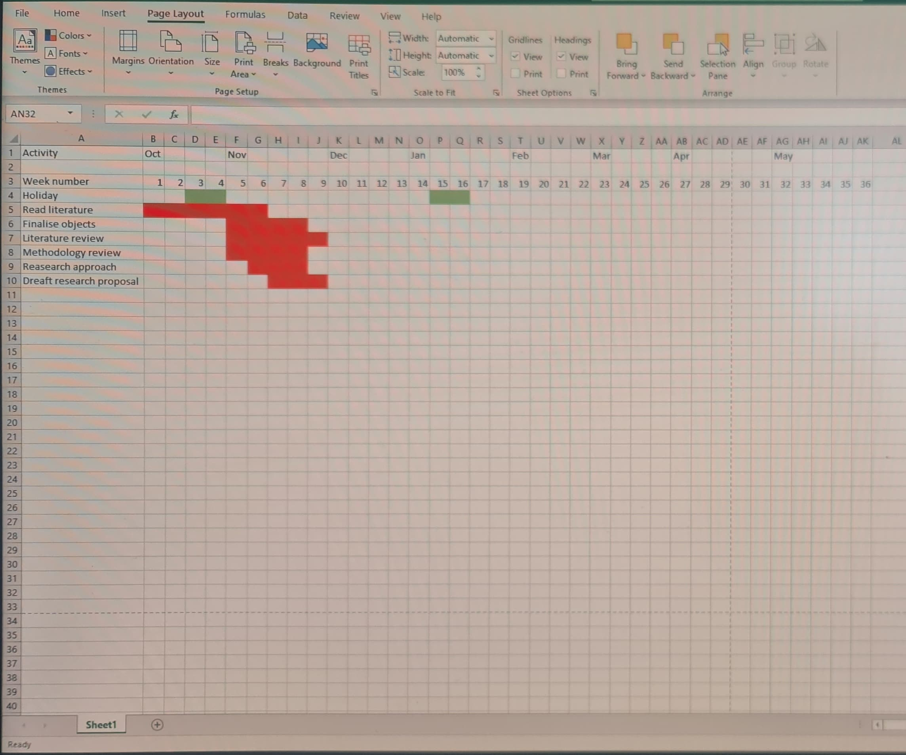

Ethical Consideration
The data I collect will be anonymous and discarded when my research is complete. The individuals taking part in the interviews will be referred to as participant 1,2 ect. All information/Data gathered will be password protected and will follow the rules and regulations to the university’s code of conduct and ethics. There will be many ethical considerations taken into account when gathering data from these individuals. The individuals will have the right to withdraw at any given time and can terminate the interview. The individuals will be unnamed and their identity will be protected. The individual will be made aware of the purpose of the research and my intensions for the interview. The individual will be made aware there is no intention to cause them any mental of physical harm such as anxiety, pain ect and they are within their rights to withdraw at any time if they feel the need to.
Limitations
I am limited to the amount of research I can do with gyms as the pandemic has forced a lot of business to closure. I am hoping in my research I can find enough individuals to take part in my interviews to get a good understanding on how people feel and what alternatives they have found to exercise. The gyms have recently opened and I am fascinated to see how they are finding new rules and restrictions set my the government. Due to the very strict rules in the area I believe they will restrict the amount of information I can gather and that may resort in me having to set up telephone conversations in replacement.

References

Kaur, H., Singh, T., Arya, Y.K. and Mittal, S., 2020. Physical Fitness and Exercise During the COVID-19 Pandemic: A Qualitative Enquiry. Frontiers in Psychology, 11.

Stockwell, S., Trott, M., Tully, M., Shin, J., Barnett, Y., Butler, L., McDermott, D., Schuch, F. and Smith, L., 2021. Changes in physical activity and sedentary behaviours from before to during the COVID-19 pandemic lockdown: a systematic review. BMJ Open Sport & Exercise Medicine, 7(1), p.e000960.

Caulfiels J.(2019). Scribbr how to do thematic analysing. Available at How to Do Thematic Analysis / A step-by-step Guide & Examples (scribbr.com) [Accessed on 28 may 2021]

