The Brain and Methods of Research Investigation Worksheet
Use the Pinel Biopsychology and other core textbooks to complete this worksheet during the seminar. You can work in groups if you want.
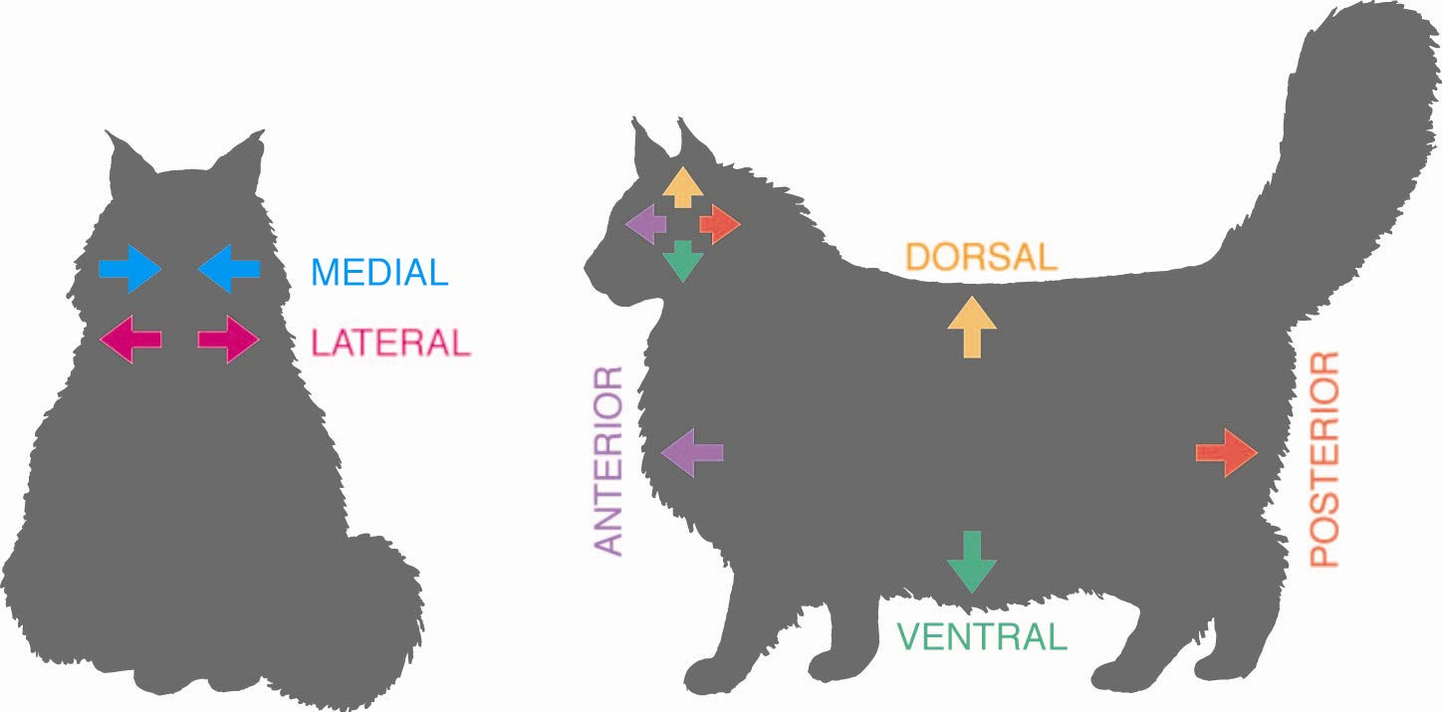
- Provide the terminology to describe the directions in the nervous system:

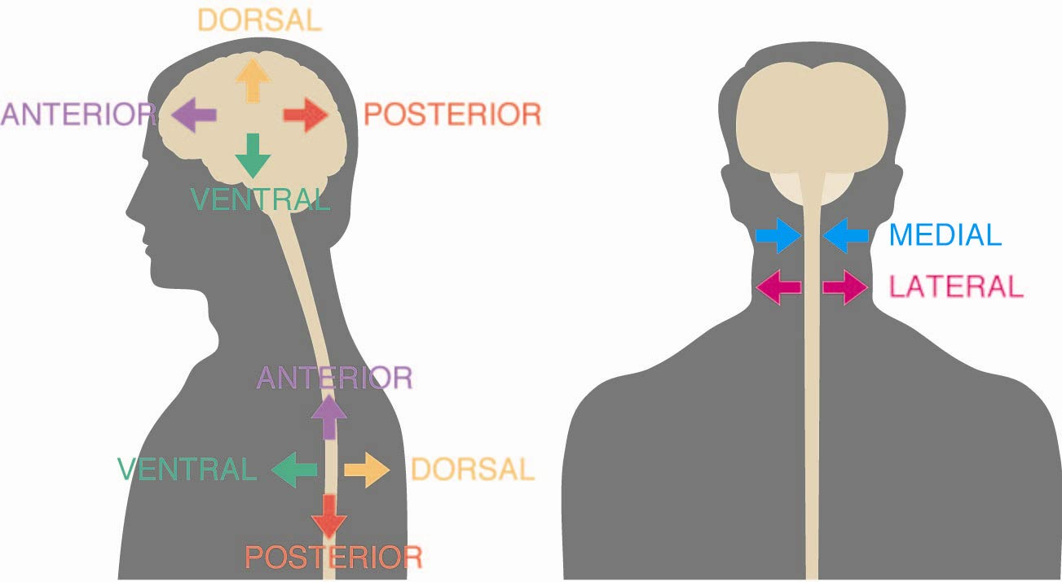

Briefly explain the differences in directions between humans and animals:
- Describe the neuroanatomical techniques used in order to view neurons

  - Golgi stain:

  - Nissl stain:

  - Electron microscopy:

- Describe the two types of Neuroanatomical tracing techniques:

  - Anterograde:

  - Retrograde:

- Fill in the terms used to describe the ways the brain can be cut or sliced.
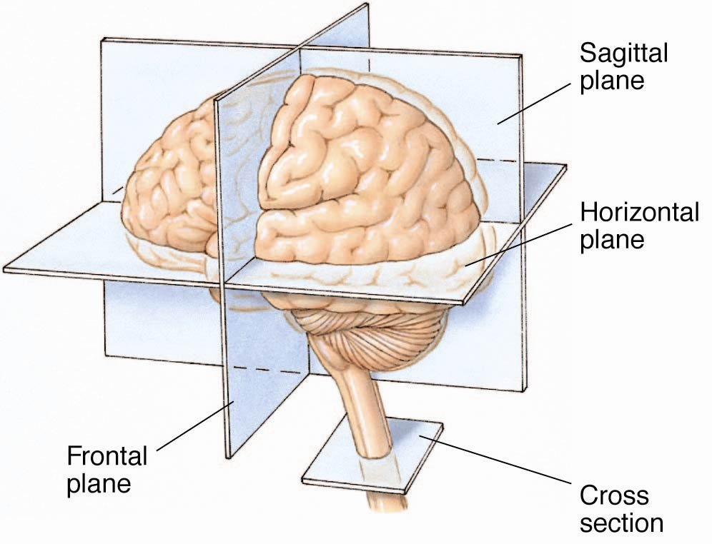

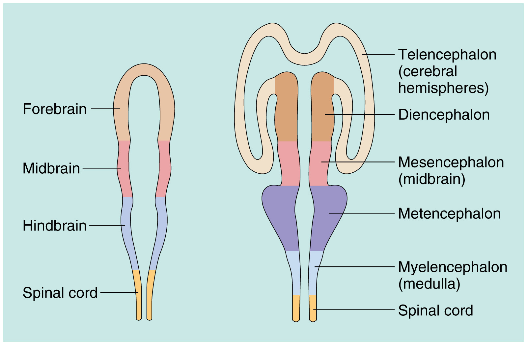
- Fill in the terms used to describe the divisions of the brain:

- In the space below, briefly describe the five major structures of the brain:

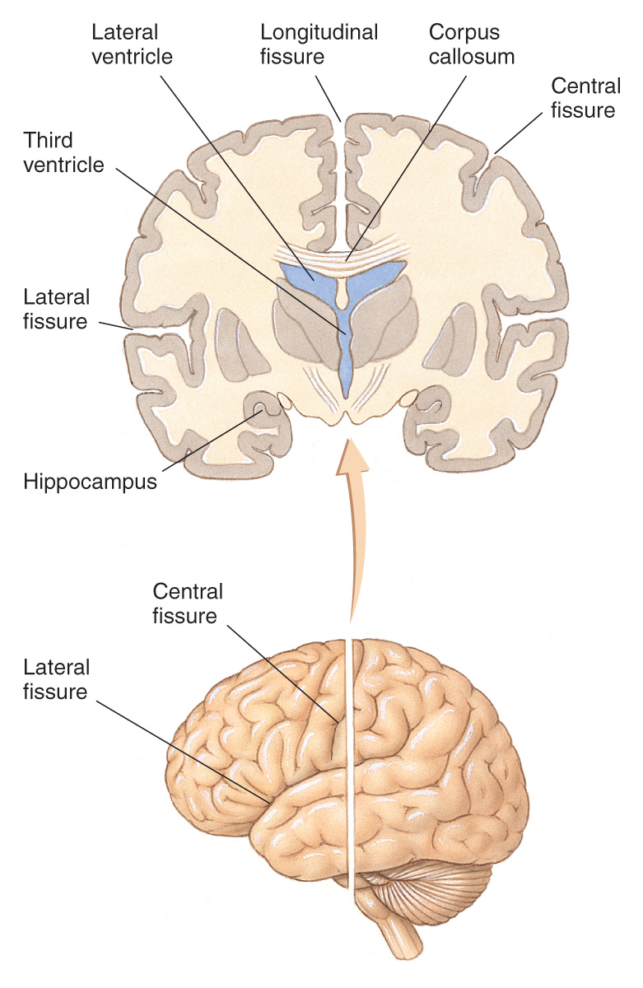
- Fill in the terms used to describe the major fissures of the brain:

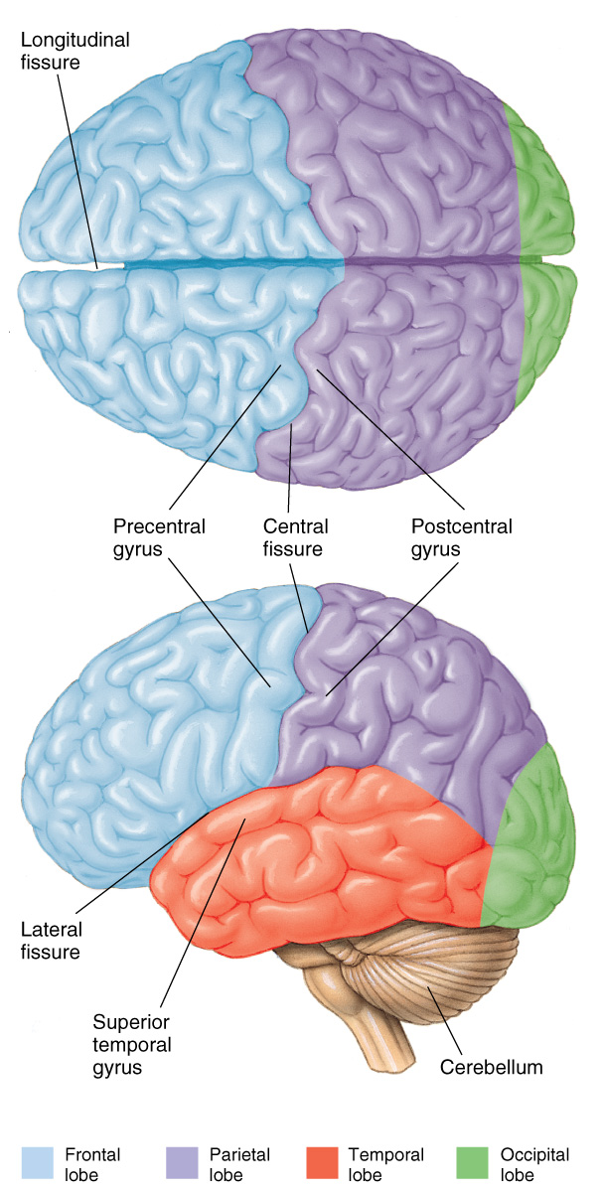
- Fill in the terms for the four lobes

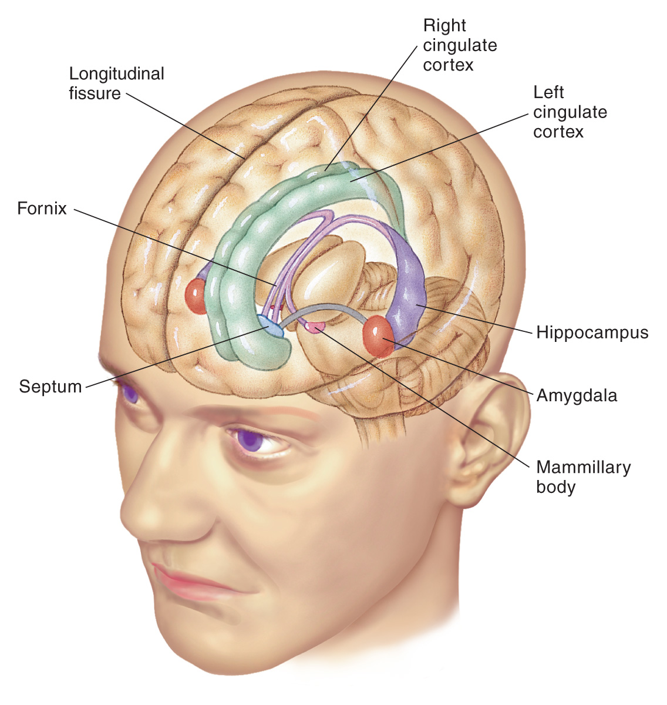
- List the structures that compose the Limbic system

Describe the function of the Limbic system in the space below:

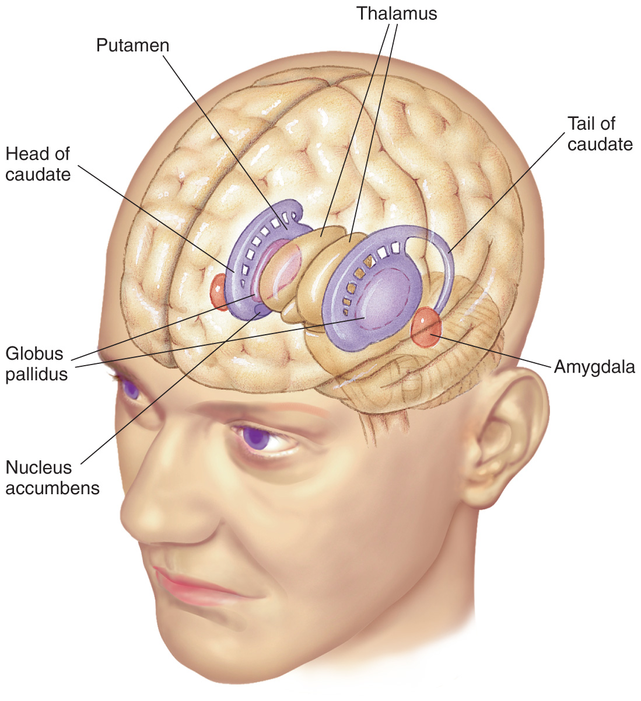
List the structures that compose the Basal Ganglia:

- Draw a line between each term in the left column with the appropriate word/phrase in the right column
Myelin
Soma
Axon Hillock
Golgi Complex
Ribosomes
Synapses
Glial Cells
Synaptic Vesicles
Astrocytes
Ganglia
Oligodendrocytes
Golgi stain
Dorsal
Posterior

gaps
cone-shaped region
packaging membrane
fatty substance
neurotransmitter storage
cell body
PNS clusters of cell bodies
Protein synthesis
The forgotten cells
CNS myelinators
black
largest glial cells
caudal
top of head

- List the three classes of conventional small-molecule neurotransmitters:

- ___________________ b. ______________________ c._________________

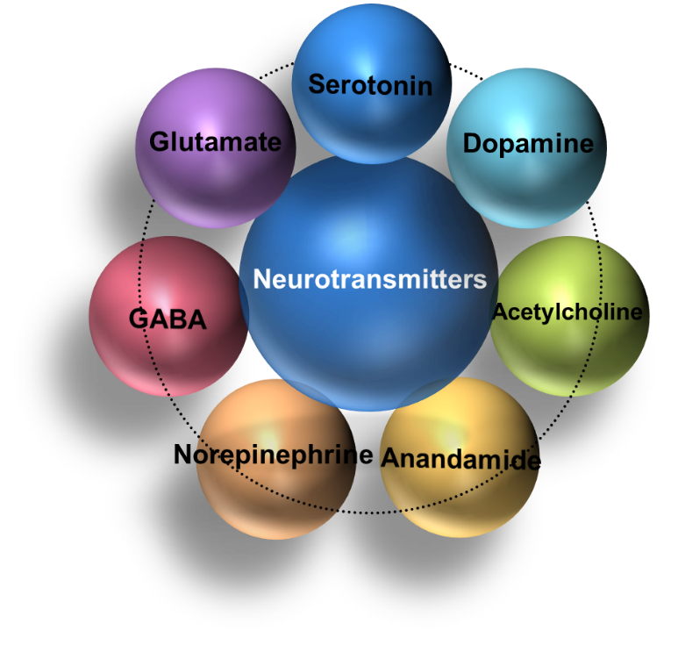
Below are seven key neurotransmitters. In the relevant spaces describe the function the neurotransmitter is involved with or explain what it regulates:

- Briefly describe the four main approaches to studying human cognition and the methods of research investigation used by each approach:

  - Cognitive Experimental Psychology

  - Cognitive Neuropsychology

  - Cognitive Neuroscience

  - Computational Cognitive Science

