Marketing plan written for

______________________________ (CROWNE PLAZA HOTEL)______________________________

Student Name

Amanioaei Eliza Andreea

Student ID number 2216057

Marketing Essentials BMIH4005

Lecturer
Christopher Wilkin

INTRODUCTION
The purpose of the marketing plan is to get the ideal customer range for the new restaurant module that would focus on minimizing the specific food waste as well as providing a significant service of takeaway. This market plan also aims to strengthen the operations of marketing to the chosen business organisation. The market plan is being prepared for the Crowne Plaza situated in London. The Marketing Plan will apply the SOSTAC model framework and 4P's of marketing assessment. In the SOSTAC model analysis, the marketing plan will focus on situational analysis, strategic analysis and objective setting module. Apart from this, the marketing plan will also include the Gantt chart of the marketing activities.

MAIN BODY
Strengths | Weaknesses
- Wider demographic and geographical presence.  - Excellent grip on the customer relationship module.  - The portfolio of organizational management is diversified as it changes with trends and occasions.  - Excellent digital outlook and implementation (Baum, 2019). | - Needs to work economically focused hotel brand.  - The parent company of the Crowne Plaza has recently slipped to 3rd position in the international hotel ranking (Sonawane 2020)
Opportunities | Threats
- The organization should focus on the fragmented hospitality market  - Global tourism has ideally increased after the COVID-19 pandemic. | - Global competition has increased recently.  - Increment in the dependences on the primary intermediaries (Novelia, Oktavio and Nugroho, 2019).
AS per the Psychographic segmentation, the Crowne Plaza is a part of the of the hospitality industry, the upscale hotel brand of IHG. It is focused on lower-price-conscious leisure and business travellers (Mahamud and Arthiranyakun, 2019). The company also offers extended-stay suites under the Stay Bridge brand and the Holiday Inn brand. The company's geographical segmentation allows it to target different segments of the hospitality industry. As a result, it offers exclusive packages to every segment of its customers. As per the customer profile analysis, it is launching a new concept called the Think Tank, which aims to enhance its position as the preferred hotel for business travellers (Sota, Chaudhr and Shrivastava, 2020). This campaign, which will be launched in September, will feature a series of events across Europe. The objective of these events is to provide guests with an opportunity to debate and discuss new ideas. Further is the Porter five forces Analysis of the Crowne plaza hotel (Calinaud, Kokkranikal and Gebbels, 2021).
Bargaining power of suppliers | If the suppliers have bargaining power, they can raise the prices of products at the Crowne Plaza.
The threat of new entrants | If the industry is threatened by new entrants, then existing players will be willing to lower their profits to lessen the impact of these competitors.
Threat of substitute | If the threat of substitution is high, then the need for continuous R&D is greater for the Crowne Plaza.
Rivalry | If there is intense competition, it can affect the operations of companies such as the Crowne Plaza.
Bargaining power of buyers | If the buyers have strong bargaining power, then the price of goods can be driven down (CROWNE PLAZA, 2023).
Through its collaborator's assessment, the hotel crowne plaza has gained access to the world's largest B2B travel trade network, which includes over 60,000 tour operators and airlines. It also benefits from the high-value guests who pay higher rates and stay longer.
Political | - Ideally, this environment should be politically stable.  - It should also not be involved in activities that are politically related (Wahyuntari, Sutarma and Antara, 2020).
Economic | - International recessions (economic)  - Reducing disposable income.
Social | - The goal is to provide the best possible service to the customers.  - This can be done through the combination of the services and the demographic aspect of the customers (Dube, Nhamo and Chikodzi, 2021)
Technological | - When it comes to investing in technology, one should consider an environment that is conducive to its availability (Seyitoğlu and Ivanov, 2020).
Environmental | - Importance of local climate  - Effect of differences (seasonal) on room pricing.
Legal | - Laws (Truth-in-menu)  - Laws (Innkeeper).
Below is the SMART objectives assessment for the crowne plaza hotel.
Specific | Measurable | Achievable | Relevant | Time-bound
Specifically focusing on the digital marketing operations of the organisation. | It will be ideally measured with the help of different digital marketing tools such as Google analytics. | Digital marketing operations are not very difficult to be achieved. It can be easily achieved with the help of the right SEO techniques. The crowne palace should focus on applying white hat SEO techniques and must focus on building ideal customer relationships. | It is significantly very relevant as it helps the company to strengthen its position on digital platforms. | Six months.
The concept of Bowman's strategy clock explores various positioning options. It aims to show how a brand, company, or organisation can position a product according to its perceived value (Fuchs, 2022). The hotel's crown plaza should focus on the hybrid price and the focus on the Bowman's clock's differentiation. A hybrid strategy combines the various aspects of low price and product differentiation to create a more compelling offer for consumers. A hybrid strategy allows a hotel to attract more consumers by offering a lower price while still providing some product differentiation. This strategy can be very effective if the added value is consistently offered. In addition to product differentiation, the hotel should also target to position its offerings at the highest price levels to attract buyers. The hotel crowne plaza currently offers a complete English breakfast. This includes a variety of dishes such as eggs, beef, and chicken. It also has continental-inspired treats and fresh fruits for breakfast (Gebbels, Pantelidis and Goss-Turner, 2020).
The hotel's crown plaza has a marketing strategy that is designed to maximise the value of its products and services. This strategy can be carried out through the various stages of the value chain. One of the most important factors that the hotel's crown plaza considers when it comes to enhancing its offerings is the quality of its delivery (Li, Yao and Chen, 2021). The company that operates the hotel crowne plaza's stores in all markets has a strong relationship with the hotel's management. Through its stores, the company's management can control the operations of the hotel's business. They also gather valuable information about the consumers' behaviour and feedback. The company's stores can additionally help the hotel crowne plaza make informed decisions regarding the products and services that it offers (Hotels, IHG, 2021).
The hotel crowne plaza will consider the various factors that affect its sales environment when it comes to implementing its price penetration strategy. This strategy will help it strengthen its position in the marketplace and attract more potential customers (Yorkulov, Mariona and Zarrina, 2022). The hotel's price points will be displayed based on the various offers that are currently available on the menu. In addition, the hotel will promote its new facilities through digital marketing. Digital marketing is a more cost-effective alternative to traditional marketing methods for the hotel crowne plaza (Kotera, Adhikari and Sheffield, 2021). Further is the GANTT chart assessment for marketing activities of Crowne Plaza.
Tasks | Week 1 | Week 2 | Week 3 | Week 4 | Week 5
Study market
Market strategy
Invital product
Marketing channels
Monitoring and control
As per the USP analysis of the crowne plaza, the objective of the crowne plaza is to provide the value that can be found outside the product or service that it offers. The hotel can measure success through analysis and determining the increase in sales. This can be done through the enhancement of the company's offerings and the development of an effective buying process. Besides this, the hotel should also provide incentives to its customers. These include providing free shipping and fast delivery (Kwan and Tong, 2022). The various features and benefits that a hotel can offer are designed to enhance its customer experience and increase its market share. These include helping boost the price aspects, loyalty, and efficiency.

CONCLUSION
According to the report, digital marketing is a promising tool for promoting the hotel crowne plaza's brand and new services. It can help the organisation promote its various offerings and services at a lower cost than traditional marketing. In addition to this, the digital marketing campaign can also help the hotel crowne plaza target its potential customers.

REFERENCES
Baum, T. (2019) Does the hospitality industry need or deserve talent? International Journal of Contemporary Hospitality Management.
Calinaud, V., Kokkranikal, J. and Gebbels, M. (2021).\ Career advancement for women in the British hospitality industry: The enabling factors. Work, Employment and Society, 35(4), pp.677-695.
CROWNEE PLAZA (2023) READY. SET.TRAVEL. CROWNEE PLAZA [online]. Available from: https://www.ihg.com/crowneeplaza/hotels/us/en/reservation. [Accessed: 16/02/23].
Dube, K., Nhamo, G. and Chikodzi, D. (2021) COVID-19 cripples global restaurant and hospitality industry. Current Issues in Tourism, 24(11), pp.1487-1490.
Fuchs, M. (2022) Crisis communication and corporate social responsibility: a case study on IHG Hotels & Resorts and what organisations can learn from Covid-19 (Doctoral dissertation).
Gebbels, M., Pantelidis, I.S. and Goss-Turner, S. (2020) Conceptualising patterns of career commitment: the leaving process in hospitality. International Journal of Contemporary Hospitality Management, 32(1), pp.126-147.
Hotels, I.H.G. (2021) IHG Celebrates Seventh Straight Year as a Best Place to Work for LGBTQ Equality.
Kotera, Y., Adhikari, P. and Sheffield, D. (2021) Mental health of UK hospitality workers: Shame, self-criticism and self-reassurance. The Service Industries Journal, 41(15-16), pp.1076-1096.
Kwan, M. and Tong, L. (2022) RESTORING GUEST’S CONFIDENCE BY DELIVERING TRUE HOSPITALITY DURING COVID-19 PANDEMIC, CASE OF INTERCONTINENTAL ZHUHAI HOTEL, IHG. International Journal of Management & Entrepreneurship Research, 4(12), pp.514-528.
Li, Y., Yao, J. and Chen, J. (2021) The negative effect of scarcity cues on consumer purchase decisions in the hospitality industry during the COVID-19 pandemic. International Journal of Hospitality Management, 94, p.102815.
Mahamud, T. and Arthiranyakun, K. (2019) The Relationship between Quality of Work Life and Employees Engagement in Crownee Plaza Hotel Bangkok. BOOK oF FULL PAPER, p.38.
Novelia, E., Oktavio, A. and Nugroho, A. (2019) The Implementation of IHG MyLearning as a Mean of Online Learning in Attempt to Human Resources Quality Enhancement at Intercontinental Hotel Bandung Dago Pakar.
Sonawane, U. (2020) The Impact of Customers' Expectations on the Cross-cultural Marketing in the Hotel Hospitality Industry: A Comparative Study of the UK
Sota, S., Chaudhry, H. and Srivastava, M.K. (2020) Customer relationship management research in hospitality industry: a review and classification. Journal of Hospitality Marketing & Management, 29(1), pp.39-64.
Yorkulov, M., Marjona, T. and Zarrina, B. (2022) USAGE OF ICT FOR HOSPITALITY INDUSTRY: ANALYSIS AND SUGGESTIONS. British View, 7(2).

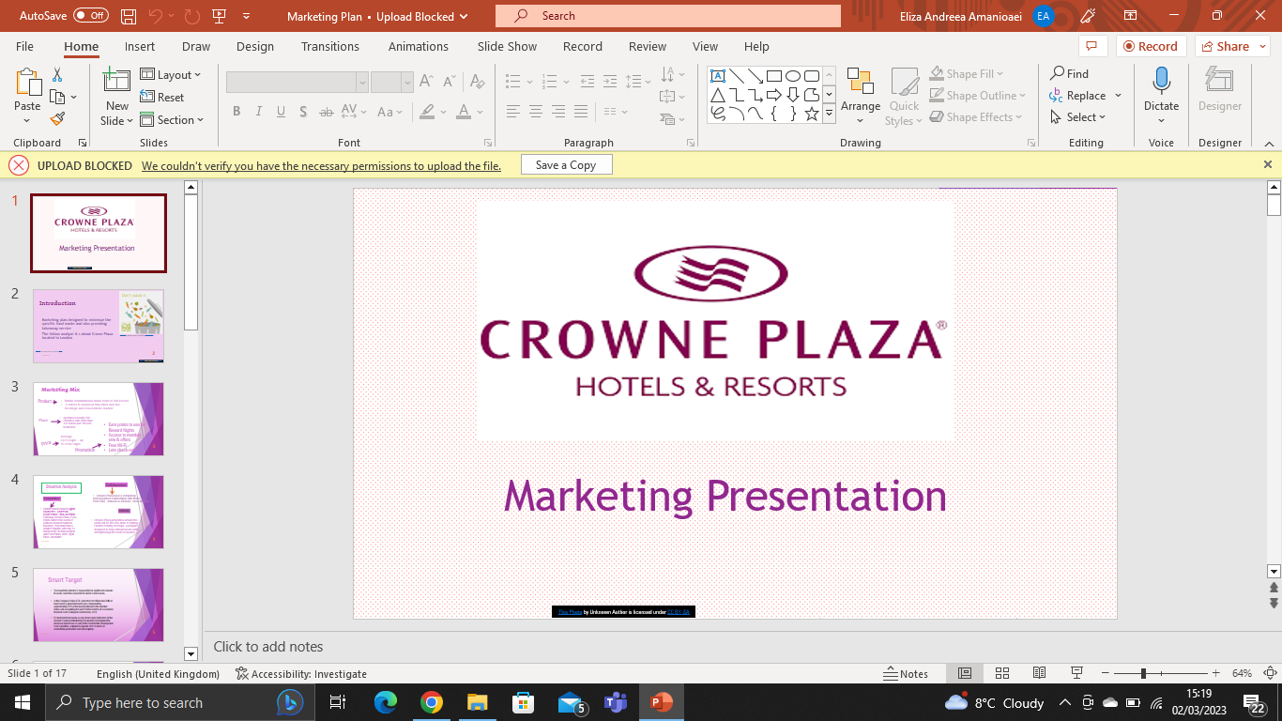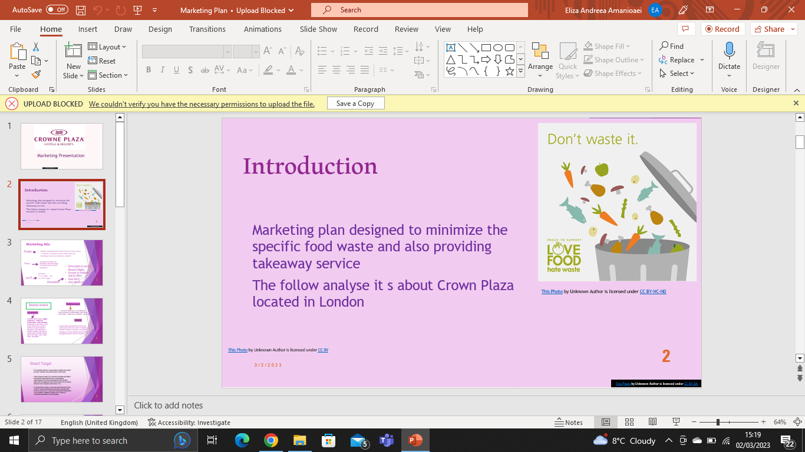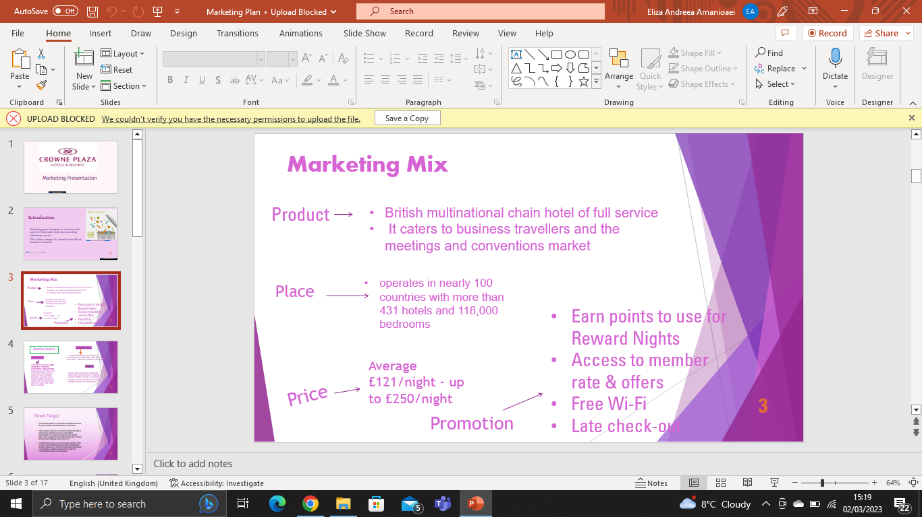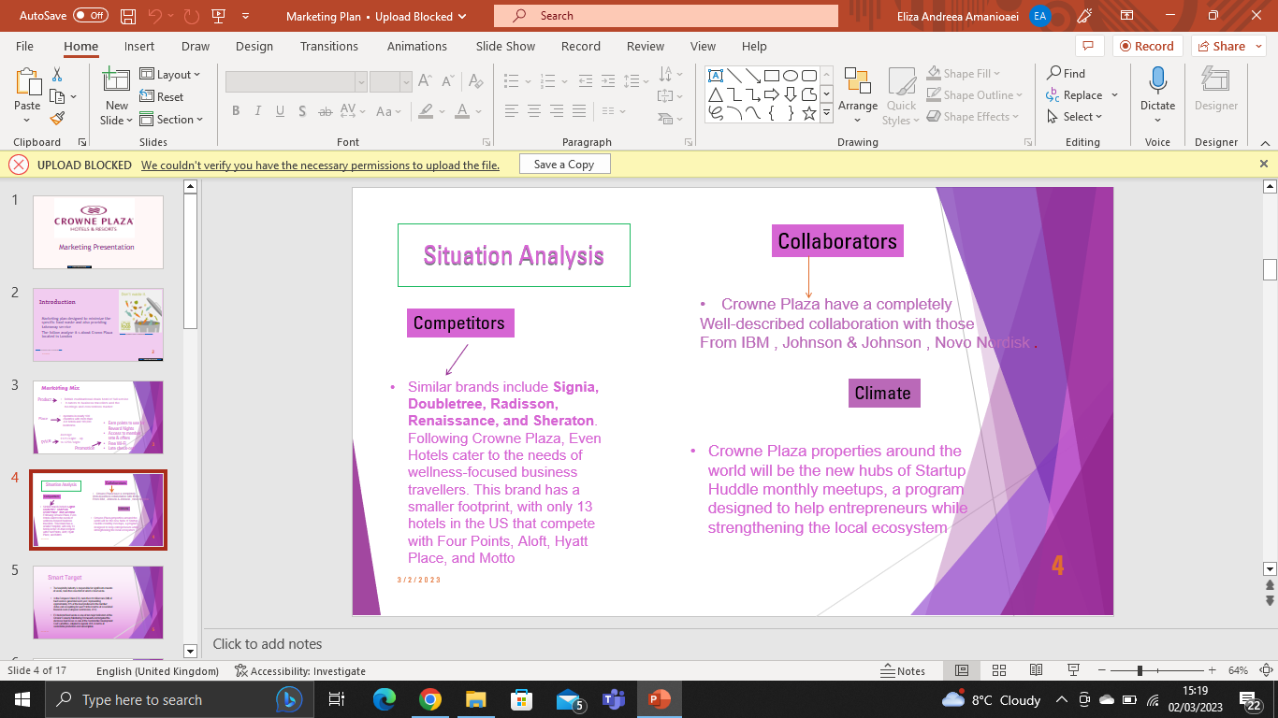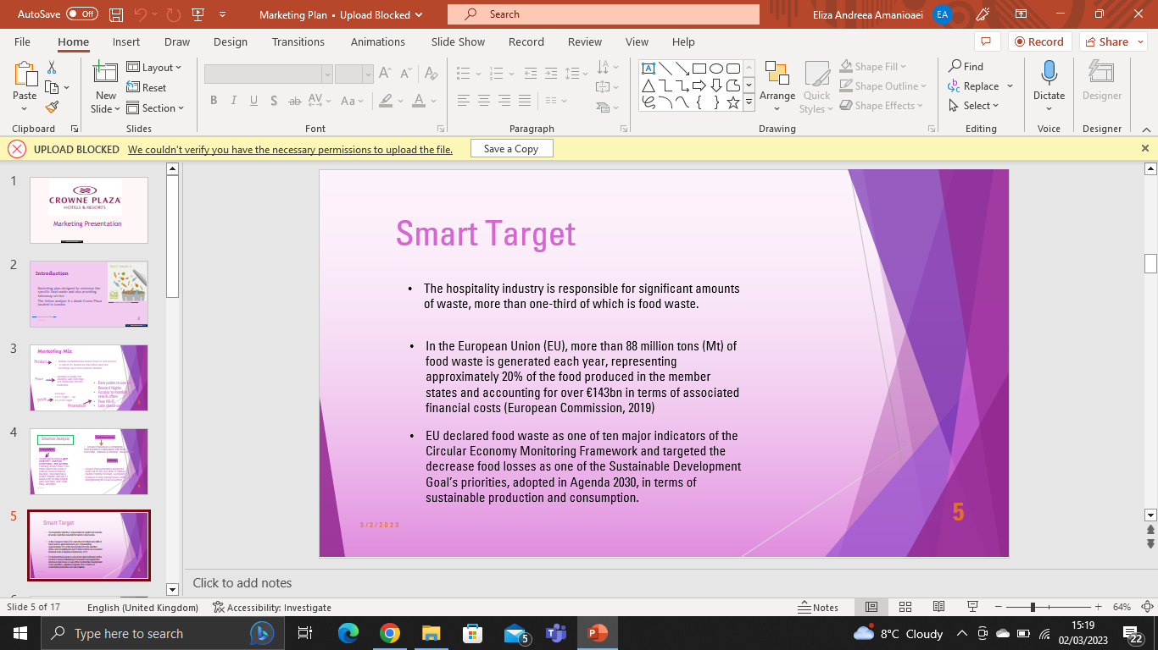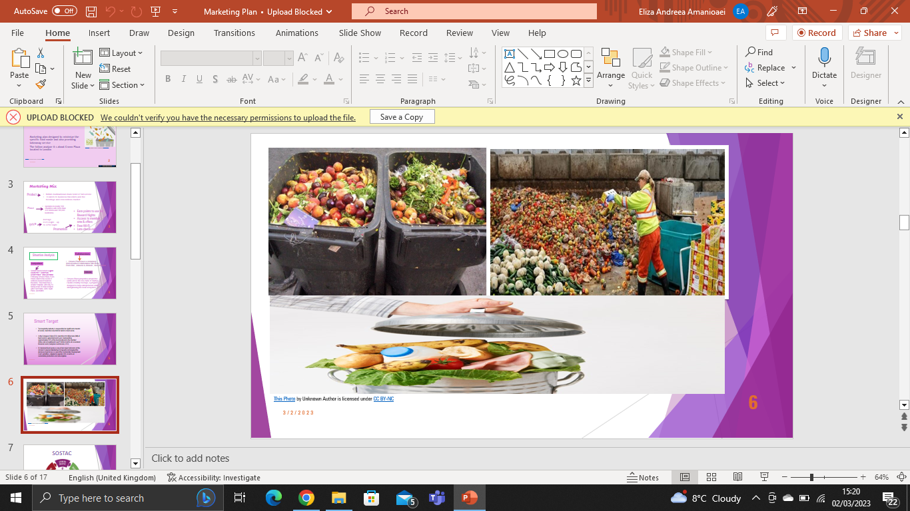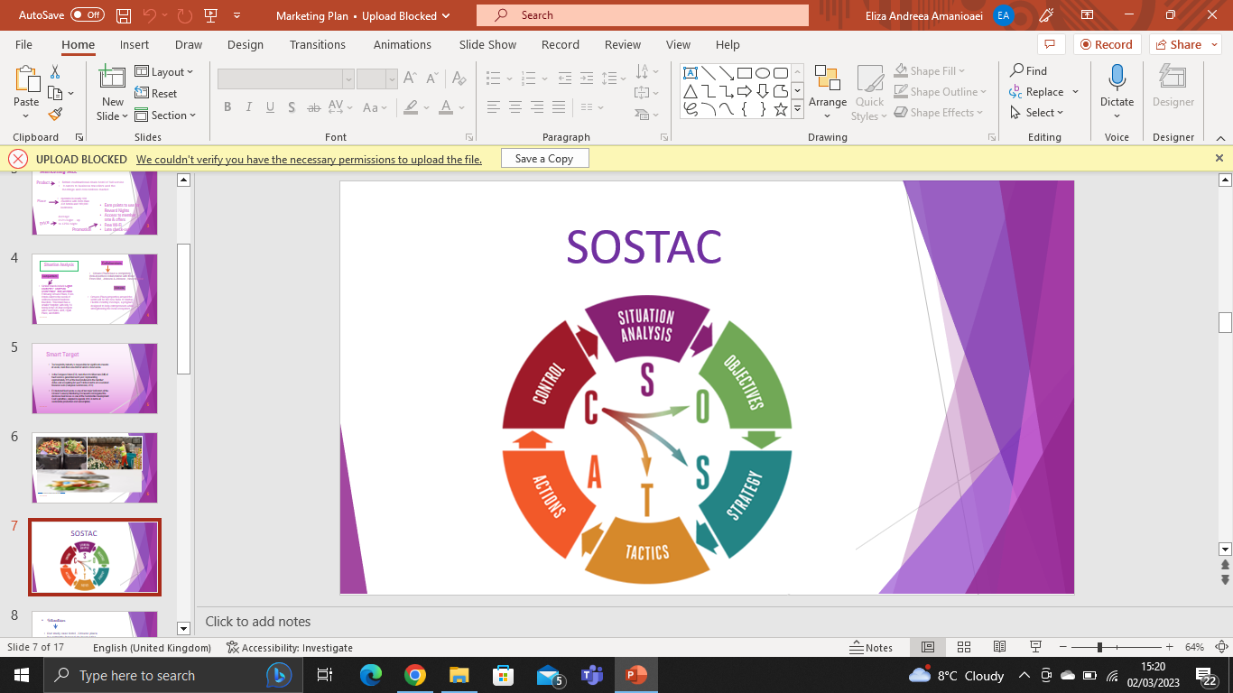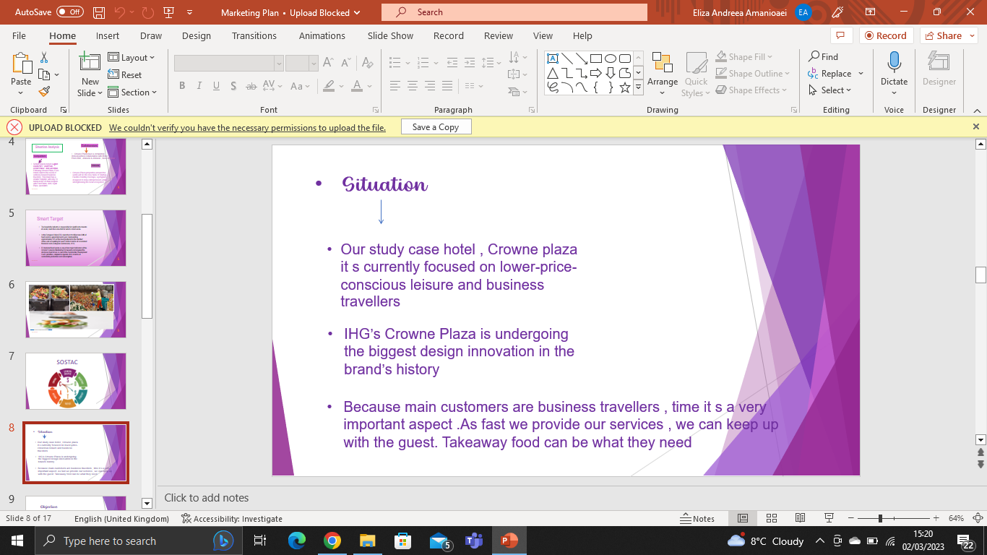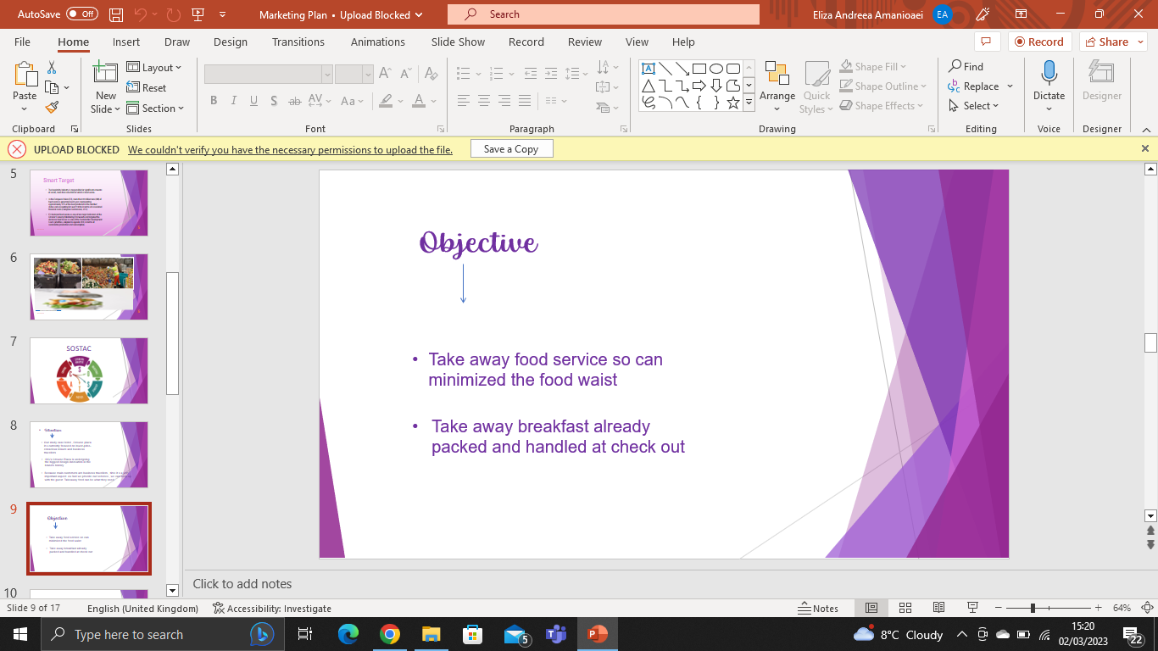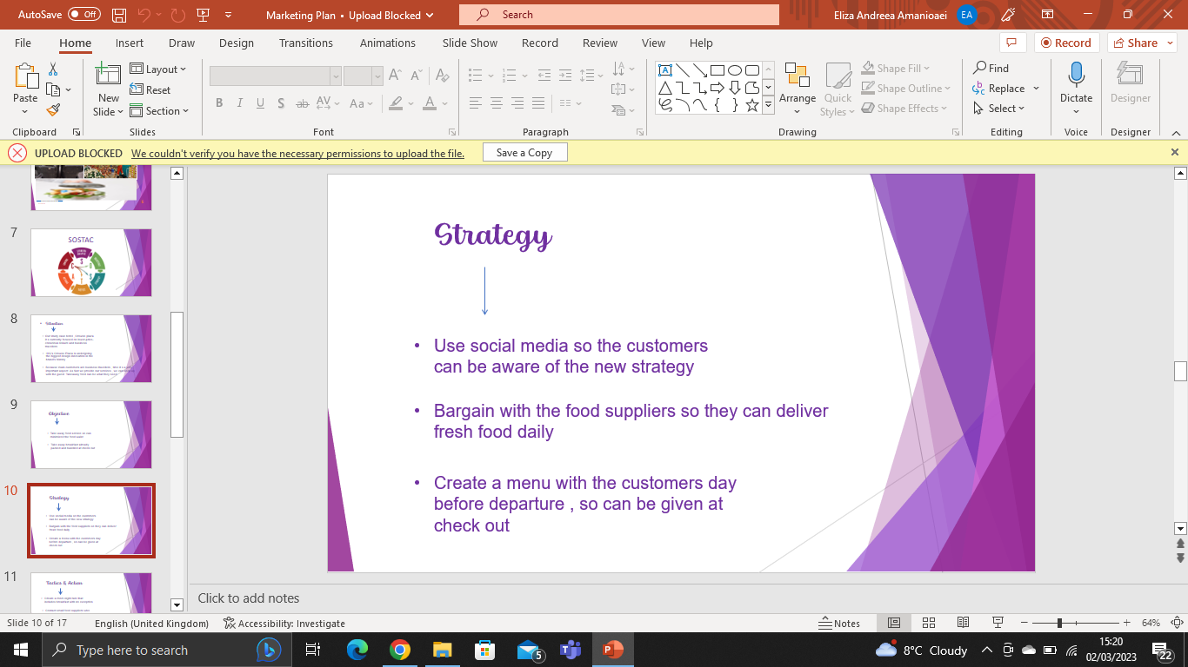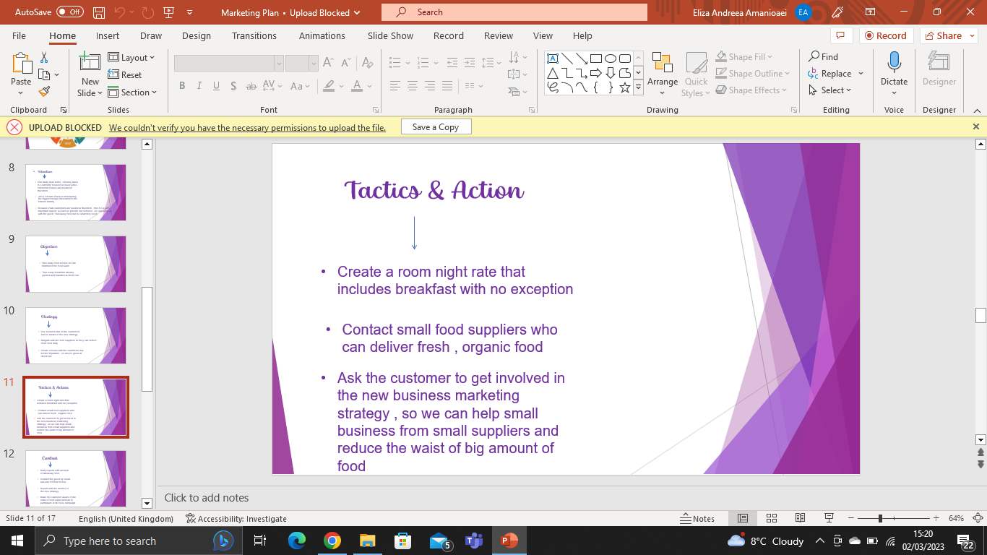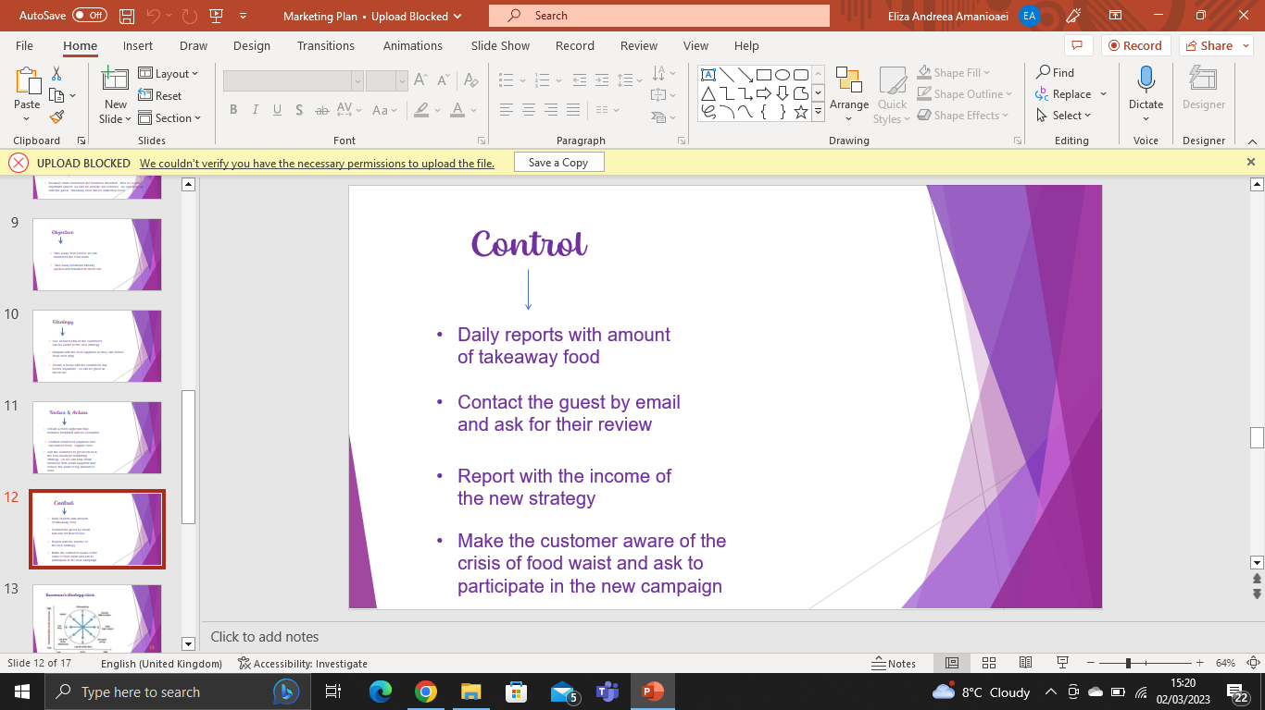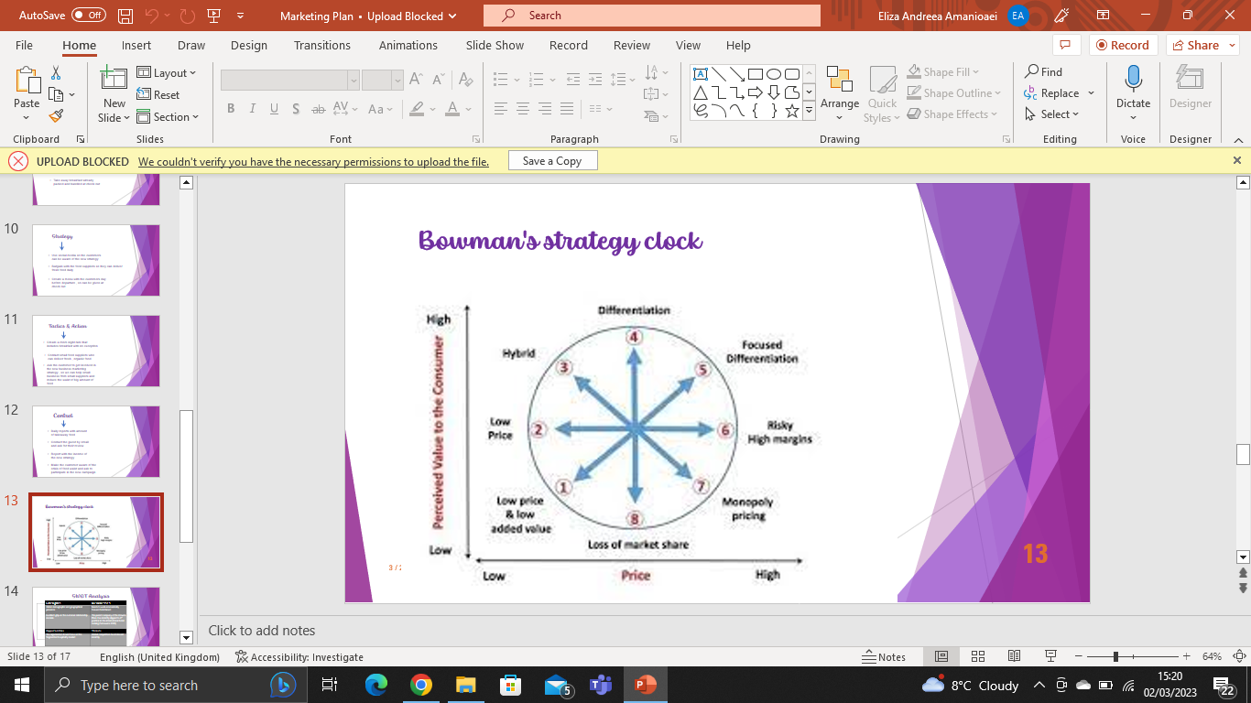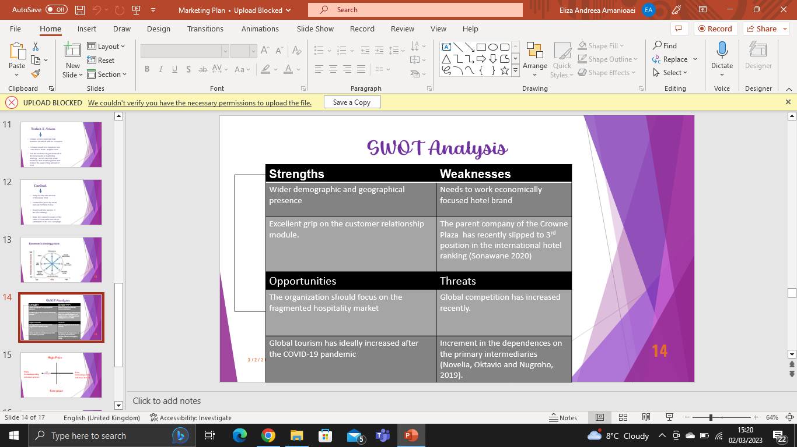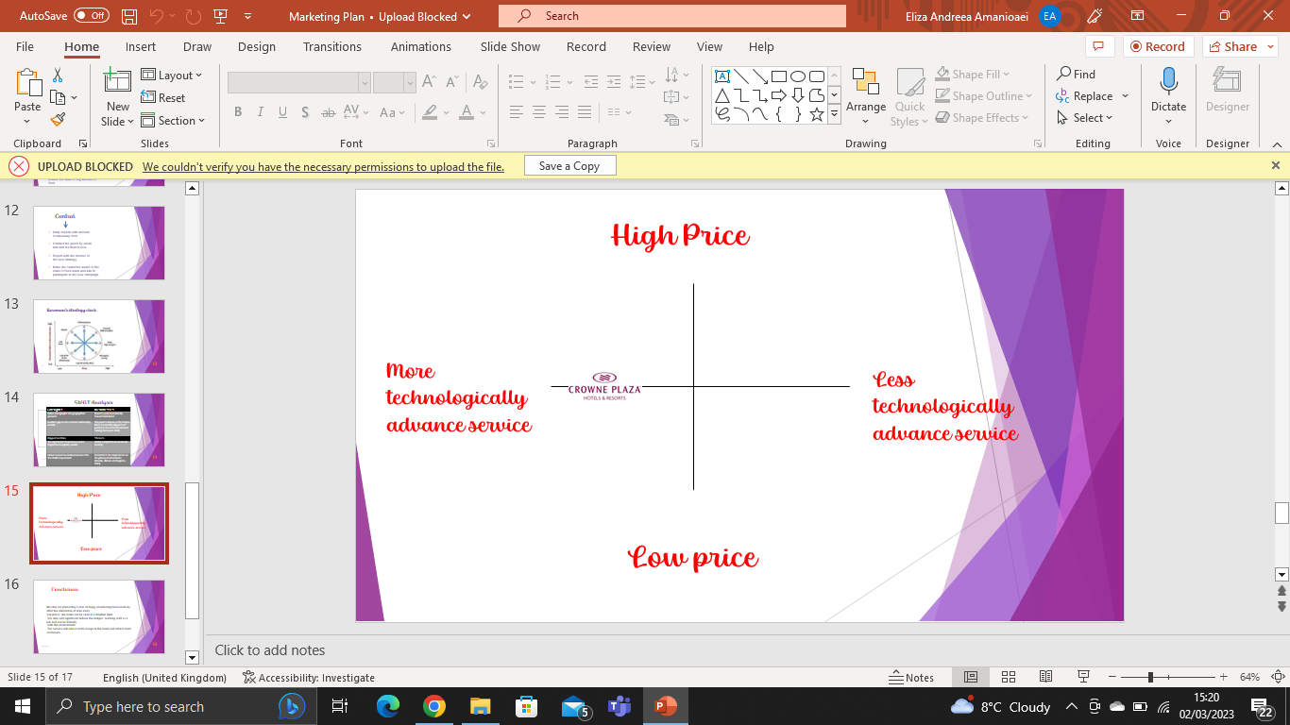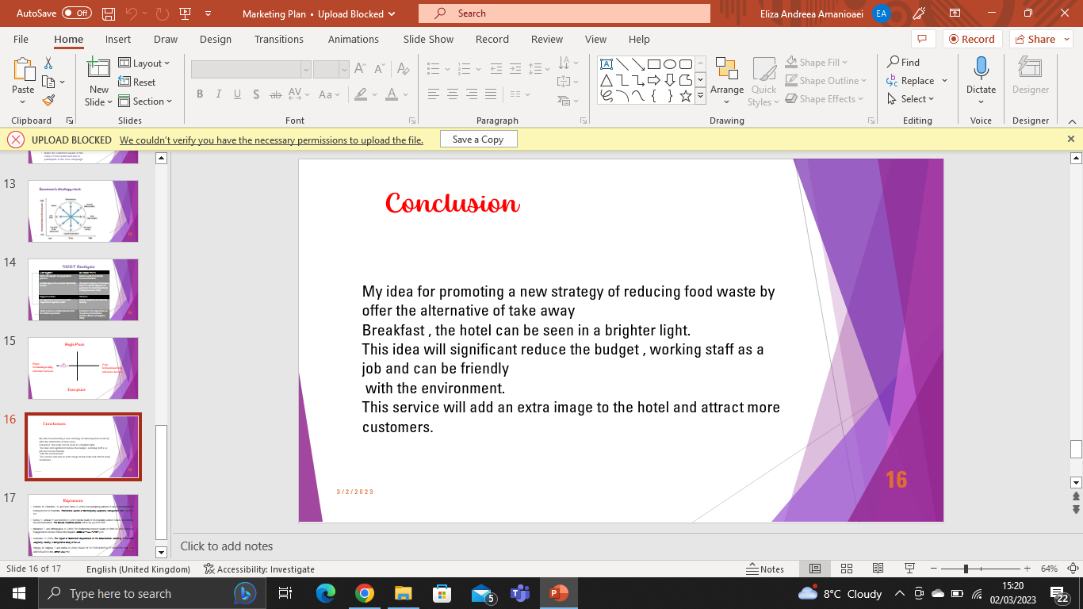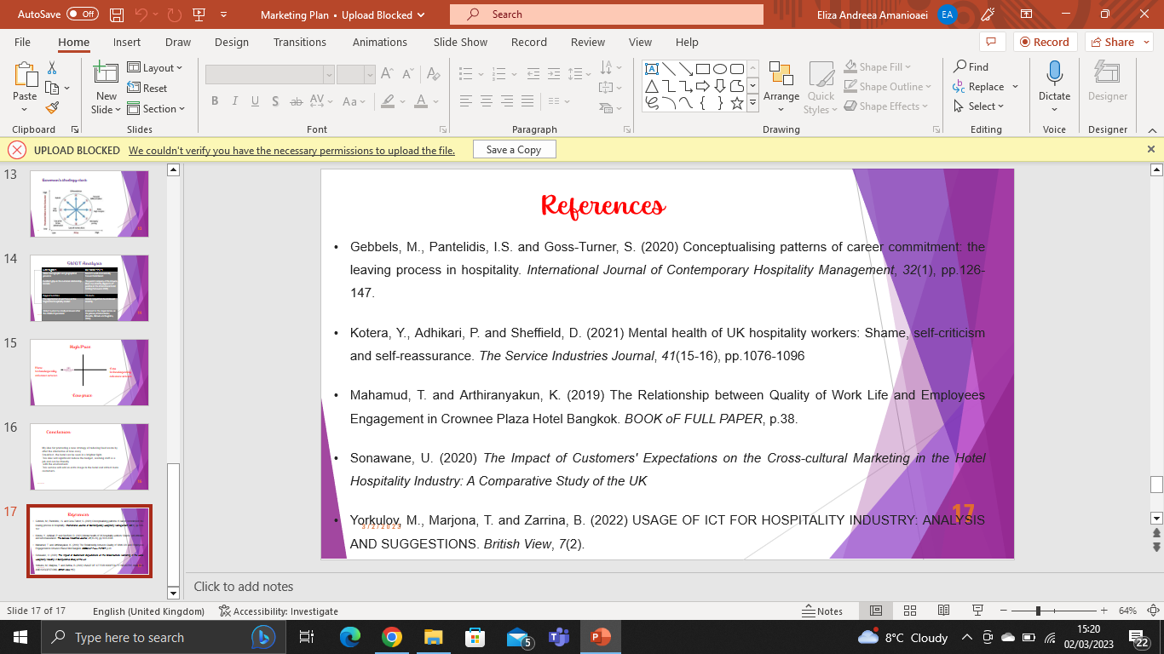

Gannt Chart


