7 DAY FOOD, FLUID AND ACTIVITY DIARY

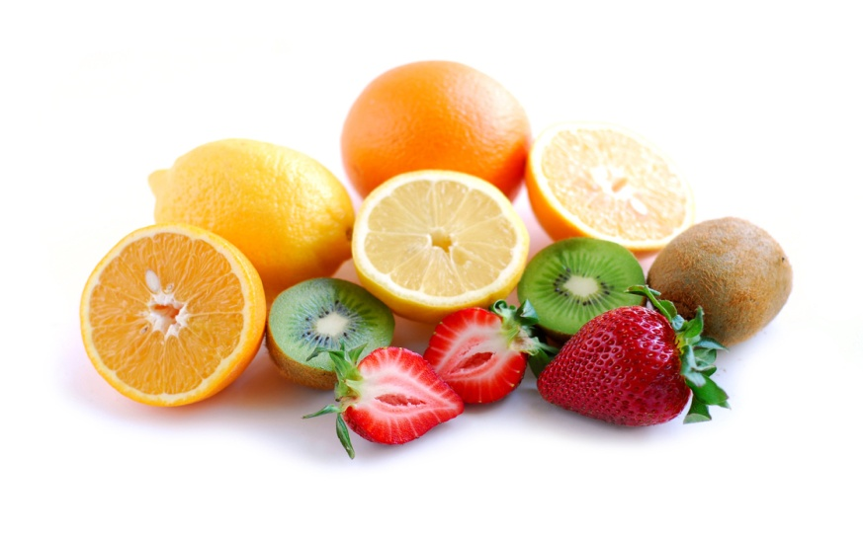

PERSONAL INFORMATION

NAME ………………………………………………….

AGE …………………………………………………….

CONTACT NUMBER ……………………………….

EMAIL …………………………………………………

ADRESS ………………………………………………

………………………………………………………….

………………………………………………………….

POST CODE …………………………………………

WEIGHT IN KG ………………………………………

HEIGHT IN METRES …………………………………

** On the following page is a sample day’s intake that will help you to complete the food diary. The more detail you provide the more accurate the assessment will be. Use the guide to help you.
You can use handy measures such as tablespoons, slices of bread, teaspoons, egg sized potatoes.

EXAMPLE FOOD DIARY

TIME | FOOD EATEN  Please give as much detail as possible including brand names etc | QUANTITY  E.g. a cup, ½ a can, teaspoon etc | Leave blank
8.00 | Bowl of cornflakes | Large bowl
 | Semi skim milk | A cup
 | orange | large
 | Digestive biscuit | medium
11.00 | Kit kat | 2 finger
12.00 | Egg mayo sandwich from the canteen | 2 slices
 | A packet of crisps | small
 | banana | medium
 | Bottle of water
2.00 | 2 cups of tea | Milk and 2 sugars
6.00 | Beef stew from Tesco | 350g
 | 2 slices of wholemeal bread | medium
 | Oven chips | Small
8.00 | 2 glasses red wine | large

PLEASE LIST ANY SUPPLEMENTS YOU HAVE TAKEN TODAY

A multi vitamin – Boots brand

HAVE YOU COMPLETED ANY EXERCISE ACTIVITY TODAY?

One hour’s football training
Walked to work and back – 40 mins in total

FOOD DIARY DATE ................................

TIME | FOOD EATEN  Please give as much detail as possible including brand names etc | QUANTITY  E.g. a cup, ½ a can, teaspoon etc | Leave blank

PLEASE LIST ANY SUPPLEMENTS YOU HAVE TAKEN TODAY

HAVE YOU COMPLETED ANY EXERCISE ACTIVITY TODAY?

