Hotel Trinity
Wales Coast Path S 7 ,Swansea Bay, Swansea, UK.
EXCLUSIVE Menu

Starters
Salmon Ceviche 8.25
Pork Rillettes 8.99

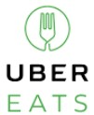

Confit Leek Tartlet 8.75
Available at
Salads and Soups
Caprese Salad 8.99
Spinach Salad 8.75
Lobster Bisque 9.00
French Onion Soup 8.50
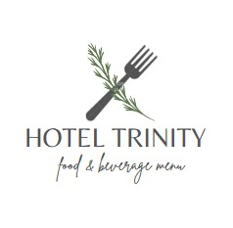
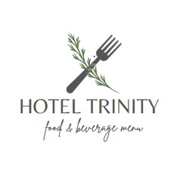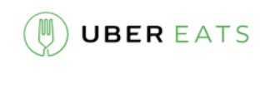
Now available at

Mains
Sirloin Steak with wild mushrooms & parmentier
potatoes 19.99 Pan Fried Sea Bream 19.75
Ricotta Tortellini 16.75
Aubergine Caponata tossed with pine nuts 16.00

Desserts
Rhubarb and Almond Friande 7.99
White Chocolate and Apricot Parfaits 7.75
Apple and Raspberry Crumble 7.50

Afternoon Tea
Moroccan Mint 3.75
Earl Grey 3.50
Victoria Rooibos Infusion 3.99

Wine
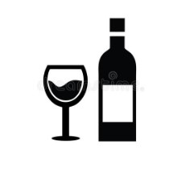 Glass Bottle
White Wine
Sauvignon Blanc 8.50 | 23.50
Viognier 8.99  Red wine | 22.00
Lux Meritage 9.99 | 24.50
Cabernet Sauvignon 8.00  Sparkling Wine | 23.00
Blanc De Blanc 9.00 | 22.75
Sparkling Rose 8.50 | 21.00
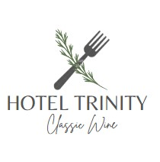

Reference List
Peters, K. and Remaud, P.H., (2020). Factors influencing consumer menu-item selection in a restaurant context. Food Quality and Preference, 82, p.103887. Begen, F.M., Barnett, J., Payne, R., Gowland, M.H., DunnGalvin, A. and Lucas, J.S., (2018). Eating out with a food allergy in the UK: change in the eating out practices of consumers with food allergy following introduction of allergen information legislation.
Clinical & Experimental Allergy, 48(3), pp.317-324.
‘ÖZDEMİR, B. and NEBİOĞLU, O., (2018). Use of menu design techniques: Evidences from menu cards of restaurants in Alanya. Advances in Hospitality and Tourism Research (AHTR), 6(2), pp.205-227.



