Surfing for Wellness: An Insight into the Perceptions of Key Stakeholders within Surf Therapy Interventions in South Wales.

Dafydd Millns

BA Outdoor Adventure Education

Undergraduate Dissertation Certificate



Name of the Programme of Study: Outdoor Adventure Education

Name of Student (Capital Letters): DAFYDD HUW REES-MILLNS

DECLARATION
I certify that the whole of this work is the result of my individual effort, and that all sources have been acknowledged.

Signed: DMillns_________

Date: 16/04/2024________

DECLARATION
I am satisfied that this work is the result of the Student’s effort.

Signed: _________________

Date: : _________________

Acknowledgements:
To begin, I’d like to thank my supervisors, Dr Kate piper for her guidance through each stage of the research process. Importantly I’d like to acknowledge all the participants who have taken their time too eagerly contribute their perspectives in developing the ST sector of South Wales. Furthermore, I’d like to acknowledge Graham Harvey and John Haylock in their support through attaining invaluable literature and rationale throughout. Over the past three years the continued support from staff and lecturers including Heddwen Davies, Denise Leonard, Tom Moore and Alison Connaughton has been key in developing my understanding and knowledge in the field of Outdoor Adventure Education and research. To conclude I’d like to thank the countless baristas of South Wales who have fuelled my recent studies with hot-chocolates and toasties. And lastly but not least I’d like to thank everyone who’s contributed to my time spent in the surf around South Wales.

Abstract:
Surf Therapy (ST) has emerged as an innovative and holistic approach to promoting health and well-being, garnering significant attention from various stakeholders including practical facilitators, psychologists, occupational therapists, and researchers. This study delves into the intricacies of facilitating ST within the context of South Wales, aiming to gain insights from key stakeholders in the field. Recent statistics highlight the increasing prevalence of mental health issues, particularly among young people and individuals with physical disabilities, underscoring the need for alternative therapeutic interventions. The COVID-19 pandemic has emphasized the importance of green and blue spaces in enhancing well-being, leading to government funding for nature-based interventions. Literature suggests that exposure to natural environments correlates with better health outcomes and quality of life, leading to the development of green social prescribing programs. Against the backdrop of South Wales' picturesque coastlines and the region's mental health strategy, ST emerges as an attractive intervention. While existing research primarily focuses on the outcomes of ST interventions, this study aims to explore the perspectives of those delivering the intervention, identifying areas for improvement and underlying themes and practices. Through qualitative analysis of semi-structured interviews with diverse stakeholders, including surf coaches, psychotherapeutic support workers, and clinical stakeholders, the study offers valuable insights. Practical implications of the findings include: 1) Embracing a holistic approach, 2) setting individualized goals, and 3) considering artificial environments to enhance accessibility. Despite identified barriers related to research, funding, and variability in practice, this research contributes to understanding ST interventions in South Wales, offering region-specific guidance. By addressing these barriers and building on the underlying principles of ST, stakeholders can work towards enhancing the efficacy and accessibility of these interventions, ultimately improving the well-being of participants in South Wales and beyond.
Keywords: Surf therapy, South Wales, Adventure Therapy, Key Stakeholders

Contents Page:
Acknowledgements…………………………………………………......................................III
Abstract………………………………...………………………………………………….....IV
Chapter 1 – Introduction………………………………………………………………….......
1.1 Introduction………………………………………………………………………………..1
Chapter 2 – Literature Review……………………………………………………………......
2.1 Literature Review………………………………………………………………………….3
Chapter 3 – Research Methodology………………………………………………………......
3.1 Method…………………………………………………………………………………….8
3.2 Participants………………………………………………………………………………...9
3.3 Data Collection…………………………………………………………………………...10
3.4 Data Analysis……………………………………………………………………………..11
Chapter 4 - Findings and Discussion…………………………………………………............
4.1 Introduction…………………………………………………………...………………….11
4.2.1 Demographic & Aims………………………………………………………………….12
4.2.2 Practical Facilitation…………………………………………………….……………...13
4.2.3 Facilitatory Staff / Supporting Roles…………………………………………………...15
4.2.4 Individualistic Practice…………………………………………………………………16
4.3.1 Threats Towards Programme Participants……………………………………………..18
4.3.2 Barriers Surrounding Finances/Funding……………………………………………….19
4.3.3 Barriers for Growth & Development…………………………………………………...20
4.3.4 Environmental Limitations……………………………………………………………..21
4.3.5 Mitigation of Barriers in Future Development…………………………………………23
4.3.6 Holistic Healthcare………………….………………………………………………….26
4.4.1 Practical Implications…………………………………………………………………..27
Chapter 5 - Conclusion………...………….…………………………………………………..
5.1 Conclusion………………………………………...……………………………………...28
5.2 Strengths & Limitations……………...…………………...……………………………...29
5.3 Directions for Future Research………………………………...…………………………29
Chapter 6 - References………………………………………………………………………...
6.1 References…..………………………………………………………………...………….30
Chapter 7 – Appendices ………………………………………………………………............ Appendix 1…………………………………………………………………………………...41
Appendix 2…………………………………………………………………………………...42
Appendix 3…………………………………………………………………………………...43
Appendix 4…………………………………………………………………………………...44
Appendix 5…………………………………………………………………………………...45
Appendix 6…………………………………………………………………………………...46

Introduction:
Surf Therapy (ST); An innovative and holistic approach to health and wellbeing has risen in momentum and popularity within recent years (Marshall, 2022). The practice has fascinated and captured the attention of practical facilitators, psychologists, occupational therapists, researchers, and communities alike (ISTO, 2018). This study will explore the dynamic and evolving intricacies of facilitating ST within the context of South Wales. Through thematic analysis a discussion will be formed collating thoughts of key stakeholders within the field.

In 2022, The Office for National Statistics reported around 1 in 6 adults to be experiencing moderate to severe depressive symptoms at a time. These statistics have risen more than 300% since 2020 (ONS, 2022). In the case of young people, the statistics are worse; rates of probable mental disorder have drastically risen from 1 in 10 in 2017 to a staggering 1 in 4 in 2022 (PublicHealthWales, 2023 & Murphey, 2023). Evidence strongly indicates that those with physical disabilities are over three times as prone to experiencing depression compared to those without (Noh, et al, 2016). This is further recorded within those with additional learning difficulties (Bishop-Fitzpatrick, et al, 2018). The World Health Organisation (WHO, 2017) says; “Depression is a leading cause of disability around the world”.

Whereas the treatment of health predominantly takes the medicinal approach, the COVID pandemic highlighted the importance of green and blue spaces in promoting positive health and wellbeing (O’Brien & Forster, 2021). It was reported that time within nature and around blue spaces led to benefits in wellbeing and quality of life; furthermore, these effects were uniform across society regardless of demographic (Poortinga, et al, 2021 & Pouso, et al, 2021). On a governmental level this led to funding being allocated in support of a “green recovery” from the pandemic. George Eustice (2020), whilst outlining a recovery plan from Covid says; “We know that a connection with nature contributes to well-being and improved mental health”.

Expanding literature suggests that exposure to natural environments is associated with better health and wellbeing (Jimenez, et al, 2021). Sequentially this leads to a lower
likelihood of non-communicable diseases and stress (WHO, 2019); this identified as being relational to exposure within these natural spaces. Regarding young people, improved birth outcomes are measured and enhanced cognitive development (White, et al, 2019). Additionally, as for blue spaces or those with water, proximity with such is linked with higher health-based quality of life (White, et al, 2021). Consequently, less medication is prescribed leading to lowered dependency and withdrawal (Garrett, et al, 2019). As a result of this heightened appreciation of natural affordances, we’ve seen the growth and development in its use within healthcare. In 2021 a two-year, £5.77 million green social prescribing programme was launched (NHS, 2023). Additionally, to connecting with nature, this concept of green social prescribing facilitates an environment for practical and emotional support. This, through working alongside social and health workers, community-based groups, and developing shared social interest goals (NASP, 2022). Groups take part in activities including but not limited to, growing, gardening, feeding wildlife, going for a walk or swimming (NASP, 2022). The potential for such provisions is absolutely huge, developing this more holistic approach leads to better health and economical savings for our health service (Claxton, 2020).

Considering the advantages of social prescribing, the picturesque coastlines in South Wales, (National Geographic, 2010) and the mental health and suicide prevention strategy implemented by the Welsh Government (2023), the utilisation of ST as an intervention seems particularly attractive. Within the field of ST, current literature focuses on the efficacy of the intervention with the majority of research measuring the outcomes of participants’ health and wellbeing. Whereas this is key to rationalising this form of intervention, limitations are identified (Sarkisian, et al, 2020a). Having this singular point of view can result in a narrowed perspective, reduced validity and risk of assumptions and generalisation, contrary it’s said that a co-produced approach further aligns with turning theory into practice (Heaton, et al, 2015). Given this, it has been identified that a deeper understanding surrounding the perspectives of those delivering the intervention would be greatly beneficial (Drake, et al, 2021). Moreover, gaining an insight into these perspectives would allow for better identification of underlying themes and principles, influence future research and provide a more holistic perspective into the sector. This leads to the aim of the study; To gain an insight into the perspectives of key stakeholders within ST interventions in South Wales. Objectives include:

- To identify and suggest areas for improvement or consideration.

- To identify underlying themes and practices

Literature review:
Within literature, the structure, facilitation and potential of ST is broad and extensive. Synthesising however, ST can be described as a physical activity-based intervention which uses the sea and coastal environment as a tool in achieving positive mental and physical change (Sarkisian, et al, 2020a & Benninger, et al, 2020).

Regarding demographic, in practice this has resulted in young people in care, veterans with mental/physical health challenges, neuro-diverse people and young people with adverse mental health conditions all spending time in the sea (Marshall, et al, 2020; Van-der-Merwe &Yarrow, 2020 & Benninger, et al, 2020). Simply putting, it could be argued that ST interventions are targeted towards marginalized, disadvantaged or vulnerable people (Sarkisian, et al, 2020a). These terms of vulnerability, disadvantaged, or marginalized however can be problematic given how broad they are and the stereotypes they carry. Furthermore, using such words suggests there to be simple solutions to what in reality is extremely complicated (Bright, 2017 & Luna, 2019). Emphasising the complexity of working with said groups, Mechanic & Tanner, (2007) suggest that the root cause of vulnerability within society can originate from developmental problems, personal incapacities, social status, insufficient interpersonal support, and degraded communities to name a few.

With such an expansive demographic to cater for, with such a diverse range of underlying factors to bear in mind, facilitation is again, very varied, often time dynamic, and takes a holistic approach (Sarkisian, et al, 2020a). The aims for facilitation range from, giving people the opportunity to try something new and being a form of respite, (Sarkisian, et al, 2020b) to a tool in order to regulate behaviour, develop resilience and build a sense of purpose within the community (Van der Merwer & Yarrow, 2020).

In practice, varied, dynamic facilitation is evident. The Jimmy Miller Memorial Foundation’s one day ocean therapy programme for example, begins with a talking circle where experiences are shared. This leads to surfing on land, followed by surfing in the ocean.
After this, participants take part in a second talking circle before getting back in the water, eating lunch and de-briefing. Through the process facilitation aims to give participants opportunities reflect on self, others, the ocean, and themes of the day (Sarkisian, et al, 2020b). Another project in contrast to this, observed by Podavkova & Dolejs, (2022) begins with warm-ups and beach games. Following this, facilitators explain their safeguarding policy before introducing information about surfing. Participants then try to pop up and are shown how to ride a board before spending most of the session in the water. They then come out about 20 minutes before the end of the session to get changed and head home. A further factor to consider is the length of these sessions or programmes; some last a few hours and some months (Gomes, et al, 2020 & Sarkisian, et al, 2020b). What we do however see to be recurring within facilitation is how safety, regardless of demographic or aims is approached.

Generally, the running of sessions aligns with Maslow's (1943) hierarchy of needs. Maslow (1943) suggests that human needs are structured in a hierarchical manner. Often portrayed in a pyramid (Appendix 1), this hierarchy begins physiologically as needs for ‘survival’ are met. In turn this leads to the ability to psychologically develop and achieve “self-actualisation” whereas one is able to fulfil their full potential. In regard to the relevance of this model within the context of ST, it’s been highlighted that themes of achieving self-actualisation are those of which are seen within traditional therapy and counselling. “Helping children to meet their basic needs within their culture and, thus, to move up Maslow’s need hierarchy towards self-actualisation” (Harper et al., 2003: 23). Identifying similarities in structure could in turn close the gap and heighten comprehension in-between practical facilitators and clinicians alike. Furthermore, supporting the relevance for this model, aligning with benefits of ST, Nyamoita (2012), synthesizes that the higher needs within Maslow’s hierarchy become increasingly long-term. This concept of longer-term programmes, aligning participants abilities with self-actualisation is seen in literature surrounding ST. Brennan et al. (2024), highlight how for the majority of participants programmes span over at least 12 months. Whereas this underlying structure of meeting basic needs and building upon then is seen within ST-based literature, this aligns with standardised practice for any surf lesson (SurfingEngland, 2018). Regardless of these similarities, the additional considerations, expertise and equipment used within the context of ST make it’s facilitation different and in turn more accessible to the aforementioned ‘vulnerable’ demographic (Sarkisian et al., 2020a).

Expanding upon the value in participants achieving self-actualisation, there are many benefits reported as a result of ST. Over a longer-term basis (3 years from initial intervention), statistics from the Wave Project (Devine-Wright & Godfrey, 2020) state increases in measures of wellbeing in participants. This includes changes in coping, resilience, and empathy, in addition to increase in trust, motivation, self-efficacy and social identification to name a few. Over a shorter period, psychological wellbeing, social confidence, autonomy and healthier parental relationships have been measured, this, given a combination of respite, social connectedness and recognised personal accomplishment (Marshal,et al, 2020 & Van Ewijk et al., 2020). In line with this, Otis et al (2020), proposed that, apart from serving as a means to address negative effects, ST was observed to possess health-promoting, qualities. Nonetheless however, in the realm of physical well-being literature seems to contradict itself. According to Van Ewijk et al. (2020), “there was no statistically significant improvement in physical well-being.” This discrepancy persists despite the heightened effectiveness observed in comparison to the general population, which vulnerable individuals may experience due to a stronger association with living a more sedentary lifestyle (Carty et al., 2021 & Vancampfort et al., 2017).

With this being said, recent studies have highlighted the principals which lead to the aforementioned benefits, these being; A safe space, social support, sensory grounding, mastery, and respite (Marshall, et al, 2023). Regarding safe spaces, influencing factors were, perceived judgment, autonomy and participatory facilitation of which have correlations with feelings of happiness and adaptability (Larson, 1989). Social support was then built through positive affirmation and providing opportunity for peer learning. Sensory grounding was attributed to allowing young people to better cope with difficult conversations, explore alternative approaches to mindful practice and further aligns with Kaplan (1995) to allow for, “a potential for direct pathway to improved well-being” (Marshall et al, 2023). Moving on the feeling of mastery of which supported through peer-to-peer acknowledgment gave young people confidence and self-belief. This self-belief in turn is said to be powerful in allowing for goal setting, initiating actions and building intrinsic motivation (Schwarzer, 1994; Martin, 2023). Finally, the respite experienced was identified by young people as a tool in maintaining health over a longer period of time (Marshall et al, 2023).

Moreover, theory further aligns with these identified contributors towards wellbeing, of which are additionally identified within ST literature (Rosa, et al, 2023; Wilkie, et al, 2022;
Reuben & Himschoot, 2021). Kaplan’s (1995) attention restoration theory (ART) suggests the existence of differing stages of attention: Directed attention, directed attention fatigue, effortless attention, and restored attention. It is suggested that a combination of immersion, distance from habitual developments, specific environmental factors, and a willingness to engage leads to ‘restored attention.’ According to Kaplan, being in such environments facilitates more effortless cognitive functioning, resulting in restorative benefits. Furthermore, this phenomenon extends to auditory experiences. Natural settings often provide a respite from noise pollution, with immersion in nature and exposure to natural sounds, such as water and wind, contributing to improvements in well-being and alertness (Franco, et al, 2017).

Expanding, self-determination theory, identified by Deci & Ryan (2012), leads to a heightened sense of eudemonic or long-term wellbeing. This aligns with feelings of competence, relatedness and autonomy of which strongly correlates with the long term affordances of ST identified previously (Otis, et al, 2020). Expanding, it’s stated that this sense of eudemonic wellbeing leads to holistic feelings of content, acceptance, and purpose within one’s life. Regarding practice this underlying theme of SDT is further identified in literature (Marshall, et al, 2020; Peacock & Brymer, 2020, & Calderon, 2023). It could be suggested, given the variability and adaptability of practice that surfing in itself is an effective tool for facilitating the above.

With the above being said however, there's the question as to whether or not the use of the word therapy is appropriate. Whereas there are statistical benefits to being outdoors, in the sea and surfing, the world therapeutic could be deemed as more appropriate. Given such a diverse range of practice discussed in regard to, time frame, facilitation and demographic it may be inappropriate to label it all as the same. This being particularly pertinent whereas literature is yet to define the timeframe and methods in which make ST most efficacious. Referring to the Institute for Outdoor Learning’s “Outdoor Mental Health & Outdoor Therapy” publication (2020), the use of the word therapy or therapeutic is dependent on the attributes of facilitators; their model suggests that a combination of outdoor professionalism combined with accredited clinical understanding is needed. Expanding facilitation needs to actively foster learning and change in tackling a range of psychological difficulties whilst dynamically utilizing the affordances of natural environments and their activities for progressive development. It’s these factors Richards, et al, (2020) say which leads to integrated outdoor therapy as opposed to simply therapeutic enhancement. The Institute for
Outdoor Learning highlight the importance of being able to distinguish practice in order to maintain quality, safety and avoid misinterpretation (Richards, et al, 2020). Moving forward it could be synthesized that it’s the accreditation of which facilitators hold in which primarily defines whether or not an intervention or activity can be defined as therapy.

Contrary however, Hywel Dda (N.D) define their aims of therapy to be to “prevent significant mental health difficulties from occurring or becoming worse,” of which aligns with measured outcomes of ST as discussed earlier. Expanding therapy within the context of outdoor activity has also been defined simply as; a facilitated experience for people to immerse themselves in a natural area with the intention of improving individual and population health and wellbeing (Lord, 2021). In the context of Wales, we see further juxtaposition in between the NHS (National Health Service) and NRW (Natural Resources Wales). Within these examples, we see ‘therapy’ being used and aligning with the IOL model (ImprovementCymru, 2023). On the other hand, simply spending time in nature is labelled as therapy, this being without any supporting or facilitatory structure involved at all (Scott, 2023). Being said, this study will continue to use the term ‘ST’ but respects the contested issues about the phrase.

Within literature, facilitators of ST are again broad, and oftentimes dictated by the participants (Sarkisian, et al, 2020a). Referring to ISTO (International Surf Therapy Organization), facilitators of associated programmes primarily consist of surf coaches (Brennan, et al, 2024 & Sarkisian, et al, 2020a). Contrary to the above IOL (2020) model, the majority of programmes don’t always have support from those with clinical accreditation (Podavkova & Dolejs, 2022). Being said, the following have been identified within literature as playing a ‘supporting’ role; psychologists, occupational therapists, volunteers, parents, youth workers and nurses to name a few (Brennan, 2024).

Regarding qualifications and training, literature is varied (Brennan, et al, 2024). Whereas not explicit, aligning with the majority of staff being surf coaches it’s assumed that resultantly, they hold standard governing body qualifications. These more than likely being a combination of ISA (International Surfing Association) surf coach, rescue and beach lifeguard qualifications. Nonetheless, in addition to this, given the vulnerability and
demographic of participants, Marshall, et al, (2019) have identified that for some this is alongside ‘in house training’. Over time however, and as the result of growth in adaptive surfing, the ISA as of 2020 developed an adaptive surf instructor course (ISA, 2020). Identified as a further rationale for this course is its value within a ‘therapeutic’ context, in the development of this course, the ISA worked with providers based in South Wales in particular (ISA, 2021). In regards to clinicians and psychologists involved within ST, its only further assumed that they again hold relevant generic governing body qualifications/accreditations.

With all of the above being said, we can synthesise that the facilitation of ST is highly varied and dynamic taking into consideration participant demographic and environment. Given this, an array of barriers has been identified in literature. Brennan, et al, (2024) identify funding or finances in being the biggest challenge faced in facilitating ST. Following this, coordinating staff, retention of participants, and staff training are all additionally prevalent. Expanding on these, further environmental barriers are seen (Drake, et al, 2021), aligning with the identification of staff training Drake, et al, (2021) further highlight ‘surf instruction techniques’ in thwarting participants basic psychological needs. Expanding, Drake, et al, (2021) also identifies lack of participant retention in which they’ve particularly attributed to family engagement.
3.1 Methodology:
Within this research project, the researcher has conducted an exploratory based qualitative study via semi-structured interviews. Given that data will be based on perspective this qualitative approach will provide some holistic understanding of the phenomenon (Guest, et al, 2011; Braun & Clarke, 2006). To complement this, research participants from multiple agencies had been chosen through a combination of purposive and snowball sampling. These participants range from a combination of professional backgrounds including, surf coaches, psychotherapeutic support workers and clinical stakeholders within Hywel Dda health board. The use of semi-structured interviews allowed participants to expand and give further context on their answers, additionally, the open-ended nature of the interviews is highlighted to lead to heightened insight and quality of data (Adams, 2015).

3.2 Participants

In regard to participants, given the multi-dimensional approach, ensuring that there was an appropriate number of representation from each professional background was important. In ensuring this, a code was derived and in turn assigned in order of relevance to each potential participant. For example, “ParicipantA” whose background is primarily based in clinical psychology but is also involved in an organisational role would be labelled as “ParticipantA-CO.” The table (Table 1) below shows the 10 chosen participants alongside their relevant primary and secondary roles within the sector.

Table 1:
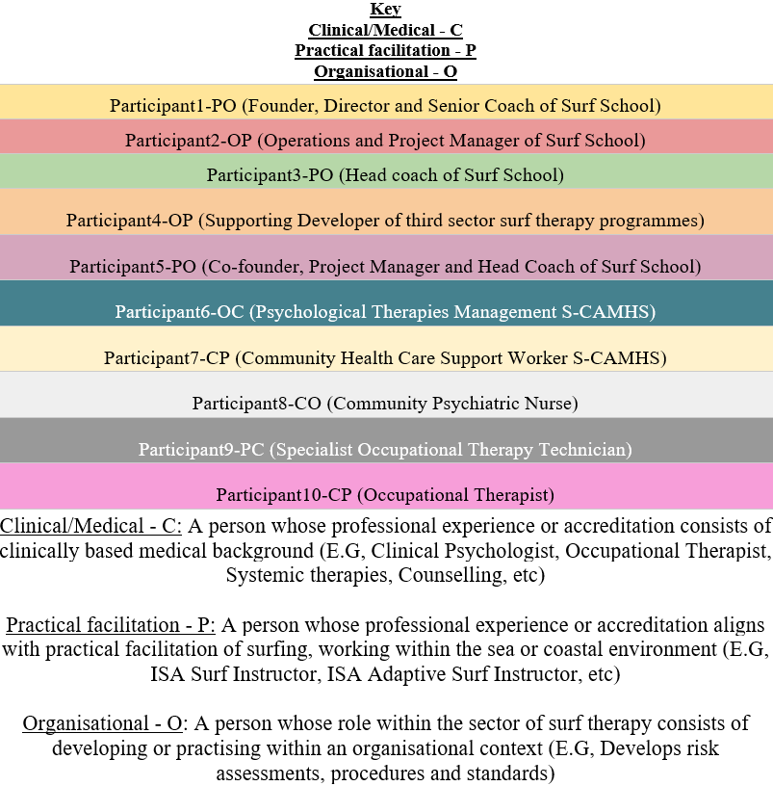

Regarding the number of participants, the study aimed to interview 6-10. Whereas more than 10 could have further saturated the field of interest, given the researchers experience and
timeframe, 10 was decided to be appropriate. Regarding inclusion-exclusion criteria regardless of professionalism or experience participants must geographically be based in South Wales, this will ensure we stay within the scope of the study.

3.3 Data Collections:
Regarding data collection, interview questions (Appendix 2) were influenced by the literature review, and aligned with Kallio et al. (2016), process’ towards developing semi-structured interview questions. In turn this leading to heightened trustworthiness and credibility (Kallio et al., 2016). Following, two pilot interviews were conducted in early December (2023), here questions were initially identified as being rather closed and assuming in nature. These were in turn amended and ‘probing’ phrases identified with the aims of engaging participants to expand. Following this process, informed consent (Appendix 3) and participant consent (Appendix 4) forms were established and distributed to participants accordingly, this, with sufficient time prior to interviews meant participants had plenty of time to withdraw from the process.

Data collection, where possible, was conducted face to face with audio being recorded through a password protected mobile device and Dictaphone. Face to face interviews lend themselves to higher engagement and more follow up questions (Johnson, et al, 2021), so this was the preferred method of data collection. Being said given, convenience, time, comfortability, costs associated with travel and the independent nature of this research the use of online platforms such as Microsoft teams, Zoom and WhatsApp were used when appropriate. Given logistics and time-based constraints of clinically based practitioners a focus group of two participants was held. In trying to mitigate bias surrounding social desirability an attempt to develop rapport and trust with participants led to more introductory and informal questions to begin with (Bergen & Labonte, 2020). In the context of misinterpreted data during analysis participants during this period were asked whether or not they’d consent to further interviews in developing clarity and context if deemed appropriate by the lead researcher. For context interviews lasted approximately 45-60 minutes on average, this with exception of the focus group. The interview process itself from the pilot study through to the ten participants spanned over roughly two months.

Regarding ethical considerations, the University of Wales Trinity St Davids research ethics and integrity code of practice was adhered too (UWTSD, 2022), this further align with
good practice on a wider scale leading to honesty, rigour, transparency, care and accountability. This included the completion of an ethics form, relevant risk assessments and informed consent forms prior to the collecting of any data.

3.4 Data analysis:
Regarding the analysis of data, Braun & Clarke’s (2006) “15-point checklist of criteria for good thematic analysis” was followed (Appendix 5). Aligning with Riessman (1993) and Bird (2005), data will be manually transcribed, which leads to heightened familiarity prior to coding. Although the use of NVIVO could have been appropriate, the researcher (given their experience) found the programme to be fairly time consuming and limiting due to the timescale of the research project. Given the researchers personal experience, both within ‘ST’ and as a service user of a number of participants in a clinical context the possibility for bias was identified. With this being said, given the possible detrimental effects on research in trying to mitigate or neutralise bias (Koopman, et al, 2020; Olmos-Vega, et al, 2023) these past experiences were taken as an opportunity to be capitalised upon. In doing so open codes were assumed prior to analysis. In time these open codes dynamically adapted into axial and selective codes; this dynamic approach further leads to researcher immersion within data (Williams & Moser, 2019). Expanding, although semantic and latent themes will be identified, a semantic approach will better align with research goals of identifying practicable measures and suggestions (Braun & Clarke, 2013). Following the generating of themes, a review and thematic ‘mapping’ took place (Appendix 6). In turn, findings were finalised; these will be highlighted in the following findings and discussion.

4.1 Findings and Discussion:
Through the data analysis process, two main themes were generated which relate to the primary aims of the research study. The first being, the ‘Underlying Structure and Principles of Sessions,’ which includes practicalities, approaches to facilitation and the underpinning role of the environment and surfing as a tool for development. And the second being, ‘Barriers and Threats,’ which identifies generic threats and limitations surrounding the practice, the barriers towards development, and challenges in which we may face through growth. From these initial themes, four findings were generated from the data:
- The underlying structure and principles of ST session in South Wales align with meeting physiological and psychological safety.

- Core facilitatory principles align with those of more so ‘traditional’ clinical intervention.

- An array of participatory threats, in practice are mitigated through facilitatory expertise.

- Funding and research both act as a barrier for expansion and sustainable development in the future.

4.2.1 Demographic & Aims
Aligning with the majority of literature (Brennan, et al, 2024 & Sarisian, et al, 2020a) the demographic for programme participation was varied, resultantly, so were aims. Within the region participants' demographics and background were identified but not limited to; individuals in care, those in mental health services (child or adult), those in supported living services (child or adult) and those with behavioural/developmental differences and/or difficulties. These groups or demographics as identified within literature (Benninger, et al, 2020) could all be categorised as ‘marginalised, disadvantaged or vulnerable’. Whereas this demographic is expected in data, an additional group of people were derived. This being, those with physical impairments or disabilities. Whereas brief remarks have been made in literature (Walter, et al, 2020; Lopes & Masdemont, 2018), South Wales in comparison, has been identified as being world leading within adaptive surfing (ISA, 2021). Expanding Participant1-PO and Particiapant5-PO elaborate.
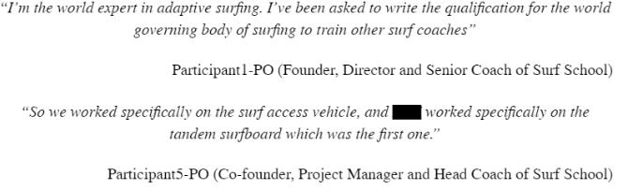

Regarding further findings and considerations, due to this additional dimension in which surf therapy takes within South Wales, criticality must be applied. Expanding similarly to literature aims align with improvements in mental wellbeing and health are seen, additionally to this we see relevance to adaptive surfing.

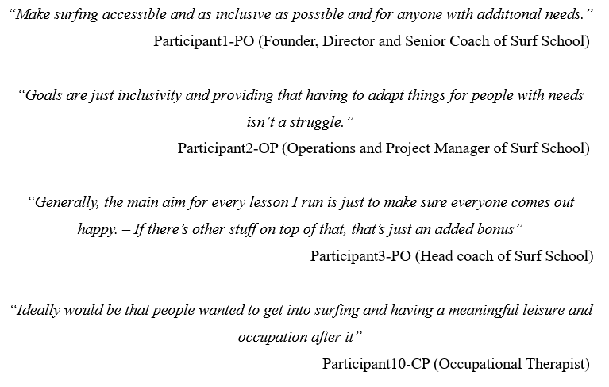

4.2.2 Practical Facilitation
Regarding practical facilitation, data showed that likewise to research, (Sarkisian, et al, 2020b) ST provision in South Wales aligns with themes of ensuring surfers’ needs are physiologically and psychologically met. In context this means that the underlying practicalities of a session follow those of standard governing body lesson structure.

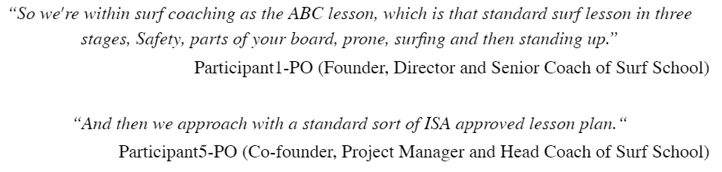

As stated this is a standard of which is followed within literature (Podavoka & Dolejs, 2022). With this being said in meeting participants’ basic needs, facilitators within ST identified other practices in eliminating barriers and dispelling misconceptions of which differ from a standard surf school. Depending on the group, coaches have visited “safe spaces” or “natural environments” such as hospitals, wards and clinics (Participant1-PO; Participant5-PO). Resultantly, they’ve been able to meet participants and have open conversations surrounding what to expect. In doing so this aligns with clinical perspectives within data.

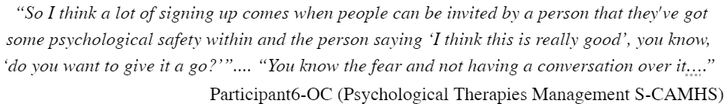

This approach to mitigating anxieties and meeting basic needs, whereas not directly attributed to, could be suggested in leading to more want than demand of which is seen within ST provisions in South Wales.
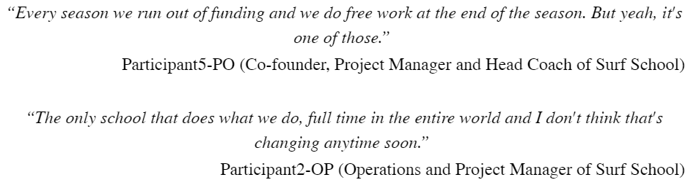

These themes of more want than demand is contrary to literature. Brennan, et al (2024) highlight participant retention in being a barrier faced by organisations; with this being said the majority of participants accounted for within their research in particular were self-referred (82%). In contrast to this, the majority of participation uptake in South Wales in the researchers' experience originates from an already existing supporting organisation. This includes national services (NHS, YouthSupportService, etc) or existing relationships within
charities or community groups. This concept of increased participation due to referral through pre-existing networks not only aligns with Participant6-OC’s narrative as to the importance of psychological safety but also results in a form of accountability which may further extrinsically motivate. This idea around a lack of psychological safety within peers is specifically identified by Drake, et al (2021) as a barrier to participant retention. This concept of psychological safety leading to heightened retention is also evident in playing a vital role in overcoming barriers (Edmondson, et al, 2016). Other examples around meeting these psychological needs and mitigating barriers identified were; sharing wetsuits prior to session in mitigating sensory barriers and sharing video tours of facilities in mitigating unfamiliarity (Participant1-PO). What literature has identified is that creating a ‘safe space’ through meeting psychological needs is a key fundamental in facilitating ST (Marshall, et al, 2019; Brennan, 2024).

4.2.3 Facilitatory Staff / Supporting roles
Regarding the facilitation of ST sessions in South Wales, ‘staff’ or ‘supporting roles’ were, given the variety in clientele, varied. Identified in data were; Surf coaches, beach crew, volunteers, peers, health care support workers, families, psychiatric nurses, occupational therapists and neuropsychologists. The selection of staff or support personnel for a given session was primarily determined by the group involved. As established, participants often already had established connections within service or community groups. In turn the staff or supporting members from said services or groups would play ‘supporting roles.’ Examples include a group of young people within mental health services being accompanied by their particular therapists or support workers (Participant8-CO, Community Psychiatric Nurse). Another could be a brain injury group whose supporting staff include relevant clinical neuropsychologists.

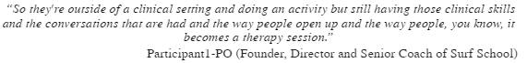

In this context it’s identified that clinicians are able to conduct psycho or physio therapeutic work alongside and throughout ST sessions. On the other hand, groups have been

identified whereas ‘supporting’ roles, contrary to the mentioned, don't have a clinical background (Participant5-PO). These themes of variability within supporting staff are further seen within literature, expanding however it’s not highlighted as to whether or not these supporting roles are internal or external to the ST organisation (Brennan, et al, 2024). Aligning with the IOL (2020) model the question then presents itself as to whether said intervention is ‘therapy’ or ‘therapeutic’. Nonetheless it has further been highlighted that regardless of ‘clinical’ support, ST through its environment and alignment with meeting basic psychological needs still facilitates underlying psychotherapeutic benefits (Moreton, et al, 2022). Moving forward, further research may benefit from evaluating the efficacy of intervention with and without clinical support. In doing so the defining of the intervention as therapy or therapeutic may become more transparent.

4.2.4 Individualistic Practice
Aligning with meeting participants' psychological needs, the setting of individualistic achievable goals was identified as key within data.
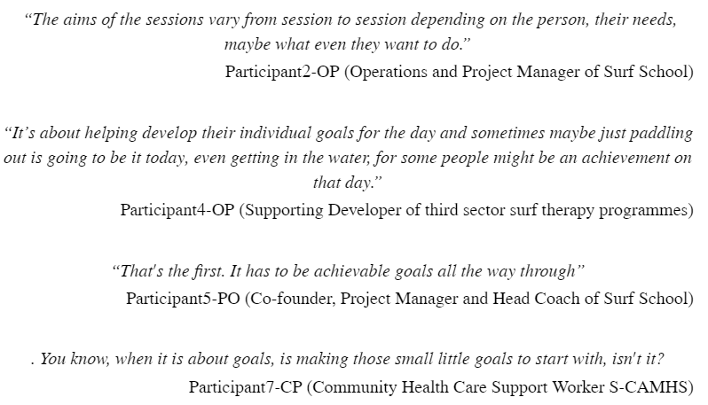

These themes around the value of individualistic goals have additionally been identified as key within literature (Marshall , et al, 2019). Furthermore, it’s highlighted that this practice aligns with self-determination theory (SDT) (Marshall, et al, 2020), and furthermore with
Maslow's hierarchy of needs (Moreton, et al, 2022). Both of which align with the development of a ‘safe space’ as earlier mentioned. Being said, consideration must be applied, given the possibility of thwarting surfers’ safe space through unrealistic or narrow aims. In doing so there’s the possibility of developing an unhealthy relationship with the environment or therapeutic process (Baumeister, et al, 1993). Given these considerations it could be suggested as being appropriate to ensure any supporting staff involved directly with surfers to have some sort of psychological understanding or suitable experience, this however is obviously very subjective. Nonetheless, this suggestion becomes even more pertinent given the identification of other facilitatory threats towards programme participants.

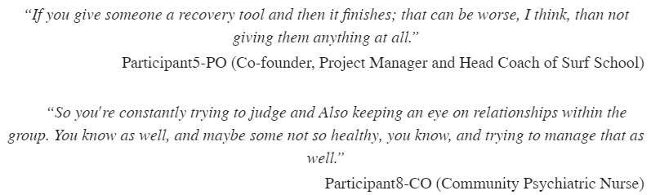

4.3.1 Threats Towards Programme Participants
This identification as to the vulnerable nature of participants in a group environment was further highlighted by Participant6-OC (Psychological Therapies Management S-CAMHS) who recognised the need for robust risk assessing and safeguarding. Whereas the same issues have not been mentioned in recent literature, Podavkova & Dolejs (2022) do make note of the managing of participant-staff relationships. Nonetheless they’ve recognised in practice that transparency and unambiguous communication between said participant and staff has never led to an issue (Podavkova & Dolejs, 2022). Moving forward however as the sector develops or changes, ensuring that a robust system is in place ensuring that the correct people are working within ‘supporting’ roles will be key.

Further threatening the long-term wellbeing of participants, data identifies the risks associated with the timeframe of ST interventions of which isn't realistic to span for years. Regarding time frames of ST intervention in SW some had identified that anything shorter than once a week for six to ten weeks ``doesn't really work” (Participant5-PO). The ideal time frame in particular has been further identified as individualistic

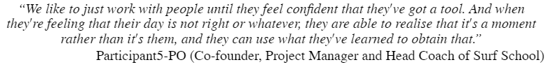

With this being said, in regard to practice, data shows that the majority of programmes are closed blocks of sessions (Set beginning and end), this structuring of programmes is identified as similar to wider literature (Brennan, et al 2024). As a result of not always being able to deliver ST intervention over a longer period of time, the following have been identified as potential threats.
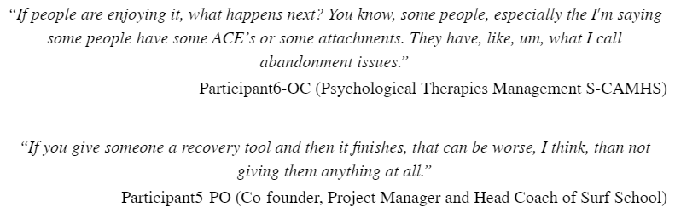

4.3.2 Barriers Surrounding Finances/Funding
Being said these are far from the biggest barriers in facilitating ST in South Wales. The majority of research participants, particularly those form a practical or organisational background, highlighted funding as being a barrier. This being consistent within wider literature (Benninger, et al, 2020; Sarkisian, et al, 2020; Brennan, et al, 2024). Whereas research participants have identified recurring charitable pots, the narrative aligns with issues around the sustainability of such

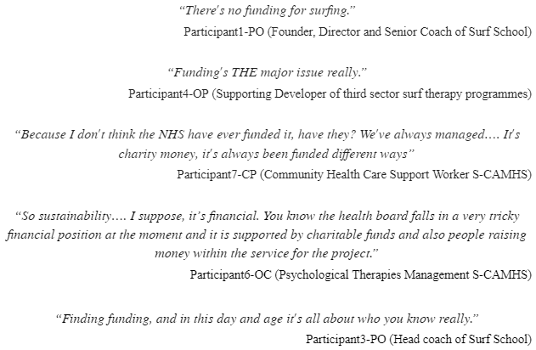

These issues surrounding funding are further seen from clinical perspectives whereas within the context of health board, support staff are found to be spending their own money in making ST accessible.

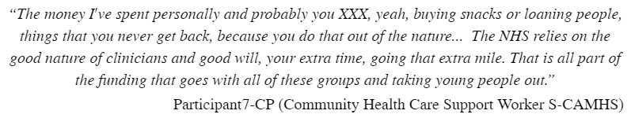

4.3.3 Barriers for Growth and Development
These issues around funding correlated with prior literature; it's here a lack of research has been highlighted as the primary crux of funding (Benninger, et al, 2020; Brennan, et al, 2024). This lack of research and funding around the intervention has been identified within other programmes as the ‘dual limitation’ to longevity and development (Brennan, et al, 2024). Similar themes are seen within our data.

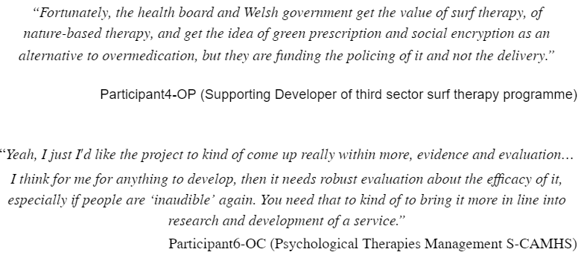

Regarding wider literature, it’s identified that research lacks standardised measures of efficacy in conjunction with traditional therapy (Brennen, et al, 2024). Given this it's identified as being difficult to attribute whether ST based programmes in particular have attributed to improved mental health and wellbeing as opposed to time or other forms of intervention. This being similar to the narrative highlighted above. Consequentially in developing this research base, there may be further opportunity for sustainable funding on a governmental level. Given the particular expertise highlighted of practical facilitators in South Wales in particular it may be appropriate to suggest they’d be valuable in developing said standardisation for measures.

4.3.4 Environmental Limitations
Expanding on the theme of vulnerability of participants, the coastal environment and being in the sea has been attributed within data as key in further developing participants’ ‘safe space,’ meeting psychological needs, and in turn, allowing for psychological vulnerability

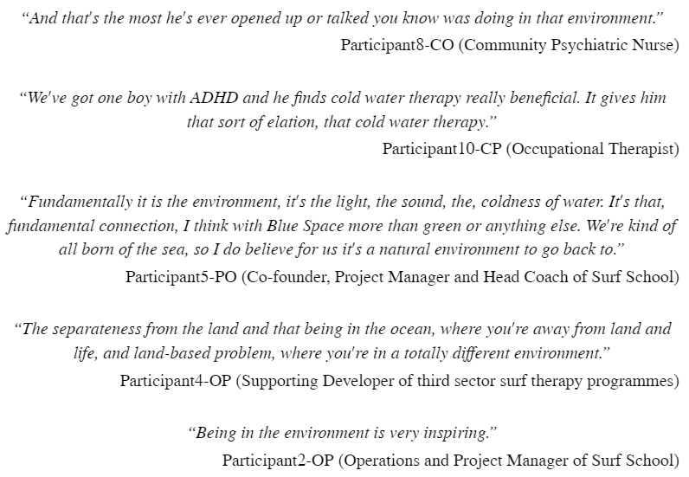

Whereas the above quotes are from the perspective of those facilitating and managing ST, their thoughts and feelings align with that of participants within further literature (Kelly, 2018). In South Wales in particular participants of surf therapy have identified nature immersion as being a contributing factor to empowerment, revitalisation and relaxation (Gibbs, et al, 2022). Amalgamating both the findings in data and literature, were able to align environmental affordances of ST to those of attention restoration theory (Kaplan, 1995). This process of restoration and relaxation could theoretically be labelled as the underpinning contributor to Participant8-CO’s experiences. With this being said, regarding considerations moving forward, we may benefit by asking ourselves what exactly ‘natural immersion’ and ‘connection’ looks like, and in turn how we can heighten or facilitate these experiences and feelings. Expanding the combination of positive psychological feelings recurring within an environment can lead to participants developing a sense of place in which could, mitigate some of the threats identified earlier. Aligning with this sense of place, Wright, et al, (2024) highlights how ST participants described developing “ a blue identity”, which resulted in attachment to the coast and consequentially the use of such environments for emotional regulation. Being said, it could be suggested as
beneficial to help participants make links in between the environment they spend time in and their wellbeing. Moving forward the exposed nature and locality of the Welsh coastline does present environmental barriers in itself. Participants expand below.

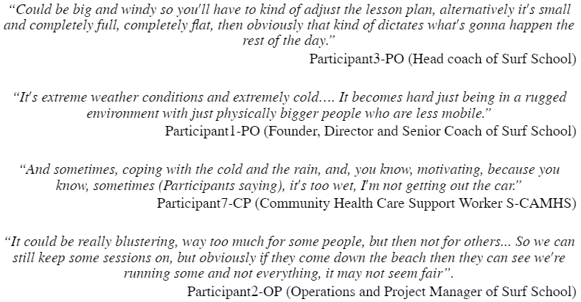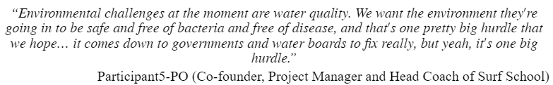

4.3.5 Mitigation of Barriers in Future Development
Whereas this is expected given the researchers personal experiences, it does introduce barriers which are not comprehensively introduced in literature. Recent literature itself seems to be limited in identifying the aforementioned environmental barriers within ST. Nonetheless, Wright, et al, (2024) have identified similar themes around weather and pollution in limiting access to blue spaces for those with ‘severe mental illness’. Regarding the mitigating of some of these barriers, although brief the utilisation of and development of artificial wave pools was mentioned within data.

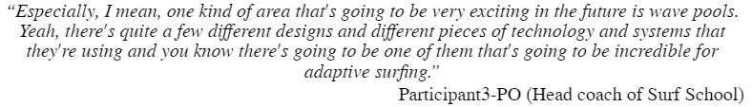

Whereas this may alleviate environmental barriers, the question remains regarding participants' ability to develop ‘nature connectedness,’ of which has been identified as key to the efficacy of intervention (Capaldi, et al, 2015; Gibbs, et al, 2022; Wilkie, et al, 2022). Being said, the use of artificial environments may certainly be valuable in particular circumstances. Expanding the use of such environments may be favoured, given additional barriers identified surrounding transport and locality, these of which arose both within data and literature (Marshall, 2022; Wilkie, 2022).
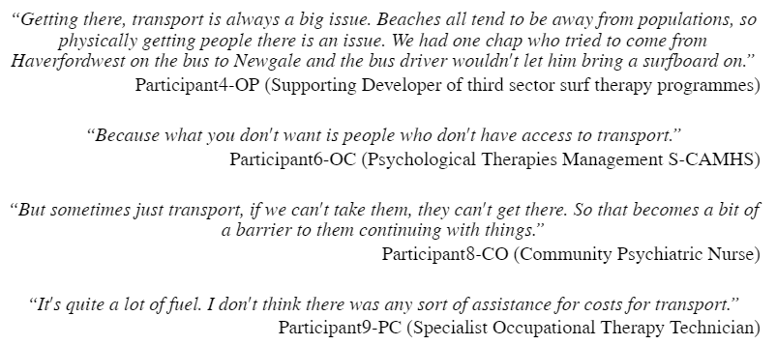

By introducing artificial wave pools, we could potentially overcome challenges related to transportation, location, and environmental constraints. These developments could additionally enhance the accessibility of ST-based interventions through purpose-built environments. Expanding ST based interventions may become more accessible for those in which live in urbanised environments, of which given statistically worse health-based quality of life may benefit from said intervention the most (Ma, et al, 2020). This aligns with Mechanic & Tanner’s (2007) study suggesting that vulnerability can stem from social status and degraded communities. `

Expanding on the future development of the sector, the majority of research participants are optimistic. This regardless as to the threats and barriers identified above. Excluding current barriers surrounding research, finances etc, barriers have been identified in the growth of ST in South Wales surrounding the quality of intervention (Participant1-PO;
Participant2-OP & Particiant5-PO). This however, being something which may be mitigated through aforementioned further research and alignment within the IOL’s mental health intervention model (2020).

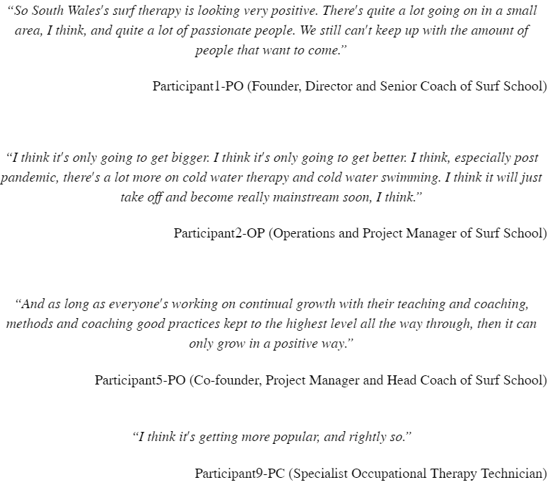

4.3.6 Holistic Healthcare
Regarding wider healthcare, data shows the value identified in taking a holistic approach

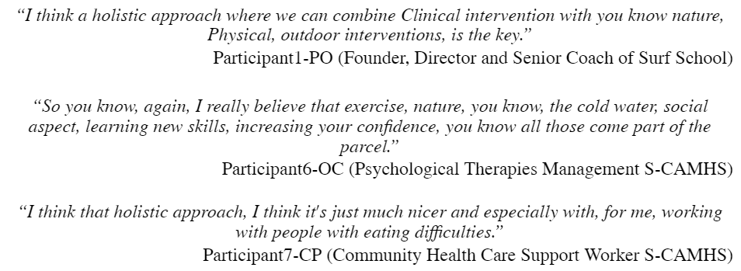
This value of ST in being a tool for holistic healthcare is again heavily seen within literature (Harris, 2015; McKenzie, et al, 2021; Gibbs, et al, 2022; Wilkie, et al, 2022). Regarding the holistic nature of ST interventions, the metaphorization of practice has been highlighted within data as key. Expanding, identified by Cade & O’Hanlon, (1993) this metaphoric approach in a therapeutic capacity allows for easier comprehension of abstract ideas alongside clearer communication. Although brief mention of using metaphors within ST have been made within literature, (Vale & Soares, 2014) the value of such approach doesn't seem to have been put into practice within a wider context yet. Participants share the following. The efficacy of said metaphorization, although not recurring with data, is further attributed by Participant7-CP, to be heightened due to the practical process in which ST takes.

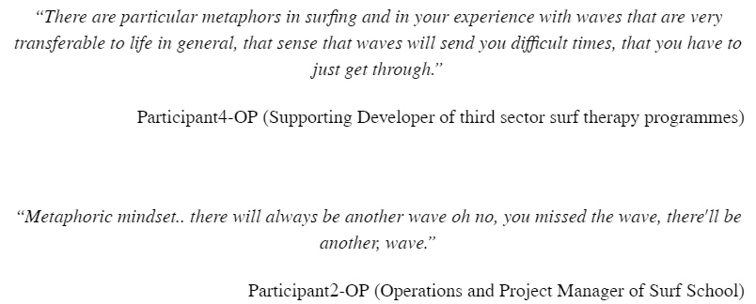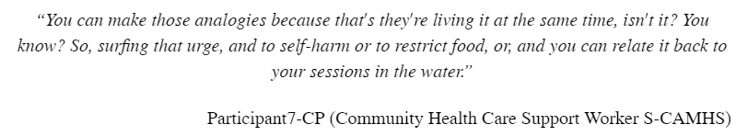

Moving forward, data suggests that the use of metaphorization alongside ‘concrete,’ tangible experiences may further enhance therapeutic processes in the water. In development, purposeful incorporation of said metaphorical approach may further align ST with traditional clinical psychiatry, in turn closing barriers in between traditional ‘medical’ literature and practice.

4.4.1 Practical Implications:
Regarding the practical implication of findings, research suggests the following.
1. Holistic Approach and Metaphorization: Facilitators should embrace a holistic approach in ST interventions, integrating metaphors to enhance communication and understanding. By metaphorically framing abstract clinical concepts alongside tangible experiences, practitioners can facilitate clearer communication and deeper comprehension among participants. This approach not only aligns with the practice's metaphoric nature but also bridges the gap between traditional medical literature and practical ST applications. Practical implementation could involve purposefully incorporating metaphorical elements into session planning and facilitation techniques.

2. Emphasize the setting of individualistic, achievable goals within ST sessions. Recognize the significance of SDT and Maslow's hierarchy of needs in shaping participants' experiences and fostering a safe space. However, exercise caution to ensure that goals remain realistic and diverse, avoiding the risk of developing unhealthy relationships with the therapeutic process or environment. In developing goals, a co-produced approach should be taken with participants in developing autonomy and relatedness. Supporting staff should ideally possess some psychological understanding or relevant experience to facilitate this process effectively.

3. Accessibility Through Artificial Environments: Consider the development and utilization of artificial wave pools to overcome environmental barriers and enhance accessibility to ST-based interventions. Artificial environments could provide a solution for challenges related to transportation, location, and environmental constraints, particularly in urbanized areas. By expanding ST interventions to purpose-built environments, practitioners can reach a broader demographic. Such developments align with the goal of making ST more inclusive and sustainable in the long term.

5.1 Conclusion:
In conclusion, this research project provides valuable insight into ST interventions in South Wales, exploring their underlying structure, principles and associated barriers. Through a qualitative approach involving semi-structured interviews, the study sheds light on the perspectives of key stakeholders, including surf coaches, psychotherapeutic support workers, and clinical stakeholders, occupational therapists, psychiatrists and organisers.

Despite the benefits of ST, findings identified barriers to sustainable practice and facilitation around research and funding. Practically given the variable nature of ST intervention, this was heightened given the addition to adaptive surfing in South Wales. The defining of standard or ‘general practice’ makes developing such a phenomenological
research base difficult. Nonetheless this more so holistic picture in which we’ve identified ST to being could be argued to be aligning with the direction in which health care is taking over time.

Overall, this research contributes to the growing body of literature on ST interventions and expands through offering region specific guidance for an affordance rich area of the UK let alone the world. By addressing identified barriers and building on the underlying principals of ST, stakeholders can work towards enhancing the efficacy and accessibility of these interventions, ultimately improving well-being of participants in South Wales and beyond.
5.2 Strengths and Limitations:
During the course of this study, limitations have been identified of which may have impacted the final discussion and in turn practical implications. The particular word count of the dissertation in itself presented as a limitation. Less constrictions surrounding word count, could have led to more context and relevance being made in both the literature review and discussion, in turn providing more value. Additionally, to this, given the researchers involvement within an institution, problems in accessing academia were found given a lack of access to particular databases. Expanding, time was identified by the researcher as a further limitation. Given the relatively short time frame it was unrealistic and unachievable to code and analyse more data, of which would have helped in developing a further holistic picture. Additionally, time became a variable in snowball sampling, as potential participants given constraints were unable to be interviewed. With this being said, the combination of fewer research participants and singular researcher meant that data was more intimately understood. Nonetheless a peer-reviewed process would go far in validating and standardising findings. Expanding, whereas mentioned in the data analysis section, the researchers personal experiences played a unique role given personal experience from several perspectives in the development of codes and themes. Given the narrow field of literature identified surrounding ST practice in South Wales, the research study further acts as a valuable contribution.

5.3 Directions for Future Research:
Moving forward, synthesising results and discussion, future research may benefit from developing and implementing standardised outcome measures specific to ST. This would allow for consistency within the field across different programmes and organisations. In a wider context this would allow for comparison and increased reliability and validity with other findings. Expanding, investigating the impact of clinical support versus non-clinical support within the context of ST would allow for a better understanding as to the role of the intervention. Alongside this, investigating if having a singular professional (A surf coach qualified in psychology) is more or less efficacious that having several professionals (A qualified surf coach alongside a qualified psychologist) is more beneficial. In further developing inclusivity and targeting a statistically more vulnerable demographic, exploring
the feasibility and effectiveness of artificial wave pools through assessing participants’ experiences, sense of immersion and therapeutic outcomes would further validify practice. In developing good practice, further research into the use of metamorphism in ST in its role in enhancing therapeutic processes would allow for further standardisation and further alignment from a ‘clinical’ perspective. By addressing these research direction, future studies can contribute to the evidence base for ST, inform best practice, and ultimately improve outcomes for participants in South Wales and beyond.

6.1 References:
Alvarsson, J., Wiens, S., & Nilsson, M. (2010). Stress recovery during exposure to nature sound and environmental noise. International Journal of Environmental Research and Public Health, 7,1036-46.

Baumeister, R. F., Heatherton, T. F., & Tice, D. M. (1993). When ego threats lead to self-regulation failure: negative consequences of high self-esteem. Journal of personality and social psychology, 64(1), 141.

Benninger, E., Curtis, C., Sarkisian, G. V., Rogers, C. M., Bender, K., & Comer, M. (2020). Surf therapy: A scoping review of the qualitative and quantitative research evidence. Glob. J. Community Psychol. Pract, 11, 1-26.

Bergen, N., & Labonté, R. (2020). “Everything is perfect, and we have no problems”: detecting and limiting social desirability bias in qualitative research. Qualitative health research, 30(5), 783-792.

Bird, C.M. 2005: How I stopped dreading and learned to love transcription. Qualitative Inquiry 11, 226/48

Bishop-Fitzpatrick, L., Mazefsky, C. A., & Eack, S. M. (2018). The combined impact of social support and perceived stress on quality of life in adults with autism spectrum disorder and without intellectual disability. Autism, 22(6), 703-711. https://doi.org/10.1177/1362361317703090

Braun, V., & Clarke, V. (2006). Using thematic analysis in psychology. Qualitative research in psychology, 3(2), 77-101

Braun, V, & Clarke, V. (2013). Successful Qualitative Research: A Practical Guide for Beginners.

Brennan, M., Stain, H.J. and Marshall, J. (2024) ‘Mapping the landscape: Surf therapy prgram delivery’, Journal of Outdoor and Environmental Education [Preprint]. doi:10.1007/s42322-023-00152-2.

Bright, C. (2017) ‘Defining child vulnerability: Definitions, frameworks and groups’. Children’s Commissioner for England.

Cade, B., & O'Hanlon, W. H. (1993). A brief guide to brief therapy. WW Norton & Co.
Calderon, M. (2023). Self-determination theory and exercise performance for individuals with autism.

Capaldi, C. A., Passmore, H. A., Nisbet, E. K., Zelenski, J. M., & Dopko, R. L. (2015). Flourishing in nature: A review of the benefits of connecting with nature and its application as a wellbeing intervention. International Journal of Wellbeing, 5(4).

Carty, C., van der Ploeg, H. P., Biddle, S. J., Bull, F., Willumsen, J., Lee, L., ... & Milton, K. (2021). The first global physical activity and sedentary behavior guidelines for people living with disability. Journal of Physical Activity and Health, 18(1), 86-93.

Claxton, R. (2020) Gardening 4 health, Gardening 4 Health. Available at: https://gardening4health.co.uk/ (Accessed: 17 December 2023).

Deci, E. L., & Ryan, R. M. (2012). Self-determination theory. Handbook of theories of social psychology, 1(20), 416-436.

Devine-Wright, H., & Godfrey, C. (2020). The Wave Project: Evidencing surf therapy for young people in the UK. Global Journal of Community Psychology Practice, 11(2), 1-15.

Drake, C.J. et al. (2021) ‘A qualitative investigation into the perceived therapeutic benefits and barriers of a surf therapy intervention for Youth Mental Health’, Complementary Therapies in Medicine, 59, p. 102713. doi:10.1016/j.ctim.2021.102713.

Edmondson, A. C., Higgins, M., Singer, S., & Weiner, J. (2016). Understanding psychological safety in health care and education organizations: a comparative perspective. Research in Human Development, 13(1), 65-83.
Eustice, G. (2020), George Eustice Speech on Environmental Recovery. Available online: https://www.gov.uk/government/speeches/george-eustice-speech-on-environmental-recovery-20-july-2020

Franco, L. S., Shanahan, D. F., & Fuller, R. A. (2017). A review of the benefits of nature experiences: More than meets the eye. International journal of environmental research and public health, 14(8), 864.

Gibbs, K., Wilkie, L., Jarman, J., Barker-Smith, A., Kemp, A. H., & Fisher, Z. (2022). Riding the wave into wellbeing: A qualitative evaluation of surf therapy for individuals living with acquired brain injury. PLoS One, 17(4), e0266388

Gomes, P., Fazenda, N., Gómez Baya, D., Rauktis, M. E., & Provost, G. (2020). Surf. Art in Portugal: daring, accomplishing and transforming portuguese youth and their communities. Glob. J. Commun. Psychol. Pract, 11, 1-18.

Hägerhäll, C. M., Laike, T., Küller, M., Marcheschi, E., Boydston, C., & Taylor, R. P. (2015). Human physiological benefits of viewing nature: EEG responses to exact and statistical fractal patterns. Nonlinear dynamics, psychology, and life sciences.

Harper, F. D., Harper, J. A., & Stills, A. B. (2003). Counseling children in crisis based on Maslow's hierarchy of basic needs. International Journal for the Advancement of Counselling, 25, 11-25.

Harris, K. B. (2015). Working with addiction through surf therapy: A phenomenological exploration of healing. Pacifica Graduate Institute

Heaton, J., Day, J., & Britten, N. (2015). Collaborative research and the co-production of knowledge for practice: an illustrative case study. Implementation Science, 11, 1-10.

HywellDda (no date) Psychological therapies, Hywel Dda University Health Board. Available at: https://hduhb.nhs.wales/healthcare/services-and-teams/psychological-therapies/#:~:text=The%20primary%20aim%20of%20our,from%20occurring%20or%20becoming%20worse. (Accessed: 07 January 2024).

ImprovementCymru (2023) Adventure therapy is helping people in Wales to recover from psychosis., YouTube. Available at: https://www.youtube.com/watch?v=uJifziH7ebM (Accessed: 13 January 2024).

ISA (2020) Isa Adaptive Surfing Instructor Program, International Surfing Association. Available at: https://isasurf.org/learning/para-surfing/isa-adaptive-surfing-instructor-program/ (Accessed: 15 April 2024).

ISA (2021) Isa Adaptive Surfing Instructor Program, Youtube. Available at: https://www.youtube.com/watch?v=HHfIIUIvAic&t=50s (Accessed: 15 April 2024).

ISTO, (2018) ‘Surf Therapy Declaration’. International Surf Therapy Organisation.

Jimenez, M. P., DeVille, N. V., Elliott, E. G., Schiff, J. E., Wilt, G. E., Hart, J. E., & James, P. (2021). Associations between nature exposure and health: a review of the evidence. International Journal of Environmental Research and Public Health, 18(9), 4790.

Johnson, D. R., Scheitle, C. P., & Ecklund, E. H. (2021). Beyond the In-Person Interview? How Interview Quality Varies Across In-person, Telephone, and Skype Interviews. Social Science Computer Review, 39(6), 1142-1158. https://doi.org/10.1177/0894439319893612

Kaplan S. (1995). The restorative benefits of nature: Toward an integrative framework. Journal of Environmental Psychology, 15, 169-182.

Kaltenbach, M., Maschke, C., & Klinke, R. (2008). Health Consequences of Aircraft Noise. Deutsches Ärzteblatt international, 105(31-32).

Kelly, C. (2018). ‘I Need the Sea and the Sea Needs Me’: Symbiotic coastal policy narratives for human wellbeing and sustainability in the UK. Marine Policy, 97, 223-231.

Koopman WJ, Watling CJ, Ladonna KA. 2020. Autoethnography as a strategy for engaging in reflexivity. Glob Qual Nurs Res. 7:2333393620970508.

Larson, R. (1989). Is Feeling “in Control” Related to Happiness in Daily Life? Psychological Reports, 64(3), 775-784. https://doi.org/10.2466/pr0.1989.64.3.775

Lopes, J. T., Masdemont, M., & Cruz, G. M. V. (2018). Adaptive surfing: leisure, competition or therapy?. Cadernos de Educação Tecnologia e Sociedade, 11(1), 148-159.

Lord, E. (2021) An ethnographic examination of the experience of ecotherapy as an intervention for mental health in South and West Wales. [Unpublished Doctoral dissertation, Swansea University). Available at: https://cronfa.swan.ac.uk/Record/cronfa57768

Louv, R. (2005) Last child in the woods: Saving our children from nature-deficit disorder. London: Atlantic Books.

Luna, F. (2019). Identifying and evaluating layers of vulnerability–a way forward. developing world bioethics, 19(2), 86-95.

Ma, L., Liu, S., Fang, F., Che, X., & Chen, M. (2020). Evaluation of urban-rural difference and integration based on quality of life. Sustainable Cities and Society, 54, 101877.

Mandelbrot, B.B. and Wheeler, J.A. (1983) “The Fractal Geometry of Nature.,” American Journal of Physics, 51(3), pp. 286–287. Available at: https://doi.org/10.1119/1.13295

Marshall, J., Ferrier, B., Ward, P. B., & Martindale, R. (2020). “When I was surfing with those guys I was surfing with family.” A Grounded Exploration of Program Theory within the Jimmy Miller Memorial Foundation Surf Therapy Intervention.

Marshall, J. (2022). A Global Exploration of Programme Theory within Surf Therapy (Doctoral dissertation).

Marshall, J., Ferrier, B., Martindale, R., & Ward, P. B. (2023). A grounded theory exploration of programme theory within waves of wellness surf therapy intervention. Psychology & Health, 1-23.

Martyn, p and Brymer, E (2016) The relationship between nature relatedness and anxiety; Journal of Health Psychology, Vol. 21(7) 1436–1445

Maslow, A. H. (1943). A theory of human motivation. Psychological Review, 50 (4), 370-96.

McKenzie, R. J., Chambers, T. P., Nicholson-Perry, K., Pilgrim, J., & Ward, P. B. (2021). “Feels good to get wet”: The unique affordances of surf therapy among Australian youth. Frontiers in Psychology, 12, 721238.

Mechanic, D., & Tanner, J. (2007). Vulnerable people, groups, and populations: societal view. Health Affairs, 26(5), 1220-1230.

Moreton, S. G., Brennan, M. K., Nicholls, V. I., Wolf, I. D., & Muir, D. L. (2022). Exploring potential mechanisms underpinning the therapeutic effects of surfing. Journal of Adventure Education and Outdoor Learning, 22(2), 117-134.

National Geographic (2010) Travel. Available at: https://www.nationalgeographic.com/travel/article/wales

NASP (2022) Natural environment- National Academy for Social Prescribing, National Academy for Social Prescribing. Available at: https://socialprescribingacademy.org.uk/what-is-social-prescribing/natural-environment-and-social-prescribing/ (Accessed: 17 December 2023).

NHS (2023) Green social prescribing, NHS choices. Available at: https://www.england.nhs.uk/personalisedcare/social-prescribing/green-social-prescribing/ (Accessed: 17 December 2023).

Nyamoita, O. L. (2012). Perceived importance of maslow’s hierarchy of needs among employees of the Institute of Advanced Technology, Nairobi (Doctoral dissertation, University of University).

O’Brien, L., & Forster, J. (2021). Physical activity supporting connection to nature, and helping to maintain wellbeing during the Covid-19 restrictions in England. International journal of environmental research and public health, 18(9), 4585.

Olmos-Vega, F. M., Stalmeijer, R. E., Varpio, L., & Kahlke, R. (2023). A practical guide to reflexivity in qualitative research: AMEE Guide No. 149. Medical teacher, 45(3), 241-251.

Olt, M (2021) Biophilia, the future of architecture | Matthias Olt | TEDxSeattle. Tedx. Available at: https://www.youtube.com/watch?v=OXZzsty5BGY (Accessed: March 9, 2023).

ONS (2022) Cost of living and depression in adults, Great Britain: 29 September to 23 October 2022, Cost of living and depression in adults, Great Britain - Office for National Statistics. Available at:
https://www.ons.gov.uk/peoplepopulationandcommunity/healthandsocialcare/mentalhealth/articles/costoflivinganddepressioninadultsgreatbritain/29septemberto23october2022#:~:text=In%20autumn%202022%2C%20around%201,of%20living%20in%20Great%20Britain. (Accessed: 25 January 2024).

Otis, N. P., Walter, K. H., Glassman, L. H., Ray, T. N., Michalewicz-Kragh, B., & Thomsen, C. J. (2020). Effects of PTSD and MDD comorbidity on psychological changes during surf therapy sessions for active duty service members. Glob. J. Community Psychol. Pract, 11, 1-23.

Peacock, S., & Brymer, E. (2020). Facilitating mental health. Good health and well-being, 193-204.

Podavkova, T., & Dolejs, M. (2022). Surf Therapy-Qualitative Analysis: Organization and Structure of Surf Programs and Requirements, Demands and Expectations of Personal

Poortinga, W., Bird, N., Hallingberg, B., Phillips, R., & Williams, D. (2021). The role of perceived public and private green space in subjective health and wellbeing during and after the first peak of the COVID-19 outbreak. Landscape and Urban Planning, 211, 104092.

Pouso, S., Borja, Á., Fleming, L. E., Gómez-Baggethun, E., White, M. P., & Uyarra, M. C. (2021). Contact with blue-green spaces during the COVID-19 pandemic lockdown beneficial for mental health. Science of The Total Environment, 756, 143984.

Reuben, A., & Himschoot, E. (2021). Nature as a mental health intervention: State of the science and programmatic. In Parks Stewardship Forum, 37 (2).

Richards, K., Hardie, A. and Anderson, N. (2020) ‘Outdoor Mental Health & Outdoor Therapy’, Institute for Outdoor Learning. Available online: https://www.outdoor-learning.org/Portals/0/IOL%20Documents/Outdoor%20Mental%20Health/Outdoor%20Therapy%20Statement%201.3%20-%2012%20Oct%202020.pdf?ver=2020-11-09-101048-717

Riessman, C.K. 1993: Narrative analysis . Sage

Rosa, C. D., Chaves, T. S., Collado, S., & Harper, N. J. (2023). Improving the analysis and reporting of studies of nature-based adventure interventions: a review of studies published in JAEOL. Journal of Adventure Education and Outdoor Learning, 1-20.

Sarkisian, G. et al. (2020a) ‘Introduction to the Special Issue on Surf Therapy Around the Globe’, Global Journal of Community Psychology Practice, 11(2). Available at: https://www.gjcpp.org/en/article.php?issue=36&article=216.

Sarkisian, G. V., Curtis, C., & Rogers, C. M. (2020b). Emerging hope: outcomes of a one-day surf therapy program with youth at-promise. Global Journal of Community Psychology Practice, 11(2), 1-16.

Scott, M. (2023) Natural Resources wales / why don’t you...try ecotherapy?, Natural Resources Wales. Available at: https://naturalresources.wales/about-us/news-and-blogs/blogs/why-don-t-you-try-ecotherapy/?lang=en (Accessed: 13 April 2024).

Schwarzer, R. (1994). Optimism, vulnerability, and self-beliefs as health-related cognitions: A systematic overview. Psychology and health, 9(3), 161-180.

SurfingEngland, (2018) ‘The ABC Lesson’. Kent Surf School. Available at: https://kentsurfschool.co.uk/wp-content/uploads/2018/07/ABC-Lesson-Plan.pdf

Vale Lucas, C., & Soares, L. (2014). Being a teen and learning how to surf anxiety: Integrating narrative methods with cognitive–behavioral therapy. Journal of Poetry Therapy, 27(2), 69-82.
Vancampfort, D., Firth, J., Schuch, F. B., Rosenbaum, S., Mugisha, J., Hallgren, M., Probst, M., Ward, P. B., Gaughran, F., De Hert, M., Carvalho, A. F., & Stubbs, B. (2017). Sedentary behavior and physical activity levels in people with schizophrenia, bipolar disorder and major depressive disorder: a global systematic review and meta-analysis. World psychiatry : official journal of the World Psychiatric Association (WPA), 16(3), 308–315. https://doi.org/10.1002/wps.20458

Van der Merwe, N., & Yarrow, P. (2020). More than surfing: inclusive surf therapy informed by the voices of South African children with autism spectrum disorder. Global Journal of Community Psychology Practice, 11(2), 1-14.

Van Ewijk, H., Wansink-Lokerman, M., Lamerz, A., & van den Broek, S. (2020). Positive effects of surfing on psychological wellbeing for children with developmental difficulties. Global Journal of Community Psychology Practice, 11(2), 1-17.

Welsh Government, (2023) Mental health and suicide prevention strategies. Available at: https://www.gov.wales/sites/default/files/pdf-versions/2023/8/5/1692978951/cabinet-paper-mental-health-and-suicide-prevention-strategies.pdf

Wilkie, L., Fisher, Z., & Kemp, A. H. (2022). The ‘rippling ’waves of wellbeing: a mixed methods evaluation of a surf-therapy intervention on patients with acquired brain injury. Sustainability, 14(15), 9605.

Williams, M., & Moser, T. (2019). The art of coding and thematic exploration in qualitative research. International management review, 15(1), 45-55.

World Health Organization. (2022). World mental health report: transforming mental health for all

Wright, K., Eden, S., Hancox, A., Windget, D., Elliott, L., Glossop, Z., ... & Bell, S. L. (2024). A qualitative exploration of the contribution of blue space to well‐being in the lives of people with severe mental illness. People and Nature.

Appendices:
Appendix 1: Maslow’s Hierarchy of needs
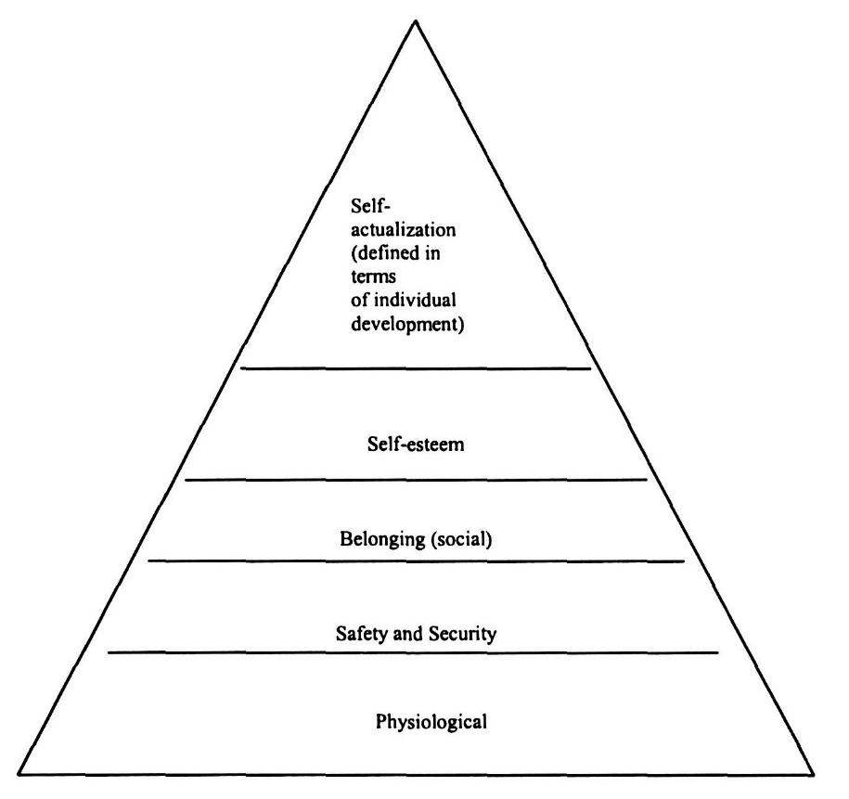

Appendix 2: Interview Questions

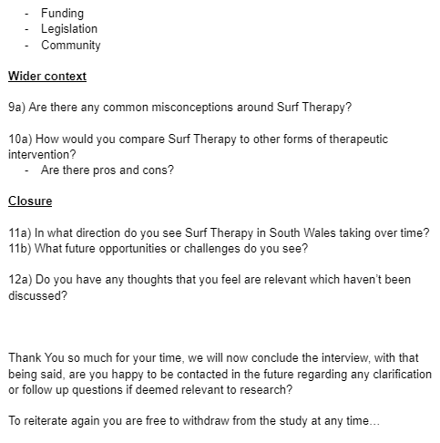
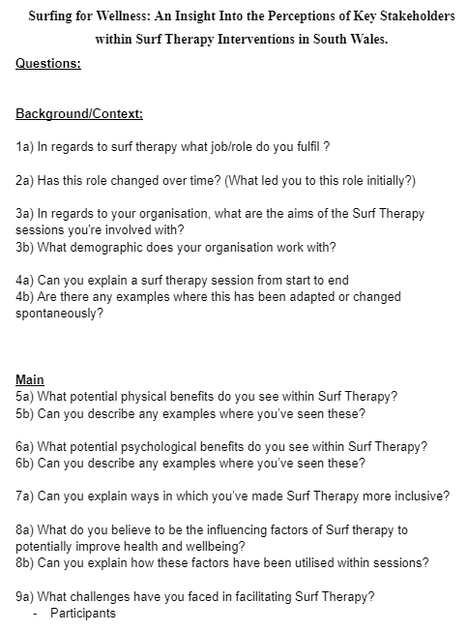

Appendix 3: Informed Consent Form
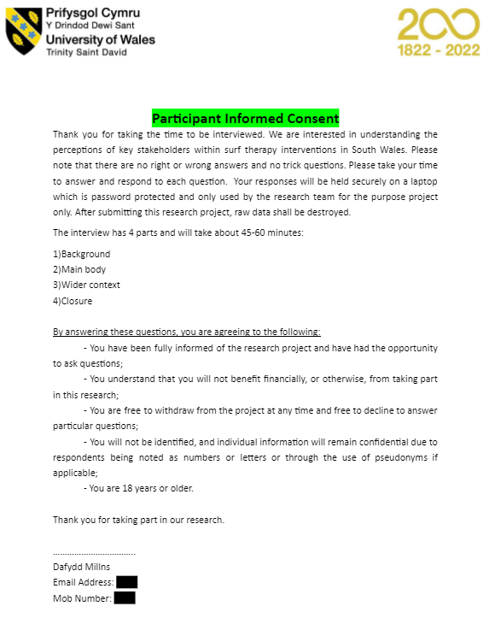

Appendix 4: Participant Consent Form
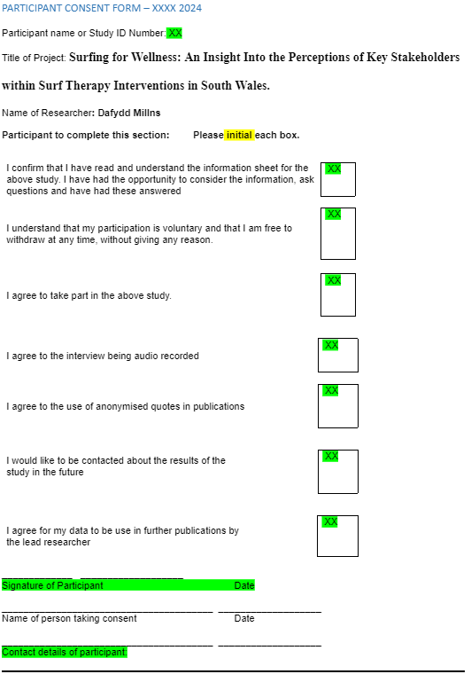

Appendix 5: Braun & Clarkes (2006) 15-point checklist for good thematic analysis
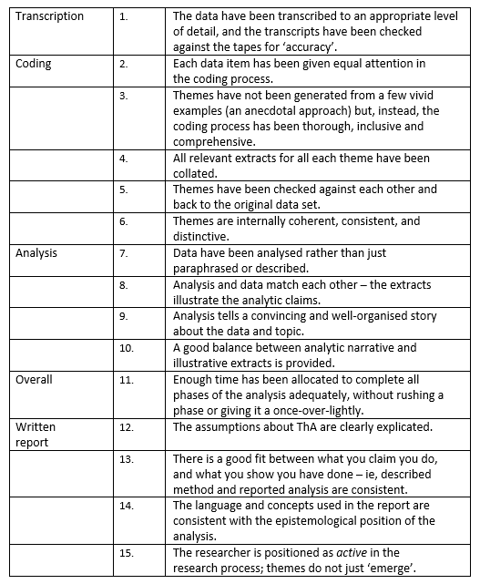

(Appendix 6): Coding and Thematic Mapping Process


