Level 4 assessment specification 2
Shayne pinto Ribeiro
2510402

Task 1
Self evaluation is a lot of stuff Self awareness improvements and achievements
I want to achieve somewhere and improve my skills i also need to learn more about self Awareness which is important to me so I relate to it

Task 2

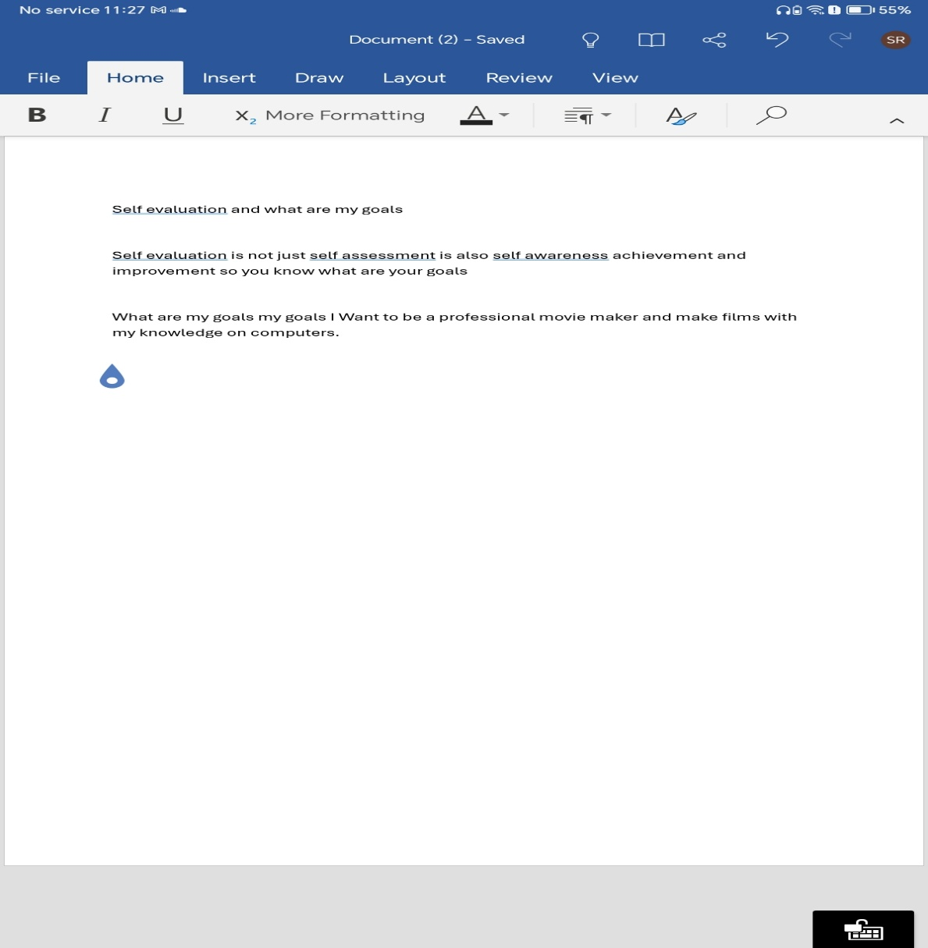

Task 3


Task 4
The video

Link to the video
What is self evaluation


