Abbas
LONDON CAMPUS
Assignment 2
Learning in the Digital Era
Video Link:
https://youtu.be/knhc-iA8nrU
Module Name: Learning in the Digital Era
Module Code: ACCA 4025

Student Name: Abbas Ahmed
Student ID:2512870
Group:2
Submission Date: 19/12/2025
Lecturer’s Name: Koushik Modak

Table of Contents
Introduction 3
Main Body 3
Conclusion 12
References 13

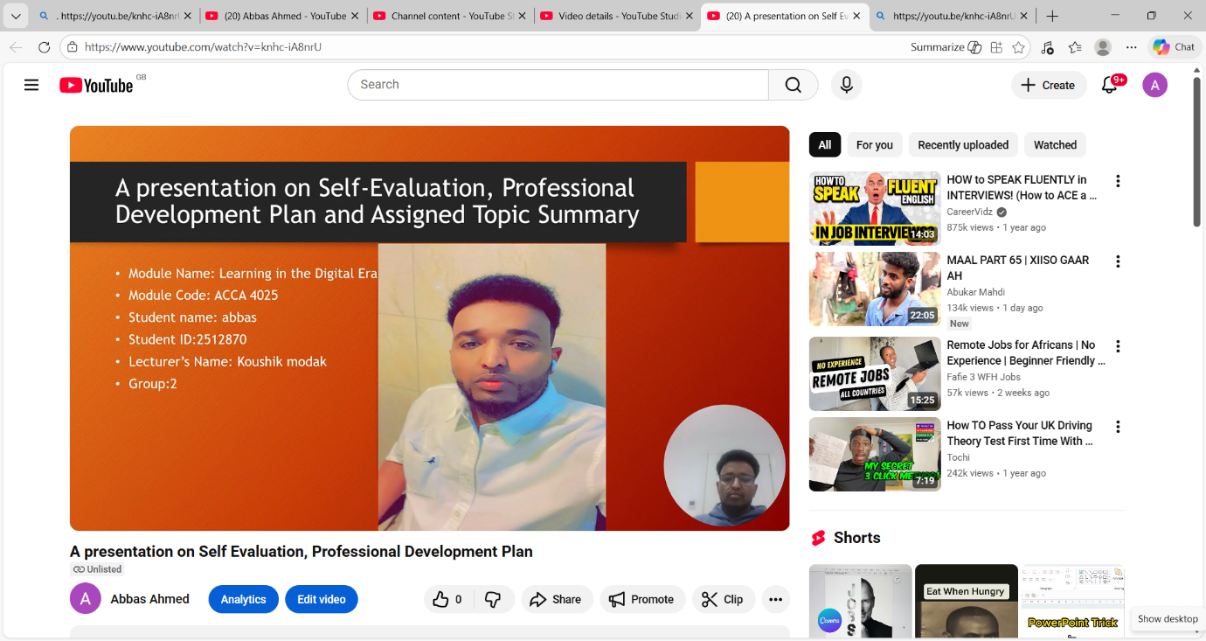

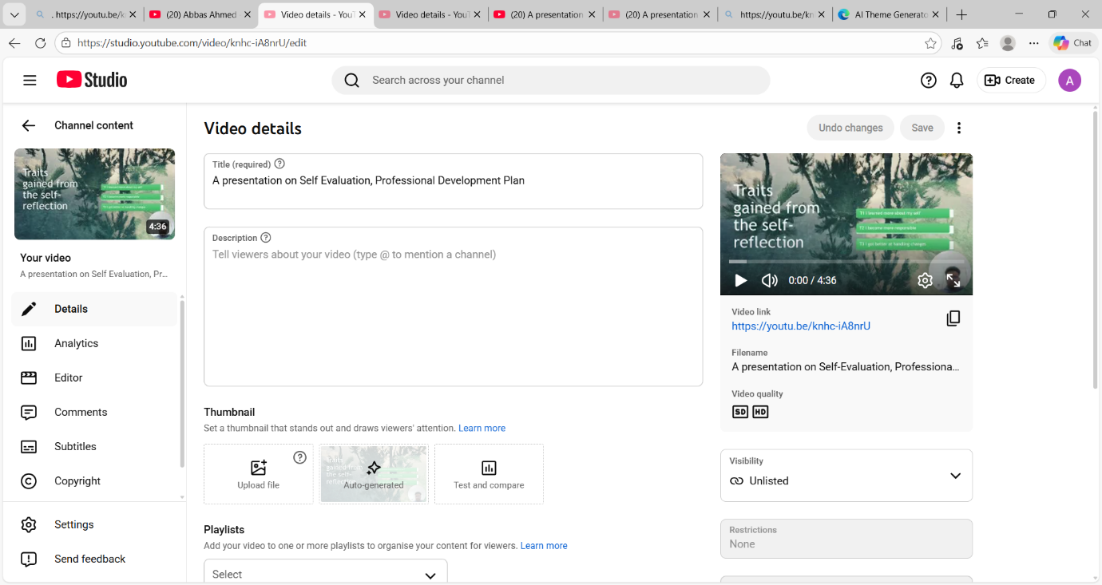

Introduction
A general introduction for this word document (Briefly in a few sentences explain what this report is going to be about)

Main Body
This main body highlights the main points of this report. A video presentation has been recorded highlighting all three tasks that are assigned to us. A video link of this presentation has been presented below
Video Link: https://youtu.be/knhc-iA8nrU
Slide 1 COVER PAGE
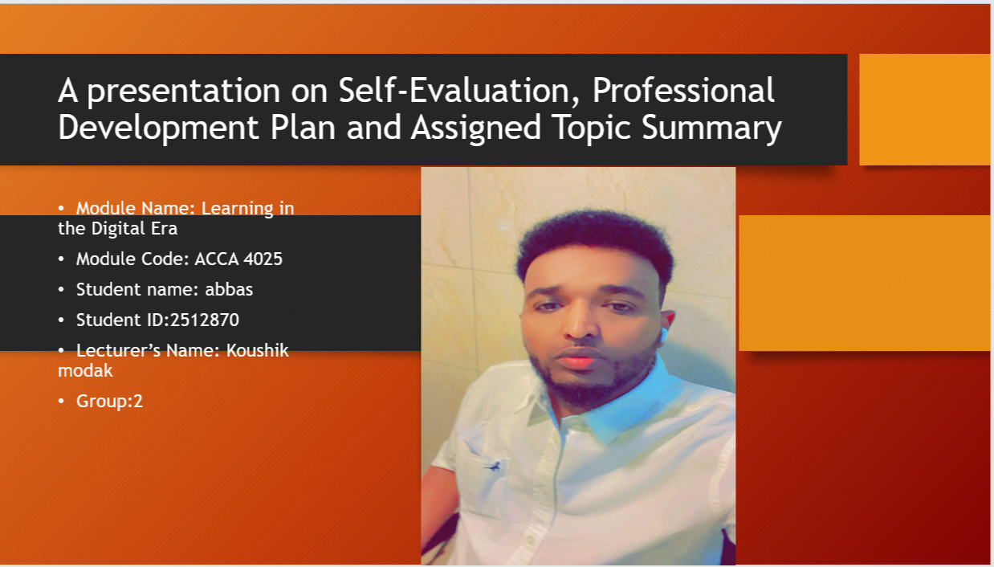

Slide 2 CONTENTS
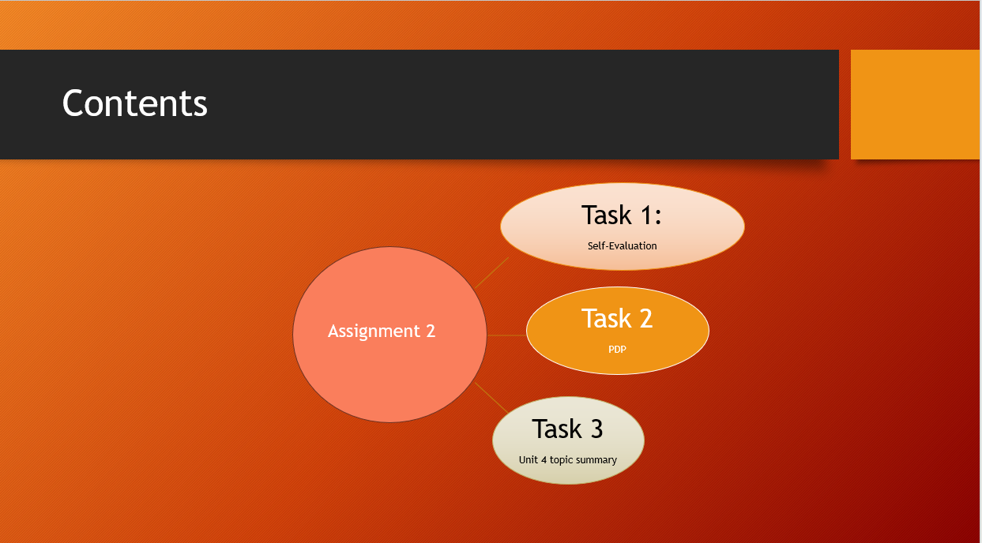
Slide 3 INTRODUCTION
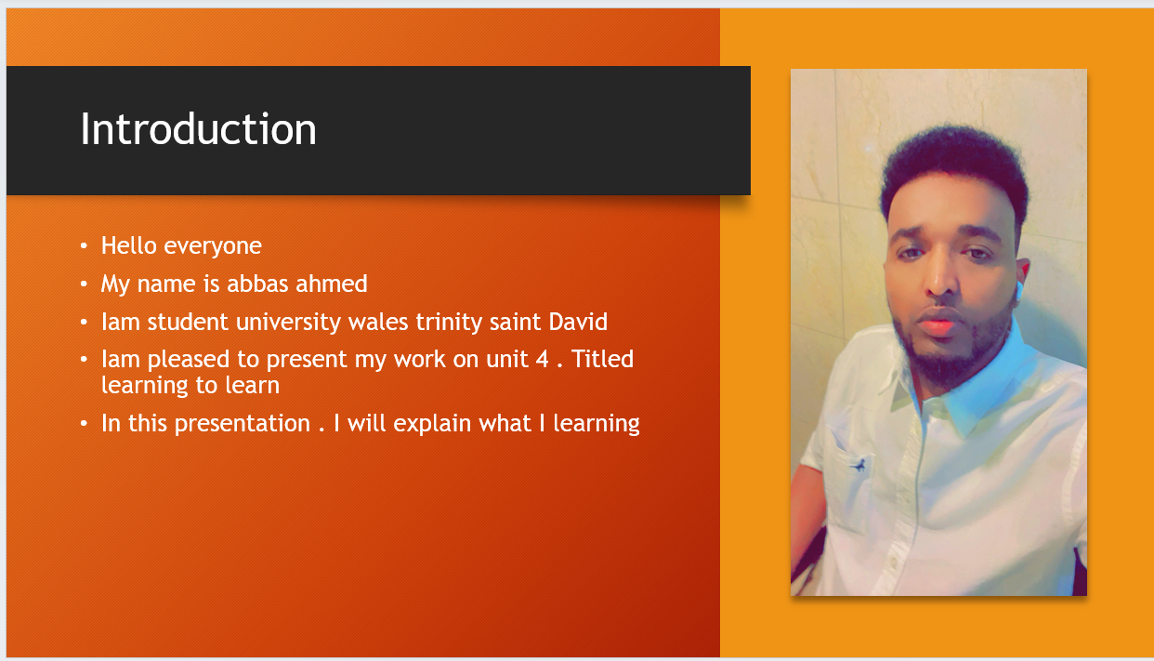
This report includes all three tasks assigned to us where in task 1 a self-evaluation has been discussed with the reflection of Gibb’s reflective model, A Professional Development plan has been highlighted in task 2 and in task 3, unit 4 topic 1 titles learning to learn has been discussed. In Task 3, I have explained what learning agility is and why unlearning is unhelpful
Habits are important. and how we can develop the characteristics of an agile learner. The aim of this session is to show how these skills support personal development.

Slide 4 MAIN BODY


The main body of this presentation focuses on three major area within the learning to learn topic first. learning agility which refers to the ability to learn quickly. Adapt to change. and apply new skills in real life situations it is a key skill that employers value because it enables individuals to respond effectively to new challenges.

Slide 5 GIBB’s REFLECTIVE MODEL
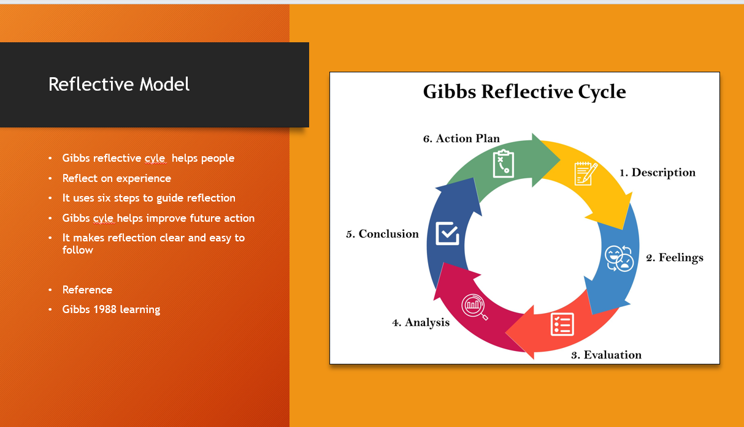
Figure:1

Brief explanation:
Gibbs reflective cycle is a six-stage model for model learning from experience Guiding. you through description. Feelings. evaluation. analysis. conclusion and an action plan to deeply process events understand your reaction and Plan for future actions. Promoting critical thinking and development Especially in education and professional settings [1]

Slide 6 TASK 1: SELF EVALUATION
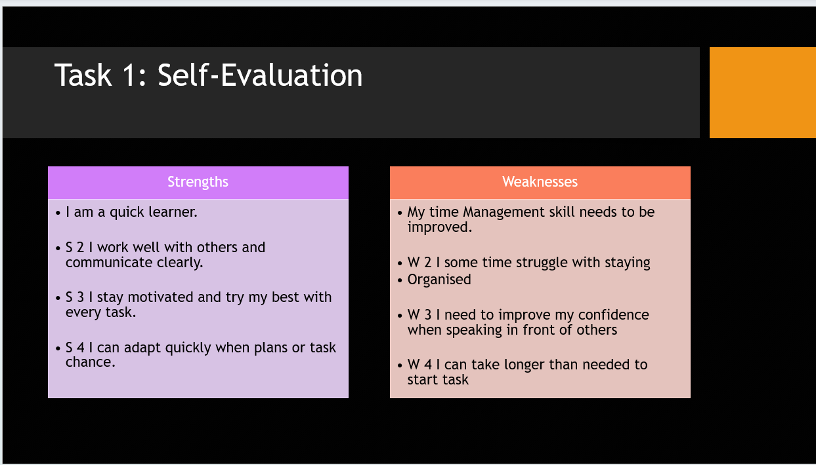
Brief explanation:
Self-evaluation is the process of critically observing analysing. and assessing your own performance. progress and professional action to identify strengths and weaknesses and set goals for future improvement. it is key tools for personal growth. career. Development and formal processes like performance.

Slide 7 TRAITS GAINED FROM THE SELF EVALUATION
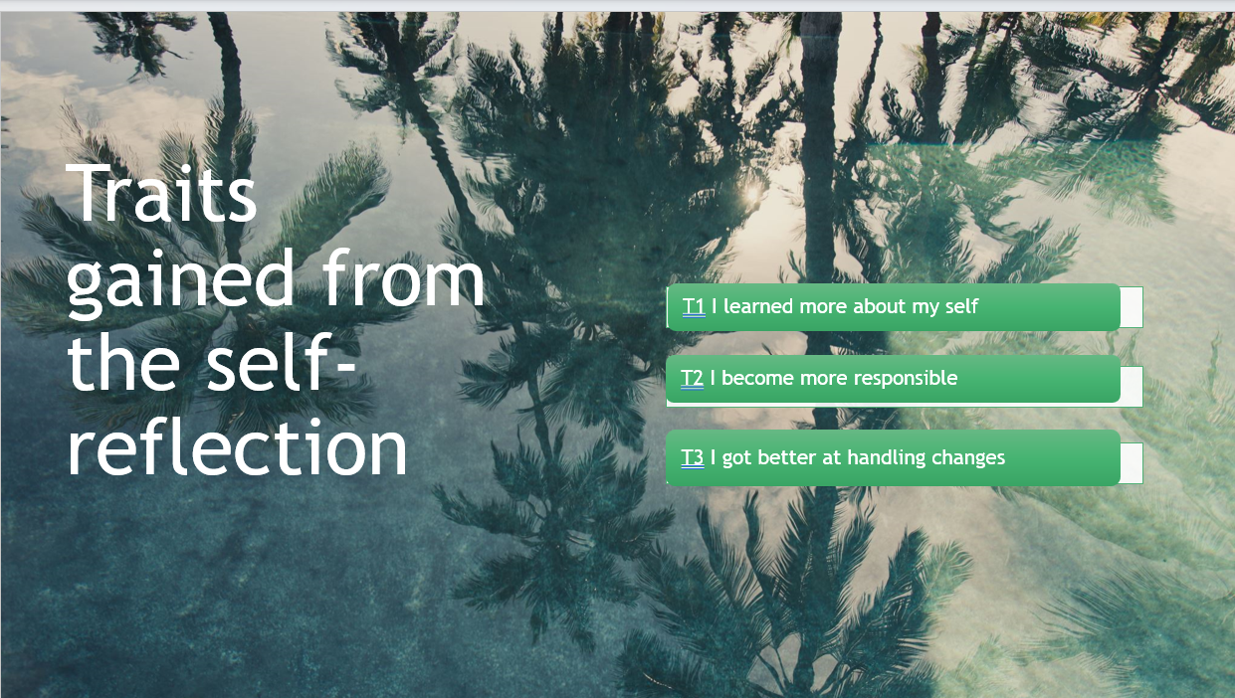

Brief explanation:
Though self-reflection. I was able to understand myself more deeply. which helped me recognize my strengths and weaknesses and motivations. This awareness encouraged me to become more responsible in my decision and actions. Additionally. reflection on post experience allowed me to adapt better to changes improving my ability to Handle new or unexpected situations with greater confidence.

Slide 8 PROFESSIONAL DEVELOPMENT PLAN
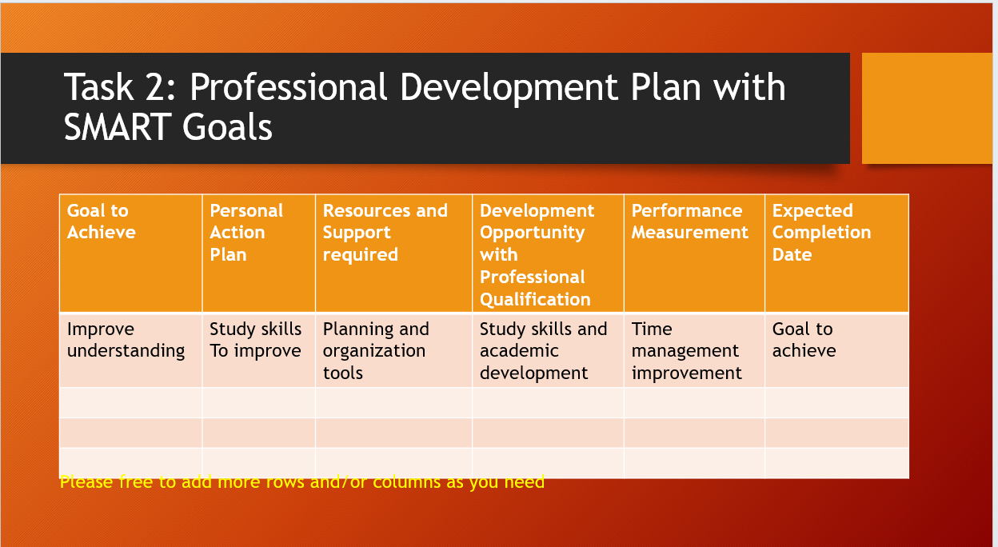
Brief explanation:
This professional development plan outlines a clear smart goal focused on improving my understanding through enhanced study skills. by using planning and organizational tools and engaging in academic development opportunities. I can track my progress through better time management setting a defined completion date helps ensure that the goal remains structured measurable. Achievable.

Slide 9 UNIT 4 TOPIC SUMMARY
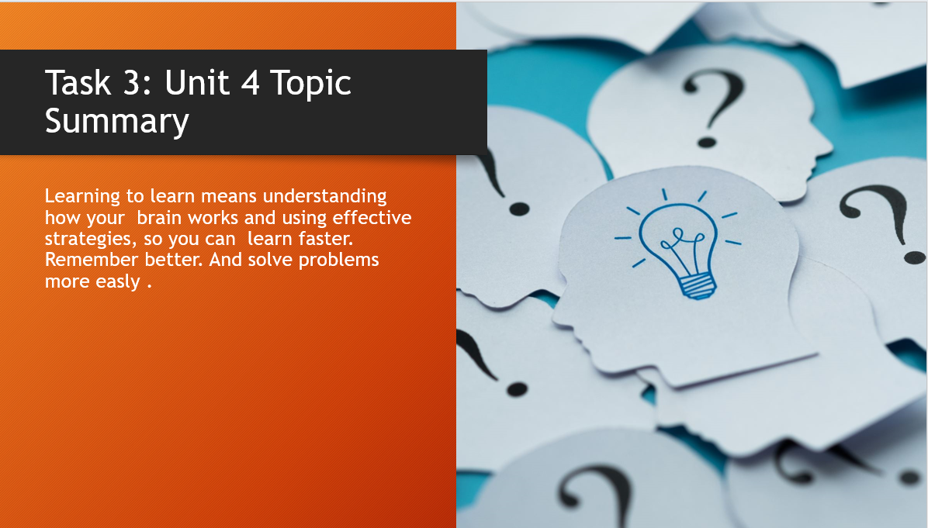
Brief explanation: Topic 1 has been chosen from Unit 4. A detailed discussion has been presented below
Learning to learn focuses in understanding how your brain works and using effective study strategies to learn more effectively. It involves techniques that help you absorb information faster, remember it longer, and solve problems more easily. By developing these skills, you can improve your overall academic performance and become a more independent learner.

Slide 10 CONCLUSION

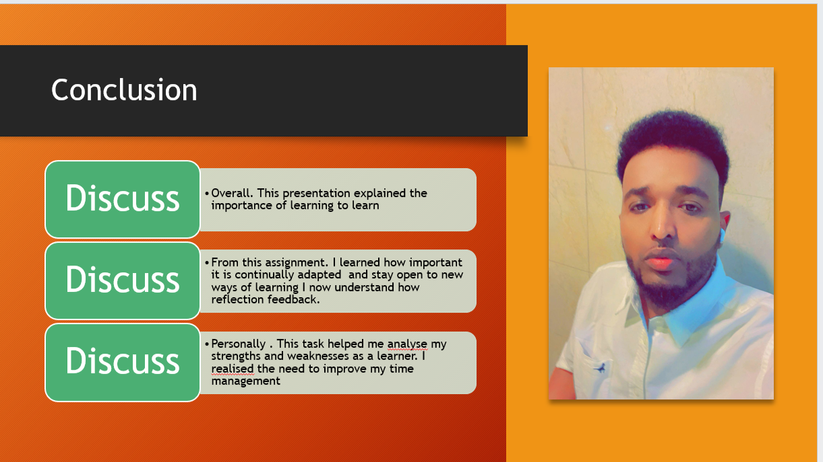

Brief explanation:
This conclusion highlights they key lessons gained from the assessment. Including the importance of learning how to learn. Staying open to new strategies. and understanding the value of reflection. it also summarizes how the tasks helped identify personal strengths and areas for improvement. such as time management and adaptability as a learner.

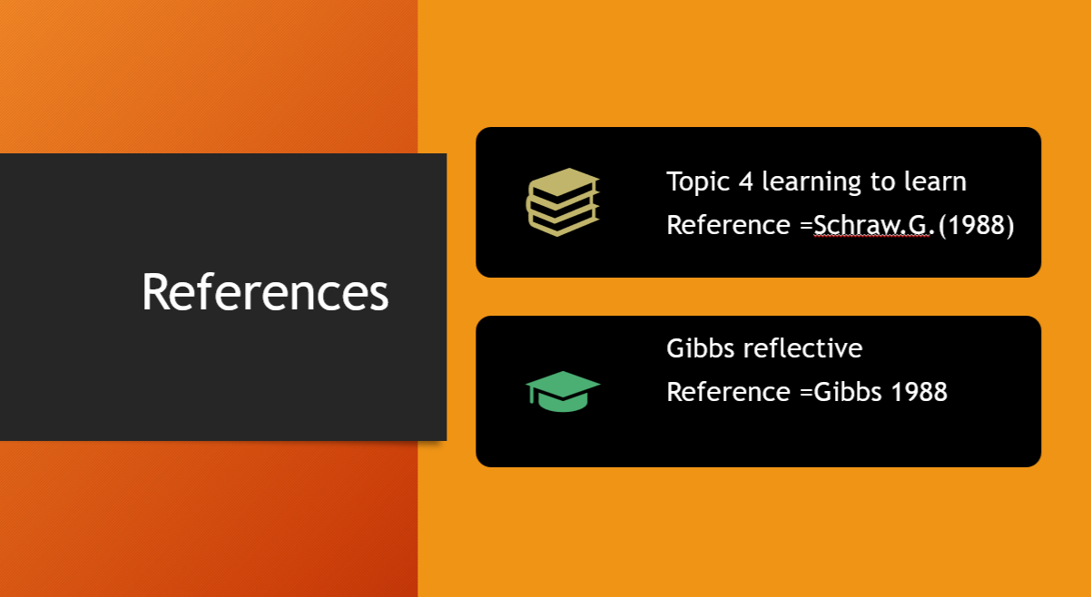(Adeani, Febriani et al. 2020)

Conclusion
A general conclusion for this word document (Briefly in a few sentences) This conclusion highlights they key lessons gained from the assessment. Including the importance of learning how to learn. Staying open to new strategies. and understanding the value of reflection. it also summarizes how the tasks helped identify personal strengths and areas for improvement. such as time management and adaptability as a learner. [2]

References
(Adeani, Febri ani et al. 2020)
[3] [4]
[1] | Gibbs Reflective Cycle. [Online].
[2] | google. [Online]
[3] | s. G, 1988.
[4] | G. G, OXFORD POLYTECHNIC, 1988.
[5] | google. [Online].

