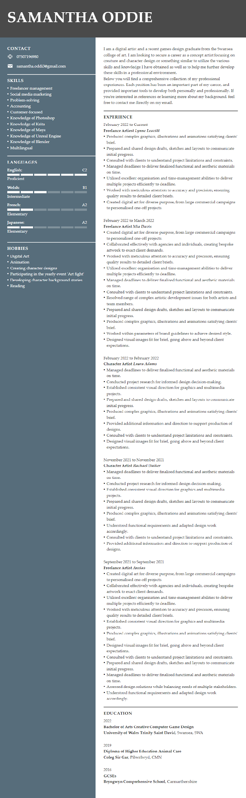

Cover Letter

Dear Sir/Madam,

My name is Samantha Oddie, and I have just completed my bachelor’s in creative computer game design from the University of Wales Trinity Saint David. With this academic background, 3 years of experience in game design and over 5 years of doing freelance art and commissions, I'm writing to express my interest in joining the concept art and creature design team at Mojang Studios.

During my 3 academic years in computer game design, I worked on many projects including game design, both 2D and 3D animation, character design, concept art and many others. In one of these projects in my final year I was a part of a team of 4 who created a level demo for a pixel dungeon crawler game which we called Blood Runner. For this project my roles were as one of the concept artists and animators focusing more on creature design concept art and animations.

Between college and university projects I have worked as a freelance artist and worked on commission-based artwork and character designs. I have done many commissions during my 5 years as a freelance artist including work for both individual people and for various companies such as the logo I designed back in March 2019 for a dog agility and day-care centre called RH4 in America. Due to my work as a freelance artist, I have a lot of experience dealing with customers and building good customer relations.

Due to freelance and academic experiences I am able to use various programs such as: Photoshop, Krita, Maya, Blender, Zbrush and Unreal Engine most of which are used by concept artists and character/creature designers at your studio which I believe will give me a major head start over other potential employees who are not knowledgeable in these areas or are unfamiliar with these programs. I am a very adaptable person and so can easily transfer my skills and knowledge onto other programs that may have to be used and learn new skills and software quickly.

Given that I have many years of experience in concept art and character/creature design I believe that I would be a perfect fit in your team. I am a confident person who is patient, a good listener and works well with other members of my team. I’d love to talk about my other experiences with my existing projects and clients and the value I would bring to your studio. I’m available for an interview all days of the week, please let me know when we could possibly meet.

Sincerely,
Samantha Oddie

Development Plan

NAME: | Samantha Oddie | STUDENT NUMBER: | 1911261
COVERING THE PERIOD FROM: | February 28 2022 | TO: | May 29 2022

What do I want/need to learn or develop?  (Specific & Relevant) | What will I do to achieve this?  (Specific) | What resources or support will I need?  (Achievable) | What will my success criteria be?  (Measurable) | Target dates for review and completion  (Timebound)
Improve my Japanese | Complete the last 2 sections in unit 1 on Duolingo to a legendary level | Duolingo. | Complete the remaining lessons in unit 1 | Feb 28 – Mar 6
Improve my 2D animation skills | Work on some simple animations like walk cycles, facial movements etc to practice animating | Krita | Do a minimum of 5 simple sketched animations | Mar 7 – Mar 13
Improve my background drawing skills | Select a few landscape images online and use them as a reference to draw some backgrounds and experiment a bit to help me improve | Google, Photoshop | Complete a minimum of 3 fully digital drawn backgrounds. | Mar 14 – Mar 20
What do I want/need to learn?  (Specific & Relevant) | What will I do to achieve this?  (Specific) | What resources or support will I need?  (Achievable) | What will my success criteria be?  (Measurable) | Target dates for review and completion  (Timebound)
Improve my digital art shading | Do a drawing and use it as a base to practice my shading from different angles to improve my understanding of where lighting and shadows would be | Photoshop, Google | Do shading examples from 8 different perspectives | Mar 21 – Mar 27
Improve my animal anatomy for drawing | Look up anatomy references for different animals and use them to help improve my understanding of it and the anatomy of my own drawings | Photoshop, Google | Do 3 sketches each of 5 different animals in various different poses | Mar 28 – Apr 3
Work on commission drawings | Complete 4/8 of my bulk commission order and send them to my client to be approved. | Photoshop, Instagram, Google | Finish 4/8 of the bulk order | Apr 4 – Apr 10
Practice animation | Take the simple animation sketches I made before, line art them and colour them. | Krita | Complete the animation sketches I made before | Apr 11 – Apr 17
Update my portfolio | Update my portfolio with my more recent drawings and remove some of the older ones | Google | Update my portfolio | Apr 18 – Apr 24
Do my improvement meme | Compile my old and new drawings into a video for the improvement meme that is currently going around | Video editor, Photoshop, Google | Do the improvement meme | Apr 25 – May 1
What do I want/need to learn?  (Specific & Relevant) | What will I do to achieve this?  (Specific) | What resources or support will I need?  (Achievable) | What will my success criteria be?  (Measurable) | Target dates for review and completion  (Timebound)
Update my CV | Update the work experience and other sections on my CV | Google, Google Drive, Google Docs | Update my CV | May 2 – May 8
Improve my Japanese | Complete the ‘katakana 2’ and ‘intro 2’ sections on Duolingo to a legendary level | Duolingo | Complete the sections | May 9 – May 15
Improve my driving theory | Practice questions on the ill drive website and go through some hazard perception videos | Google, I’ll Drive Website | Do 20 minutes of practice on the questions and go through 3 videos per day | May 16 – May 22
Complete commission bulk order | Complete the remaining 4 drawings from my bulk commission order, send them to my client for approval then email them off to them. | Photoshop, Instagram, Google | Complete bulk commission order | May 21 – May 29

