
Business Plan balu’s den
Sustainable Guest House


Dragos Sculeac 1913775
UWTSD
08.12.2020
Word count:2553

Contents
1. Company concept 3
2. Company name 3
3. Mission statement 4
4. Business Aims 4
5. Business Objectives 4
6. Legal Identity 4
7. Marketing and PR Plan 5
8. Pricing Strategy 5
9. 7 P’s 6
Product 7
Price 7
Promotion 8
Place 8
People 8
Process 8
Physical evidence 9
10. Marketing samples 9
11. Physical Location 10
12. Human Resource Strategy 11
13. Sources of Finance 13
14. Cash flow forecast 13
15. SWOT Analysis 16
16. References 17

- Company concept
The concept of my business is to build a sustainable guest house in Untesti, Romania, where families from around the world can come and relax and connect with the environment in an eco-friendly manner.
I have always dreamed of having my own business that can combine the relaxation with the connection to the environment. I noticed the potential for such a business in Romania for a few years now, but I was waiting for the right time to act. At the same time, in Romania, I can access non-reimbursable funds up to £200.000 from the E.U. budget, especially since no one developed such a business in the chosen county.
The guests will be offered plenty activities like bike rentals, horse riding lessons, farming, hot tubs, fishing and after the first year, an activity park.
Sustainable tourism is important as it helps us to preserve the world we live in and the cultures around us. It provides us the opportunity to travel whilst respecting the environment and the people.
It was Butler (1999) who defined sustainable tourism as one that can maintain its viability for an indefinite amount of time without altering the environment in which it exists.
Recent work in sustainable tourism has also focused on the benefits it can bring to the local communities and so Higgiens-Desbiolles et al (2019) have brought a new tourism definition that is centred around them. According to them, sustainable tourism must focus on the needs and interests of the local communities.

- Company name
The name chosen for my guest house had to be representative not only for my guests, but also for myself and my family. I wanted to emphasize the connection between people and nature by expressing the idea of comfort, cosiness, and safety that a den provides to its habitants. This is how I came up with the name of Balu’s Den.
The name Balu is actually a nickname for my son, Decebal, but everyone who hears it first, always thinks about the bear Baloo from Jungle Book. I like the fact that they associate the name with the famous bear, who is always cheerful and caring and I think it is going to pose an advantage for my business as it is easy to remember.

- Mission statement
Our mission is to provide a unique experience for all our guests and help them connect with the environment by operating in a sustainable manner.

- Business Aims
Our aim is to make all our guests enjoy the countryside and the activities we offer whilst minimising the impact on the environment.
We plan on operating in a sustainable manner by using renewable energy, local fruit, vegetable, and meat produce, fairtrade products where possible and several recycling methods.

- Business Objectives
My objectives for the first year are:
- to start making profit
- to build global awareness of the concept and of the guest house
- to attract more national and international attention to Untesti, Romania
- to collaborate with Romanian small brands
- to start building an Adventure Park for kids
- liaise with local food producers.

- Legal Identity
I choose to operate as a sole trader because I will have absolute control over my business, full ownership over the profits and less bureaucracy and paperwork to deal with (Cassidy, J, 2006). It is the simplest form of business organisation and will allow me to employ staff and manage the guest house myself.
There are also some disadvantages (McEachern 2017) I need to keep in mind, like a complete liability for debts. In case the business is not successful and acquires debts, I will need to rely on my savings and even my home to dissolve these debts.
Another risk it implies operating as a sole trader is that it might be more difficult to access funds through a loan or from other investors.

- Marketing and PR Plan
My target market is represented by families with a desire for a healthy, eco-friendly and sustainable life, along with corporate businesses who wish to offer their employees short trips for team building or events holding. I want to make the guest house a place of relaxation, an escape from the urban, where one can connect with the nature, and pass the passion for a sustainable life to the future generations.
I plan on listing the property on the www.ecobnb.com, a website known along the eco-friendly enthusiasts, and on www.airbnb.com, which is the most known and used booking website.
Regarding the marketing, I want to promote my business by using the word of mouth, since it is the most effective (McMillen, 2020). For this, I am planning on collaborating with Romanian influencers such as Adela Popescu (1.2M followers), Radu Valcan (353K followers), Dana Rogoz (613K followers), Laura Cosoi (672K followers) and British influencers such as Anna Saconne (1.3M followers). They will be contacted by myself and I will offer them a free weekend at the guest house, and they will enjoy all the activities for them and their children and pets. In exchange for the free weekend accommodation, they will post stories on their Instagram page during their visit, also add 2 or three pictures on the grid and at the end of their visit, each will post a giveaway on their social media platform, where the winners will receive a free, all inclusive weekend at Balu’s Den. At the same time, I am planning on creating business cards, for possible collaborations with Travel Agencies, Facebook and Instagram Page.

- Pricing Strategy
Since there are no competitors in the area, I choose to use two pricing strategies: Psychological Pricing and Penetration Pricing. By using the Penetration Pricing Strategy, I will offer the rooms at the smallest price possible (Ellsworth, 2019). On the other hand, by using the Psychological Pricing Strategy, I will set the prices as unrounded (Boachie, 2016).
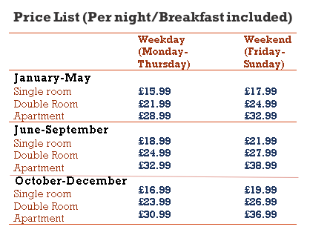

- 7 P’s
The marketing strategy is essential for every business’ success and it is based on a marketing mix.
Initially this mix was suggested by McCarthy (1960) who classified the marketing tools into four factors: price, place, product and promotion. Later this mix was extended to include 7 factors (Booms and Bitner, 1981), by adding people, process and physical evidence.
The 7 P’s of Marketing represent the company’s view of the available marketing tools to influence its potential customers.

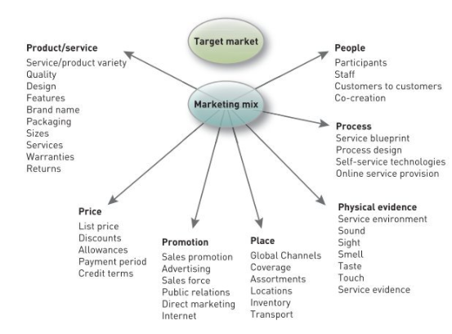Figure 1. Description of marketing 7p’s (Adapted from Kotler, Keller, Brady, Goodman and Hansen, 2009)

Product
When thinking about the product that I am looking to sell to the potential customers, as a guest house, this will be represented by a service. However, by coming to Balu’s Den, the guests will not only benefit form a good quality accommodation, but an overall experience of relaxation and activities that will connect them with nature.
Among the activities that we will be offering are: bike rentals for sightseeing, horse riding, fishing pond, learning about farming. In the first year of operating, we will also be looking at building an adventure park.
These activities will be included in the accommodation price, but they will also be available independently, at an extra charge, to those who are only looking to spend time at the guest house during the day, without staying overnight.

Price
As the business location is unknown to many and unexploited, I will be adopting the Penetration Pricing Strategy so that I can offer a lower price for the accommodation. In this price the guests will also be having breakfast and activities included. There will be extra charges for lunch and dinner, but they can benefit from a discount if it is all paid in advance when booking.
Another incentive we can offer to build a regular customer base will be to give discounts for multiple stays and for their birthday month. The guest will also have the option of purchasing gift cards for their friends.
For the international guests, we can also offer a charge for picking them up at the airport, considering the nearest one is 70 miles away.

Promotion
For the business promotion I will be considering a classic but modified approach, by emphasising on the activities offered that make this place worth visiting. The campaign will mostly be digital, I will be building a website with content in Romanian and English for the international guests, social media pages and will be collaborating with Romanian influencers who are representative for my target market.

Place
This factor involves all the ones mentioned above, and it is represented by two concepts, geographical and communication channels.
The marketing campaign will be similar for the national and international guests, as it is involving a self-sustainable concept, which is becoming more popular among different cultures.
The communication channel will be word of mouth, as this is the most effective when growing a customer base. The guests will be encouraged to leave reviews for the change of participating in frequent giveaways where they can earn special discounts, or free all-inclusive family weekend.

People
The people involved in the business will be its employees, the collaborating influencers and local food suppliers.
Apart from the ones mentioned, the clients also have a significant role in the marketing process, as without them the business will not be able to operate and be successful.

Process
We will focus on making the guests’ accommodation an enjoyable experience from the moment they arrive until they check out. We will offer pick up service for international guests, local activities for every family member, including pets, free water, coffee, and tea for the whole of their stay. We will also be offering free organic food for babies and toddlers.

Physical evidence
This last factor is all about providing evidence to the guests of what they will be getting during their stay.
They will be able to enjoy lovely sightseeing, like the pond or the near forest, will be tasting local and organic food, can also learn about growing their own food produce and animals.

- Marketing samples
I created a logo, which was inspired by the name of the company, and, in my opinion, will perfectly represent my business.
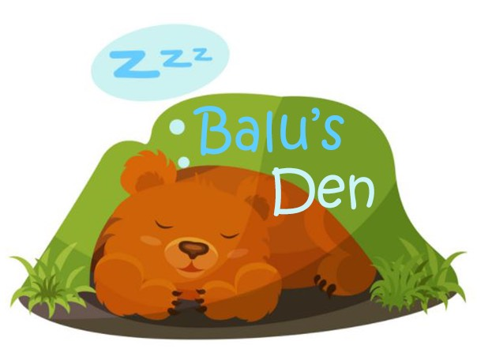
I created a business card, that I plan to use in the meeting with possible partners.
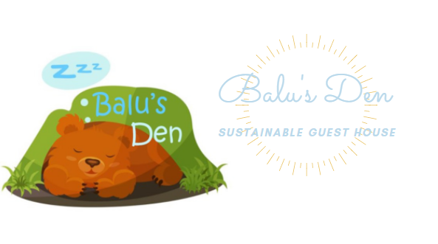
I created a website, where people can get to know our story, view the activities we offer and be able to make bookings.
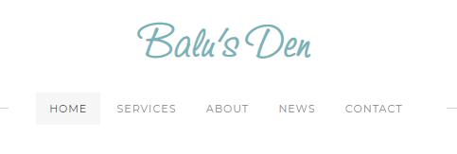
The domain of our website is currently www.balusden.weebly.com, but when the business will open, I will change it to www.balusden.com, and I will pay for the domain.
At the same time, I created an Instagram page, where we can interact with potential customers. It is a business page, in this way the credibility will increase, and we will be able to be transparent regarding the partnership with the influencers.
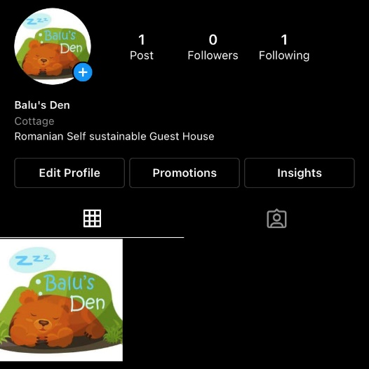

- Physical Location
I have decided to build the guest house in Untesti, Vaslui County, Romania. Although it is an unknown location, according to the National Agency for Rural Growth and Fishing, it is considered an area with touristic potential, but still unexploited. Therefore, it is listed as one of the villages that can benefit from non-refundable European grand for building a sustainable guest house and improving local tourism.
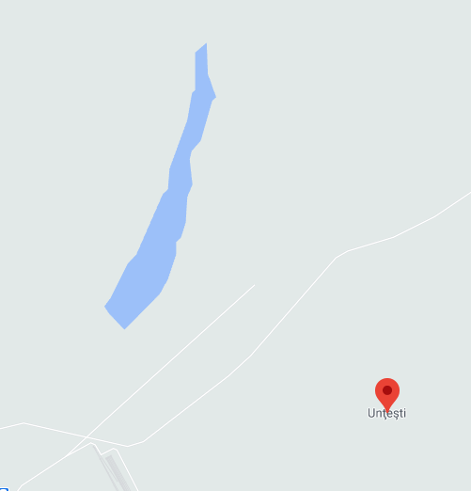
Another reason for choosing this location is that together with my wife are already owning the land, about 5 acres, there is also a built house with all the facilities which will be used for my family accommodation. There is also enough space for building the guest house, that will include 8 double rooms with en suite, a family suite,
a large kitchen, restaurant, reception area, a children play room and a large living room.
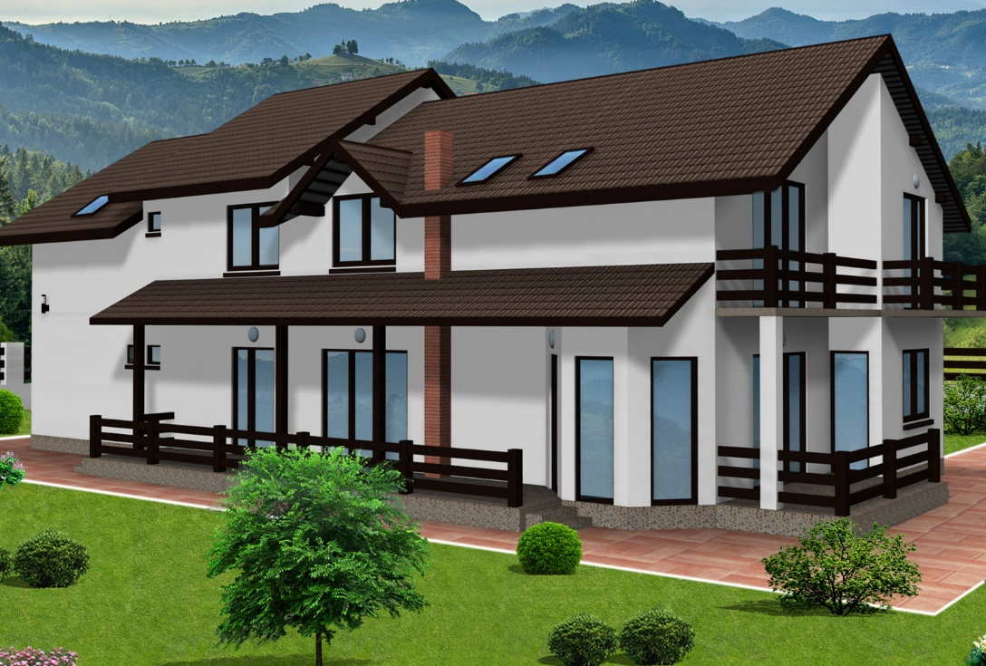
At the same location, our family also manages a farm, and we are already growing cows, sheep, pigs and seasonal fruits and vegetables that we plan to introduce to our future guests.

- Human Resource Strategy
As the owner of the business, I will also be the one who will be dealing with the management of the guest house. My wife is going to be helping me with the admin and the reception duties.
The accommodation will be operating every day of the year and so I will be needing to have some permanent employees, these being: a chef, a cleaner, a chef aid, a waiter, a receptionist, an activity guide, a farmer. I will also be collaborating with an accountant for a few hours per month.
Some of the employees will be having a full-time contract, like the chef, farmer, and the receptionist; the chef aid, waiter, cleaner and activity guide will be part time employees.
In terms of recruiting, I will be looking to employ people from community if possible, by advertising the jobs online on the county hall’s website and other local job search sites.
Salaries / per annum
- Manager: £12000
- Receptionist: £6000
- Chef: £9000
- Chef aid: £2500
- Cleaner: £2000
- Farmer: £5400
- Activity guide: £3000
- Accountant: £4000
Organisation Chart

- Sources of Finance
As I intend to be a sole trader, the most relevant source of finance for my business is going to be the personal investment, I will be using my savings and some assets me and my wife possess and with the business plan I will then be looking to get a non-refundable European grant.
The guest house will be located in Romania and I estimate that I will be needing around £300.000, but I can obtain up to £200.000 from a non-refundable European grant (Your Europe, 2020). I would need to have a 10% deposit, and this is going to be represented by my savings. I already own the land where it is going to be built and some of the facilities.
For the rest of the finances, I will be looking to get a bank loan.

Costs (£)
Building costs for 3800 square feet | £160,000
Parking lot: | 7500
Solar panels and water supply: | 20000
Furniture | 12000
Room electrical appliances | 6000
Bar | 2000
Restaurant furniture | 2500
Kitchen appliances and facilities | 8000
Linen and bedding | 1500
Mountain bikes | 5000
People carrier | 15000
Lighted sign | 500
Fishing gear | 5000
Stationary | £300
Log burners | £1,500
Hot tub | £10,000
Total | £256,800

Cash flow forecast
I have attached below the forecast for the first 12 months.

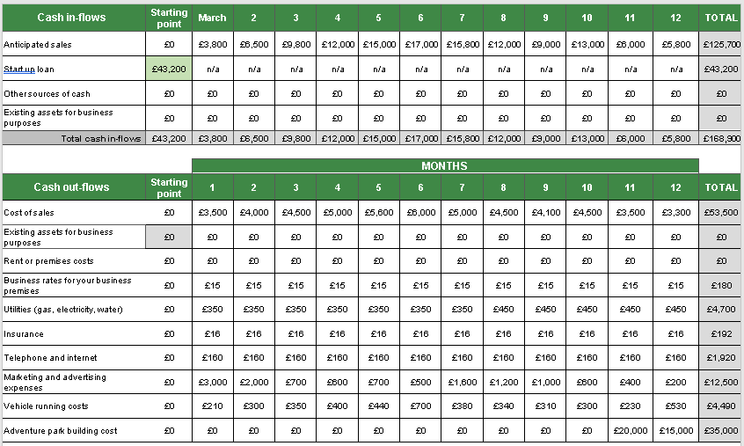

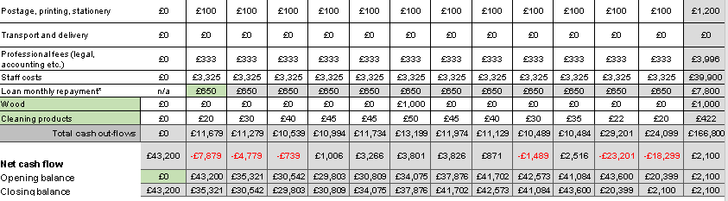

- SWOT Analysis

Strengths:
- Skilled management
- Local sourced and home-grown food produce
- Lower start-up cost as already owning the land and some of the facilities
- Rural location, easily accessible
- Unique concept in the area
- Suitable for families and corporate businesses looking for relaxation
- Offers a number of activities for both children and adults
- Pet friendly

Weaknesses:
- Unknown and unexploited location
- No previous experience in tourist business
- High building costs
- Poor local infrastructure
- Competition from established guest houses in the area

Opportunities:
- An increased interest towards sustainable accommodations
- Accessing non-refundable European funds
- Introducing more tourist activities in the next years
- Strengthening communities and encouraging local business growth

Threats:
- Loss of interest during winter months
- Unknown location and reluctancy from people to travel to one of the poorest areas of the country
- Cultural clashes can occur as a result of differences in values, cultures, lifestyles of those who visit
- Standardisation and commercialisation
- Local resources can be affected as a high demand can put pressure on resources and infrastructure.
- Heavy bureaucracy in Romania
- Risk of not getting the finance
- Increase pollution

- References
- Boachie, P. (2016) 5 Strategies of 'Psychological Pricing’. Available at: https://www.entrepreneur.com/article/279464 (Accessed: 22nd November 2020)
- Booms, B. H. and Bitner, M. J. (1981), Marketing strategies and organizational structures for service firms marketing of services, Chicago, American Marketing Association
- Butler R., Nelson J. C., Wall G., Tourism and Sustainable Development: Monitoring, Planning, Managing, Decision Making: a Civic Approach University of Waterloo, Department of Geography
- Cassidy, J. (2006), Concise Corporation Law, Federation Press
- Ellsworth, M. (2019) What is Penetration Pricing? Advantages and Disadvantages for Brands. Available at: https://blog.wiser.com/what-is-penetration-pricing/ (Accessed: 22nd November 2020).
- Higgins-Desbiolles, F., Carnicelli, S., Krolikowski, C., Wijesinghe, G., & Boluk, K. (2019). Degrowing tourism: Rethinking tourism. Journal of Sustainable Tourism, 27(12), Available at https://doi.org/10.1080/09669582.2019.1601732 (Accessed 4th of December 2020)
- https://www.instagram.com/annasaccone/?hl=ro
- https://www.instagram.com/lauracosoi/?hl=ro
- https://www.instagram.com/adela_popescu/?hl=ro
- https://www.instagram.com/raduvalcan/?hl=ro
- https://www.instagram.com/danarogoz/?hl=ro
- https://ecobnb.com/
- https://www.airbnb.co.uk/host/homes
- https://www.apdrp.ro (Accessed 21st November 2020)
- Kotler, P., Keller K.L., Brady M., Goodman M. and Hansen, T, Marketing Management, (2009), Pearson Education, Business & Economics, 17-18
- McCarthy, J. (1960), Basic Marketing: A managerial Approach, McGraw Hill
- McEachern, W. A. (2017) Contemporary Economics, Business and Economics, South Western Cengage Learning
- McMillen, J. (2020) Word-of-Mouth Marketing: Building a Strategy That Really Works. Available at: https://www.yotpo.com/blog/word-of-mouth-marketing/ (Accessed: 22nd November 2020).
- Your Europe (2020) Access to finance. Available at: https://europa.eu/youreurope/business/finance-funding/getting-funding/access-finance/index_en.htm (Accessed: 22nd November 2020).

Presentation



