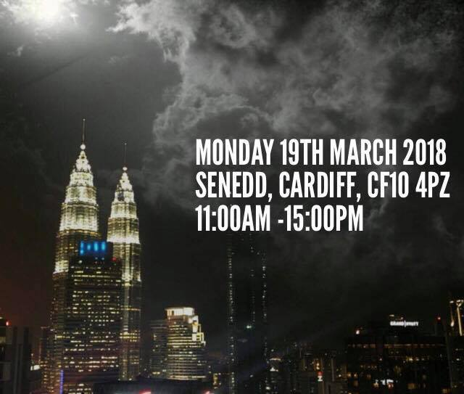
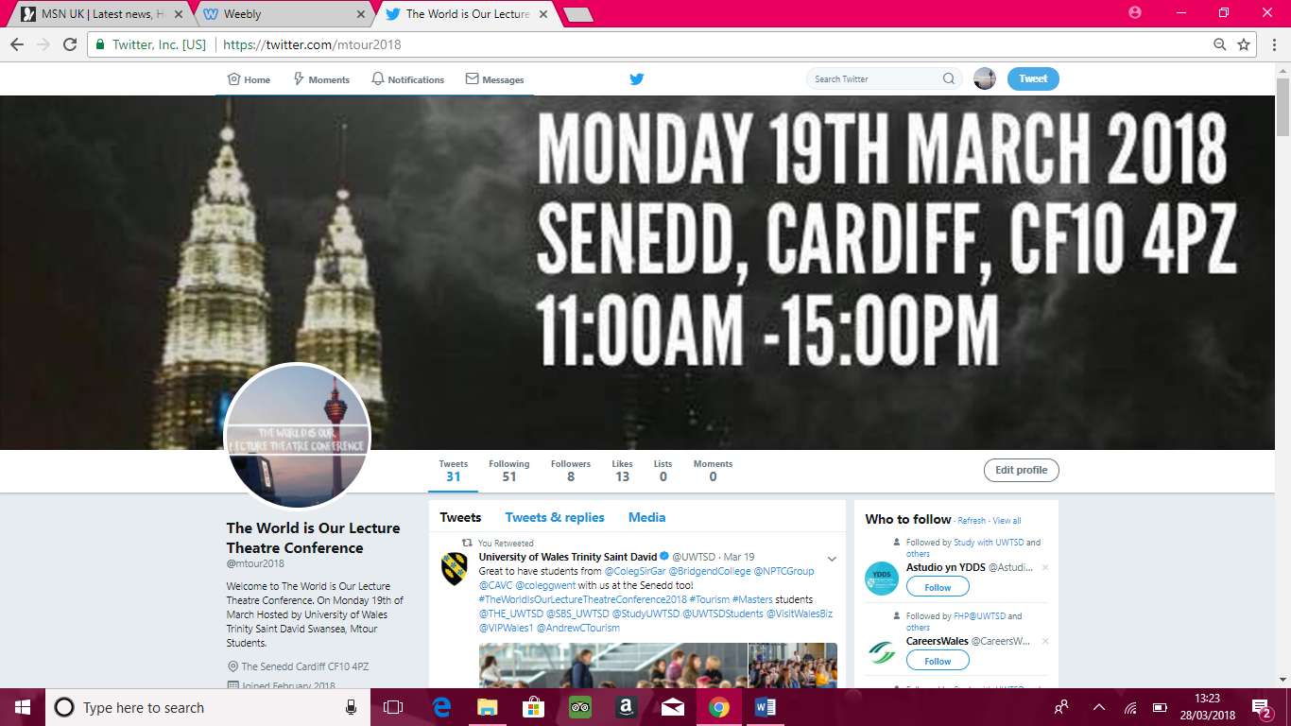
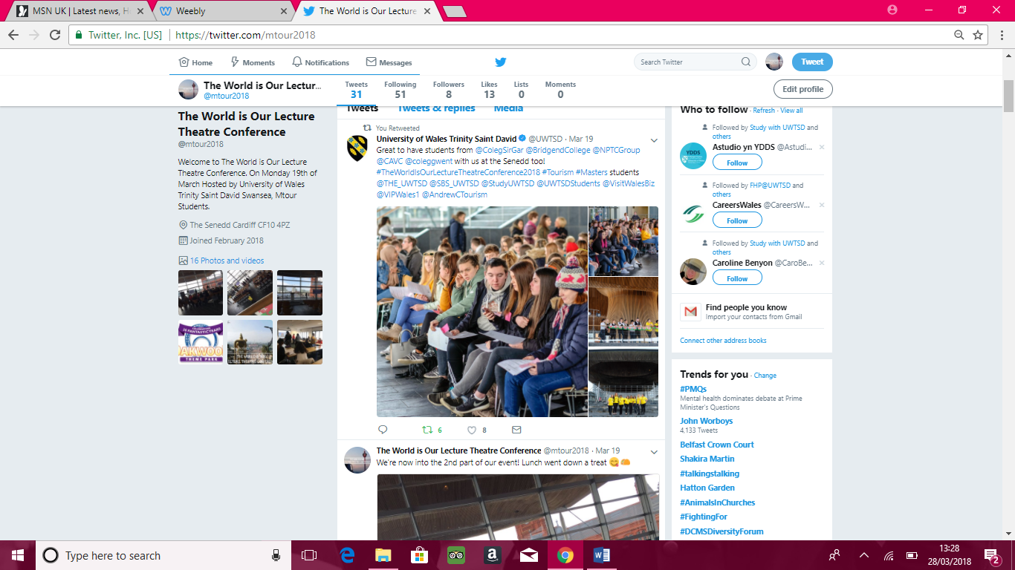
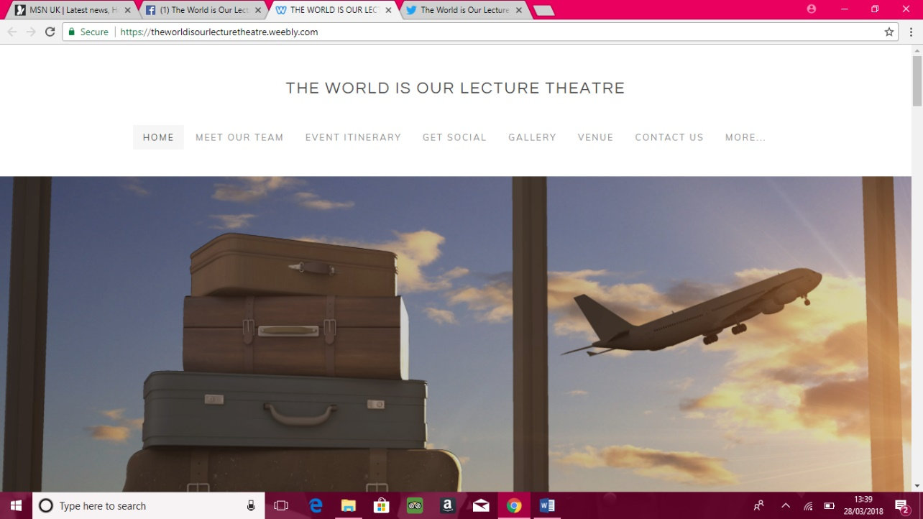
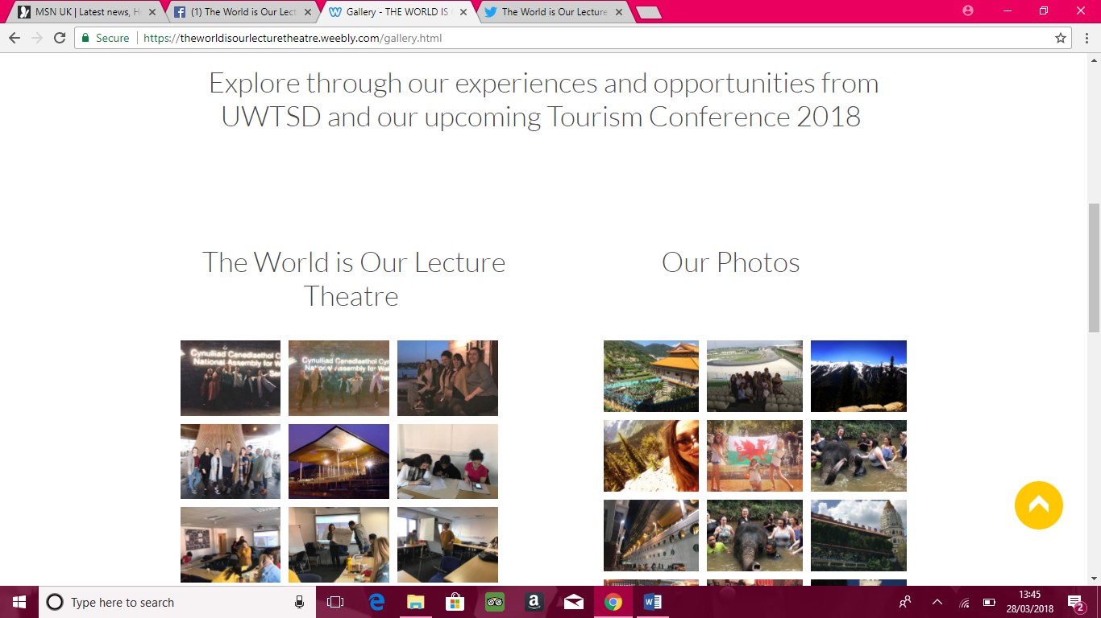
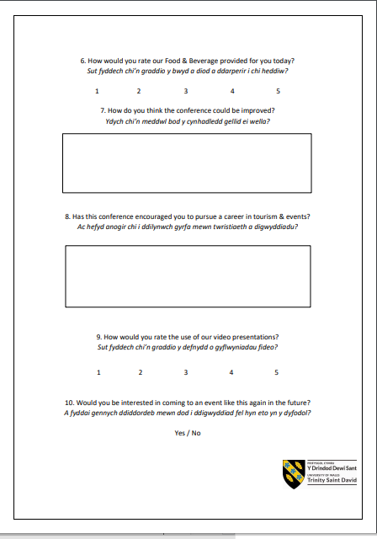
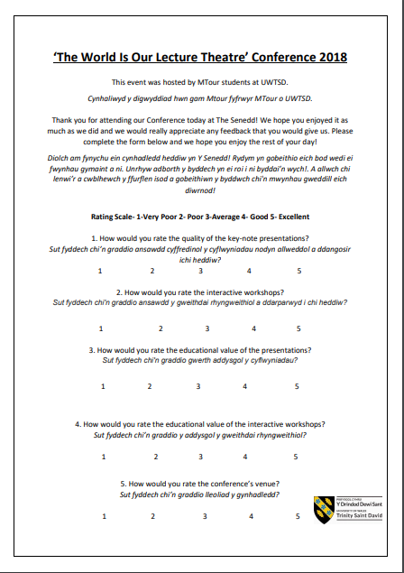
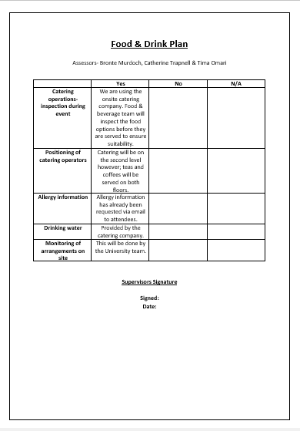
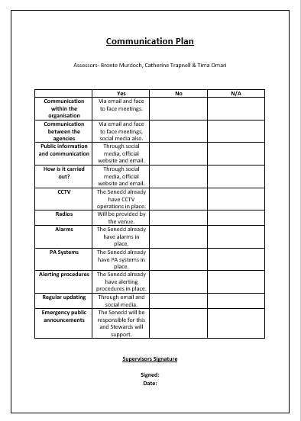
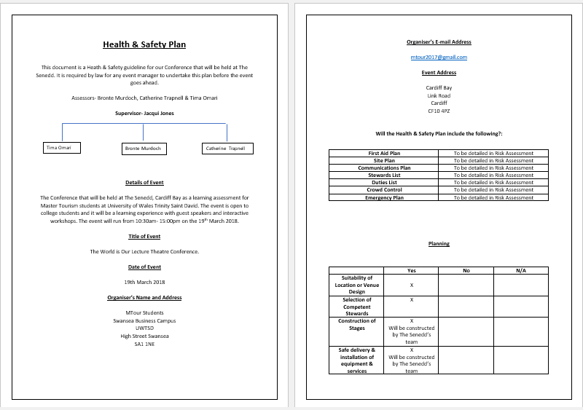
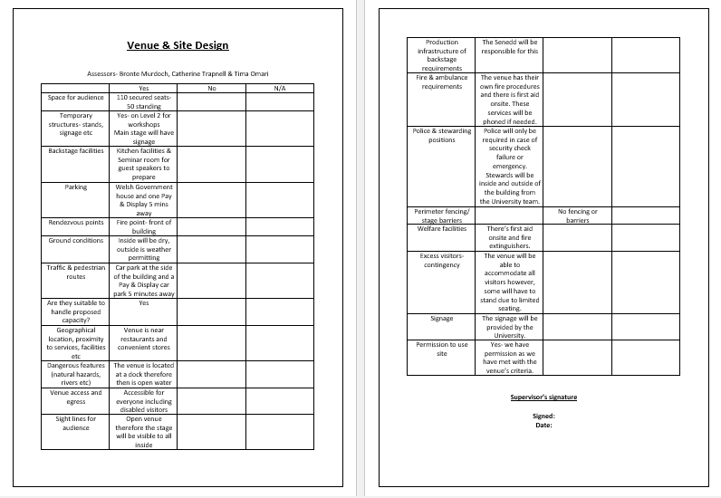
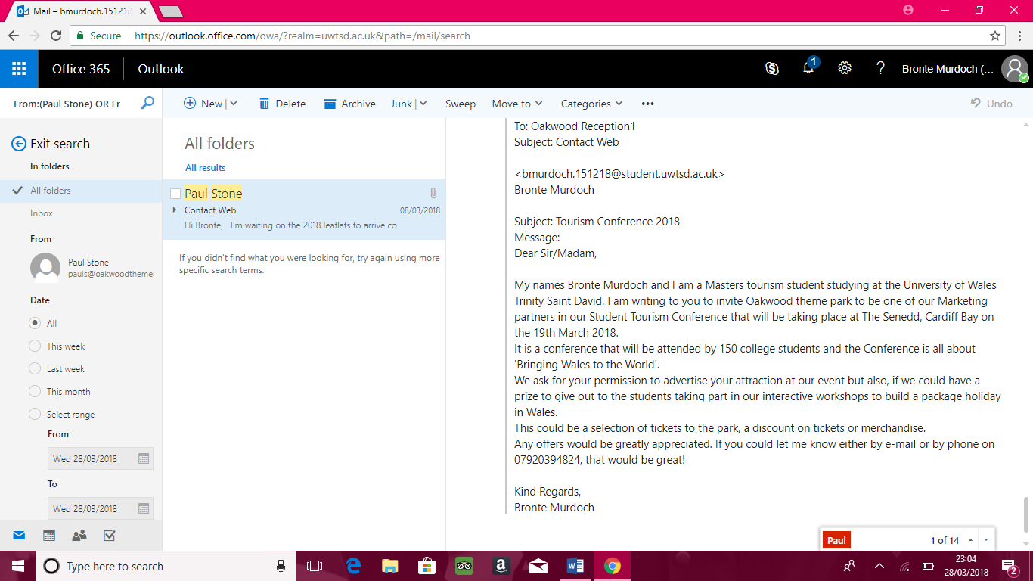
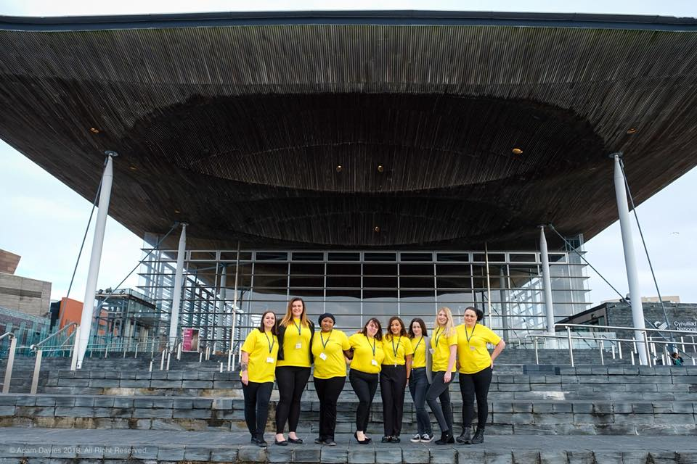
‘The World Is Our Lecture Theatre’ 2018 Reflective Portfolio
Bronte Murdoch- P121518
Introduction
The purpose of this document is to review and reflect on the planning, implementation and my own personal experience of ‘The World is Our Lecture Theatre’ 2018 which took place on the 19th March 2018.
The conference was held at The Senedd, Cardiff Bay and its purpose was to engage college students through guest speakers and interactive workshops. The conference’s subject was ‘Bringing Wales to the World’ which meant celebrating Wales as a tourism destination whilst also describing our personal journeys through University of Wales Trinity Saint David.
As a team of 9 students, we all had our roles and responsibilities during the planning phase and the implementation. Below I will be detailing my personal roles and responsibilities.
Work Samples
My main role during the planning phase was social media. I was in a team with 2 others and we all were in charge of one social media channel each as well as helping to design the conference’s website. My social media channel was Twitter and I began running it on the 14th February. The purpose of this social media channel was to advertise the event, it’s guest speakers and workshops.
The page has 8 followers which wasn’t a great following considering I was following 51 accounts. I posted 31 times, which was once a day, leading up to the event. I do feel that Twitter is the least popular social media channel compared to Facebook and Instagram which is why this page had the least following. The page can be found at https://twitter.com/mtour2018.
My other role, as part of the social media team, was to help create the conferences website on Weebly.com.
One of our social media team members created the website and we all then designed the pages.
The pages that I designed were:
Get Social
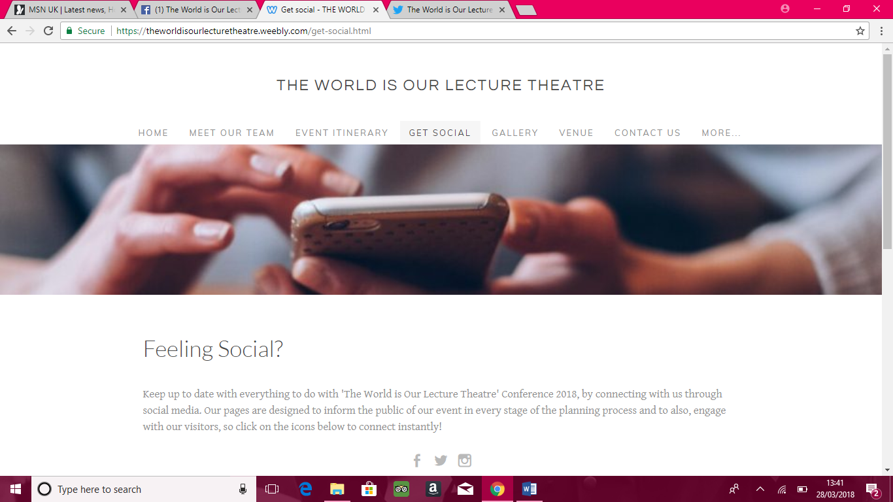
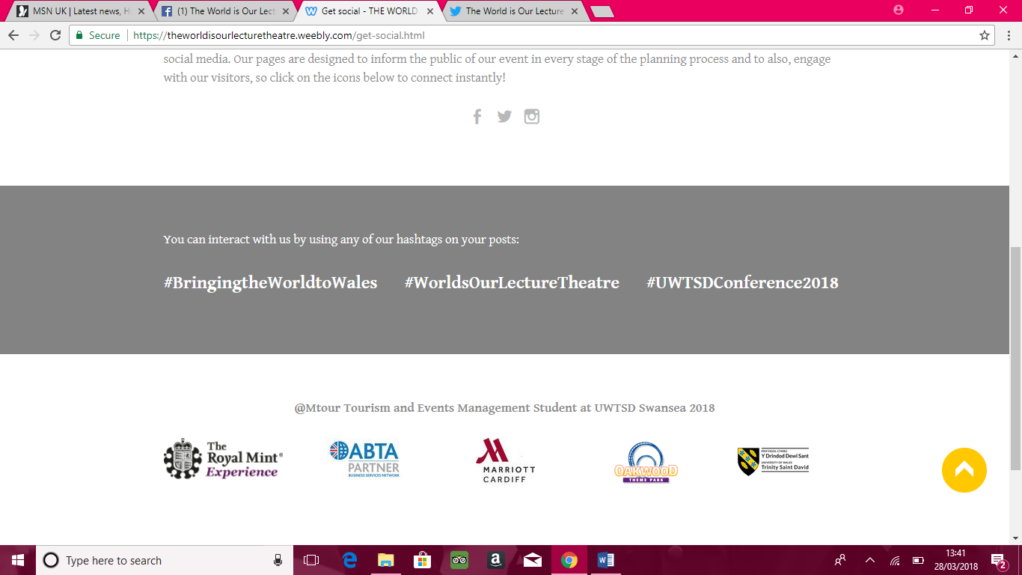
Our Supporters
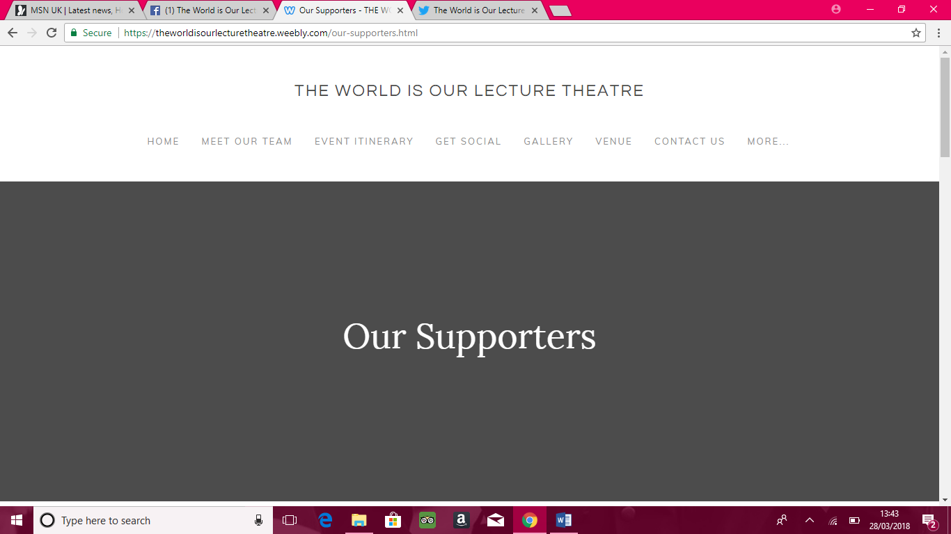
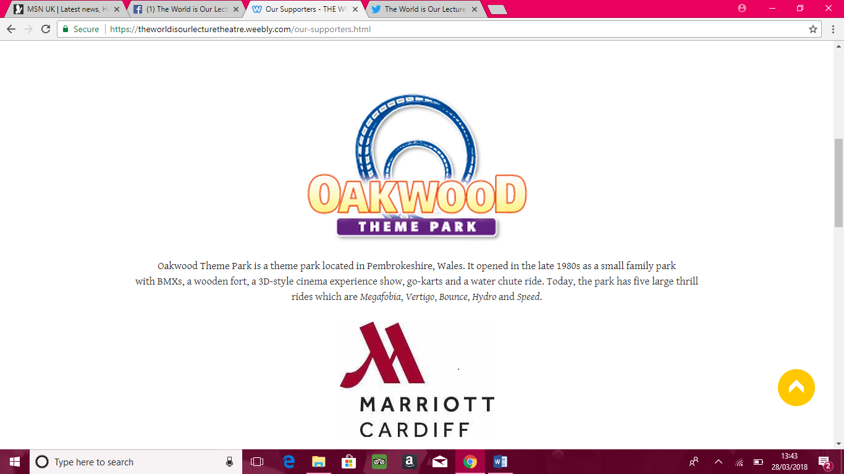
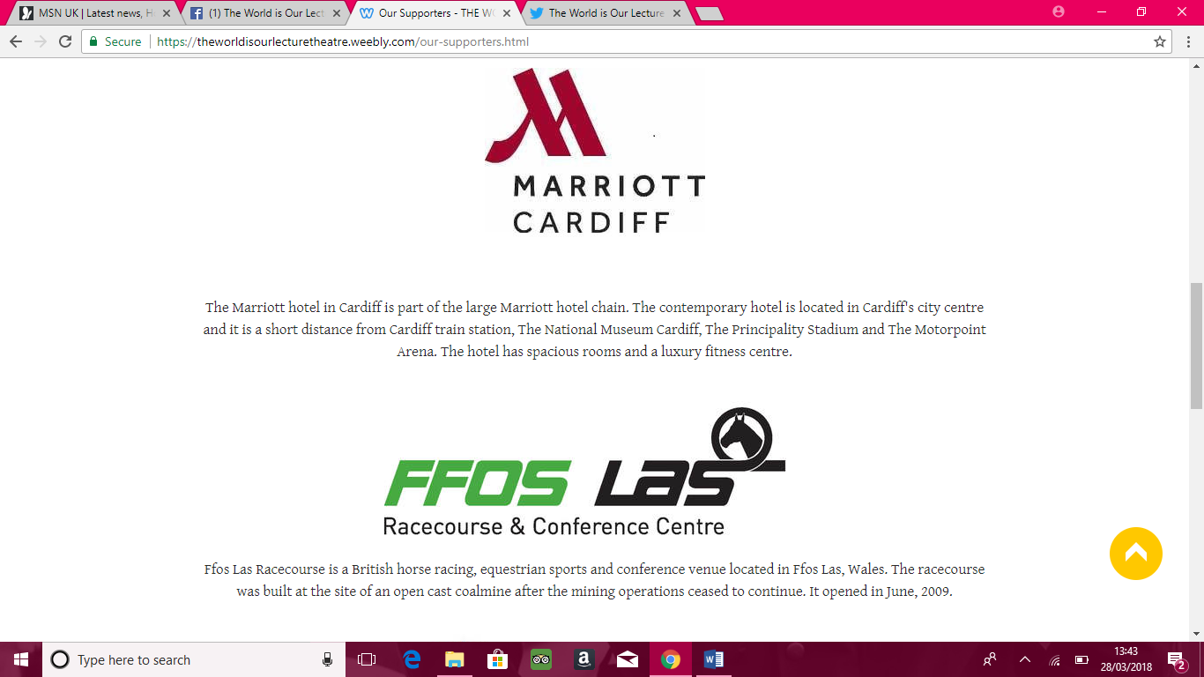
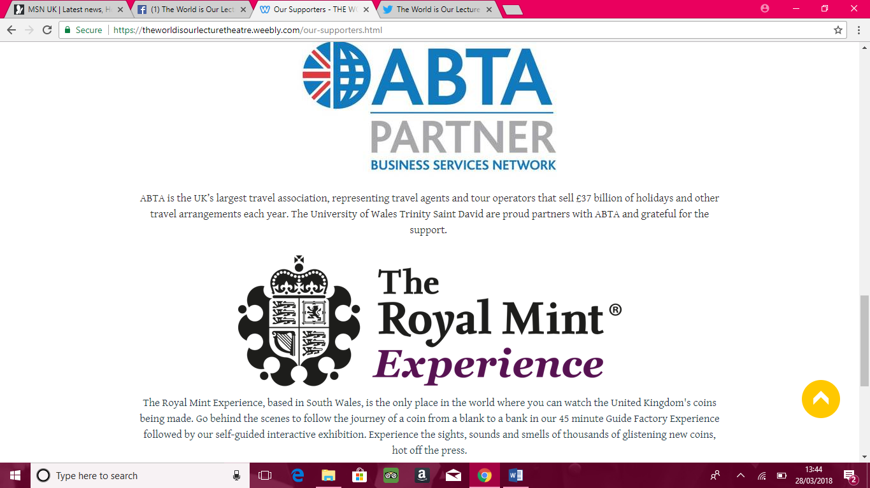
I also contributed to The Gallery.
The site can be found at https://theworldisourlecturetheatre.weebly.com.
My last responsibility as part of the social media team was to create the feedback form which was intended to be given to the 150 students that attended to review their experience at the conference.
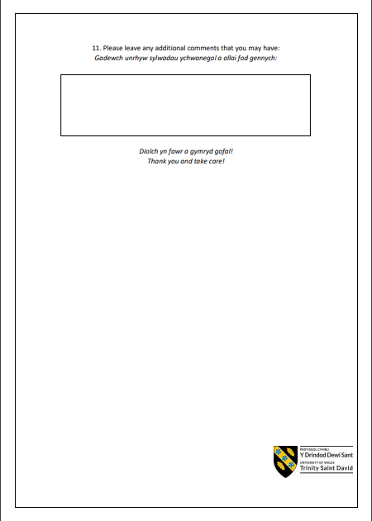
There was a confusion as to whether these documents were needed and whether I was meant to be helping out with the risk assessments, so I helped the Venue team with these documents:
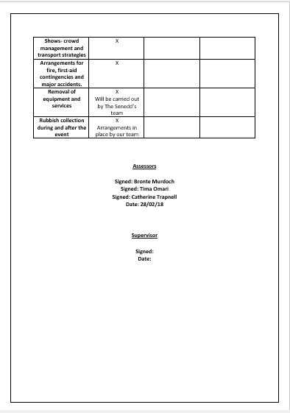
Outside of my roles and responsibilities, I took it upon myself to contact Oakwood Theme Park to ask them whether they would like to be our partners for the event. I did this through my student email which I later realised should’ve been done through the event’s email address therefore, after some communication I began emailing him off of that address which is mtour2017@gmail.com.
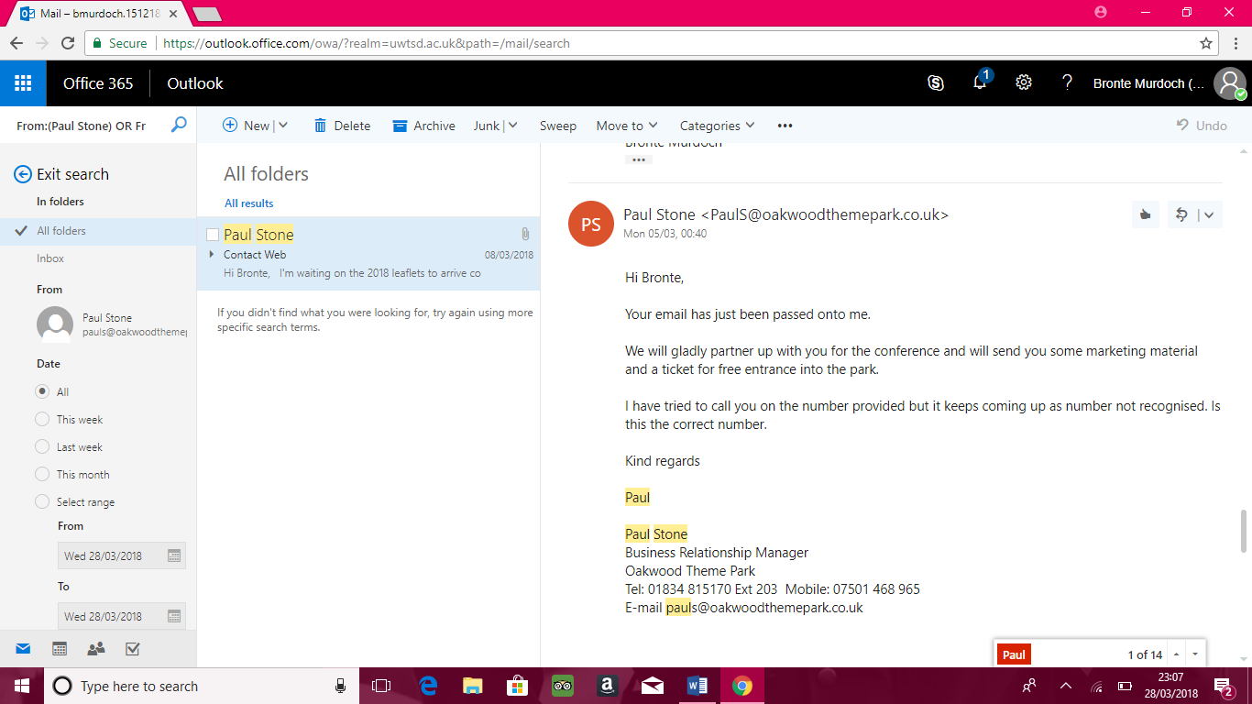
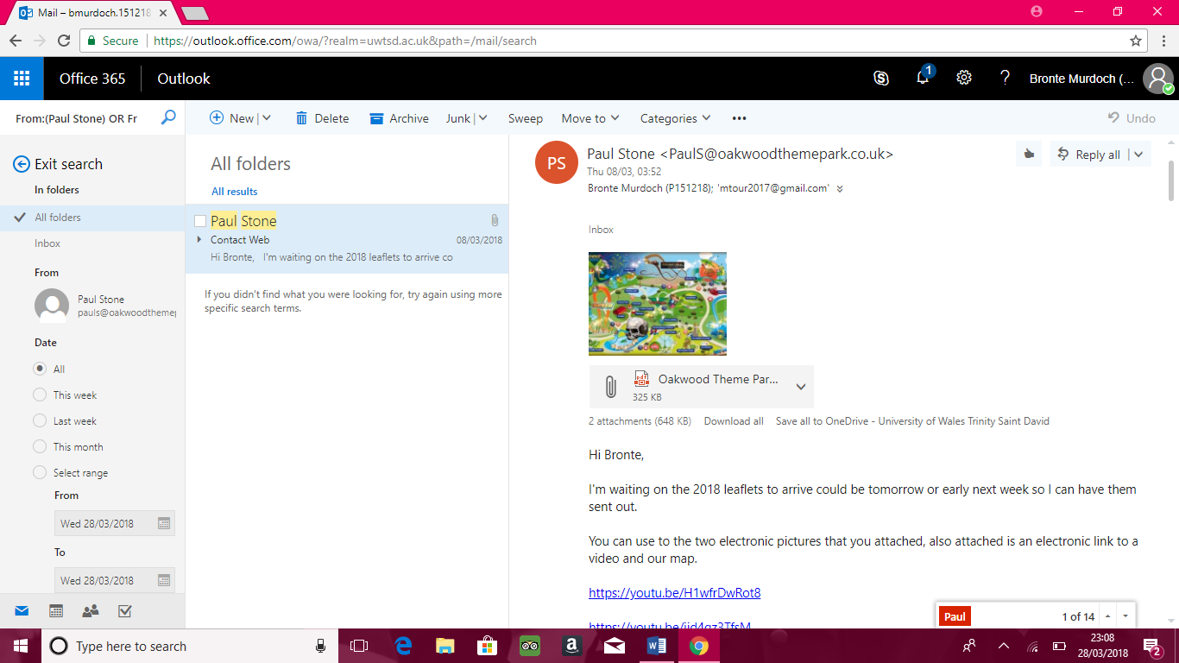
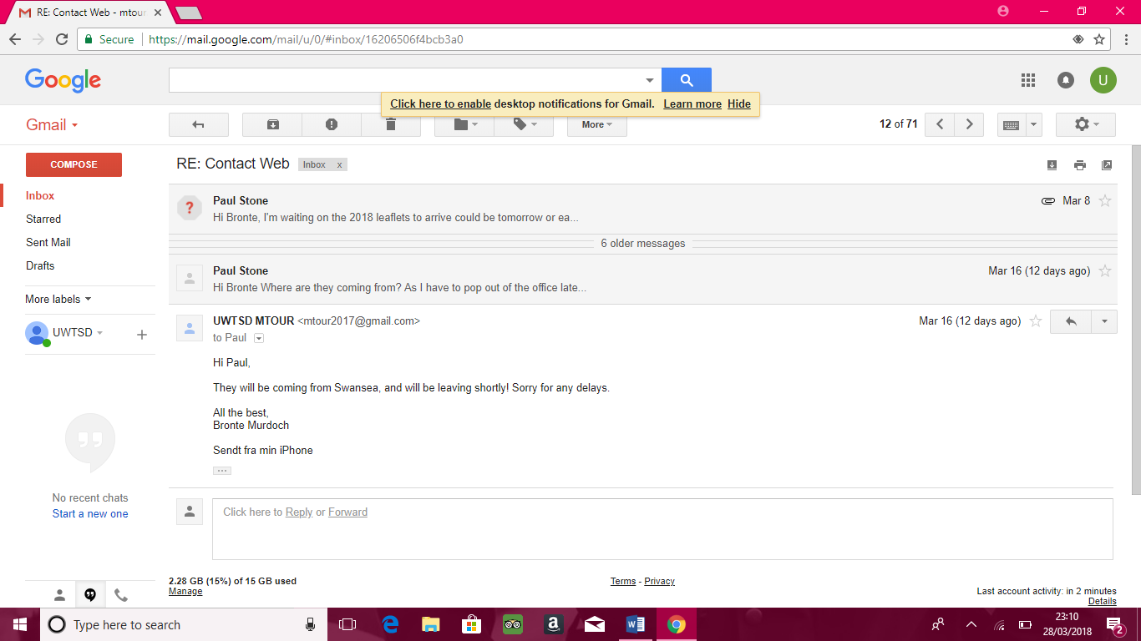
Reflection
Looking back at the planning phase of the event, I was very happy with my social media role as I’ve always had an interest in Marketing and I feel that this had given me an insight into what event marketing would be like. I would make daily posts on Twitter, but myself and the rest of the social media team would always be in communication about what to post as we wanted all three sites to have the same design, brand and information. I really enjoyed this aspect of the planning stage.
As I have previously mentioned, there was confusion as to whether or not I had also been given the ‘risk assessment’ task. For some reason, there was a feeling that myself and a few others were not doing enough which is why they had given me this extra task. It was then decided that the risk assessment needed to only be a short document due to The Senedd having their own risk assessments, and our supervisor didn’t understand why three people would’ve been put on such a simple task. Despite this, I still helped with the risk assessment by stating my opinion on what needed to be in there and I helped with the Communication Plan, Food and Drink Plan, Venue Design and Health & Safety Plan. We were then told we didn’t need these either however, I am glad we went into that much detail as it has given me an insight into what an event planner would have to consider.
There was definitely a divide between the group and I couldn’t really put my finger on why that was. I stayed out of it as I’m not one to get involved in things like that especially when we were meant to be a team. It seemed that there was a power struggle going on with some wanting to take credit for what was being done outside of their knowledge. There was no team feeling, instead it felt as if there was a battle going on within the team. This led to much confusion and a lot of mis-communication. Most of the team’s communication came through Facebook Messenger which I think added to the confusion and mis-communication as its so informal and its easy to miss things especially when so many people are talking on there at once. In reflection, I don’t think this was an effective method of communication and I think everything should’ve been done through email. This also meant that our supervisor wasn’t aware of what was going on and in any other event planning scenario, they would be Cc’d into emails. We did start to communicate through email towards the end of the planning phase but by then a lot of the mix-ups had already happened.
The Senedd was a great venue for our event and it was a fantastic opportunity to showcase our University in such an iconic venue for Wales, however, having our event there did mean that we needed to put in a lot more work than if it was held in the University. This included visits to The Senedd, transporting equipment from the University to the venue and communication with The Senedd staff. If it was held in the University, I feel that we would have had a lot more control in terms of what volume the music could be, the screen sizes for the presentations and the venue temperature as it was quite cold in there. It would’ve been ideal to have tables as well so that the students could work on them instead of having the big sheets of paper on their laps.
On the day, the event went well and I felt that the guest speakers delivered some amazing presentations. Our personal videos that were played really gave the event our personal touch, thanks to the visuals team. I think the workshops could’ve been better as our stallholders didn’t show up and the students had to work on their laps as I have previously mentioned. The Food & Beverage options were limited with only sandwiches and some sushi, in comparison to last year’s conference where they had an array of options.
My role on the day was managing the guest speakers which meant timing their presentations. I found this difficult to do as I didn’t know how to approach them when I knew their time was running out. I managed to speak to a few of the guest speakers beforehand, but I couldn’t pinpoint some of them to be able to tell them how much time they had to present. They were all given itinerary’s and made aware of their timeslots beforehand but I don’t think I managed it as well as it could have been.
Conclusion
Overall, I feel that the event was a success with our event having amazing partners such as Oakwood Theme Park and Ffos Las Racecourse to be able to provide prizes for our workshop winners. I do think that the conference was engaging and encouraging to those young individuals to pursue a career in tourism. Like any event, there were definitely improvements that could be made such as timings, venue layout and catering options and these will hopefully be taken into consideration when planning the next event.
Peer Review
Social Media 23/30
Team Member A 9/10
Team Member B 6/10
Team Member C 8/10
Workshop 21/30
Team Member D 7/10
Team Member E 7/10
Team Member F 7/10
Visuals 10/10
Team Member G 10/10
Venue 16/20
Team Member H 8/10
Team Member I 8/10

