Organisational Consultancy
BMIH6005
Organisational Consultancy for Hyatt regency St. Louis At The Arch
Hyatt Hotels US

Florin Snopu – 2026401
Julia Ault

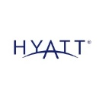
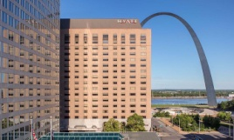
Executive Summary
The problem at stake: In this consultancy report, the current challenges faced by Hyatt Regency St. Louis Arch are identified with the appropriate use of secondary research approach. Major issues, which are located in the research, are related to poor customer experience caused due to unhygienic rooms and a lack of trained staff. Further, improper decisions made by the hierarchies, low sales during the pandemic and employee motivation and professionalism inside the workplace. From the PESTEL analysis, it is found that the lower disposable income in the US creates an additional challenge for the business development of Hyatt Hotels. Likewise, a SWOT analysis is conducted and it is identified that higher market competition and losing the trust of the customers can create huge challenges to the global hotel chain and reduce the market share of the brand.
The star model is used to understand the current performance of the hotel and the lack of presence in the process that leads to greater challenges for business. Dirty rooms and the presence of bed bugs in the rooms of Hyatt Regency St. Louis Arch lower the value of the brand and create a negative image of Hyatt Hotels on online platforms like Glassdoor and Bookings. Around 1,300 hotel staff was cut during the pandemic situation, which causes huge risks related to managing the people of the brand. Similarly, the decision made by the hierarchies to reduce the payments of senior managers made the business process more complex and restricts growth. These are the major issues found by using different frameworks and models in the consultancy report.
Findings: It has been identified through the creation of the PESTEL analysis, that the political perception score of the US is quite significantly high. It has implied through high scores that the corruption level in the US is considerably low. Additionally, it has also been understood that the inflation rate has been declining which outlines that the prices of the products and services are reduced making the services of the organisation more lucrative to various targeted customers. Moreover, the low social disposable income in the US underlines that the business functions of the US are majorly reduced and operational practices are lowered. Moreover, the SWOT analysis that has been conducted outlines the strengths of the organisation involving wide a range of services and brands. Lastly, it has been found through the completion of the study that the issues pertaining to customer satisfaction have been the major challenges that have been faced by the organisation effectively.
Analysis: After analysing the whole findings, it has been analysed that Hyatt Hotels failed to achieve the desired performance as a global luxury hotel and manage their people in an organised way to get better outcomes from the business. Firstly, it is found that general services including maintaining the cleanliness of the rooms become difficult for the hotel. Additionally, they have not been able to manage their people due to the wrong decisions made by the business hierarchies and poor employee management practices. Thus, the organisation is struggling to maintain its business growth and follow a sustainable business process. Moreover, it can be considered that the causes for these challenges are a lack of employee training and effective customer interaction.
Recommendations: Various recommendations have been provided in the general process of completing the study. These have included strategies such as the creation of innovative marketing processes through social media platforms. Moreover, it has also specified that through the creation of a standard operating procedure, effectively clean and hygienic services can also be provided to employees effectively. Furthermore, it can ensure that by implementing a training module there can be several benefits to the operating procedure of the organisation effectively. This also aids in majorly improving the performance of the organisation and thereby creates higher market demand.
Conclusion: Thus, it can be concluded that this consultancy report can help Hyatt Regency St. Louis Arch to deal with the current issues faced by the organisation. Additionally, some recommendations are provided at the end of this report for guiding the international hotel chain in boosting their performance and increasing sales.
Table of Contents
Introduction 5
Scope and Analysis 6
Main Body 12
Research methods 12
The Star Model 12
Fishbone model 15
Change Management at Hyatt Regency 17
Findings and Results 19
Action Plan 24
Recommendations 28
Conclusion 29
Reference List 30
Appendices 37
Appendix 1: ACSI score 37
Appendix 2: Hotel location 37

Introduction
Organisational consultancy is a service that provides additional guidance to businesses with the help of experts in a specific field (Newton, 2010). Thus, organisational consultants can access better insights into a company through effective research and analysing of the information related to the business. Managing the business becomes an essential approach for organisations operating in the hospitality sector. Identifying the reasons for the performance gap and developing effective solutions relevant to the issues becomes easier by hiring an organisation consultant. This report aims to provide an action plan and recommendations depending on the identified problems that affect the customer experience of the selected organisation Hyatt Regency St. Louis Arch. Additionally, the consultancy report will provide a detailed description of the challenges currently faced by the company considering the different operations of the selected hotel organisation. The purpose of this report is to provide organisational consultancy for Hyatt Regency St. Louis Arch. Issues related to customer experience, management decisions of hierarchies, managing employees and the influence of Covid 19 will be addressed based on the data found relevant to the organisation. On the other hand, the influence of both internal and external factors on Hyatt Regency will be evaluated with the use of different models including SWOT, PESTEL and TOWS analysis. These will be implemented for mitigating the potential threats that can influence the success of the selected hotel (PIRNAR, KURTURAL and ERİŞ, 2019).
Change management refers to a systematic approach that allows organisations to boost their performance and work towards fulfilling the organisational goals (Kotter, 2012). In order to outline the essential change in the management process of Hyatt Regency, Lewin's Change Management Model will be used. Hyatt Regency made the foundation of its business in 1957 and currently, they are one of the top hospitality companies worldwide (Hyatt, 2023). Caring for people is the aim that helps the brand to get success and mark its uniqueness over other brands operating in the same sector. As per the data of 2021, the organisation operates in around 70 different countries including 6 continents and over 1,150 hotel properties were included in their portfolio. In 2022, the global brand value of Hyatt Hotels Corporation was recorded at 5.9 billion U.S. dollars, which shows the success of the company (Statista, 2023).

Scope and Analysis
Hyatt Hotel Corporation is a chain of hotels that are headquartered in the United States of America, in Chicago (Hyatt, 2023). It manages franchises, owns and develops hotels and resorts along with customer service activities. It operates under various brands such as the Hyatt Regency, Hyatt Place, Aila, Destination by Hyatt, Hyatt Ziva, Hyatt Residence Club, Hyatt Zialara and others (Global data, 2023). Moreover, the Restaurants and bars in the hotels provide a range of food and beverage to the various customers that are offered in general.
The Hotel Chain has approximately 1150 hotels across 70 different countries that are located on seven different continents. Moreover, the organisation has approximately, 266048 rooms in the different hotels that are operational internationally (Statista, 2023).
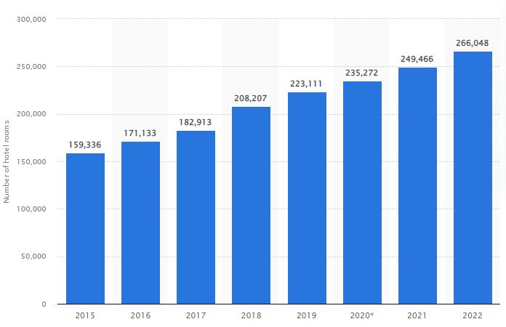
Figure 1: Number of Rooms in the Hyatt Hotels Globally
(Source: Statista, 2023)
Moreover, Hyatt Hotels have been in operation since 1957 when it was founded by Jay Pritzker (Hyatt, 2023). There have been recent issues in the functioning of the Hyatt hotels during the Covid-19 virus as it had to lay off approximately 1300 employees as the travel demand reduced by veritable margins (Simon, 2020). Based on the reduction in the demand for travel has also established the areas through which it can facilitate major issues such as the generation of a significant level of net loss. However, on a positive aspect, the laid-off employees have been provided with a generous severance package. Additionally, the hotel has created a major provision based on which the laid-off can acquire financial aid from the Hyatt Care Fund for a specific time period. In this regard, the organisation has been facing issues pertaining to a lack of trained staff, and unhygienic infrastructure in the US.
PESTEL Analysis
Pestel is a framework through which an organisation can effectively evaluate the macroeconomic factors that have an impact on the functioning of a business concern (Thomaset al., 2021).
Factor | Particulars
Political | The corruption index score of the US is 69 out of 100 (Trading Economics, 2023)
Economic | The inflation rate has decreased from 5 percent to 4.9 percent (Trading Economics, 2023)
Social | The disposable income of US citizens is 56088 USD in 2021 (Pino, 2022)
Technological | The innovation index score in the US is 60.23 reduced from 61.8 points in 2022 (Global Economy, 2022).
Environment | Resource Conservation and Recovery Act governs the waste management process in the US (EPA, 2023).
Legal | Consumer Rights and Consumer Protection law governs the interactions that consumers have with different business organisations (HG, 2023).
Table 1: PESTEL Factors
(Source: Created by the learner)
Political: The corruption index score of the US has been observed to be veritably low, which elaborates that businesses are positively impacted in running and managing their businesses. It ensures that the corruption level in the US is not very high which establishes that all business activities are conducted without many issues that are involved in the course of operations. Herein, the Hyatt Hotel US will be positively impacted as the low corruption score implies that it can carry on the business in a significant manner and thereby assures that it can provide a transparent and fair interaction with customers. It also facilitates that the customer service provided by the organisation is properly enhanced.
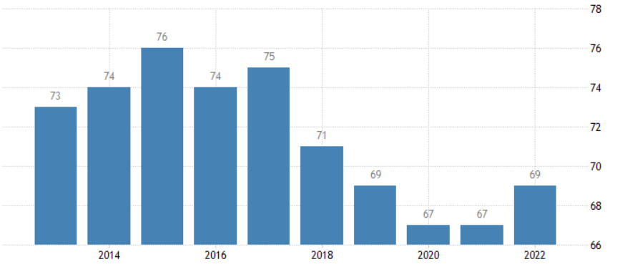
Figure 2: Corruption Perception in the US
(Source: Trading Economics, 2023)
Economic: The inflation rate in the US has declined from 5 percent to 4.9 percent. This implies that the business processes are cheaper for the organisation as it outlines that the costs of acquiring diverse supplies are lower. It also indicates that the services that are offered to customers are more affordable which positively affects the business in generating a higher demand in the markets.
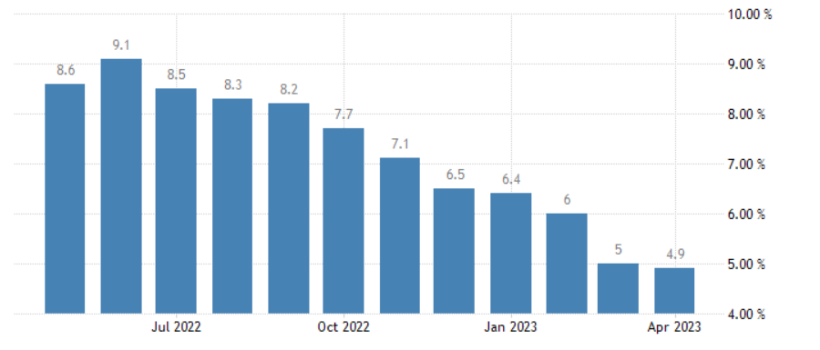
Figure 3: Inflation rates in the US
(Source: Trading Economics, 2023)
Social: Based on the high average disposable income of various citizens in the US, there is a significant benefit that the organisation attains from it. Herein it specifies that the Hyatt Hotel US has a higher chance of mitigating the issues pertaining to low demand in the markets of the nation. Additionally, it also underlines that the customers can properly afford the cost of its services in a more able manner.
Technological: It has been identified from the research that the US has a high technological innovation index score. This implies that it can effectively resolve the issues relevant to the lack of technological infrastructure present in the organisation properly. It can quicken the check-in and check-out times that the customers and employees have to endure by applying innovative technology in business processes.
Legal: The Consumer Rights and Consumer Protection Law in the US regulates the way in which an organisation outlines the various procedures that it has to undertake to interact with customers. Herein, this will positively impact the brand as it provides them with a guideline based on which it can ensure that the customer service issues are mitigated.
Environmental: The RCRA outlines the diverse mechanisms through which an organisation operates in the UK with the application of hygiene methods. Herein, it has been identified that the organisation has faced major issues regulating its waste management processes. It implies that through proper adherence to the regulatory guidelines of the Law, the organisation can ensure brand equity can be generated through sustainable operations.
SWOT Analysis
SWOT is an analytical framework that outlines the inherent capabilities that are entailed in the internal environment of an organisation while elaborating on external opportunities and threats (Benzaghta et al., 2021).
Strengths | Weaknesses
- Convenient locations of operations (Booking, 2023)  - Wide brand portfolio  - Established goodwill in the hospitality markets in the US  - Picturesque view  - Strong brand  - Established Infrastructure | - Unhygienic processes  - Improper customer service (Booking, 2023)  - Lack of staff training  - Inadequate parking facilities  - Lack of technological infrastructure resulting in increased check in a check out times
Opportunities | Threats
- The utilisation of social media for promotions (Maria et al., 2019).  - Creation of innovative advertisements leveraging its strengths  - Implementation of customer surveys | - High competition from other hotels chains in the USsuch as Drury Plaza, comfort suite and others (TripAdvisor, 2023)  - Safety concerns  - Losing the faith of customers  - Reduction in market share  - Boutique alternatives
Table 2: SWOT Analysis
(Source: Created by the learner)
Strengths: It has been understood through the above evaluation that the Hyatt Hotel has been effective in the course of operations through which it can ensure that the business is attractive in the general operational processes. It also helps in generating an improved number of operations and thereby has a higher revenue generation potential. Additionally, customer attractiveness is also enhanced based on the location in which it operates. This can be attributed to the fact that it is very near to various sightseeing locations.
Weaknesses: A number of weaknesses have been identified in the preceding sections that have been outlined through which it can face major difficulties in its operational procedure. Herein, it has faced issues in removing a bed bug infestation in the hotel. Moreover, it has also been observed that there is a significant lack of employee training that can be outlined in the organisational functioning that can outline lower productivity and efficiency in its operating procedure.
Opportunities: There are several opportunities that Hyatt Hotels US can leverage to enhance its performance and properly mitigate the issues that have been identified. Through the utilisation of social media marketing, it can target customers in a more specific manner and also ensure that a larger customer base can be attracted. Additionally, it can underline the usage of its resources in a more targeted way.
Threats: The risks that have been identified in the preceding areas in the operations of Hyatt Hotels US indicate that the hotel will face considerable issues in managing the market share present in the hospitality market effectively.

Main Body

Research methods
For this consultancy report, secondary research approach has been followed, as it helps the consultant to get better insights into the hotel brand by accessing the business reports and news articles (Largan and Morris, 2019). Moreover, to get quantitative information about the current issues faced by Hyatt Regency, both the published data have been collected. The major elements used for this study to understand the frameworks and their significance are e-books, news articles, and e-journals. Furthermore, using the keywords while researching, finding relevant papers on the selected topic becomes easier. Keywords used by the consultant in this study are Hyatt Regency, Customer Experience of Hyatt, Organisational Performance of Hyatt and Employee Satisfaction in Hyatt. Only reliable sources from Google Scholar, news articles, company websites and online review platforms were used while making the consultancy report. Thus, the following guidelines and suitable measures are followed in this report including data reliability and integrity.

The Star Model
Majority of the organisation are facing issues with successfully creating their value proportion and appropriately executing the business model becomes essential for the businesses. Galbraith's Star Model is an essential tool that allows organisations to align the business model with five key areas depending on the behaviour and decision-making process of the business (Galbraith, 2011). Determining the five different policies and decision-making power of the organisation can define the mindset and skills of employees. Implementation of this model in the operations of organisations can help in coping with the rapidly changing business environment. Additionally, the star model allows the business to get better insights into the market and helps in making innovations in operationalising the business model (Lemus-Aguilar et al., 2019).
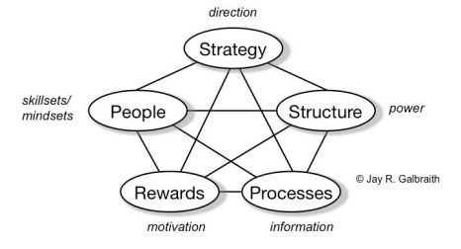
Figure 4: The Star Model
(Source: Galbraith, 2011)
Strategy: For maintaining customer satisfaction and deal with the potential issues related to customer service, Hyatt Hotels developed a feedback system on their official webpage (Hyatt, 2023). Here people can share their thoughts and makes suggestions for the hotel, which can make their operation quality better and provide better value to their customers. However, they are facing several issues related to consumers’ payment and failing to provide better service to them. Travellers who are staying with their families in this hotel complained about their services and “Bed Bug”. It affects the experience of the travellers and influences the potential guests of the brand negatively (Bookings, 2023). Thus, the current strategy of the organisation lacks in providing a satisfactory experience to their guests as a luxury hotel that causes lowering brand image and overall sales reduces. Additionally, investing more in cleanliness, and giving better facilities and discounts will help Hyatt Hotels to make the brand value for money and provide a better experience to their customers (Gaur et al., 2021).
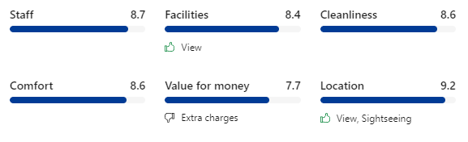
Figure 5: Hyatt Regency Saint Louis at The Arch review
(Source: Bookings, 2023)
Structure: Managing the structure of the organisation is essential for the Hyatt Regency as they are dealing with a huge number of customers, hotel properties and people, which makes the structure more complex for the business. Thus, the organisation collaborates with MWT Architect since 1994, which provides them with engineering solutions (Hotel Architect, 2023). It allows the brand to focus more on its organisational structure rather than spending time on managing people for building infrastructure design. However, depending on MWT Architect increases the operational cost for Hyatt Hotels and becomes a major concern for the hierarchies of the business. Creating a professional team for each business operation and hiring professional staff will help Hyatt to resolve the potential issues related to structure (Guo et al., 2021; Dhevabanchachai and Muangasame, 2021).
Processes: The business process of Hyatt Hotels is at a huge risk as they are not able to deal with the issues related to taxation and other legal policies considering the major factors including consumer protection (Reuters, 2023). It becomes an essential step for hotel organisations to boost their operational process by considering both external and internal factors. The higher inflation in the US causes a huge loss for the business as they failed to provide satisfactory service to their stakeholders. Moreover, the organisation did not respond to Paxton's lawsuit, which shows the faulty process of Hyatt Hotels. However, paying the taxes timely and making the business process more transparent to the stakeholders and hierarchy of the organisation can help Hyatt to deal with this kind of issue (Baloch et al, 2022).
Rewards: Employee discounts, food and complimentary stay, Disability insurance, Health Care and Insurance are the key benefits and rewards provided by Hyatt Hotels for managing their people (Glassdoor, 2023). It helps the hotel to boost its employee performance and make staff more engaged with their responsibilities. However, the limitations of these benefits and the huge time taken for making the payments for the insurance create a big chaos inside the organisation and negatively influence employee engagement. Ensuring faster insurance claims and providing more leaves with complimentary stays in the city hotels can improve the reward process (Ali et al., 2020).
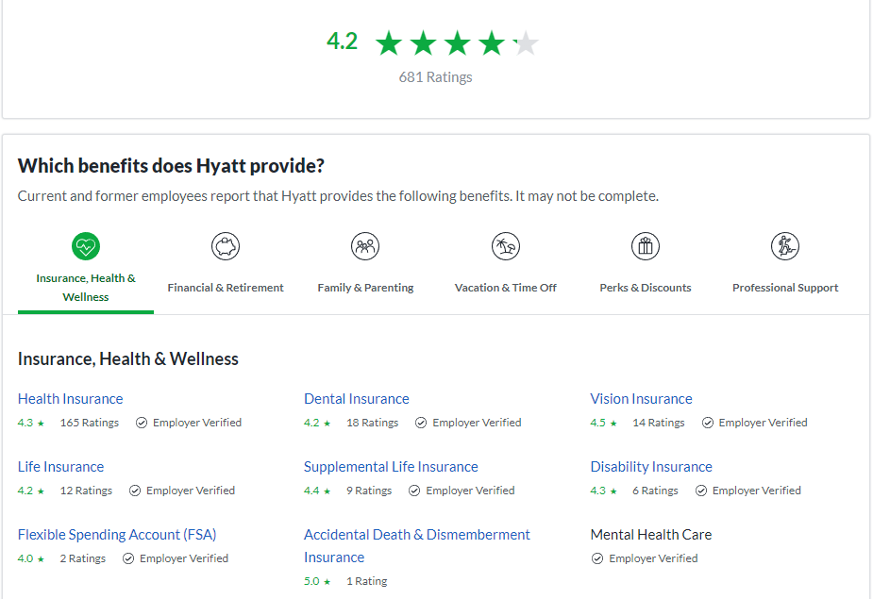
Figure 6: Employee benefits provided by Hyatt
(Source: Glassdoor, 2023)
People: Hyatt Hotels laid off around 1300 employees due to the huge losses faced during Covid 19 pandemic (Reuters, 2020). Moreover, they had to cut the pay of service managers due to investing more in restructuring and managing change in the business process. However, encouraging people of the brand became difficult for Hyatt as people are worrying more about their job rather than maintaining quality services. Moreover, investing more in training and development for the hotel staff can motivate employees to work with the organisation (Ababneh, 2021).

Fishbone model
A fishbone diagram allows a brand to categorise the potential issues related to the business with the cause in an effective visualisation form (Sakdiyah, Eltivia and Afandi, 2022). Thus, the root cause of the business can be identified easily and implementing strategies related to it will become easier for Hyatt.
Strategic issues of Hyatt Hotels
Bad customer experience
Influence of Covid-19
Employee management
Decisions of Hierarchies
Cleanliness
Lowering of sales
Employee cuts and low salary
Poor decision-making
Figure 7: Fishbone Model
(Source: Created by the learner)
From the above analysis, it can be identified that the organisation is dealing with several issues and failed to provide a satisfactory result to their stakeholders and sustain their business. The major challenges faced by Hyatt Hotels are discussed below
Bad customer experience: The major issues faced by the travellers in Hyatt Hotels are uncleaned rooms and poor room service (Expedia, 2023). It leads to unhappy customers and negatively influences the growth of the existing hospitality business and the image of the brand. The guests also complained about Bed Bugs, which is a common issue for Hyatt Regency St. Louis Arch. Managing the well-being of the customer is more difficult for the organisation by continuing these issues. Moreover, the violent staffs of the hotel and inappropriate billing including extra charges affect the online review of the business (Trustpilot, 2023). Thus, Hyatt Hotels faces losses both in getting potential leads and retaining existing customers.
Influence of Covid-19: Pandemic keeps the travellers at home and created restrictions on travel activities for a certain time. It is found that the total revenue of the hotel business fell by around 56% as the tour and travel industry and leisure demand reduced (Reuters, 2021). Thus, it influences the operation of the Hotel chain and lowers the business profitability. The total loss of Hyatt Hotels Corporation was 686 million US Dollars in 2020 (Hyatt, 2020). Lowering sales makes the business management process difficult for Hyatt and they changed their business operations to deal with the specific issue.
Employee management: Lower salaries lead to unhappy employees and managing the staff became difficult for Hyatt Hotel. Moreover, the huge cut-off in job opportunities reduced the current workforce and negatively influence the business development of the global hotel chain. Likewise, work reduction, improper pay and temporary furloughs become the major issues for the brand and development of the business (Hyatt, 2023).
Decisions of Hierarchies: Due to the lowering of sales during the Covid-19 situation the sales of Hyatt Hotels have dropped and faced huge losses. However, the higher authority of the corporation was optimistic about the situation and pulled different strategies to deal with the issues. For dealing with the huge business cost and managing these existing properties, the hierarchies planned to change the structure of their business and laid off about thirteen hundred employees (Reuters, 2020). Moreover, they reduced the salaries of the senior management in order to cope with the Corona virus situation. Thus, the employees’ morale was highly affected by the specific situation.

Change Management at Hyatt Regency
Organisational change refers to the alteration of the processes that consider the requirements for changing the structure and processes of the business (Hanelt et al., 2021). It allows the organisation to change their rules and policies including the operation for the betterment of the business performance resolving the current challenges faced by the firms. Lewin's Change Management Model involves three different stages that help organisations to implement the change needed by solidifying the new process and behaviour of the organisation (Tamunomiebi and Lawrence, 2020). As Hyatt Hotel is facing several issues in managing its business effectively, they need to implement some changes for developing the business and coping with the current industry trend.
Unfreeze: Communicating with the stakeholders is the major activity that follows during the unfreeze stage as it allows people to understand better the requirements of the proposed change in the business process. The analysis of a survey among the employees will help the organisation to engage them with the change management process. Thus, creating strategic decisions becomes easier for Hyatt Hotel. Additionally, interacting more with the customers and identifying the need of the travellers will help the organisation to point out the requirements for changes in the business process.
Change: Arranging workshops and different training seminars relevant to managing the quality service and customer satisfaction will be implemented as change for the employees. It will allow the hotel staff of Hyatt to understand more about the hospitality services and the behaviour they need to follow while interacting with guests. Hyatt Regency St. Louis At the Arch needs to boost their social media platforms, as communicating with travellers becomes easier for the brand depending on this strategy. Likewise, identifying the requirements of the travellers will help the brand to identify the current market trend.
Refreeze: After implementing the above changes, collecting employee feedback will help Hyatt Hotels to measure the performance and monitor the growth of the business. Hyatt Hotels should also adopt and explore digital platforms for customer interaction. Thus, the hotel organisation will get better opportunities by resolving the issues related to managing employees and providing better value to the guests.
Forces in support of change
- The global workforce and diverse culture in the workplace.
- Commitment towards employee well-being and value for their customers.
Forces resisting change
- Employee cut-off and job dissatisfaction.
- Lack of cleanliness in the hotel rooms and poor customer service.
For the effective implementation of the proposed project, Hyatt Regency needs to follow some measures, which are discussed below.
- Communicating with staff in the organisation before planning the change in the business process (Li et al., 2021).
- Understanding the current market and analysing travel activities and trends to get the best outcome from the change process.
- The use of different social media platforms improves customer engagement and promotes the best decisions for resolving potential issues.

Findings and Results
Parameter | Details | Linking with issues
Customer | The hotel had an American customer satisfaction score of 73 (Statista, 2023). | Even though the organisation has faced significant issues in customer services that were included in the organisational operations. It has maintained customer satisfaction levels over a specific time period (Alzoubi et al., 2022).  However, there have been several areas in which customers have faced numerous issues such as a hygienic functioning process. There have been instances where customers have had to face problems of bed bug infestation. This implies that there have been major issues relating to organisational operations.
Employee | The organisation has employed more than 130,000 individuals in various operational locations that are present in the US (Hyatt, 2023). | There are several issues that it has faced in managing employees that are working in the organisation. Herein, instances of employee discrimination and improper compensation have been identified in the general functional processes involved in business operations.
Management | Instances of significant management bias have been observed in the Hyatt Hotels in the US (Hyatt, 2023). | This has been a major challenge for the organisation as it results in the creation of diverse issues in employee productivity.
Covid-19 | The company recorded a loss based on the Covid-19 pandemic (Hyatt, 2020). | This had a significant on the operational effectiveness and efficiency with which it functions. Moreover, there have been instances of issues in the supply chain of the organisation.
Table 3: Findings table
(Source: Created by the learner)
Analysis
Herein, it has been identified that there have been various issues that have pestered the workable procedure that is entailed in Hyatt Hotels US. The primary issue identified in the organisational operations has been the improper regulation of customer interactions. It has been recognised that the organisation has faced numerous issues in properly interacting with the various customers that visit the organisation. Instances such as lack of cleanliness and the rise of hygiene-based issues have been the most fundamental challenge that the organisation has to face in providing high-quality services.
Additionally, the organisation has also faced major issues in managing and monitoring its employees in a competent manner. Thereby ensuring that the business processes are more efficient and illustrating an enhanced operational module that demonstrates better performance in general. This has a major adverse impact on the business functioning as it has more than 130,000 individuals working in different capacities in several locations. Herein it has been identified that a reward mechanism that has been provided for the employees which heavily time-consuming. It notably diminishes the motivation of employees that work in the organisation. Additionally, it has also been recognised that the complementary hotel rooms that are provided to employees are at far-off places which causes major discomfort for the employees working in the Hyatt Regency St. Louis Arch.
Moreover, there have been instances in which the management orientation to the employees has not been up to the mark as it elucidates and reeks of partiality. Herein, it outlines that lower intentions of employees to complete organisational duties had caused lower performance and efficiency.
Covid-19 has also been found to be a major parameter to understanding the strategies adopted by the business in executing diverse challenges associated with it. Herein, it has been identified that the organisation had to lay off 1300 employees to sustain itself in the market. Furthermore, it also faced a major decline in revenue generation potential as it recorded an emphasised loss in the first quarter after the occurrence of the pandemic.
Thus, the organisation had to face a number of issues based on the various parameters that have been identified in the preceding section.
TOWS
TOWS is a framework that is utilised in evaluating the correlation that the internal strengths and weaknesses of an organisation have in accordance with external threats and opportunities (Datta et al., 2020).
 | Opportunity  - The utilisation of social media marketing  - Creation of the innovative advertisements  - Conduction of customer surveys | Threats  - High competition  - Safety concerns  - Boutique alternatives
Strengths  - Wide brand portfolio  - Established goodwill  - Locational advantage  - Established infrastructure | The wide brand portfolio that has been created by the organisation can be utilised to showcase it to customers through various social media platforms and thereby generate a higher level of demand (Rajagopal and Rajagopal et al., 2019).  Additionally, based on the ability to innovate advertisements, Hyatt Hotels can ensure leverage of the picturesque locations at which it operates. | By catering wide brand portfolio and established goodwill, the high level of competition can be mitigated in business operations (De Canha et al., 2020).  Moreover, the enhancement of Technological infrastructure can aid in addressing the safety concerns that have been identified.  Additionally, with the combination of good locales, brand value, and goodwill, the risk to the boutique’s alternatives can be avoided.
Weakness  - Lack of staff training  - Inadequate technical infrastructure  - Unhygienic processes | Based on the conduction of custom surveys the organisation can understand the requirements that customers need thereby addressing the unhygienic practices (Habel et al., 2020). Additionally, this can also outline the areas in which the employees are not effective  It can thereby establish a training program based on which there can be various processes involved in the business procedures effectively.  Moreover, innovative advertisements can ensure that the strengths are highlighted to the customers and weaknesses are mitigated. | Herein the organisation can aim to develop strategies to enhance the competencies of the staff and staff to enable better check-ins and check-outs (Xiang et al., 2022). It can create skill development programs for the housekeeping staff to maintain a more hygienic process of operation. Additionally, it also involves the creation of a larger financial reserve to create better operating procedures in general.
Table 4: TOWS Matrix
(Source: Created by the learner)

Action Plan
Action Plan is a framework that outlines the way in which objectives can be fulfilled through a systematic method (van Heuvel et al., 2022).
Number | Problem | Solution | Desired Outcome | Time scale | Completion Date | Planned Budget
1. | Issues with customer experience in areas of cleanliness and hygiene | Various processes can be implemented through which the organisation can mitigate this issue. Particularly, it can apply a more competent housekeeping team. Additionally, the organisation can also adopt a process of implementing a guideline that can be followed in effecting hygienic and cleanliness-related operations. | This can reduce issues that the customer has with the organisation and thereby ensure that the business revenue generation potential is maintained and enhanced. | 6 months | 15.12.2023 | 20000 British Pounds
2. | Employee layoffs and salary cuts of senior employees | This can be effectively resolved through the creation of a revised operational structure of compensation for the employees that are present in the operational process of the organisation effectively. Additionally, by reducing indirect costs other than salaries, the employees’ motivations can be improved. | It has been desired that employee compensation through the revised structure can ensure that the motivation of employees is maintained. Additionally, it will generate better employee motivation in general which implies that the business processes are majorly enhanced. | 7 months | 1.1.2024 | 50000 British Pounds
3. | Poor decision-making of management | This can be enhanced through the identification and prioritisation of key business areas. Additionally, decisions can be enhanced through a proper evaluation of different areas of business environments and thereby implement a better decision-making procedure. | This will ensure that the decisions are enhanced and overall operational practices are enhanced and operational practices are enhanced. Additionally, it is also desired that employee and customer satisfaction are prioritised and improved. | 3 months | 9. 9. 2023 | 5000 British Pounds
4. | Lower sales and market share for covid-19 | The solution for the lower sales and market share can be enhanced by providing comprehensive discounts and offers on the services that are provided to prospective customers which enhances the attractiveness of the services of the organisation. | It is desired that the business needs to have a higher amount of market share and sales figures. | 6 months | 15.12.2023 | 15000 GBP
Table 5: Action Plan
(Source: Created by the leaner)

Recommendations
Various recommendations have been provided to veritably improve the issues and challenges that have been identified in the preceding sections of the report:
- Creation of a housekeeping standard operating procedure: This can be implemented in the operating procedure of the Hyatt Regency St. Louis Arch to effectively ensure that the employees are operating in a clean and hygienic manner (Mijatovic, Maricic and Horvat, 2019).
- Implementation of training modules for staff: It can facilitate that the employees have the requisite skill sets to perform organisational duties. This can aid the Hyatt Regency St. Louis Arch to provide better services to customers (Grabiec, 2021).
- Restructuring of salary structure: Through restructuring the compensation structure, the issues relating to sustenance are addressed. Moreover, it also facilitates the development of higher employee morale and productivity (Spisakova, 2019).
- Reduction in fixed overheads: This can veritably reduce the issues faced by the company relevant to operational aspects can be properly mitigated. It also enhances the nature of the operation working capital that is available to the organisation mitigating verily daily financial challenges that are involved in the functioning procedure that is involved in Hyatt Hotels (Rivero-Camacho et al., 2023).
- Implementation of clear and concise evaluation of the business environment and situations: this can help the organisation in the creation of a better and more accurate decision-making process that ensures that the business has a higher level of performance and thereby can generate an enhanced profit generation potential in its normal way of functioning (Dvorský et al., 2020).
- Increment in discounts and offers: The application of this methodology ensures that the organisation records a higher level of attractiveness in the markets of the US. It also outlines that the demand for the services of the organisation in the US markets is more desirable and can confirm the increase in brand equity in the general operational process (Kim, Kim and Wang, 2021).
- Innovative marketing campaigns: Additionally, the organisation can look to implement an innovative marketing campaign through the generation of various social media platforms as it can ensure better reach of customers (Păvăloaia, Anastasiei and Fotache, 2020).

Conclusion
This consultancy report can be provided as an essential document to the client, as it includes all the current and potential issues of Hyatt Hotel that hampers the growth and opportunity for the specific hotel brand. From the report, it can be concluded that organisational consultancy plays an important role in the business development process. With expert guidance for developing the business, managing the business operations becomes easier for the brand. Additionally, hotel chains can get better advice through it for resolving their issues caused by the influence of both external and internal environmental factors. Hyatt Regency St. Louis Arch is facing several issues related to getting satisfied customers and management of the performance of their staff which caused a lowering of the current brand image. In addition to that, Hyatt Hotels faced a huge loss of around 686 million US dollars due to the adverse effect of the Corona virus pandemic. From PESTEL analysis it is found that social factor such as disposable income is negatively influencing the business of Hyatt and lack of staff training and unhygienic processes are the major weaknesses of the brand that poses several challenges to the brand.
Bed Bugs and employee turnover are the biggest problems of the organisation that needed to be fixed for getting better opportunities. Identifying the market requirement and interacting with the stakeholders is the best way to implement change in the process. The wide brand portfolio can help Hyatt Regency St. Louis Arch to resolve the issues related to higher market competition. Other than that, restructuring the salary can help the brand to manage its employees and handle the business operations with motivated employees. The rapid change in the business portfolio can possess more challenges for the brand and they might require additional guidance in the future to deal with the potential risks for business development.

Reference List
Ababneh, O.M.A. (2021) How do green HRM practices affect employees' green behaviours? The role of employee engagement and personality attributes. Journal of Environmental Planning and Management, 64(7), pp.1204-1226.
Ali, A.A.A.M., Kee, D.M.H., Singh, A., Pandey, R., Alhamlan, H., Ahmad, K.M., Quttainah, M.A., Siw, M.Y., Ong, R.S. and Narayanan, Y. (2020) Does motivation improve employees job performance? A case of absolute hotel services. International Journal of Tourism and Hospitality in Asia Pasific (IJTHAP), 3(3), pp.9-21.
Alzoubi, H., Alshurideh, M., Kurdi, B., Akour, I. and Aziz, R. (2022) Does BLE technology contribute towards improving marketing strategies, customers’ satisfaction and loyalty? The role of open innovation. International Journal of Data and Network Science, 6(2), pp.449-460.
Baloch, Q.B., Shah, S.N., Raheem, F. and Khan, A.U. (2022) Restoration & Rebuilding Pakistan’s Tourism & Hospitality Sector: Transforming Business Processes. Abasyn University Journal of Social Sciences, 15(1).
Benzaghta, M.A., Elwalda, A., Mousa, M.M., Erkan, I. and Rahman, M. (2021) SWOT analysis applications: An integrative literature review. Journal of Global Business Insights, 6(1), pp.55-73.
Booking (2023) Hyatt Regency Saint Louis at The Arch. Available at:https://www.booking.com/hotel/us/hotel-st-louis-at-the-arch.en-gb.html?keep_landing=1&aid=356980&sid=9b5fc5e5fa10521ce6de60174048c954&label=gog235jc-1DCAso7AFCGmhvdGVsLXN0LWxvdWlzLWF0LXRoZS1hcmNoSDNYA2hsiAEBmAEJuAEXyAEM2AED6AEBiAIBqAIDuALQnOejBsACAdICJGRmZTRlY2JhLTQwOGMtNDE0Ny05NGJjLTY5MTk1MjE3Yzg2OdgCBOACAQ&dist=0&type=total&sb_price_type=total#tab-main (Accessed: 3 June 2023)
Buttrick, R. (2009) The Project Workout, London:PrenticeHall
Datta, N.R., Kok, H.P., Crezee, H., Gaipl, U.S. and Bodis, S. (2020) Integrating loco-regional hyperthermia into the current oncology practice: SWOT and TOWS analyses. Frontiers in oncology, 10, p.819.
De Canha, N., Ewing, M. and Tamaddoni, A. (2020) The Impact of Advertising on Market Share: Controlling for Clutter, Familiarity, and Goodwill Decay. Journal of Advertising Research, 60(1), pp.87-103.
Dhevabanchachai, N.T. and Muangasame, K. (2021) Establishing an In-house Hotel Training Centre in a University: A case of an international college hotel training centre in Thailand. Practical Learning in Hospitality Education.
Dvorský, J., Belas, J., Novotna, I., Fero, M. and Petrakova, Z. (2020) Quality of business environment of the SME: A sectoral view. Communications-Scientific Letters of the University of Zilina.
EPA (2023) Resource Conservation and Recovery Act (RCRA) Laws and Regulations. Available at: https://www.epa.gov/rcra (Accessed: 3 June 2023)
Expedia (2023) Guest reviews Available at: https://www.expedia.com/St-Louis-And-Vicinity-Hotels-Hyatt-Regency-St-Louis-At-The-Arch.h14877.Hotel-Reviews?pwaDialogNested=PropertyDetailsReviewsBreakdownDialog (Accessed: 2 June 2023)
Galbraith, J.R. (2011) The star model. The STAR Model.
Gaur, L., Afaq, A., Solanki, A., Singh, G., Sharma, S., Jhanjhi, N.Z., My, H.T. and Le, D.N. (2021) Capitalizing on big data and revolutionary 5G technology: Extracting and visualizing ratings and reviews of global chain hotels. Computers and Electrical Engineering, 95, p.107374.
Glassdoor (2023) Hyatt Benefits Available at: https://www.glassdoor.com/Benefits/Hyatt-US-Benefits-EI_IE2839.0,5_IL.6,8_IN1.htm (Accessed: 2 June 2023)
Global Data (2023) Hyatt Hotels Corp: Overview Available at:https://www.globaldata.com/company-profile/hyatt-hotels-corp/ (Accessed: 3 June 2023)
Global Economy (2022) USA: Innovation index. Available at:https://www.theglobaleconomy.com/USA/GII_Index/#:~:text=The%20average%20value%20for%20the,128%20countries%20is%2032.09%20points. (Accessed: 3 June 2023)
Google (2023) Hyatt Regency St. Louis At The Arch Available at: https://www.google.com/maps/place/Hyatt+Regency+St.+Louis+At+The+Arch/@38.6262038,-90.1899584,17z/data=!4m9!3m8!1s0x87d8b31de5f5865d:0x3f5edb427f2add1b!5m2!4m1!1i2!8m2!3d38.6262038!4d-90.1877697!16s%2Fm%2F0wfjf34?entry=ttu (Accessed: 2 June 2023)
Grabiec, O. (2021) Training needs and the benefits of training for employees of Polish enterprises. European Research Studies, 24(3B), pp.350-360.
Guo, M., Ahmad, N., Adnan, M., Scholz, M. and Naveed, R.T. (2021) The relationship of csr and employee creativity in the hotel sector: The mediating role of job autonomy. Sustainability, 13(18), p.10032.
Habel, J., Kassemeier, R., Alavi, S., Haaf, P., Schmitz, C. and Wieseke, J. (2020) When do customers perceive customer centricity? The role of a firm’s and salespeople’s customer orientation. Journal of Personal Selling & Sales Management, 40(1), pp.25-42.
Hanelt, A., Bohnsack, R., Marz, D. and Antunes Marante, C. (2021) A systematic review of the literature on digital transformation: Insights and implications for strategy and organizational change. Journal of Management Studies, 58(5), pp.1159-1197.
HG (2023) Consumer Rights - Consumer Protection Law. Available at:https://www.hg.org/consume.html#:~:text=Consumer%20rights%20and%20consumer%20protection,of%20information%20or%20bargaining%20power.(Accessed: 3 June 2023)
Hotel Architect (2023) Hyatt Architect, Design, Plans & Interior. Available at: https://www.hotelarchitect.com/hyatt-architect/(Accessed: 2 June 2023)
Hyatt (2020) HYATT HOTELS CORPORATION. Available at: https://d18rn0p25nwr6d.cloudfront.net/CIK-0001468174/6b0aaf49-6404-48a5-86fe-565455f79d90.pdf (Accessed: 2 June 2023)
Hyatt (2023) About Hyatt. Available at: https://about.hyatt.com/en.html (Accessed: 2 June 2023)
Hyatt (2023) Doing What’s Right. Available at:https://s2.q4cdn.com/278413729/files/doc_downloads/corp%20gov/2019/HHC-Code-of-Business-Conduct-and-Ethics-(FINAL-approved-Dec-2017-effective-Jan-2018).pdf (Accessed: 3 June 2023)
Hyatt (2023) Hyatt.com Feedback. Available at: https://www.hyatt.com/contact-hyatt/share-website-feedback (Accessed: 2 June 2023)
Hyatt (2023) OUR story. Available at:https://about.hyatt.com/en/hyatthistory.html#:~:text=Hyatt%20was%20founded%20by%20Jay,the%20Los%20Angeles%20International%20Airport. (Accessed: 3 June 2023)
Hyatt (2023) Statement on Hyatt Corporate Workforce Actions in Response to COVID-19. Available at: https://newsroom.hyatt.com/statement_corporate_workforce_covid-19 (Accessed: 2 June 2023)
Hyatt (2023) The perfect pace: Hyatt resorts. Available at: https://www.hyatt.com/ (Accessed: 3 June 2023)
Hyatt (2023) WE care FOR PEOPLE SO THEY CAN BE THEIR best. Available at:https://about.hyatt.com/en.html (Accessed: 3 June 2023)
Kim, J., Kim, J. and Wang, Y. (2021) Uncertainty risks and strategic reaction of restaurant firms amid COVID-19: Evidence from China. International Journal of Hospitality Management, 92, p.102752.
Kotter, J.P. (2012) Leading change. Harvard business press.
Largan, C. and Morris, T. (2019) Qualitative secondary research: A step-by-step guide. Sage.
Lemus-Aguilar, I., Morales-Alonso, G., Ramirez-Portilla, A. and Hidalgo, A. (2019) Sustainable business models through the lens of organizational design: A systematic literature review. Sustainability, 11(19), p.5379.
Li, J.Y., Sun, R., Tao, W. and Lee, Y. (2021) Employee coping with organizational change in the face of a pandemic: The role of transparent internal communication. Public Relations Review, 47(1), p.101984.
Maria, S., Pusriadi, T., Hakim, Y.P. and Darma, D.C. (2019) The effect of social media marketing, word of mouth, and effectiveness of advertising on brand awareness and intention to buy. Jurnal Manajemen Indonesia, 19(2), pp.107-122.
Mijatovic, I., Maricic, M. and Horvat, A. (2019) The factors affecting the environmental practices of companies: The case of Serbia. Sustainability, 11(21), p.5960.
Newton, R (2010). The management consultant : mastering the art of consultancy. Financial Times.
Noordzife, G. (2014) Project Management of HotelOpening Processes: Exploring Better Ways to Manage New Hotel Openings, CreateSpace
Păvăloaia, Anastasiei and Fotache, D. (2020) Social media and e-mail marketing campaigns: Symmetry versus convergence. Symmetry, 12(12), p.1940.
Pino, I. (2022) What does it mean to have disposable income and how should you use it?. Available at:https://fortune.com/recommends/banking/what-is-disposable-income/ (Accessed: 3 June 2023)
PIRNAR, İ., KURTURAL, S. and ERİŞ, E.D. (2019) SWOT-TOWS Analysis of Urla Destination’s Alternative Tourism Development. International Journal of Contemporary Tourism Research, 3(2), pp.235-244.
Rajagopal and Rajagopal (2019) Brand portfolio management. Competitive Branding Strategies: Managing Performance in Emerging Markets, pp.143-173.
Reuters (2020) Hyatt to lay off 1,300 employees as pandemic cripples travel Available at: https://www.reuters.com/article/uk-hyatt-hotels-layoffs/hyatt-to-lay-off-1300-employees-as-pandemic-cripples-travel-idUKKBN22O0AB (Accessed: 2 June 2023)
Reuters (2021) Hotel operator Hyatt posts bigger loss as pandemic keeps people at home Available at: https://www.reuters.com/business/hotel-operator-hyatt-posts-bigger-loss-2021-05-04/ (Accessed: 2 June 2023)
Reuters (2023) Texas Settles With Marriott, Sues Hyatt Over 'Resort Fees' Available at: https://www.usnews.com/news/top-news/articles/2023-05-16/texas-sues-hyatt-hotels-for-misleading-marketing-and-charging-hidden-fees (Accessed: 2 June 2023)
Rivero-Camacho, C., Martín-del-Río, J.J. and Marrero-Meléndez, M. (2023) Evolution of the life cycle of residential buildings in Andalusia: Economic and environmental evaluation of their direct and indirect impacts. Sustainable Cities and Society, 93, p.104507.
Sakdiyah, S.H., Eltivia, N. and Afandi, A. (2022) Root Cause Analysis Using Fishbone Diagram: Company Management Decision Making. Journal of Applied Business, Taxation and Economics Research, 1(6), pp.566-576.
Simon, H. (2020) Hyatt to lay off 1,300 employees, restructure roles. Available at: https://www.hotelmanagement.net/operate/hyatt-to-lay-off-1-300-employees-restructure-roles (Accessed: 3 June 2023)
Spisakova, E.D. (2019) Position of employee benefits in remuneration structure. Transformations in Business & Economics, 18(2), p.47.
Statista (2023) American Customer Satisfaction Index scores for Hyatt hotels in the United States from 2008 to 2022. Available at:https://www.statista.com/statistics/194730/customer-satisfaction-with-us-hyatt-hotels-since-2008/ (Accessed: 3 June 2023).
Statista (2023) Revenue of Hyatt Hotels Corporation worldwide 2008-2022. Available at: https://www.statista.com/statistics/257362/revenue-of-the-hyatt-hotels-corporation/ (Accessed: 2 June 2023)
Tamunomiebi, M.D. and Lawrence, D. (2020) Change management and organizational resilience. International Journal of Innovative Research and Advanced Studies, 7(2), pp.158-163.
Thomas, P.J.M., Sandwell, P., Williamson, S.J. and Harper, P.W. (2021) A PESTLE analysis of solar home systems in refugee camps in Rwanda. Renewable and Sustainable Energy Reviews, 143, p.110872.
Trading Economics (2023) United States Corruption Index. Available at:https://tradingeconomics.com/united-states/corruption-index(Accessed: 3 June 2023)
Trading Economics (2023) United States Inflation Rate. Available at: https://tradingeconomics.com/united-states/inflation-cpi (Accessed: 3 June 2023)
TripAdvisor (2023) Saint Louis Hotels. Available at: https://www.tripadvisor.in/Hotels-g44881-Saint_Louis_Missouri-Hotels.html (Accessed: 3 June 2023)
Trustpilot (2023) Hyatt Hotels Available at: https://www.trustpilot.com/review/www.hyatt.com (Accessed: 2 June 2023)
van Heuvel, L., Caini, S., Dückers, M.L. and Paget, J. (2022) Assessment of the inclusion of vaccination as an intervention to reduce antimicrobial resistance in AMR national action plans: a global review. Globalization and health, 18(1), pp.1-10.
Whittington, R. et al (2020) Exploring Strategy. Harlow:PearsonEducation Limited.
Xiang, K., Huang, W.J., Gao, F. and Lai, Q. (2022) COVID-19 prevention in hotels: Ritualized host-guest interactions. Annals of Tourism Research, 93, p.103376.

Appendices

Appendix 1: ACSI score
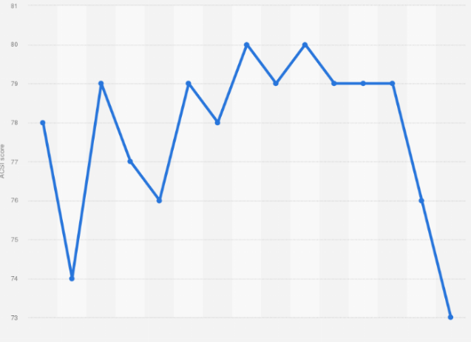
Figure 8: ACSI scores
(Source: Statista, 2023)

Appendix 2: Hotel location
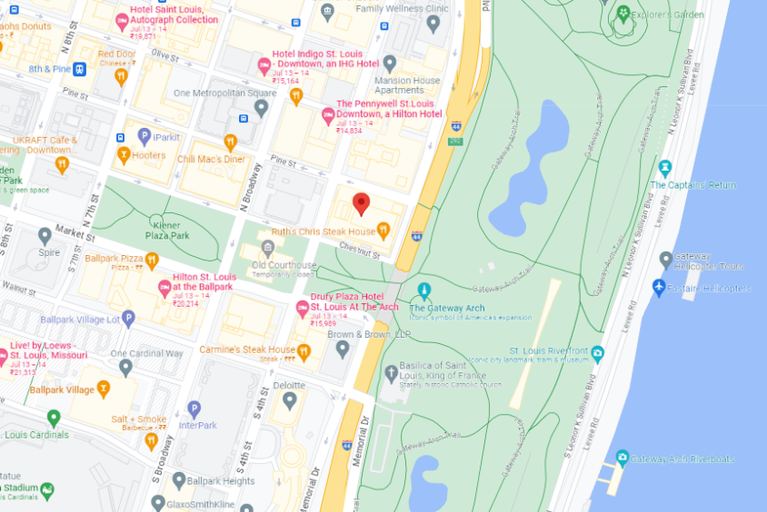
Figure 9: Hotel location
(Source: Google, 2023)

