
Clinical Assessment sheet

Date:
Therapist:

Patient name:
Address:

Contact number:
DOB:
Occupation:
GP name & address:

Patient consent to assessment & treatment: …………………………………………….

HPC

When, activity, mechanism, start to now
SOCRATES
P&N / Para / B&B / C&S /
HA’s & Migraines / 5D’s & 3N’s
Sleep

Aggravating:
Relieving:
Behaviour of symptoms:
SIN:

PMH / Investigations / Surgeries / Imaging

Previous operations, accidents,
illness, other health problems

Medications:

Family Hx:

Systems check: CVS / GI / Neuro / Obs&Gyne / GU / Endocrine / Resp / Other

BP …………………………….. Pulse ……………

Examination

Observation/Palpation:

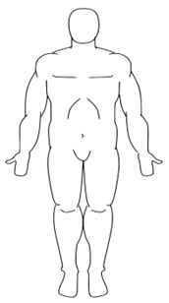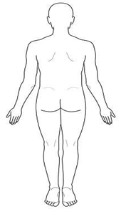

ROM – AROM / PROM / RROM / Accessory tests (inc. joints above/below)

Muscle/ligament tests

Functional tests

Special tests/other tests (inc. myotomes/dermatomes/reflexes)

Working diagnosis

Cautions/contraindications:

Signed (therapist): ………………………………………………… Date: …………………………………..

